# Short Descriptive Title

# Objective

Write a statement that will explain what you are setting out to do.

For example, the objective of this lab is to give students a chance to observe the basic relationship described by Ohm's Law and the basic relationships of combining loads in series.

# Procedures

This is the main body of the report. State what was done, show how it was done, and why; also show the results. The lab should consist of several short procedures, all connected together by the overall objective of the lab.

You can outline your procedures in number steps:

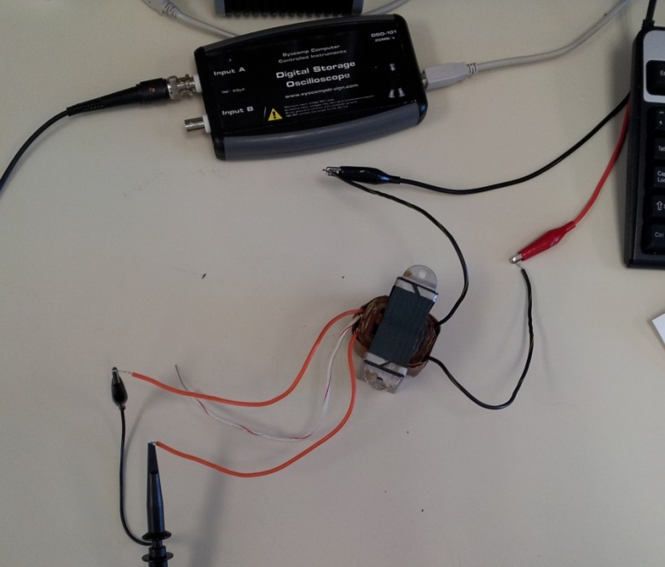

Connecting with a Transformer. Transformer is in red circle, with the secondary wires connected on the left and primary on the right.

1. First measure the resistance of each of your resistors using the DMM. Look at the picture to the right to see what I mean (which actually has nothing to do with DMM):

Include images within same context of procedures, and be sure to label the images and explain the labels.

2. Set the DC power supply to a voltage between +3V and +5V; be sure to record the voltage you chose.

3. Measure the current through the circuit with each resistor, in turn, connected (one at a time) to the power supply.

Show your results in any form that will get the answer across, preferably in an organized fashion.

4. Set the function generator to sine wave output, 60 Hz, maximum amplitude. Measure this amplitude with the oscilloscope. Apply this signal to the primary side of the transformer and measure the voltage out of the secondary side. Assume the input ampacity to be 1.0 Amps; calculate the output ampacity.

V1/V2 = I2/I1

V1 = 19.38 Vp-p; V2 = 4.58 Vp-p

19.38 V/4.58 V = I2/1.0 Amp

**I2 = 4.2314 A**

When appropriate, use tables, as shown below in an example that once again has nothing to do with the above:

|  |  |  |  |
| --- | --- | --- | --- |
| **Measured R** | **Predicted I** | **Actual I** | **% difference** |
| 3.317 kΩ | 0.910 mA | 0.919 mA | +1.00% |
| 0.9765 kΩ | 3.093 mA | 3.088 mA | -0.16% |
| 329.7Ω | 9.160 mA | 8.888 mA | -3.00% |
| 100.4Ω | 30.080 mA | 26.552 mA | -11.73% |

You can also include your own diagrams and charts where instructed as appropriate. If you are using other programs, you can include screenshots. Please include everything within one document with your submissions.

# Equipment Used

Record the manufacturer and model number of each piece of equipment used.

Example: Oscilloscope, function generator, transformer, 27 mH inductor, DMM, and various cables.

You are welcome to get more specific here and include pictures of the various equipments. The more specific you are, the more credit you will get on your submission.

# Report

Compare your results against what you expected. Interpret your findings.

This is often lumped with the conclusion and/or the procedure, and it should not be. The results are included with the procedures. This section is for review of the results and interpretation of the findings. You can post the results again here and compare them against what you were expecting to find. Explain why results may have differed and expound on this. This could be no longer than a paragraph, although you can do more if you wish.

# Conclusion

Tell what you have learned from this experiment. Step back, think, review, and get a good feeling for what you have done and what it has meant to you, then write it down.

Each lab report will include what you will need to write for this, but also include was is stated above in this section as well. Again, this could be no longer than a paragraph, although you can do more if you wish. Do not lump this with the report.

**John Doe**

**May 15, 2014**