Garcia_Jessenia_Assignment_#3

Hispanic.Total Hispanic.Men Hispanic.Women

Min. : 8.60 Min. : 8.00 Min. : 9.00

1st Qu.:11.62 1st Qu.:11.15 1st Qu.:11.97

Median :13.30 Median :12.90 Median :13.70

Mean :13.58 Mean :13.41 Mean :13.87

3rd Qu.:15.18 3rd Qu.:15.43 3rd Qu.:15.75

Max. :20.10 Max. :21.20 Max. :19.00

**Hispanic Total**

Mean: 13.58

Median 13.30

Mode: 11.7, 13.2

**Hispanic Men**

Mean: 13.41

Median 12.90

Mode: 11.5, 14.6, 14.9

**Hispanic Women**

Mean: 13.87

Median: 13.70

Mode: 14.4

Describe the variables through variation

Hispanic Total 9.497611

Hispanic Men 11.87077

Hispanic Women 7.168066

Discuss Normality. How can you tell?

Visual tests let us determine normality. I have used histograms and qq plots to answer this question. The further the deviate , the less normal the distribution.

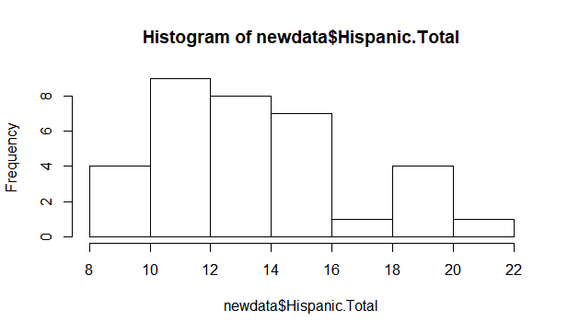

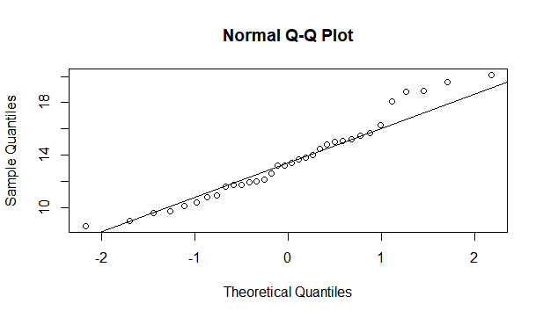

The histogram and QQ plot show that the graph is positively skewed.

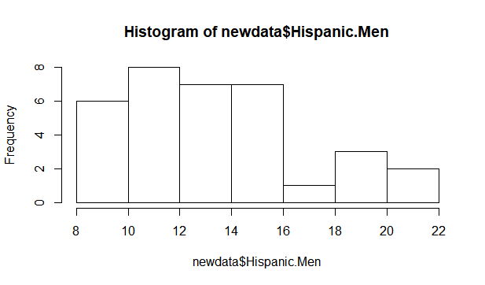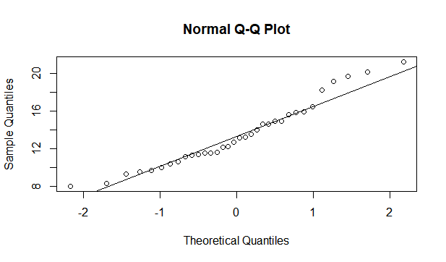

The graphs for the rate of Hispanic men who are unemployed also shows a positive skew.

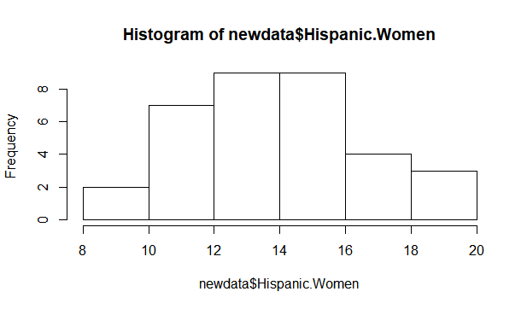

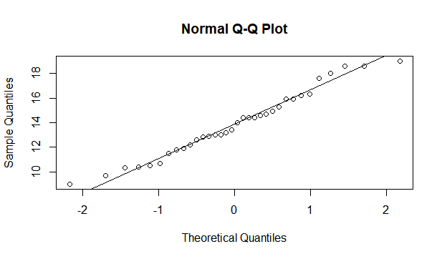

Out of all three variables, the rate of Hispanic women unemployment is the closest to being a normal distribution.