16S and 18S rRNA gene metabarcoding provide complementary insights into the responses of sediment communities to eutrophication

Jesse P. Harrison*†, Panagiota-Myrsini Chronopoulou, Iines Salonen, Tom Jilbert & Karoliina A. Koho

Aquatic Biogeochemistry Research Unit, Ecosystems and Environment Research Programme, Faculty of Biological and Environmental Sciences, University of Helsinki, Helsinki, Finland

Helsinki Institute of Sustainability Science, Faculty of Biological and Environmental Sciences, University of Helsinki, Helsinki, Finland

* Corresponding author. E-mail: jesse.harrison@csc.fi

† Current address: CSC – IT Center for Science Ltd., Espoo, Finland
Abstract

Metabarcoding analyses of bacterial and eukaryotic communities have been proposed as efficient tools for environmental impact assessment. It has been unclear, however, to which extent these analyses can provide similar or differing information on the ecological status of the environment. Here, we used 16S and 18S rRNA gene metabarcoding to compare eutrophication-induced shifts in sediment bacterial and eukaryotic community structure in relation to a range of porewater, sediment and bottom-water geochemical variables, using data obtained from six stations near a rainbow trout farm in the Archipelago Sea (Baltic Sea). Shifts in the structure of both community types were to a correlated with a shared set of variables, including porewater ammonium concentrations and the sediment depth-integrated oxygen consumption rate. Canonical correspondence analyses showed that variables typically employed in impact assessments, such as bottom water nutrient concentrations, explained less of the variance in community structure than alternative variables selected due to their low collinearity (up to 28% vs. 35% of the variance explained, respectively). In monitoring surveys where analyses of both bacterial and eukaryotic communities may be impossible, 16S and 18S rRNA gene metabarcoding can interchangeably serve as reliable indicators of wider ecological changes due to eutrophication.
Introduction

Assessing the ecological integrity of benthic habitats is crucial to marine ecosystem management (Fernandes et al. 2001), with seafloor monitoring efforts having traditionally relied on morphological inventories of macrofauna (≥0.5 mm size fraction) and associated indices (Lejzerowicz et al. 2015; Pawlowski et al. 2016). While producing such inventories requires considerable time, taxonomic expertise and finances, environmental DNA (eDNA) metabarcoding has emerged as a high-throughput and low-cost option for characterizing the structure and composition of sediment communities (Pawlowski et al. 2018). Comparisons of morphology-based and metabarcoding approaches for the characterization of sediment macrobenthos have demonstrated that the latter can function as a promising complement to traditional surveying methods (Aylagas et al. 2014; Aylagas et al. 2016; Cordier et al. 2017; Lobo et al. 2017; Cahill et al. 2018; Stoeck et al. 2018). By relying on total DNA extraction from sample materials, eDNA metabarcoding also enables investigations of microbial and meiofaunal (≤0.5 mm) communities that are extremely challenging to study by traditional means, providing a more comprehensive snapshot of ecosystem health than macrofaunal surveys alone (e.g. Chariton et al. 2015, Pawlowski et al. 2016, Stoeck et al. 2018).

Efforts to explore the use of metabarcoding in benthic ecosystem monitoring have involved analyses of both sediment eukaryotic (18S rRNA gene) and bacterial (16S rRNA gene) communities (reviewed in Pawlowski et al. 2018). In the context of aquaculture-induced organic enrichment, this work has focused on foraminifera (Pawlowski et al. 2014, Pawlowski et al. 2016, He et al. 2019) and ciliates (Forster et al. 2018), as well as general analyses of eukaryotic (Chariton et al. 2015) and bacterial communities (Dowle et al. 2015, Fodelianakis et al. 2015, Stoeck et al. 2018, Verhoeven et al. 2018, Moncada et al. 2019). The use of metabarcoding as a monitoring tool has also been explored with reference to localized disturbances caused by dredging (Zhang et al. 2017) and off-shore drilling (Lanzén et al. 2016, Laroche et al. 2017).These studies have shown that bacterial and eukaryotic metabarcoding analyses can serve as sensitive methods to detect anthropogenic impacts on sediment habitats, including both short-term responses and long-term effects on community resilience and stability.

Despite the promising results reported in previous studies and the increasing affordability of large-scale sequencing surveys, neither 16S nor 18S rRNA gene metabarcoding have yet been adopted as a routine component of monitoring programmes (but see Lefrançois et al. 2018). While using both techniques in tandem would provide particularly comprehensive data on the status of sediment communities, this is likely to be unfeasible due to monitoring programmes being subject to strict time and financial limitations (Borja and Elliott 2013; Borja et al. 2016). It also remains unclear to what extent these methods can offer similar or contrasting information on the status of seafloor habitats, particularly with reference to identifying those physical and chemical variables that are likely to drive community shifts at multiple trophic levels. Although several studies have correlated water column and/or sediment geochemical variables with metabarcoding data (Pawlowski et al. 2014, Chariton et al. 2015, Dowle et al. 2015, Fodelianakis et al. 2015, Lanzén et al. 2016, Forster et al. 2018, Moncada et al. 2019, He et al. In press), there is a lack of research on this topic involving cross-comparisons of prokaryotic and eukaryotic communities. In cases where both types of metabarcoding analyses have been employed, shifts in community structure have either not been correlated with geochemical data or only a limited set of measurements has been used (La Rosa et al. 2001, Zhang et al. 2017, Keeley et al. 2018, Stoeck et al. 2018). Addressing this absence of information, therefore, is essential to establishing a full understanding of how metabarcoding can be best employed as a tool for marine ecosystem monitoring.

Here we used a field transect approach to compare 16S and 18S rRNA gene metabarcoding as tools to obtain insights into the impacts of aquaculture-induced eutrophication on the structure and composition of sediment communities in the coastal Archipelago Sea (Baltic Sea, Finland). In addition, we determined whether shifts in the structure of these communities were correlated with a shared or divergent set of environmental variables, and whether variables routinely included in benthic monitoring programmes could reliably predict community responses to eutrophication. The data show that eutrophication-associated shifts in bacterial and eukaryote community structure are to a large extent linked to a common set of variables, suggesting that community changes detected by 16S or 18S rRNA gene metabarcoding are likely to reflect wider ecological responses to increased organic loading. Our findings demonstrate that the sensitivity of monitoring approaches could be markedly improved through more carefully designed protocols for the collection of environmental metadata, especially with reference to understanding the impacts of eutrophication at multiple levels of biological organization.

Materials and Methods

Study location and sampling strategy

Six stations (S1–S6) were sampled in the vicinity of a rainbow trout farm adjacent to Haverö Island, Archipelago Sea, Baltic Sea (Fig. 1, Table S1). The farm was operational between 1987 and 2008 (Jokinen et al. 2018), after which it has been intermittently used for storing live fish. Sites S1–S3 were situated within a basin where the farm was located, S4 on a sill, S5 on the seaward side of the sill and S6 was included as a reference site outside the direct influence of the farm (Fig. 1). At each site, water column variables were measured with a conductivity-temperature-depth (CTD) profiler (SBE 19 SEACAT, Sea-Bird Electronics Inc., Washington, USA), and sediment cores were collected with a GEMAX twin corer (internal ⌀ 9 cm) in September 2017. Separate cores were collected for geochemical analyses (of porewater and bulk sediment), and for microbiological analyses.

Porewater sampling and analysis

Porewater samples for geochemical analyses were taken immediately upon retrieval of sediment cores at two-centimetre depth intervals from 0–20 cm depth, using rhizon samplers (Seeberg-Elverfeldt et al. 2005). Two cores were taken for rhizon samples, one for nutrient analysis and the other for analysis of hydrogen sulfide (H₂S). From the first core, subsamples for analysis of dissolved nitrogen species were stored at −20°C, while subsamples for inductively coupled plasma mass spectrometry (ICP-MS) analysis of phosphorus were immediately acidified with 1M nitric acid (HNO₃) and stored at 4°C. Samples for H₂S (from the second column) were prepared as described in Jilbert et al. (2018) with pre-addition of 1 ml of 2 M zinc acetate to the sampling syringe. A third core was subsampled with mini-cores (internal ⌀ 2.3 cm) (n = 1 for site S1 and n = 3 for S2–S6) for determination of the porewater oxygen profile.

Porewater nitrate (NO₃⁻), nitrite (NO₂⁻) and ammonium (NH₄⁺), concentrations were measured at Tvärminne Zoological Station, Hanko, Finland. NO₃⁻ and NO₂⁻ concentrations were measured using an autoanalyser equipped with a cadmium reduction column (Aquakem™ 250, Thermo Fisher Scientific™, Waltham, MA, USA; detection limit of 0.2 µM), according to standard methods (Finnish Standards Association methods SFS 3030 and 3032). NH₄⁺ concentrations were measured manually with a detection limit of 0.14 µM, according to methods described in Koistinen et al. (2018). Total porewater phosphorus (P) concentrations were determined at Geo Lab, Utrecht University, the Netherlands, using a Thermo Scientific™ Element 2™ ICP-MS (P determined as ³¹P). Replicate analyses with reference to in-house standards indicated that the relative error for analyses of porewater nutrient concentrations was <5% in all cases.

Porewater H₂S concentrations were determined by spectrophotometry as described in Jilbert et al. (2018). An acidic solution of ferric chloride (FeCl₃) and N,N-dimethyl-p-phenylenediamine was added directly to sample vials. The zinc sulfide (ZnS) precipitate formed during sampling complexes S as methylene blue, allowing spectrophotometric analysis at 670 nm (Cline, 1969; Reese et al., 2011). H₂S concentrations were calibrated against a series of standard solutions of sodium sulfide (Na₂S•3H₂O), whose S concentrations were determined by iodometric titration.

Inventories of porewater NH₄⁺, dissolved P and H₂S were calculated for the uppermost 20 cm of the sediment column, including bottom water concentrations. Depth-integrated concentrations are likely to provide more detailed information on biogeochemical processes taking place in the sediment than spot measurements of bottom water or surface sediment concentrations. The concentrations (μmol cm⁻²) are expressed as depth-integrated values (Inv_{x}):

where Φ is the sediment porosity and Conc. (x) is the porewater concentration of NH₄⁺, P or H₂S at each sediment depth interval or in bottom water (represented by a value of −1 in the above equation). The equation is modified from Canfield (1989).

Porewater oxygen profiles were measured with an oxygen microsensor (OX-100; Unisense A/S, Aarhus, Denmark). The microsensor was two-point calibrated in 100% air-saturated filtered seawater, collected from the study site, and in anoxic solution containing sodium ascorbate and NaOH (both at 0.1M). Measurements were carried out at depth intervals of 100 µm. Depth-integrated sediment pore water oxygen consumption rates were calculated from oxygen microprofile data using a least squares fitting routine in the PROFILE software package (http://faculty.virginia.edu/berg/modeling/) (Berg et al. 1998).

DNA Isolation, PCR and Sequencing of 16S and 18S rRNA genes

DNA was isolated from 0.25 g of surface sediment (top 1 cm; five biological replicates for each sampling site, each from a separate core) using a Powersoil® DNA isolation kit (MO BIO, Carlsbad, CA, USA) according to the manufacturer’s instructions. A kit control (n = 1) with no added sediment was prepared. PCR was used to amplify 16S rRNA gene (V1–V3 regions) and 18S rRNA (V4 region) gene sequences (details of primers and primer mix preparation in Table S2). Each PCR contained 0.5 μl of template DNA, 1× Phusion™ Flash High-Fidelity PCR Master Mix (Thermo Fisher Scientific, Waltham, MA, USA), and 0.5 μM of forward and reverse primer mixes, made up to a total volume of 25 μl with sterile ultrapure water. Technical duplicates and no-template controls were included in each PCR run. Cycling conditions were 98 °C for 10 s, followed by 20–22 or 28–32 cycles (16S and 18S rRNA gene, respectively) of 98 °C for 10 s and 72 °C for 15 s, and a final extension step at 72 °C for 1 min. PCR products were visualized following electrophoresis on 1% (w/v) agarose gels, after which the duplicates were pooled. Further sample processing was carried out by the DNA Sequencing and Genomics Laboratory, Institute of Biotechnology, University of Helsinki (http://www.biocenter.helsinki.fi/bi/dnagen/). Custom barcodes for sample demultiplexing (Somervuo et al. 2018) were attached in a second PCR step and the obtained PCR products were purified using Agencourt® AMPure® XP magnetic beads (Beckman Coulter, CA, USA), quantified and pooled in iso-molecular quantities (Salava et al. 2017), followed by sequencing on the Illumina MiSeq platform.

Sequence Processing and Bioinformatics

Following the removal of MiSeq adapter and barcode sequences, further sequence processing was carried out using micca v. 1.6.2 (http://micca.org/) (Albanese et al. 2015). Paired-end reads were merged using ‘micca mergepairs’ (Table S3; Rognes et al. 2016) and primer sequences were trimmed using ‘micca trim’ (Martin 2011). Quality filtering was performed using ‘micca filter’ (Table S3; Rognes et al. 2016). The command ‘micca otu’ was used for chimera filtering and OTU clustering, with the clustering step employing a de novo greedy clustering algorithm with a 97% similarity threshold (parameters -d 0.97 -c) (Westcott and Schloss 2015, Rognes et al. 2016). Taxonomic assignments were carried out using ‘micca classify’ and RDP Classifier v. 2.11 (16S rRNA gene sequences; Wang et al. 2007) or the SILVA 132 database (18S rRNA gene sequences, majority taxonomy mapping file with seven taxonomic levels; Quast et al. 2003). 16S rRNA and 18S rRNA gene sequences supporting the results of this article are available in the GenBank Database (http://www.ncbi.nlm.nih.gov/genbank/) under accession numbers XXXX to XXXX.

Additional data processing was carried out using R v. 3.6.0 (R Core Team 2019). To improve inter-sample comparability, two replicates that markedly deviated from other replicates in terms of sequencing depth or the number of phylotypes observed were omitted from the 18S rRNA gene sequence data set, based on the visual inspection of rarefaction curves (Fig. S1). Further replicates were then randomly discarded to obtain a balanced design for statistical analysis, with the final data set retaining four replicates for each site. Unclassified phyla and 16S rRNA gene sequences annotated as ‘Chloroplast’ at the class level were removed. Unclassified 16S and 18S rRNA gene sequences had maximal within-station relative abundances of ≤ 0.1 % and 21 %, respectively, with similar values observed for each sampling station (Fig. S2). Removing unclassified and chloroplast sequences had no major influence on sample clustering, as indicated by comparisons of non-metric multidimensional scaling (nMDS) ordinations (Fig. S3). Both data sets were subjected to a further denoising step using a 5 % prevalence threshold (Callahan et al. 2016) (Fig. S4). The term ‘prevalence’ refers to the number of samples in which a taxon appears at least once (Callahan et al. 2016). The results of this step were comparable to those obtained by singleton and doubleton removal (data not shown).

Statistical Analysis

Statistical analyses were performed using R v. 3.6.0 (R Core Team 2019). Diversity values (observed OTU frequencies, Chao1 indices and Shannon’s diversity) based on non-normalized data were calculated using the phyloseq package (v. 1.28.0) (McMurdie and Holmes 2013).

Bray-Curtis resemblance matrices calculated from Hellinger-transformed data (Legendre and Gallagher 2001) were used to derive nMDS ordinations of the 16S and 18S rRNA gene sequence data using phyloseq (McMurdie and Holmes 2013). Hellinger transformations were used to minimize the effects of rare species and zero values that are common in OTU abundance data (Legendre and Gallagher 2001, Ramette 2007). The Bray-Curtis matrices were used to conduct one-way permutational analyses of variance (PERMANOVA) with ‘sampling site’ as the factor, using vegan v. 2.5-6 (999 permutations; Oksanen et al. 2018). Post-hoc pairwise comparisons (999 permutations) including a Benjamini-Hochberg correction (Benjamini and Hochberg 1995) were performed using RVAideMemoire v. 0.9-73 (Hervé 2018). Tests for the homogeneity of multivariate dispersions (PERMDISP; Anderson, 2006) were performed with vegan (999 permutations; Oksanen et al. 2018).

To explore correlations between community structure and environmental variables, linear dependencies between sediment, sediment porewater and water column geochemical variables were identified by a principal component analysis (PCA) using the princomp() function with centered and scaled data (Fig. 2; see Table S4 for a full list of environmental metadata), and by inspecting variance inflation factors (VIFs). Two sets of up to five explanatory variables (see Table 1) were then selected for canonical correspondence analyses (CCA; see Ramette 2007) performed with vegan (Oksanen et al. 2018). Variables in the first model (Model 1) were selected due to their minimal multicollinearity (VIFs of ≤ 6), while the second model (Model 2) was limited to variables similar to those often measured during environmental monitoring surveys (see e.g. the HELCOM Monitoring Manual http://www.helcom.fi/action-areas/monitoring-and-assessment/monitoring-manual/) and had VIFs of ≤ 13.7 (Table 1). Both models were run using Hellinger-transformed 16S or 18S rRNA gene sequence data (relative abundance values), resulting in a total of four model runs. Environmental variables were projected onto the ordination space using the envfit() function in vegan (Oksanen et al. 2018), with fitting performed on linear scores of the ordination axes. Following global significance tests for the ordinations, the variance explained by each variable was compared using permutation tests with the remaining variables included as covariates [999 permutations, anova() function in vegan; Oksanen et al. 2018].

Results

Bacterial community structure and composition

Following quality filtering, a total of 1,662,489 reads (clustered into 7345 OTUs) were retained in the 16S rRNA gene sequence data set. Sediment bacterial community structure differed between sampling stations, as demonstrated by metabarcoding analysis of a total of 30 microbial communities (1-way global PERMANOVA: pseudo-F_{5,24} = 5.521, p < 0.001) (Fig. 3a). Post-hoc pairwise comparisons showed that all six stations were distinct in terms of bacterial community structure (PERMANOVA with Benjamini-Hochberg correction: p = 0.014 for all tests). These differences were partially due to inter-site variation in multivariate dispersions (PERMDISP: pseudo-F_{5,24} = 3.991, p = 0.008). A post-hoc Tukey’s HSD test showed that sediment bacterial communities at station S6 (intra-site variation) exhibited significantly higher multivariate dispersion compared with S1, S3 and S4 (Fig. S5). Sediment bacterial communities within the basin containing the fish farm (S1–S5; Fig. 1) had comparable multivariate dispersions (Fig. S5).

Sediments from all sites were dominated by 16S rRNA gene sequences from the phylum Proteobacteria (primarily Deltaproteobacteria and, to a lesser extent, Gammaproteobacteria; Fig. 4a; see Fig. S6 for relative abundances at the class level). While the relative abundances of this phylum were similar in all locations (45–56 %), there were up to three-fold differences in the abundances of the five next most dominant phyla, including members of the Bacteroidetes, Planctomycetes, Acidobacteria, Actinobacteria and Chloroflexi (Fig. 5a). For example, sediments within the site nearest to the fish farm (S1) showed a high relative abundance (>15%) of sequences from the phylum Bacteroidetes (class Bacteroidia; Fig. S6) and low abundances of Planctomycetes, Acidobacteria and Chloroflexi (class Anaerolineae) in comparison with sites farther from the farm (S4–S6) (Fig. 5a and Fig. S6). Comparable differences in taxon abundance were observed for S2–S3 vs. S4–S6, with the exception of the phylum Chloroflexi (Fig. 5a). While the relative abundances of Actinobacteria in sediments within site S1 were higher than in S2 or S3, the abundances of this phylum were generally lower in the basin (S1 – S5) than in sediments within the reference site (S6; see Fig. 5a).

Eukaryotic community structure and composition

A total of 6,902,650 reads (clustered into 548 OTUs) were retained in the 18S rRNA gene sequence data set following quality filtering. Similarly to the bacterial data, metabarcoding analysis of 24 sediment eukaryote communities demonstrated significant differences between stations (1-way global PERMANOVA: pseudo-F_{5,18} = 2.458, p < 0.001, and Fig. 3b). Each station had a distinct eukaryote community structure (post-hoc pairwise PERMANOVA with Benjamini-Hochberg correction: p = 0.036 for all tests), with multivariate dispersions differing between sites (PERMDISP: pseudo-F_{5,18} = 5.763, p = 0.004). In contrast with the bacterial data, sediment eukaryote communities at site S4 exhibited a higher degree of multivariate dispersion than at S1, S5 and S6 (Fig. S5). Moreover, sediment eukaryote communities showed no significant difference in multivariate dispersion (PERMDISP, p > 0.05) between site S6 and most sites within the basin (Fig. 3b).

The relative abundances of 18S rRNA gene sequences from several microeukaryotic and algal phyla (e.g. Cercozoa, Chlorophyta, Ciliophora, Dinoflagellata and Ochrophyta) were comparable within sediments from all stations (Fig. 4b). However, the relative abundances of OTUs corresponding to Metazoa were approximately three-fold lower in sediments from site S1 than within sites S4–S6 (x̅ = 3.7 ± 0.1% SD in S1 vs. typical values of >10% in S4–S6), with a similar decline in taxon diversity also observed (Fig. 5b, Table S5). The relative abundances of Metazoa were also lower in site S2 and S3 sediments in comparison with stations farther from the farm (Fig. 5b). Metazoa detected in sediments from site S1 included nematodes (Monhysterida and Chromadorida), copepods (Calanoida) and gastrotrichs (Chaetonotida) (Fig. 5b). Examples of taxa encountered in sites S4–S6 but either absent or present at low relative abundances (<0.5%) from S1–S3 included Enoplida (nematodes), Haplotaxida (annelids), Podocopida (ostracods) and Homalorhagida (kinorhynchs) (see Fig. 5b).

Correlations between community structure and environmental variables

Sediment depth-integrated O₂ consumption rates were two orders of magnitude higher in sites near the fish farm (S1–S3; rates up to 0.016 μmol^{–1} cm^{–2} s^{–1}) than within other sites (rates up to 0.006 μmol^{–1} cm^{–2} s^{–1}) (Table S4). Oxygen concentrations in the bottom water were also up to two times lower in sites near the farm than in other sites (minimum of 80.1 µmol L^{–1} in S1). Concentrations of porewater nutrients (NH₄⁺, NO_{x}, P) and sediment organic carbon (C_{org}) were high in S1–S3, with the NH₄⁺ inventory in S1 (18.7 μmol cm^{–2}) being approximately an order of magnitude higher than those in S4–S6. Differences in bottom water nutrient concentrations were also observed. Bottom water P concentrations were relatively low in sites S2–S6 (2.3–6.3 μmol L^{–1}), with a high concentration detected at S1 (42.3 μmol L^{–1}). Variation in bottom water NO_{x} concentrations was less pronounced, with the highest concentration (14.3 μmol L^{–1}) observed at S1. While the sediment within site S4 consisted of fine sand (median grain size of 93.6 μm), all other sites had muddy sediments (median grain sizes of 3.1–13.1 μm). Further information on the environmental conditions within each sampling station is given in Table S4.

Correlations between site-specific environmental conditions and sediment bacterial or eukaryotic community structure were explored using CCAs constructed using two separate sets of five environmental variables (Models 1 and 2; details on model construction in Statistical Analysis and Table 1). The first CCA model (Model 1) explained 35% (global permutation test: pseudo-F_{5,24} = 2.589, p < 0.001) and 28.9% (global permutation test: pseudo-F_{5,18} = 1.460, p < 0.001) of the variance in sediment bacterial and eukaryotic community structure, respectively (Fig. 6a and 6b). Variation in bacterial community structure was most strongly correlated with porewater NH₄⁺ concentrations and distance to the farm, while being more weakly correlated with sediment depth-integrated O₂ consumption rates and sediment grain size (permutation test results in Table 2). The sediment C_{org}:N_{tot} ratio was not significantly correlated with bacterial community structure (p = 0.08; see Table 2). Porewater NH₄⁺ concentrations and sediment depth-integrated O₂ consumption rates were also correlated with variation in eukaryotic community structure (Table 2). In contrast with bacterial communities, distance to the farm did not explain additional variance in eukaryotic community structure when the other four variables were included as covariates (Table 2). Moreover, both sediment grain size and the C_{org}:N_{tot} ratio were more strongly correlated with eukaryotic community structure than with bacterial community structure (Table 2).

The second CCA model (Model 2) had less explanatory power compared with Model 1, explaining 27.7% (global permutation test: pseudo-F_{4,25} = 2.393, p < 0.001) and 23.7% (global permutation test: pseudo-F_{4,19} = 1.475, p < 0.001) of the variance in sediment bacterial and eukaryotic community structure, respectively (Fig. 6c and 6d). In contrast to C_{org}:N_{tot} (in Model 1), significant correlations were observed between the sediment C_{org} content and both bacterial and eukaryotic community structure (Table 2). Shifts in the structure of both community types were also correlated with bottom water NO_{x}, P and O₂ concentrations (Table 2). Moreover, the effect sizes (i.e., pseudo-F values) within the bacterial data set often exceeded those in the eukaryotic data set (Table 2). For example, an over two-fold difference in effect sizes was observed in relation to sediment porewater NH₄⁺ inventories (see Model 1 in Table 2).

Discussion

16S and 18S rRNA gene metabarcoding have been proposed as alternatives to morphology-based macrofaunal inventories that have been traditionally used in benthic monitoring surveys (reviewed by Pawlowski et al. 2018). To date, little information has been available concerning the ability of these methods to provide similar versus contrasting information on ecosystem health. Here, we employed a field transect study to compare shifts in bacterial and eukaryotic community structure in relation to 18 sediment and water column variables along an aquaculture-induced eutrophication gradient near a rainbow trout farm in the Archipelago Sea (Baltic Sea, Finland). Correlations between community structure and environmental variables were explored using two separate models including environmental variables selected either on account of their low multicollinearity or because they are often measured during monitoring surveys.

A key feature of the data was that sites near the farm (S1–S3) showed increased relative abundances of anaerobic taxa belonging to the phylum Bacteroidetes (class Bacteroidia) in parallel with a reduction in the abundance of other bacterial taxa (members of the phyla Planctomycetes, Acidobacteria and Actinobacteria), compared with sites S4–S6. The abundances of Chloroflexi were also low in site S1 compared to other sites. High relative abundances of Bacteroidia have been found to occur in flocculent matter and microbial mat samples within a hard-bottom salmonid farm in the Hermitage Bay area (Newfoundland, Canada) (Verhoeven et al. 2016). Flocculates sampled near salmonid farming cages exhibited higher abundances of Bacteroidetes than samples collected from less disturbed sites (Verhoeven et al. 2018). Since our community analyses focused on the surficial centimeter of the sediment and the samples typically consisted of fine mud, they likely included materials that had originally remained suspended in the water column (Milligan and Law 2005). We are unaware of previous studies that have reported declines in the relative abundances of Planctomycetes, Acidobacteria, Actinobacteria and Chloroflexi in the immediate vicinity of fish farming cages. In contrast with our findings, Stoeck et al. (2018) observed a shift towards Alphaproteobacteria-dominated communities in less-impacted sites.Moncada et al. (2019) also reported an increased abundance of Chloroflexi (Anaerolineae) near fish farming cages. While we did not find a similar increase in the relative abundance of Chloroflexi, the abundances of this phylum were relatively high in sediments from sites S2–S6. Despite the differences between our results and those reported by Moncada et al. (2019), it therefore remains possible that members of the Chloroflexi are comparatively resilient to eutrophication. While such differences could be due to site-specific factors, the decline we observed in the relative abundance and diversity of sediment metazoa near the farm was in general agreement with evidence for a shift towards a microbially-dominated state within areas impacted by aquaculture (e.g. La Rosa et al. 2001, Mirto et al. 2012).

Our data showed distinct correlations between bacterial and eukaryotic community structure in relation to the sedimentological and water column variables that were examined (Table 1 and Table S4; see Correlations between community structure and environmental variables). Interestingly, the results further indicated that shifts in the structure of both community types were correlated to a shared subset of environmental variables, including sediment porewater NH₄⁺ concentrations and the sediment depth-integrated oxygen consumption rate. While these and other variables have been previously related to variation in either microbial or macrobial community structure within eutrophic sediments (e.g. Edlund et al. 2005, Chariton et al. 2015, Dowle et al. 2015, Fodelianakis et al. 2015), our cross-comparison of 16S and 18S rRNA metabarcoding data provides simultaneous information about both domains. The net intensity of organic matter remineralization, as recorded by the porewater NH₄⁺ inventory and rate of O₂ consumption, appears to be the key predictor of microbial and macrobial community structure in the studied locations. Intensity of remineralization is likely strongly coupled to microbial activity and hence the measured environmental variables. While the present results are based on a field transect approach, our CCA models also corroborate the experimental findings in Birrer et al. (2018), who found the sensitivity of bacterial communities to two pollutant classes (fertilizer and metals) to exceed that of eukaryotic communities. Indeed, our results showed that sediment bacterial community structure is particularly well correlated to variation in porewater NH₄⁺ inventories (see Table 2).

Taken together, our data support the use of 16S and 18S rRNA gene metabarcoding analyses as efficient tools to detect anthropogenic impacts such as eutrophication on marine ecosystems (Stoeck et al. 2018, Pawlowski et al. 2018). The overlap in bacterial and eukaryotic community responses to nutrient enrichment and oxygen depletion suggests that either method can provide useful insights into the overall impacts of eutrophication on ecosystem health. Where the variable of interest is known to be associated with shifts in the structure of both bacterial and eukaryotic communities (such as in the case of NH₄⁺), 16S rRNA metabarcoding can provide a highly sensitive measure of ecosystem-level responses to eutrophication. As shown by comparisons of multivariate dispersions, the bacterial community data also often exhibited less pronounced within-station variation than the eukaryote community data. Ultimately the choice of which approach to use will depend on the overall goals of the monitoring survey as well as the available resources. Sediment grain size, for example, was found to have a stronger influence on eukaryotic community structure than on bacterial community structure, which could be of relevance to interpreting the ecological impacts of activities that can disturb the surrounding sediment grain size composition, such as drilling and dredging (Miller and Law 2005, Smit et al. 2008) as well as offshore wind farms (Floeter et al. 2017).

The results of this study further suggest that the selection of environmental metadata variables to measure can have wide-ranging consequences for interpreting the results of marine impact assessments. For both the bacterial and eukaryotic data sets, CCAs constructed using variables based on their low collinearity explained a greater proportion of the variance in community structure than the second set of CCAs employing alternative variables (see Tables 1 and 2). This implies that, although measurements performed using bottom water samples did correlate with the structure of sediment bacterial and eukaryotic communities, the sensitivity of monitoring could be improved by substituting these variables with appropriate sedimentological data (such as sediment porewater nutrient inventories and/or depth-integrated O₂ consumption rates). We also found that while the sediment C_{org} content was clearly correlated with variation in both bacterial and eukaryotic community structure, the sediment C_{org}:N_{tot} ratio was more strongly associated with eukaryotic community shifts. While further work would be needed to ascertain the generality of this finding, our data reinforce the need to base the design of environmental monitoring protocols on comprehensive background data involving multiple trophic levels, even if the surveys ultimately focus on a pre-defined taxonomic group(s). This type of work is therefore likely to be critical to the successful use of metabarcoding as a tool to assess marine ecosystem health (Pawlowski et al. 2018).

To further improve our ability to devise the best possible tools and strategies for benthic marine impact assessments, the types of comparisons performed in our study could also be extended to functional gene expression data. Moncada et al. (2019) showed a reduction in the abundance of dissimilatory sulfate reductase and nitrite reductase genes in mariculture-impacted sediments. While the authors were able to establish correlations between gene expression data and the abundances of selected microbial taxa, they noted that in certain instances this was impossible, likely because we only have a limited understanding of the ecological functions performed by many of the OTUs within sequencing data sets (Moncada et al. 2019). While rRNA gene metabarcoding analyses do not yield direct information on functional gene expression, the choice of which metabarcoding approach to use (and what environmental variables to measure) could nevertheless be greatly aided by the availability of such data.

Conclusions

In summary, our results show that rRNA gene metabarcoding analyses targeting bacterial or eukaryotic communities provide complementary information on the impacts of aquaculture-associated eutrophication on sediment communities. While bacterial community analyses can function as a particularly sensitive approach to detect impacts of eutrophication on seafloor habitats, ultimately the choice between 16S and 18S rRNA gene metabarcoding should be guided by the aims of the study in question and on the environmental variable(s) of interest. In this context, our findings directly demonstrate how the usefulness of both metabarcoding methods is directly dependent on the types of environmental metadata that have been collected. Therefore, in order to facilitate the adoption of eDNA metabarcoding as a tool for marine impact assessment, a major challenge will be to determine how diverse physical and chemical variables correlate with microbial versus macrobial community shifts not only locally, but regionally and with reference to multiple habitats.

Acknowledgements

We thank the R/V Aurelia crew and Markus Weckström for help with sample collection, and the staff of the Archipelago Research Institute (University of Turku, Finland) for access to sample processing facilities. We also acknowledge Lars Paulin and the staff of the DNA Sequencing and Genomics Laboratory (Institute of Biotechnology, University of Helsinki, Finland) for their guidance and carrying out the Illumina MiSeq sequencing analyses. This work was funded by the Academy of Finland (Grant No. 278827, 304006 awarded to KK).

Author Contributions

JPH performed DNA isolations and initial PCRs for sequencing analyses, bioinformatics and data analyses, and wrote the manuscript. KK is responsible for the study design. KK, IS and MC carried out the fieldwork and sampling. KK and TJ performed sample preparations for geochemical analyses and performed the HS measurements. All authors contributed to data interpretation, reviewed the manuscript and approved of its publication.

Electronic Supplementary Material

The online version of this article (https://doi.org/TBA) contains supplementary material, which is available to authorized users.

Conflict of Interest

The authors declare no conflict of interest.

References

Albanese D, Fontana P, De Filippo C, Cavalieri D, Donati C. MICCA: a complete and accurate software for taxonomic profiling of metagenomic data. Sci. Rep. 2015;5:9743.
Anderson MJ. Distance-based tests for homogeneity of multivariate dispersions. Biometrics 2006;62:245–253.
Aylagas E, Borja Á, Rodríguez-Ezpeleta N. Environmental status assessment using DNA metabarcoding: towards a genetics based Marine Biotic Index (gAMBI). PLoS ONE 2014;9:e90529.
Aylagas E, Borja Á, Irigoien X, Rodríguez-Ezpeleta N. Benchmarking DNA metabarcoding for biodiversity-based monitoring and assessment. Front. Mar. Sci. 2016;3:96.
Benjamini Y, Hochberg Y. Controlling the false discovery rate: a practical and powerful approach to multiple testing. J. R. Stat. Soc. Series B Stat. Methodol. 1995;57:289–300.
Berg P, Risgaard-Petersen N, Rysgaard S. Interpretation of measured concentration profiles in sediment pore water. Limnol. Oceanogr. 1998;43:1500–1510.
Birrer SC, Dafforn KA, Simpson SL, Kelaher BP, Potts J, Scanes P, Johnston EL. Interactive effects of multiple stressors revealed by sequencing total (DNA) and active (RNA) components of experimental sediment microbial communities. Sci. Tot. Env. 2018;637–638:1383–1394.
Borja Á, Elliott M. Marine monitoring during an economic crisis: the cure is worse than the disease. Mar. Pollut. Bull. 2013;68:1–3.
Borja Á, Elliott M, Snelgrove PVR, Austen MC, Berg T, Cochrane S et al. Bridging the gap between policy and science in assessing the health status of marine ecosystems. Front. Mar. Sci. 2016;3:175.
Cahill AE, Pearman JK, Borja A, Carugati L, Carvalho S, Danovaro R et al. A comparative analysis of metabarcoding and morphology-based identification of benthic communities across different regional seas. Ecol. Evol. 2018;8:8908–8920.
Callahan BJ, Sankaran K, Fukuyama JA, McMurdie PJ, Holmes SP. Bioconductor workflow for microbiome data analysis: from raw reads to community analyses. F1000Research 2016;5:1492.
Canfield DE. Sulfate reduction and oxic respiration in marine sediments: implications for organic carbon preservation in euxinic environments. Deep Sea Res. 1989;36:121–138.
Chariton AA, Stephenson S, Morgan MJ, Steven ADL, Colloff MJ, Court LN et al. Metabarcoding of benthic eukaryote communities predicts the ecological condition of estuaries. Environ. Poll. 2015;203:165–174.
Cline J. Spectrophotometric determination of hydrogen sulfide in natural waters, Limnol. Oceanogr. 1969;14:454–458.
Cordier T, Esling P, Lejzerowicz F, Visco J, Ouadahi A, Martins C et al. Predicting the ecological quality status of marine environments from eDNA metabarcoding data using supervised machine learning. Environ. Sci. Technol. 2017;51:9118–9126.
Dowle E, Pochon X, Keeley N, Wood SA. Assessing the effects of salmon farming seabed enrichment using bacterial community diversity and high-throughput sequencing. FEMS Microbiol. Ecol. 2015;91:fiv089
Edlund A, Soule T, Sjöling S, Jansson JK. Microbial community structure in polluted Baltic Sea sediments. Environ. Microbiol. 2006;8:223–232.
Fernandes TF, Eleftheriou A, Ackefors H, Eleftheriou M, Ervik A, Sanchez-Mata A et al. The scientific principles underlying the monitoring of the environmental impacts of aquaculture. J. Appl. Ichthyol. 2001;17:181–193.
Floeter J, van Beusekom JEE, Auch D, Callies U, Carpenter J, Dudeck T, Eberle S, Eckhardt A, Gloe D, Hänselmann K, Hufnagl M, Janßen S, Lenhart H, Möller KO, North RP, Pohlmann T, Riethmüller R, Schulz S, Spreizenbarth S, Temming A, Walter B, Zielinski O, Möllmann C. Pelagic effects of offshore wind farm foundations in the stratified North Sea. Prog. Oceanogr. 2017;156:154–173.
Fodelianakis S, Papageorgiou N, Karakassis I, Ladoukakis ED. Community structure changes in sediment bacterial communities along an organic enrichment gradient associated with fish farming. Ann. Microbiol. 2015;65:331–338.
Forster D, Filker S, Kochems R, Breiner H-W, Cordier T, Pawlowski J et al. A comparison of different ciliate metabarcode genes as bioindicators for environmental impact assessments of salmon aquaculture. J. Eukaryot. Microbiol. 2018;0:1–15.
He X, Sutherland TF, Pawlowski J, Abbott CL. Responses of foraminifera communities to aquaculture-derived organic enrichment as revealed by environmental DNA metabarcoding. Mol. Ecol. 2019;28:1138–1153.
Hervé M. RVAideMemoire: testing and plotting procedures for biostatistics. R package version 0.9-69; 2018. http://CRAN.R-project.org/package=RVAideMemoire
Jilbert T, Asmala E, Schröder C, Tiihonen R, Myllykangas J-P, Virtasalo JJ et al. Impacts of flocculation on the distribution and diagenesis of iron in boreal estuarine sediments. Biogeosciences 2018;15:1243–1271.
Jokinen SA, Virtasalo JJ, Jilbert T, Kaiser J, Dellwig O, Arz HW et al. A 1500-year multiproxy record of coastal hypoxia from the northern Baltic Sea indicates unprecedented deoxygenation over the 20th century. Biogeosciences 2018;15:3975–4001.
Keeley N, Wood SA, Pochon X. Development and preliminary validation of a multi-trophic metabarcoding biotic index for monitoring benthic organic enrichment. Ecol. Indicators 2018;85:1044–1057.
Koistinen J, Sjöblom M, Spilling K. Determining Inorganic and Organic Nitrogen. In: Methods in Molecular Biology. Humana Press: New York, NY, USA, 2018; e-pub ahead of print 27 March 2018; doi:10.1007/7651_2018_128
La Rosa T, Mirto S, Mazzola A, Danovaro R. Differential responses of benthic microbes and meiofauna to fish-farm disturbance in coastal sediment. Environ. Poll. 2001;112:427–434.
Lanzén A, Lekang K, Jonassen I, Thompson EM, Troedsson C. 2016. High-throughput metabarcoding of eukaryotic diversity for environmental monitoring of offshore oil-drilling activities. Mol. Ecol. 2016;25:4392–4406.
Laroche O, Wood SA, Tremblay LA, Lear G, Ellis JI, Pochon X. Metabarcoding monitoring analysis: the pros and cons of using co-extracted environmental DNA and RNA data to assess offshore oil production impacts on benthic communities. PeerJ 2017;5:e3347.
Lefrançois E, Apothéloz-Perret-Gentil L, Blancher P, Botreau S, Chardon C, Crepin L et al. Development and implementation of eco-genomic tools for aquatic ecosystem biomonitoring: the SYNAQUA French-Swiss program. Environ. Sci. Pollut. Res. 2018;25:33858–33866.
Legendre P, Gallagher ED. Ecologically meaningful transformations for ordination of species data. Oecologia 2001;129:271–280.
Lejzerowicz F, Esling P, Pillet L, Wilding TA, Black KD, Pawlowski J. High-throughput sequencing and morphology perform equally well for benthic monitoring of marine ecosystems. Sci. Rep. 2015;5:13932.
Lobo J, Shokralla S, Costa MH, Hajibabaei M, Costa FO. DNA metabarcoding for high-throughput monitoring of estuarine macrobenthic communities. Sci. Rep. 2017;7:15618.
Martin M. Cutadapt removes adapter sequences from high-throughput sequencing reads. EMBnet.journal 2011;17:10–12.
McMurdie PJ, Holmes SP. phyloseq: an R package for reproducible interactive analysis and graphics of microbiome census data. PLoS ONE 2013;8:e61217.
Milligan TG, Law BA. The Effect of Marine Aquaculture on Fine Sediment Dynamics in Coastal Inlets. In: Hargrave BT (ed) Environmental Effects of Marine Finfish Aquaculture. Handbook of Environmental Chemistry, vol 5M. Springer: Berlin, Heidelberg, Germany, 2005; 239–251.
Mirto S, Gristina M, Sinopoli M, Maricchiolo G, Genovese L, Vizzini S, Mazzola A. Meiofauna as an indicator for assessing the impact of fish farming at an exposed marine site. Ecol. Indicators 2012;18:468–476.
Moncada C, Hassenrück C, Gärdes A, Conaco C. Microbial community composition of sediments influenced by intensive mariculture activity. FEMS Microbiol. Ecol. 2019;95:fiz006.
Oksanen J, Blanchet FG, Friendly M, Kindt R, Legendre P, McGlinn D et al. Vegan: community ecology package. R package version 2.5-2; 2018. http://CRAN.R-project.org/package=vegan
Pawlowski J, Esling P, Lejzerowicz F, Cedhagen T, Wilding TA. Environmental monitoring through protist next-generation sequencing metabarcoding: assessing the impact of fish farming on benthic foraminifera communities. Mol. Ecol. Res. 2014;14:1129–1140.
Pawlowski J, Esling P, Lejzerowicz F, Cordier T, Visco JA, Martins CIM et al. Benthic monitoring of salmon farms in Norway using foraminiferal metabarcoding. Aquacult. Environ. Interact. 2016;8:371–386.
Pawlowski J, Kelly-Quinn M, Altermatt F, Apothéloz-Perret-Gentil L, Beja P, Boggero A et al. The future of biotic indices in the ecogenomic era: integrating (e)DNA metabarcoding in biological assessment of aquatic ecosystems. Sci. Tot. Env. 2018;637–638:1295–1310.
Quast C, Pruesse E, Yilmaz P, Gerken J, Schweer T, Yarza P et al. The SILVA ribosomal RNA gene database project: improved data processing and web-based tools. Nucleic Acids Res. 2013;41:D590–D596.
R Core Team. R: A language and environment for statistical computing. R Foundation for Statistical Computing 2019: Vienna, Austria. http://www.R-project.org/
Ramette A. Multivariate analyses in microbial ecology. FEMS Microbiol. Ecol. 2007;62:142–160.
Reese BK, Finneran DW, Mills HJ, Zhu M, Morse JW. Examination and refinement of the determination of aqueous hydrogen sulfide by the methylene blue method. Aquat. Geochem. 2011;17:567–582.
Rognes T, Flouri T, Nichols B, Quince C, Mahé F. VSEARCH: a versatile open source tool for metagenomics. PeerJ 2016;4:e2409v1.
Salava A, Aho V, Lybeck E, Pereira P, Paulin L, Nupponen I, Ranki A, Auvinen P, Andersson S, Lauerma A. Loss of cutaneous microbial diversity during first 3 weeks of life in very low birthweight infants. Exp. Dermatol. 2017;26:861–867.
Seeberg-Elverfeldt J, Schlüter M, Feseker T, Kölling M. Rhizon sampling of porewaters near the sediment-water interface of aquatic systems. Limnol. Oceanogr. Methods 2005;3:361–371.
Smit MGD, Holthaus KIE, Trannum HC, Neff JM, Kjeilen-Eilertsen G, Jak RG, Singsaas I, Huijbregts MAJ, Hendriks AJ. Species sensitivity distributions for suspended clays, sediment burial, and grain size change in the marine environment. Environ. Toxicol. Chem. 2008; 27:1006–1012.
Somervuo P, Koskinen P, Mei P, Holm L, Auvinen P, Paulin L. BARCOSEL: a tool for selecting an optimal barcode set for high-throughput sequencing. BMC Bioinformatics 2018;19:257.
Stoeck T, Frühe L, Forster D, Cordier T, Martins CIM, Pawlowski J. Environmental DNA metabarcoding of benthic bacterial communities indicates the benthic footprint of salmon aquaculture. Mar. Pollut. Bull. 2018;127:139–149.
Verhoeven JTP, Salvo F, Hamoutene D, Dufour SC. Bacterial community composition of flocculent matter under a salmonid aquaculture site in Newfoundland, Canada. Aquacult. Environ. Interact. 2016;8:637–646.
Verhoeven JTP, Salvo F, Knight R, Hamoutene D, Dufour SC. Temporal bacterial surveillance of salmon aquaculture sites indicates a long lasting benthic impact with minimal recovery. Front. Microbiol. 2018;9:3054.
Wang Q, Garrity GM, Tiedje JM, Cole JR. Naïve Bayesian classifier for rapid assignment of rRNA sequences into the new bacterial taxonomy. Appl. Environ. Microbiol. 2007;73:5261–5267.
Westcott SL, Schloss PD. De novo clustering methods outperform reference-based methods for assigning 16S rRNA gene sequences to operational taxonomic units. PeerJ 2015;3:e1487.
Zhang N, Xiao X, Pei M, Liu X, Liang Y. Discordant temporal turnovers of sediment bacterial and eukaryotic communities in response to dredging: nonresilience and functional changes. Appl. Environ. Microbiol. 2017;83:e02526-16.

Figure Legends

Fig. 1. Locations of field sites used for sediment sampling near a rainbow trout farming site in the Archipelago Sea (Baltic Sea, Finland).

Fig. 2. Principal component analysis showing linear dependencies between a total of 18 sediment, sediment porewater and water column variables (centered and scaled data). The data correspond to measurements determined for a total of six field sampling sites in the Archipelago Sea (Baltic Sea, Finland).

Fig. 3. Non-metric multidimensional scaling (nMDS) ordinations of sediment communities in field sites sampled along a eutrophication gradient in the Archipelago Sea (Baltic Sea, Finland). The ordinations were derived from a Bray-Curtis resemblance matrix calculated from Hellinger-transformed Illumina MiSeq relative abundance data. Data are shown for a) bacterial communities (stress = 0.05) and b) eukaryotic communities (stress = 0.15).

Fig. 4. Overall relative abundances (%) of a) bacterial and b) eukaryotic taxa within sediment samples collected from a total of six sampling sites in the Archipelago Sea (Baltic Sea). The bacterial data are shown at the phylum level (see Fig. S6 for corresponding data at the class level). The eukaryotic data are shown at the “Rank 4” level of the SILVA 132 majority taxonomy mapping file with seven taxonomic levels (comprising multiple levels of taxonomic classification).

Fig. 5. Relative abundance (%) data corresponding to subsets of a) bacterial and b) eukaryotic communities within sediments collected from a total of six sampling sites in the Archipelago Sea (Baltic Sea, Finland). The bacterial community subset corresponds to the top five most abundant phyla, aside from members of the Proteobacteria. The eukaryotic community subset corresponds to metazoa.

Fig. 6. Canonical correspondence analyses (CCA) of sediment bacterial and eukaryotic communities, based on two types of models (see Table 1 for details). Data are shown for a) bacterial communities (Model 1), b) eukaryotic communities (Model 1), c) bacterial communities (Model 2) and d) eukaryotic communities (Model 2). Environmental variables were projected onto the ordination space using the R function envfit() fitted on linear scores of the ordination axes.
Figures

Fig. 1
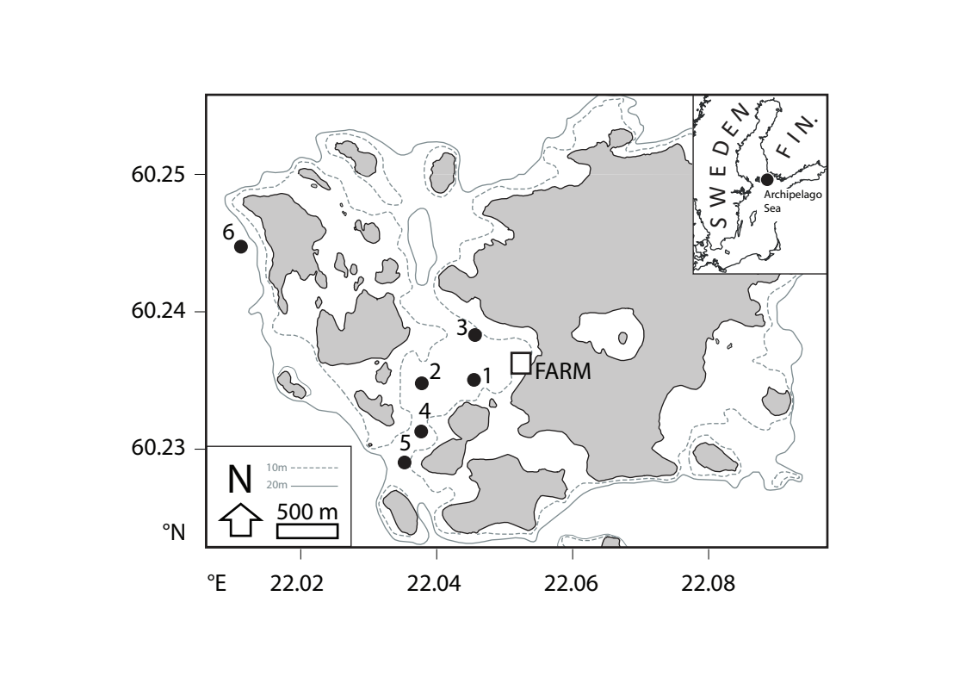
Fig. 2

Fig. 3
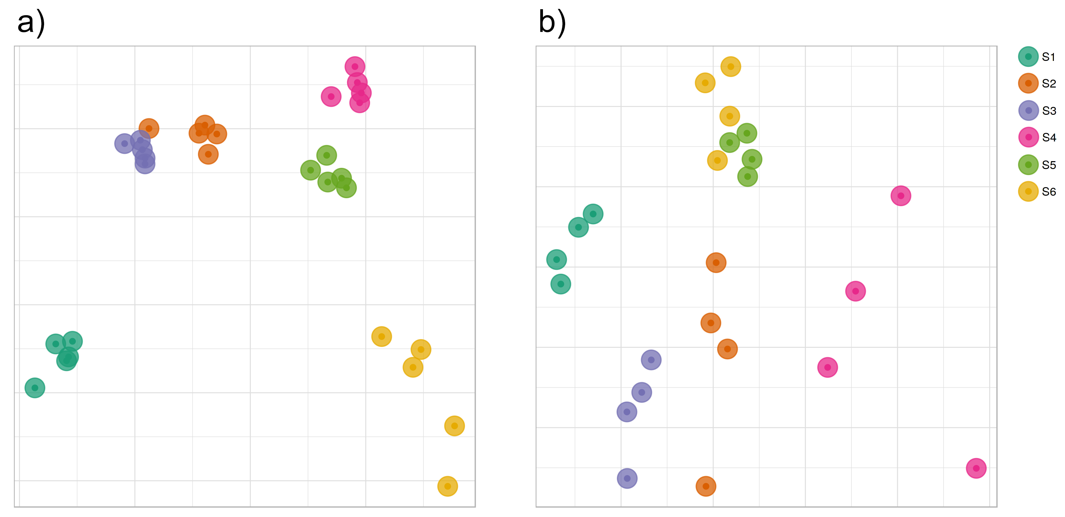
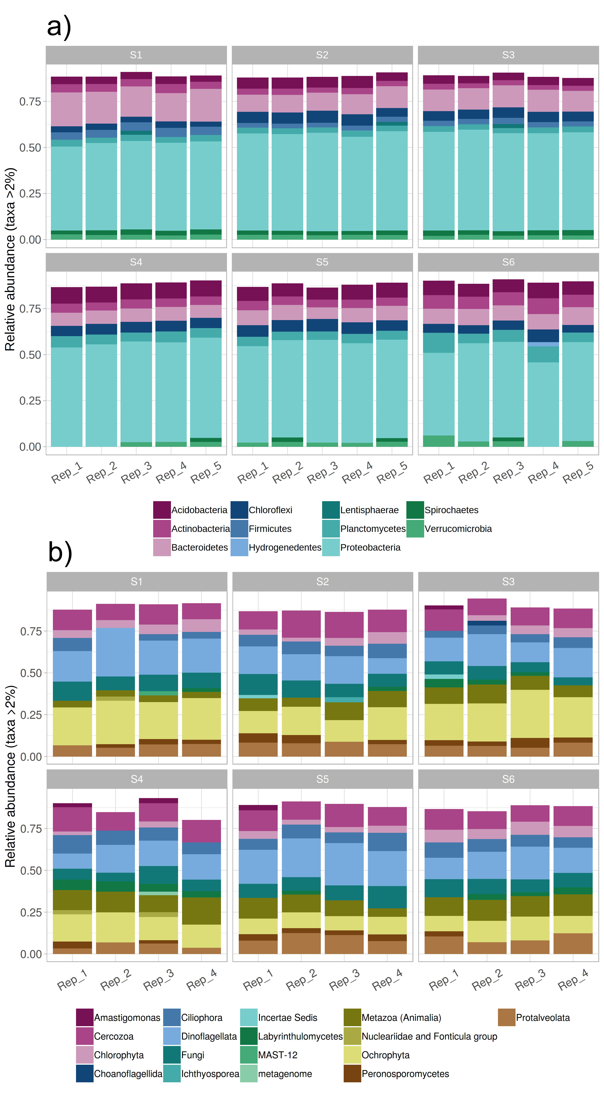
Fig. 4

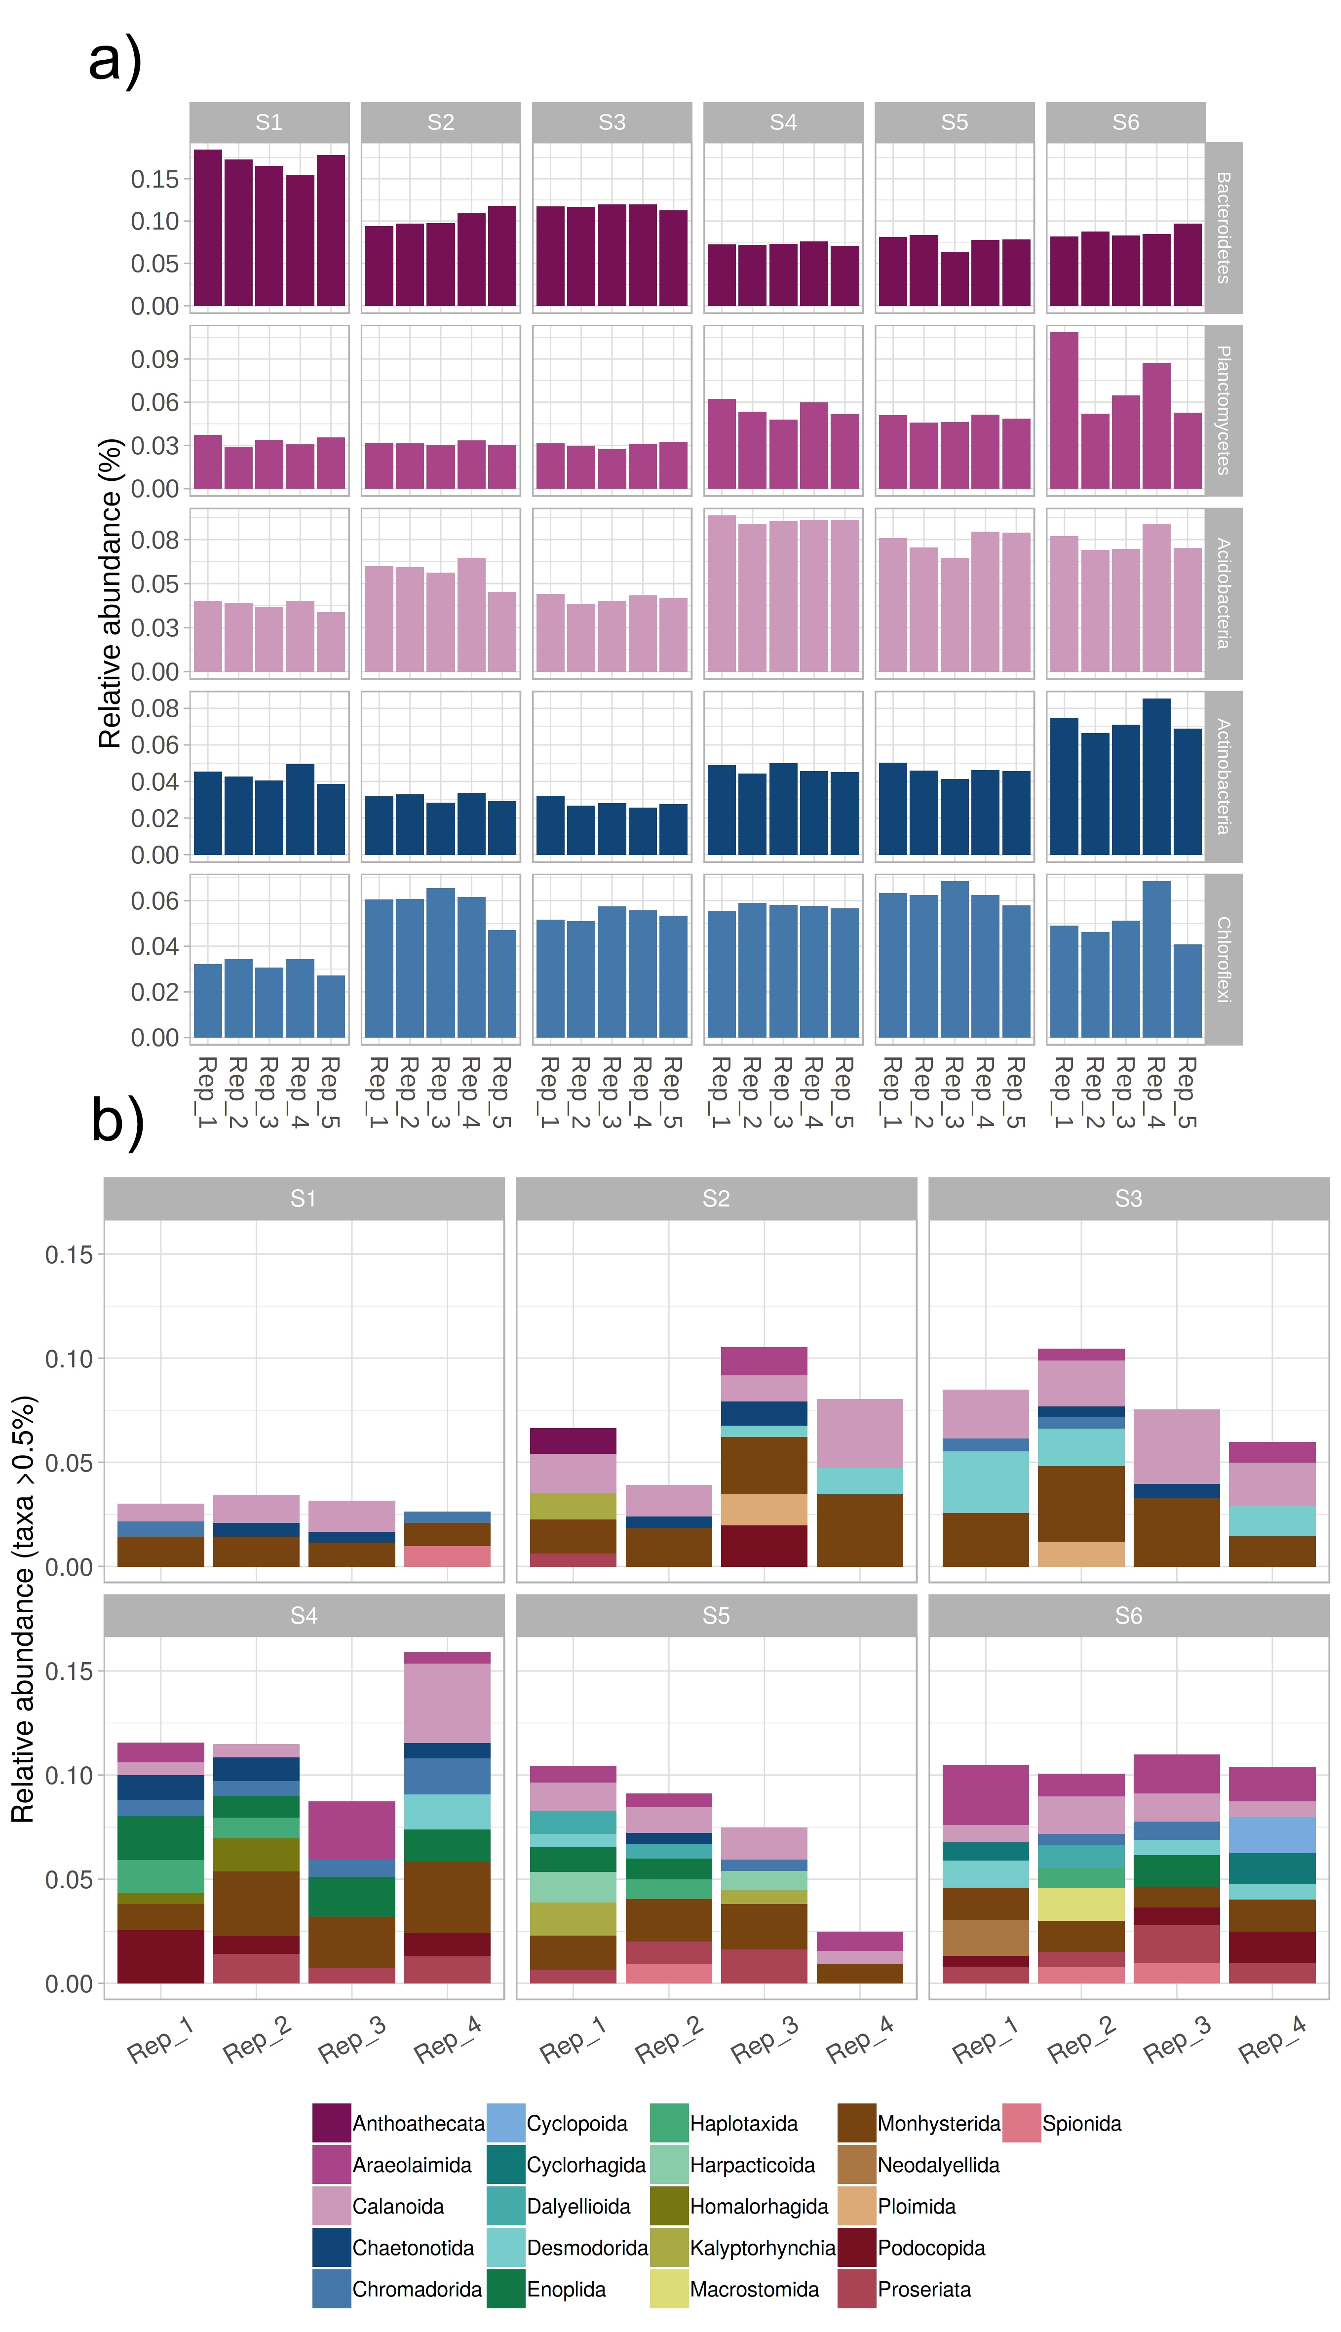
Fig. 5

Fig. 6
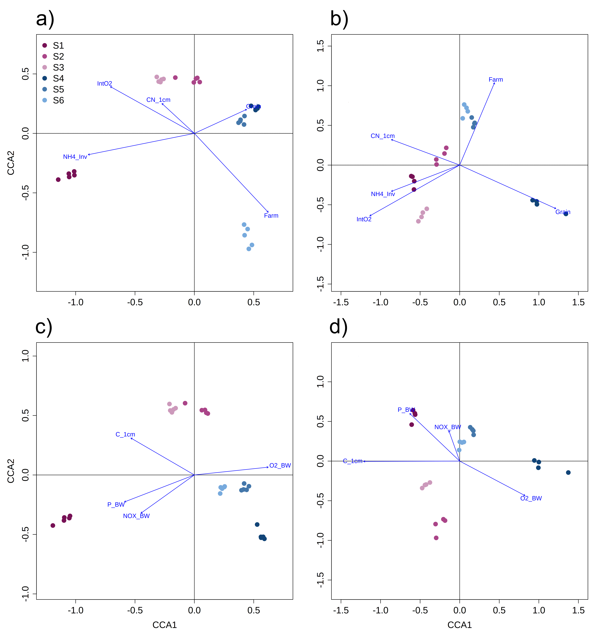
Tables

Table 1. Physical and chemical variables used for CCA model construction. Variance inflation factor (VIF) values are provided for each variable.
Model | Variable | Variance inflation factor
Model 1 | Porewater NH₄⁺ inventory (μmol cm⁻²) | 2.08
 | Distance to farm (km) | 5.35
 | Sediment depth-integrated O₂ consumption rate (μmol⁻¹ cm⁻² s⁻¹) | 6.04
 | Sediment median grain size (μm) | 5.48
 | Sediment C_{org}:N_{tot} ratio, top 1 cm (mol:mol) | 2.31
Model 2 | Sediment C_{org} content, top 1 cm (% dry mass) | 7.33
 | Bottom water NO_{x}* concentration (μmol L⁻¹) | 11.54
 | Bottom water P concentration (μmol L⁻¹) | 8.49
 | Bottom water O₂ concentration (mg L⁻¹) | 13.71
* NO₂⁻ and NO₃⁻

Table 2. Permutation test results for CCA explanatory variables (999 permutations). The variance explained by each environmental property was tested using the remaining four variables as covariates. For details on model construction, see Materials and Methods.
 |  | 16S rRNA gene metabarcoding |  | 18S rRNA gene metabarcoding
Model | Variable | Pseudo-F | p_{B-H} | Pseudo-F | p_{B-H}
Model 1 | Porewater NH₄⁺ inventory (μmol cm⁻²) | 2.861 | 0.005 | 1.213 | 0.020
 | Distance to farm (km) | 1.923 | 0.008 | 1.064 | 0.247
 | Sediment depth-integrated O₂ consumption rate (μmol⁻¹ cm⁻² s⁻¹) | 1.633 | 0.018 | 1.252 | 0.020
 | Sediment median grain size (μm) | 1.371 | 0.043 | 1.270 | 0.020
 | Sediment C_{org}:N_{tot} ratio, top 1 cm (mol:mol) | 1.290 | 0.080 | 1.305 | 0.020
Model 2 | Sediment C_{org} content, top 1 cm  (% dry mass) | 2.024 | 0.004 | 1.407 | 0.005
 | Bottom water NO_{x}* concentration  (μmol L⁻¹) | 1.778 | 0.004 | 1.367 | 0.005
 | Bottom water P concentration  (μmol L⁻¹) | 1.740 | 0.004 | 1.347 | 0.005
 | Bottom water O₂ concentration  (mg L⁻¹) | 1.625 | 0.010 | 1.248 | 0.020
* NO₂⁻ and NO₃⁻

Supplementary Figure Legends

Fig. S1. Rarefaction curves for a) bacterial and b) eukaryotic Illumina MiSeq metabarcoding data. The data were generated following PCR amplification of bacterial 16S rRNA genes and eukaryotic 18S rRNA genes amplified from eDNA isolated from sediments from six sampling sites in the Archipelago Sea (Baltic Sea, Finland). Curves are shown for OTUs based on a similarity cut-off threshold of 97%, following removal of chimeric sequences.

Fig. S2. Relative abundances (%) of classified versus unclassified OTUs (97% similarity cut-off) determined using Illumina MiSeq data. Data are shown for sediment a) bacterial and b) eukaryotic communities.

Fig. S3. Non-metric multidimensional scaling (nMDS) ordinations of sediment communities in field sites sampled along a eutrophication gradient in the Archipelago Sea (Baltic Sea, Finland). The ordinations were derived from a Bray-Curtis resemblance matrix calculated from Hellinger-transformed Illumina MiSeq relative abundance data. Data for bacterial communities are shown a) prior to filtering out sequences assigned as “NA” or chloroplasts, b) after filtering out “NA” sequences, and c) after filtering out “NA” and chloroplast sequences. Data for eukaryotic communities are shown d) prior to filtering out “NA” sequences and e) after filtering out “NA” sequences.

Fig. S4. Phylum-level prevalences (given as fractions) versus total read counts for a) bacterial and b) eukaryotic community Illumina MiSeq data.

Fig. S5. Distances to the group centroid for Illumina MiSeq relative abundance data. Data are shown for a total of six sampling sites in the Archipelago Sea (Baltic Sea, Finland), corresponding to either sediment a) bacterial communities or b) eukaryotic communities. Different letters above the boxes indicate significant differences between sampling sites (PERMDISP with 999 permutations, p < 0.05).

Fig. S6. Relative abundances (%) of bacterial classes within sediment samples collected from a total of six sampling sites in the Archipelago Sea (Baltic Sea).

Supplementary Figures

Fig. S1
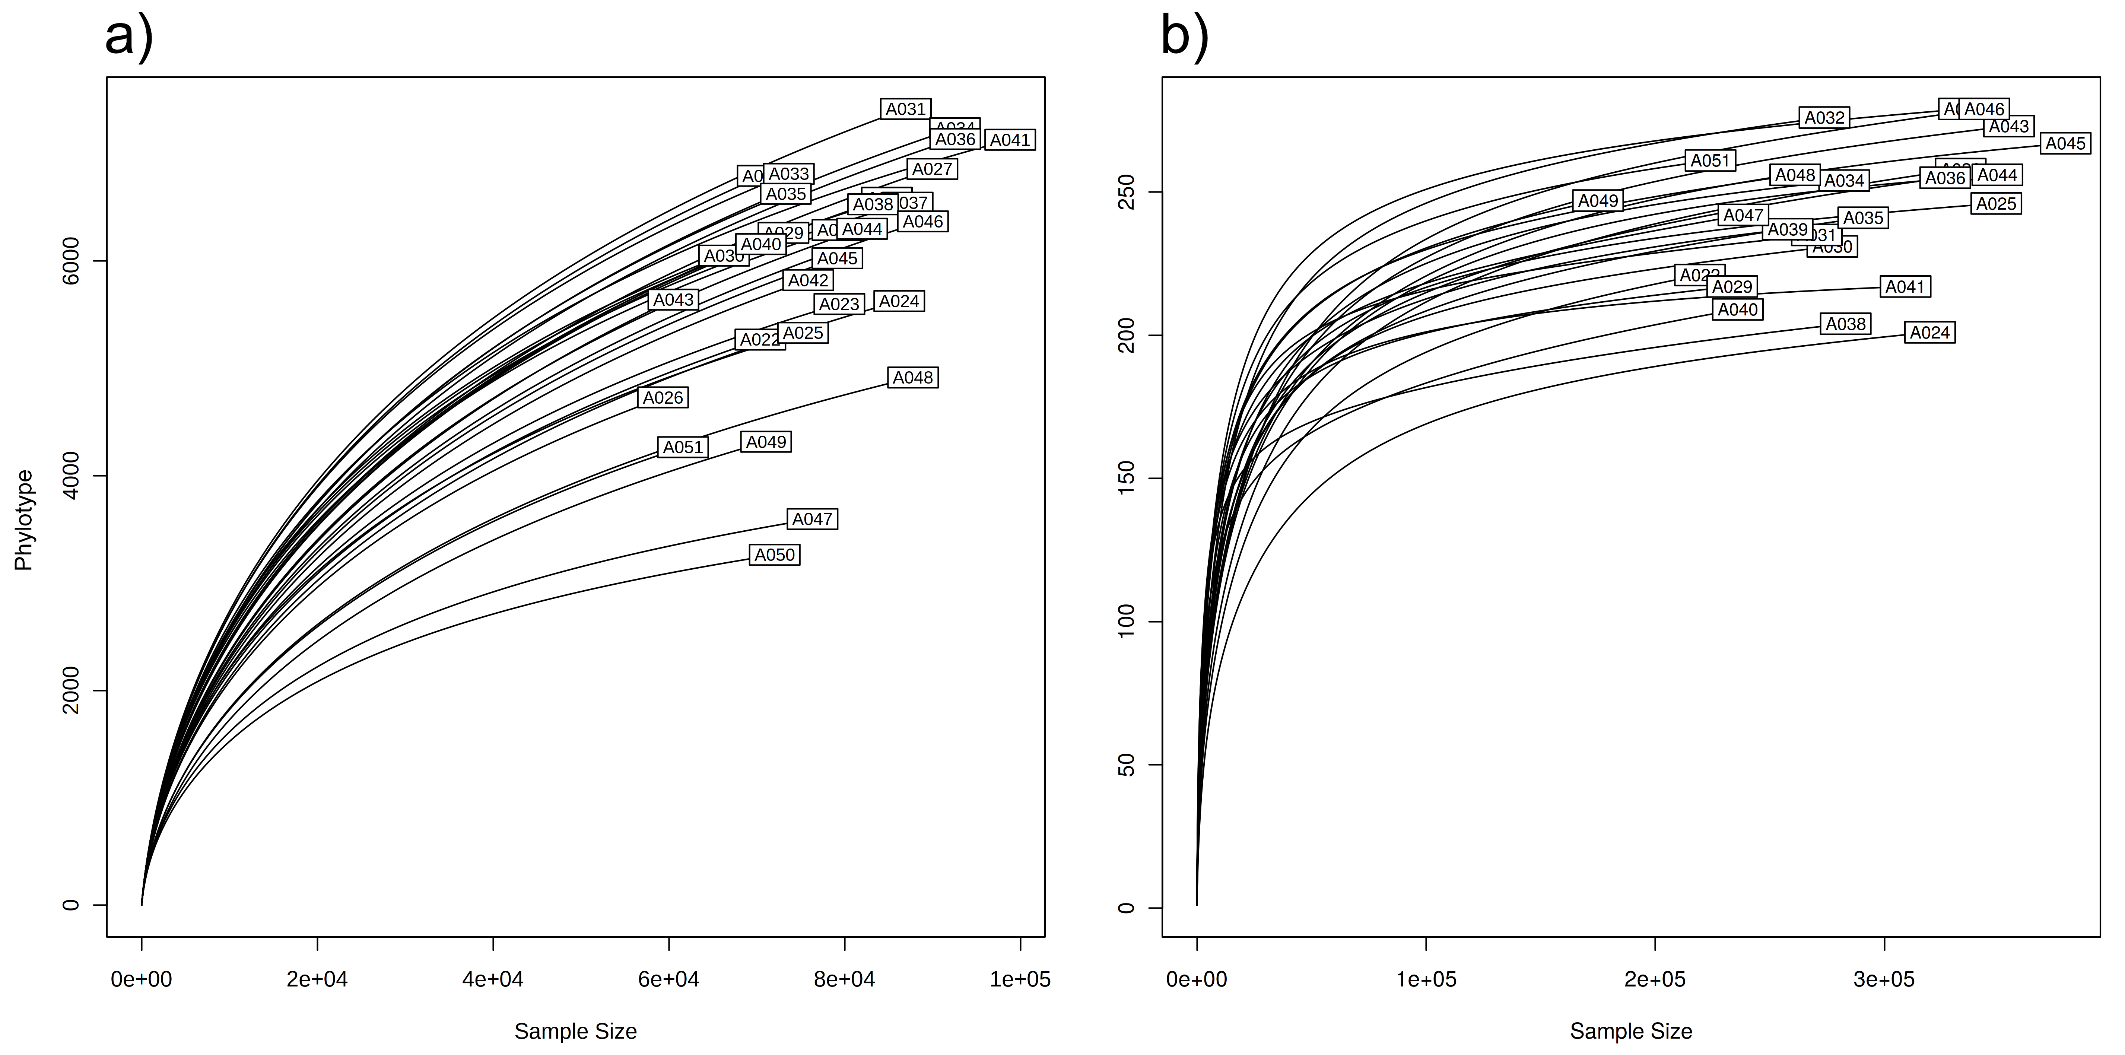
Fig. S2
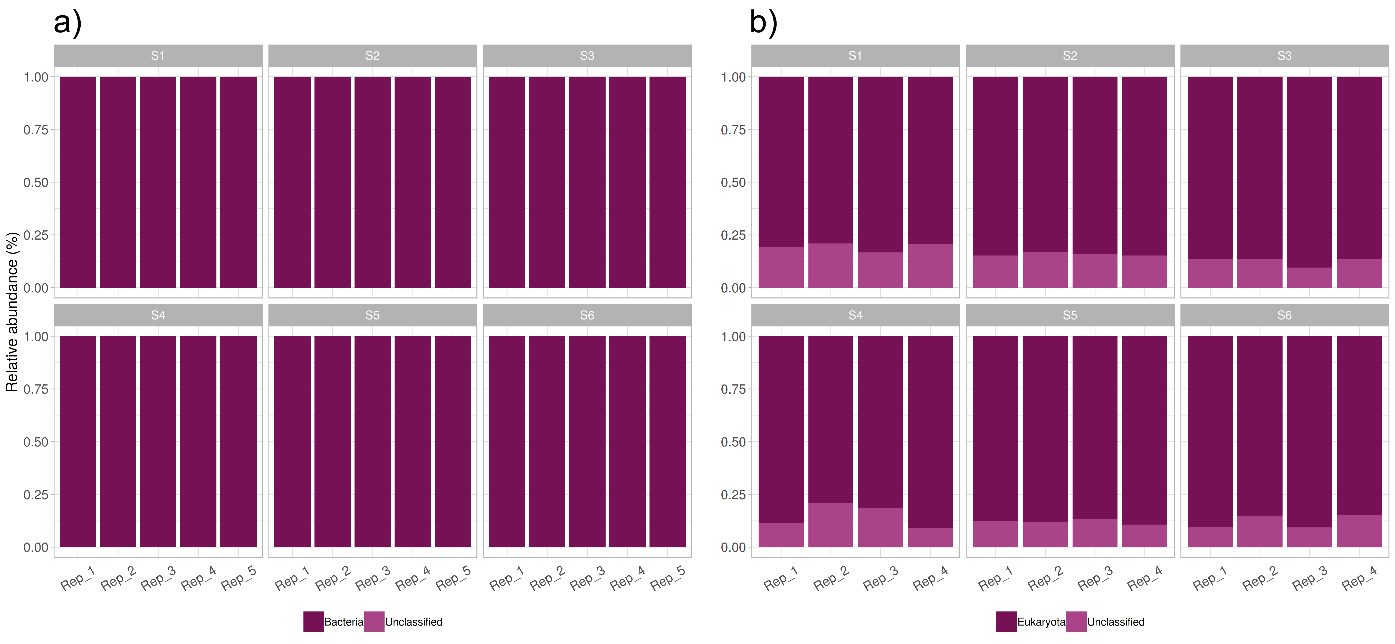
Fig. S3
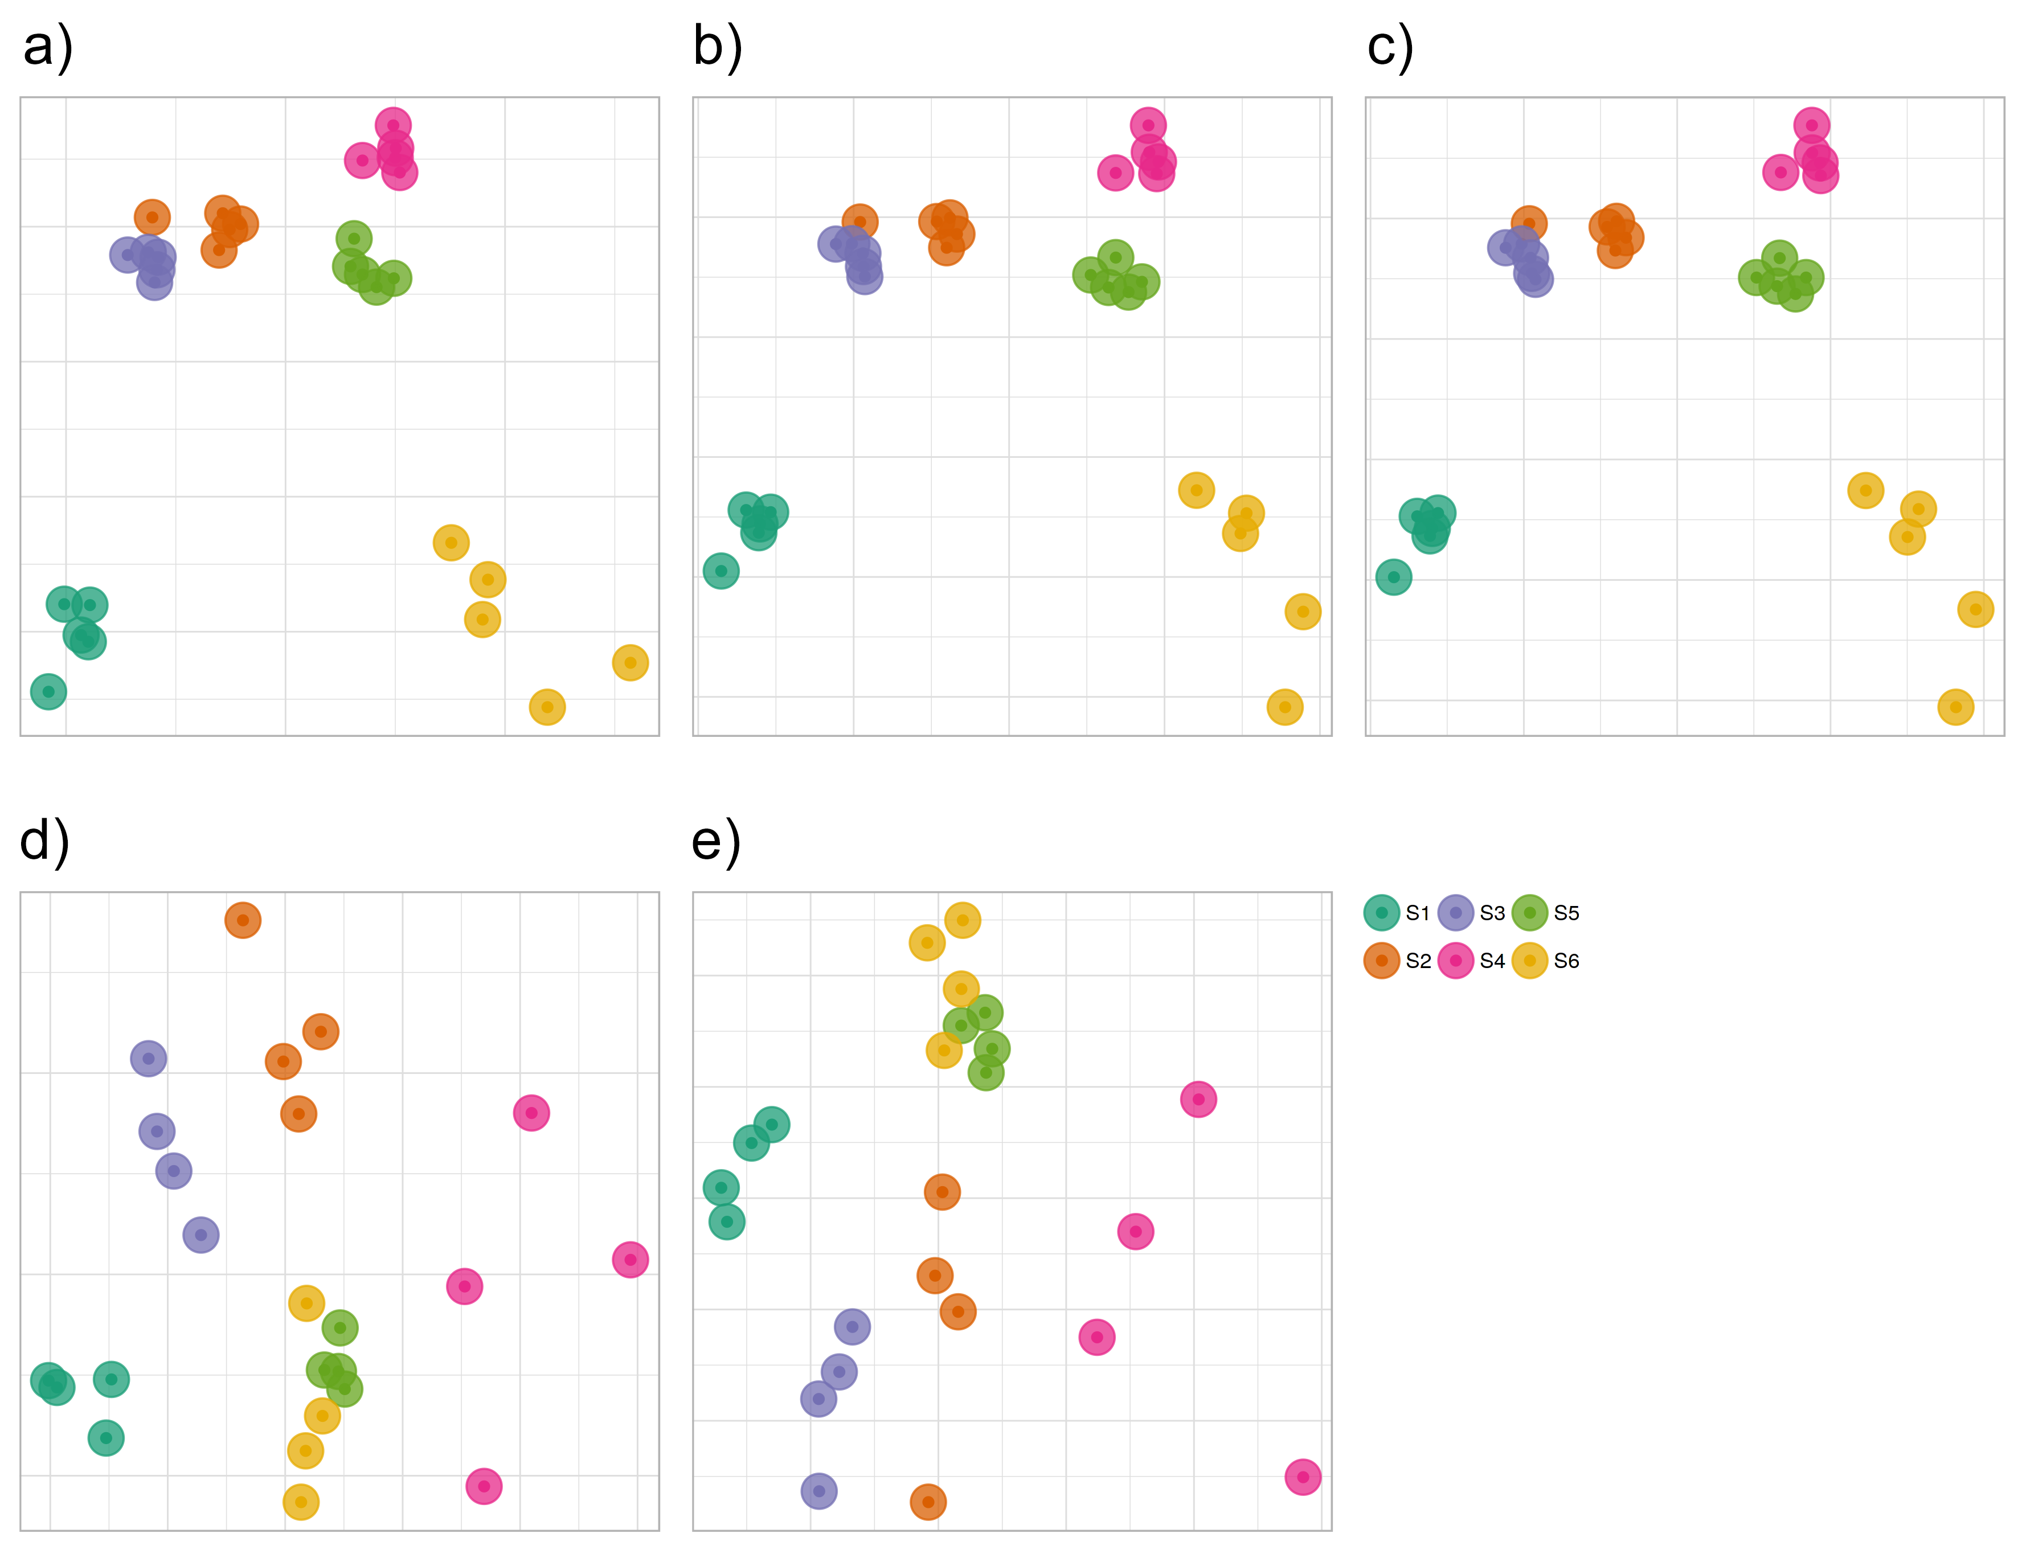
Fig. S4
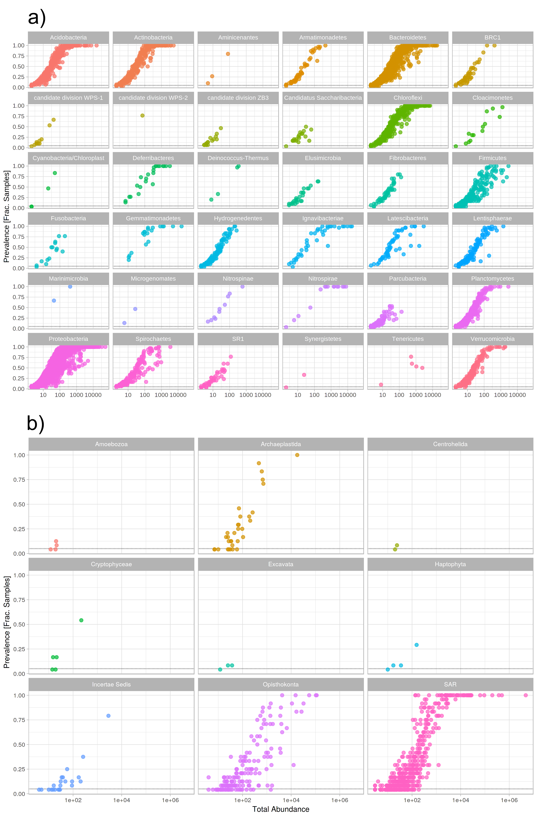
Fig. S5
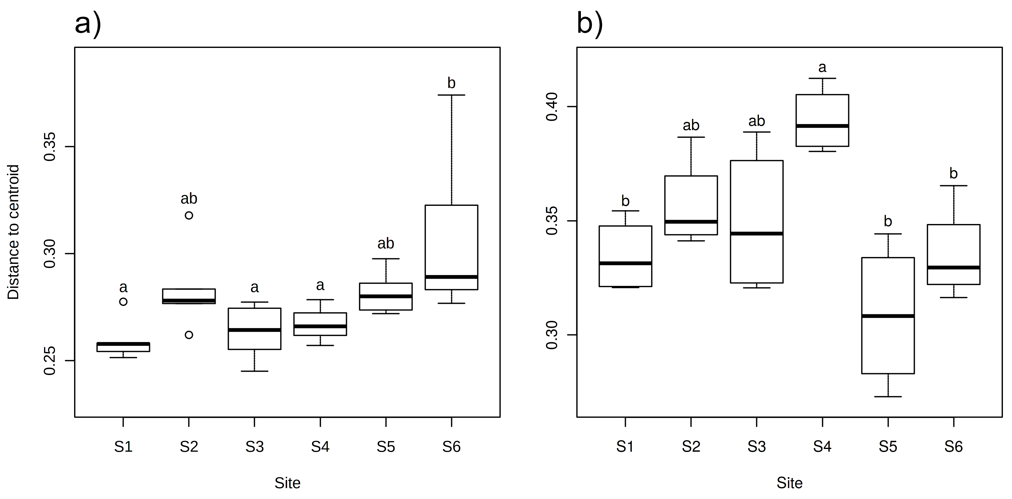
Fig. S6
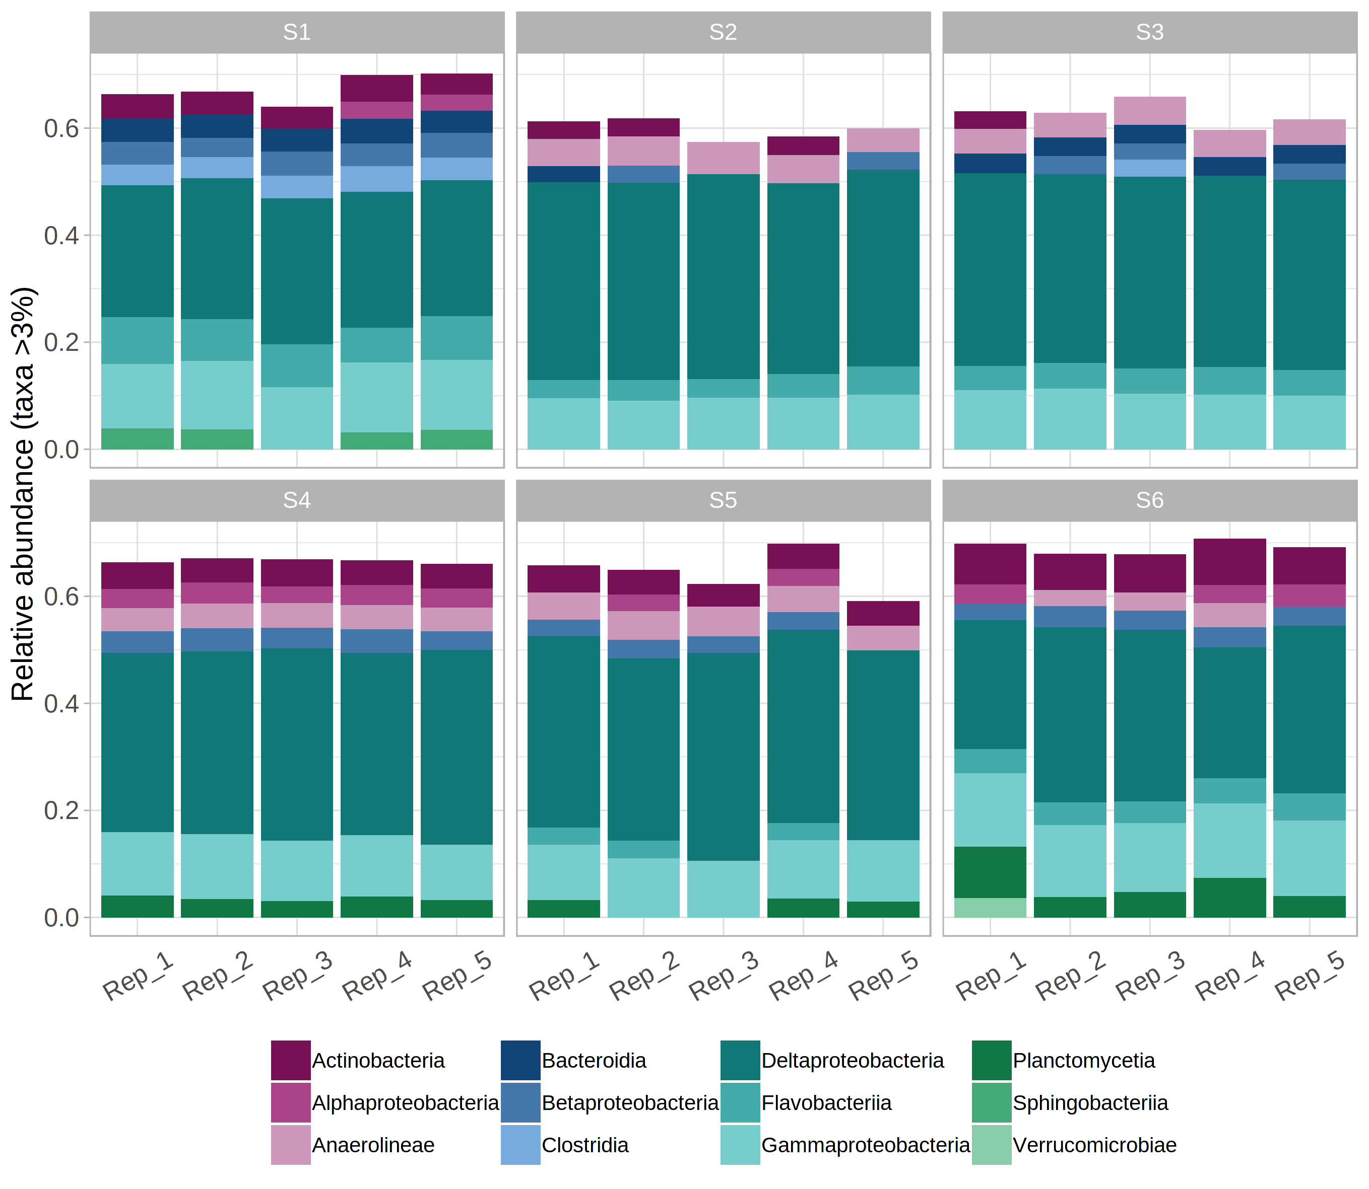
Supplementary Tables

Table S1. Latitudinal and longitudinal coordinates corresponding to the field sampling sites in the Archipelago Sea (Baltic Sea, Finland).
Station | Coordinates
 | N | E
Station 1 | 59°52,800 | 23°14,155
Station 2 | 59°52,776 | 23°13,507
Station 3 | 59°52,840 | 23°14,730
Station 4 | 59°52,808 | 23°15,345
Station 5 | 59°52,692 | 23°15,991
Station 6 | 59°52,463 | 23°13,804

Table S2. Primers and primer mixes used for the PCR amplification of 16S rRNA and 18S rRNA genes from DNA extracted from sediments collected from the Archipelago Sea (Baltic Sea).
Primer | Nucleotide sequence including overhang (5′– 3′) * | Primer mix | References
27F1 | ATCTACACTCTTTCCCTACACGACGCTCTTCCGATCT  AGAGTTTGATCMTGGCTCAG | PCR targeting 16S rRNA gene V1–V3 regions:  27F1–3 and 518R1–3 mixed in 1:1:1 ratio | Lane (1991)  Muyzer et al. (1993)
27F2 | ATCTACACTCTTTCCCTACACGACGCTCTTCCGATCT  TAGAGAGTTTGATCMTGGCTCAG |  | Lane (1991)  Muyzer et al. (1993)
27F3 | ATCTACACTCTTTCCCTACACGACGCTCTTCCGATCT  CTCTAGAGTTTGATCMTGGCTCAG |  | Lane (1991)  Muyzer et al. (1993)
518R1 | GTGACTGGAGTTCAGACGTGTGCTCTTCCGATCT  GTATTACCGCGGCTGCTG |  | Lane (1991)  Muyzer et al. (1993)
518R2 | GTGACTGGAGTTCAGACGTGTGCTCTTCCGATCT  CGTATTACCGCGGCTGCTG |  | Lane (1991)  Muyzer et al. (1993)
518R3 | GTGACTGGAGTTCAGACGTGTGCTCTTCCGATCT  TAGTATTACCGCGGCTGCTG |  | Lane (1991)  Muyzer et al. (1993)
E572F1 | ACACTCTTTCCCTACACGACGCTCTTCCGATCT  CYGCGGTAATTCCAGCTC | PCR targeting 18S rRNA gene V4 region:  E572F1–4 and 897R1–4 mixed in 1:1:1:1 ratio | Comeau et al. (2011)  Hugerth et al. (2014)
E572F2 | ACACTCTTTCCCTACACGACGCTCTTCCGATCT  GCYGCGGTAATTCCAGCTC |  | Comeau et al. (2011)  Hugerth et al. (2014)
E572F3 | ACACTCTTTCCCTACACGACGCTCTTCCGATCT  TGMCYGCGGTAATTCCAGCTC |  | Comeau et al. (2011)  Hugerth et al. (2014)
E572F4 | ACACTCTTTCCCTACACGACGCTCTTCCGATCT  ARTTACYGCGGTAATTCCAGCTC |  | Comeau et al. (2011)  Hugerth et al. (2014)
897R1 | GTGACTGGAGTTCAGACGTGTGCTCTTCCGATCT  TCYDAGAATTYCACCTCT |  | Comeau et al. (2011)  Hugerth et al. (2014)
897R2 | GTGACTGGAGTTCAGACGTGTGCTCTTCCGATCT  AGTCYDAGAATTYCACCTCT |  | Comeau et al. (2011)  Hugerth et al. (2014)
897R3 | GTGACTGGAGTTCAGACGTGTGCTCTTCCGATCT  CAATTCYDAGAATTYCACCTCT |  | Comeau et al. (2011)  Hugerth et al. (2014)
897R4 | GTGACTGGAGTTCAGACGTGTGCTCTTCCGATCT  GTRAGTTTCYDAGAATTYCACCTCT |  | Comeau et al. (2011)  Hugerth et al. (2014)
* Overhang indicated with italics and primer sequence indicated in bold

References (Table S2)
Comeau AM, Li WKW, Tremblay J-É, Carmack EC, Lovejoy C. Arctic Ocean microbial community structure before and after the 2007 record sea ice minimum. PLoS One 2011;6:e27492.
Hugerth LW, Muller EEL, Hu YOO, Lebrun LAM, Roume H, Lundin D, Wilmes P, Andersson AF. Systematic design of 18S rRNA gene primers for determining eukaryotic diversity in microbial consortia. PLoS One 2014;9:e95567.
Lane DJ. 16S/23S rRNA sequencing. In: Stackebrandt E, Goodfellow M (eds) Nucleic acid techniques in bacterial systematics. John Wiley and Sons: New York, NY, USA, 1991; 115-175.
Muyzer G, de Waal EC, Uitterlinden AG. Profiling of complex microbial populations by denaturing gradient gel electrophoresis analysis of polymerase chain reaction-amplified genes coding for 16S ribosomal RNA. Appl. Environ. Microbiol. 1993;59:695–700.
Table S3. Data processing parameters for 16S rRNA and 18S rRNA gene sequences (implemented in micca v. 1.6.2; http://micca.org).
Command | 16S rRNA gene sequences | 18S rRNA gene sequences
micca mergepairs | -l 50 -d 15 | -l 250 -d 85
micca filter | -e 0.25 -m 465  (71.3% of reads retained) | -e 0.25 -m 315  (92% of reads retained)

Table S4. Environmental properties corresponding to six sampling stations in Haverö, Archipelago Sea (Baltic Sea, Finland). Inventory calculations were performed for the top 20 cm of sediment cores (see Materials and Methods).
 | Sampling Station
Variable | S1 | S2 | S3 | S4 | S5 | S6
Distance to farm (km) | 0.38 | 0.79 | 0.47 | 0.94 | 1.2 | 2.48
Water column temperature (°C) | 10.1 | 14.4 | 14.4 | 15.2 | 14.7 | 13
Water column depth (m) | 23 | 16.2 | 17.5 | 12.1 | 18.9 | 24.2
Water column salinity (no unit) | 5.87 | 6.07 | 6.05 | 6.03 | 6.09 | 6.18
Bottom water O₂ concentration (µmol L⁻¹) | 80.1 | 163.3 | 133.2 | 173.1 | 184.2 | 151.9
Bottom water NO_{x}* concentration  (μmol L⁻¹) | 14.3 | 6.4 | 6.8 | 10.1 | 3.4 | 6.2
Bottom water P concentration (μmol L⁻¹) | 42.3 | 6.3 | 4.1 | 3.2 | 2.3 | 3.7
Sediment O₂ penetration depth (mm) | 1.5 | 2.1 | 1.4 | 3.9 | 3.5 | 4
Sediment depth-integrated O₂  consumption rate (μmol⁻¹ cm⁻² s⁻¹) | 0.0119 | 0.0119 | 0.0156 | 0.003 | 0.006 | 0.005
Sediment median grain size (μm) | 3.1 | 3.4 | 3.1 | 93.6 | 13.1 | 3.6
Sediment C_{org} content, top 1 cm (% dry mass) | 4.9 | 4.1 | 4.1 | 1.2 | 2.9 | 3.2
Sediment δ¹³C_{org}, top 1 cm (Δ PDB) | −24 | −22.8 | −23.6 | −24.6 | −23.7 | −23.8
Sediment C_{org}:N_{tot} ratio, top 1 cm (mol:mol) | 8.36 | 8.65 | 8.37 | 8.14 | 8.34 | 8.33
Porewater H₂S inventory (μmol cm⁻²) | 6.7 | 0.5 | 0.8 | 0 | 0.5 | 0.7
Porewater P inventory (μmol cm⁻²) | 4.45 | 2.47 | 1.59 | 0.76 | 0.73 | 0.98
Porewater NH₄⁺ inventory (μmol cm⁻²) | 18.65 | 5.33 | 4.48 | 1.3 | 1.86 | 1.79
Porewater NO_{x} inventory (μmol cm⁻²) | 0.2 | 0.34 | 0.16 | 0.07 | 0.03 | 0.03
Porewater NO₂⁻ inventory (μmol cm⁻²) | 0.001 | 0.002 | 0.001 | 0.003 | 0.003 | 0.003
* NO₂⁻ and NO₃⁻

Table SX. Observed bacterial and eukaryotic OTU frequencies and diversity indices (Chao1 and Shannon’s diversity) for sediment samples collected from six sampling stations in Haverö, Archipelago Sea (Baltic Sea, Finland). The values are given as means ± standard error (n = 5 for bacteria, n = 4 for eukaryotes).
 | Bacterial OTUs |  |  | Eukaryotic OTUs
Site | Observed | Chao1 | Shannon’s  diversity | Observed | Chao1 | Shannon’s  diversity
S1
S2
S3
S4
S5

