Part 1:
Task 1:
- 192.168.10.0
- 192.168.10.255
- Usable hosts range from 192.168.10.1 -> 192.168.10.254, so there are 254 usable hosts that can connect
- The subnet mask is 255.255.255.000
Task 2:
Subnet | Subnet Address | CIDR Notation | Usable host range
Smart home devices | 192.168.10.0 | /26 | xx.1->xx.62
Gaming devices | 192.168.10.64 | /26 | xx.65->xx.126
Personal devices | 192.168.10.128 | /26 | xx.129->xx.190
Guest devices | 192.168.10.192 | /26 | xx.193->xx.254

Task 3:
Destination Network | Prefix | Next Hop
Smart home devices | 192.168.10.0/26 | Router Interface 1
Gaming devices | 192.168.10.64/26 | Router Interface 2
Personal devices | 192.168.10.128/26 | Router Interface 3
Guest devices | 192.168.10.192/26 | Router Interface 4
All other traffic | 0.0.0.0/0 | Internet Gateway

- A possible source IP address is 192.168.10.12 for the smart home device. We could assume that the data is being sent to a personal device to monitor, meaning a possible IP destination is 192.168.10.135 and packets will be sent to Router Interface 3.
- A possible source IP address is 192.168.10.68 for the gaming console. Since it is connected to an online server, this falls in to the “All other traffic” bucket meaning the packets will be sent to the internet gateway
- A possible source IP address is 192.168.10.135 for the personal device. Since it is accessing a public server, this falls in to the “All other traffic” bucket meaning the packets will be sent to the internet gateway.

Task 4:
- In destination-based IP forwarding, a more specific route can be implemented by adding an entry with a longer prefix length. This also means we increase the CIDR number. The router will try to match this IP first, so a smart lock would be routed to the new interface first instead of going to the more generic smart home devices route. We will call the interface “Security Gateway”
- Yes, the packet could match multiple entries. It could match the most specific entry (for only the smart lock), the generic smart home devices entry, and the default route.
- The routing logic would choose the new, specific route when traffic sources from the smart lock. The selection logic is based on the number of bits that match. Because the new route has more bits, meaning more possible bits to match, it will be chosen over any more generic route. The Security Gateway interface is chosen due to this.

Destination Network | Prefix | Next Hop
Smart lock | 192.168.10.5/32 | Security Gateway
Smart home devices | 192.168.10.0/26 | Router Interface 1
Gaming devices | 192.168.10.64/26 | Router Interface 2
Personal devices | 192.168.10.128/26 | Router Interface 3
Guest devices | 192.168.10.192/26 | Router Interface 4
All other traffic | 0.0.0.0/0 | Internet Gateway

Task 5:
- Situations:
  - UDP Gaming packet: The router will see a couple of key things. First, it will see that the protocol is UDP. It can then also use the MAC address, IP address, and/or source device info to confirm that it is coming from a gaming device. With the packet being a confirmed UDP gaming packet, it can be prioritized for processing and forwarding.
  - Email packer: The router will look to confirm that the source port matches a known, common email port (ie 25 for SMTP). It may also look to confirm that the packet is TCP. With these aspects confirmed, the router can “route it differently”, whatever that may mean for the network.
  - Traffic from blocked device: The router should mainly use the MAC address and source device info to check whether the device is blocked. The source IP address can also help, but may have been modified from the original blocked IP, so it should not be the sole determiner. When a blocked device is detected, the packet will be dropped.
- In this network, matching is first completed by examining the following:
- Who/what sent the packet? (Source devices, MAC, IP)
- Where is it going? (Destination MAC, IP)
- What form is the packet in? (UDP/TCP/ICMP)
- What application is it from? (Source port number)
- What application is it going to? (Destination port number)
Based on the answers to these questions, the router can match the packet to an action. The actions include:
- Dropping packets (blocked device)
- Prioritize/place at front of queue (gaming device)
- Forward (email)
- The match + action in this situation differs from destination-based forwarding by adding logic outside of IP address to determine what happens to traffic. Because of this, custom rules and actions are much easier to configure. There is also a higher level of security and flexibility.

Part 2:
Task 1:
- Ipconfig
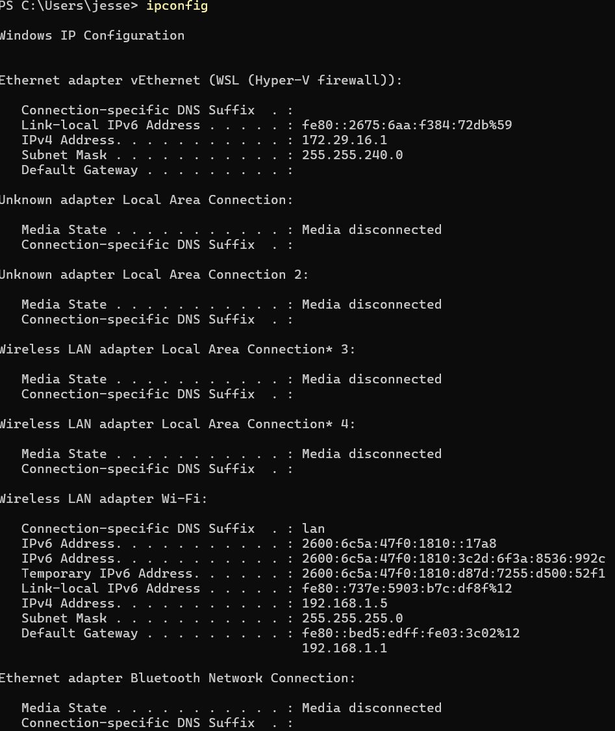
- Ipconfig /release
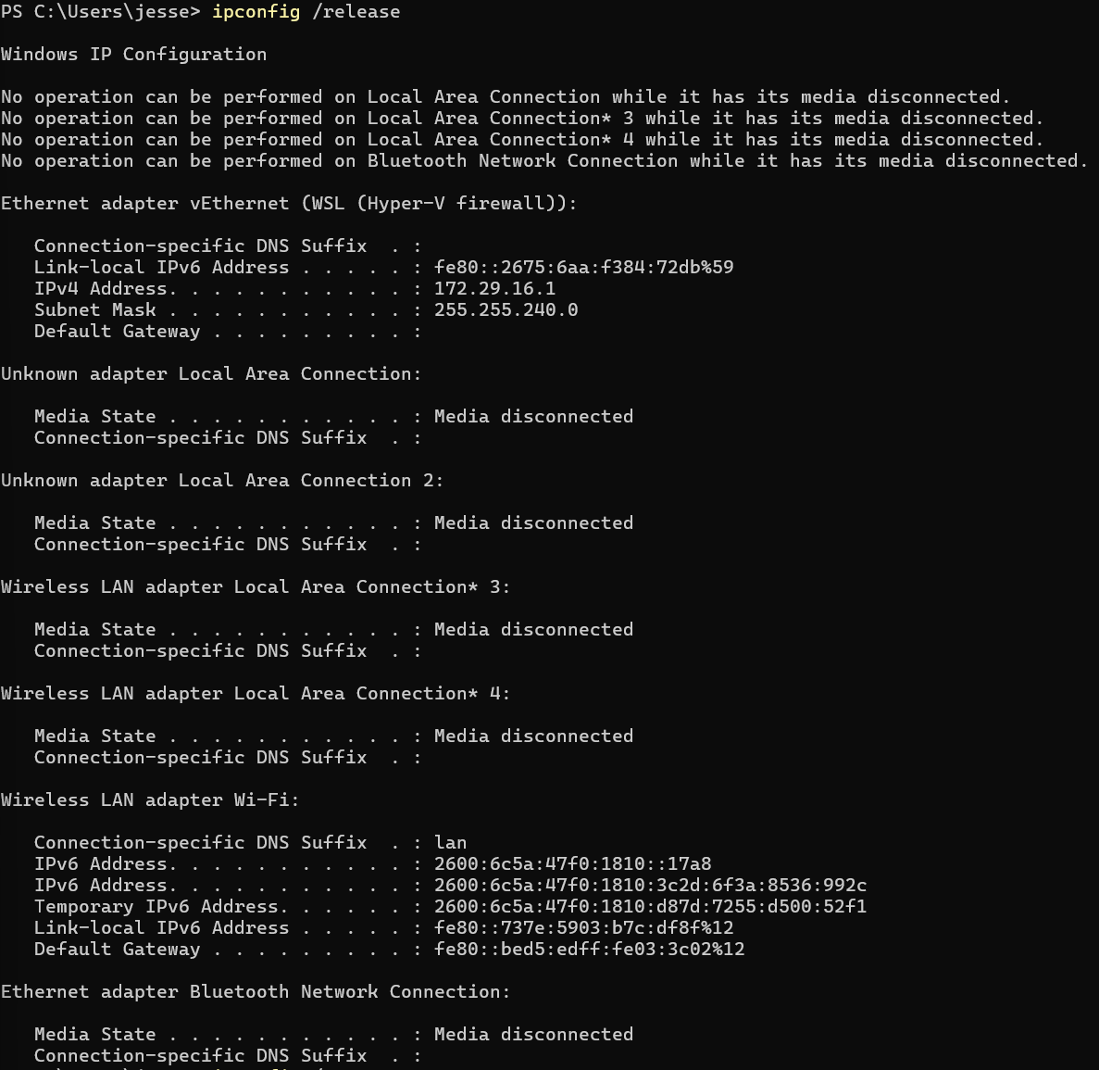
- Ipconfig /renew
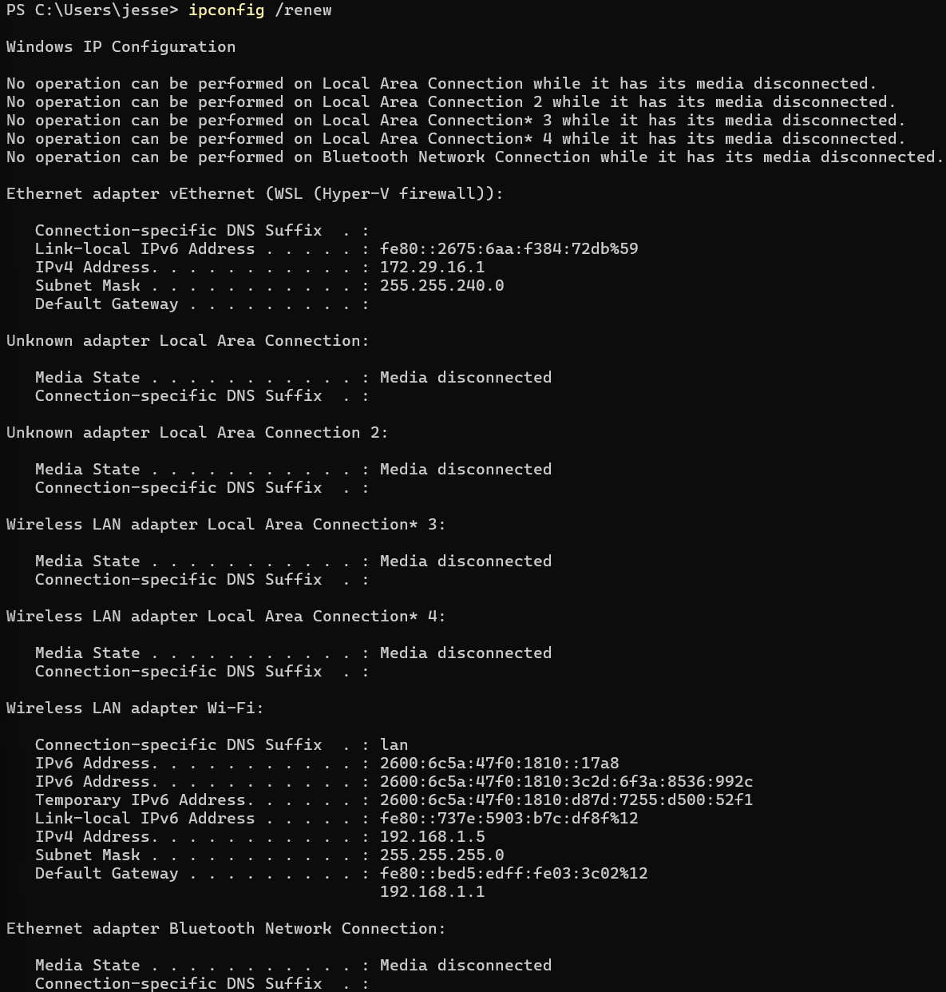
- Ipconfig
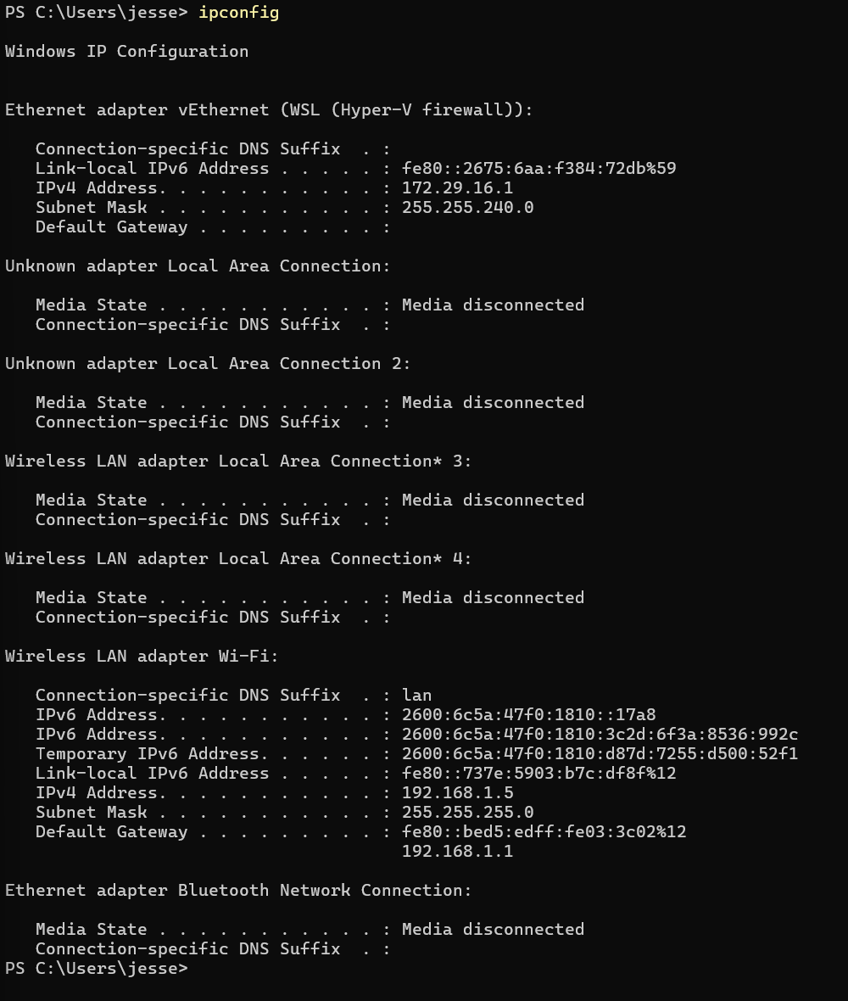

Task 2:
- Discover
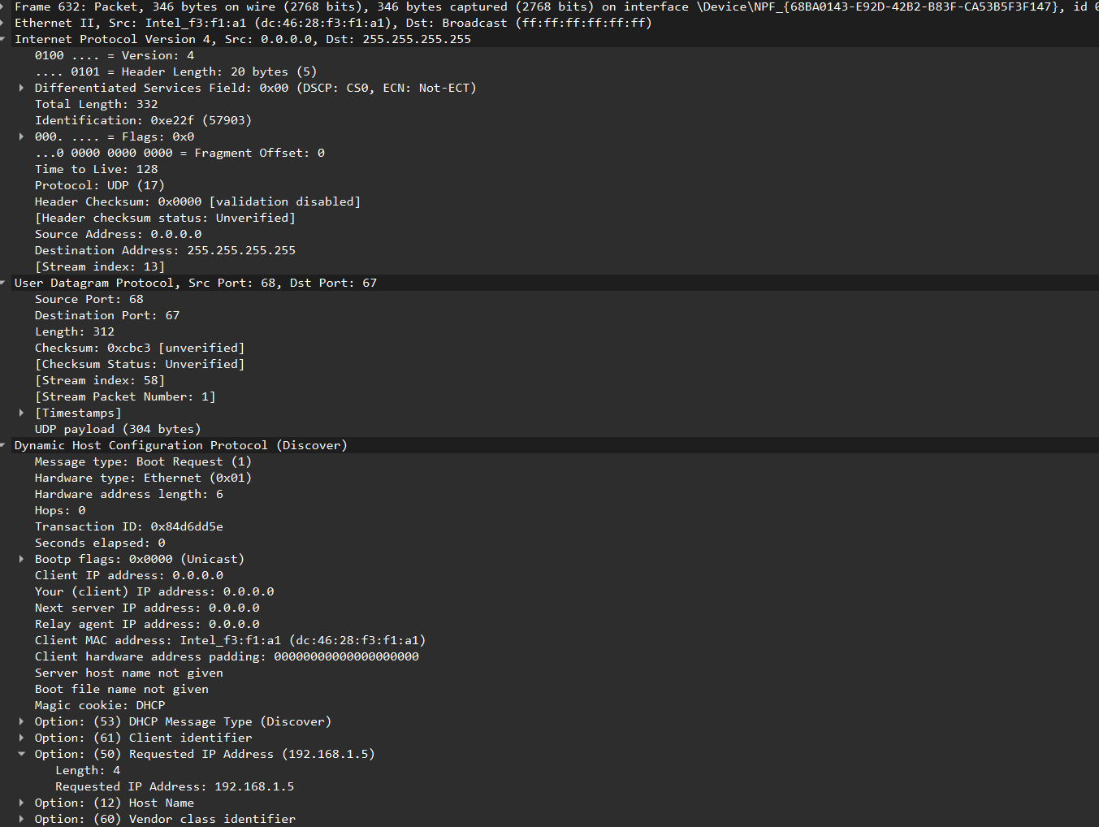
- Offer
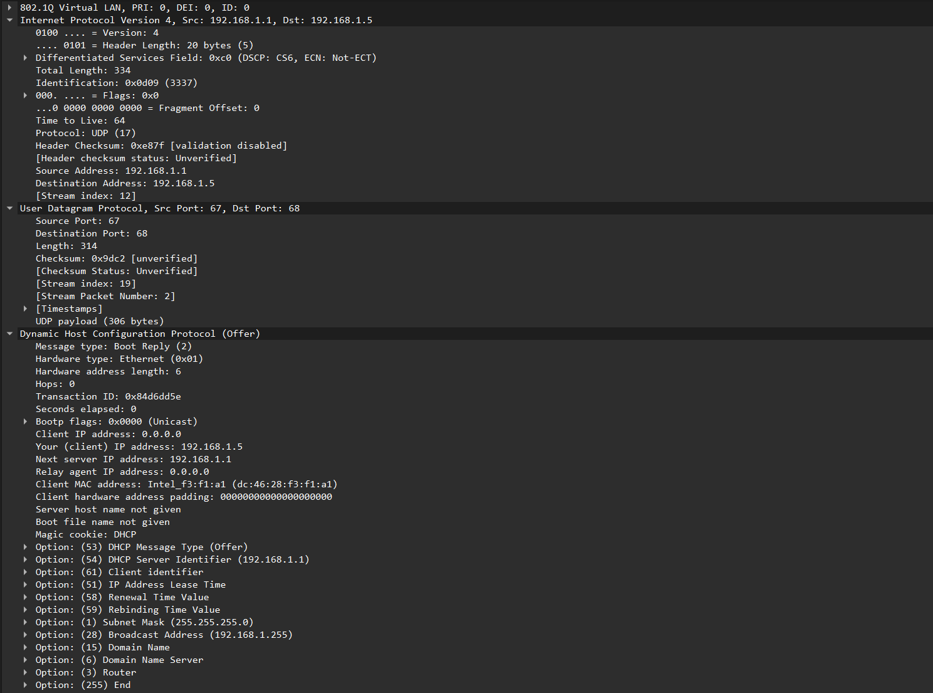

- Request
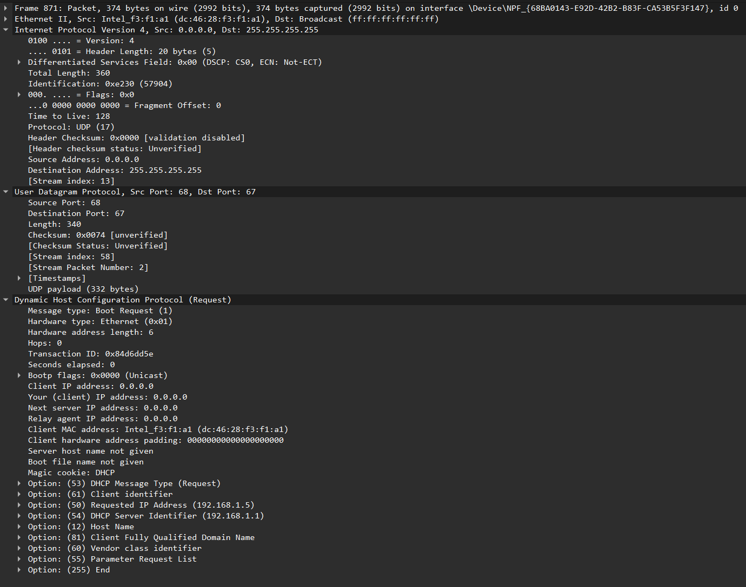
- Acknowledge
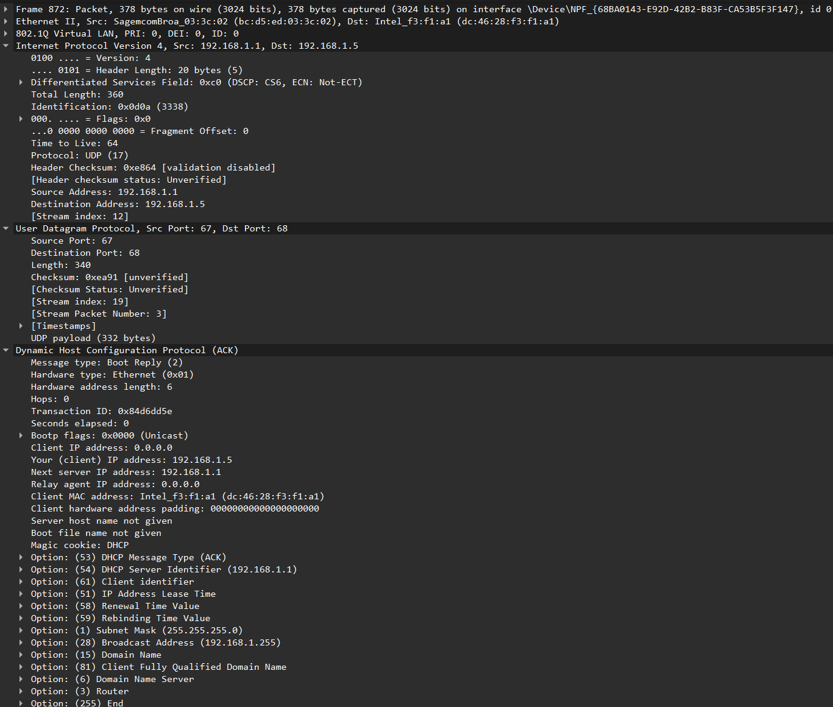

Stage | Source IP | Destination IP | Explanation
Discover | 0.0.0.0 | 255.255.255.255 | Client joins network with no IP Address. It sends out a message to search for a DHCP server.
Offer | 192.168.1.1 | 192.168.1.5 | DCHP server receives message and searches for available IP addresses. One is sent back to the client
Request | 0.0.0.0 | 255.255.255.255 | The client accepts the IP address, and broadcasts this acceptance
Acknowledge | 192.168.1.1 | 192.168.1.5 | DCHP server confirms the IP address has been set, and the client is now fully connected to the network.
- The DHCP server’s IP is 192.168.1.1 and the port number is 67

