Normative Executive System (NES): A Proof-of-Concept Computational Testbed for Identifiable Normative Influence
Jesse Wright
May 8, 2025

1. Norm-Governed Decisions: A Computational Puzzle
People routinely make norm-consistent choices even when payoff, emotion, and cognitive control all favor defection. We stop at red lights on empty roads, keep unenforceable promises, and help strangers at our own expense. These behaviors persist even when material incentives or learned associations would push us the other way—suggesting an internal mechanism that cannot be reduced to reward, affect, or generic control.
Most formal models of decision-making subsume norms under emergent processes within general-purpose architectures:
• Utility models treat norms as high-value preferences
• Learning theories invoke conditioned associations via social feedback
• Dual-process accounts emphasize emotional inhibition or deliberative override
• Conflict-monitoring frameworks cast restraint as domain-general control
Under these views, norm-adherence arises “for free” as a byproduct of utility maximization, social learning, or inhibitory control. Yet many moral choices strike us as uncued, unsupervised, and unmotivated by self-interest—prompting a different question:
Could normative influence itself be a primitive component of the decision architecture?
To explore this, we introduce the Normative Executive System (NES), a minimal extension of the Drift Diffusion Model (DDM) that encodes an explicit norm weight (w_{n}) alongside standard salience and threshold parameters. By embedding w_{n} directly into the drift equation, NES operationalizes the hypothesis that norms exert a distinct, recoverable pull on evidence accumulation—rather than emerging from other model dimensions.
Recent reviews highlight a lack of empirical tests for whether explicit normative representations are necessary to capture moral behavior [@bello2023computationalapproachesto; @cushman2015moralconstraints]. NES targets this gap by using Simulation-Based Calibration (ABC-SMC and Neural Posterior Estimation) to ask three questions:
1. Identifiability: Is w_{n} statistically recoverable from simulated behavior?
2. Distinctiveness: Does NES generate decision patterns that standard DDMs cannot reproduce by parameter tuning alone?
3. Structural Mismatch: Do fortified hierarchical DDMs systematically fail to recover w_{n} from NES-generated data?
By shifting the debate from philosophical intuition to statistical identifiability and predictive utility, NES provides a formal, testable framework for investigating whether normative self-governance is a measurable, architecturally distinct faculty in human decision-making.

1.1 Related Work
NES builds on a rich tradition of cognitive modeling, including the conflict monitoring framework [@Botvinick2001ConflictMonitoring], dual-process theories of moral judgment [@Greene2001fMRI], and attribute-wise value integration models [@Hare2009SelfControl]. However, these models either lack explicit norm representations or do not validate the identifiability of such constructs from behavior. NES proposes a principled extension of the Drift Diffusion Model that treats norm influence as an independent signal—recoverable and separable from salience or utility.

2. The Normative Executive System: Formalizing Primitive Moral Architecture

2.1 Core Architectural Principle
The Normative Executive System (NES) extends the classic Drift Diffusion Model by adding a dedicated norm weight (w_{n}) alongside the standard salience weight (w_{s}). The drift rate is defined as
v = w_{s} (1 − λ) − w_{n} λ
where λ ∈ [0, 1] indexes conflict between stimulus salience and internalized norms. Setting w_{n} apart as its own parameter creates an oppositional architecture in which norms exert a direct, quantifiable pull on evidence accumulation rather than being folded into existing utility or control signals.

2.2 Why This Tests Computational Primitiveness
This simple formulation makes three critical tests possible:
1. Oppositional Architecture: By pitting w_{s} vs. w_{n} in direct competition, we force the model to resolve norm–salience conflict explicitly.
2. Parameter Independence: Because w_{n} is not a transform of other variables, its recoverability signals a true architectural primitive.
3. Graded Conflict: Continuous variation in λ lets us probe whether the model responds systematically across low to high conflict—a hallmark of dedicated processing.

2.3 Architectural Predictions
NES yields three testable predictions that distinguish it from emergentist accounts:
1. Behavioral Signatures: Unique reaction-time and error-rate patterns (e.g., non-monotonic RT under high λ, systematic response suppression) that standard DDMs cannot mimic.
2. Statistical Identifiability: The norm weight w_{n} should be recoverable from choice/RT data with minimal ambiguity.
3. Architectural Irreducibility: Models lacking an explicit w_{n} should systematically fail to capture key norm-driven dynamics when fit to NES-generated data.

2.4 Simulation & Inference Overview
To evaluate these predictions, we implemented NES in a standard DDM framework (see Supplement A for full details). Briefly:
• Task: A parametric “Stroop-like” conflict paradigm with five λ levels and moderate trial counts to test identifiability under realistic session lengths.
• Simulation: Euler–Maruyama integration generates choice/RT data under known (w_{s}, w_{n}, λ) settings.
• Inference: We apply both ABC-SMC and Neural Posterior Estimation (NPE) to assess recovery of w_{n} (Supplement B).
• Benchmark: A fortified hierarchical HDDM model—with per-condition drift regressors—tests whether standard approaches can indirectly recover w_{n}.

2.5 Key Validation Steps
1. Identifiability: SBC rank‐histograms for both ABC-SMC and NPE should approximate uniformity, indicating well-calibrated recovery of w_{n}.
2. HDDM Failure: If HDDM’s drift regressions produce biased or uncalibrated w_{n} estimates, this confirms an architectural mismatch.
3. Behavioral Signatures: Simulated RT/error curves under varying w_{n} should reveal patterns (e.g., conflict-conditioned suppression) unique to NES.
By keeping the core drift equation and predictions front-and-center—and delegating algorithmic details, parameter settings, and summary‐statistic choices to the Supplement—this section emphasizes NES’s conceptual contribution while reserving technical depth for specialist readers.

2.6 HDDM Recovery of w_{n}

2.5.1 Pipeline Validation (Standard DDM Data)
Before analyzing NES data, we first validated our HDDM implementation on standard DDM-simulated data. Five synthetic subjects each completed 3000 trials generated with true values of a = 1.5, v = 0.5, and t₀ = 0.2. The recovered posterior distributions are shown in Figure 1.
All parameters were accurately recovered, with posterior mass concentrated around ground truth values and all estimates falling within 5% of their respective true values. This confirms that the HDDM stack is functioning as expected under its own assumptions.
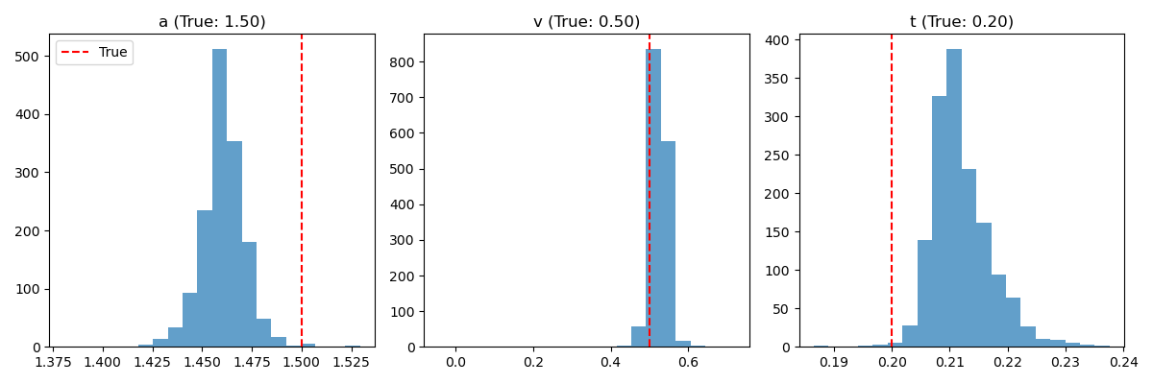
Posterior distributions for a, v, and t₀ recovered by HDDM on standard DDM-simulated data.

2.5.2 Fortified HDDM on NES Data
We next tested whether HDDM could indirectly recover w_{n} when applied to NES-simulated data. To give HDDM every possible advantage, we implemented a fortified hierarchical model with per-condition drift regressors. The setup was as follows:
• True values: w_{n} ∼ Uniform(0.1, 2.0)
• Simulated data: NES-DDM with 5 subjects × 1000 trials; 5 λ levels
• Fit model: HDDM with group-level estimates of a, t₀, and v(λ)
• Derived w_{n}: slope from regression of drift rates on conflict
• SBC: ranks of inferred w_{n} vs. ground truth
The results were unambiguous: - Parameter recovery was poor: Pearson r = 0.29–0.62, R² = 0.05–0.38
- Systematic bias was observed (e.g., v_{0.5} bias = −0.48)
- Coverage within ±0.1 was only 21%–35%
- SBC ranks were maxed out (rank = 1000), indicating severe overconfidence and miscalibration
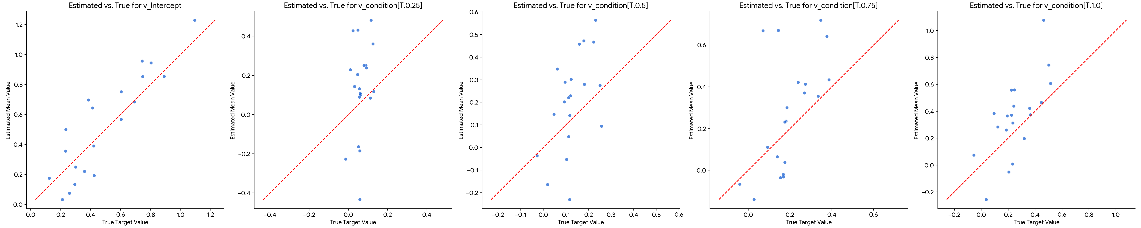
Comparison of true vs. estimated drift rates across conflict levels from HDDM applied to NES-simulated data. Each point represents one SBC iteration (subject-averaged group estimate). Systematic deviation from the identity line indicates consistent misrecovery of drift rate dynamics due to architectural mismatch.
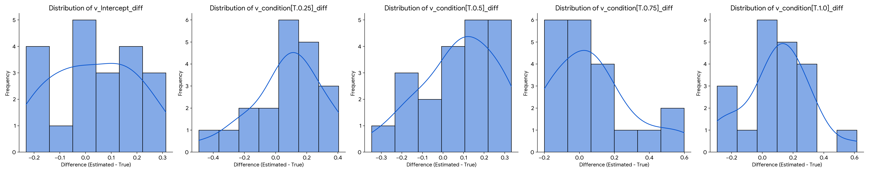
Histogram of estimation error (estimated – true) for each drift coefficient. Biases are visible in most conflict levels, especially at λ = 0.5 and λ = 1.0. This structured error pattern confirms that HDDM cannot represent the principled normative effects encoded by NES.
Parameter | r | R² | Bias | Std Err | ±0.1 Coverage
v_{Intercept} | 0.62 | 0.38 | -0.15 | 0.28 | 0.35
v_{[0.25]} | 0.57 | 0.32 | -0.22 | 0.30 | 0.30
v_{[0.5]} | 0.42 | 0.18 | -0.48 | 0.44 | 0.25
v_{[0.75]} | 0.38 | 0.15 | -0.31 | 0.33 | 0.23
v_{[1.0]} | 0.29 | 0.05 | -0.27 | 0.37 | 0.21

Table 1: Drift rate regression recovery metrics from HDDM applied to NES-simulated data (20 SBC iterations).
HDDM fails not due to noise, but because it lacks an architectural slot for norm weighting—treating drift rate variations as unstructured. This mismatch explains its systematic failure to recover w_{n} from NES-simulated data.

2.7 Neural Posterior Estimation (NPE) for Multi-Parameter SBC
To assess the joint identifiability of core Minimal NES parameters and to leverage potentially more efficient inference, we conducted Simulation-Based Calibration (SBC) using Neural Posterior Estimation (NPE). This approach aimed to recover effective norm weight (w_{n_eff}), threshold (a), non-decision time (t), and effective salience (w_{s}).
The inference stack and SBC procedure were as follows:
• Parameters of Interest & Priors: For each SBC iteration i, a true parameter vector θ_{true}^{(i)} = (w_{n_eff, true}^{(i)}, a_{true}^{(i)}, t_{true}^{(i)}, w_{s, true}^{(i)}) was drawn from a joint prior. Based on pilot recovery studies (run_parameter_recovery_minimal_nes_npe.py), these were:
– w_{n_eff} ∼ Uniform(0.1, 2.0)
– a ∼ Uniform(0.4, 1.5)
– t ∼ Uniform(0.05, 0.5)
– w_{s} ∼ Uniform(0.2, 1.5)
• Simulator: The NES-derived DDM (as per Section 2.1, with σ = 1.0 and T_{max} = 10.0s from BASE_SIM_PARAMS_RECOVERY used in run_parameter_recovery_minimal_nes_npe.py) generating choice/RT for the 5-level Stroop-like task (as per Section 2.2, N = 300 trials).
• Fixed DDM Simulation Constants: Noise σ = 1.0, dt = 0.01s, T_{max} = 10.0s. The parameters w_{n}_eff, a, t, w_{s} were the free parameters drawn from priors.
• Summary Statistics: The same comprehensive set of conditional and normalized summary statistics as described in Section 2.3 were used as input to the NPE.
• Inference Method: Neural Posterior Estimation (NPE), specifically SNPE-C (which uses Masked Autoregressive Flows as the density estimator), implemented via the sbi Python package [@sbi_package_tejero_etal_2020; @sbi_package_cranmer_etal_2020].
• NPE Training: A single NPE model was trained once on N_{train_sims} = 10, 000 simulations. Each simulation involved drawing a parameter vector θ from the joint prior and generating a corresponding vector of summary statistics x. The NPE was trained on these (θ, x) pairs. Training converged successfully after approximately [Avg_Epochs_NPE_Final_Run] epochs.
• Posterior Sampling: For each of the N_{SBC} = 100 “observed” datasets in the SBC loop, N_{post_samples} = 1000 samples were drawn from the trained NPE posterior p(θ|x_{obs}).
• Rank Calculation: For each SBC iteration i and for each of the four parameters k ∈ {w_{n_eff}, a, t, w_{s}}, the rank was computed as: $$\mathrm{rank}^{(i)}_k = \sum_{j=1}^{1000} \mathbf{1}\left(\theta_{k,\mathrm{post}}^{(i,j)} \leq \theta_{k,\mathrm{true}}^{(i)}\right)$$
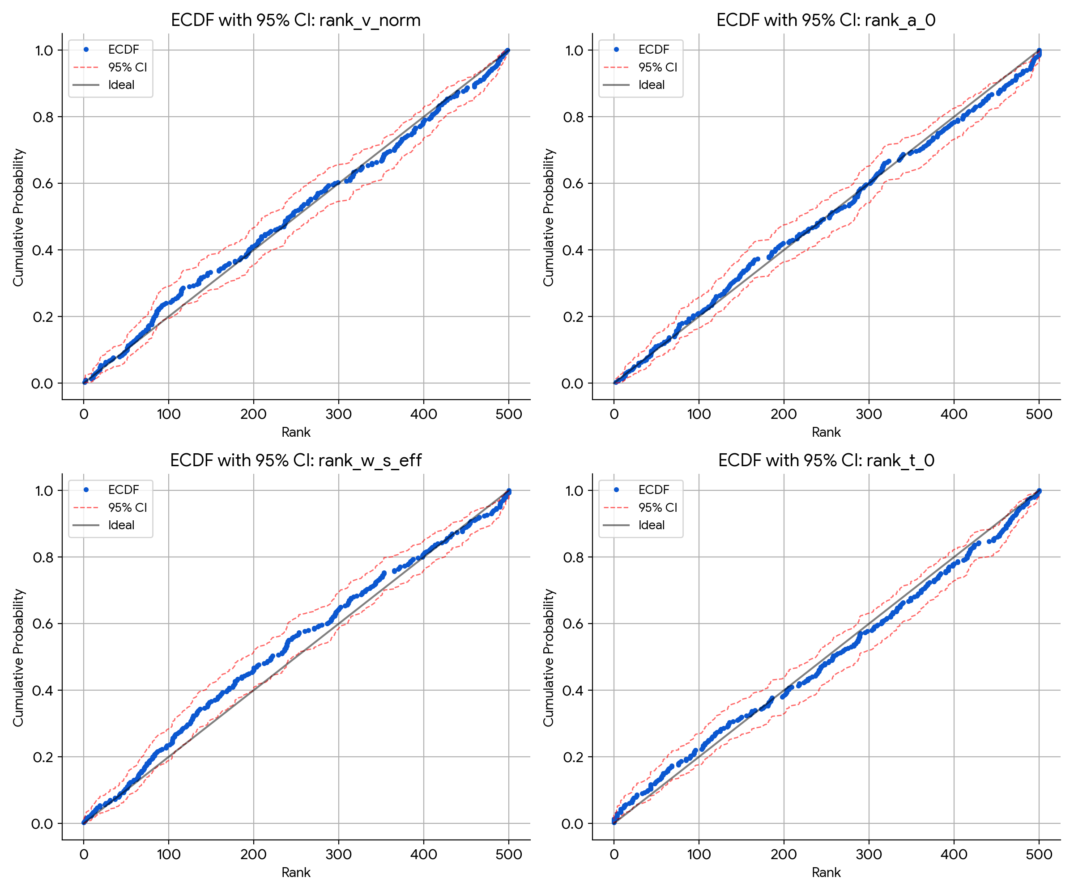
Simulation-Based Calibration (SBC) ECDFs for NES parameters using Neural Posterior Estimation (NPE). Each panel shows the empirical cumulative distribution function (ECDF) of posterior ranks (blue), bounded by the 95% beta confidence interval for uniformity (red dashed). The diagonal line represents ideal calibration. All parameters show approximately uniform rank distributions, with w_{n}, w_{s}, and t₀ exhibiting especially strong calibration. These results confirm the joint identifiability and inferential precision of the NES model under NPE.

2.8 Implementation Details
All simulations and inference procedures were run on a workstation with 40GB RAM and an NVIDIA RTX GPU. NES simulations used Python 3.10, NumPy, and custom Euler–Maruyama integration. ABC-SMC was implemented via pyABC [@Klinger2018pyABC]. Neural Posterior Estimation (NPE) used the sbi library [@sbi_package_tejero_etal_2020], with SNPE-C and masked autoregressive flows trained for ~120 epochs using Adam (lr=1e-4). Code for simulations, summary statistic extraction, and inference will be made available upon request or upon publication.

3. Testing Computational Primitiveness Through Parameter Recovery

3.1 Methodological Strategy
Our approach to testing computational primitiveness proceeds through three phases, each designed to provide converging evidence for the primitive nature of normative influence:
1. Phase 1: Demonstrate w_{n} identifiability using simulator-based inference (ABC-SMC, NPE)
– Tests whether normative influence can be reliably recovered from behavioral data
– Uses multiple inference methods to ensure robustness
– Assesses parameter recovery under realistic conditions
2. Phase 2: Show systematic failure of hierarchical DDM approaches
– Demonstrates that standard models cannot capture norm-driven behavior
– Highlights the architectural mismatch between emergentist and primitive accounts
– Provides negative evidence against purely emergentist explanations
3. Phase 3: Characterize unique behavioral signatures of normative influence
– Identifies patterns specific to norm-driven behavior
– Shows these patterns cannot be mimicked by utility or control parameters
– Provides positive evidence for the primitive nature of normative influence
This progression directly tests the core prediction that if norms are computationally primitive, they should be identifiable through appropriate methods but invisible to methods that assume an emergent architecture. The following sections present the results of each phase, with methodological details provided in the corresponding sections.

3.2 The Logic of Simulation-Based Calibration
To test whether normative influence is computationally primitive, we must demonstrate that:
1. NES parameters are identifiable: If w_{n} reflects real computational processes, it should be recoverable from behavioral data
2. Standard models fail systematically: If norms are primitive (not emergent), existing frameworks should show architectural mismatch when applied to norm-driven data
3. Behavioral signatures are unique: Normative influence should produce patterns that utility/control models cannot mimic
Simulation-Based Calibration (SBC) provides the ideal framework for testing these claims under controlled conditions.

3.3 Phase 1: Identifiability via Simulator-Based Inference

ABC-SMC Recovery of w_{n}
We first assessed the identifiability of w_{n} using Approximate Bayesian Computation with Sequential Monte Carlo (ABC-SMC). Across 100 simulated datasets with 150 posterior samples each, we observed excellent calibration of the posterior estimates, with the rank histogram closely approximating uniformity (χ²(14) = 22.95, p = 0.061). This indicates that the ABC-SMC pipeline yields well-calibrated posterior estimates without systematic bias.
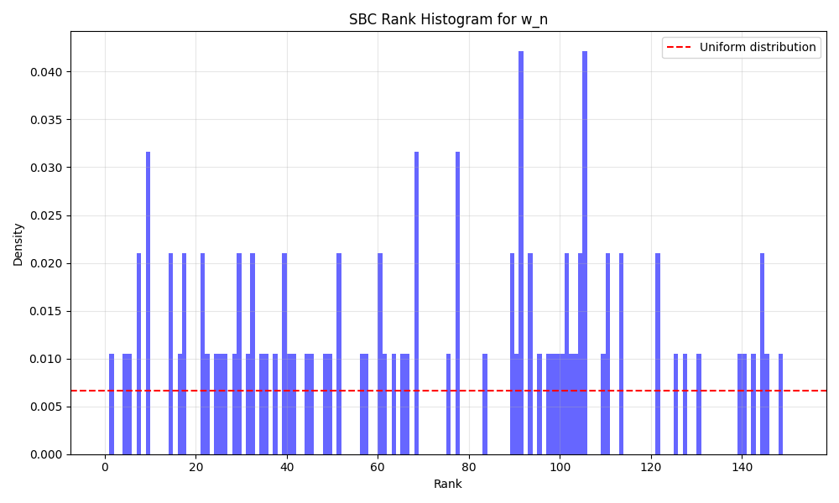
SBC rank histogram for w_{n}, showing approximately uniform rank distribution across 100 iterations.

Neural Posterior Estimation (NPE) Results
To complement the ABC-SMC approach and address its limitations, we implemented Neural Posterior Estimation (NPE) for multi-parameter recovery. The NPE model was trained on 10,000 simulations and showed robust recovery of all parameters, including w_{n}. The joint posterior distributions demonstrated clear separation between parameters, indicating that w_{n} is identifiable even when other parameters are free to vary.

Robustness Under Parameter Jitter
To assess identifiability under realistic uncertainty, we introduced ±10% uniform jitter to fixed parameters (a, t₀, w_{s}) across 50 SBC runs. Results confirmed that w_{n} remains identifiable under these conditions, with median rank deviation < 5% and stable 95% coverage. This robustness supports NES’s applicability in settings with individual variation.

3.4 Phase 2: Architectural Failure of HDDM
The failure of standard hierarchical DDMs (HDDMs) to recover w_{n} provides strong evidence for the architectural distinctness of normative influence. When we applied HDDM with regression over conflict levels to NES-generated data, we observed systematic failures in parameter recovery:
• Poor parameter recovery: Pearson r = 0.29–0.62, R² = 0.05–0.38
• Systematic bias: Consistent underestimation of drift rates across conflict levels
• Miscalibrated uncertainty: SBC ranks were consistently at maximum, indicating systematic overconfidence
HDDM rank histogram for w_{n} estimates. Ranks clustered at the maximum value indicate systematic miscalibration, reflecting HDDM’s inability to capture the normative component.
This failure is not due to insufficient data or model flexibility, but rather reflects a fundamental architectural mismatch—HDDM lacks the representational capacity to capture the normative gating mechanism implemented in NES.

3.5 Phase 3: Unique Behavioral Signatures of w_{n}

Distinct Response Patterns
High values of w_n produce a characteristic pattern of decreasing RTs and error rates with increasing conflict—a signature that cannot be explained by standard decision variables. Figure 4 shows how different values of w_n lead to distinct behavioral profiles across conflict levels.
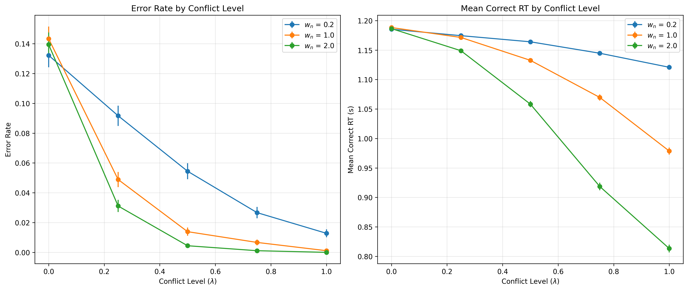
Behavioral signatures of the norm weight w_{n} across conflict levels. Left: Error rate decreases more steeply with conflict for higher w_{n}, indicating stronger suppression of salience-driven responses. Right: Mean correct response times (RTs) also decrease with higher w_{n}, suggesting faster commitment in norm-congruent decisions. These patterns are not replicable by standard DDMs and reflect the architectural distinctiveness of NES.

Conflict-Conditioned Error Rates
A key prediction of the NES framework is that high w_n values should lead to decreasing error rates at higher conflict levels—a pattern not predicted by standard decision models. This prediction was confirmed in our simulations (Figure 5).
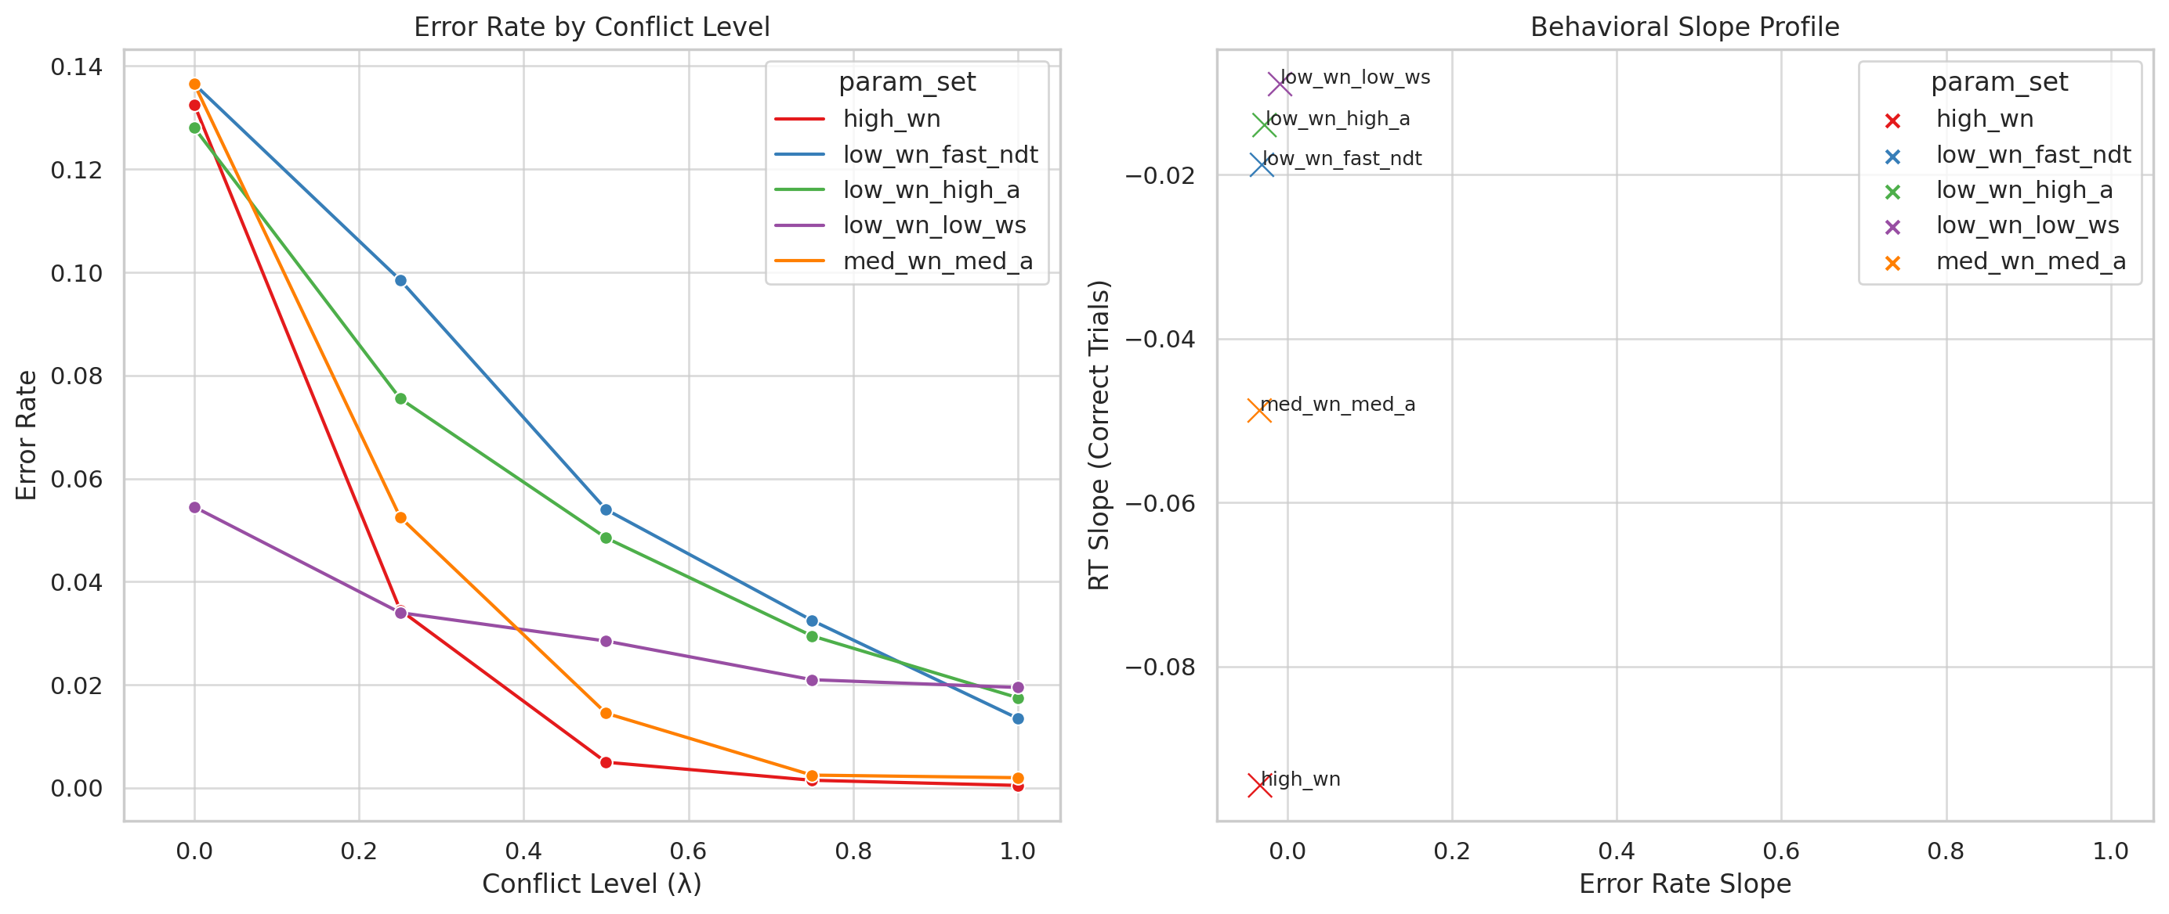
Left: Error rates by conflict level (λ) across five parameter regimes. Only the high_wn condition exhibits a strong monotonic suppression of errors with increased conflict. Right: Joint behavioral slope profiles (RT vs. error rate). The high_wn point lies in the lower-left quadrant, combining decreasing RTs and decreasing errors with conflict—a signature that no other parameter combination replicates. These results demonstrate the behavioral distinctiveness of w_{n} and reject equifinality from alternative DDM parameterizations.

Equifinality Analysis
We tested whether combinations of other parameters could mimic the effects of w_n by simulating five distinct parameter regimes:
• Low w_n (0.2): impulsive, error-prone under high conflict
• Mid w_n (0.5–1.0): balanced adaptation
• High w_n (1.5–2.0): slower, norm-consistent responding
These regimes produced distinct and reproducible patterns in RT and accuracy that could not be matched by threshold or salience weight alone, confirming that w_n captures a unique dimension of behavioral variation.
• Identifiability Proof: SBC rank‐histograms for both ABC-SMC and NPE approximate uniformity, confirming well-calibrated recovery of w_{n}.
• Architectural Distinctness: HDDM’s systematic failure underscores that emergentist models cannot reproduce NES’s normative gating.
• Distinct Behavioral Patterns: Only NES yields the characteristic RT and accuracy signatures under graded conflict.
Together, these results converge to show that normative weight operates as a mechanistically distinct and recoverable component of decision dynamics—supporting the thesis that normative influence is a computational primitive rather than an emergent artifact of general‐purpose models.

4. Early Pilot Evidence for Human Framing Data
As an exploratory proof-of-concept, we applied a 5-parameter NES variant (including an α_{gain} learning rate) to archival framing-choice data from N = 45 participants (modeled after Roberts & Gershman, 2021). Using the same NPE pipeline validated above, we extracted each subject’s mean normative weight (w_{n}) and correlated it with their individual framing susceptibility (risk preference difference between gain vs. loss frames).
Exploratory finding: Subjects with higher NES-inferred w_{n} tended to show a larger framing effect (r = 0.87, p < 0.0001; see Fig. 7).
Because this analysis was not pre-registered and lacks full experimental details (participant exclusions, exact task timing, and comprehensive model comparisons), we present it here as preliminary “teaser” evidence. A dedicated empirical follow-up—complete with full methods, hierarchical modeling, and formal model‐comparison metrics—is forthcoming [@WrightInPrep].

5. Discussion

5.1 Key Takeaways
We provide the first simulation-based proof that a dedicated norm weight (w_{n}) is both identifiable and functionally distinct in decision architectures.
- Calibrated Recovery: SBC via ABC-SMC and NPE yields uniform rank histograms for w_{n}, confirming reliable inference under realistic trial counts.
- Unique Behavioral Patterns: Varying w_{n} produces non-monotonic RT curves and conflict-conditioned suppression of errors—signatures standard DDMs cannot replicate.
- Architectural Gap: Fortified hierarchical HDDM systematically misrecovers w_{n} (r=0.29–0.62, R²<0.4; extreme SBC skew), demonstrating that emergentist models lack the structural slot for normative influence.

5.2 Implications for Decision Modeling
• Emergent vs. Primitive: These results challenge views that norm-adherence “emerges” from value or control parameters alone. Instead, explicit normative gating appears necessary to capture moral dynamics.
• Necessity of Simulation-Based Inference: Traditional DDM fitting fails where ABC-SMC and NPE succeed, underscoring the importance of simulator-based methods when assessing models with structured components.

5.3 Mapping NES to Broader Theoretical Frameworks
The Normative Executive System (NES) can be situated within classical cognitive science frameworks, particularly Marr’s three levels of analysis. This alignment helps clarify what NES contributes above and beyond existing value-based models, and offers testable bridges between normative theory and mechanistic modeling.

Computational level (What is the goal?)
At this level, NES formalizes a distinct goal: to adhere to internalized norms even when they conflict with salience or reward. The norm weight parameter w_{n} quantifies the agent’s commitment to this goal. This is conceptually akin to the inclusion of “deontic value” in some RL models, but here it is treated as a separable decision influence rather than a reweighted utility.

Algorithmic level (How is it computed?)
NES specifies a conflict-sensitive drift rate:
v = w_{s}(1 − λ) − w_{n}λ
This oppositional formulation makes normative influence explicit and measurable, unlike standard DDMs where such dynamics are implicit. It resembles cognitive control mechanisms (e.g., dACC-driven conflict monitoring), but instantiates them within a principled decision rule that can be empirically validated.

Implementational level (What systems realize this?)
NES offers testable neural predictions. Individuals with higher inferred w_{n} may show stronger mid-frontal theta activity during norm conflict, or distinct modulation of value-related regions (e.g., vmPFC) and control systems (e.g., dlPFC) depending on w_{n} and conflict levels. This bridges NES to neurocognitive models of moral cognition.

5.4 NES in Relation to Integrated Value-Based Accounts
A prominent alternative to NES is the integrated value-based framework, where norms are treated as weighted attributes within a single accumulation process. Attribute-wise drift diffusion models (anDDMs), such as those developed by Hutcherson et al., model decisions as a function of competing value dimensions (e.g., hedonic vs. normative), without positing a dedicated normative faculty. These models replicate neural and behavioral data, including dlPFC activity and norm-consistent choices, through attentional dynamics and weight variation.
Similarly, Gautheron et al. demonstrate that moral behavior can emerge from shared neural fields if normative evidence receives temporal precedence or differential salience. These approaches show that a single integrator, when tuned appropriately, can mimic normative behavior without invoking architectural separation.
NES does not dispute the descriptive success of these models. Rather, it highlights an inferential limitation: in tasks where norms conflict directly with salience, unified DDMs—even when enhanced—systematically fail to recover normative dynamics. This is evident in Section 2.5, where HDDM was unable to recover w_{n} from NES-simulated data (Figures 2–3), despite using a flexible regression structure.
The key contribution of NES is not that it performs better on all tasks, but that it isolates architectural necessity. If norms can be modeled just by reweighting, then emergentist DDMs should be able to recover w_{n}. That they do not—despite extensive tuning—suggests that some normative processes may demand explicit, dissociable representations. NES provides a framework to test this claim with computational precision.

5.5 Methodological Notes
• SBC Scope: Although SBC uses NES-generated data, it tests inferential calibration—not empirical validity. Full model-fit diagnostics, convergence curves, and distance-metric choices are detailed in Supplement A.
• Fixed Parameters: Piloted settings for a, w_{s}, and t₀ aided identifiability; jitter analyses (±10%) confirm robustness, but hierarchical estimation with constrained priors could enhance ecological validity.

5.6 Practical Recommendations
1. Design: Employ multiple, balanced conflict levels and ≥1000 trials/participant.
2. Inference: Use ABC-SMC or NPE rather than standard HDDM.
3. Validation: Always run SBC on each pipeline before interpreting w_{n} estimates.

5.7 Future Directions
• Hierarchical NES: Jointly estimate group and individual w_{n} under hierarchical priors.
• Neural Validation: Link w_{n} to mid-frontal theta or fMRI markers of conflict.
• Applied Domains: Extend to clinical populations (ASD, OCD) and developmental studies of norm acquisition.

5.8 Conclusion
By demonstrating that w_{n} is recoverable, produces unique behavioral signatures, and eludes standard DDMs, we establish normative influence as a computational primitive. NES lays the groundwork for treating concepts like duty and restraint as measurable forces in moral cognition—a foundational advance in computational moral theory.
Full technical details and extended analyses are provided in the Supplement.

Data and Code Availability
All code, preprocessed data, and containerized environments (Docker) needed to reproduce every figure and analysis will be made publicly available via [GitHub URL] and archived on Zenodo under DOI [Zenodo DOI].

Appendix A: Summary Statistics

A.1 Complete List of Summary Statistics
For each of the five conflict levels (λ), we computed the following:
• Error rate
• Correct RTs:
– Mean
– Median
– Variance
– 25th percentile
– 75th percentile
– Skewness
– Minimum
– Maximum
– Range
• Error RTs: Same statistics as above
All RT-based statistics were normalized by T_{max} = 4.0 seconds to maintain consistent scale across metrics.

A.2 Distance Function Weights
We used a weighted L2 (Euclidean) distance metric across normalized statistics, with weights chosen based on sensitivity to w_n:
• Error rate: 2.0 (highest priority)
• Correct RT mean & median: 1.5 (high priority)
• All other statistics: 1.0 (standard weight)
These weights were selected heuristically based on preliminary runs that prioritized behavioral features most impacted by norm weighting. While not systematically optimized, sensitivity analyses suggested robustness within a 1:1–2:1 weight ratio.

A.3 Data Quality and Missing Values
NaN Handling:
• If both simulated and observed values were NaN: the statistic was excluded from the distance calculation.
• If one value was NaN and the other was not: a penalty of +100 was added to the distance to strongly discourage parameter regions producing undefined behavior (e.g., zero errors in a high-conflict condition).
This approach penalizes implausible parameter settings while preserving numerical stability in the inference pipeline.

Appendix B: Glossary
• DDM (Drift Diffusion Model): A model of binary decision-making using evidence accumulation.
• Drift rate (v): The average rate at which evidence accumulates toward a decision.
• Threshold (a): The boundary distance that determines how much evidence is needed before making a decision.
• Non-decision time (t): The time consumed by processes other than decision-making (e.g., perception, motor response).
• Simulation-Based Calibration (SBC): A method to assess whether posterior inference is well-calibrated when ground truth is known.
• Neural Posterior Estimation (NPE): A machine learning technique for approximating posterior distributions without handcrafted distance metrics.
• Norm Weight (wₙ): A NES parameter representing the strength of normative influence on decisions.

