Assignment 1 – Dimensionality Reduction using PCA

**Question 1: MNIST Dataset**

After PCA, the bottom image is the result. Data became dense and computation became faster.

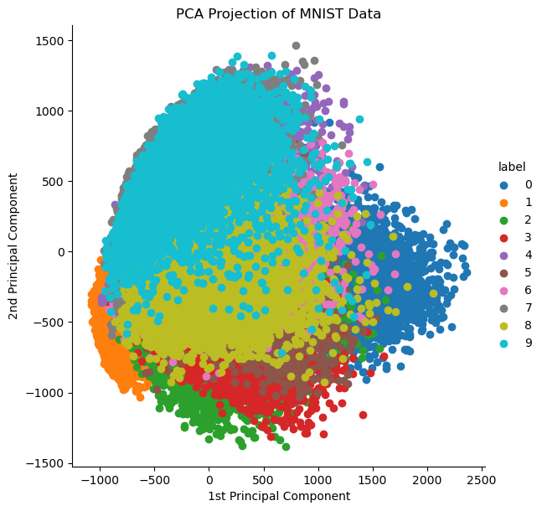

**Challenge Encountered:**

**Plotting X_train versus X_train_reduced**

The shape of X_train has 784 features as opposed to X_train_reduced that has 154. To be able to compare the two, X_train_reduced must be returned back to the original feature space by using inverse_transform.

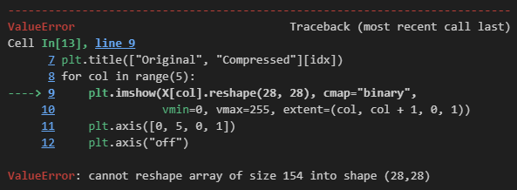







**Result:**

The image below shows the comparison between the original and compressed digits that were generated after using **Incremental PCA and inverse_transform**.

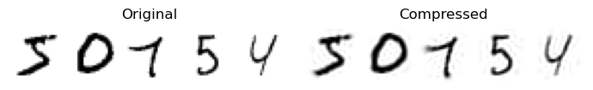

**Question 2: Swiss Roll Dataset**

The image below is the generated Swiss roll dataset.

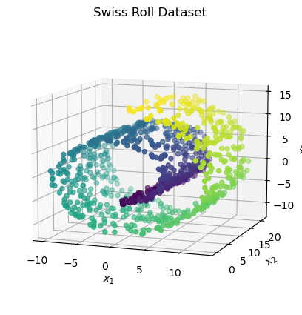

The image below resulted from applying linear, rbf and sigmoid kernels to the dataset. However, it is difficult to determine which kernel is best for this model. The best way to decide is use GridSearchCV.

**Challenge Encountered:**

**Fitting the grid_search to X_swiss together with t calls ValueError**

Since t is an array with continuous values, it cannot be fitted into grid_search. To solve this, I used feature discretization **KBinsDiscretizer** to change t into integers. Feature discretization decomposes each feature into a set of bins, one-hot encoded and then given to the classifier.

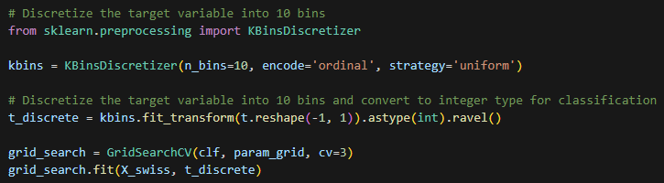

**Result:**

One would think that unrolling the Swiss Roll will result to a better performance for the Logistic Regression. However, upon comparison with the pipeline for choosing the best kernel and gamma values, linear won with 0.03 gamma and a score of 87% whereas unrolling only has 30% accuracy. Also, unrolling the Swiss roll only resulted to more segments.

**