**Sole source justification for single molecule FISH (smFISH) imaging system**

I, Erin Nishimura of Colorado State University, seek to obtain a DeltaVision Elite widefield microscope system for my laboratory. This instrument will be used for visualizing fluorescently-labeled mRNA molecules in fixed *C. elegans* embryos with single-molecule resolution.

***Argument of Continuity***

The visualization of mRNA using single molecule Fluorescence *In Situ* Hybridization (smFISH) is a specialized technique performed by only a handful of labs. I developed my protocol for smFISH micrsocopy during my postdoctoral studies. I optimized conditions for three years before I even saw a dim fluorescent spot; many more months were required to improve the procedure into a consistent, high-quality research tool. Currently, my smFISH images are robust, reproducible, and have been praised for their clarity. I developed my smFISH protocol in the lab of Paul Maddox at University of North Carolina where I used a DeltaVision Elite widefield microscope for image capture. I would like for my lab here at Colorado State University to continue to use a DeltaVision Elite widefield microscope system. The continuity of using this system will capitalize on my time investment and maintain my reputation for high quality smFISH images. Were we to switch to a different system, we would need to invest additional time for 1) fixation media optimization (there are twelve different potential fixation solvents to test), 2) mounting media optimization (media must be matched to the optics), and 3) photbleaching assays (differs with different mounting media). By switching to a different system, we would incur a minimum of six months of time for these calibration and optimization experiments. Further, it is not clear to me that other systems can ***ever*** be optimized to match the quality of data we obtain with the DeltaVision Elite widefield microscope system. By switching to another system, we would be taking a serious risk of a cost of roughly 25 % of my start up package as well as our valuable time, risking the possibility that the competing system may not ever work to support the quality of research I was hired to produce.

An additional argument for maintaining continuity is that we are in the process of writing a manuscript for which several figures have already been prepared using a DeltaVision Elite widefield microscope in Paul Maddox’s lab. Purchasing an alternative system would necessitate re-doing the previous figures, roughly a six-month investment.

I have previously published images of smFISH microscopy using the DeltaVision Elite System (Osborne Nishimura, PLoS Genetics, 2015), am engaged in several collaborations requiring this instrument, and preparing a number of NIH and one NSF grant for submission.

***Argument of Feasibility***

The visualization of mRNA using single molecule Fluorescence *In Situ* Hybridization (smFISH) is a specialized technique with many technical challenges. It is not clear to me that another make or model of microscope can meet the challenges of our assay and obtain images of the quality we capture with the DeltaVision Elite widefield microscope system. The fluorescent probes used in smFISH are dim, have high background, and are prone to photobleaching. Further, the embryos we image are thick (14 um), an additional challenge. Confocal microscopy is not appropriate for smFISH imaging because light capture is not sufficiently efficient and because the probes photobleach too readily. TIRF microscopy is not appropriate because the samples are too thick. Widefield microscopy is therefore the option of choice. However, different widefield microscope systems vary in their abilities to capture high-quality smFISH images. No single rubric, like sensitivity or resolution, can determine whether a widefield microscope is adequate for smFISH microscopy. We have found that the combination is required:

1. a widefield microscopy set up for maximal light capture
2. a simplified, direct light path for maximum signal loss
3. a cooled CCD camera to minimize noise
4. a camera with a minimum of 6.45 um x 6.45 um pixel size for single-molecule resolution
5. a high quality deconvolution software package for image refinement

Prior to settling on a vendor, we tried alternative options to double check that the DeltaVision Elite widefield microscopy system was indeed the best suited for our purpose. In total, I tested seven microscopes and ten different cameras. I tested two Nikon Eclipse Ti systems specifically designed by Andrew Cahill (Nikon, Inc) including five different cameras on those systems, I tested a widefield Zeiss microscope, a laser scanning Zeiss confocal microscope, a custom made microscope specifically designed for single-molecule resolution imaging, and two DeltaVision models. Of these instruments, only the DeltaVision Personal and Elite models of microscopes met all the five criteria listed above. Of these, only the Elite model is currently available for purchase. I will outline below how the other models were insufficient and why the DeltaVision Elite is the only available microscope that met all of our requirements.

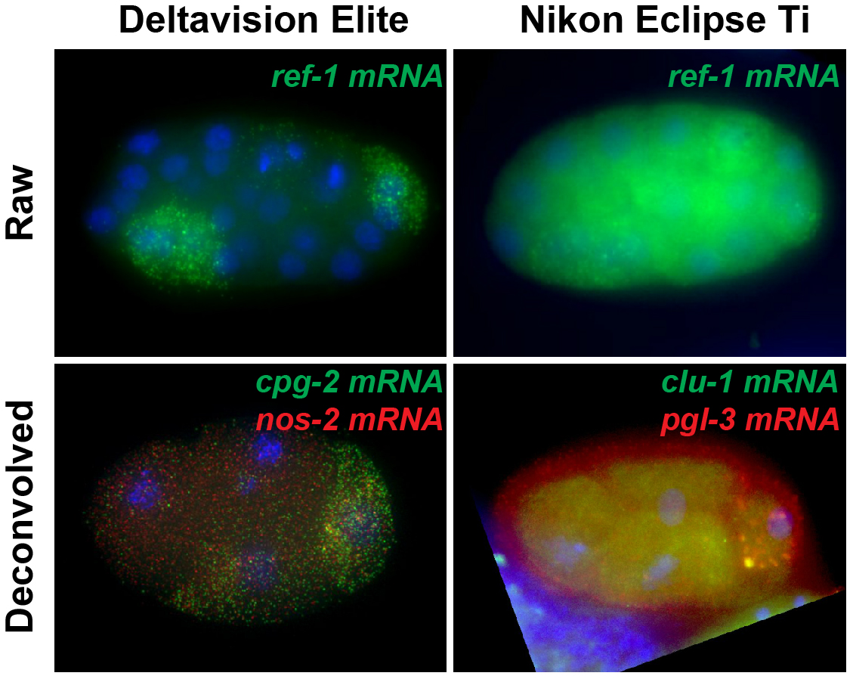**Nikon Eclipse Ti microscopes.** First, I worked with Andrew Cahill of Nikon to use modify a TIRF microscope in the MIN network to suit our application. We outfitted the microscope with a new camera (the MYO cooled CCD camera), new objective lens, we turned the TIRF function off, and we added deconvolution software to the microscope. Unfortunately, though we were able to visualize smFISH spots, these modifications were not sufficient to acquire good smFISH images of a caliber necessary for quantifying the number of mRNA molecules with single count resolution. The convoluted light path yielded images were too dim, had low signal-to-noise, and were not crisp (Figure 1). Further, Nikon’s deconvolution software distorted the images instead of improving them.

I next tested a newer Ti microscope model from Nikon that Andrew Cahill specifically designed with our application in mind. We tested this system with three different state-of-the-art cameras available through Nikon (CCD, EM-CCD, and sCMOS). It boasted an updated light path, a brighter, higher sensitivity light source, and more deconvolution algorithms. Images captured were not an improvement from previous attempts reaffirming that the cooled MYO CCD camera was the most superior of the the cameras we had tried. We found that the light path was still lacking in its efficiency, the deconvolution software distorted images instead of improving them, and any cameras with a pixel resolution higher than 6.45 um x 6.45 um were not sufficient to resolve individual molecules of mRNA.

Figure 1. C. elegans embryos at the 24-stage or 4-cell stage were captured with the DeltaVision Elite system (left) or the Nikon Eclipse Ti and MYO system (right). mRNA molecules should appear as discrete fluorescent puncta (red or green). Deconvolution should remove diffuse background while preserving the fluorescent punctate signal. DNA is visualized using DAPI (blue).

**Zeiss widefield and confocal microscopes.** I tested a widefield Zeiss microscope at the UNC core microscopy facility. Unfortunately, smFISH signal did not rise above noise to a sufficient degree. The microscope facility curator recommended trying a laser scanning confocal microscope he hoped would be an improvement over previous spinning disc confocal microscopes I had tested years before. These images looked like radio static, insufficient to discern even the brightest smFISH puncta.

**Custom built microscope.** I tested a custom-built microscope system developed by the Tim Stasevich lab at CSU for the purpose of visualizing RNA molecules with single-molecule resolution in live cells. Their system boasted a state of the art scientific CMOS camera, far superior to any we had tried before as well as one of the most efficient light paths developed. Though we saw some improvement in their system over the Nikon and Zeiss systems, ultimately we re-affirmed that scientific CMOS cameras are not well suited to our purpose as there was insufficient resolution and high noise. The images were not high quality enough to rationalize the daunting task of custom building our own microscope without the expertise of the Stasevich lab personnel at hand.

**Deltavision Personal.** Next, we tested a Deltavision microscope on CSU campus, a discontinued model called the DeltaVision Personal (DeLuca lab). We were able to visualize beautiful single-molecule resolution smFISH images with this system. Image capture had high signal-to-noise ratios, good resolution, excellent deconvolution, and software that allowed for spot thresholding and quantification.

**Deltavision Elite.** Bolstered by our success with the DeltaVision Personal system, we hosted a demonstration of the currently available DeltaVision Elite system. We were very impressed. The new DeltaVision Elite system surpassed the DeltaVision Personal system with an improved efficiency light path that required 1/4 of the exposure time of the Personal system, preserving our probes from photobleaching significantly. This yielded high signal-to-noise ratios of images, clear discrete puncta, high resolution, and low background. According to GE Electronics, this power is due to “the TruLight Illumination System, a radical new design for the DeltaVision fluorescence illumination light path that delivers outstanding signal-to-noise capability and increases light transmission to the sample by 5 fold and offers uniform illumination.” This met our requirement of (1) widefield maximum light capture and (2) minimum signal loss due to a simplified-direct light path. The DeltaVision Elite is equipped with a CoolSnap HQ2 cooled CCD camera that has the 6.45 um x 6.45 um resolution we require for (3 & 4) single-molecule resolution. In addition to the camera, DeltaVision microscopes come with a set of NA matched oils to ensure that the light path is not distorted as it travels from the sample to the objective. This really improves the clarity of the samples and makes digital counting of individual molecules of mRNA possible. Finally, the deconvolution software outperformed any we had previously tried satisfying our criteria for (5) a high quality deconvolution system. Unlike Nikon or third party deconvolution software, DeltaVision’s deconvolution can be performed right after sample collection while the next microscopy images are being taken, so it is highly efficient. The ability to drop out noise from the background was striking and a large improvement over other strategies. And finally, the deconvolution was surprisingly fast. A single deconvolution processing procedure required 1 – 3 minutes.

In addition, there were several other features that made the DeltaVision Elite more enjoyable:

1. Unlike Nikon models, sample acquisition is logged in .txt files that can be easily parsed with our home-written shell or python scripts.
2. Unlike Nikon models, all samples are acquired using file names compatible with the linux systems we use for processing. This saves us the step of writing our own software to convert file names.
3. The DeltaVision Elite system has a built-in map of the microscope slide area, making it really easy to see what you have imaged previously and making it difficult to erroneously image the same sample twice.
4. The DeltaVision Elite system automatically allows the user to inspect each wavelength’s image capture as it being captured in real-time.
5. The DeltaVision software includes applications for spot thresholding and quantification allowing us to count discrete molecules of mRNA within the acquisition software itself and eliminating the need to write our own software for this task.

After spending the last five months investigating and organizing demonstrations of these microscopy systems, I can confidently say that the DeltaVision Elite widefield microscope system is the only system on the market that meets all of our complex set of needs.

**DeltaVision Elite widefield microscope system**

The system we propose to purchase consists of the following components. The system is a packaged deal. There is little customization required as each microscope is specifically designed to accommodate to a wide range of tasks. We were able to opt out of environmental control options to reduce the price.

1. Olympus IX-71 Microscope body with 20x, 60x, and 100x objectives – high efficiency light path and filters result in high efficiency and maximal light capture
2. CoolSnap HQ2 camera – this camera has some of the lowest noise on the market and boasts 6.45 um x 6.45 um pixel size for the high resolution we require
3. 7 Color Combined InsightSSI – LED light source for high speed, multicolor, high-efficiency illumination
4. DIC capabilities – required for imaging worms at specific stages of embryonic development
5. Ultimate focus module – required for maintaining focus for high numbers of samples and through longer time course assays.
6. Standard isolation table – for maintaining focus and eliminating distortion due to vibration.

Due to our argument of continuity and our argument of feasibility, we would like to request a waiver of the bid process for the purchase of this equipment. Neither I nor anyone in my lab has any conflict of interest related to any vendors mentioned in this proposal.

Sincerely,

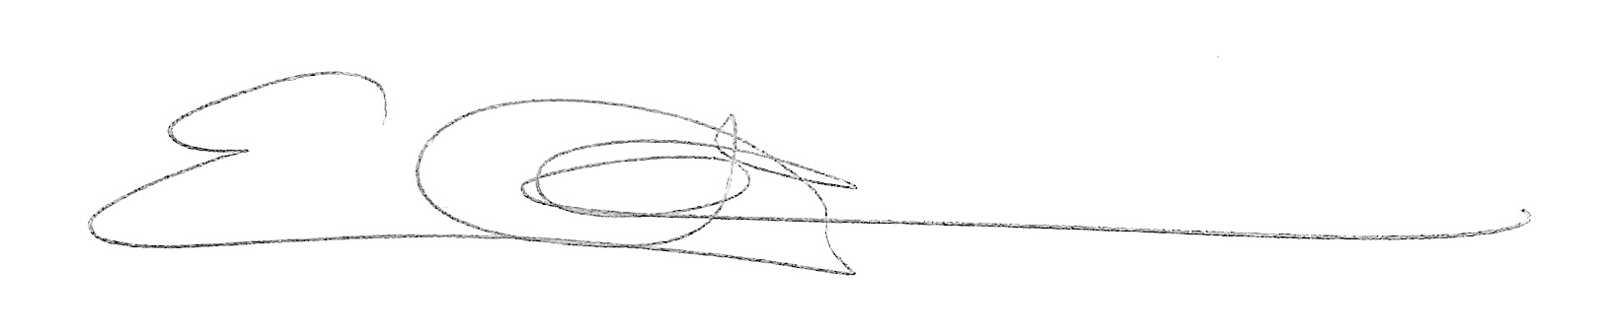

Erin Nishimura, PhD

Assistant Professor

Biochemistry & Molecular Biology

239 Molecular Radiobiological Building

Colorado State University

[erinnish@colostate.edu](mailto:erinnish@colostate.edu)