Stock Market Charting

Jessia E Joby

764712

ER DIAGRAM:

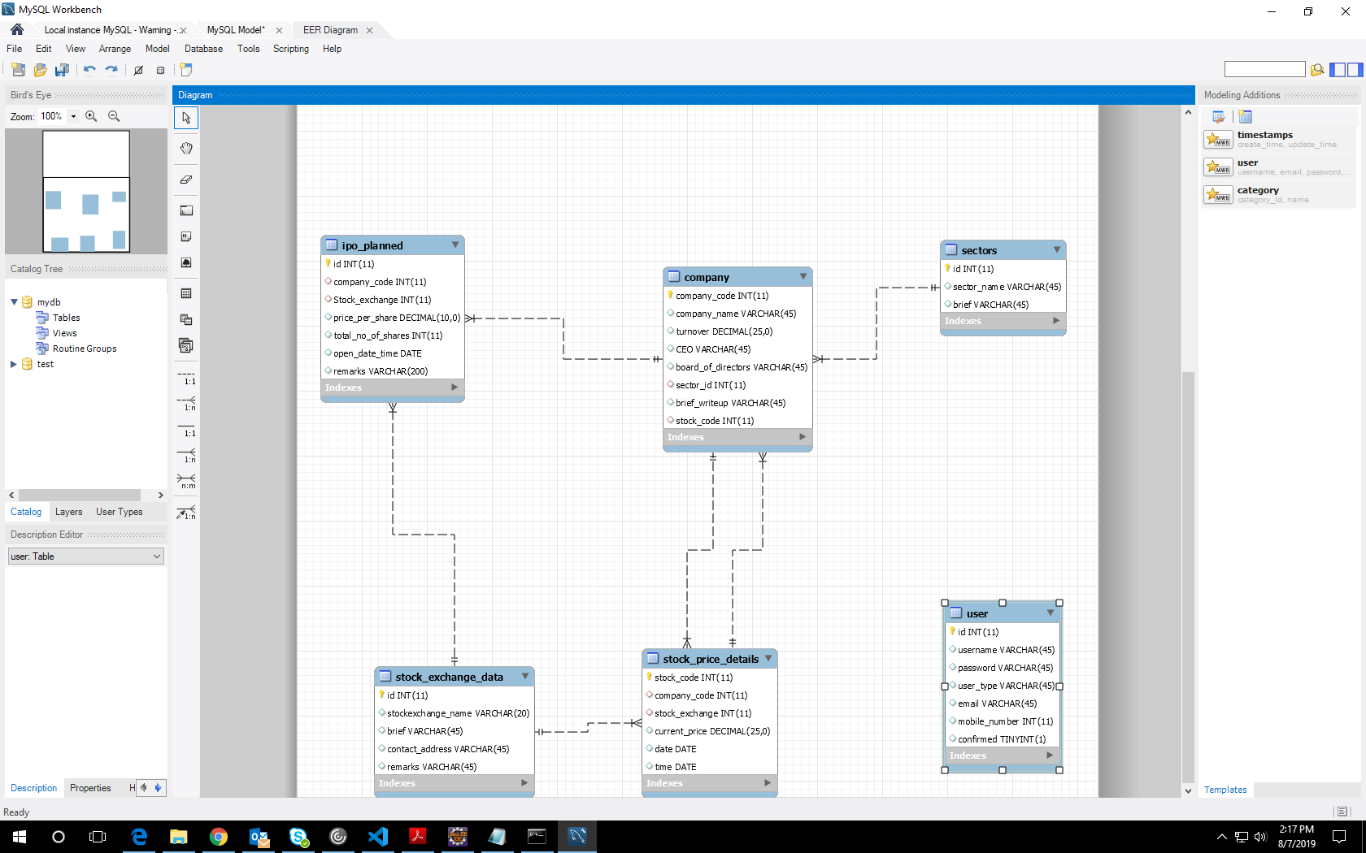

HTML PAGES:

ADMIN LANDING PAGE:

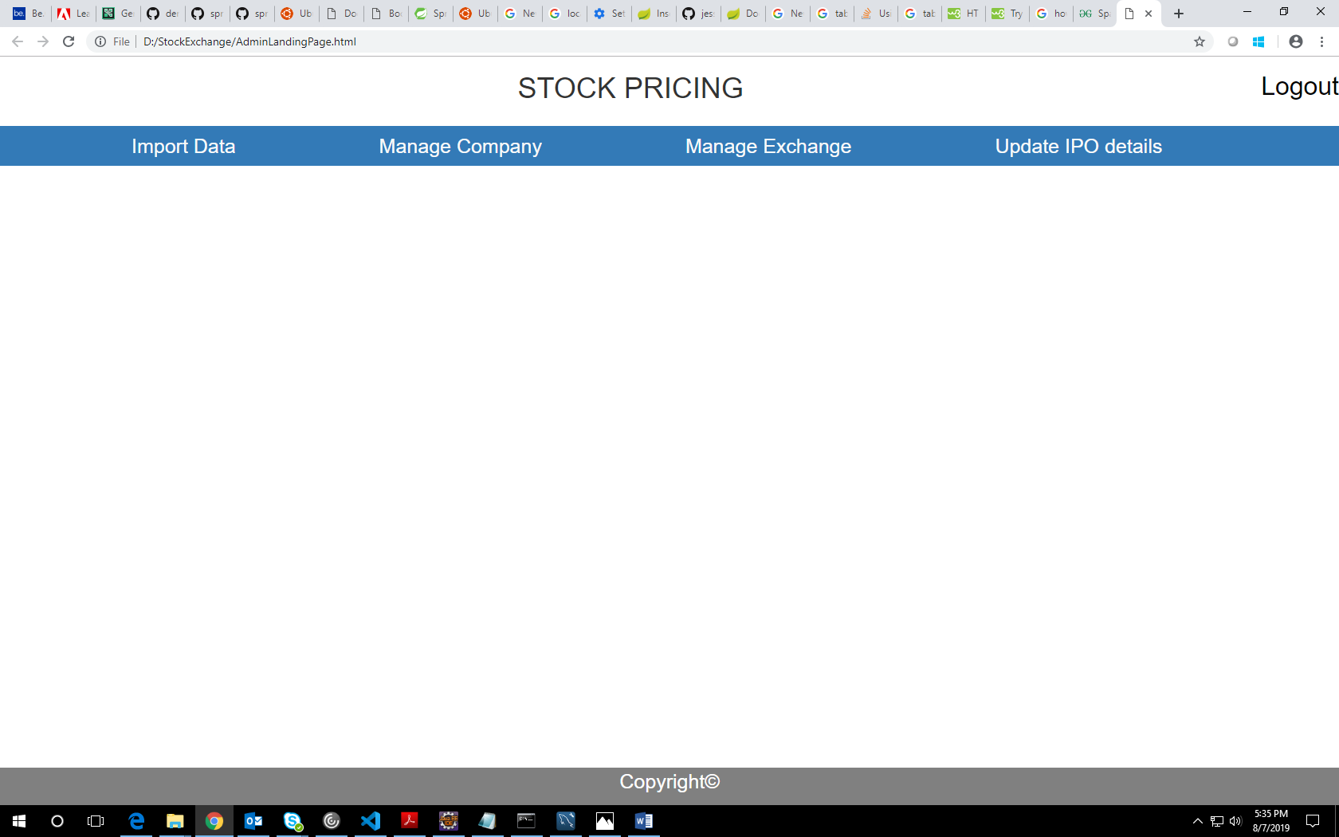

IMPORT DATA:

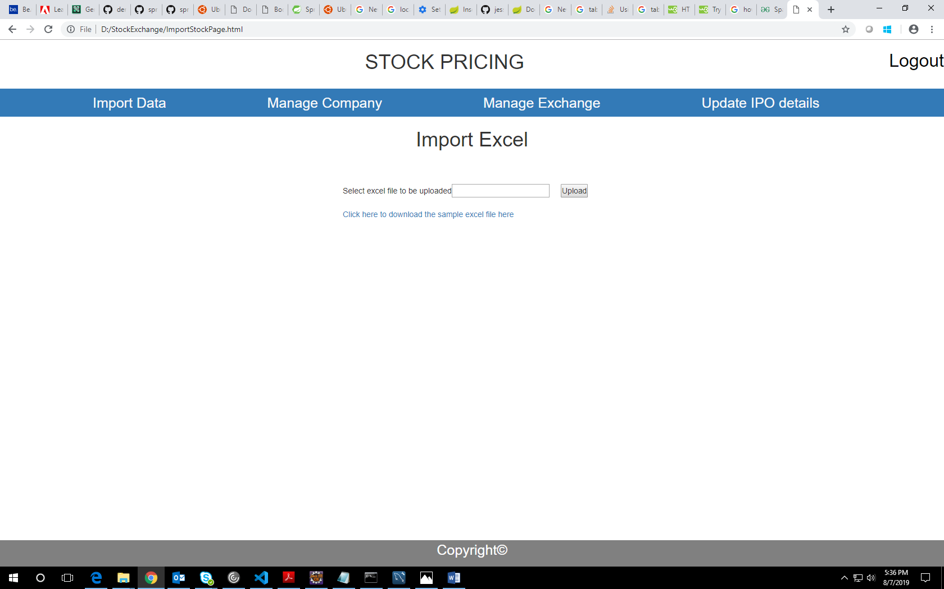

SUMMARY OF UPLOAD PAGE:

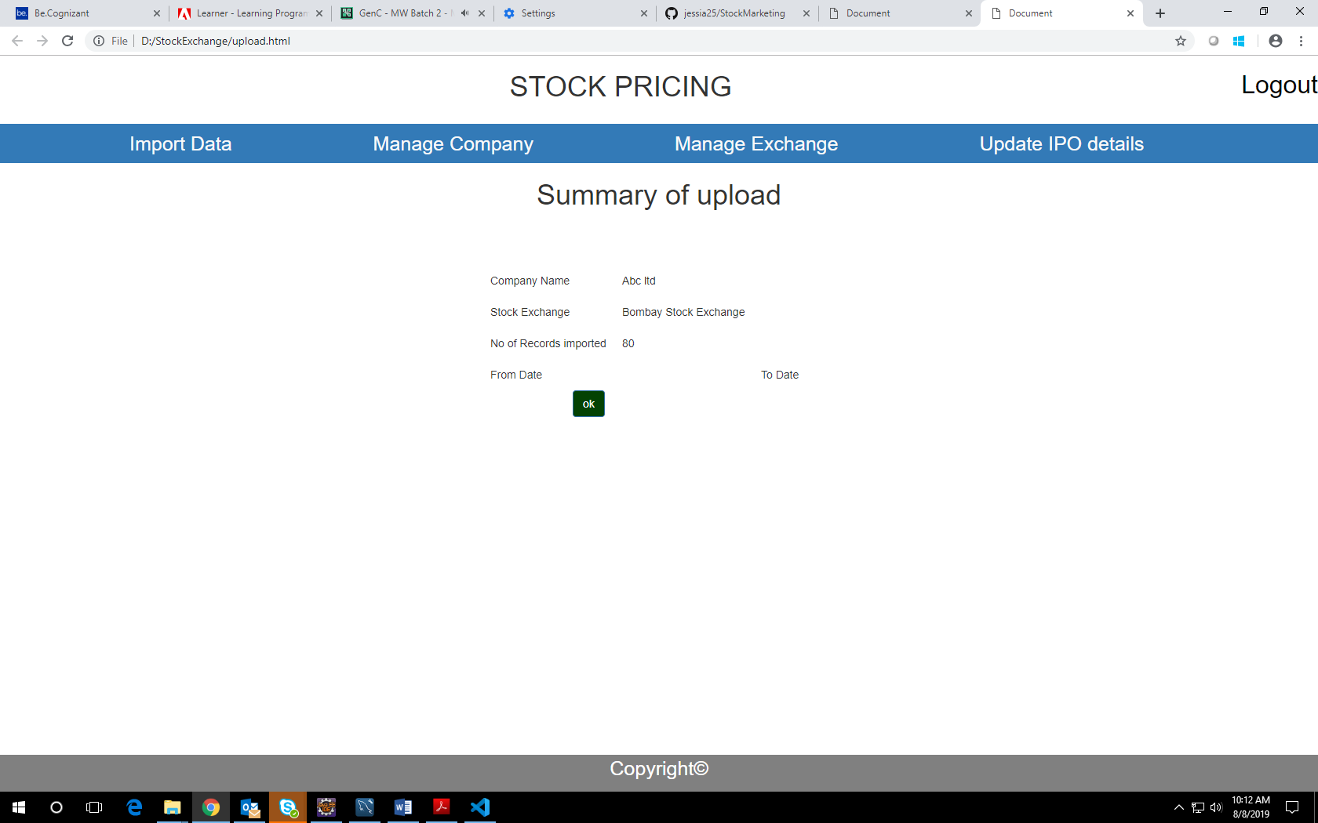

MANAGE COMPANY:

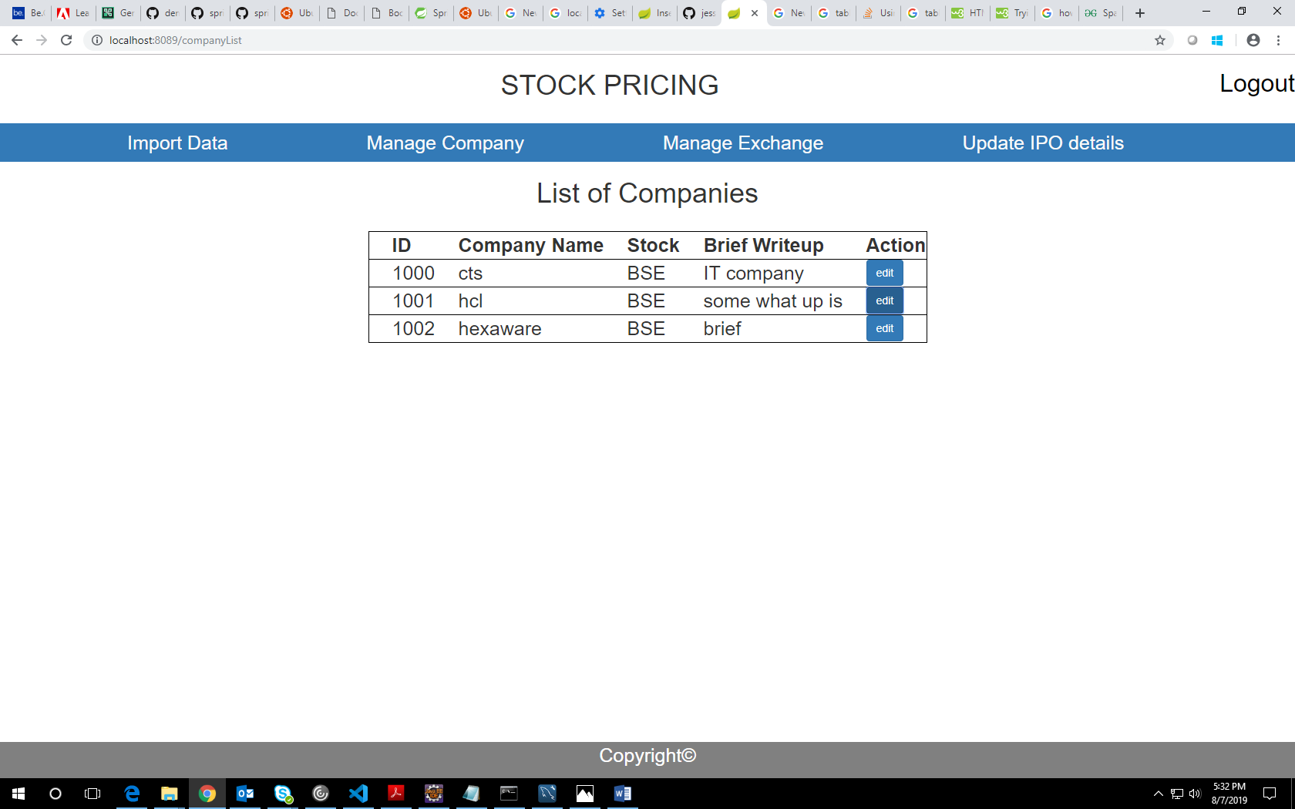

USER LANDING PAGE:

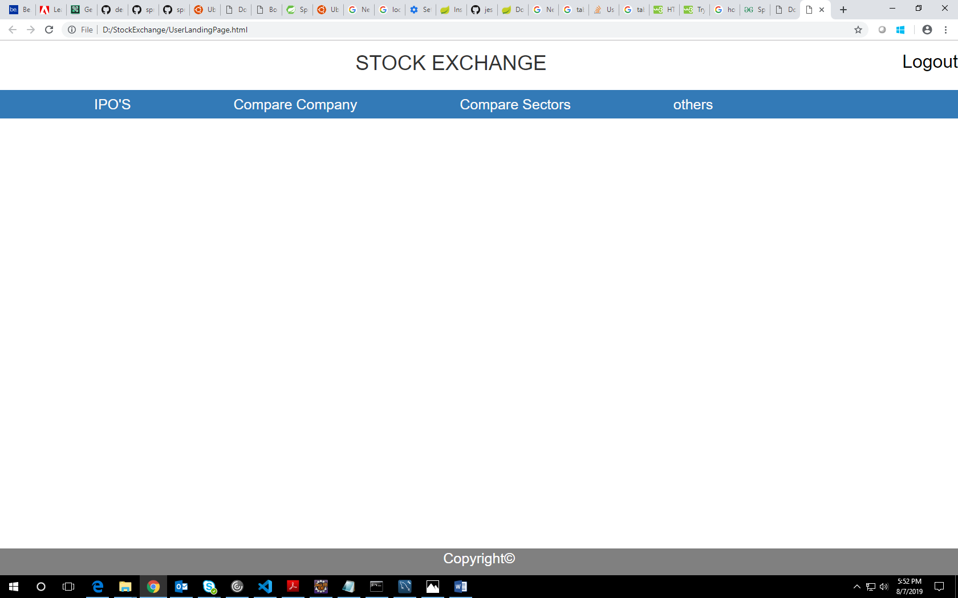

COMPARISION CHART:

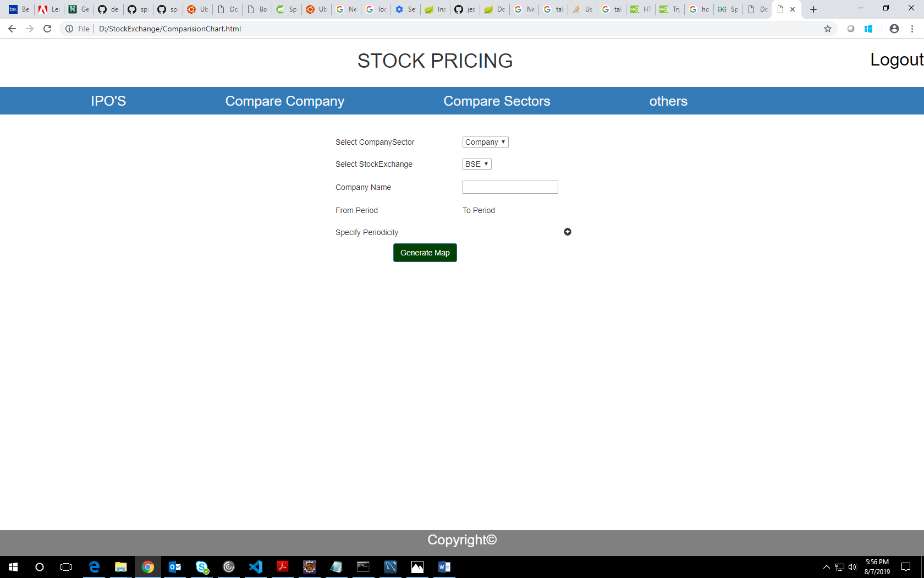

COMPANY:

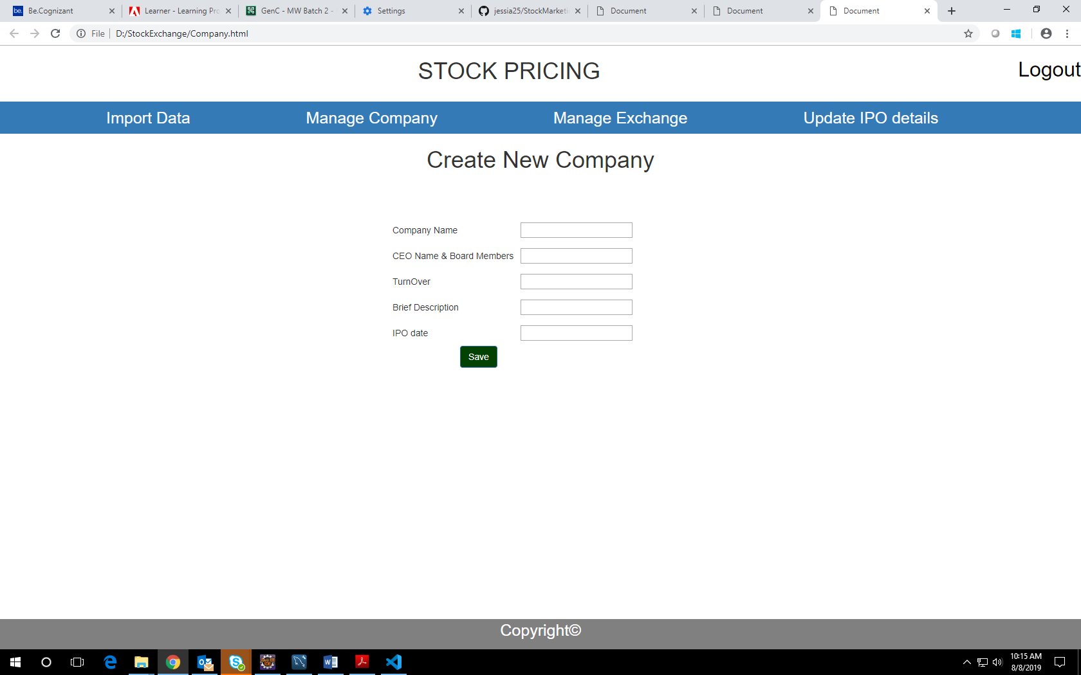

GITHUB LINK:

https://github.com/jessia25/StockPricing