ORIGINAL ON FILE IN THIS OFFICE

Oct 16 2025

REFERENCE ID: 2036456
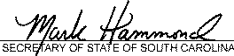

STATE OF SOUTH CAROLINA SECRETARY OF STATE

ARTICLES OF ORGANIZATION
Limited Liability Company - Domestic

Filing Date: 09/30/2025

The undersigned delivers the following articles of organization to form a South Carolina limited liability company pursuant to S.C. Code of Laws Section 33-44-202 and Section 33-44-203.

- The name of the limited liability company (Company ending must be included in name*)

I '"'·",_ "'

*Note: The name of the limited liability company must contain one of the following endings: "limited liability company" or "limited
company" or the abbreviation "L.L.C.", "LLC", "LC.", "LC", or "Ltd. Co."

- The address of the initial designated office of the limited liability company in South Carolina is 621 6th Ave S unit 152

(Street Address)
North Myrtle Beach• South Carolina 29682 (City. State. Zip Code)
- The initial agent for service of process is Jessica Hawk

(Name)

(Signature of Agent)

And the street address in South Carolina for this initial agent for service of process is: 621 6th Ave S. unit 152

(Street Address)
North Myrtle Beach South Carolina 29582

(City)
---(Z-ip C-od-e) -----

- List the name and address of each organizer. Only one organizer is required, but you may have more than one. (a)
Jessica Hawk

(Name)
621 6th Ave S unit 152

(Street Address)
North Myrtle Beach , South Carolina 29582 (City. State. Zip Code)

Form Revised by South Carolina Secretary of State, August 2016
SC Secretary of State Mark Hammond

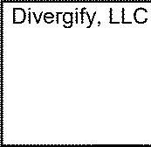
Name of Limited Liability Company
(b)

(Name)

(Street Address)

(City, State, Zip Code)

5, D Check this box only if the company is to be a term company, If the company is a term company, provide the term specified.
□

- Check this box only if management of the limited liability company is vested in a manager or managers. If this company is to be managed by managers, include the name and address of each initial manager.
(a)

(Name)

(Street Address)

(City, State, Zip Code)
(b)

(Name)

(Street Address)

(City, State, Zip Code)

- 0 Check this box only if one or more of the members of the company are to be liable for its debts and obligations under Section 33-44-303(c). If one or more members are so liable, specify which members, and for which debts, obligations or liabilities such members are liable in their capacity as members. This provision is optional and does
not have to be completed.

- Unless a delayed effective date is specified, these articles will be effective when endorsed for filing by the Secretary of State. Specify any delayed effective date and time _

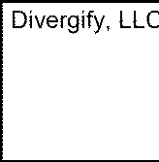
Name of Limited Liability Company

- Any other provisions not consistent with law which the organizers determine to include, including any provisions that are required or are permitted to be set forth in the limited liability company operating agreement may be included on a separate attachment. Please make reference to this section if you include a separate attachment.

- Each organizer listed under number 4 must sign.

Jessica Hawk: (Electronically Signed) Signature of Organizer
Date: 09/30/2025

Signature of Organizer

Date: _
REFERENCE n:Allticles of Organization of Divergify, LLC
J-\.flll,;ltf I - l'\lclflltt
The name of the limited liability company is: Divergify, LLC.

Article 2 - Designated Office
The street address of the initial designated office is:
621 6th Avenue South, Unit 152 North Myrtle Beach, SC 29582

Article 3 - Registered Agent
The name and street address of the initial registered agent for service of process are: Jessica Hawk
621 6th Avenue South, Unit 152 North Myrtle Beach, SC 29582

Article 4 - Management
The company is to be managed by its members.

Article 5 - Business Purpose
The purpose for which the company is organized is to engage in any lawful business for which a limited liability company may be organized under the laws of South Carolina.

Article 6 - Duration
The duration of the company shall be perpetual unless otherwise stated in the operating agreement.

Article 7 - Organizer
The name and address of the organizer are:
Jessica Hawk
621 6th Avenue South, Unit 152 North Myrtle Beach, SC 29582

Execution
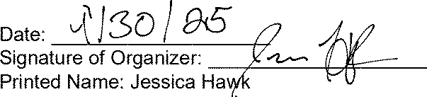
I certify that I am the person who executed these Articles of Organization, which are true under penalty of perjury.

