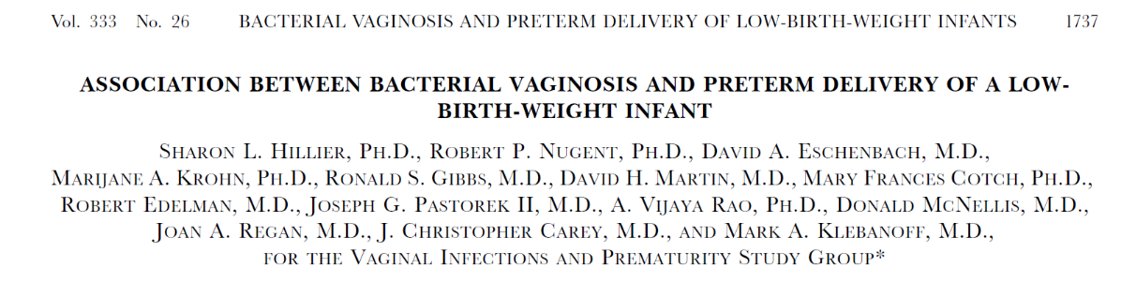

**Overview:**

* A total of 13,914 women were enrolled at seven medical centers between 1984 and 1989.
* Women were enrolled in the study during routine prenatal visits after 23-26 weeks of gestation had been completed
* Medical, obstetrical, sexual, and social history was taken and cultures of the vagina and cervix were obtained.

**Exclusion Criteria**

* Age less than 16 years
* Many other clinical exclusions:
  + Rh isoimmunization
  + Use of antibiotics in the preceding two weeks
  + Multiple gestation
  + Cervical cerclage
  + Prior use of tocolytic agents during the pregnancy
  + Hypertension requiring treatment with medication
  + Insulin dependent diabetes
  + Current use of corticosteroids
  + Chronic renal or symptomatic organic heart disease
  + Intention to deliver at a nonstudy hospital

**Definitions:**

* Estimates of gestational age were based on LMP. If the date was not considered accurate, the clinical examination, history, and/or ultrasound findings were used.
* Preterm delivery was defined as delivery at less than 37 weeks gestation.
* Low birth weight was defined as less than 2500 grams.

**Coding Guide:**



