Runtime environment: apache2.4.39 php7.2.9 mysql5.7.26

We adopt PHpstudy +VScode

**Step1**：download and install phpstudy into your directory

**Note**: The installation path must not contain "Chinese" or "space", otherwise an error will be reported

**Download link**: <https://www.xp.cn/download.html>

**Stept2**: start the WAMP service

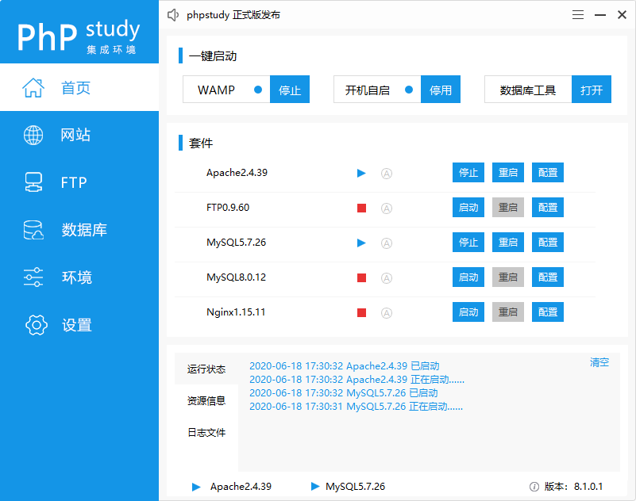

**Stept3**： Configure the required version of the service under the environment option

The required versions of this project are available：apache2.4.39 php7.2.9 mysql5.7.26

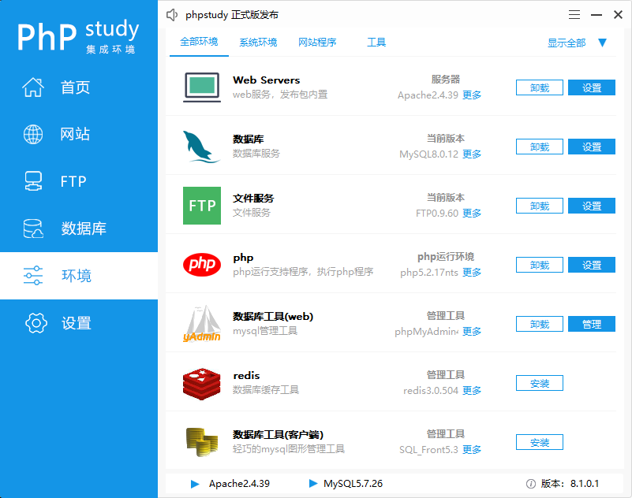

**Stept4**：Create a new site （under the site tab）

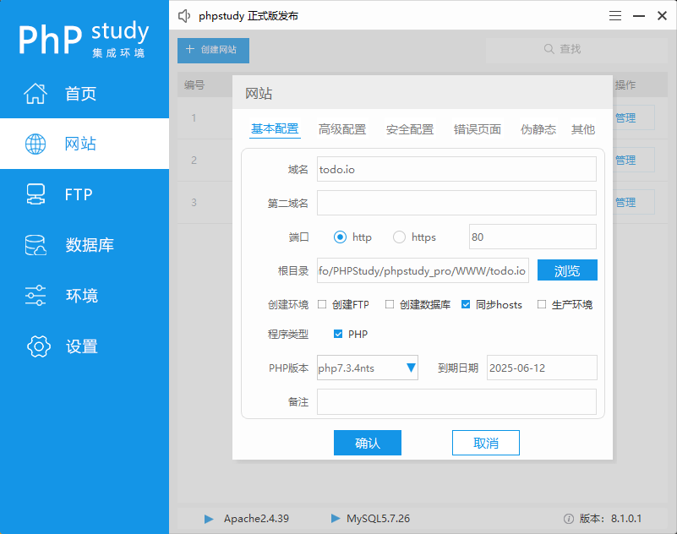

**Stept5**：Place all the files in the Code folder in the deployed root directory

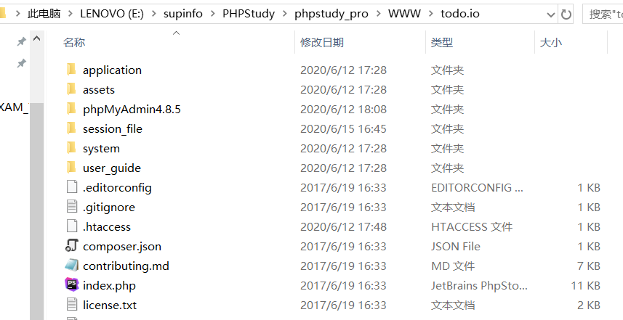

**Stept6**：Create new database todo（username：sroot；password：Supinf0）,

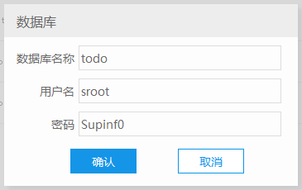

“操作”🡪“导入” (find “todo.sql” in “code” directory)

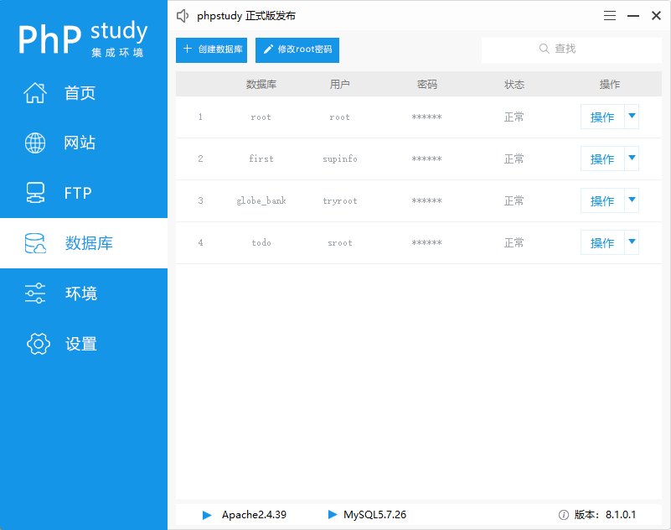

**Stept7**：Configure the following extensions

“网站”->todo.io->“管理”->“php拓展”

php_curl

php_fileinfo

php_gd2

php_gettext

php_mbstring

php_mysqli

php_openssl

php_pdo_mysql

php_pdo_pgsql

php_pdo_sqlite

php_pgsql

php_sockets

php_xmlrpc

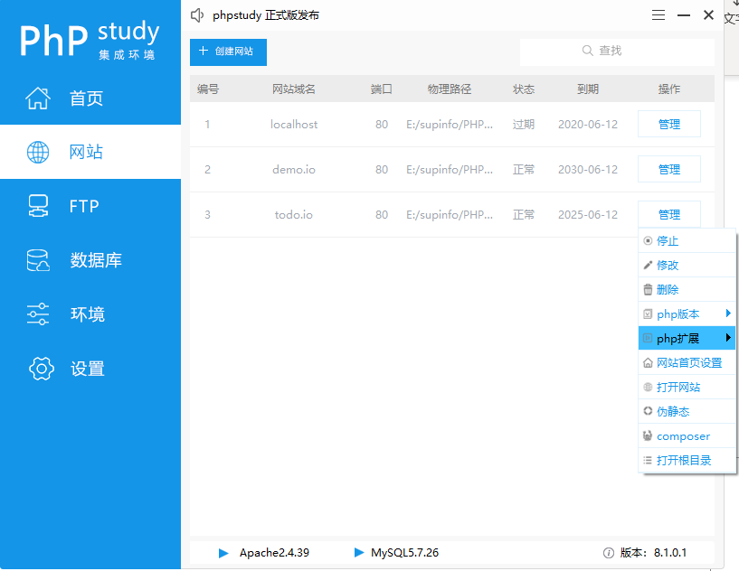

**Stept8**：Here ，username and password should be with appllication/config/database.php –> $db[‘default’]=array ( username and password setting ) keep same.

