面向对象分析与设计文档要求

1.内容及数量要求：
完整的用例模型
用例的规格说明书6个以上
顺序图6个以上
每个顺序图对应的协作图
活动图3个以上
状态图1个以上
类图1个以上(至少包括20个类）
组件图1个以上
部署图1个
源代码

2.电子稿，要求以“面向对象分析与设计”+姓名列表为邮件标题，将以下电子文档压缩到一个压缩文件中，以附件形式发送到5637839@qq.com邮箱。我收到会发送回复邮件，如果过几天还没有收到回复邮件，请重发。
- 分析与设计说明书，格式为WORD文档，里面内容包括项目背景以及分析和设计的各阶段模型截图以及用例的规格说明等。格式参考我要求的分析与设计说明书.doc
- ROSE中建立模型的原始文档，即.MDL文档。

3.打印稿,将WORD格式的分析与设计说明书一组打印一份上交。

4．WORD文档格式如下页：
注意：提交文档中，将以下格式中的说明文字删除掉。

面向对象分析与设计课程设计

题 目： 知乎APP模型
组员姓名： 20173943 朱妍佳 20173944左川玲

日期： 2019年 5月 7日
目 录

用例模型
- 知乎APP用例总图
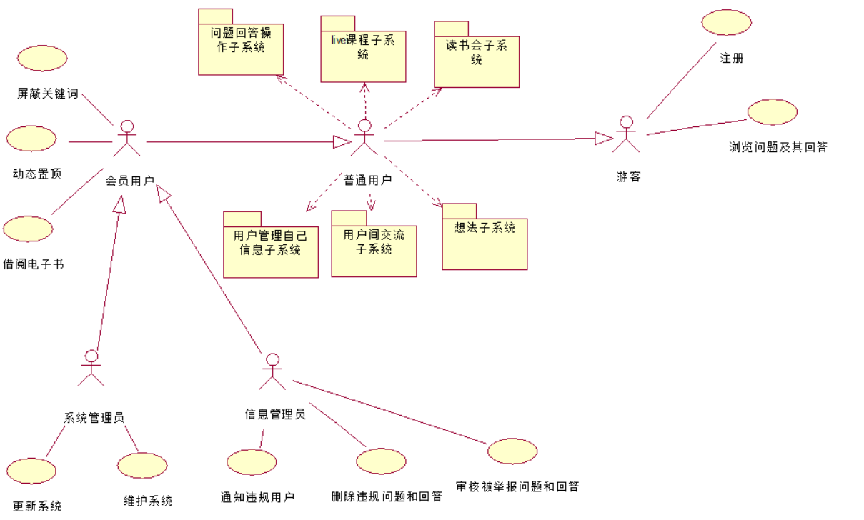
图1-
- 问题回答操作子系统
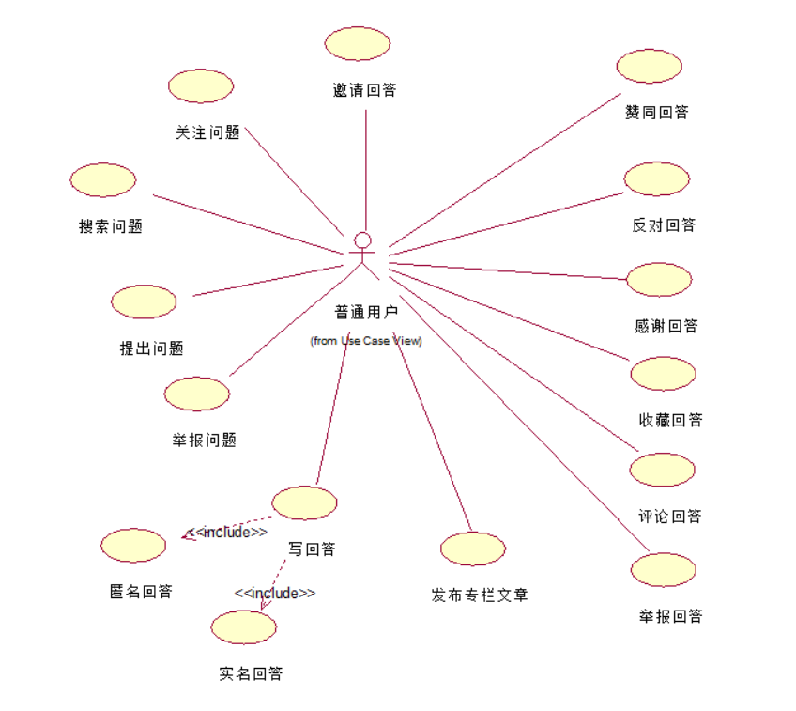
图1-
- Live课程子系统
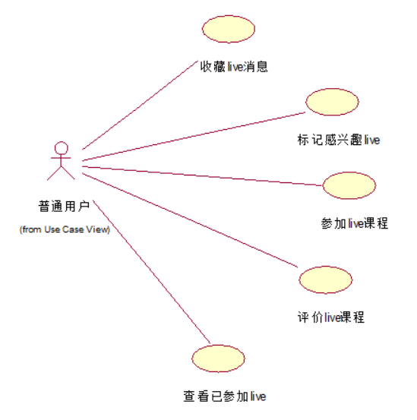
图1-
- 读书会子系统
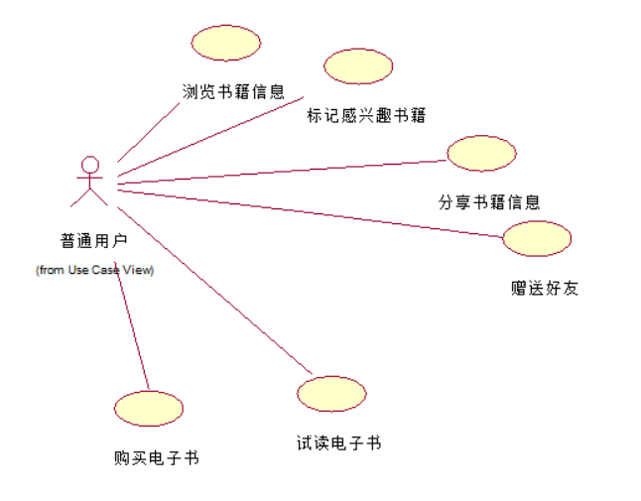
图1-
- 用户管理自己信息子系统
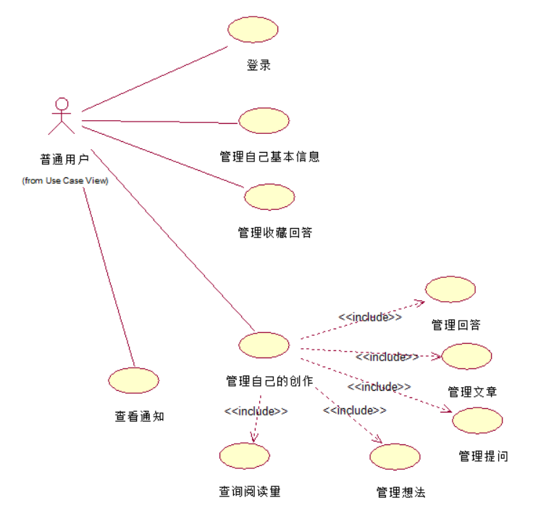
图1-
- 用户间交流子系统
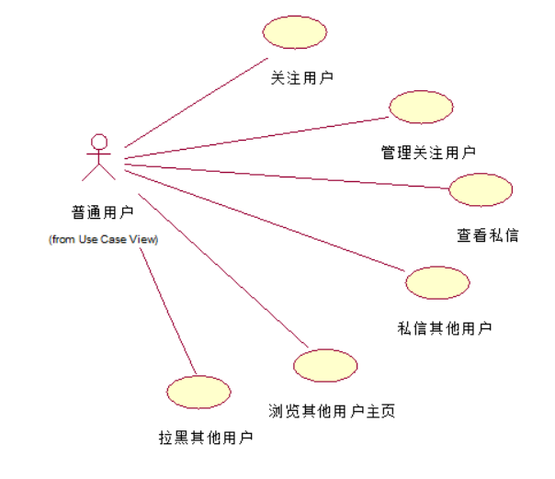
图1-
- 想法子系统
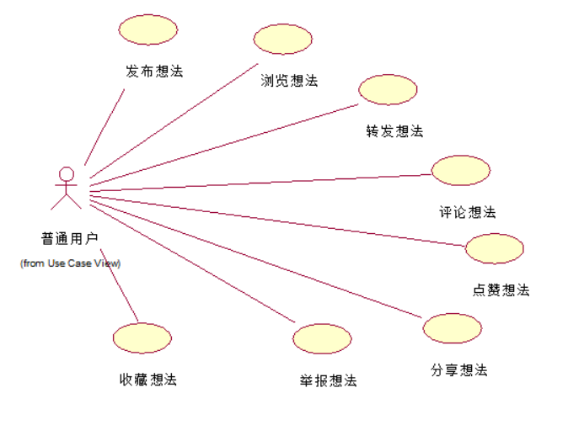
图1-

用例规格说明书
要求：6个
- 登录
- 拉黑其他用户
- 赞同回答
- 邀请回答
- 写回答
- 搜索问题
- 反对回答
- 评论想法

顺序图
- 登录顺序图
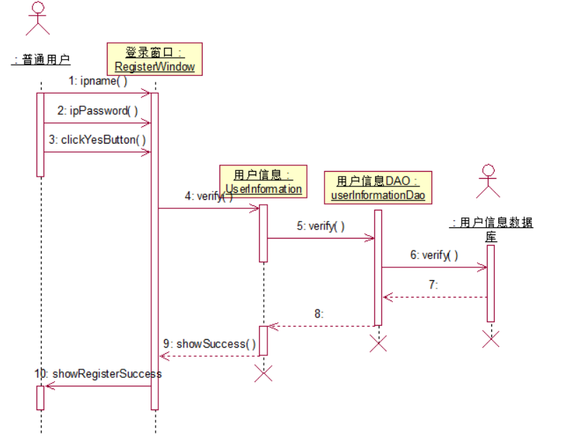
图3-
- 拉黑其他用户顺序图
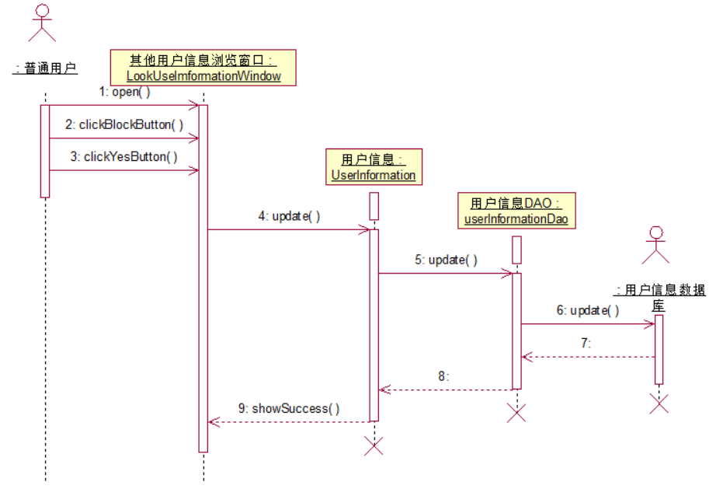
图3-
- 赞同回答顺序图
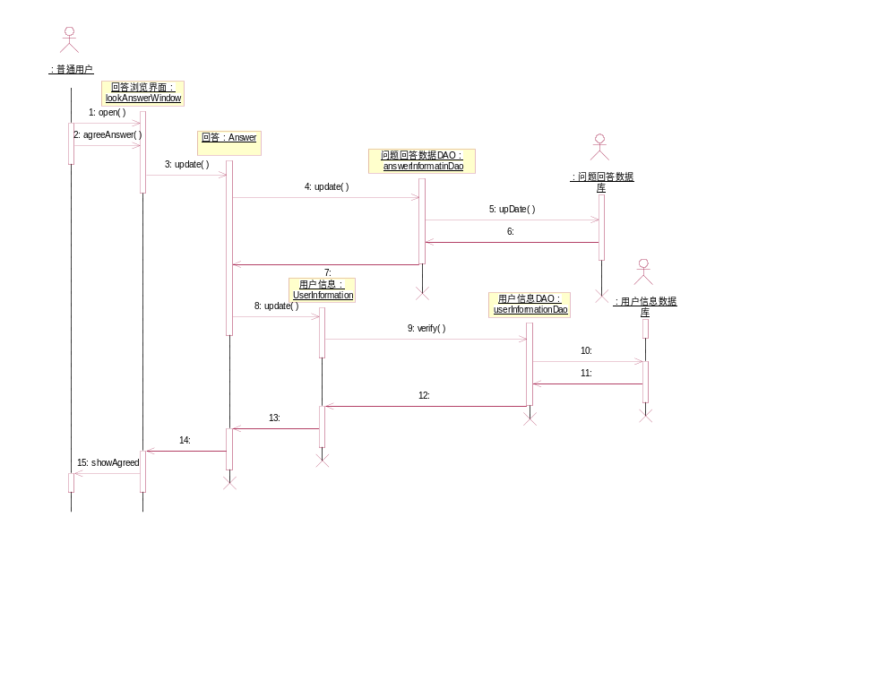
图3-
- 邀请回答顺序图
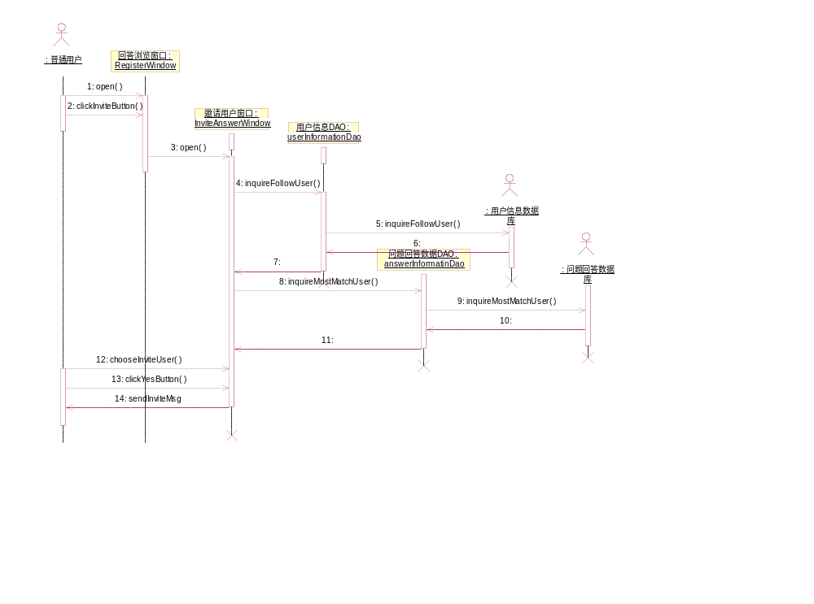
图3-
- 写回答顺序图
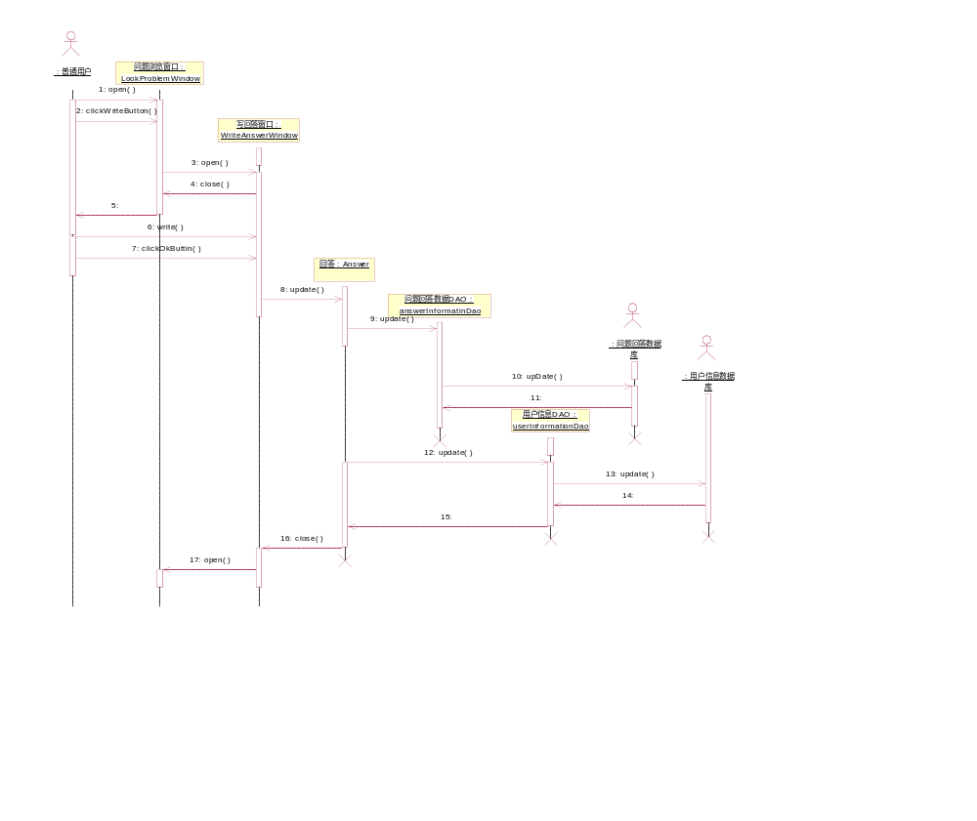
图3-
- 搜索问题顺序图
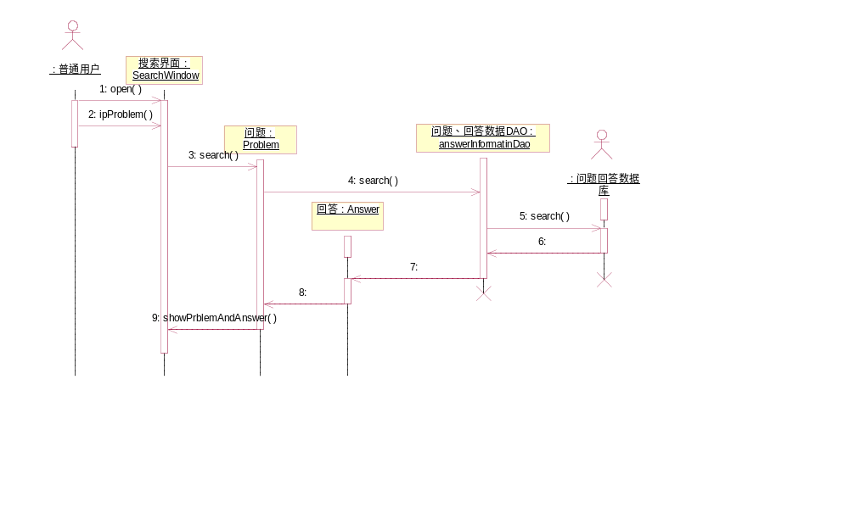
图3-
- 反对回答顺序图
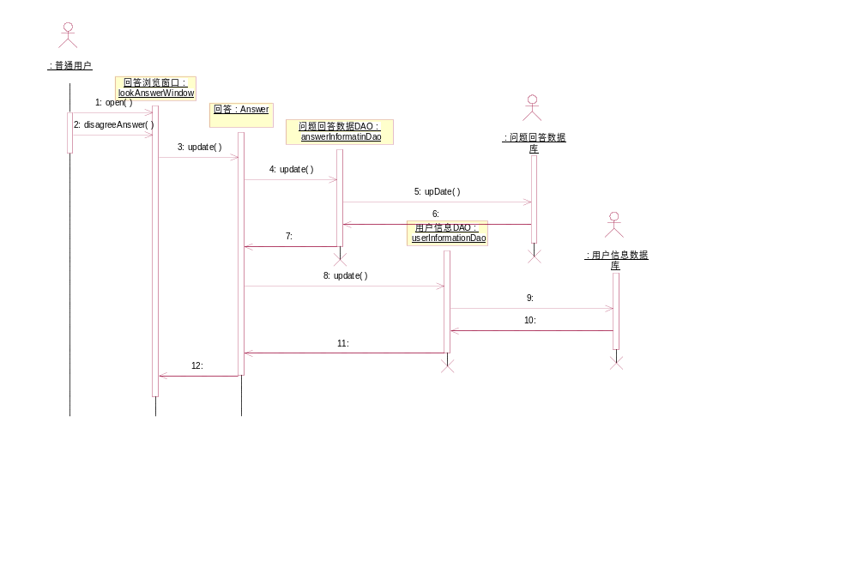
图3-
- 评论想法顺序图
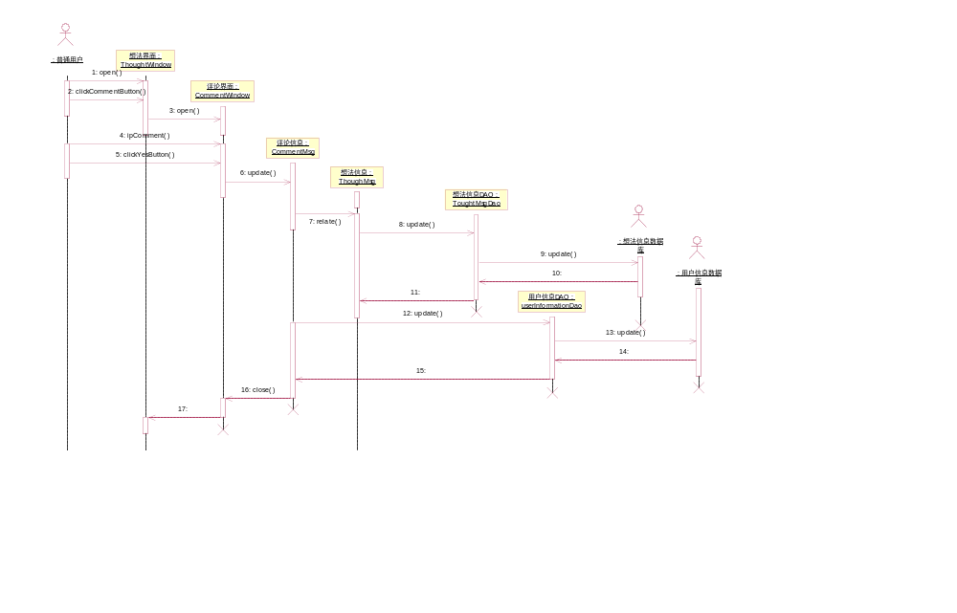
图3-

协作图
- 登录协作图
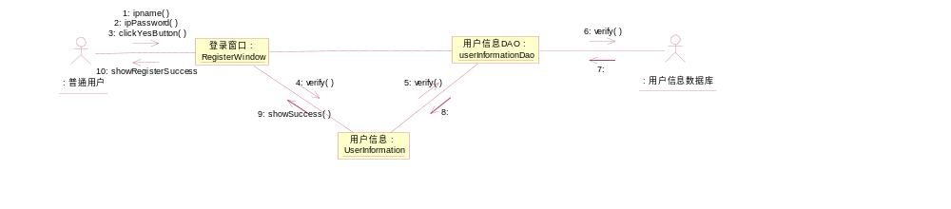
图4-
- 拉黑其他用户协作图
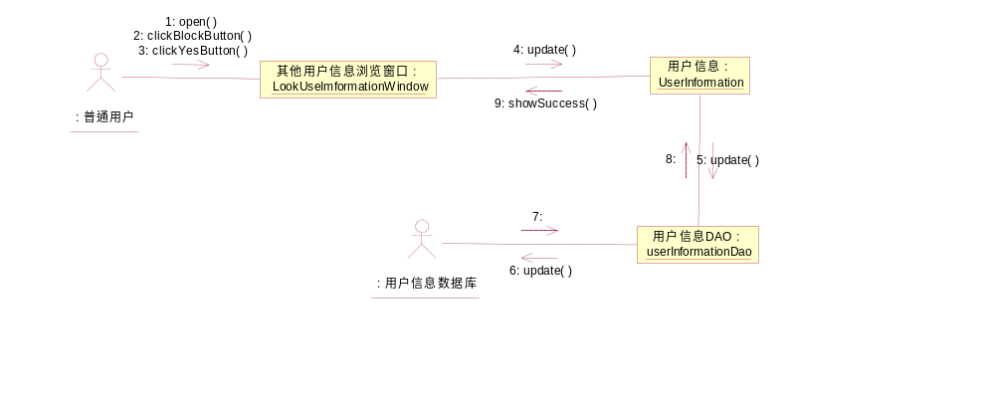
图4-
- 赞同回答协作图
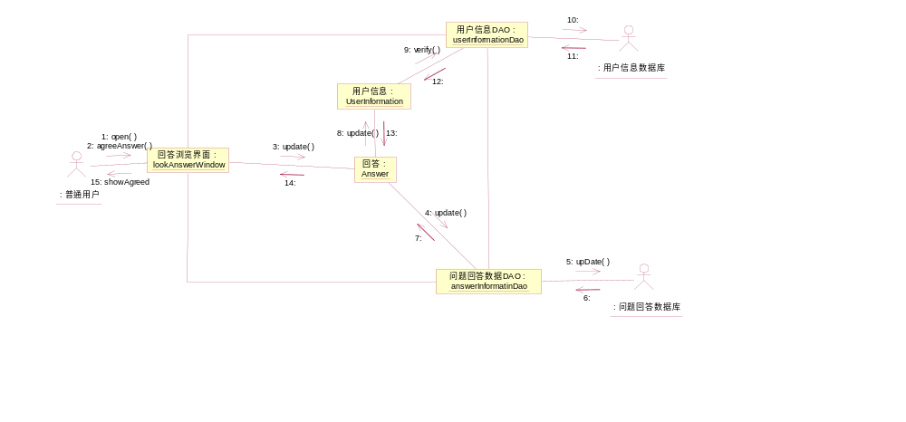
图4-
- 邀请回答协作图
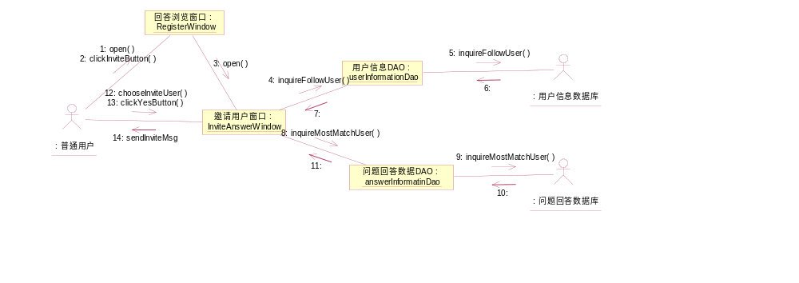
图4-
- 写回答协作图
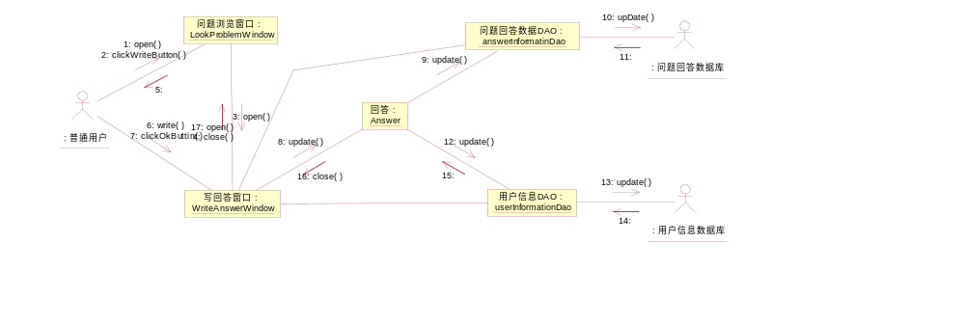
图4-
- 搜索问题协作图
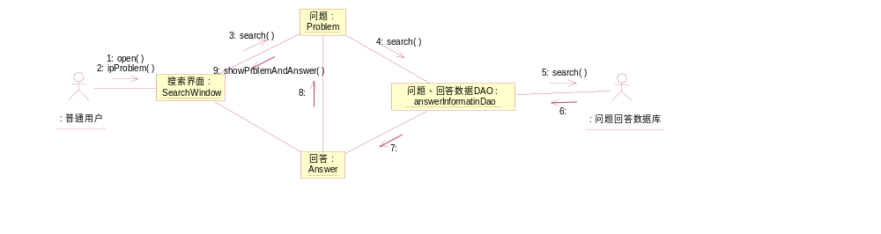
图4-
- 反对回答协作图
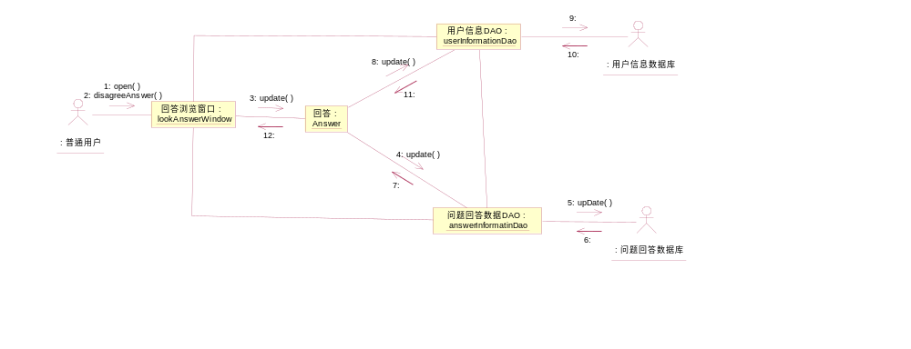
图4-
- 评论想法协作图
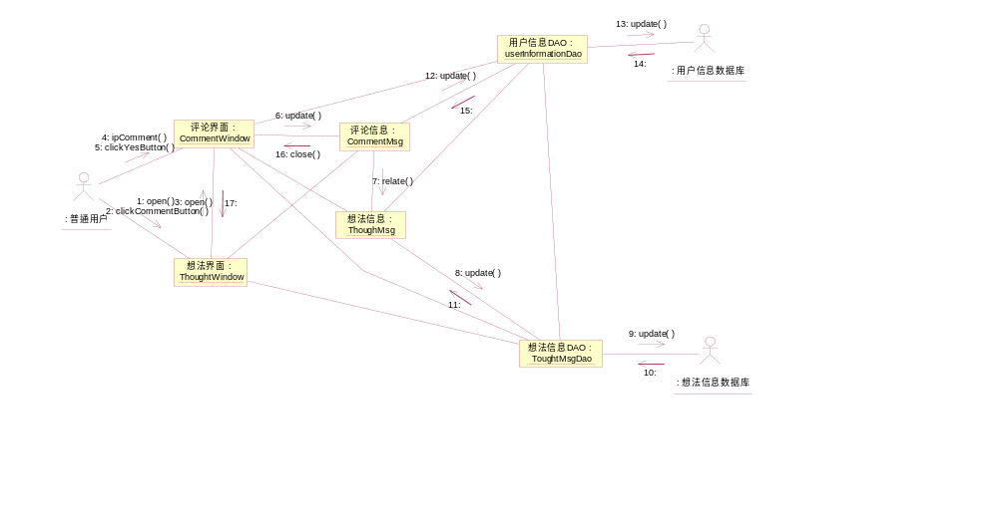
图4-

活动图
赞同回答活动图： 登录活动图：
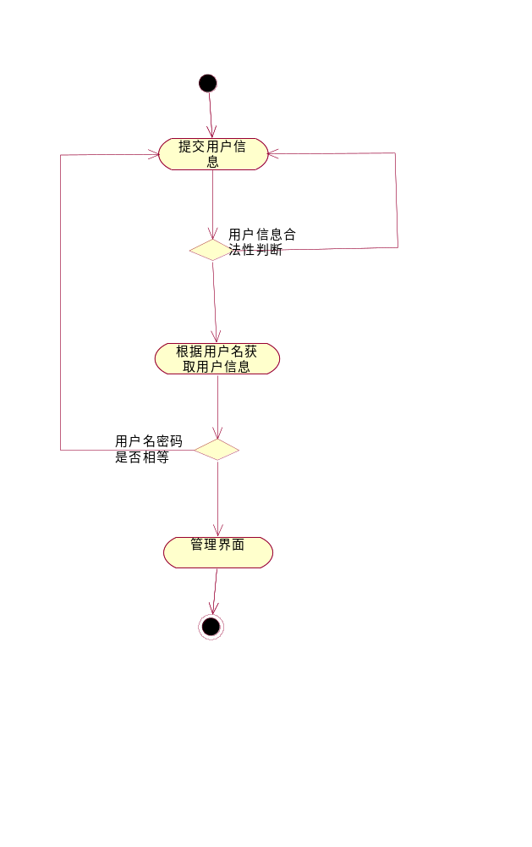
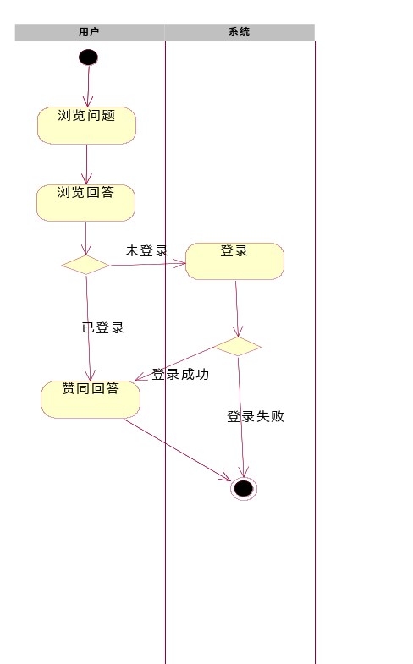
图5-1
图5-2

状态图
赞同回答状态图：
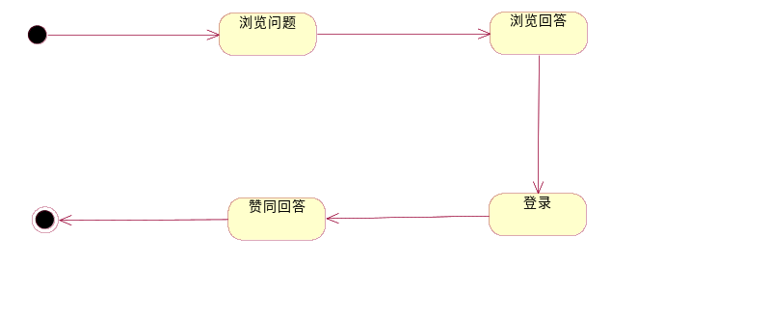

类图
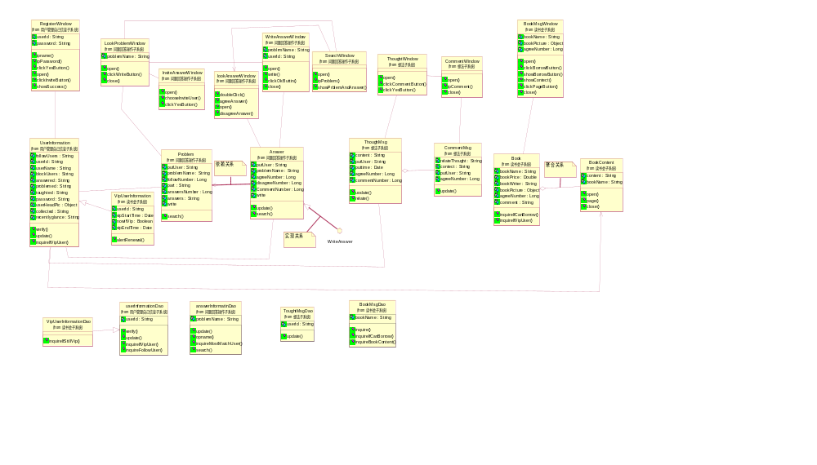
图7-

组件图
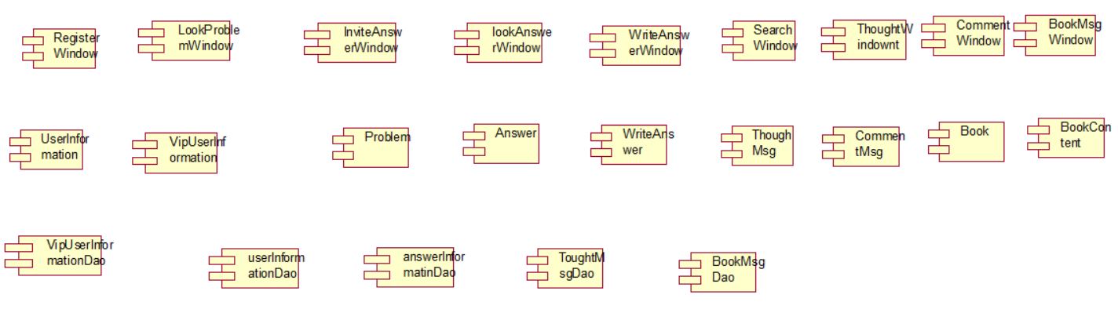
图8-

部署图
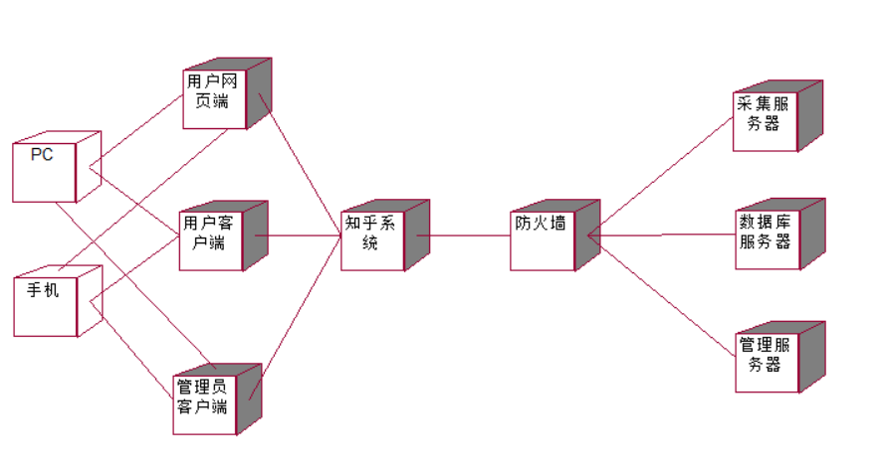
图9-

源代码
- 类名：Answer
  - 源代码文件名：Answer.java
  - 源代码：
public class Answer
{
private String putUser;
private String problemName;
private Long agreeNumber;
private Long disagreeNumber;
private Long CommentNumber;
private int write;
public UserInformation theUserInformation;
public lookAnswerWindow theLookAnswerWindow;
public WriteAnswerWindow theWriteAnswerWindow;

/**
* @roseuid 5CD19B840059
*/
public Answer()
{

}

/**
* @roseuid 5CCEF6A70393
*/
public void update()
{

}

/**
* @roseuid 5CCFB9BC0194
*/
public void search()
{

}
}
- 类名：answerInformatinDao
  - 源代码文件名：answerInformatinDao.java
  - 源代码：
public class answerInformatinDao
{
private String problemName;

/**
* @roseuid 5CD19B850317
*/
public answerInformatinDao()
{

}

/**
* @roseuid 5CADE0D00220
*/
public void update()
{

}

/**
* @roseuid 5CCED61601E2
*/
public void opname()
{

}

/**
* @return Object
* @roseuid 5CCED684007A
*/
public Object inquireMostMatchUser()
{
return null;
}

/**
* @roseuid 5CCFB9D0021C
*/
public void search()
{

}
}
- 类名：Book.
  - 源代码文件名：Book.java
  - 源代码：
public class Book
{
private String bookName;
private Double bookPrice;
private String bookWriter;
private Object bookPicture;
private Long agreeNumber;
private String comment;
public BookMsgWindow theBookMsgWindow;
public BookContent theBookContent;

/**
* @roseuid 5CD19B8403BC
*/
public Book()
{

}

/**
* @roseuid 5CCEFA4A001D
*/
public void inquireIfCanBorrow()
{

}

/**
* @roseuid 5CCEFB2300C4
*/
public void inquireIfVipUser()
{

}
}
- 类名：BookContent
  - 源代码文件名：BookContent.java
  - 源代码：
public class BookContent
{
private String content;
private String bookName;
public Book theBook;

/**
* @roseuid 5CD19B85009F
*/
public BookContent()
{

}

/**
* @roseuid 5CCECC3B00F8
*/
public void open()
{

}

/**
* @roseuid 5CCED0DB0032
*/
public void page()
{

}

/**
* @roseuid 5CD15CD70156
*/
public void close()
{

}
}
- 类名：BookMsgDao
  - 源代码文件名：BookMsgDao.java
  - 源代码：
public class BookMsgDao
{
private String bookName;

/**
* @roseuid 5CD19B8600E0
*/
public BookMsgDao()
{

}

/**
* @return String
* @roseuid 5CCEC9D6010C
*/
public String inquire()
{
return null;
}

/**
* @roseuid 5CCECA9803CD
*/
public void inquireIfCanBorrow()
{

}

/**
* @roseuid 5CCECD180163
*/
public void inquireBookContent()
{

}
}
- 类名：BookMsgWindow
  - 源代码文件名：BookMsgWindow.java
  - 源代码：
public class BookMsgWindow
{
private String bookName;
private Object bookPicture;
private Long agreeNumber;
public Book theBook;

/**
* @roseuid 5CD19B830072
*/
public BookMsgWindow()
{

}

/**
* @return Boolean
* @roseuid 5CCEC9B00275
*/
public Boolean open()
{
return null;
}

/**
* @return Boolean
* @roseuid 5CCECB010106
*/
public Boolean clickBorrowButton()
{
return null;
}

/**
* @roseuid 5CCECCDB002D
*/
public void showBorrowButton()
{

}

/**
* @return String
* @roseuid 5CD15DA003B9
*/
public String showContect()
{
return null;
}

/**
* @roseuid 5CD15DCB0293
*/
public void clickPageButton()
{

}

/**
* @roseuid 5CD15DF900D2
*/
public void close()
{

}
}
- 类名：CommentMsg
  - 源代码文件名：CommentMsg.java
  - 源代码：
public class CommentMsg
{
private String relateThought;
private String contect;
private String putUser;
private Long agreeNumber;
public ThoughMsg theThoughMsg;
public CommentWindow theCommentWindow;

/**
* @roseuid 5CD19B8402B0
*/
public CommentMsg()
{

}

/**
* @roseuid 5CCEF4380226
*/
public void update()
{

}
}
- 类名：CommentWindow
  - 源代码文件名：CommentWindow.java
  - 源代码：
public class CommentWindow
{
public ThoughtWindow theThoughtWindow;
public CommentMsg theCommentMsg;

/**
* @roseuid 5CD19B820380
*/
public CommentWindow()
{

}

/**
* @return Boolean
* @roseuid 5CCD46C40051
*/
public Boolean open()
{
return null;
}

/**
* @return String
* @roseuid 5CCD474A037C
*/
public String ipComment()
{
return null;
}

/**
* @roseuid 5CCEF5DD0104
*/
public void close()
{

}
}
- 类名：InviteAnswerWindow
  - 源代码文件名：InviteAnswerWindow.java
  - 源代码：
public class InviteAnswerWindow
{
public LookProblemWindow theLookProblemWindow;

/**
* @roseuid 5CD19B8102E9
*/
public InviteAnswerWindow()
{

}

/**
* @roseuid 5CCED4FD012B
*/
public void open()
{

}

/**
* @roseuid 5CCED5F102B1
*/
public void chooseInviteUser()
{

}

/**
* @roseuid 5CCED7C2027A
*/
public void clickYesButton()
{

}
}
- 类名：lookAnswerWindow
  - 源代码文件名：lookAnswerWindow.java
  - 源代码：
public class lookAnswerWindow
{
public Answer theAnswer;

/**
* @roseuid 5CD19B8103C2
*/
public lookAnswerWindow()
{

}

/**
* @roseuid 5CADDDC30368
*/
public void doubleClick()
{

}

/**
* @roseuid 5CADDFEB0281
*/
public void agreeAnswer()
{

}

/**
* @return Boolean
* @roseuid 5CCEB18F0091
*/
public Boolean open()
{
return null;
}

/**
* @return Boolean
* @roseuid 5CCEB234000A
*/
public Boolean disagreeAnswer()
{
return null;
}
}
- 类名：LookProblemWindow
  - 源代码文件名：LookProblemWindow.java
  - 源代码：
public class LookProblemWindow
{
private String problemName;
public SearchWindow theSearchWindow;
public InviteAnswerWindow theInviteAnswerWindow;
public WriteAnswerWindow theWriteAnswerWindow;
public Problem theProblem;

/**
* @roseuid 5CD19C510299
*/
public LookProblemWindow()
{

}

/**
* @return Boolean
* @roseuid 5CCEEA8D00A4
*/
public Boolean open()
{
return null;
}

/**
* @return Boolean
* @roseuid 5CCEEB5303E6
*/
public Boolean clickWriteButton()
{
return null;
}

/**
* @return Boolean
* @roseuid 5CCEECDB0334
*/
public Boolean close()
{
return null;
}
}
- 类名：Problem
  - 源代码文件名：Problem.java
  - 源代码：
public class Problem
{
private String putUser;
private String problemName;
private Long followNumber;
private String part;
private Long answersNumber;
private String answers;
private int write;
public UserInformation theUserInformation;
public LookProblemWindow theLookProblemWindow;

/**
* @roseuid 5CD1995100C3
*/
public Problem()
{

}

/**
* @roseuid 5CCFBB9F008F
*/
public void search()
{

}
}
- 类名：RegisterWindow
  - 源代码文件名：RegisterWindow.java
  - 源代码：
public class RegisterWindow
{
private String userId;
private String password;
public UserInformation theUserInformation;

/**
* @roseuid 5CD1981702FB
*/
public RegisterWindow()
{

}

/**
* @roseuid 5CA5B3000315
*/
public void ipname()
{

}

/**
* @return Boolean
* @roseuid 5CA5B3470066
*/
public Boolean ipPassword()
{
return null;
}

/**
* @return Boolean
* @roseuid 5CCD4C970048
*/
public Boolean clickYesButton()
{
return null;
}

/**
* @return Boolean
* @roseuid 5CCED4BC02D2
*/
public Boolean open()
{
return null;
}

/**
* @return Boolean
* @roseuid 5CCED4E70113
*/
public Boolean clickInviteButton()
{
return null;
}

/**
* @return String
* @roseuid 5CCEF08001BF
*/
public String showSuccess()
{
return null;
}
}
- 类名：ThoughMsg
  - 源代码文件名：ThoughMsg.java
  - 源代码：
public class ThoughMsg
{
private String content;
private String putUser;
private Date puttime;
private Long agreeNumber;
private Long commentNumber;
public UserInformation theUserInformation;
public ThoughtWindow theThoughtWindow;
public CommentMsg theCommentMsg;

/**
* @roseuid 5CD19B8401BE
*/
public ThoughMsg()
{

}

/**
* @roseuid 5CCEF2560175
*/
public void uodate()
{

}

/**
* @roseuid 5CCEF4620171
*/
public void relate()
{

}
}
- 类名：ThoughtWindow
  - 源代码文件名：ThoughtWindow.java
  - 源代码：
public class ThoughtWindow
{
public ThoughMsg theThoughMsg;
public CommentWindow theCommentWindow;

/**
* @roseuid 5CD19B820226
*/
public ThoughtWindow()
{

}

/**
* @return Boolean
* @roseuid 5CCD454D02F3
*/
public Boolean open()
{
return null;
}

/**
* @return Boolean
* @roseuid 5CCD4586002B
*/
public Boolean clickCommentButton()
{
return null;
}

/**
* @roseuid 5CCD47710348
*/
public void clickYesButton()
{

}
}
- 类名：ToughtMsgDao
  - 源代码文件名：ToughtMsgDao.java
  - 源代码：
public class ToughtMsgDao
{
private String userId;

/**
* @roseuid 5CD19B860066
*/
public ToughtMsgDao()
{

}

/**
* @roseuid 5CCECEF4011B
*/
public void update()
{

}
}
- 类名：UserInformation
  - 源代码文件名：UserInformation.java
  - 源代码：
public class UserInformation
{
private String followUsers;
private String userId;
private String userName;
private String blockUsers;
private String answered;
private String problemed;
private String toughted;
private String password;
private Object userHeadPic;
private String collected;
private String recentlyglance;
public RegisterWindow theRegisterWindow;
public ThoughMsg theThoughMsg;
public Problem theProblem;
public BookContent theBookContent;
public Answer theAnswer;

/**
* @roseuid 5CD19B8301DB
*/
public UserInformation()
{

}

/**
* @roseuid 5CCEF0250176
*/
public void verify()
{

}

/**
* @roseuid 5CCEF71403AC
*/
public void update()
{

}

/**
* @return Boolean
* @roseuid 5CD15B4302E8
*/
public Boolean inquireIfVipUser()
{
return null;
}
}
- 类名：userInformationDao
  - 源代码文件名：userInformationDao.java
  - 源代码：
public class userInformationDao
{
private String userId;

/**
* @roseuid 5CD19B850205
*/
public userInformationDao()
{

}

/**
* @return Boolean
* @roseuid 5CADD3EE0351
*/
public Boolean verify()
{
return null;
}

/**
* @roseuid 5CADE073007E
*/
public void update()
{

}

/**
* @return Boolean
* @roseuid 5CCECB2303DD
*/
public Boolean inquireIfVipUser()
{
return null;
}

/**
* @roseuid 5CCED50B01FA
*/
public void inquireFollowUser()
{

}
}
- 类名：VipUserInformation
  - 源代码文件名：VipUserInformation.java
  - 源代码：
public class VipUserInformation extends 用户管理自己信息子系统.UserInformation
{
private String userId;
private Date vipStartTime;
private Boolean nowifVip;
private Date vipEndTime;

/**
* @roseuid 5CD19B8302A9
*/
public VipUserInformation()
{

}

/**
* @roseuid 5CD15F2E00B0
*/
public void alertRenewal()
{

}
}
- 类名：VipUserInformationDao
  - 源代码文件名：VipUserInformationDao.java
  - 源代码：
public class VipUserInformationDao extends 用户管理自己信息子系统.userInformationDao
{

/**
* @roseuid 5CD19B85015F
*/
public VipUserInformationDao()
{

}

/**
* @return Boolean
* @roseuid 5CD15BF600CB
*/
public Boolean inquireIfStillVip()
{
return null;
}
}
- 类名：WriteAnswer
  - 源代码文件名：WriteAnswer.java
  - 源代码：
public interface WriteAnswer
{
private String content;
private Object wordType;

/**
* @roseuid 5CD261CB0299
*/
public void wrtie();

/**
* @return Boolean
* @roseuid 5CD261D30386
*/
public Boolean save();

/**
* @return Boolean
* @roseuid 5CD261D601C0
*/
public Boolean delete();

/**
* @return 问题回答操作子系统.Answer
* @roseuid 5CD261DA024C
*/
public 问题回答操作子系统.Answer change();
}
- 类名：WriteAnswerWindow
  - 源代码文件名：WriteAnswerWindow.java
  - 源代码：
public class WriteAnswerWindow
{
private String problrmName;
private String userId;
public LookProblemWindow theLookProblemWindow;
public Answer theAnswer;

/**
* @roseuid 5CD19B8200E1
*/
public WriteAnswerWindow()
{

}

/**
* @roseuid 5CCEEB9503A5
*/
public void open()
{

}

/**
* @roseuid 5CCEEBAE00F5
*/
public void write()
{

}

/**
* @roseuid 5CCEEBCF01EE
*/
public void clickOkButtin()
{

}

/**
* @roseuid 5CCEEC4100FF
*/
public void close()
{

}
}

课程心得及建议

