STA504 HW2 Jessica Choe

#1. Call libraries

library(tidyverse)

## Warning: package 'tidyverse' was built under R version 3.6.2

## -- Attaching packages --------------------------------------- tidyverse 1.3.0 --

## v ggplot2 3.2.1 v purrr 0.3.3  
## v tibble 2.1.3 v dplyr 0.8.3  
## v tidyr 1.0.2 v stringr 1.4.0  
## v readr 1.3.1 v forcats 0.4.0

## Warning: package 'tidyr' was built under R version 3.6.2

## Warning: package 'readr' was built under R version 3.6.2

## Warning: package 'purrr' was built under R version 3.6.2

## Warning: package 'forcats' was built under R version 3.6.2

## -- Conflicts ------------------------------------------ tidyverse_conflicts() --  
## x dplyr::filter() masks stats::filter()  
## x dplyr::lag() masks stats::lag()

library(ggplot2)  
library(dplyr)  
library(tidyr)  
library(readxl)

## Warning: package 'readxl' was built under R version 3.6.2

library(lubridate)

## Warning: package 'lubridate' was built under R version 3.6.2

##   
## Attaching package: 'lubridate'

## The following object is masked from 'package:base':  
##   
## date

library(stringr)  
library(ggthemes)

## Warning: package 'ggthemes' was built under R version 3.6.2

#2. Read in data and clean column name

#Read in columne name (second row) from the data  
col_names <- array(read_excel('C:/Users/user/Desktop/2020spring/504 data visualization/hw/hw2/US_Crude_Oil.xlsx', sheet = 'Sheet1', n_max = 1,skip=1, col_names = FALSE))

## New names:  
## * `` -> ...1  
## * `` -> ...2  
## * `` -> ...3  
## * `` -> ...4  
## * `` -> ...5  
## * ... and 5 more problems

#Read in the entire data except column name(from 4th row)  
oil <- data.frame(read_excel('C:/Users/user/Desktop/2020spring/504 data visualization/hw/hw2/US_Crude_oil.xlsx', sheet = 'Sheet1', skip = 3, col_names = FALSE))

## New names:  
## * `` -> ...1  
## * `` -> ...2  
## * `` -> ...3  
## * `` -> ...4  
## * `` -> ...5  
## * ... and 6 more problems

options(pillar.sigfig = 8)   
  
#insert the columne name into oil data.  
colnames(oil) <- col_names  
head(oil,2)

## Year-Month Week 1 NA Week 2 NA Week 3 NA Week 4  
## 1   1983-Jan 01/07  8,634    01/14  8,634    01/21  8,634    01/28   
## 2   1983-Feb 02/04  8,660    02/11  8,660    02/18  8,660    02/25   
## NA Week 5 NA  
## 1 8,634    <NA>      
## 2 8,660    <NA>

#Give names to columns with no name.  
names(oil)[3] <-"Wk1"  
names(oil)[5] <-"Wk2"  
names(oil)[7] <-"Wk3"  
names(oil)[9] <-"Wk4"  
names(oil)[11] <-"Wk5"  
head(oil,2)

## Year-Month Week 1 Wk1 Week 2 Wk2 Week 3 Wk3 Week 4  
## 1   1983-Jan 01/07  8,634    01/14  8,634    01/21  8,634    01/28   
## 2   1983-Feb 02/04  8,660    02/11  8,660    02/18  8,660    02/25   
## Wk4 Week 5 Wk5  
## 1 8,634    <NA>      
## 2 8,660    <NA>

#remove any unnecessary hidden dots in Year-Month column   
oil$`Year-Month`<-str_trim(oil$`Year-Month`)   
  
head(oil,5)

## Year-Month Week 1 Wk1 Week 2 Wk2 Week 3 Wk3 Week 4  
## 1 1983-Jan 01/07  8,634    01/14  8,634    01/21  8,634    01/28   
## 2 1983-Feb 02/04  8,660    02/11  8,660    02/18  8,660    02/25   
## 3 1983-Mar 03/04  8,677    03/11  8,677    03/18  8,677    03/25   
## 4 1983-Apr 04/01  8,677    04/08  8,686    04/15  8,686    <NA>  
## 5 1983-May <NA>     05/13  8,682    05/20  8,682    <NA>  
## Wk4 Week 5 Wk5  
## 1 8,634    <NA>      
## 2 8,660    <NA>      
## 3 8,677    <NA>      
## 4     04/29  8,686     
## 5     <NA>

#3. Create a tall table for “date”

# From wide to tall table for date.  
oil_date <-oil%>%   
 select(`Year-Month`,  
 `Week 1`,`Week 2`,`Week 3`,`Week 4`, `Week 5`)%>% gather(key="Week",value="Month-Date",2:6)   
  
head(oil_date)

## Year-Month Week Month-Date  
## 1 1983-Jan Week 1 01/07   
## 2 1983-Feb Week 1 02/04   
## 3 1983-Mar Week 1 03/04   
## 4 1983-Apr Week 1 04/01   
## 5 1983-May Week 1 <NA>  
## 6 1983-Jun Week 1 06/03

# remove any rows with NA from the tall table(oil_date).  
oil_date<-oil_date[complete.cases(oil_date), ]   
head(oil_date)

## Year-Month Week Month-Date  
## 1 1983-Jan Week 1 01/07   
## 2 1983-Feb Week 1 02/04   
## 3 1983-Mar Week 1 03/04   
## 4 1983-Apr Week 1 04/01   
## 6 1983-Jun Week 1 06/03   
## 7 1983-Jul Week 1 07/01

# Create date variable in POSIX format.  
date_long <- oil_date %>%  
 mutate(Year=str_sub(`Year-Month`,1,4),  
 Date.string = paste0(Year, "/",`Month-Date`))   
head(date_long)

## Year-Month Week Month-Date Year Date.string  
## 1 1983-Jan Week 1 01/07  1983 1983/01/07   
## 2 1983-Feb Week 1 02/04  1983 1983/02/04   
## 3 1983-Mar Week 1 03/04  1983 1983/03/04   
## 4 1983-Apr Week 1 04/01  1983 1983/04/01   
## 5 1983-Jun Week 1 06/03  1983 1983/06/03   
## 6 1983-Jul Week 1 07/01  1983 1983/07/01

#change the date in string format into POSIX format.  
date_long2 <- date_long %>%   
 mutate(Date = ymd(Date.string)) %>%  
 arrange(Date) %>%   
 select(`Year-Month`,Week,Date)  
  
head(date_long2,8)

## Year-Month Week Date  
## 1 1983-Jan Week 1 1983-01-07  
## 2 1983-Jan Week 2 1983-01-14  
## 3 1983-Jan Week 3 1983-01-21  
## 4 1983-Jan Week 4 1983-01-28  
## 5 1983-Feb Week 1 1983-02-04  
## 6 1983-Feb Week 2 1983-02-11  
## 7 1983-Feb Week 3 1983-02-18  
## 8 1983-Feb Week 4 1983-02-25

#4. Create a second tall table for “Production” and combine 2 tables together into one table

#Select weekly production amount variables together with Year-Month variable.  
production_tall<-oil%>%   
select(`Year-Month`,  
 `Wk1`,`Wk2`,`Wk3`,`Wk4`,`Wk5`)  
  
#Change the column names so that later we can combine the two tables with same value.  
colnames(production_tall)<-c("yearmonth","Week 1","Week 2","Week 3","Week 4","Week 5")  
head(production_tall)

## yearmonth Week 1 Week 2 Week 3 Week 4 Week 5  
## 1 1983-Jan 8,634    8,634    8,634    8,634         
## 2 1983-Feb 8,660    8,660    8,660    8,660         
## 3 1983-Mar 8,677    8,677    8,677    8,677         
## 4 1983-Apr 8,677    8,686    8,686        8,686     
## 5 1983-May     8,682    8,682             
## 6 1983-Jun 8,676    8,676    8,676    8,676

#From Wide to Tall format  
production_tall<-production_tall%>%   
 gather(key="production_wk",value="Production",2:6)   
head(production_tall,3)

## yearmonth production_wk Production  
## 1 1983-Jan Week 1 8,634     
## 2 1983-Feb Week 1 8,660     
## 3 1983-Mar Week 1 8,677

#Find white cells(empty-looking cells) with hidden character"   ", change it into NA, and then erase the row if it contains NA  
hidden_dots=production_tall[5,3]  
production_tall<-production_tall %>%  
 mutate_all(~ifelse(. %in% c("null",hidden_dots),NA,.)) %>%  
 na.omit()  
head(production_tall)

## yearmonth production_wk Production  
## 1 1983-Jan Week 1 8,634     
## 2 1983-Feb Week 1 8,660     
## 3 1983-Mar Week 1 8,677     
## 4 1983-Apr Week 1 8,677     
## 6 1983-Jun Week 1 8,676     
## 7 1983-Jul Week 1 8,676

#Combine two tables together.  
colnames(date_long2)

## [1] "Year-Month" "Week" "Date"

colnames(production_tall)

## [1] "yearmonth" "production_wk" "Production"

date_production<-date_long2 %>% inner_join(production_tall, by =c("Year-Month"="yearmonth","Week"="production_wk"))  
head(date_production)

## Year-Month Week Date Production  
## 1 1983-Jan Week 1 1983-01-07 8,634     
## 2 1983-Jan Week 2 1983-01-14 8,634     
## 3 1983-Jan Week 3 1983-01-21 8,634     
## 4 1983-Jan Week 4 1983-01-28 8,634     
## 5 1983-Feb Week 1 1983-02-04 8,660     
## 6 1983-Feb Week 2 1983-02-11 8,660

#remove whitespace and "," in Production column and then change its type in numeric   
head(date_production,2)

## Year-Month Week Date Production  
## 1 1983-Jan Week 1 1983-01-07 8,634     
## 2 1983-Jan Week 2 1983-01-14 8,634

date_production$Production<-str_trim(date_production$Production)   
date_production$Production<-as.numeric(gsub(",","",date_production$Production))  
  
#Show two columns only as final table.  
date_production_only<-select(date_production,Date,Production)  
head(date_production_only)

## Date Production  
## 1 1983-01-07 8634  
## 2 1983-01-14 8634  
## 3 1983-01-21 8634  
## 4 1983-01-28 8634  
## 5 1983-02-04 8660  
## 6 1983-02-11 8660

#5. Create 3 plots (Question 2) # Create first 2 plots using Weekly(Plot1) and Monthly(Plot2) data

#Plot 1. Weekly average production amount  
ggplot() +  
 geom_line(aes(x=Date,y=Production,color="Weekly"),  
 data=date_production,size=1)+  
 scale_y_continuous(label = scales::comma)+ labs(x="Year",y="Thousand Barrels Per Day",color="Computation Method",size=2)+  
 ggtitle("Weekly U.S. Production of Crude Oil",  
 subtitle="From Jan 7th 1983 to Feb 7th in 2020")+  
 theme_clean()+  
 theme(plot.title = element_text(size = 10,  
 hjust=0.5,face = "bold", color="navy"),  
 plot.subtitle=element_text(size=8, hjust=0.5, face="italic"),  
 legend.text=element_text(size=8),  
 legend.title=element_text(size=8))+  
 theme(legend.position= "bottom")

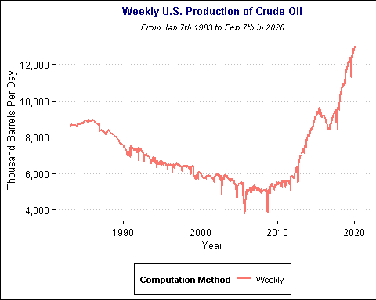

# Plot 2. Quarterly average production amount  
  
#Calculate average monthly production and create month format.(The first date of each month will represent each month itself.(example: 1983-01-01 means January 1983))  
monthly_production <-date_production %>%   
 group_by(`Year-Month`) %>% summarise(monthly_production=mean(Production))  
  
head(monthly_production)

## # A tibble: 6 x 2  
## `Year-Month` monthly_production  
## <chr> <dbl>  
## 1 1983-Apr 8683.75   
## 2 1983-Aug 8653   
## 3 1983-Dec 8612   
## 4 1983-Feb 8660   
## 5 1983-Jan 8634   
## 6 1983-Jul 8652.800

monthly_string <- monthly_production %>%  
 mutate(month.string = paste0(`Year-Month`,"-01"))   
monthly_production2 <-monthly_string %>% mutate(Month = ymd(`month.string`))  
head(monthly_production2)

## # A tibble: 6 x 4  
## `Year-Month` monthly_production month.string Month   
## <chr> <dbl> <chr> <date>   
## 1 1983-Apr 8683.75 1983-Apr-01 1983-04-01  
## 2 1983-Aug 8653 1983-Aug-01 1983-08-01  
## 3 1983-Dec 8612 1983-Dec-01 1983-12-01  
## 4 1983-Feb 8660 1983-Feb-01 1983-02-01  
## 5 1983-Jan 8634 1983-Jan-01 1983-01-01  
## 6 1983-Jul 8652.800 1983-Jul-01 1983-07-01

#Second plot (Monthly plot)  
  
ggplot()+  
 geom_line(aes(x=Month,y=monthly_production,  
 color="Monthly"),size=1,  
 data=monthly_production2)+  
 scale_y_continuous(label = scales::comma)+   
 labs(x="Year",y="Thousand Barrels Per Day",color="Computation Method",size=1)+  
 ggtitle("Monthly U.S. Production of Crude Oil",  
 subtitle="From Jan 7th 1983 to Feb 7th in 2020")+  
 theme_clean()+  
 theme(plot.title = element_text(size = 10,  
 hjust=0.5,face = "bold", color="navy"),  
 plot.subtitle=element_text(size=8, hjust=0.5, face="italic"),  
 legend.text=element_text(size=8),  
 legend.title=element_text(size=8))+  
 theme(legend.position= "bottom")

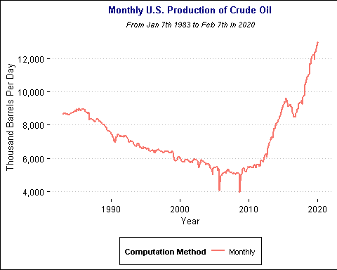

#6. Plot 3. Combined plot (Quarterly, Yearly)

#Categorize each month into the combination of year and quarter  
quarterly_production <- monthly_production2 %>%  
 mutate(Quarter=paste(year(Month),"-",quarter(Month)),  
 quarter.num=quarter(Month))%>%group_by(Quarter)  
  
# Change the order of quarter(1st/2nd/3rd/4th qt) into date format.  
# Example:3rd quarter->"-10-01"(oct 1st:First day of each Quarter)  
quarterly_production$quarter.num <-  
case_when(  
 quarterly_production$quarter.num==1 ~ "-01-01",  
 quarterly_production$quarter.num==2 ~ "-04-01",  
 quarterly_production$quarter.num==3 ~ "-07-01",  
 TRUE ~ "-10-01"  
)  
# Create a string format for Quarterly first date and change it into date format. Select necessary columns only.  
quarterly_production2<-quarterly_production %>% mutate(year.str=str_sub(Month,1,4)) %>% mutate(qt.str = paste0(year.str,quarter.num)) %>% mutate(Quarter.date = ymd(qt.str)) %>% select(Quarter.date, monthly_production)

## Adding missing grouping variables: `Quarter`

head(quarterly_production2,3)

## # A tibble: 3 x 3  
## # Groups: Quarter [3]  
## Quarter Quarter.date monthly_production  
## <chr> <date> <dbl>  
## 1 1983 - 2 1983-04-01 8683.75  
## 2 1983 - 3 1983-07-01 8653   
## 3 1983 - 4 1983-10-01 8612

#Calculate average of each quarter  
quarterly_mean<- quarterly_production2%>%group_by(Quarter.date) %>% summarise(Quarterly_Production=mean(monthly_production))  
  
date_production <-date_production%>%  
 select(Date,Production)  
names(quarterly_mean) <- c("Year","Production")  
names(date_production) <- names(quarterly_mean)  
Quarterly<-quarterly_mean  
Weekly<-date_production  
  
#Third plot for quartly and weekly  
ggplot()+  
 geom_line(aes(x=Year,y=Production,color="Quarterly"),  
 data=Quarterly,size=1,  
 alpha=1)+  
 geom_line(aes(x=Year,y=Production,color="Weekly"),  
 data=Weekly,size=0.3,  
 alpha=0.6)+   
 labs(x="Year",y="Thousand Barrels Per Day",color="Computation Method")+  
 theme(legend.position= "bottom")+  
 scale_y_continuous(label = scales::comma)+  
 ggtitle("Production of Crude Oil In the U.S.(Week/Quarter)",subtitle="From January in 1983 to February in 2020, Thousand Barrels Per Day")+  
 theme_clean()+  
 theme(plot.title = element_text(size = 10,hjust=0.5, color="navy"),  
 plot.subtitle=element_text(size=8, hjust=0.5,  
 face="italic", color="black"),  
 legend.text=element_text(size=7),  
 legend.title=element_text(size=7))+  
 theme(legend.position= "bottom")

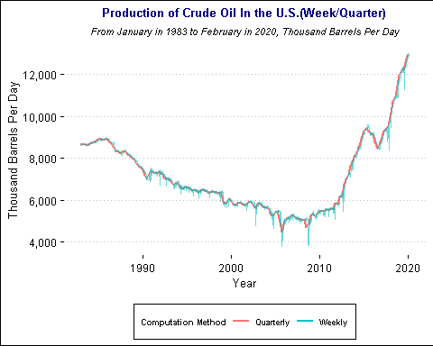

#Additional aesthetic feature: Letter face type(Italic), title location(center), a special theme(clean) added