1. See notebook

2. Top ten features with scores and RMSE:

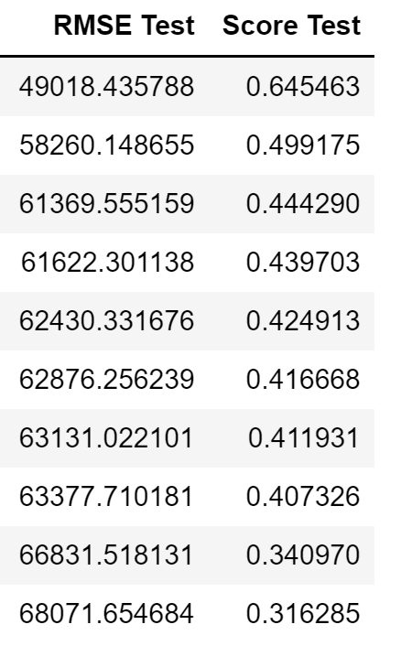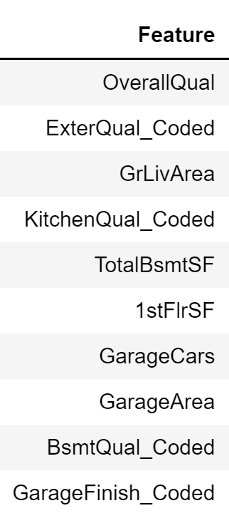

3. Top ten two-pair predictors with scores and RMSE:

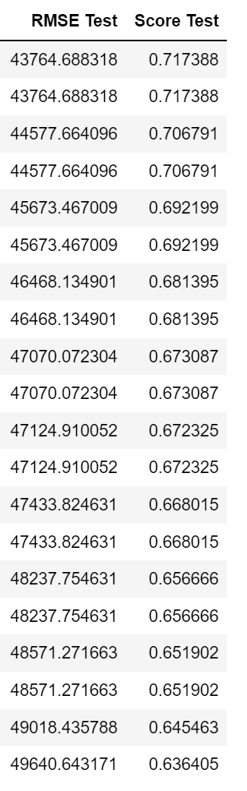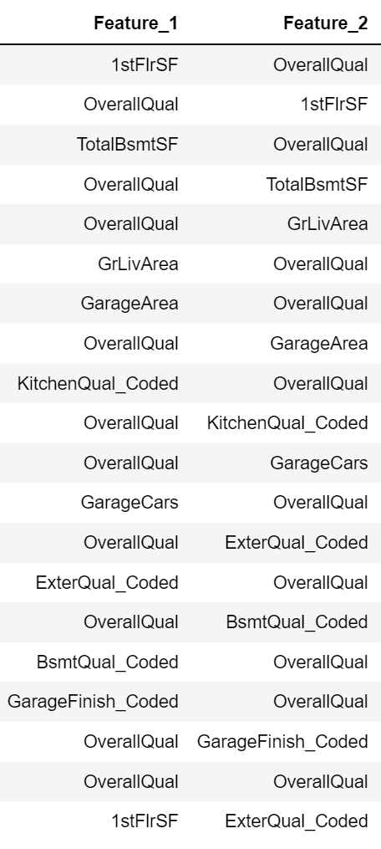



4. Single model with all features:

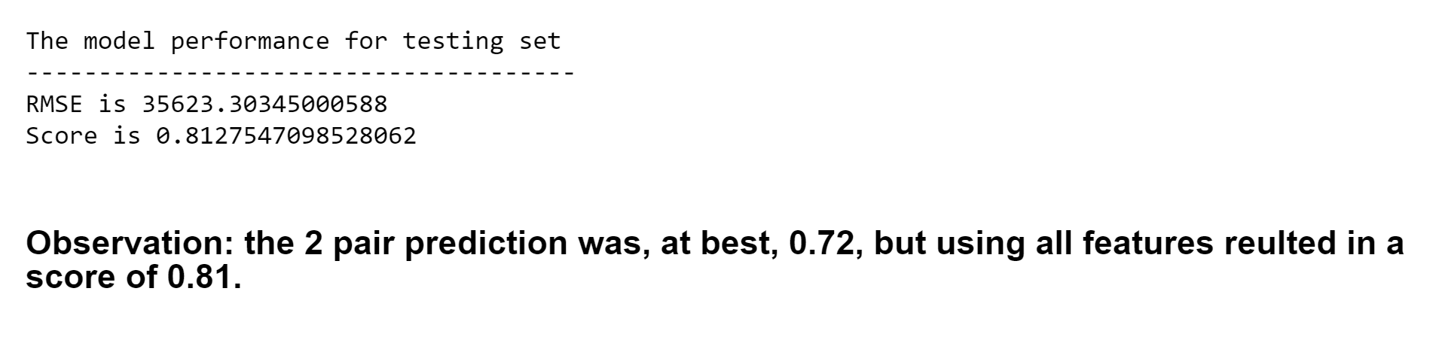

5. 5NN and 10NN

5NN:

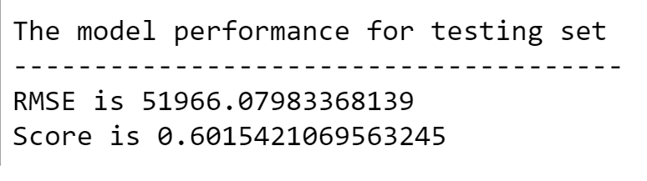

10NN

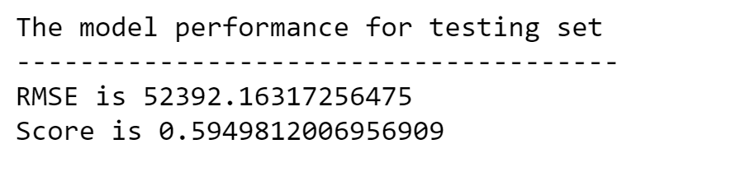

6. 