**Self Learning 1 – Web Programming**

**1. index.php (pada soal welcome.php)**

**2. register.php**

**3. registerProcess.php (validasi error input)**

**4. login.php**

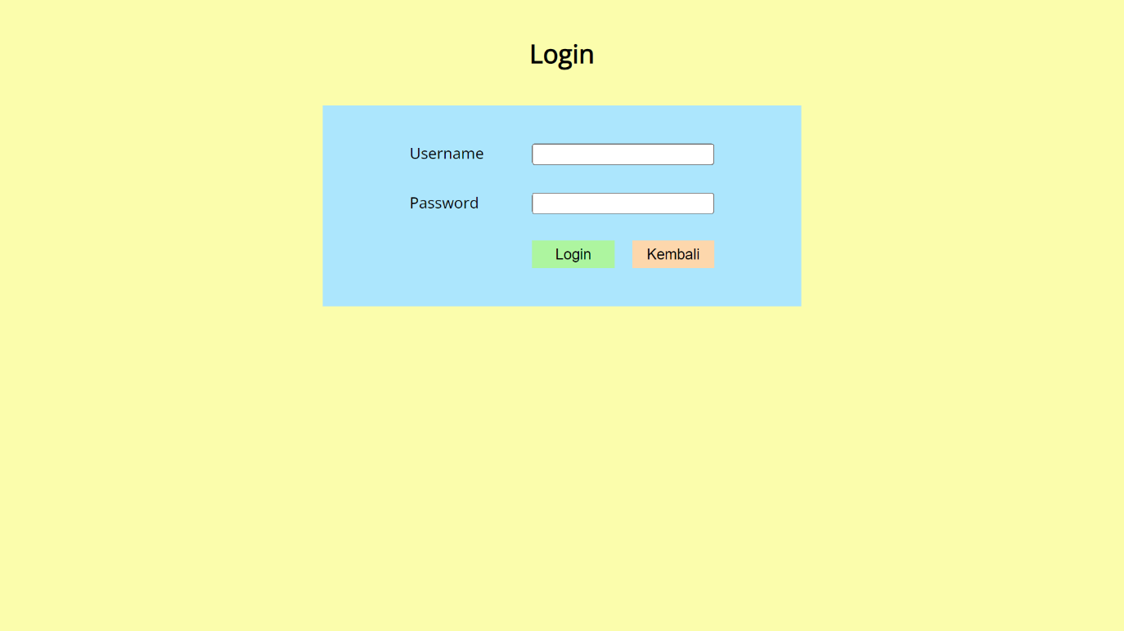

**5. loginProcess.php (validasi error input)**

**6. home.php**

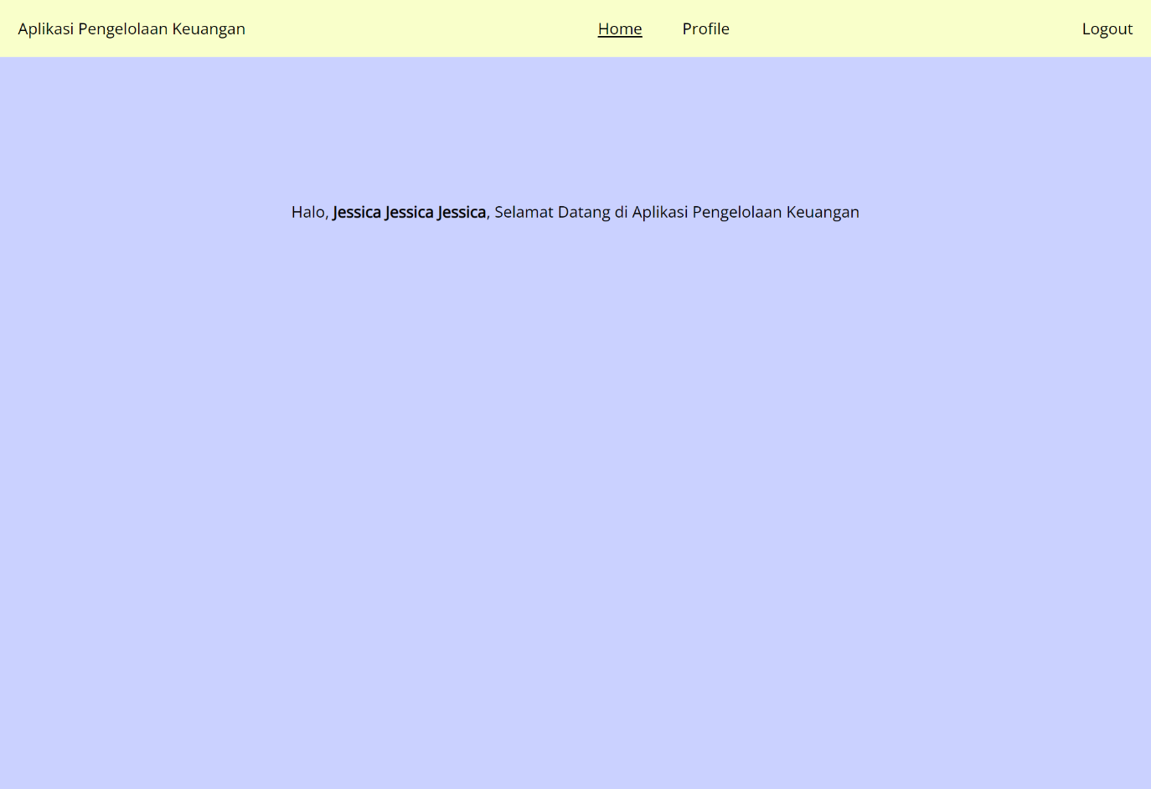

**7. profile.php**

