Homework1

library(alr4)

## Loading required package: car

## Loading required package: carData

## Loading required package: effects

## lattice theme set by effectsTheme()  
## See ?effectsTheme for details.

data("oldfaith")  
x<-oldfaith$Duration  
y<-oldfaith$Interval  
mod<-lm(y~x,data=oldfaith)  
summary(mod)

##   
## Call:  
## lm(formula = y ~ x, data = oldfaith)  
##   
## Residuals:  
## Min 1Q Median 3Q Max   
## -12.3337 -4.5250 0.0612 3.7683 16.9722   
##   
## Coefficients:  
## Estimate Std. Error t value Pr(>|t|)   
## (Intercept) 33.987808 1.181217 28.77 <2e-16 ***  
## x 0.176863 0.005352 33.05 <2e-16 ***  
## ---  
## Signif. codes: 0 '***' 0.001 '**' 0.01 '*' 0.05 '.' 0.1 ' ' 1  
##   
## Residual standard error: 6.004 on 268 degrees of freedom  
## Multiple R-squared: 0.8029, Adjusted R-squared: 0.8022   
## F-statistic: 1092 on 1 and 268 DF, p-value: < 2.2e-16

scatterplot(x,y)

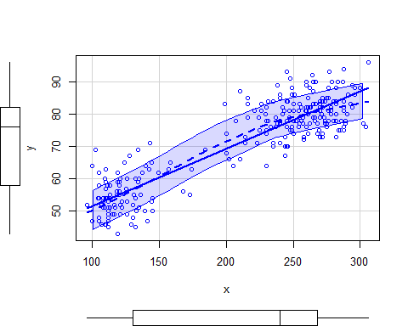

newy<-data.frame(x=c(250))  
predict(mod,newdata = newy, interval="prediction", level=0.95)

## fit lwr upr  
## 1 78.20354 66.35401 90.05307

playbill <- read.csv("playbill.csv")  
mod<- lm(playbill$CurrentWeek ~ playbill$LastWeek, data=playbill)

plot(playbill$CurrentWeek,playbill$LastWeek)  
abline(mod)

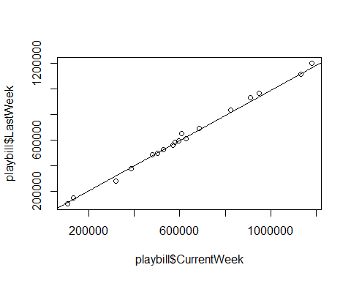

conflicts(mod)

## character(0)

summary(mod)

##   
## Call:  
## lm(formula = playbill$CurrentWeek ~ playbill$LastWeek, data = playbill)  
##   
## Residuals:  
## Min 1Q Median 3Q Max   
## -36926 -7525 -2581 7782 35443   
##   
## Coefficients:  
## Estimate Std. Error t value Pr(>|t|)   
## (Intercept) 6.805e+03 9.929e+03 0.685 0.503   
## playbill$LastWeek 9.821e-01 1.443e-02 68.071 <2e-16 ***  
## ---  
## Signif. codes: 0 '***' 0.001 '**' 0.01 '*' 0.05 '.' 0.1 ' ' 1  
##   
## Residual standard error: 18010 on 16 degrees of freedom  
## Multiple R-squared: 0.9966, Adjusted R-squared: 0.9963   
## F-statistic: 4634 on 1 and 16 DF, p-value: < 2.2e-16

newy<-data.frame(x=c(250))  
predict(mod,newdata = newy, interval="prediction", level=0.95)

## Warning: 'newdata' had 1 row but variables found have 18 rows

## fit lwr upr  
## 1 689780.7 650496.37 729065.0  
## 2 496833.1 457432.08 536234.1  
## 3 594655.3 555428.26 633882.3  
## 4 526320.1 486996.28 565643.9  
## 5 559681.4 520419.22 598943.6  
## 6 284515.9 243945.06 325086.8  
## 7 579532.2 540293.69 618770.7  
## 8 156899.3 115134.52 198664.2  
## 9 110608.9 68326.94 152890.9  
## 10 828766.8 789000.18 868533.5  
## 11 959610.5 918971.60 1000249.4  
## 12 646933.5 607702.61 686164.3  
## 13 378265.4 338341.68 418189.2  
## 14 1100362.4 1058361.92 1142362.9  
## 15 610044.5 570823.37 649265.6  
## 16 923894.2 883532.30 964256.1  
## 17 1187793.2 1144743.40 1230843.0  
## 18 486673.5 447240.93 526106.0