**Admin Dashboard with CSS Grid Layout and Theme Switching**

**Objective**

**Design and build a professional, responsive admin dashboard using:**

* **HTML & CSS Grid for layout**
* **JavaScript for theme switching (Light/Dark mode)**

**The dashboard features:**

* **A Header with dashboard title and theme toggle**
* **A Sidebar with navigation links (Home, Users, Settings)**
* **A Main Content Area for data or reports**
* **A Footer with copyright**

**Dashboard Layout Preview**

**Code Screenshot**

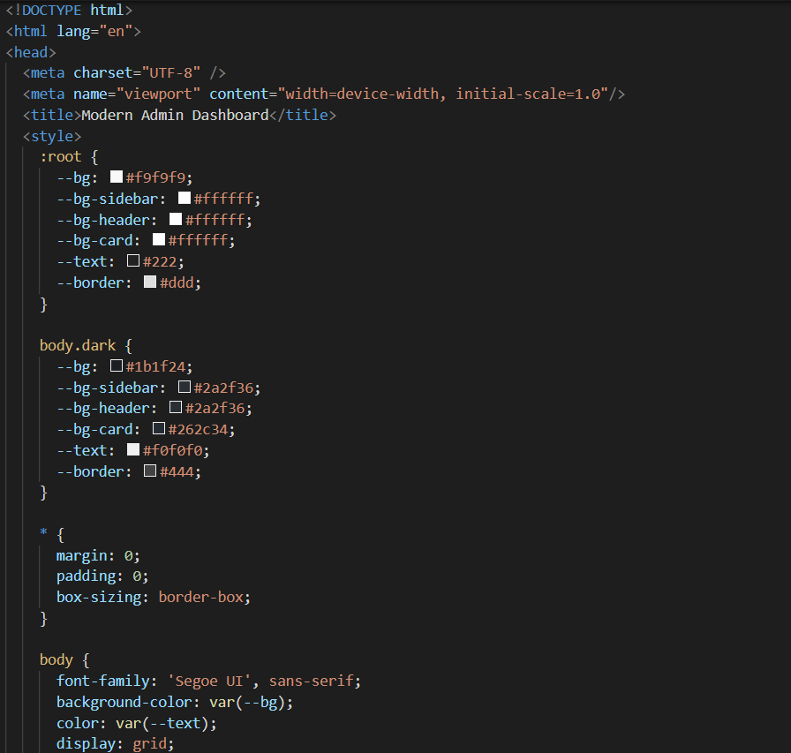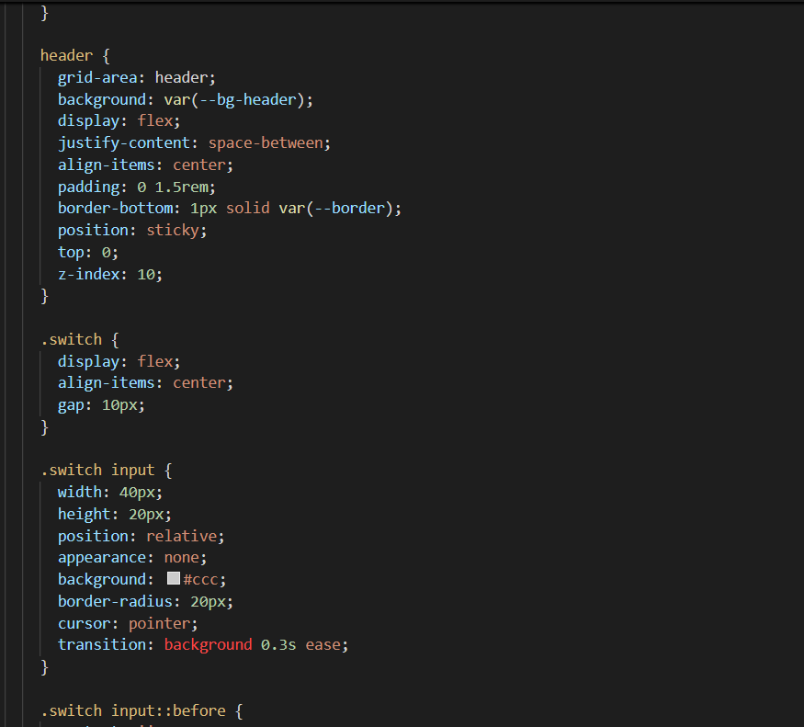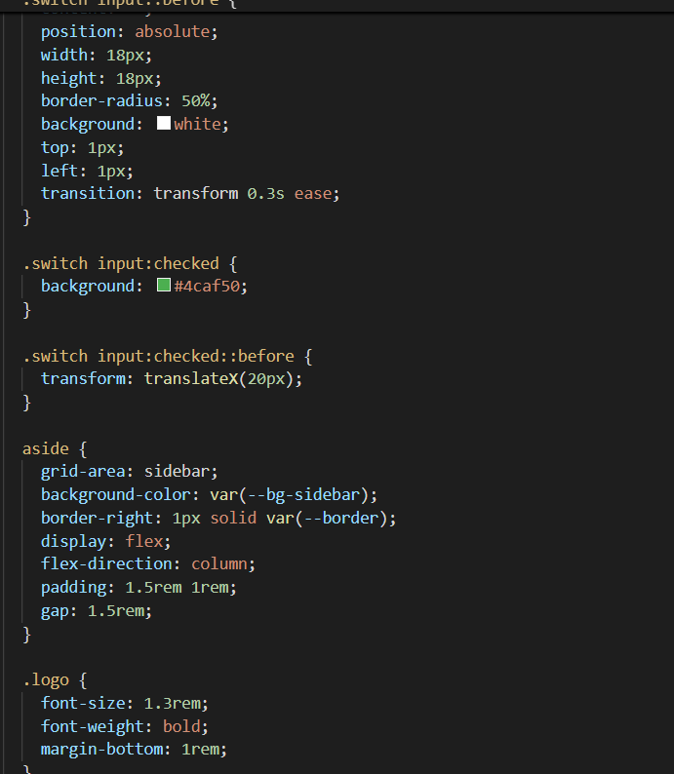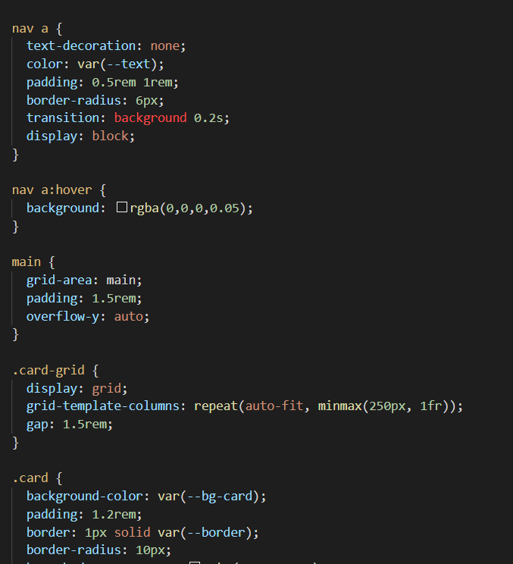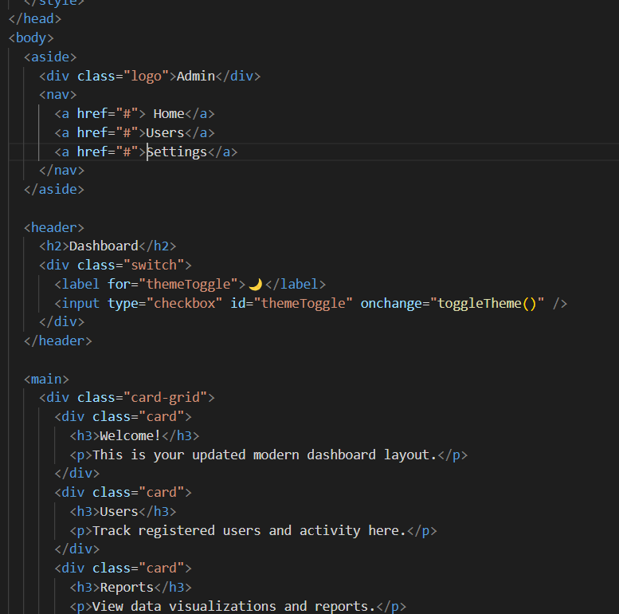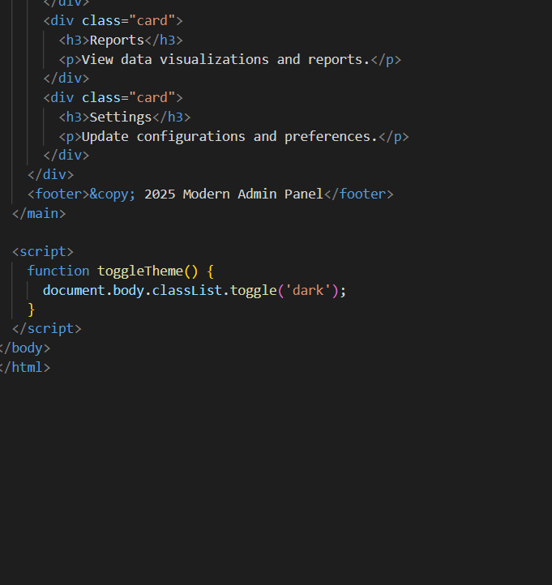

**Output Screenshot (Light Mode)**

**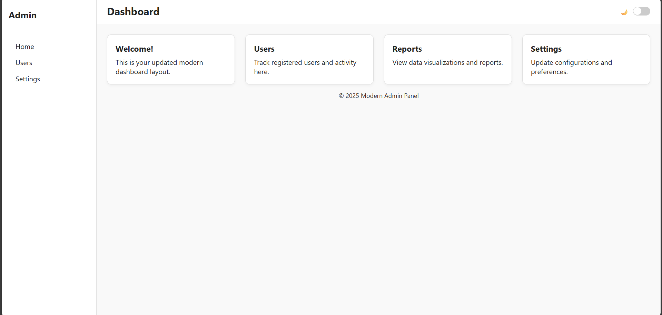  
Output Screenshot (Dark Mode)**

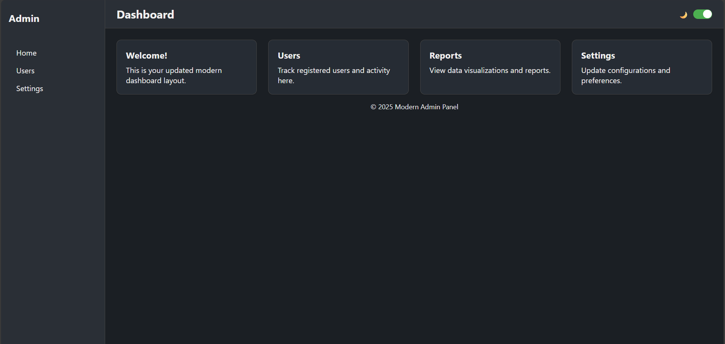

**Features**

* **CSS Grid layout for responsive UI**
* **Theme switch (Light/Dark) using JavaScript**
* **Dynamic theming without page reload**