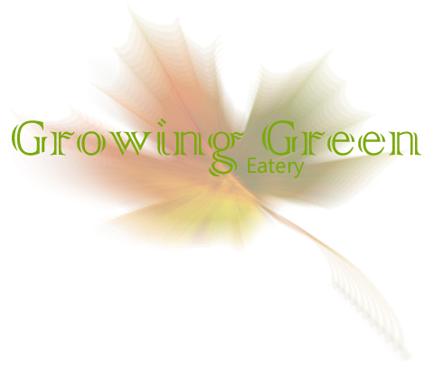

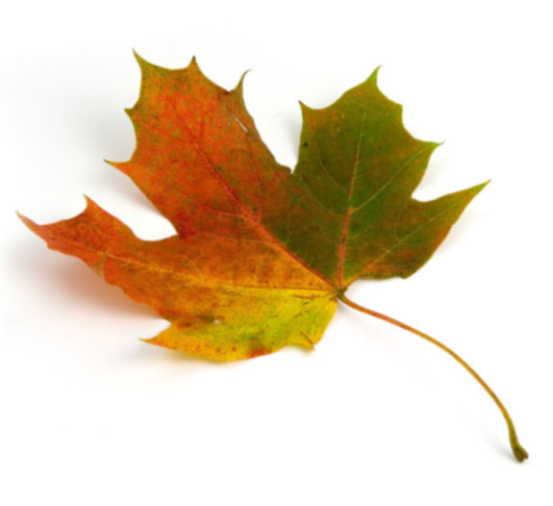
127 Vine Street
Willow Grove, Pennsylvania
Phone: 348-342-3454
Fax: 874-389-3455
Email: growinggreentogether@gmail.com

Attention all food lovers!

Attention Food Lovers!
Attention Food Lovers!
Growing Green is a restaurant that has its customer’s health at heart. With a greenhouse on site, our company guarantees our clients that they will be indulging in the highest quality foods available to them. Our home-grown produce results in organic, low calorie food which doesn’t just taste better, but is better for you.
We cater to everyone, regardless of your style of life or food preference. Vegan and vegetarian dishes are available, as well as children’s menus. There are also senior citizen’s specials on Sundays. Growing Green maintains a homey atmosphere which is perfect for family dinners or date nights. You may choose to be seated inside the restaurant in the air conditioning, or you may dine in the green house amongst the plants that we grow, and harvest for our dishes.
Our staff of experienced cooks and gardeners guarantees the highest quality food in both taste and health. The dining experience that you have at Growing Green will simply not compare to any other restaurant. Our restaurant is determined to make the world a greener place, one plate at a time.
Don’t just go green, grow green.

greenhouse on site, our company guarantees our clients that they will be indulging in the highest quality food available to them. Our home-grown produce results in organic, low calorie food which doesn’t just taste better, but is better for you.
Don’t just go green, grow green.

