

|  |
| --- |
| WEBSCRIPTING ASSIGNMENT: MILLIONAIRE GAME |
|  |
| FEBRUARY 9 2023  Tolbize Anne-lou  2203_24299  BWT/22A/FT |

# INTRODUCTION

|  |
| --- |
| The millionaire game The goal of the assignment is to create a millionaire game that can be run online. |

# THE FUNCTIONALITIES

The login functionalities.

1. Registration

First name and last name.

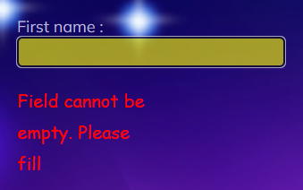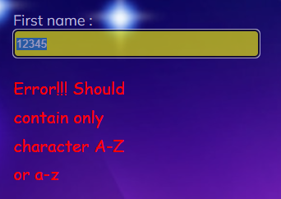

Codes

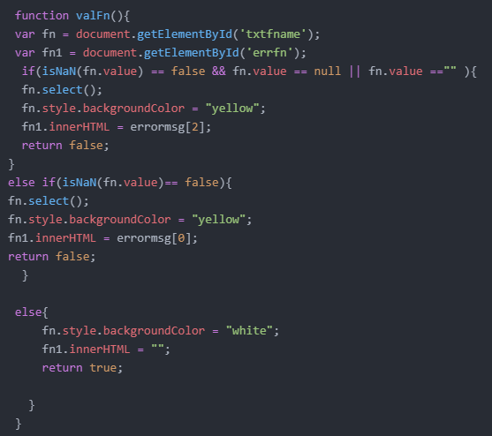

1. NIC

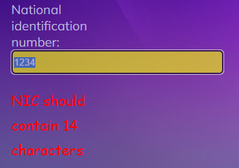

Codes

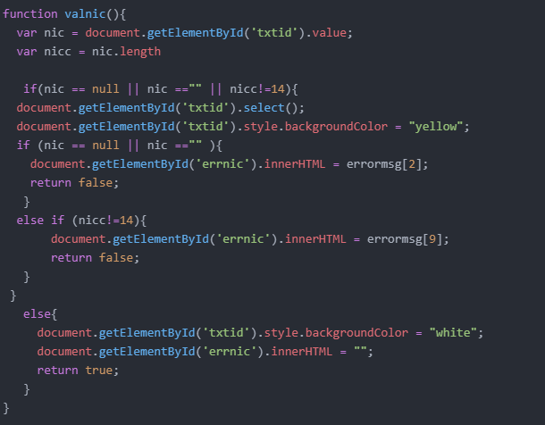

3.Phone number

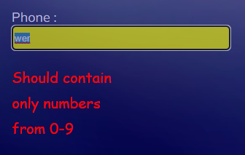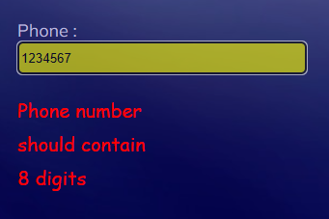

Code

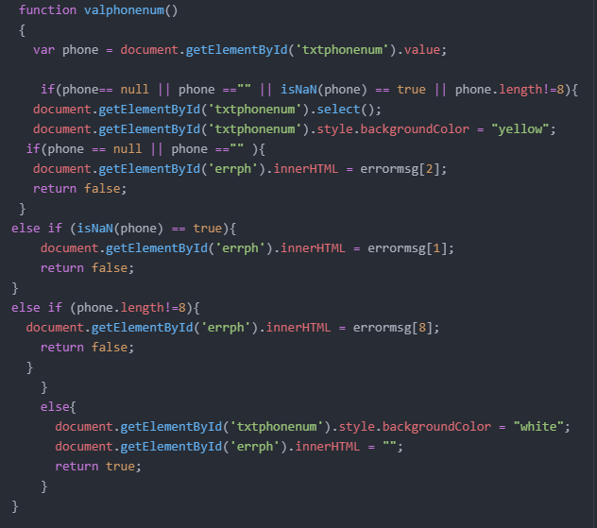

1. State hide when player choose Mauritius.

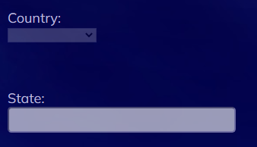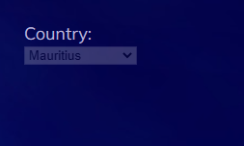

Code

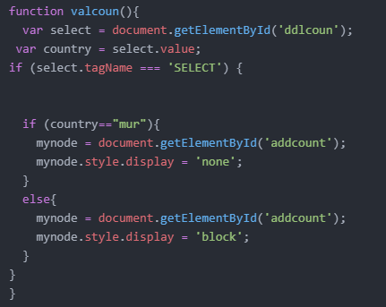

1. Email

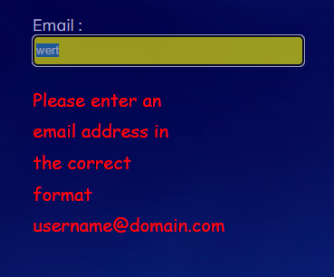

Codes

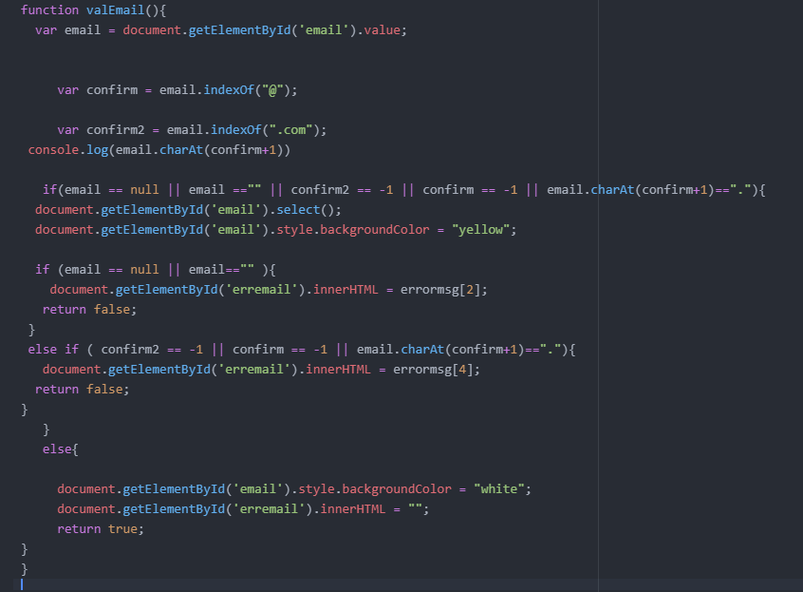

5.Password

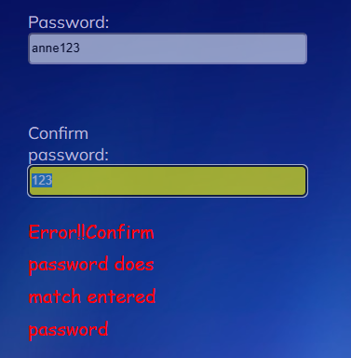

Codes

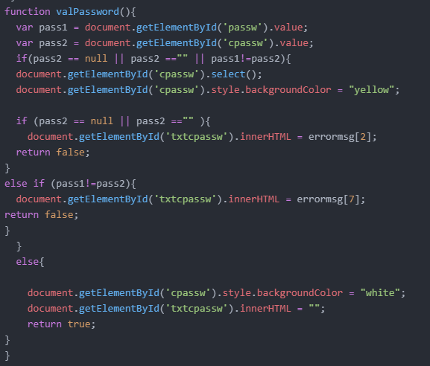

7.Captcha

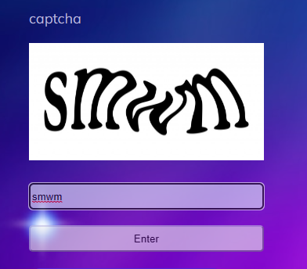

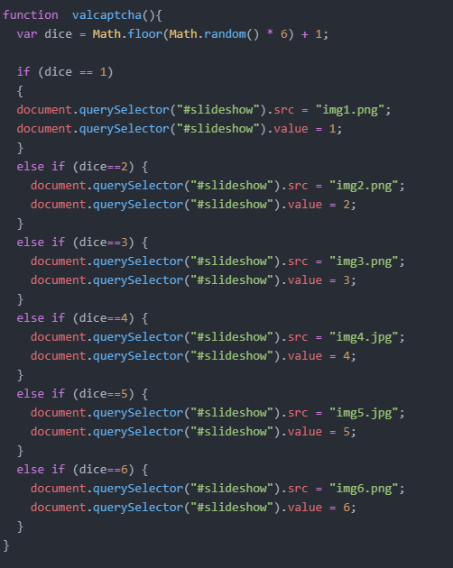

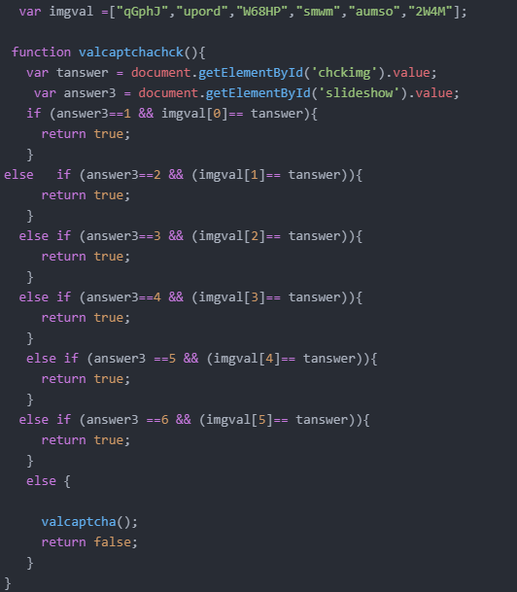

6.Username

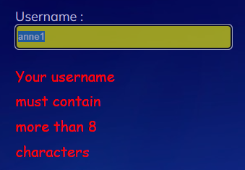

Codes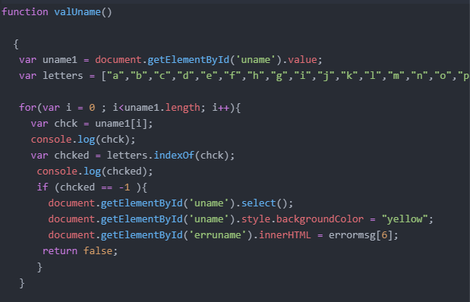

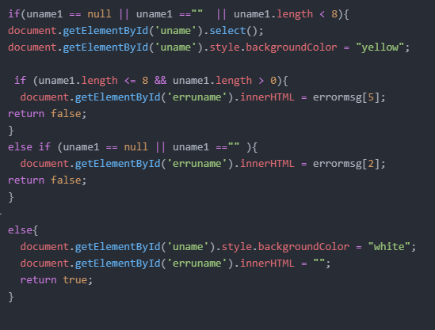

9. reset

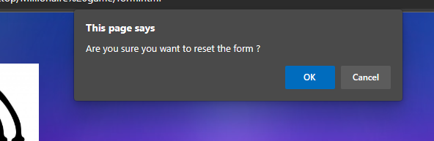

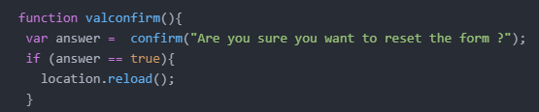

# The Game Functionalities

1.The MCQ’s will be comprised of four answers, with only one possible correct

**Answer.**

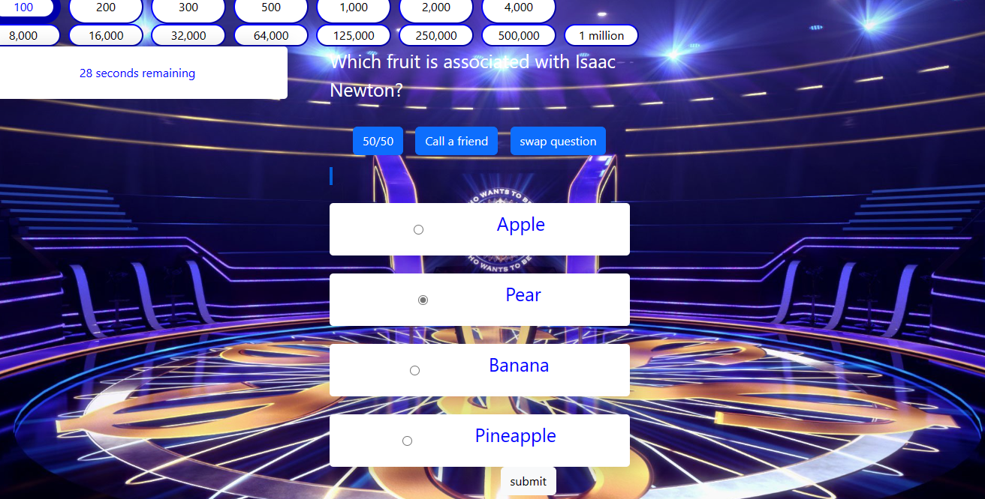

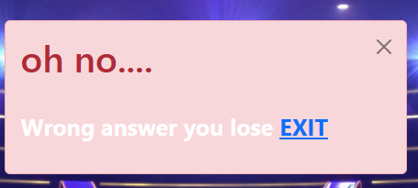

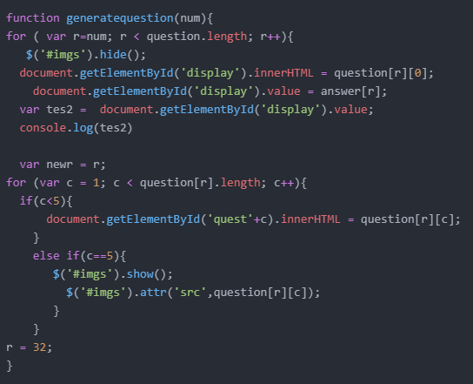

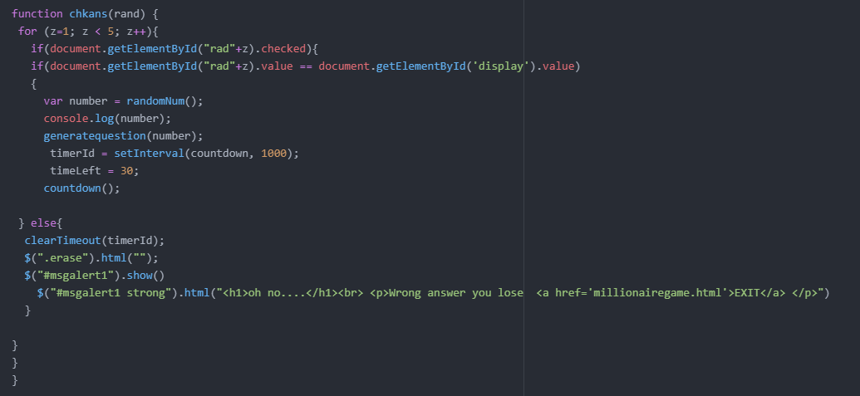

**2.There should be a pool of 30 questions**

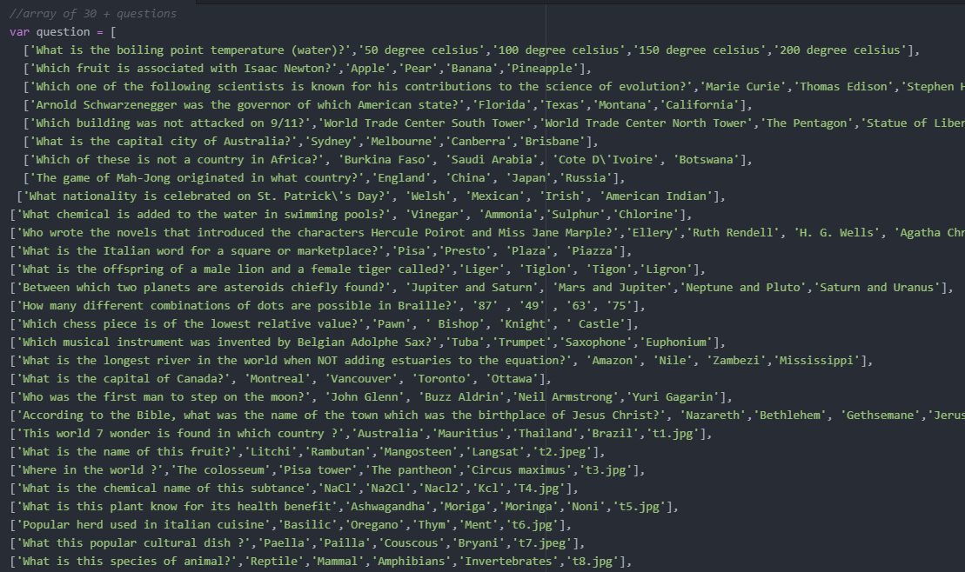

**Kick start the game, by pressing the button “PLAY”.**

The contestant has 30 seconds to answer a question, otherwise the game

**comes to an end.**



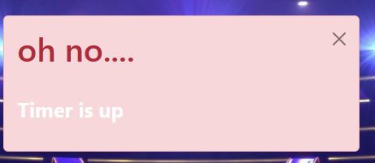

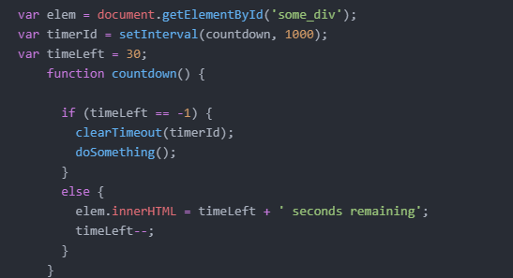

**15 Random** questions must be generated from the MCQ pool and only one

**question to be displayed at a time and MCQs which have already been used cannot be displayed again**

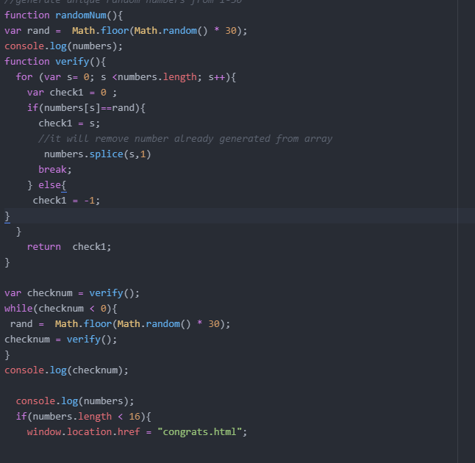

The contestant has three lifelines namely: ***50:50*** , ***Phone a friend*** and ***Swap***

***Question.***

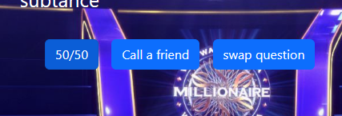

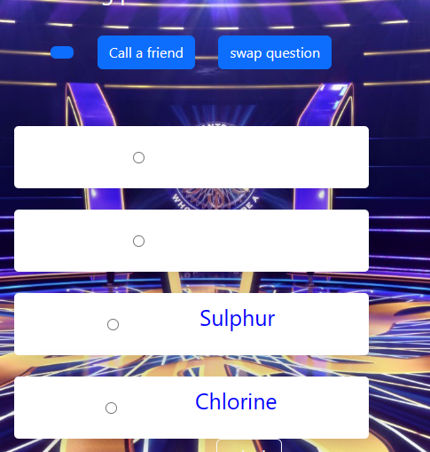

The ***Phone a friend*** will randomly propose an answer which needs to be

**highlighted with a color. This can be triggered by pressing a button.**

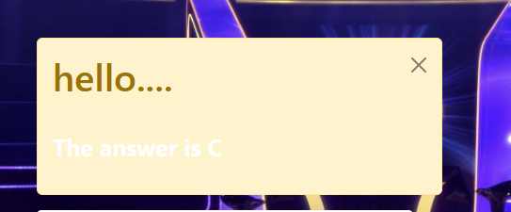

Some questions may also contain a picture

