Mean MaxN Comparison

Jessica Madden

December 16, 2020

This document investigates the mean maxN through time of south coast fish species from 2019. The term ‘mean maxN’ in this document refers to the mean of the maxn for each fish species across time segments within the 1 hour of video for each BRUV. This mean maxN was calculated for every 5 min time segment across the hour and for every 10 min time segment across the hour. These data sets of maxn by 5 min and 10 min were calculated in the rmd named ‘mpa-south-2019-bruv-compiling-points.rmd’ in the src folder of the project.

# Mean MaxN through time

### Barred surfperch at Percos and Refugio

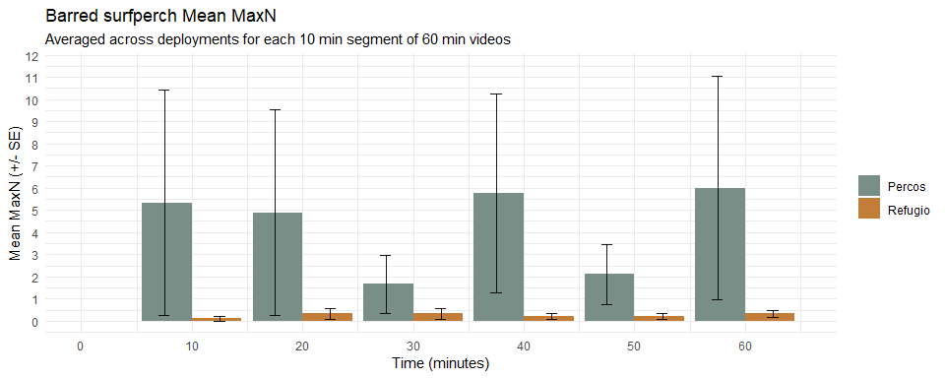

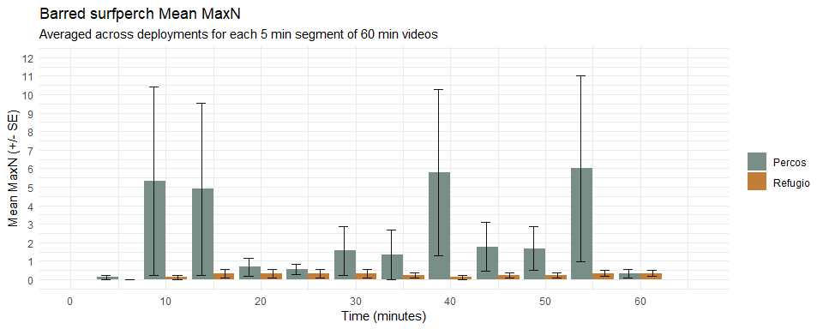

### Leopard sharks at Dume Cove and Leo Carrillo

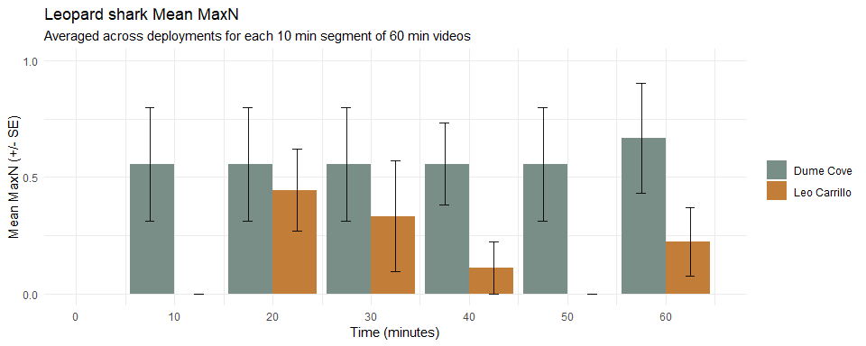

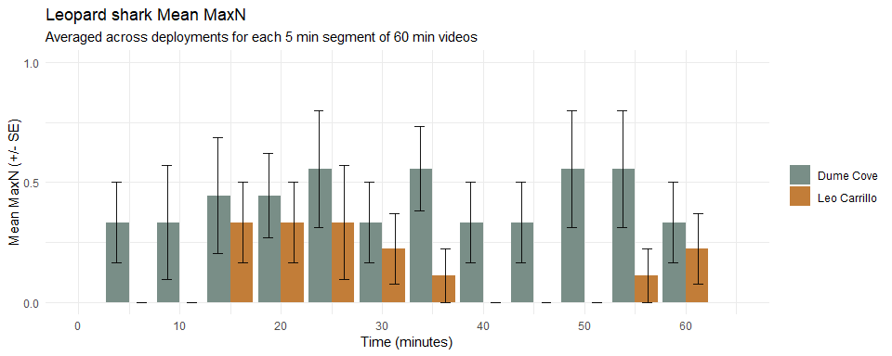

### Unknown silversides at South Campus and Haskells

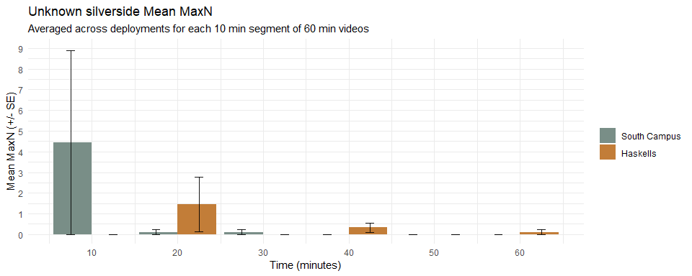

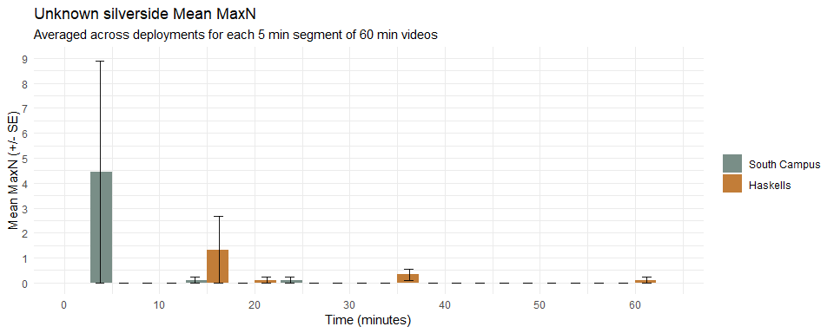

# Mean MaxN across sites

Mean Max N comparison between:

* deployments as replicates
* 5 min time segments as replicates
* 10 min time segments as replicates for each site

### Barred surfperch at all sites

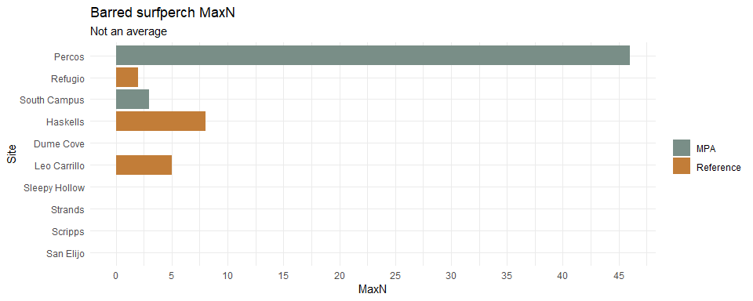

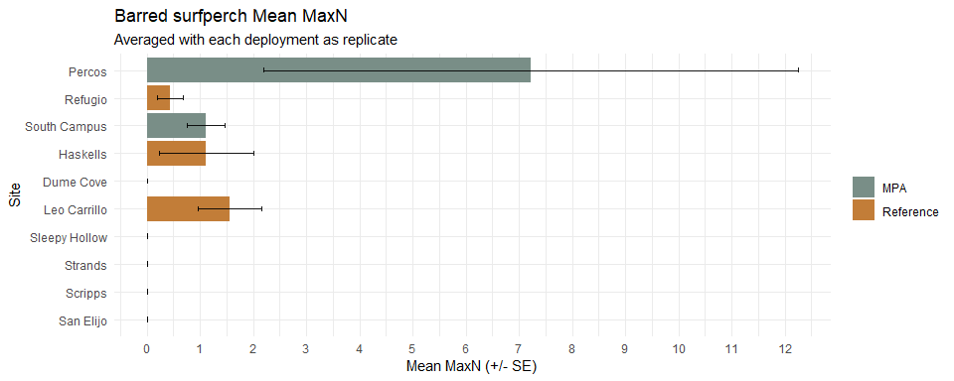

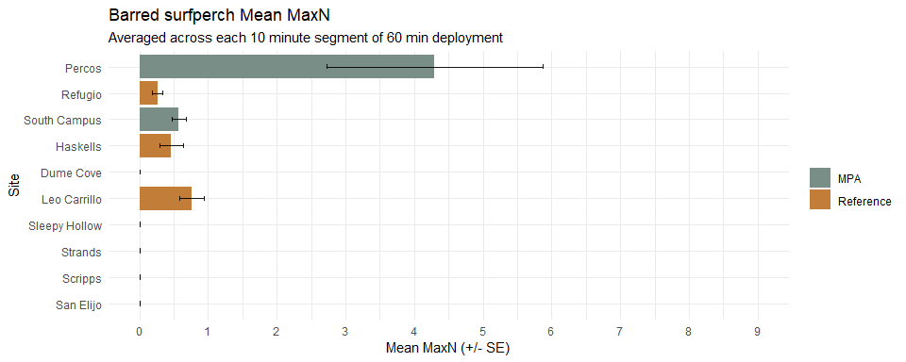

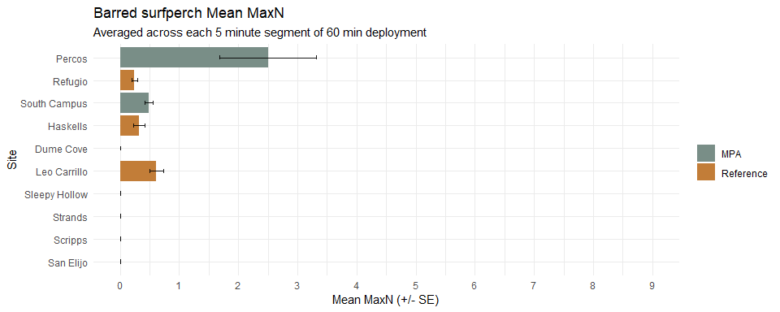

#### Yellowfin croaker at all sites

