Jessica Bonin

ECo 634 - Analysis of Environmental Data Lab

September 10, 2021

1. OneDrive

2. Azure Virtual Desktop

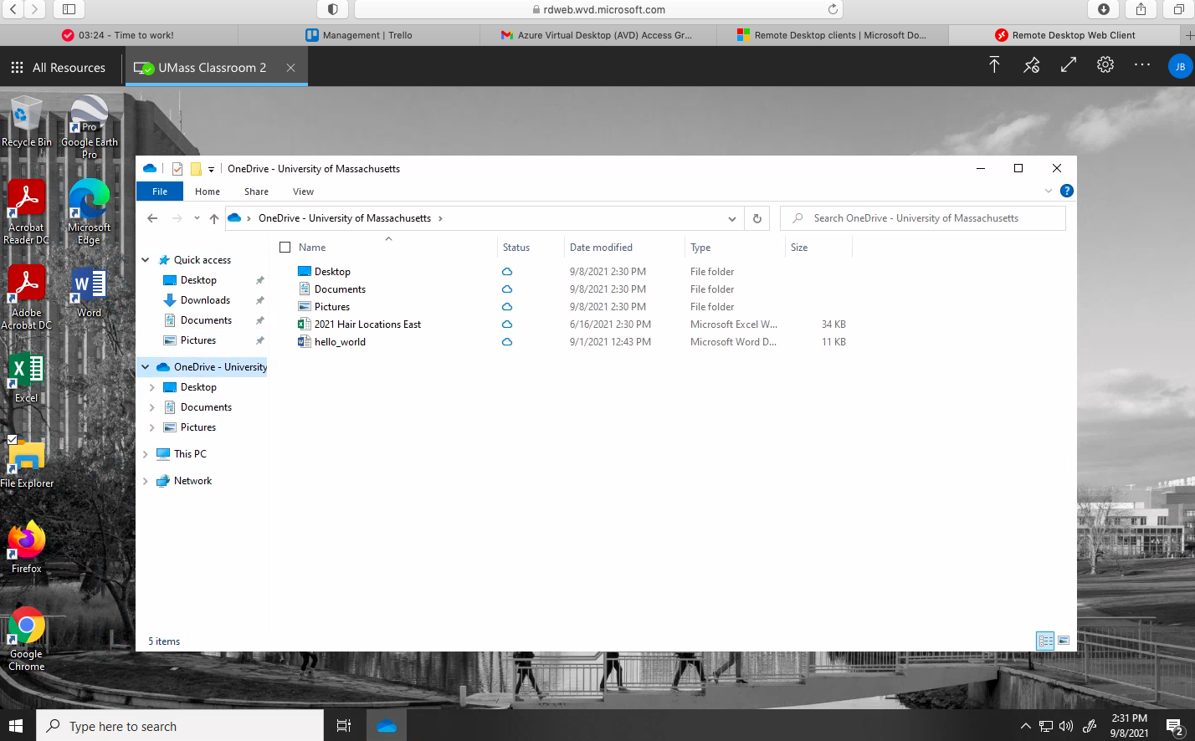

3. RStudio session with hello world

