**Deep Learning Model on Fashion MNIST dataset**

This blog explores the intricacies of employing a specialised model to an image-based dataset using features such as Dropout, Flattening and Adam optimiser.

The Fashion MNIST dataset consisted of 60,000 training images and 10,000 test images. The aim of this task was to classify the images into 10 different fashion categories with the use of a deep learning model using the Keras library.

The approach was to construct a sequential neural network with layers designed for different classification purposes. Firstly, as shown the first layer’s function was to flatten the images to a vector so it could be readable for the machine.

Regarding hidden layers, a dense layer with 256 units and Relu activation was used. To avoid overfitting within the layer, a regularisation of 50% was included which represents changes within the accuracy graph. Subsequent dense layers with 128 and 32 units to give a smooth de-escalation of layer, both using Relu activation. The output layer consisted of 10 units with softmax activation for multi-class classification.

The use of early stopping was used to prevent overfitting with a combination of dropout, however dropout alone proved more suitable as early stopping was causing a decrease in the accuracy and may have caused underfitting.

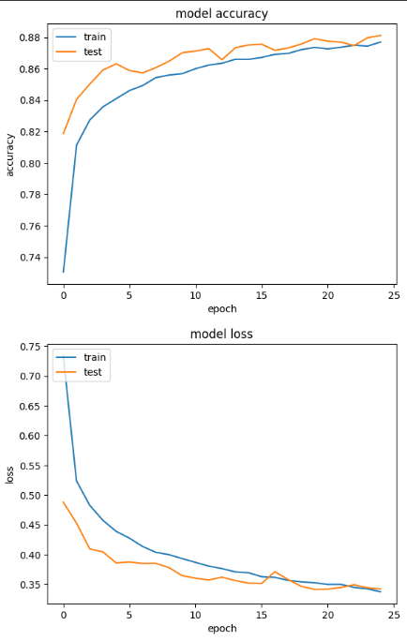

From the graph above, the train and test data is accurate towards the prediction and the final accuracy was a value of 0.8835. The use of Dropout decreases the accuracy; however, it creates a better model outlook overall with the test data being closer to the train data.

In conclusion, the score of 0.88 was a good percentage, however had room for increase. A feature which could’ve increased the accuracy would’ve been data augmentation to introduce more variability within the dataset, further reducing overfitting.