Analysis of Enviornmental Data

Software Setup Assignment

Jessica Martinez

1.

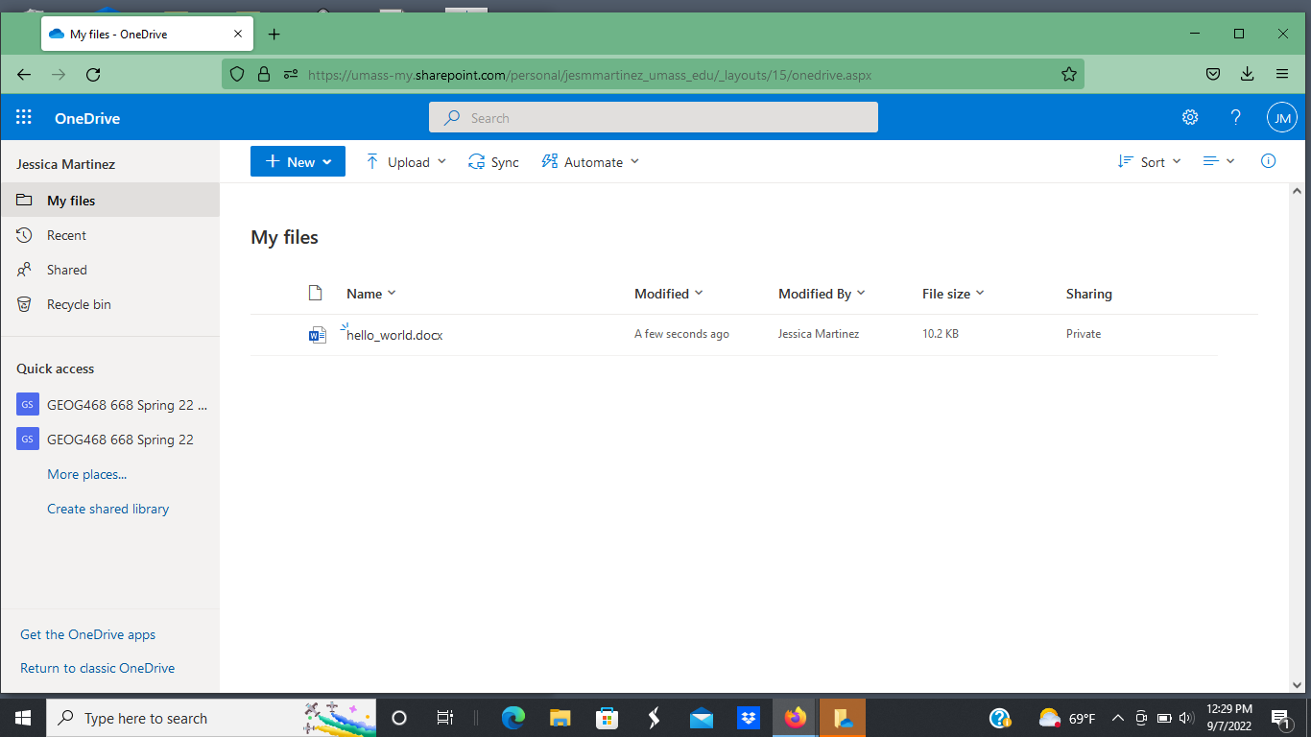

2.

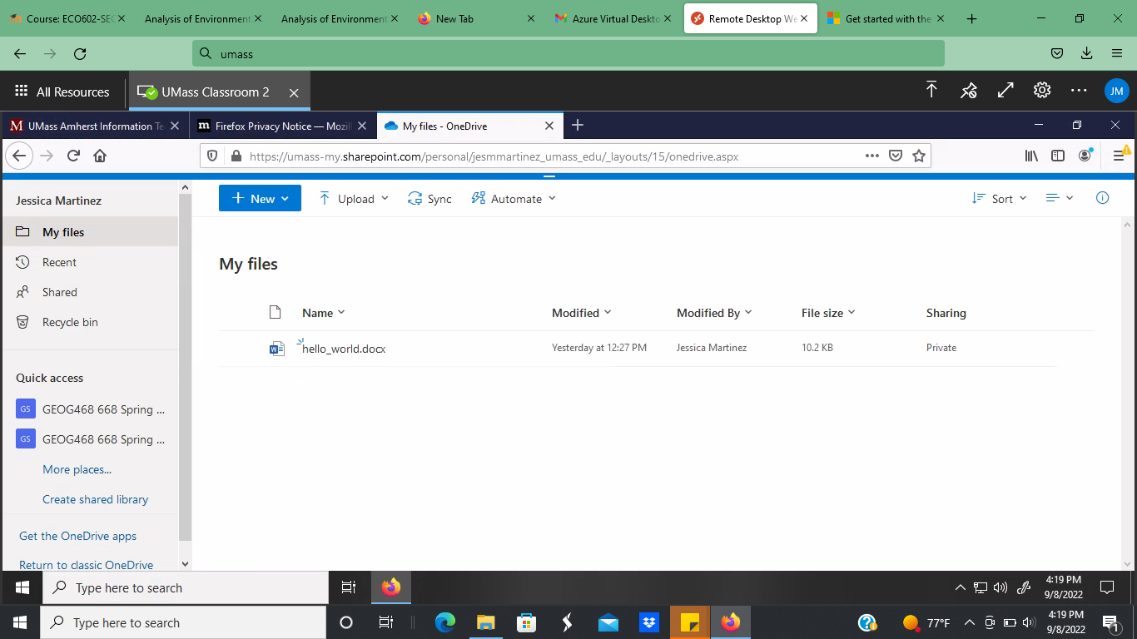

3.

4.

5.