**AN APPROACH TO SIMULATE FLUID STRUCTURE INTERACTION INVOLVING FREE SURFACE FLOWS**

Vom Fachbereich Maschinenbau

an der Technischen Universität Darmstadt

zur Erlangung des Grades eines

Doktor-Ingenieurs (Dr.-Ing.)

eingereichte

**Dissertation**

vorgelegt von

**Dipl.-Ing. Jessica Marcela Mariño Salguero**

aus Ecuador

Berichterstatter: Prof. Dr. rer. nat. Michael Schäfer

Mitberichterstatter: Prof. Dr.-Ing. #####

Tag der Einreichung: #.#.2020

Tag der mündlichen Prüfung: #.#.2020

Darmstadt 2020

D 17

**Abstract**

Simulating the interaction of multiphase flows with rigid or flexible structures is of great interest for enhancing the design of marine structures. Another problem is the dependence on a low Courant number to accurately capture the fluid interface, resulting in excessively long computational times. This work overcomes the mentioned problems with a new efficient and stable implicit partitioned fluid-structure interaction (FSI) approach where the fluid calculation is performed with the in-house solver FASTEST, using a finite volume method, while the structural calculation is solved with the CALCULIX program, based on the finite element method. The two solvers are coupled via the PRECICE multiphysics platform. In each time step, the solvers act iteratively, serially or in parallel, the fluid solver receives displacements and sends forces, while the structural solver receives forces and send displacements. The coupling is stabilized and accelerated with quasi-Newton methods, filters, and extrapolation.

The multiphase dynamics are described with the one-fluid formulation of the Navier-Stokes equations and the volume fraction transport equation in the arbitrary Lagrangian-Eulerian (ALE) framework to deal with the moving domain. The fluid interface is captured with an algebraic volume of fluid (VOF) method based on high-resolution schemes implemented through a new modified normalized weighting factor (MNWF) technique that maintains fluid interface sharpness and stability for high Courant numbers (Co > 1). Consequently, FSI simulations can use large time-steps and thus reduce the computational time. Also, dynamic switching between SIMPLE and PIMPLE is applied to achieve high convergence of the pressure-velocity coupling. The new approach is validated considering a dam break with an elastic obstruction as a test case. The simulation results are in accordance with the literature references, and the method shows a positive effect on accuracy, computational time and stability.

**ACKNOWLEDGEMENTS**

This work is supported by the “Excellence Initiative” of the German Federal and State Governments within the Graduate School of Computational Engineering at Technische Universität Darmstadt.

**CONTENTS**

1. INTRODUCTION 4

1.1. Introduction and motivation 4

1.2. State of the art 5

1.2.1. Numerical Methods to solve free-surface flows 5

1.2.2. Interface Tracking Methods (ITM) 7

1.2.3. Meshless methods 7

1.2.4. Capture Methods 7

1.2.5. From tracking methods or Level set methods 8

1.3. Numerical Methods for tracking fluid-structure interface 8

1.3.1. Immersed boundary methods 8

1.4. Numerical Methods for modeling fluid-structure interaction (FSI) problems 9

1.5. Fluid-structure interaction involving free surface flows 9

1.6. Scope and Objectives 9

1.7. Outline 10

2. MATHEMATICAL DESCRIPTION OF THE PHYSICAL PHENOMENA 11

2.1. Introduction 11

2.2. Two-phase fluid domain 11

2.3. Elastic structural domain 12

2.4. Interaction conditions 14

3. Discretization of the fluid domain 15

3.1.1. Discretization of the equations 15

3.1.2. Discretization of the momentum equation 18

3.1.3. Convective term 24

3.1.4. Set of linear equations 25

3.1.5. Equilibrium condition and discretization of volume forces 25

3.1.6. Boundary conditions 25

3.1.7. Pressure and velocity coupling 25

3.2. Discretization of the volume-fraction transport equation 25

3.2.1. Temporal discretization 25

3.2.2. Spatial discretization 25

3.2.3. Normalized variable diagram and high-resolution schemes 25

3.2.4. Normalized variables on non-uniform and unstructured mesh 25

3.2.5. Compressive high-resolution schemes 25

3.2.6. Discretization of surface tension term 25

3.2.7. Comparison of compressive high-resolution schemes 25

List of Figures

List of Tables

Notation and Nomenclature

# INTRODUCTION

## Introduction and motivation

Fluid-structure interaction (FSI) involving free-surface flows is a transitory and non-linear multi-physical phenomenon. On the one hand, fluid-structure interaction refers to the physical phenomenon produced when a flow induces compression and shear forces on the surface of a structure which move or deform the structure. Subsequently, this change of the position of the structure has effects on the dynamics of the surrounding flow resulting in a change of the compression and shear forces on the structure. Thus, it is a continuous process where each adaptation of the flow also induces an adaptation of the position of the structure. The physical coupling of the fluid field and structural field is mathematically modeled as a dynamic equilibrium at the fluid-structure interface.

According Naudascher & Rockwell (Naudascher & Rockwell, 2012), in a fluid-structure interaction situation, two basic elements exist the oscillators and a source of excitation. Oscillators are structural or fluid mass systems that restore forces if they deviate from their equilibrium positions. A structural oscillator can be a rigid structure that is elastically supported, or an elastic structure because they can perform flexural movements. The fluid oscillator is a passive mass of fluid that may undergo oscillations due to the compressibility of the fluid or by gravity. A fluid oscillator can cause undesirable fluid pulsations when excited (e.g. rogue waves); and can amplify the vibration of a structural oscillator if one of its natural frequencies matches the natural frequency of the structural oscillator.

The sources of excitation are basically classified in three types: extraneously induced excitation, instability-induced excitation, and movement induced excitation. The extraneously induced excitation is caused by fluctuations in flow velocities or pressures that are independent of any flow instability originated by the structure and independent of structural movements. An example is a cylinder being hit by the turbulence of the incoming flow. By contrast, the instability-induced excitation is produced through a flow process (or flow instabilities). This instability is inherent to the flow created by the structure considered. An example of this situation is presented in the FSI test case of Turek and Hron (Turek & Hron, 2006). The oscillation of an elastic beam caused by the alternating vortex shedding from an upstream cylindrical structure. Whereas, the movement-induced excitation is due to fluctuating forces arising from the movements of the structural oscillator or flow oscillator. The vibrations of the latter are self-excited. For example, if a hydrofoil receives an adequate disturbance, the flow will induce a pressure field that tends to increase that disturbance. This situation can be described in terms of a dynamic instability of the structural oscillator that results in the transfer of energy from the main flow to the structure.

On the other hand, free-surface flows are a special case of the multiphase flow systems. Regularly this implies the two-phase flow system form by air-water. ….

The fluid-structure interaction (FSI) involving free-surface flows plays a dominant effect in the design and operation of many engineering systems especially in the field of naval architecture, civil engineering, and marine engineering. Since marine structures such as ships and offshore structures are massive and capital-intensive structures placed in an unfriendly environment where the green water effect produced by regular and giant waves can damage them. The wave overturning, breaking and collapse during the initial stage of green water phenomena results in high-frequency vibration of the deck structure that produces damages by fatigue. Additionally, the dropping impact induced by the vast water volume that falls onto the deck can lead to a relatively large structure deformation (Hu, Tang, Xue, Zhang, & Wang, 2017). Consequently, research to better comprehends the interaction of structures with free surface flows, skilled engineers, and efficient design tools are required in order to enhance and optimize the designs of marine structures and prevent damage.

Because this multi-physical phenomenon has no analytical solutions for the most part and laboratory experiments are difficult and expensive to perform. The numerical simulations seem to be a better choice to obtain valuable information about the phenomena with less effort. In the last three decades, several numerical methods have been developed that partially solve the problem. Intensive investigations have focused on creating numerical models that accurately describe the dynamics of free surface water flow around moving rigid bodies. For example, the doctoral works by Fekken (Fekken, 2004) presents a simulation model for studies of floating ship-type, interacting in waves with or without impact phenomena. The water entry of wedge-shaped geometries was also investigated. A good summary of the methods currently applied for ship hydrodynamics is given by (Wackers et al., 2011), and other examples the reader can find in (Akkerman, Bazilevs, Benson, Farthing, & Kees, 2012; Pin, Idelsohn, Oñate, & Aubry, 2007). They have reached their maturity of development. They are now commonly used to solve real industrial applications. For example, in the shipping industry, numerical simulation of flow around a rigid ship moving at a certain speed is used in the design stage to estimate the hydrodynamic resistance of the ship and then minimize it by proper hull-shape design (Wackers et al., 2011). Also, researchers are using these methods to explore alternatives to propeller propulsion, such as fin propulsion (Pedersen, 2015).

On the other hand, the consideration of the structure as a rigid body does not apply to the design of the new generation of large containers. Ultra-large container ships have large open deck areas and thereby highly non-linear wave-induced loading, so hull flexibility plays an essential role in the response of the vessel. For these ships, the hull-beam vibration natural frequencies become as low as 0.40 Hz. They can be continually excited due to the high-frequency components in the wave spectrum and to non-linear excitation effects. So, to calculate the wave-induced load and prevent fatigue damage to the hull, the flexibility of the structure must be considered. Similarly, for offshore structures used for the extraction of hydrocarbons and minerals below the seabed at great water depths or in arctic waters, as well as for sustainable energy production, the flexibility of these floating platforms and their support elements are an important parameter to properly estimate fatigue damages and prevent direct resonance with dominant ocean wave frequencies (Pedersen, 2015). Therefore, the development of consistent, efficient, and stable numerical methods is required to calculate the interaction between waves and elastic structures.

Another critical point is the improvement of hydrodynamic calculation procedures involving flow around the slender bodies which is essential for the development of offshore wind turbines.

However, the numerical methods that describe the interaction between free-surface flows and elastic structure when the deformation is not neglected is still a challenge. Because the two fields describing multiphase fluid dynamics and structural dynamics must be carefully coupled to overcome the instability and decoupling caused by abruptly changing load conditions at the fluid-structure interface which result from the large density differences within the flow domain (Bogaers, Kok, Reddy, & Franz, 2016).

## State of the art

### Numerical Methods to solve free-surface flows

The last decades, several different methods for computations of multifluid flows (two different fluids) have been developed and improved. In this section I will give a brief overview of the major efforts to simulate multifluid flows.

In the sixties, Harlow and From (Harlow & Welch, 1965) introduced the marker-and-cell (MAC) method which opened up the possibility for simulating real free surface flows. Originally, the MAC method assumed a free surface flow, so there was only one fluid involved method. The fluid was identified by marker particles distributed along the fluid region and the governing equations solved the fluid region and the empty part of the domain. The dam breaking, the Rayleigh-Taylor problem, and the splash when a droplet hits a liquid surface and other various cases were deeply studied at Los Alamos by Harlow and collaborators. The method quickly became popular and was developed to solve two-fluid problems. Daly (Daly, 1967) computing with the MAC method the evolution of the two fluid Rayleigh-Taylor instability at different density ratios. Chan and Street (Chan & Street, 1970) used it to model a solitary wave on a vertical wall, and Nichols and Hirt (Nichols & Hirt, 1973) calculated the three-dimensional transient dynamics of free surface flows in the vicinity of submerged and penetrate obstacles.

However, the marker particles could cause inaccuracies, so the Los Alamos group replaced the particles by a marker function to solve the problem. Whit this idea the volume-of-fluid (VOF) of Hirt and Nichols (Hirt & Nichols, 1981) was born and was the begin for the next generation of methods for multifluid flows. In the VOF method, a scalar indicator function called volume fraction determines the spatial distribution of the two fluids. The volume fraction tracks one of the fluids and takes values between zero and one. A value of one denotes presence and zero denotes absence of the traced fluid. A volume fraction between zero and one indicates a mixture, and the value of 0.5 defines the flow interface. The main drawback of method is the poor accuracy of interface position due to of the numerical diffusion resulting form working with a cell-averaged market function. To prevent the diffusion, the interface is reconstructed in such a way that the marker does not start flowing into a new cell until the current cell is full. In the early implementation of VOF the interface was consider vertical plane for advection in the horizontal direction and horizontal for the vertical direction. This assumption often led to large amount of small unphysical droplets that break away from the interface that degraded the accuracy of the computation.

In the case of free-surface flows, specifically air-water flows, an essential requirement for the numerical approaches is the robust solution concerning breaking waves. For most practical applications, the exact modelling of the breaking is not necessary. However, the evaluation of the global effect of forces produced by the breaking waves is mandatory. Another requirement is that the methods are stable even at high Courant numbers to use practical time-steps and reduce computational time.

The computational methods to describe the interface location and how it moves can be classified into four categories: interface tracking methods, meshless methods, from tracking methods and interface capture methods. The first is preferred for its efficiency and accuracy in solving simple free surface flows, and the other for their applicability for computing complicated and variety problems than included arbitrarily complex geometries. Fig. # illustrated the methods.

|  |  |  |  |
| --- | --- | --- | --- |
|  | | | |
| 1. Interface tracking method | 1. Meshless method | 1. Capture method | 1. From tracking method |

Fig. 1 Techniques to solve the free-surface flow

### Interface Tracking Methods (ITM)

In the interface tracking methods, the grid is constantly regenerated to fit each current free surface shape. A technic in this group is the Arbitrary Lagrangian-Eulerian (ALE) method. The free surface is approximated as a mesh boundary that moves influenced by the flow. The pressure of the air is assumed constant, and the viscous stresses in the air are negligible. Then, the jump conditions (no phase-change, no-slip at the interface, and force balance) of the interface become a boundary condition for the liquid domain (Tryggvason, Scardovelli, & Zaleski, 2001).

An advantage of the fitting methods is that the form and location of the free surface is explicitly known, and it is always sharp. Thus, more details of the flow near the wave surface are known, and the accuracy of force computation increases (Hoekstra, 1998). The ALE method is very suitable for simulating free-surface problems with large deformation of the interface, but no topological changes are present (Wall, Genkinger, & Ramm, 2007). The method has difficulty in addressing topology changes generated by breaking waves, overturning, or splashing. The strong deformation or topological changes of the interface lead to a degeneration of the computational mesh, and the remeshing techniques are also an additional source of errors. For this reason, in industrial applications, it is usually applied for prediction of steady flow around ship hulls or flows with mild breaking only (Wackers et al., 2011).

### Meshless methods

Particles are used to track the movement of the interfaces. The grid that they form may be adapted to account for any changes in the interfacial shape (Unverdi & Tryggvason, 1992). A successfully approaches are the Smooth Particle Hydrodynamics (SPH) method originally developed in (Gingold & Monaghan, 1977) or the Moving Particle Semi-Implicit Method (MPS) (Koshizuka & Oka, 1996). The SPH method represents the fluid by large particles of fluid which are subject to Newton’s Second Law. The spatial derivatives are estimated by analytical expressions and do not need fixed computation grid. One disadvantage of the method is the difficulty in correctly modeling the boundaries.

The implementation of the method is straightforward and can handle complex free-surface problems and conserves mass. However, the accuracy is limited for multidimensional flows and depend on the number of particles used.

### Capture Methods

The capture methods present some advantages in contrast to the other described above. The first significant advantage is that only the transport equation for the volume fraction needs be solved to determine the proportion of fluid in each cell. The second and the most important is the inherent mass conservation and applicability for structure and unstructured grids. Finally, the third is the robustness to handle most of the complex free-surface flows present in naval hydrodynamics, e.g. overturning, breaking waves and splashing (Wackers et al., 2011).

. The accuracy of the VOF approach depends on the discretization advection schemes. It should ensure a monotonic change of the volume fraction (boundedness) and reduces the numerical diffusion and dispersion near the interface. In the 1980s, some approaches to geometrically reconstruct the interface appeared. The mots used were the PLIC (for Piecewise Linear Interface Calculation) (Lötstedt, 1982) and SLIC (for Simple Line Interface Calculation) (Ashgriz & Poo, 1991). A comprehensive review of these methods are presented in (Rider & Kothe, 1998).They accurately approximate the shape of the interface, but are limited for structured grid discretization and requires substantial computational effort (Zaleski, 1996). Later in the 1990s, Davis (Davis, 1994) introduced a more practical approach. The convection of the contact discontinuity by higher-order blended discretization schemes. He proposed a combination between a less diffusive scheme, which reduces the smearing of the profile, and a compressive scheme, which removes any diffusion near the interface. This idea is until now the basis to develop several blending advection schemes, also known as interface-capture schemes, for example, CICSAM (Ubbink & Issa, 1999), HRIC (Muzaferija & Peric, 1998), IGDS (Jasak, Weller, & Gosman, 1999), STACS (Darwish & Moukalled, 2006), BICS (Queutey & Visonneau, 2007), FBICS (Tsui, Lin, Cheng, & Wu, 2009), and others. The blending strategy considers the angle between the flow direction and the grid lines.

### From tracking methods or Level set methods

The interface location is approximated as surface mesh, and its evolution is directly computed by Lagrangian advection of the discrete points located on the interface. In the level set methods (Osher & Fedkiw, 2001; Osher & Sethian, 1988; Sussman, Smereka, & Osher, 1994), the subdomains occupied by water and air are designated as negative and positive values of a hyperbolic scalar function denominated as level set function and the set of discrete points located on the interface as the zero-level set function. Thus, the level set function is a signed-distance function, its magnitude represents the distance from a point in space to the interface, and its sign determines if the point is in water or air domain (Akkerman et al., 2012).

In the field of water-air problems, the level set methods are divided into two-phase and single-phase approach. The two-phase approach solves both water and air regions. In contrast, the single-phase approach only computes the water region, and the air region is extrapolated using the free surface boundary condition (Hino, 2006). The second approach is nowadays most used because it requires less computational time.

The benefit of the level set methods is that they always compute an explicit sharp interface and can model topology changes of the free surface. Hence, they are sustainable for use in the case of strong breakings. Although the method is not inherently mass conservative and demand surface tension treatment. It is commonly believed that the advection of the level set function and re-initialization of the interface are the main sources of the problem (Bai, Avital, Munjiza, & Williams, 2014).

Another methodology but less used is the MCLS method (van der Pijl, Segal, Vuik, & Wesseling, 2005) which is a combination of the VOF and level set methods. This combination exploits the accurate interface reconstruction of the LS and the conservation property of the VOF.

## Numerical Methods for tracking fluid-structure interface

The computation of the fluid-structure interface should be treated as a sharp interface. Thus, some combined Lagrangian-Eulerian methods are the most appropriate.

### Immersed boundary methods

The immersed boundary method was firstly used by (Peskin, 1977) to estimate the blood interaction with a heart valves.

For these methods, the domain is a fixed grid, and the interface is represented by a curve (2D) or surface (3D) that are defined by a polynomial fitting to a set of marker points. The method generates a diffusive interface and the information near the interface is smeared over a few cells. Thus, the interface thickness is in order of the mesh size (Fekken, 2004). The fluid and solid subdomains are smoothly defined by a Heaviside step function. The forces at interface are considered an integral source term in the momentum equation.

## Numerical Methods for modeling fluid-structure interaction (FSI) problems

In general, there are two main approaches to model FSI problems, the monolithic approach or partitioned approach.

The monolithic approach solves the fluid, structure, and interface equations simultaneously in a single and specialized solver. This procedure results in an inherent coupling between the subfields, which does not require the interpolation of the loads and the changes between the computational grids of the subfields.

In contrast, in the partitioned approach, the domain is decomposed in non-overlapping domains for the flow and the structure. Then, two separate field solvers solve the fluid dynamics and the structure dynamic in an iterative process and explicitly use the interfacial conditions to relate information between fluid and structure solutions. Often the Lagrangian formulation is preferred for the solid part since the deformation hast to be determined from a known reference configuration, which can be done by tracking the corresponding material points, whereas the Eulerian formulation is usually applied for the fluid part since the pressure and velocity at a specific location of the problem domain can be determined (Schäfer, 2006), and generally the mesh for the flow domain in much finer than for the structure domain. The main challenge with this approach is the coupling of the solvers. This takes place at the fluid-structure interface, which require technics to exchange information over the interface and the corresponding interpolation algorithms to interpolate the loads and displacements between the non-matching meshes (de Boer, van Zuijlen, & Bijl, 2007).

The monolithic methods generally are more robust and sometimes more efficient than partitioned schemes (Degroote, Bathe, & Vierendeels, 2009). However, the formulation must be adapted to each problem, so it is less versatile than the partitioned approach. Because of this, nowadays, the partitioned approach is the most applied approach due to its modularity and the possibility of re-using existing software (Kassiotis, Ibrahimbegovic, & Matthies, 2010). Furthermore, more complex computation such as multiphase flows, or turbulence in the fluid part or hyperelastic materials in the structural part can be solved. For this reason, the partitioned approach is used as FSI approach in this work.

In partitioned fluid-structure interaction problems, the solvers act as black-boxes with a given input-output relation at the common boundary. Regularly, the fluid solver receives velocities as an input and returns forces as an output. The structure solver takes forces as an input and returns displacements. The coupling conditions between flow and structural equations are not part of a large system of the fluid or structural equations (Mehl et al., 2016). The classical method to couple fluids and structures solvers is a staggered execution: in each new iteration, the velocity and boundary position calculated from displacements are prescribed in the fluid solver, then it calculates the pressure that is transferred to the structure solver as a surface load on the interface fluid-solid in the structure domain to solve the displacement. The convergence occurs when the difference between the velocities of the fluid and the solid boundary is less than the acceptable error. Serial execution of the coupling becomes often slow, the parallel implicit coupling can overcome the problem (Mehl et al., 2016).

## Fluid-structure interaction involving free surface flows

## Scope and Objectives

Despite several approaches have been developed to predict the fluid-structure interaction in the context of multiphase flows, there are still many challenges to combine the two fields and to simulate more complex real systems, mainly because the solving algorithms show some limitations in getting stable and accurate results when second order derivatives are involved in the governing equations. Therefore, the major objective of this work is to develop, investigate, and apply computational methods that allow a reliable simulation of fluid-structure interactions involving free-surface flows with high numerical efficiency.

The problem will be focused on a partitioned FSI approach. On the one hand, the fluid-dynamics will be solved in solver FASTEST where the domain is discretized using finite volume method (FVM) and block-structured meshes. On the other hand, the solid part will be computed with a finite element method (FEM) in the solver CALCULIX. The two solvers are coupled with a implicit method in the multiphysics environment preCICE. Consequently, the specific research aims of this project are:

## Outline

# Mathematical modeling of the physical phenomena

**Abstract** The chapter provides an overview of the conservation principles governing multiphase-flow, specifically two-phase flow, elastic structures, and the fluid-structure interface. The physical conservation principles are written in the form of partial differential equations. First, the continuity, momentum, and volume of transport equation that controlling the dynamics of the two-phase flow are presented. Second, a basic and general overview about elastic structure is introduced. Finally, the condition for the coupling problem are defined.

## Introduction

We consider a free-surface flow interacting with an elastic structure. Thus, the domain of this problem consists of a two-phase fluid domain and a structural domain denoted by  and , respectively. The fluid-structure interface  is the boundary where the flexible structure interacts with the fluid. The dynamics of the fluid domain are governing by the Navier-Stokes equations formulated in the Arbitrary Lagrangian-Eulerian (ALE) framework and solved by finite volume method (FVM). Whereas the structure domain is modelled in a Lagrangian framework, which solves the structure deformation by finite element method (FEM).

Besides, the study is limited for laminar flows.

## Two-phase fluid domain

The fluid domain is a multiphase flow formed by two incompressible, viscous, immiscible, and isothermal Newtonian fluids. Fig. # illustrates the fluid domain.

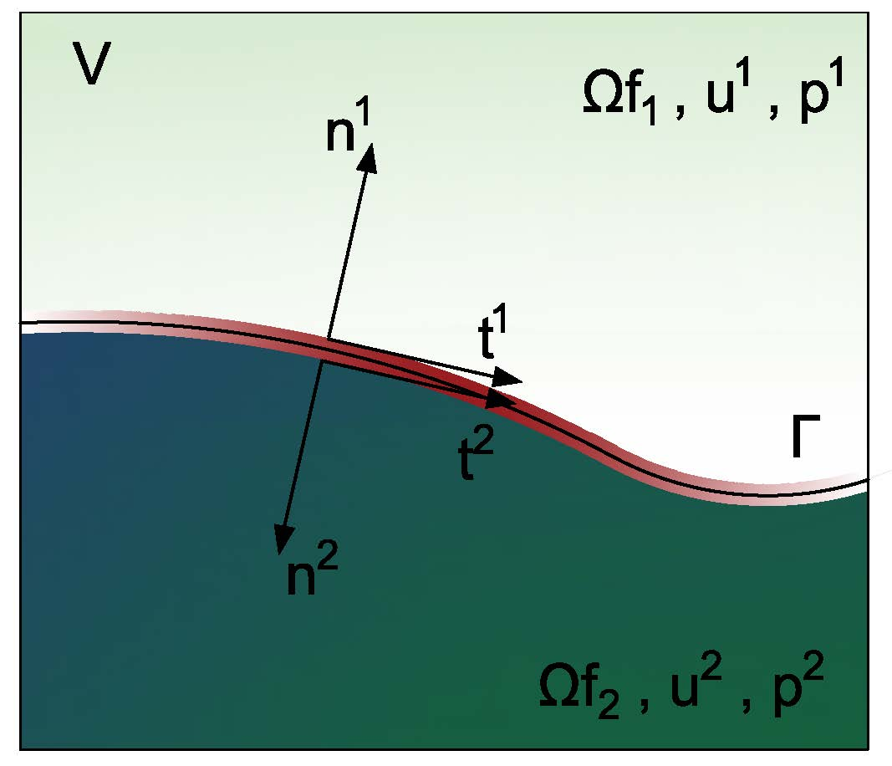

Fig. Two-phase flow domain.  is the interface between two fluids.

For modeling purposes, however, the two fluids are considered as a single continuum effective fluid with varying physical properties that change abruptly across the fluid interface. Furthermore, no mass transfer in the normal direction of the interface and a non-slip condition are assumed. Then the set of governing equations that describe the phenomenon are the one-fluid formulation of the mass and the momentum conservation equations (Navier-Stokes equations), and the volume fraction transport equation. To handle the unsteady moving domain, the expressions are formulated in the Lagrangian-Eulerian Arbitration Framework (ALE) as







where **v** is the fluid velocity, ρ the density,**u***g* the grid velocity due to the displacement of the structural part,  the stress tensor, ** is the volumetric forces, and *α* the volume fraction of one of the fluids. For Newtonian incompressible fluids, the stress tensor is assumed to be a linear function of the rate of strain and is defined with the Stokes law as



where μ is the dynamic viscosity, *p* the pressure, and **I** the unit tensor.

Further, the reader hast to note that here the non-conservative form of the moment equation is used.

Since the material properties, density, and viscosity, vary from one fluid to the other. The average values are recovered from the volume fraction and individual material properties of each constituent fluid by



that are an algebraic statement of local mass conservation.

Moreover, the volumetric force term is the sum of the gravitational forces and the surface tension effects given by



where **g** is the gravity, and the second term represents the surface tension effects formulated as a volume force acting in a normal direction towards the interface. This depends on the constant surface tension coefficient σ, the Gaussian curvature κ, the unitary normal vector to the flow interface **n**, and the absolute value of the volume fraction gradient (Wacławczyk, 2007).

Finally, the importance of the last two terms, gravitational forces, or surface tension forces, in the complete formulation is determined by the interface shape. When the radius of the interface curvature tends to infinity, e.g. water waves, the curvature tends to zero, and the surface tension vanishes. Whereas for small curvatures radius, e.g. a small water droplet, the surface tension is dominant, and the gravity force is neglected.

## Elastic structural domain

When the elastic deformation of the structure is a partial aspect of the fluid-structure interaction coupling, the structural domain should be mathematically modelled with an elasticity model. To describe how solid objects reversibly deform and become internally stressed due to flow-induced loads. An elasticity model is based on the kinematics, the balance law, and a constitutive law.

### Kinematics

The kinematics describe the motion of the object and is the relation between displacement and strain. The motion can be translation, rotation, or deformation of the solid. The position before the movement is described by a set of coordinates **X** known as coordinates in the reference state or *material coordinates*, and the position after the movement by a set of coordinates **x** that are called *spatial coordinates*. The resulting location at time t is mapped from its reference state. Considering an infinitesimal vector d**X** in reference state and d**x** in spatial state, one can write



where **F** is the deformation gradient and represents the Jacobian matrix of the motion from the material into de spatial state (Dhondt, 2004).

The measures of the deformation are the displacement **u** and the Lagrangian strain tensor ****. The displacement is the vector connecting the reference position of a material particle at **X** to its new position **x** at time t. One can determine as . The displacement is the measure of the change from d**X** to d**x** regardless of the real size of d**x**. On the other hand, the Lagrangian strain tensor or sometime called Green-Lagrange strain tensor  establishes a relationship between the displacements and the distortions, and can be interpreted as measures for the change of length in a body.

### Balance Law

The balance of the deformation and related stress is given by the balance of the linear momentum equation also called Newton’s second law. This principle of conservation asserts that the time rate of change of linear momentum is proportional to the total force acting on a body, which could include both surface forces and body forces. The gravity force () is a body force, and the surface tractions () are a surface forces. Therefore, by considering a masa  of volume , density  the velocity , Newton’s law in Lagrangian coordinates can be written as



where  is the Jacobian, and  is the Cauchy stress tensor field which is considered as the true stress since it is defined in the spatial state of reference. The For further details see for instance (Dhondt, 2004).

### Constitutive law

The material properties are included in the definition of the structural domain through a constitutive law. The constitutive law relates strains and stresses and, in this way, models the specific behavior of the material. In this investigation, only elastic materials or materials without memory are considered. The two materials of interest are the isotropic linear elastic materials and isotropic hyperelastic materials.

The isotropic linear elastic material also called St Venant-Kirchhoff material is characterized by an elastic potential of which only the quadratic terms in the strain are kept . Its constitutive law is given as



with Lamé constants  with Young’s module E and Poisson’s coefficient . Common steels are usually in this category.

On the other hand, for the isotropic hyperelastic materials, e.g. rubber, the resulting stress is not necessarily linear in **ε**. For this material, the potential function is a function of the strain invariants only. This covers the large family of models such as neo-Hooke, Mooney-Rivlin, Ogden and many others. For further information the reader is referred to (Dhondt, 2012).

## Interaction conditions

Finally, the problem formulation is closed by prescribed suitable boundary and interface conditions. On solid and fluid boundaries  and  standard conditions as for individual solid and fluid problems can be prescribed. Whereas in the fluid-structure interface the dynamic and kinematic conservation hast to be satisfied. This implies the no-slip condition for the flow, and that the forces on the interface are in balance. So, the boundary conditions are assumed to be



where  is the velocity of the solid along the interface, and  is a unit normal vector to the interface .

# Discretization of the fluid domain

**Abstract** This chapter details the discretization process of the fluid domain. In the present work the finite volume method is used for the spatial discretization of the equations and the finite difference method for the time discretization. The finite volume method transforms the set of partial differential equations into a system of linear algebraic equations. First, the flow domain is divided into control volumes, and then the partial equations are integrated and transformed into balance equations over every control volume. This requires changing the surface and volume integrals into discrete algebraic relations over control volumes and their surfaces using an integration quadrature of a specified order of accuracy. The result is a set of semi-discretized equations. In the second step, interpolation profiles are chosen to approximate the variation of the variables within the element and relate the surface into algebraic equations.

The following sections will be dedicated to the discretization the most relevant terms of the momentum equation that influence the calculation of multiphase flows. The methods and implementation presented in this section are built on the version of the flow solver FASTEST-3D (Durst & Schäfer, 1996) from the institute of numerical methods for mechanical engineering of the TU-Darmstadt.

The final form of the general conservation equation for the transport of a property  is expressed as



### Spatial discretization of the fluid domain

All discretization methods first require the discretization of the spatial problem domain. This is done by the definition a suitable grid structure covering the physical problem domain. In FASTEST-3D, the grid is defined dividing the physical space into several arbitrary hexahedral control volumes which form a block-structured grid. A block structured grid is characterized by a regular arrangement of the grid cells, thereby the neighboring relation between the grid points follow a certain fixed patter which simplifies the discretization process (Schäfer, 2006).

The finite difference method and the finite volume method implemented in FASTEST build on a Cartesian coordinate system. Therefore, the generally irregular and curvilinear physical domain (global coordinates) hast to be mapped to a regular Cartesian one (local coordinates) as is depicted in Fig. #.

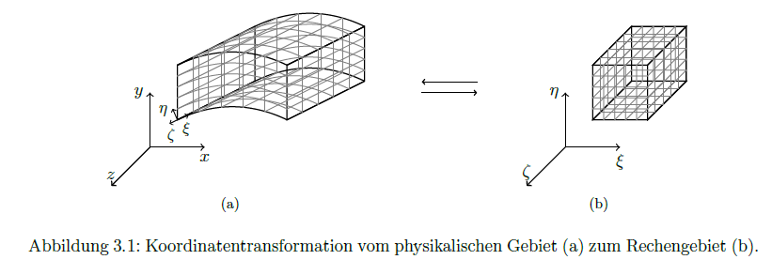

The global coordinates system is denoted by  and the local coordinate system by . The mapping between the two coordinate systems , j = 1,2,3 is performed with the transformation matrix 



The components of the transformation matrix are approximated with the second order central differences method that depend on the topology of the control volumes. In FASTEST-3D, a control volume is defined by eight vertices point (1-8) and a center point P as is shown in Fig. #. The centers of the surrounding control volumes are identified by W, E, S, N, B and T which refer to west, east, south, north, bottom, and top, respectively. The designation corresponds to the orientation of the adjacent centers with respect to the point P. The center of the faces of the control volume are identified by corresponding lower case letters (w,e,s,n,b,t).

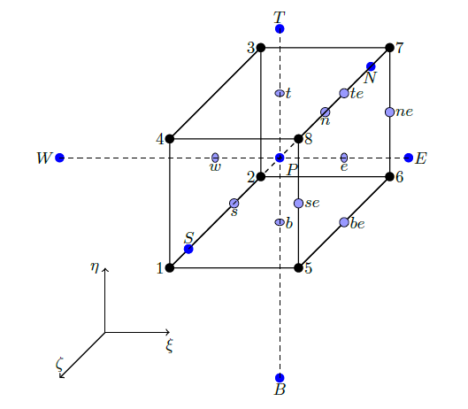

Fig. 2 Topology of a control volume in FASTEST-3D. Local coordinate system defined in the center of the control volume P.

For example, if the origin of the local axis is in the center of the control volume P, the element b11 is defined as:



where  is here generally assumed. The coordinates , and  are not direct known and are interpolated from the surrounding grid coordinates



For more information about the coordinate transformation the reader can review (Münsch, 2015).

Since the global coordinates system is used in the discretization, the derivatives with respect to global coordinates need to transform into the local coordinates applying the chain ruler:



where  is the Jacobian and  is the adjoint of the transformation matrix which is defined as the transpose of the cofactor matrix of .

The generic convective/diffuse transport equation in computational domain results in



where



represent the contravariant velocity, which is proportional to the velocity component normal to the coordinate surface . The coefficients  are mixed coefficients with unequal indexes defined as:



which become zero when the grid is orthogonal, either it is rectilinear or curvilinear.

Equation (2.3) retains the form of equation (1.11), but each derivative consists of the sum of three terms whose coefficients are the derivatives of the coordinates. For the convective term it is not a difficulty, but for the diffusive term, the coefficient  multiplying the mixed derivatives can cause numerical problems in non-orthogonal grids. Because the coefficients of the mixed derivatives can be greater than the diagonal coefficient when the angle between grid lines is small and the aspect ratio is large (Ferziger, Perić, & Street, 2020). To prevent this problem, the mixed derivatives are explicitly addressed.

### Discretization of the equations

The fluid domain is discretized in space with the second order Finite Volume Method (FVM) and in time with the finite difference approach. A detailed explanation of the them can be found in (Ferziger et al., 2020; F. H. Moukalled, Mangani, & Darwish, 2016) and more specific aspects related to multiphase flow systems in the doctoral work of Sauer (Sauer, 2000) or Wacławczyk (Wacławczyk, 2007).

The first step for the spatial discretization using FVM is to integrate the governing equations over each control volume, and applying the Gauss theorem, the volume integrals are transformed to surface integrals over the boundary **S** that closes the volume V of the cell. Following these steps, the equation (#) result in







where **n** is the normal vector to the volume surface and directed outwards. The grid velocity is determined with the discrete form of the space conservation law (SCL) (Demirdžić & Perić, 1988) given by



Fig. #. 2D fluids domain discretized by Finite volume method

### Discretization of the momentum equation

Replacing the surface integral over an arbitrary cell P by a summation of the flux terms over the faces of cell P, the surface integral of the diffusion become



Of this expression, the first diffusive flux  is included in the convection term and the second term  is included in the source term.

The total diffusive flux is calculated with a deferred correction method using a higher and a lower  order of discretization, and with a diffusive blending factor ,



where the higher order discretization of the whole viscous part is



here the velocity gradients are firstly defined at the center of the control volume and secondly that interpolated to obtain the value on the face of the control volume.

Whereas the lower order discretization of the first term of diffusive flux is:



Where ,  are the velocities in the center of the control volumes, and  is the area of the face.

However, using this discretization in non-orthogonal grids, an oscillatory solution may appear. Since the face center is not located on the vector that joins the centers of the volumes that form the face. To avoid this problem, the convective/diffusive equation should be reformulated in a local reference frame (Wacławczyk, 2007)

The local reference frame is defined by three vectors , ,  associated with the face f of the control volume V, as illustrated in Fig. 3.3.

Figure 3.3 Control volume P and its east neighbor E with local coordinate system defined by the vectors , ,  on the face f=e

Then, the variable  is changed from the global to local reference frame using the transformation matrix between the two coordination systems , following the next expression,



where  has non-zero Jacobian determinant () to change the frame of reference.



where  is estimated using a discretized matrix of dimension (3x3) that contains the vector components of the three vectors associated to the face geometry, for more details see Ref. (Wacławczyk, 2007).





The superscript S denotes the vector components associated with the face that are calculated with the following formulas,



Under those considerations, the momentum equation in the local reference system is rewritten considering a new source term  which groups all the terms of the right side of Eq. (3.18).



Regarding this reformulated equation, the term directly affected by the changes is the first part of the diffusion term. Therefore, It is discretized again,



where  was approximated as ,  is an auxiliary control volume and  is equal to 1, 2 or 3 depending on the face of the control volume employed for flux calculation, i.e., east , west , or north , respectively.

### Green Gauss gradient with the midpoint correction for non-orthogonal grids

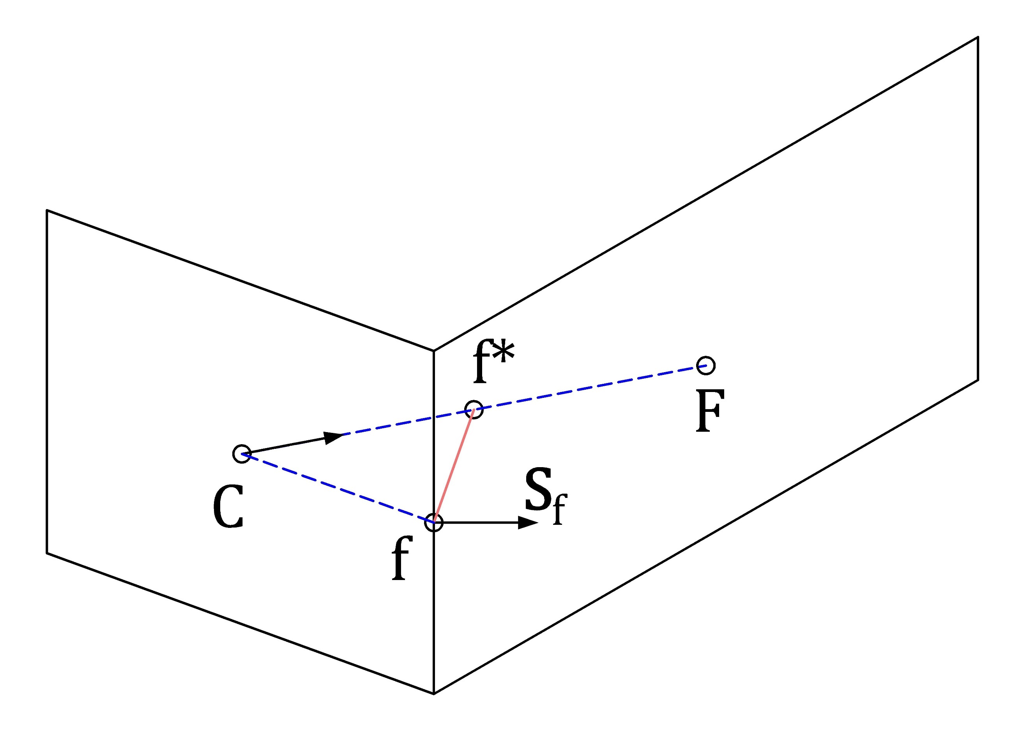

Fig. 3 Connection between two non-orthogonal control volumes using the midpoint approach in a two-dimensional configuration.

The calculation of the gradient field over the domain is an iterative process that proceeds as follows:

During the first iteration, calculate the gradient field as follows:

1. Calculate the face value 
2. Calculate the Green Gauss gradient 

From the second iteration onward, correct the gradient field according to the following procedure:

1. Update 
2. Update 
3. Go back to step 3 and repeat

### Face values of density and viscosity

However, the issue of correct viscous stress modeling at fluid interfaces – e.g., correct capturing of the viscosity term within at the free-surface is a quite important one, though not being addressed often in the literature dealing with the VOF approach: it is common practice to use a arithmetic mean as for the mixture viscosity – as being done for the mixture density. However, being confronted with free-surface flows possessing gross and abrupt changes of the viscosity across the interface the correct evaluation of µ at the interface (i.e., the interfacial viscosity) is crucial for reproducing the correct free-surface dynamics in numerical simulations. Simply using an arithmetic mean causes an artificial (increased) acceleration of fluid elements in the lighter phase which yields too high velocities due to an unphysical viscous term

The harmonic mean is more accurate when the interface tend to be aligned with the Flow direction, however, it is less robust than arithmetic mean in flows with with large density differences.

The cell face viscosity and density are determined using an interpolation factor  which accounts for the two-fluid flow interface/cell face orientation, and evaluating the phase value  in the limits of a harmonic mean  and an arithmetic mean , as follow:



Where  and 

here  is the geometric weighting factor, and the interpolated gradient to the face of the volume fraction is evaluated according the procedure presented in (F. Moukalled, Mangani, & Darwish, 2016)





where the nodal gradients are calculated with the Green Gauss gradient with the midpoint correction approach, and gC is a corrected geometrical weighting factor that can be computed applying the minimum distance approach



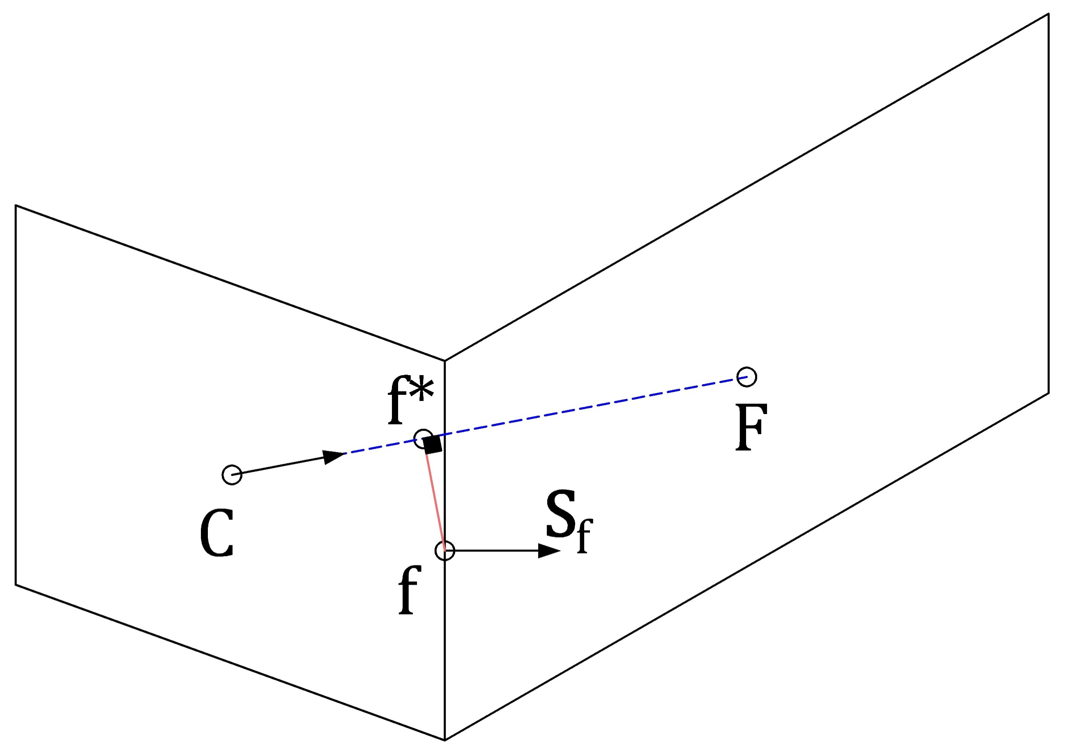

Fig. 4 Connection between two non-orthogonal control volumes using the minimum distance approach in a two-dimensional configuration.

### Treatment of the Body Force Term

The Rhie-Chow interpolation scheme works well if the pressure field is sufficiently smooth, but if abrupt variations occur, nonphysical spikes in the velocity field can be appeared near the abrupt variations of the pressure field. The abrupt pressure variation is closely related to the abrupt changes of body forces. This relation becomes clear if we consider the momentum equation for one-dimensional stationary fluid  that result in



where the pressure gradient should be in equilibrium with the body forces to avoid unphysical spikes.

In multiphase flows, e.g. gas-liquid, the sudden variation in density results in such as variation in body forces. Another example is bubbles or droplets whose strong surface tension causes abrupt changes of the body forces field in the vicinity of the flow interface.

In order to preserve the equilibrium between body forces and pressure gradient even abrupt changes of the body forces are present and thus to avoid the apparition of the so-called spurious currents, I use the approach introduced by Mencinger (Mencinger, 2012) for collocated grids. The remedy consists in evaluating the body forces in a similar stencil as the pressure which implicates a redistribution of the body force term. This redistribution can best derived by considering the one-dimensional stationary flow illustrated in fig. 5. The double bar indicates two average steps.

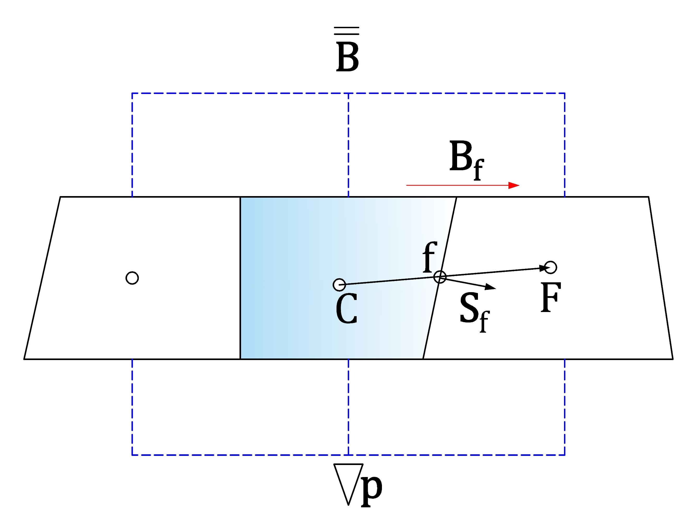

Fig. 5 One dimensional stationary flow

The method begins by assuming that the solution of the momentum equation for a stationary fluid is satisfied on all control volumes faces



when using the Rhie-Chow correction. Then, the dot product of Eq. (2.13) with the vector from the point C to F, , is applied which results in



where the body force on the face is linearly interpolated from the nodal neighbor values



The second part is applying the condition of a stationary fluid for the central point



where the pressure gradient is computed with the Green Gauss gradient, and the pressure on faces again with linear interpolation



Inserting (2.16) and (2.13) in (2.15) results in



where the first term is equal zero because  for any closed surface. Finally,



The above expression represents the re-distributed body forces that hast to be used in the momentum equation instead the direct volume body forces to avoid unphysical spikes in the velocity field.

Considering that for FSI cases, the grid is in constant deformation, we applied the expression (2.19), however, the body forces are interpolated to the faces using the Taylor-series expansion (TSE) approach (Lehnhäuser & Schäfer, 2002) instead to the linear interpolation because TSE preserves second-order accuracy even in distorted grids. The TSE interpolation approach defines the face value using the nodal values of the volumes near the face. For example, the force at east face, e, of a control volume P with neighbors E, N, S, T, B located according the fig. 3 is determined as:



where the γ factors are geometric. More details how to define this factor is found in (Lehnhäuser & Schäfer, 2002)

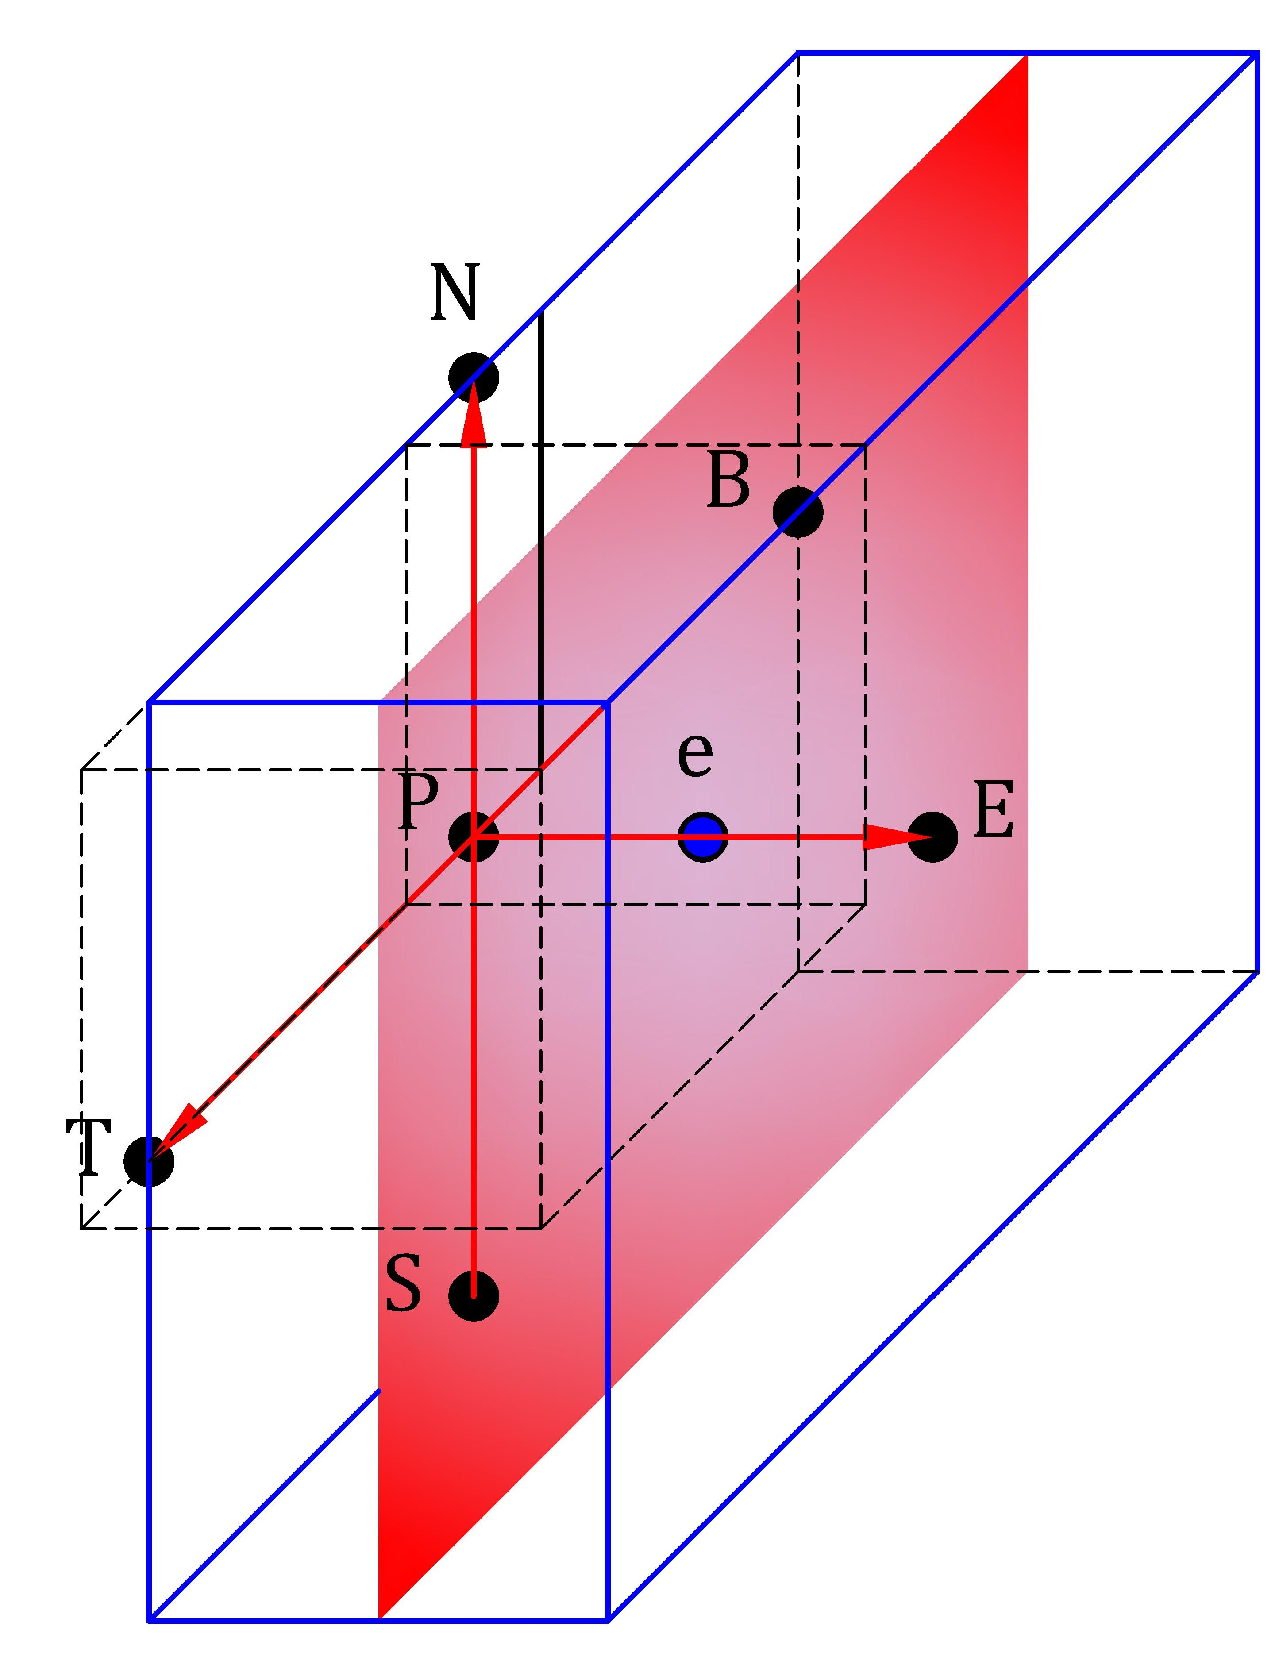

Fig. 6 Volume around the n face of the control volume P and location of the neighbor’s nodal points to the control volume P

### Convective term

Although the convection term looks simple

### Set of linear equations

### Equilibrium condition and discretization of volume forces

### Boundary conditions

### Pressure and velocity coupling

The cell center variable arrangement is used.

## Discretization of the volume-fraction transport equation

### Temporal discretization

### Spatial discretization

### Normalized variable diagram and high-resolution schemes

### Normalized variables on non-uniform and unstructured mesh

### Compressive high-resolution schemes

### Discretization of surface tension term

### Comparison of compressive high-resolution schemes

Akkerman, I., Bazilevs, Y., Benson, D. J., Farthing, M. W., & Kees, C. E. (2012). Free-Surface Flow and Fluid-Object Interaction Modeling With Emphasis on Ship Hydrodynamics. *Journal of Applied Mechanics*, *79*(1), 010905. https://doi.org/10.1115/1.4005072

Ashgriz, N., & Poo, J. Y. (1991). FLAIR: Flux line-segment model for advection and interface reconstruction. *Journal of Computational Physics*. https://doi.org/10.1016/0021-9991(91)90194-P

Bai, X., Avital, E. J., Munjiza, A., & Williams, J. J. R. (2014). Numerical simulation of a marine current turbine in free surface flow. *Renewable Energy*, *63*, 715–723. https://doi.org/10.1016/j.renene.2013.09.042

Bogaers, A. E. J., Kok, S., Reddy, B. D., & Franz, T. (2016). An evaluation of quasi-Newton methods for application to FSI problems involving free surface flow and solid body contact. *Computers & Structures*, *173*, 71–83. https://doi.org/10.1016/j.compstruc.2016.05.018

Chan, R. K.-C., & Street, R. L. (1970). A computer study of finite-amplitude water waves. *Journal of Computational Physics*, *6*(1), 68–94. https://doi.org/10.1016/0021-9991(70)90005-7

Daly, B. J. (1967). Numerical Study of Two Fluid Rayleigh-Taylor Instability. *Physics of Fluids*, *10*(2), 297. https://doi.org/10.1063/1.1762109

Darwish, M., & Moukalled, F. (2006). Convective Schemes for Capturing Interfaces of Free-Surface Flows on Unstructured Grids. *Numerical Heat Transfer, Part B: Fundamentals*, *49*(1), 19–42. https://doi.org/10.1080/10407790500272137

Davis, S. F. (1994). Flux difference splittings and limiters for the resolution of contact discontinuities. *Applied Mathematics and Computation*. https://doi.org/10.1016/0096-3003(94)90162-7

de Boer, A., van Zuijlen, A. H., & Bijl, H. (2007). Review of coupling methods for non-matching meshes. *Computer Methods in Applied Mechanics and Engineering*, *196*(8), 1515–1525. https://doi.org/10.1016/j.cma.2006.03.017

Degroote, J., Bathe, K. J., & Vierendeels, J. (2009). Performance of a new partitioned procedure versus a monolithic procedure in fluid-structure interaction. *Computers and Structures*, *87*(11–12), 793–801. https://doi.org/10.1016/j.compstruc.2008.11.013

Demirdžić, I., & Perić, M. (1988). Space conservation law in finite volume calculations of fluid flow. *International Journal for Numerical Methods in Fluids*, *8*(9), 1037–1050. https://doi.org/10.1002/fld.1650080906

Dhondt, G. (2004). *The Finite Element Method for Three-Dimensional Thermomechanical Applications*. https://doi.org/10.1002/0470021217

Dhondt, G. (2012). *CalculiX CrunchiX USER ’ S MANUAL*. 2012. Retrieved from http://www.bconverged.com/calculix/doc/ccx/html/index.html

Durst, F., & Schäfer, M. (1996). A parallel block-structured multigrid method for the prediction of incompressible flows. *International Journal for Numerical Methods in Fluids*, *22*(6), 549–565. https://doi.org/10.1002/(SICI)1097-0363(19960330)22:6<549::AID-FLD366>3.3.CO;2-Z

Fekken, G. (2004). *Numerical simulation of free-surface flow with moving rigid bodies*. Groningen: s.n.

Ferziger, J. H., Perić, M., & Street, R. L. (2020). *Computational Methods for Fluid Dynamics*. https://doi.org/10.1007/978-3-319-99693-6

Gingold, R. A., & Monaghan, J. J. (1977). Smoothed particle hydrodynamics: theory and application to non-spherical stars. *Monthly Notices of the Royal Astronomical Society*, *181*(3), 375–389. https://doi.org/10.1093/mnras/181.3.375

Harlow, F. H., & Welch, J. E. (1965). Numerical Calculation of Time-Dependent Viscous Incompressible Flow of Fluid with Free Surface. *Physics of Fluids*, *8*(12), 2182. https://doi.org/10.1063/1.1761178

Hino, T. (2006). CFD-based estimation of propulsive performance in ship design. *26th Symposium on Naval Hydrodynamics*. Rome.

Hirt, C. ., & Nichols, B. . (1981). Volume of fluid (VOF) method for the dynamics of free boundaries. *Journal of Computational Physics*, *39*(1), 201–225. https://doi.org/10.1016/0021-9991(81)90145-5

Hoekstra, M. (1998). PARNASSOS: An efficient method for ship stern flow calculation. *Third Osaka Colloquium on Advanced CFD Applications to Ship Flow and Hull Form Design*, 331–357.

Hu, Z., Tang, W., Xue, H., Zhang, X., & Wang, K. (2017). Numerical study of rogue wave overtopping with a fully-coupled fluid-structure interaction model. *Ocean Engineering*, *137*, 48–58. https://doi.org/10.1016/j.oceaneng.2017.03.022

Jasak, H., Weller, H. G., & Gosman, A. D. (1999). High resolution NVD differencing scheme for arbitrarily unstructured meshes. *International Journal for Numerical Methods in Fluids*, *31*(2), 431–449. https://doi.org/10.1002/(SICI)1097-0363(19990930)31:2<431::AID-FLD884>3.0.CO;2-T

Kassiotis, C., Ibrahimbegovic, A., & Matthies, H. (2010). Partitioned solution to fluid–structure interaction problem in application to free-surface flows. *European Journal of Mechanics - B/Fluids*, *29*(6), 510–521. https://doi.org/10.1016/j.euromechflu.2010.07.003

Koshizuka, S., & Oka, Y. (1996). Moving-Particle Semi-Implicit Method for Fragmentation of Incompressible Fluid. *Nuclear Science and Engineering*, *123*(3), 421–434. https://doi.org/10.13182/NSE96-A24205

Lehnhäuser, T., & Schäfer, M. (2002). Improved linear interpolation practice for finite-volume schemes on complex grids. *International Journal for Numerical Methods in Fluids*, *38*(7), 625–645. https://doi.org/10.1002/fld.232

Lötstedt, P. (1982). A front tracking method applied to Burgers’ equation and two-phase porous flow. *Journal of Computational Physics*. https://doi.org/10.1016/0021-9991(82)90075-4

Mehl, M., Uekermann, B., Bijl, H., Blom, D., Gatzhammer, B., & van Zuijlen, A. (2016). Parallel coupling numerics for partitioned fluid–structure interaction simulations. *Computers & Mathematics with Applications*, *71*(4), 869–891. https://doi.org/10.1016/j.camwa.2015.12.025

Mencinger, J. (2012). An Alternative Finite Volume Discretization of Body Force Field on Collocated Grid. In *Finite Volume Method - Powerful Means of Engineering Design*: *Vol.* *Di*. https://doi.org/10.5772/38813

Moukalled, F. H., Mangani, L. (Luca), & Darwish, M. (Marwan). (2016). Discretization of the Convection Term. In *The Finite Volume Method in Computational Fluid Dynamics* (p. 791).

Moukalled, F., Mangani, L., & Darwish, M. (2016). *The Finite Volume Method in Computational Fluid Dynamics*. https://doi.org/10.1007/978-3-319-16874-6

Münsch, M. (2015). *Entwicklung und Anwendung eines semi-impliziten Kopplungsverfahrens zur numerischen Berechnung der Fluid-Struktur-Wechselwirkung in turbulenten Strömungen mittels Large-Eddy Simulationen*. Friedrich-Alexander-Universität.

Muzaferija, S., & Peric, M. (1998). Computation of free-surface flows using interface-tracking and interface-capturing methods. *Computational Mechanics*, (Nonlinear water-wave interaction). Retrieved from https://www.researchgate.net/publication/320979291

Naudascher, E., & Rockwell, D. (2012). *Flow-induced vibrations: an engineering guide*. Courier Corporation.

Nichols, B. D., & Hirt, C. W. (1973). Calculating three-dimensional free surface flows in the vicinity of submerged and exposed structures. *Journal of Computational Physics*, *12*(2), 234–246. https://doi.org/10.1016/S0021-9991(73)80013-0

Osher, S., & Fedkiw, R. P. (2001). Level Set Methods: An Overview and Some Recent Results. *Journal of Computational Physics*. https://doi.org/10.1006/jcph.2000.6636

Osher, S., & Sethian, J. A. (1988). Fronts propagating with curvature-dependent speed: Algorithms based on Hamilton-Jacobi formulations. *Journal of Computational Physics*, *79*(1), 12–49. https://doi.org/10.1016/0021-9991(88)90002-2

Pedersen, P. T. (2015). Marine Structures: Future Trends and the Role of Universities. *Engineering*, *1*(1), 131–138. https://doi.org/10.15302/J-ENG-2015004

Peskin, C. S. (1977). Numerical analysis of blood flow in the heart. *Journal of Computational Physics*, *25*(3), 220–252. https://doi.org/10.1016/0021-9991(77)90100-0

Pin, F. Del, Idelsohn, S., Oñate, E., & Aubry, R. (2007). The ALE/Lagrangian Particle Finite Element Method: A new approach to computation of free-surface flows and fluid–object interactions. *Computers & Fluids*, *36*(1), 27–38. https://doi.org/10.1016/j.compfluid.2005.06.008

Queutey, P., & Visonneau, M. (2007). An interface capturing method for free-surface hydrodynamic flows. *Computers & Fluids*, *36*(9), 1481–1510. https://doi.org/10.1016/j.compfluid.2006.11.007

Rider, W. J., & Kothe, D. B. (1998). Reconstructing Volume Tracking. *Journal of Computational Physics*, *141*(2), 112–152. https://doi.org/10.1006/jcph.1998.5906

Sauer, J. (2000). *Instationär kavitierende Strömungen: ein neues Modell, basierend auf front capturing (VoF) und Blasendynamik*. Universität Karlsruhe.

Schäfer, M. (2006). Computational engineering - Introduction to numerical methods. In *Computational Engineering - Introduction to Numerical Methods*. https://doi.org/10.1007/3-540-30686-2

Sussman, M., Smereka, P., & Osher, S. (1994). A Level Set Approach for Computing Solutions to Incompressible Two-Phase Flow. *Journal of Computational Physics*, *114*(1), 146–159. https://doi.org/10.1006/jcph.1994.1155

Tryggvason, G., Scardovelli, R., & Zaleski, S. (2001). *Direct Numerical Simulations of Gas–Liquid Multiphase Flows*. https://doi.org/10.1017/CBO9780511975264

Tsui, Y.-Y., Lin, S.-W., Cheng, T.-T., & Wu, T.-C. (2009). Flux-blending schemes for interface capture in two-fluid flows. *International Journal of Heat and Mass Transfer*, *52*(23–24), 5547–5556. https://doi.org/10.1016/j.ijheatmasstransfer.2009.06.026

Turek, S., & Hron, J. (2006). Proposal for numerical benchmarking of fluid-structure interaction between an elastic object and laminar incompressible flow. In *Fluid-structure interaction* (pp. 371–385). Dortmund: Springer Berlin Heidelberg.

Ubbink, O., & Issa, R. I. (1999). A Method for Capturing Sharp Fluid Interfaces on Arbitrary Meshes. *Journal of Computational Physics*, *153*(1), 26–50. https://doi.org/10.1006/jcph.1999.6276

Unverdi, S. O., & Tryggvason, G. (1992). A front-tracking method for viscous, incompressible, multi-fluid flows. *Journal of Computational Physics*, *100*(1), 25–37. https://doi.org/10.1016/0021-9991(92)90307-K

van der Pijl, S. P., Segal, A., Vuik, C., & Wesseling, P. (2005). A mass-conserving Level-Set method for modelling of multi-phase flows. *International Journal for Numerical Methods in Fluids*, *47*(4), 339–361. https://doi.org/10.1002/fld.817

Wackers, J., Koren, B., Raven, H. C., van der Ploeg, A., Starke, A. R., Deng, G. B., … Ohashi, K. (2011). Free-Surface Viscous Flow Solution Methods for Ship Hydrodynamics. *Archives of Computational Methods in Engineering*, *18*(1), 1–41. https://doi.org/10.1007/s11831-011-9059-4

Wacławczyk, T. (2007). *Numerical modelling of free surface flows in ship hydrodynamics*. Polish Academy of Sciences.

Wall, W. A., Genkinger, S., & Ramm, E. (2007). A strong coupling partitioned approach for fluid–structure interaction with free surfaces. *Computers & Fluids*, *36*(1), 169–183. https://doi.org/10.1016/j.compfluid.2005.08.007

Zaleski, S. (1996). Simulations of high Reynolds number breakup of liquid-gas interfaces. In *Lecture series-van Kareman Institute for fluid dynamics* (pp. L1–L31).