Jessica Long-Heinicke

M1 Assignment

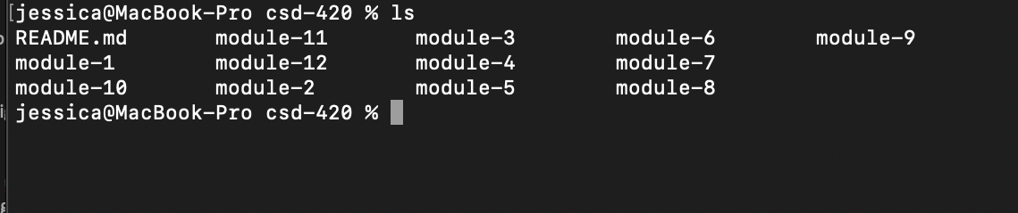

https://github.com/jessicanlh/csd-420.git