Kulsoom Mansoor and Jessica Oriondo

Graphics Final Project Proposal

11/17/16

**App Proposal:**

**Name:** Do You Want to Build a Snowman?

**Type:** Builder and game

**Technical Requirements:**

1. **A purpose: you must be able to describe the purpose of your application in 5 sentences. Your description and the actual app you build should correspond.**
   1. **Friendly layout and UI**

User gets to build a snowman of their liking using shapes provided to them. After the user is done building their snowman, they can play a simple game where the user has to move their snowman (left or right) away from the falling icicles. If the user is able to dodge all the icicles they win. If an icicle hits the snowman, they lose. The purpose of the application is to let users create and customize their own snowman character and then allow them to play with their creation. For layout and UI, see Visual Aid section.

1. **Work with graphical objects:**
   1. **SceneNode hierarchy, of at least two generations**

SceneNode hierarchy of Application:

Parent SceneNode: Snowman body

Children SceneNode: Upper arms of snowman, eyes, eyebrows, nose, mouth, buttons, hat, etc.

Grandchild SceneNode: lower arms of snowman

* 1. **At least three SceneNodes**

Yes, there are at least three SceneNodes

1. **Ability to edit graphical objects: select and modify**
   1. **Selection: must be LMB clicking (E.g., area around the center of object is acceptable)**
   2. **Modify: can simply be removal, and/or changing of transform**

The user will have the option to delete whatever shape (SceneNode) they inserted by clicking on the “erase” button and then LMB clicking on the shape they want to delete. For example, if the user wants to delete the whole mouth, they LMB click on the center of the mouth and the whole mouth will disappear. The number of renderables in the mouth, eyes and eyebrows cannot change. If the user wants to delete a piece of the mouth, they have to delete the whole mouth. The same applies to the eyes and eyebrows. Also, the user cannot delete any of the renderables of the parent SceneNode, meaning the main body of the snowman (or any part of the main body) cannot be deleted.

1. **Two Different Views**
   1. **At least two viewports**

During build mode, there will be two viewports. The first viewport is the main view of the game, where the snowman is shown at the bottom of the canvas and the icicles are top of the canvas. The second viewport is the builder view, where the camera will zoom-in on the snowman. This second viewport will take up around 1/3rd of the canvas. The user will build the snowman using the builder view, meaning all shapes that are added to the snowman are added in the builder view and the results will be seen in the main view of the game. When the user is done building their snowman, they click the “Done” button and the builder viewport will disappear. The user will then enter game mode.

1. **Direct manipulation in the world**
   1. **Support at least one form of direction manipulation of something in your world**

While building the snowman and while not in erase mode, the user can click on the center of each child and grandchild SceneNode and directly manipulate them. We will provide a direct manipulator (similar to MP5’s direct manipulator) that the user can access when they LMB the center of the SceneNode. Using the direct manipulator, the user can then rotate, scale, and translate each child/grandchild SceneNode. In build mode, the user will not be able to directly manipulate the parent SceneNode (snowman’s main body) because we do not want to let the user make the snowman too big or too small since it could create problems during game mode.

**Confidence in Meeting Deadline:**

We plan on making the snowman prototype with the direct manipulator (without builder functionality) in MP5. After MP5, all that would be left is to add the two viewports, create the builder functionality and then create the game functionality. We are confident that we will meet the deadline because we will be doing the most difficult part in the prototyping for MP5 since we still have to learn how to include the direct manipulator. But everything else will not be as difficult because we already know how to add two viewports from MP4 and how to add shapes and modify them from MP3. The game functionality should also be fairly simple because all we are doing is making the icicle shapes at the top of the canvas fall toward the bottom of the canvas and let the user move the snowman left or right within the canvas.

**Visual Aid:**

* Initial state of page.

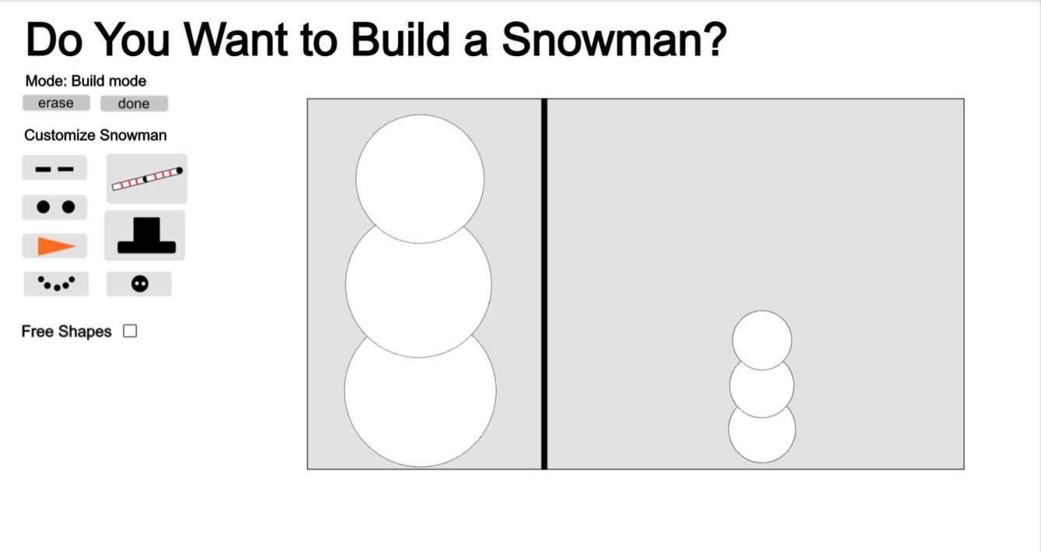

* Enabling free Shapes

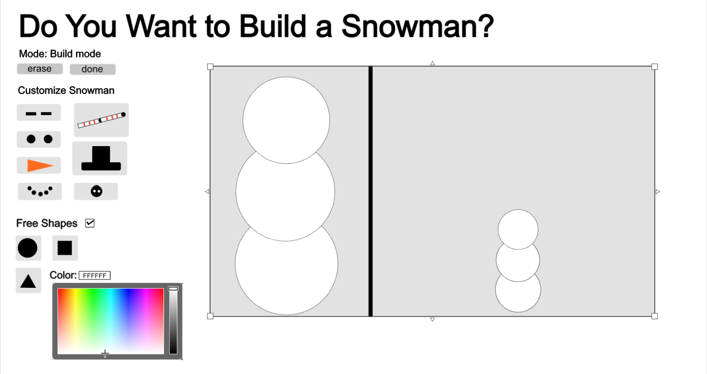

* User direct manipulation

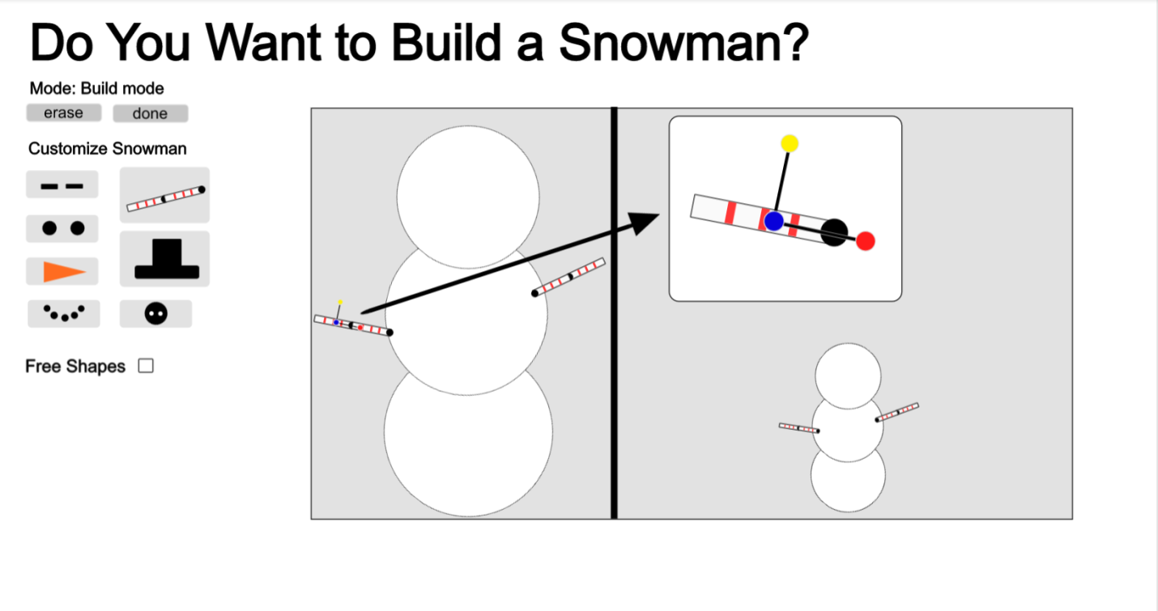

* Game mode after user clicks done

