Jessica Pardo.

Rice University Data Analytics and Visualization Boot Camp

Assignment 1 – Excel: Kickstart My Chart

**Kickstart My Chart Report**

**Background**

Over $2 billion was raised using the massive and successful crowdfunding service, Kickstarter, but not every project has been successful. Of the 300,000 plus projects launched on Kickstarter, only a third have made it through the funding process with a positive outcome.

Getting funded on Kickstarter requires meeting or exceeding the project's initial goal, so many organizations spend months looking through past projects in an attempt to discover tricks for finding success. For this week's homework, the project was to organize and analyze a database of 4,000 past projects in order to uncover hidden trends.

1. Given the provided data, what are three conclusions we can draw about Kickstarter campaigns?

After analyzing the dataset for over 4000 projects, I focused in both the categories and subcategories to determine primarily the success rate which resulted in the following three main conclusions:

1. Music is the category that showed having the highest success rate with 77% followed by Theater with 60%. Both campaigns are outperforming the other campaigns as shown in figure 1.

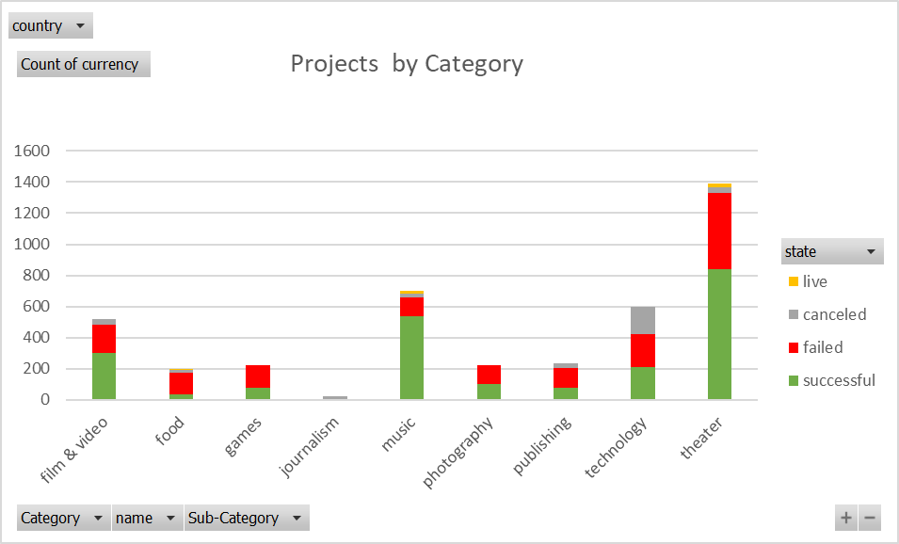

Figure 1. Outcomes by Category

Furthermore, analyzing the sub-categories, the results from figure 2 shows that rock (derived from its parent category, Music) has the highest success rate. Rock outperforms any other sub-category by a big margin confirming that Music is the most successful outcome of the projects analyzed.

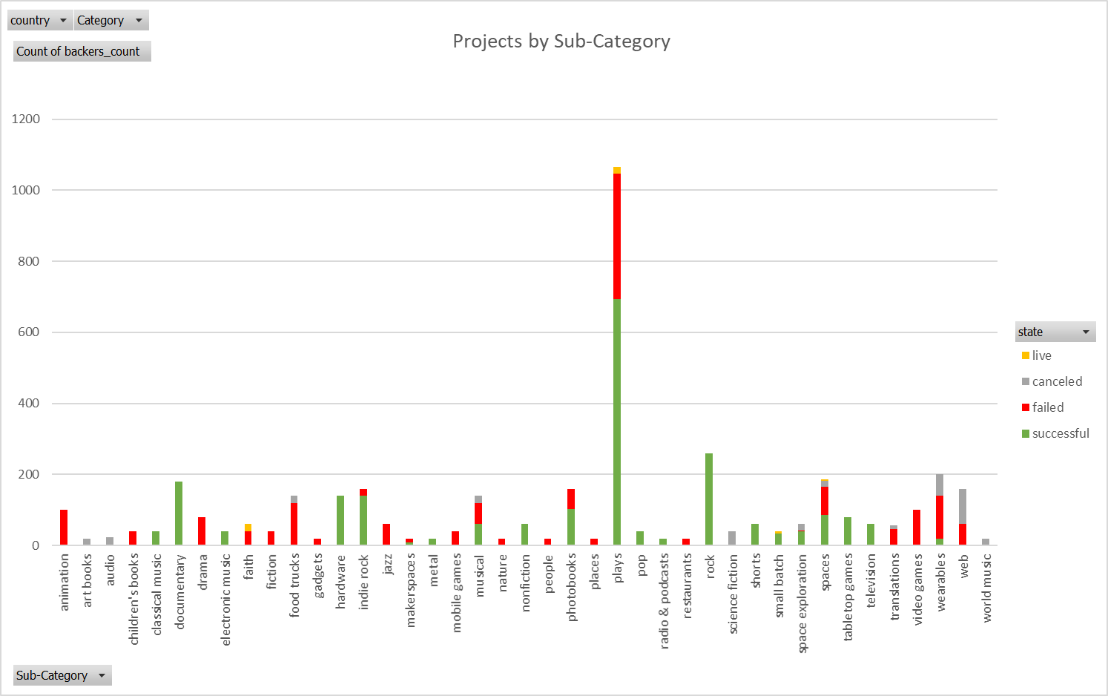

Figure 2. Outcomes by Sub-Category

1. The campaign exhibiting the lowest success rate is food with 17% as shown in Figure 1. Looking closer at the details and its sub-categories, the data shows that the main reason for this category to generate failed results is mainly due to the food trucks (Figure 3).

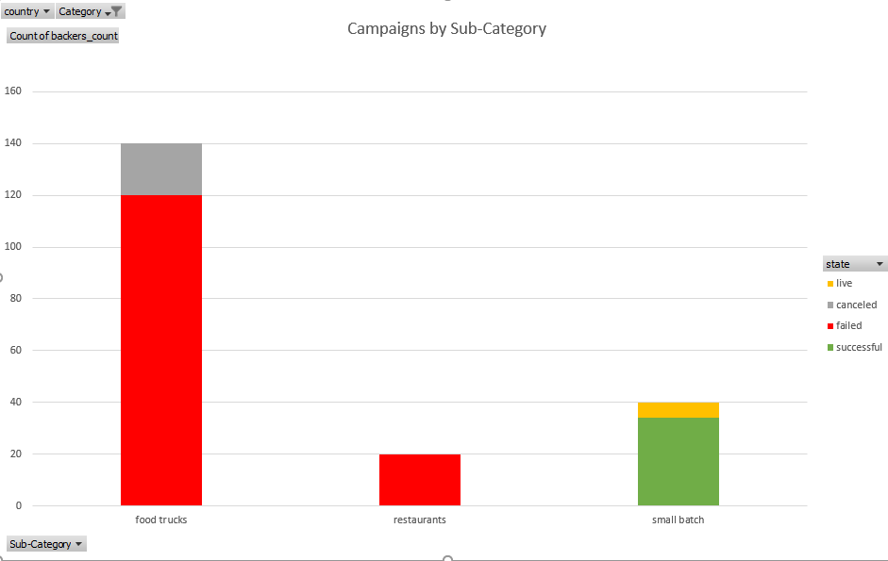

Figure 3. Outcomes by Food Sub-Category

1. Analyzing the data based on the time of the year (monthly) the project was performed, the data shows higher success in projects performed in the first half of the year versus those projects performed in the second half. The most successful month was May and the least successful month was December (Figure 4).

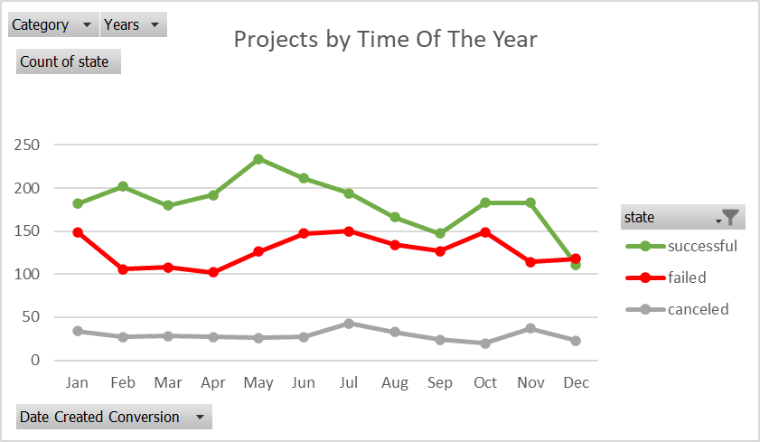

Figure 4. Project outcome by month

2. What are some limitations of this dataset?

* The database analyzes only 4000 projects from more than 300,000 projects launched on Kickstarter which represents a small sample of less than 2% of the total data.
* Uncertainty around which campaigns and sub-categories follows a trend of decreased success due to an increase/extension in the campaign’s goals.
* The database does not show information about geographic location and demographics.

3. What are some other possible tables and/or graphs that we could create?

* Tables showing the most successful categories/subcategories versus the least successful categories/subcategories including detailed data into each category/subcategory’s level of success.
* Tables and graphs that include percentage funded and average donation.
* Tables and graphs analyzing the duration of the projects.