User Manual Part 2 Jessica Payne

Where are you?

Health: 1/2

My health is composed of my mental, emotional, physical, and spiritual well-being. I would say that I am at about a half a tank on all of those traits. I am not where I would like to really be on any of them

Work: 1/4

For work, I feel like I am at a fourth of a tank because I am lacking in my motivation to finish up the current semesters with my classes.

Play: 0

Play is doing anything of enjoyment that I choose to do of my own free will. I am at an empty tank with this because I feel as though I have no time for myself. I hardly can get out of the house for class or a walk.

Love: 3/4

Love is how much love I feel I can give out and how much love I am receiving. I feel like my heart is full and that I am getting a decent amount of love in return. I am not full on this category because my family has been pressuring me about how much time we spend with my husband’s side of the family.

Making a Compass

Workview

Work is something that is required to live because money is required to live. It is something you get paid to do. If you get paid to do something you like, that’s great but work is still required. Work can stave off boredom and idleness. Idleness is not good. Through work, we can learn many valuable character-building attributes. We can learn things like dealing with complicated people, integrity, responsibility, honesty, loyalty, etc. As a society, we have to have people working otherwise we would not be prosperous or get anything really achieved. If we all minded to our own business and did just enough to survive, it would be like the medieval times when there wasn’t any progress or inspiration. Work can be fun but is also a necessity.

Lifeview

We are here on Earth living because of God’s plan to become like him and inherit our rightful place as Gods and Goddesses ourselves. We are here to be tested, tempted, and to make learning mistakes. The relationship between others that we make during this life is to help us become who we need to be. Relationships can show us who we don’t want to be or who we want to be. Children teach us unconditional love as they are needy and don’t express love or give back until they are older. The rest of the world is there to see us succeed and fail, throwing its own unique challenges to each of us. Life is to learn from and most importantly enjoy. Work conflicts on that view sometimes because a work schedule can prevent us from enjoying different events and may teach us sacrifice. We go to work to provide for our life endeavors.

Keep a Good Time Journal

1. I went out to dinner with my husband to a restaurant. It was nice to get away from the baby and have some adult social time, but I also could not keep my mind from wondering to my baby. It was an informal interaction. We made a point to not use our phones during the time we were out. Overall, it was a positive experience.
2. We visited my in-laws for the past week in Twin Falls, Idaho. We had a good time for the most part, but at times I felt like I was walking on glass trying to be the perfect daughter-in-law and mother. We didn’t really go out and do anything to so there wasn’t much structure to our activities. For me it was a positive and a negative experience.
3. I made a complex homemade dinner for my husband for Father’s Day. I felt happy to do something more for my husband that I don’t usually do. I usually just make simple dinners. It was hard to do because I made him something with dairy and I have to be dairy-free to breastfeed my son, so I couldn’t taste the food as I made it to make sure the flavor was good. My husband said that he liked it and it was a positive experience.
4. I went for a walk with my husband. We had a good conversation while we went for a good walk. The temperature was nice, and the breeze was slight, and it was a positive experience for us to spend the time together.
5. I helped my sister-in-law make and post pregnancy announcement pictures. She didn’t really take anyone else’s ideas besides hers and only posted pictures that were just her idea. I helped take the pictures that she had planned out, but she didn’t like any of my suggestions. It was mostly a negative experience.
6. I watched a show with my husband after dinner. He got distracted halfway through and went to his computer which was a moment killer. He started playing games and made me feel kind of abandoned when we were supposed to be spending the time together and he could only spend 10 minutes with me. It was a negative experience.

Mind Map

Walk with Husband

Father’s Day Dinner

Out to dinner

Meal with loved one

Quality Time

Service and Appreciation

Conversation

Mind Map Job Descriptions and Roles

Quality Time: Individual must be able to give undivided attention in a meaningful way through an activity.

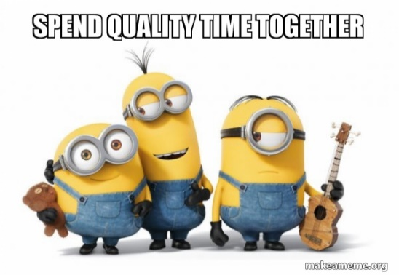

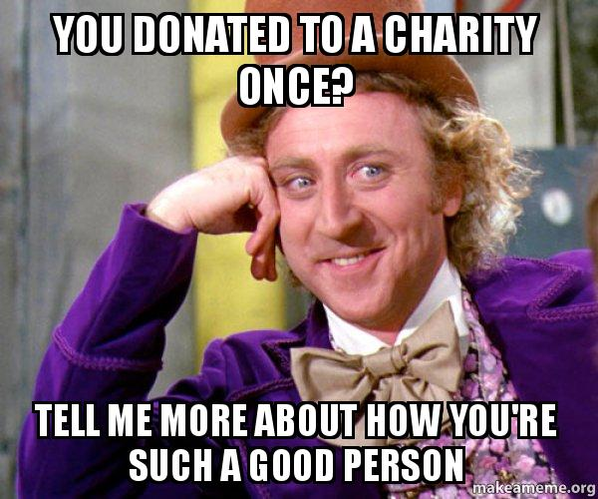 Service: Individual must not think of themselves and do things that would benefit others.

Conversation: Individual must communicate effectively and talk in a two-way conversation for at least ten minutes without getting distracted.

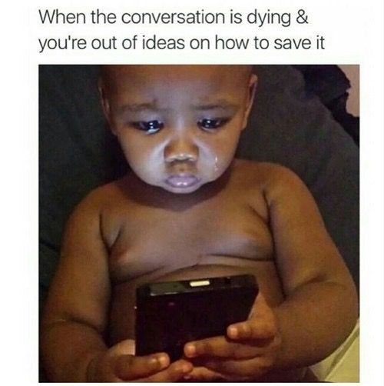

Odyssey Plans

Plan A: Student and Graduate of BYUI

* When will I have time for kids if I am working full time?
* Will I want to go on past a bachelor's degree?
* Would I work until retirement age or stop sooner?

Plan B: Stay-at-home Mom

* Will we have enough money for our family if I do not work?
* Would I homeschool my kids?
* Would I feel unaccomplished and feel stuck in the same routine?

Plan Unlimited: Family Time and Fun Experiences

* Would we get tired of travelling and going and doing things?
* Would we run out of things to do and places to see?
* Would we make our family bigger than originally planned?

|  |  |  |  |  |  |  |
| --- | --- | --- | --- | --- | --- | --- |
| Plans | Year 0- Now | Year 1 | Year 2 | Year 3 | Year 4 | Year 5 |
| Plan A:  Student and Graduate of BYUI | Graduate from college as a software engineer | Get a remote career as a software engineer | Contribute to income and have another child | Move into a new house. | Continue to work and have another child | Evaluate current workplace and see if there is better |
| Plan B:  Stay-at-home Mom | Take care of my child and keep up the housework | Take care of my child and keep up the housework. Have another child | Take care of my child and keep up the housework | Take care of my child and keep up the housework. Have another child | Take care of my child and keep up the housework | Take care of my child and keep up the housework.  Have another child |
| Plan Unlimited:  Family Time and Fun Experiences | Buy a sizable house to live in | Go on fun trips and have lots of experiences this year | Have another child and renovate house/yard | Continue to go on fun trips and raise our kids. | Have another child. Hire a tutor, house cleaner, and cook | Continue to go on fun trips and raise our kids. |