DATA WRANGLING WITH PANDAS PROBLEM 1

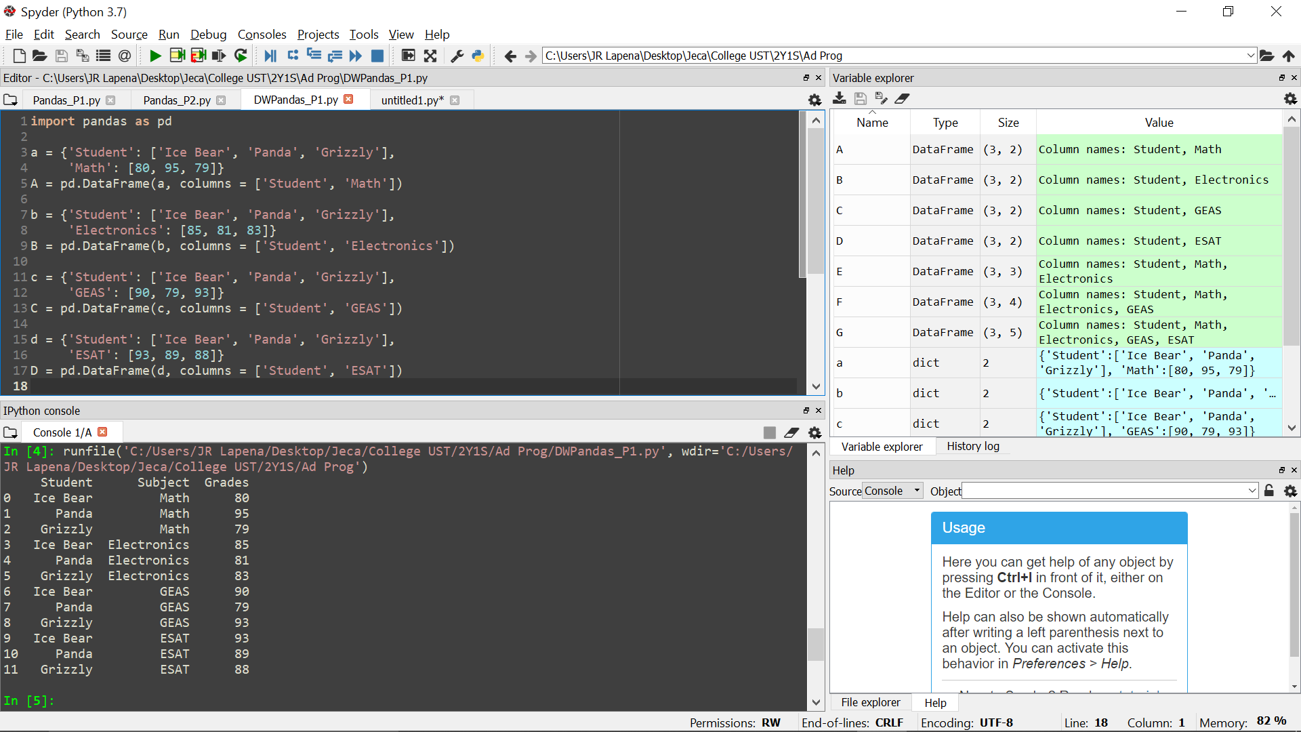

DATA WRANGLING WITH PANDAS PROBLEM 2

