|  |  |
| --- | --- |
| **Lapena, Jessica Ricci A.** | **2ECE-C** |
| **Ting, Andryiel C.** | **ECE2112** |

**MACHINE PROBLEM 1: MATLAB**

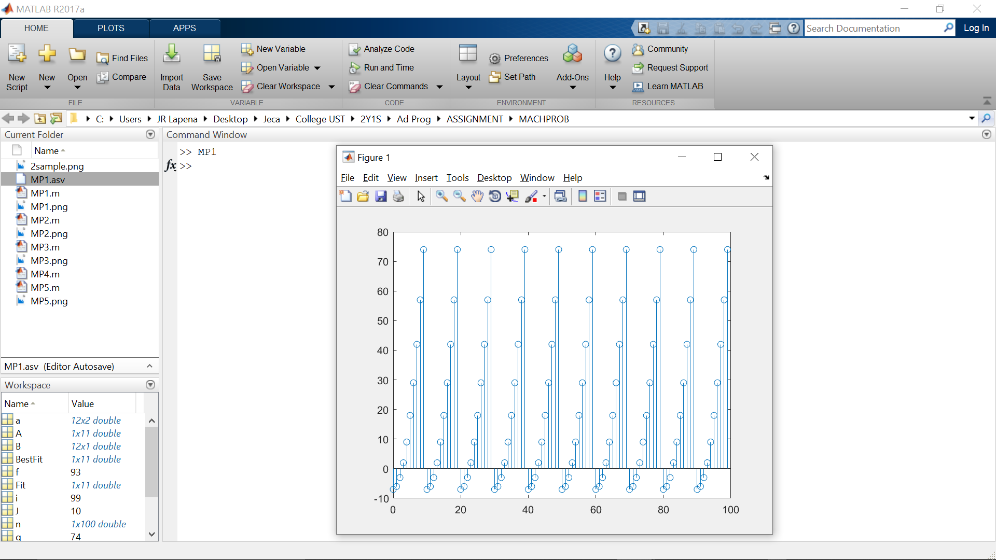

The graph above has shown that the x-coordinates are equally distanced having an increment of one, while the y-coordinates ranges from -7 to a certain value of 74. It is a cycle that repeats once the y-coordinate reaches the peak value between 74 then it will return to the value between -7 once again.