Module 03 Lab 01 Alternative

Jessica J. Scharber

Rasmussen College

Author Note

Submitted to Professor Syed Nabeel for Microsoft C# Programming class, on 11/25/18.

Tutorial: Get started with ASP.NET Core

# Create a web app project –

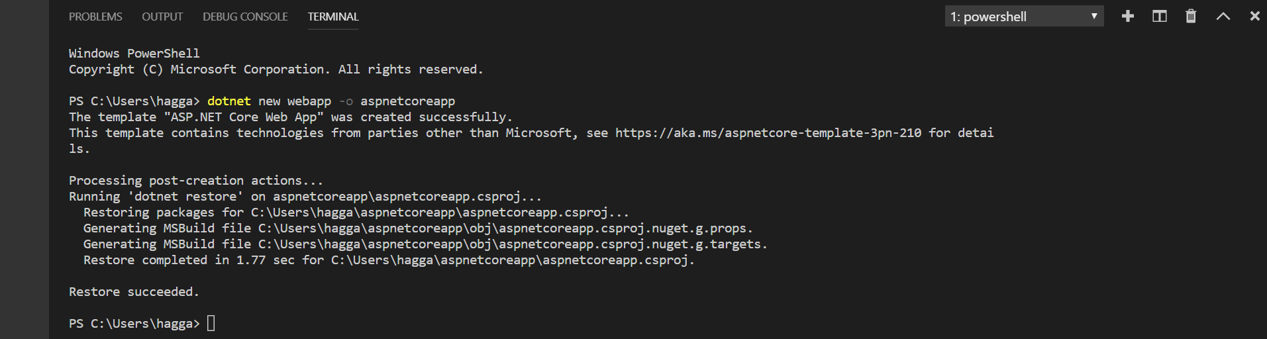

# Enable local HTTPS –

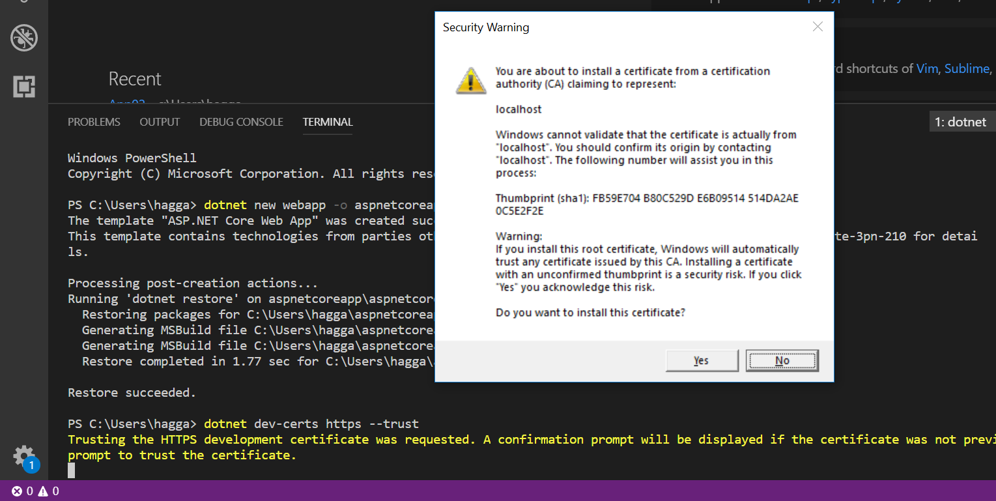

# Run the app –

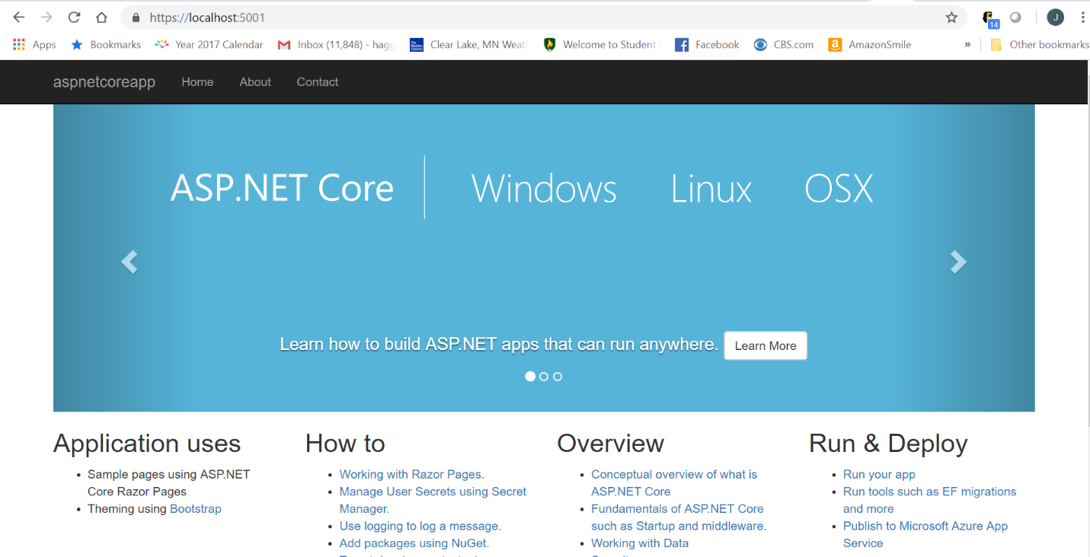

# Edit a Razor page –

