Module 03 Lab 02 Alternative

Jessica J. Scharber

Rasmussen College

Author Note

Submitted to Professor Syed Nabeel for Microsoft C# Programming class, on 11/25/18.

# Get started with ASP.NET Core MVC and Visual Studio

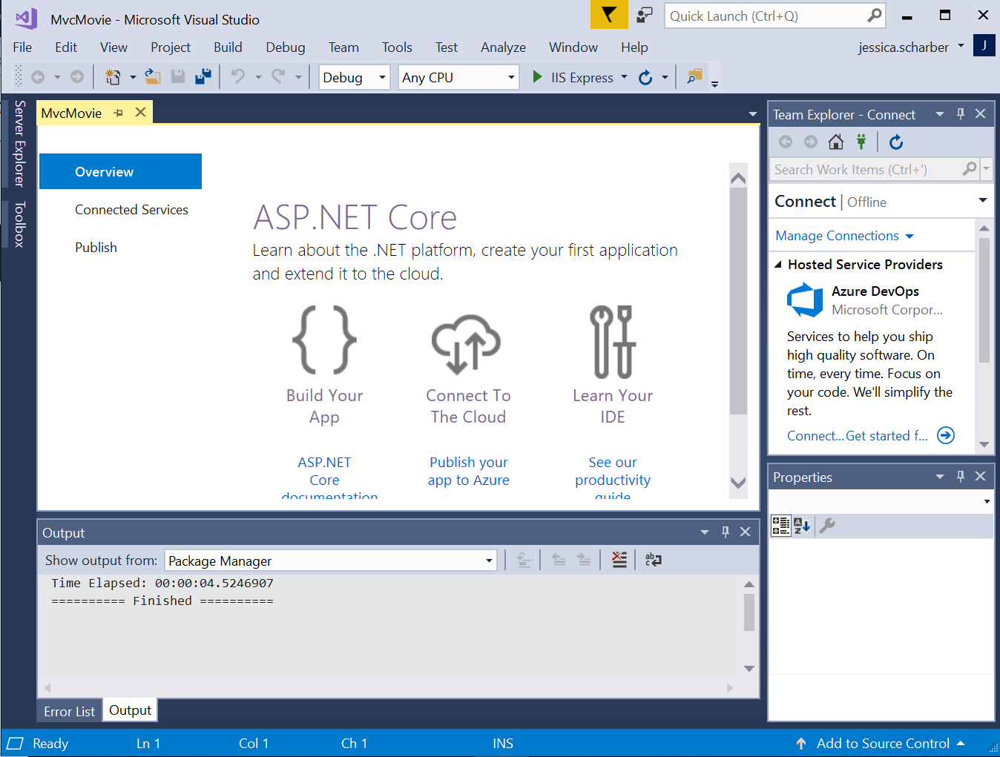

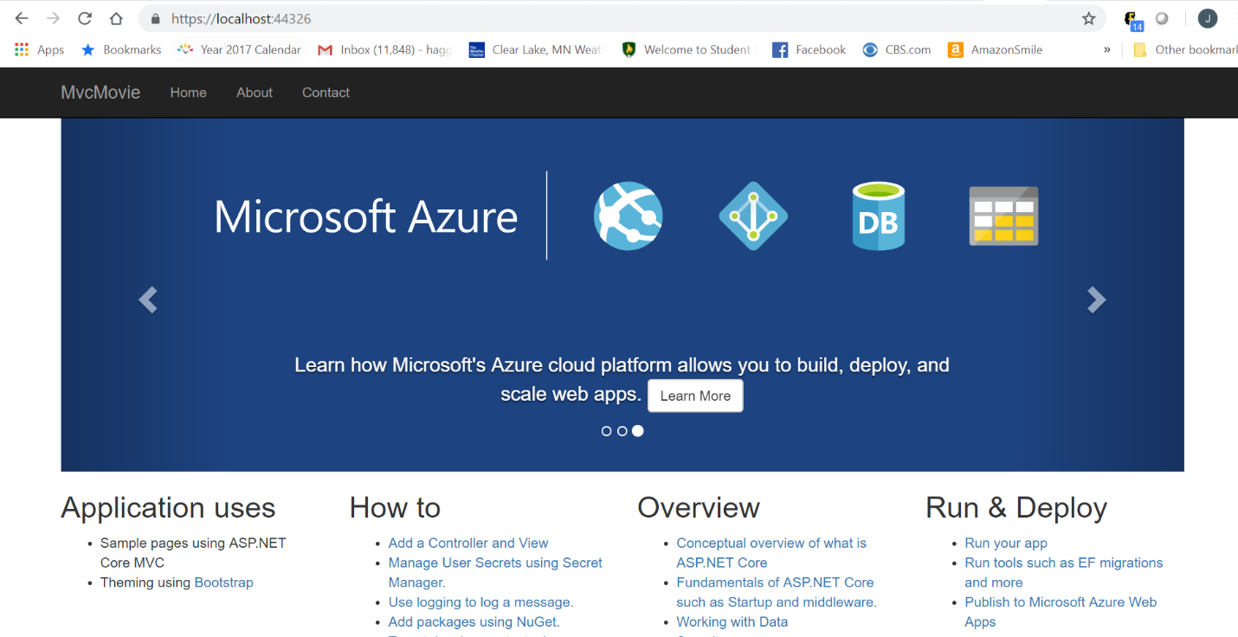

# Add a controller to an ASP.NET Core MVC app

# 

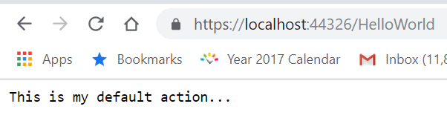

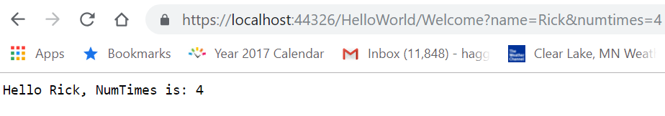

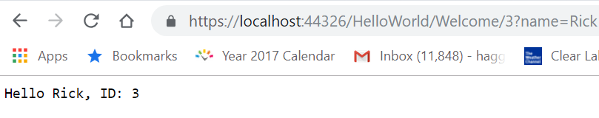

# Add a view to an ASP.NET Core MVC app

# 

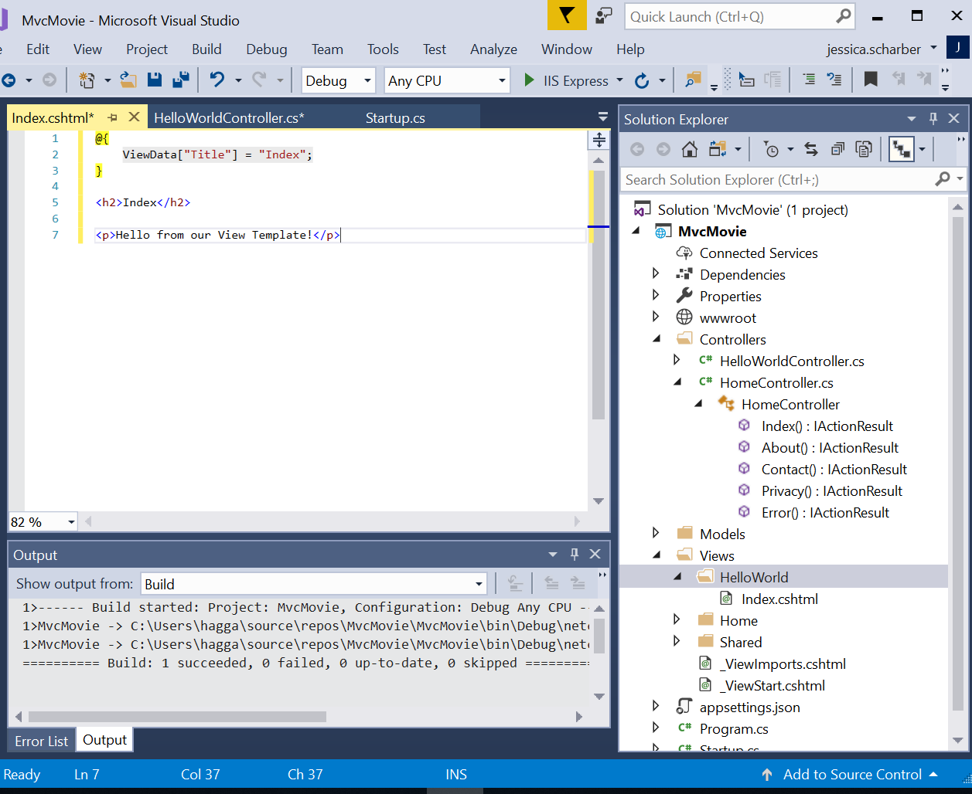

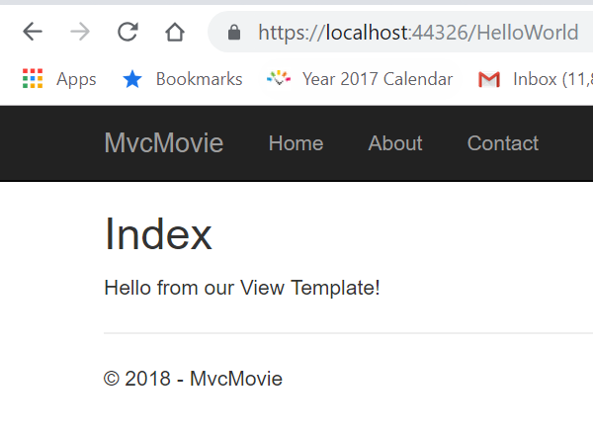

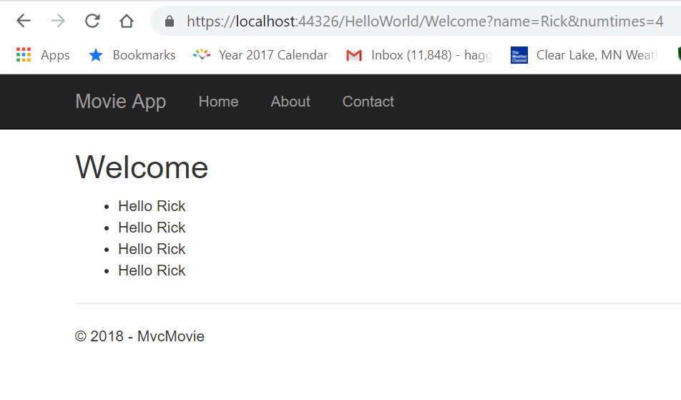

# Add a model to an ASP.NET Core MVC app

# 

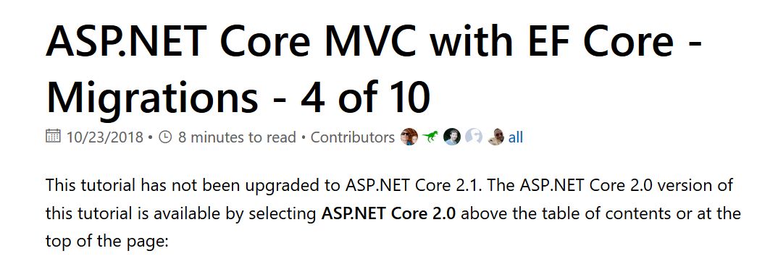

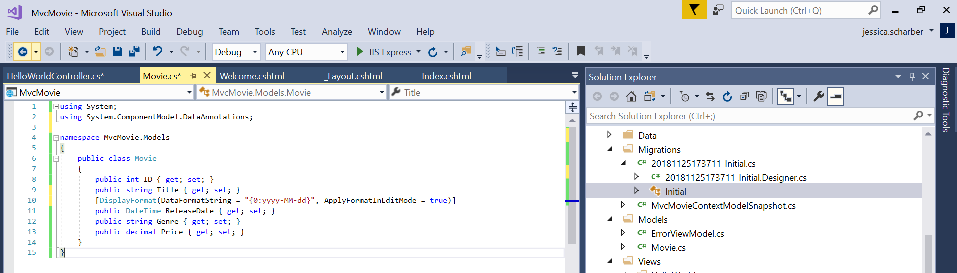

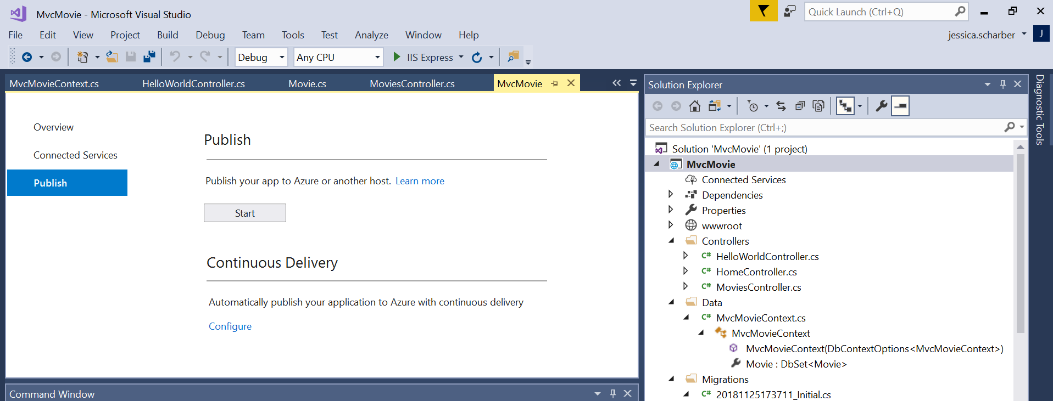

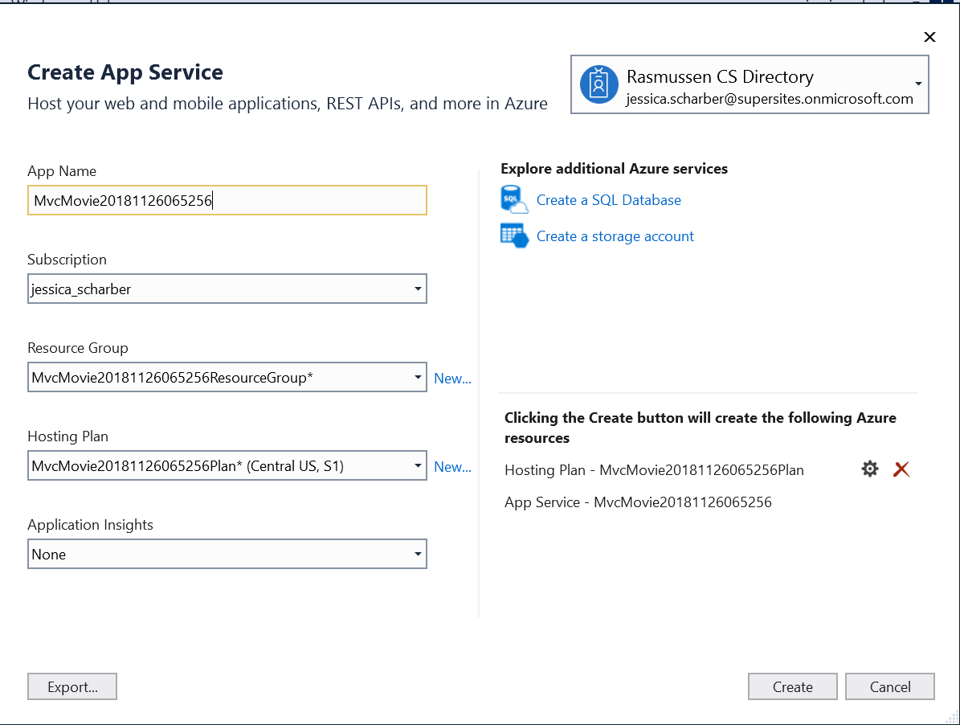

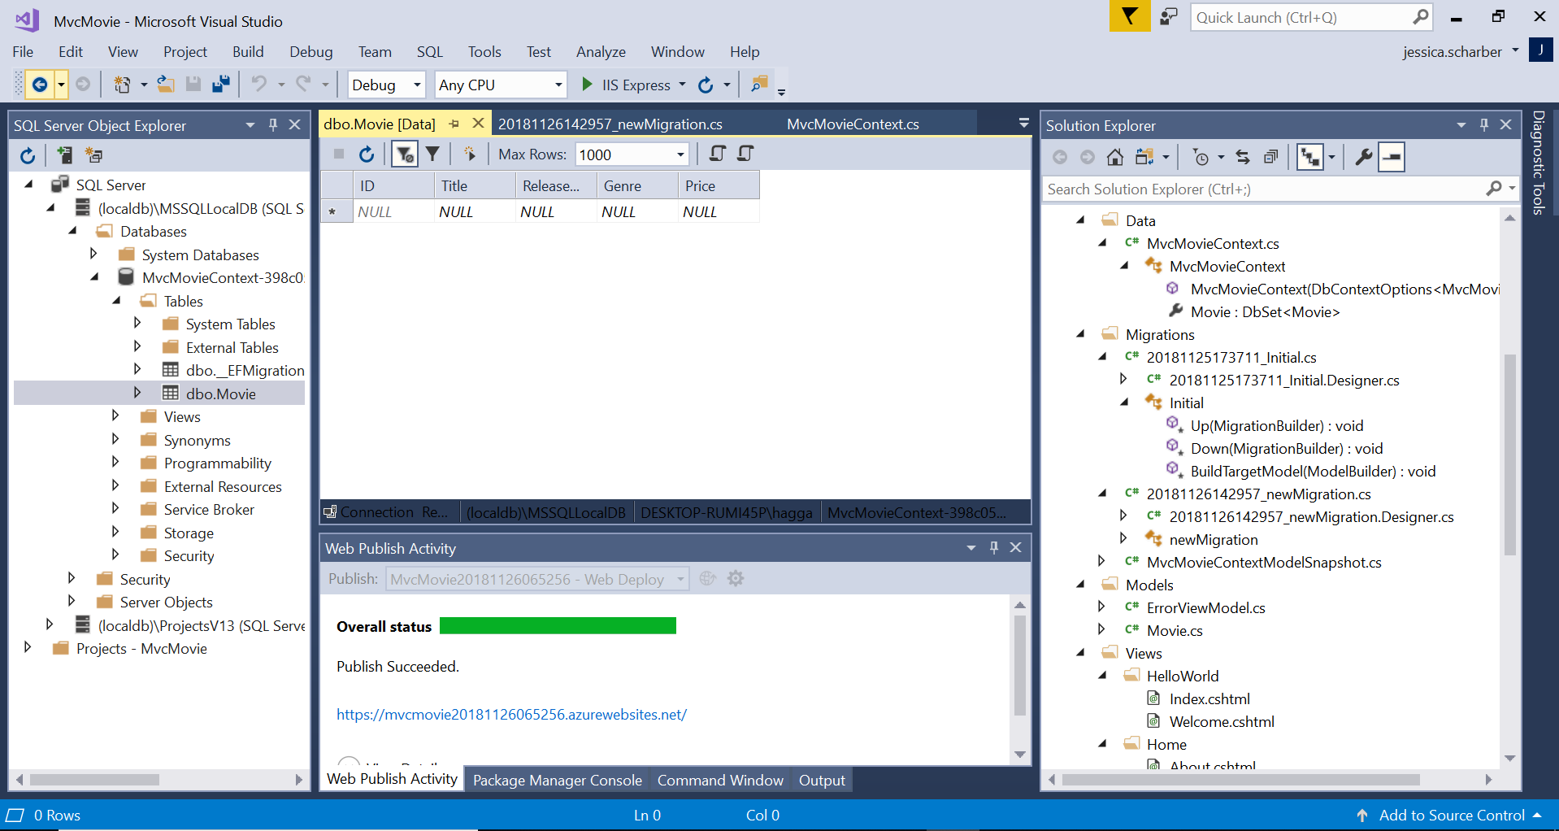

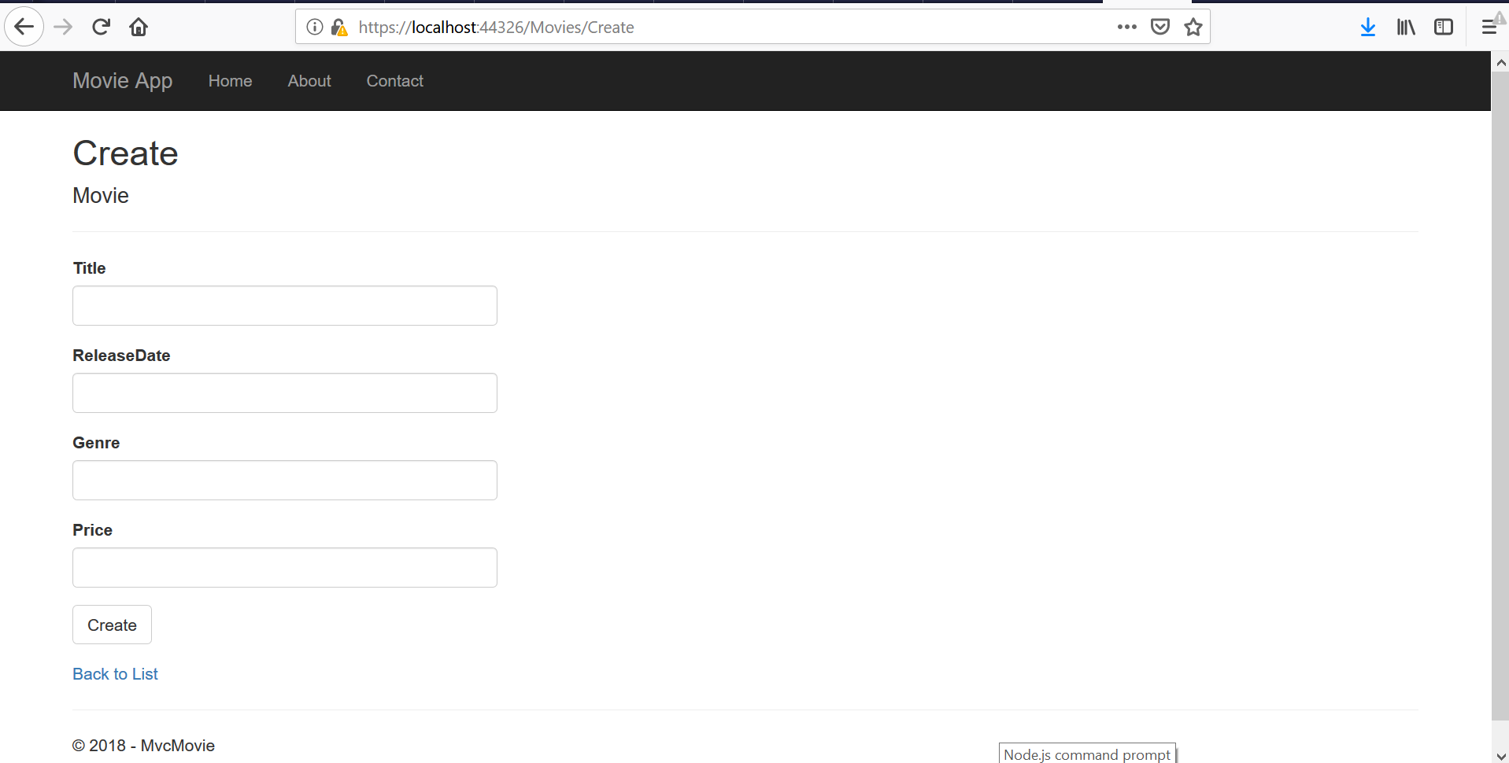

# Work with SQL Server LocalDB in ASP.NET Core

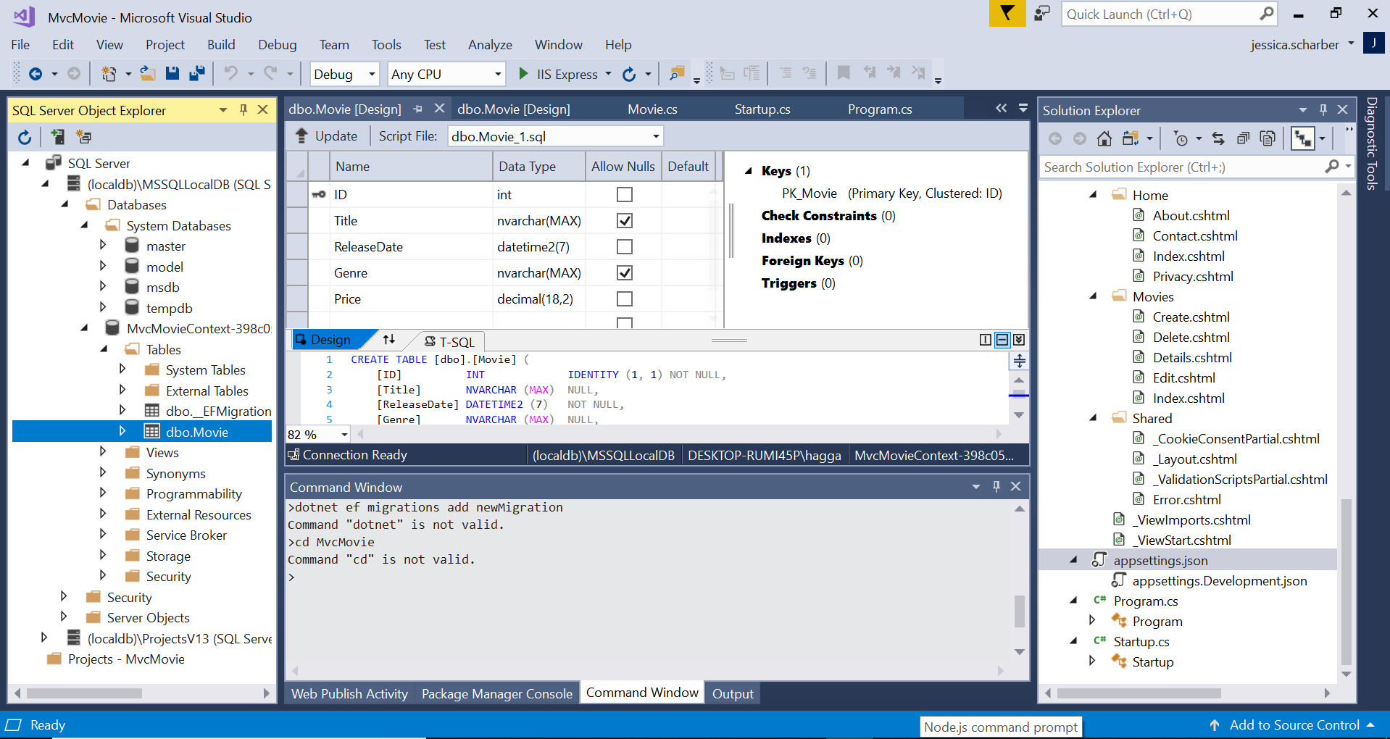

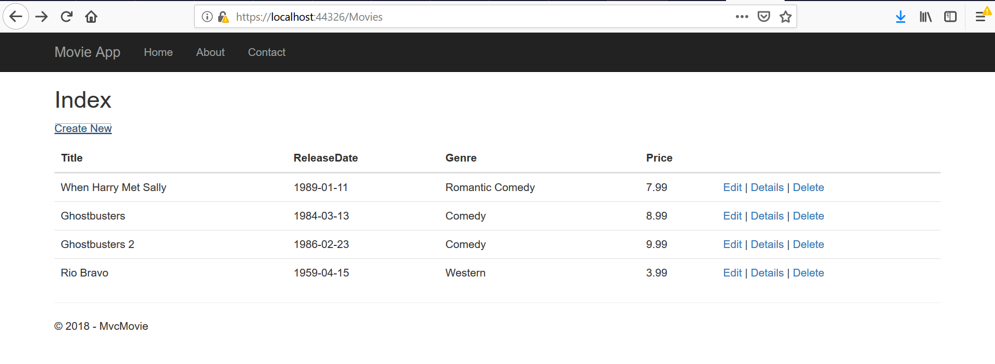

# Controller methods and views in ASP.NET Core

# 

