**‘WeRateDogs’ Twitter archive data visualization and insights**

Jessica Sarah Stow | [stowjess@gmail.com](mailto:stowjess@gmail.com)

*ALX-T Udacity Data Analytics 2022 student*

**Data visualization:**

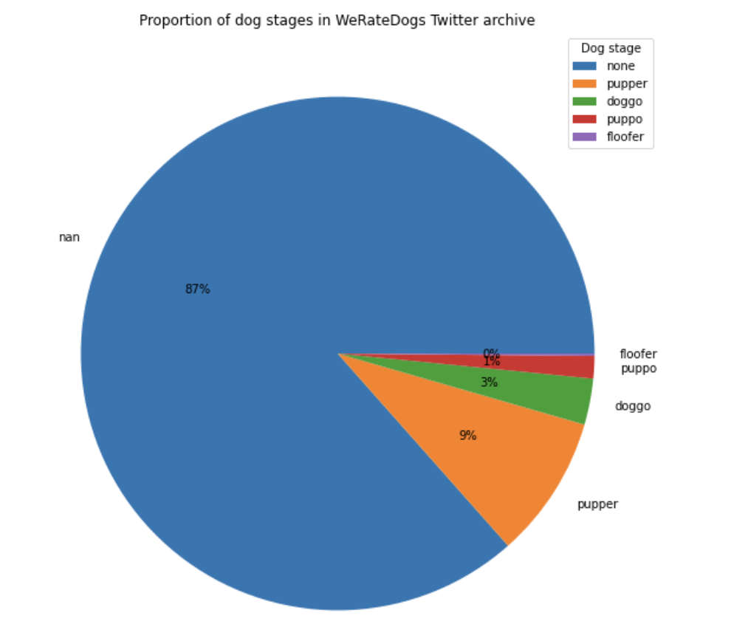

*Pie chart 1: Proportion of dog stages in WeRateDogs Twitter archive*

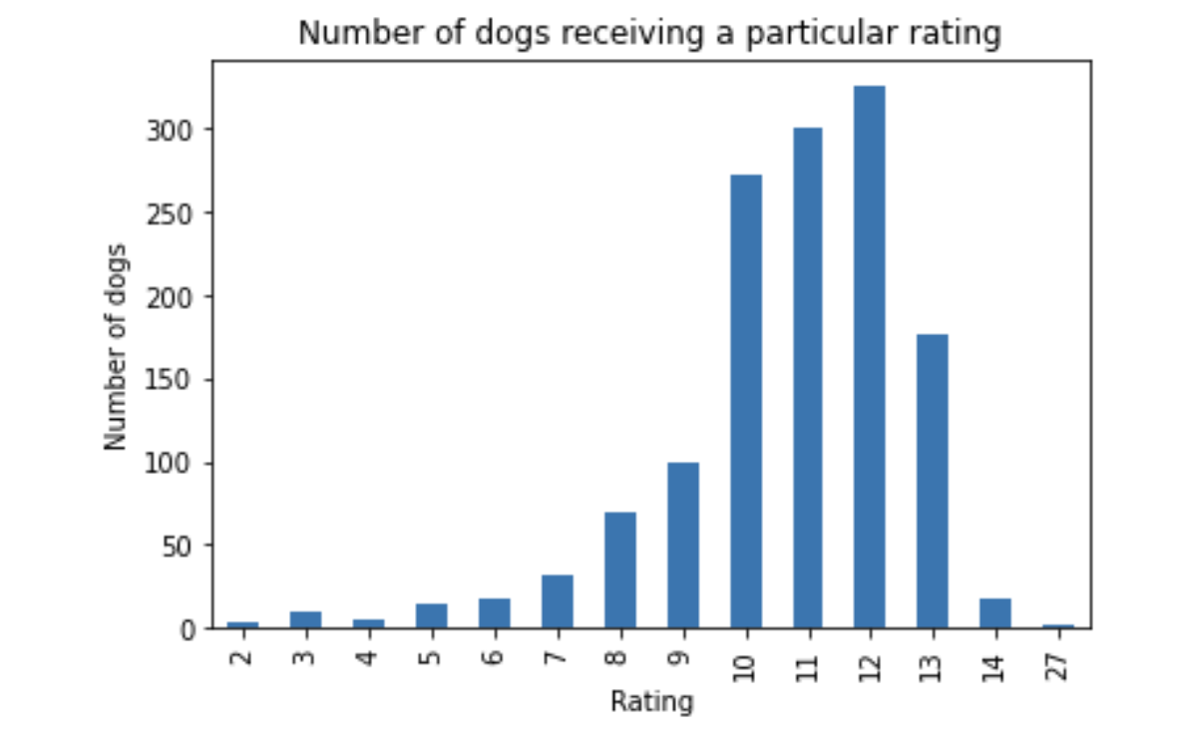

*Bar chart 1: Number of dogs receiving a particular rating*

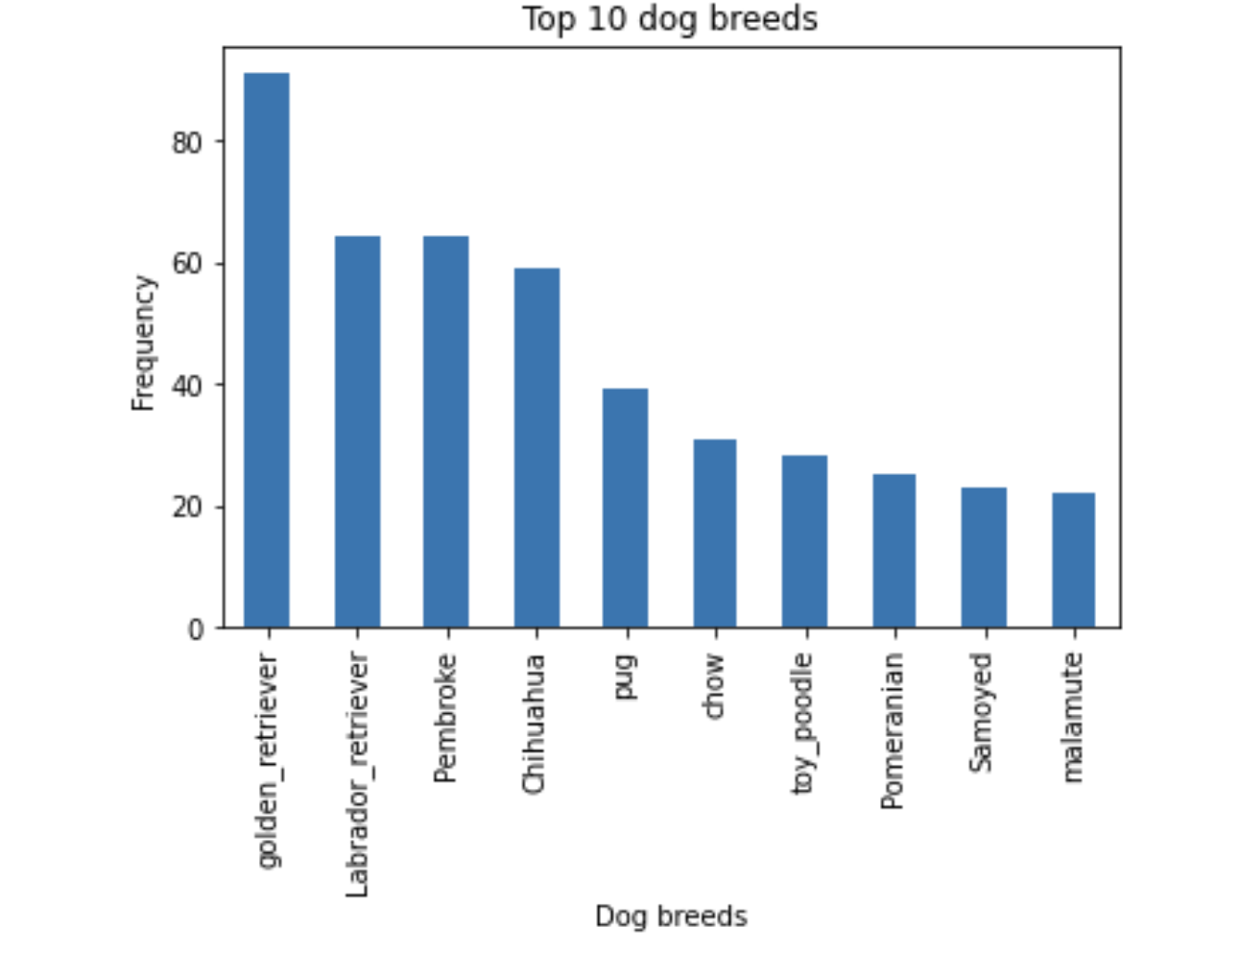

*Bar chart 2: Top 10 dog breeds*

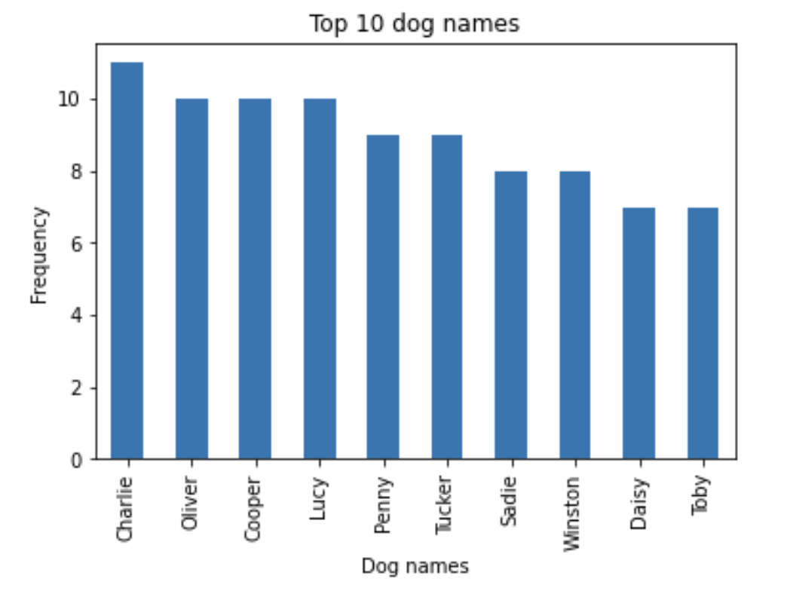

*Bar chart 3: Top 10 dog names*

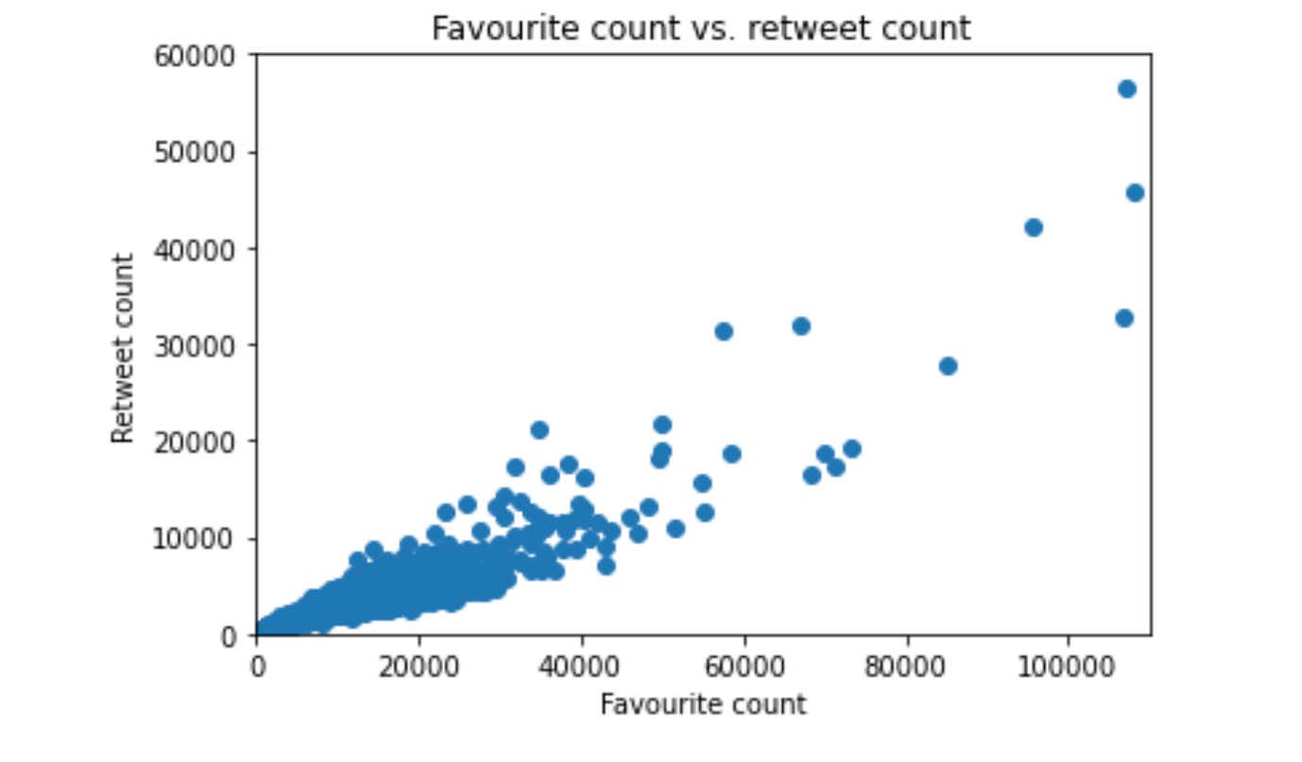

*Scatterplot 1: Favorite count vs. retweet count*

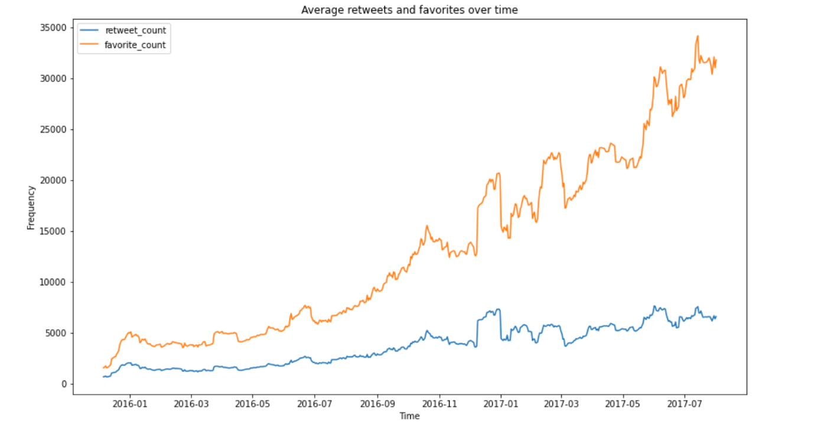

*Line graph 1: Average retweets and favorites over time*

**Insights:**

**From my brief analysis and data visualization I can conclude that, for the WeRateDogs Twitter archive:**

1. Most of dogs were not classified into a specific dog stage (*Pie chart 1*). Apart from those not classified, the most popular dog stage was ‘pupper’.
2. The most popular rating for dogs was 12/10; there were 326 dogs that received this rating (*Bar chart 1*).
3. The most popular dog breed posted is the golden retriever (91 posts with golden retrievers), followed by Labrador retrievers (64) and Pembroke (64) (*Bar chart 2*).
4. The most popular dog name is ‘Charlie’ (11 dogs), followed by ‘Oliver’, ‘Cooper’ and ‘Lucy’ (each had 10 dogs with the name) (*Bar chart 3*).
5. There is a positive relationship between retweet counts and favorite counts, so it is fair to assume that if a tweet has a high retweet count, it should also have a high favorite count (*Scatterplot 1*).
6. Dogs with ratings of 13/10 had the highest total favorite (4 147 381 total favorites) and retweet count (1 129 025 total retweets).
7. The most popular tweet by favourite count was tweet_id #879415818425184262 (107 956 favorites).
8. The most popular tweet by retweet count was tweet_id #807106840509214720 (56 625 retweets).
9. Dogs with a rating of 14/10 had the highest average retweet count (average of 10 702 retweets per tweet) and highest average favorite count (average of 32 852 favorites per tweet).
10. 11 January 2017 had the highest number of retweets (71755) and favorite counts (171062) in a single day.
11. Over time, the average favorite count for each WeRateDogs tweet steadily increased.
12. Over time, there was a slight increase in the average retweet for each WeRateDogs tweet over time.