Technical Report: Virtual Agent Data Pipeline & Training Architecture
1. Variable Architecture (Input/Output)
The data is structured into three main categories using an "Egocentric" approach. The model does not view the boat and the players from a global, top-down perspective; instead, it "embodies" a specific seat (the Self). The input variables (43 channels in total) are divided into three tensors:
- Endogenous Variables (8 channels): These represent the kinematics (arm extension). Channel 0 is always dedicated to the Self player (the target to be predicted). Channels 1 to 7 contain the movements of the other teammates (Others). If a seat is empty, a placeholder padding of -1.0 is applied.
- Exogenous Variables (19 channels): These define the environment surrounding the boat and the gameplay inputs. They include:
  - Global position and rotation (Bow X, Z, and Boat Angle)
  - Metronome Frequency (Hz)
  - Team Score (the current performance of the group)
  - Props (Attractors and Distractors - dX, dZ) where d means the distance between the bow and the attractor or distractor.
  - Raycast distances from the riverbanks (5 Rays x 2 Axes: dx, dz)
- Conditional Variables (16 channels): Static features including the rowing side (RowSide: right 0 /left 1) and the 3D player generation point (SpawnPoint) for all 8 seats.
Target (Output): The network predicts the future distance (arm extension) of the Self.
2. Normalization Strategy
I opted for a Physical Scalar Normalization within the [0 1] or [-1 1] range. Human kinematics in VR have absolute physical limits that do not depend on the statistical sample. For instance, the arm extension is divided by the subject's maximum arm length, yielding a standardized extension percentage [0 1]. Similarly, the raycast distances are divided by the limit of the Unity engine (e.g., 200 meters). This ensures that the network learns real geometric proportions and allows us to natively handle missing players (assigned the impossible physical value of -1.0, which the network should learns to ignore).
The data are sampling at 30 Hz.
3. Dataset Extraction and Data Augmentation
To extract the data, we use a sliding window approach with a Lookback of 100 frames (3.3 s) and a Horizon of 25 frames (833 ms). Instead of extracting global samples I implemented an Egocentric Translation Data Augmentation. For every time step T, the algorithm places each real player on Channel 0 (Self) in turn, shifting the others to the peripheral channels (Others). This forces the neural network to evaluate the exact same scene from multiple, independent points of view, multiplying the dataset size by the number of active players without creating artificial redundancy.
4. Partitioning and Shuffle
- Sequential Split: The data was cut in strict chronological order for each single player and each single session (70% Train, 15% Validation, 15% Test).
- Dataloader Shuffle: Shuffling occurs exclusively in the RAM (via PyTorch DataLoader with shuffle=True) at the beginning of each Epoch, and only for the Training Set. This prevents the network from memorizing the macro-sequence of the match, forcing it to generalize the physics from the context.
5. Model Architecture and Training
The model employed is the Patch Transformer Encoder-only. Instead of evaluating all 100 frames individually, the time series is divided into "patches" with length=10.
Loss Function and Early Stopping: At each step, the GPU processes a batch of 2048 samples (batch size) in parallel. For each sample, I calculate the Mean Squared Error (MSE) point-by-point between the 25 frames of the predicted Horizon ($\hat{Y})$ and the 25 frames of the real trajectory $(Y)$. Squaring the error ensures positive numbers and heavily penalizes diverging trajectories. The Batch Loss is the arithmetic mean of these 2048 squared errors, which is then backpropagated to update the Transformer's gradients.
An Epoch is complete when the network has seen all 52,411 training samples. At the end of each Epoch, the weights are frozen, and the MSE Loss is evaluated on the Validation Set. The Validation Set acts as a beacon: if the Training Loss decreases but the Validation Loss starts to rise, the model is entering Overfitting. An Early Stopping system monitors this Validation Loss and, if it fails to establish a new minimum for N consecutive epochs (patience=100), the training is halted to preserve the model's generalization capabilities.
6. Experimental Results & Complexity Tuning
During the optimization phase, I conducted a study testing three architectural sizes of the Patch Transformer to find the best trade-off between complexity and generalization. The smallest model outperformed the larger ones.
- Model A (Lightweight): d_model=32, num_layers=2, n_heads=4, dropout=0.2, patch_len=10
  - Test Loss: 0.0338 (Best performer, perfectly captured the underlying physics).
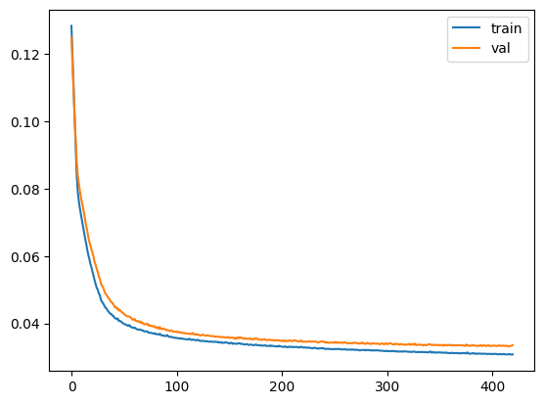
- Train loss: 0.030792431093943425
- Val loss: 0.03355811969103182
- Test loss: 0.03385409252608523

- Model B (Medium): d_model=64, num_layers=4, n_heads=8, dropout=0.25, patch_len=10
  - Test Loss: 0.0346 (Slight performance degradation).
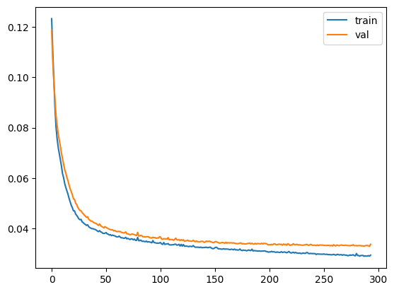
- Train loss: 0.0294142345396372
- Val loss: 0.03367717859937864
- Test loss: 0.034696085597662366

- Model C (Heavy): d_model=128, num_layers=6, n_heads=8, dropout=0.3, patch_len=5
  - Test Loss: 0.0382 (Worse performance, triggered premature Early Stopping due to overfitting on micro-movements).
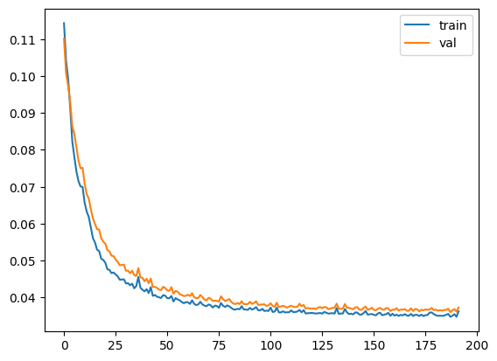
- Train loss: 0.0363229461109791
- Val loss: 0.03731584866695544
- Test loss: 0.03825029500705354

The "Forced Regularization" Test
To verify if Model C was simply overfitting, we attempted to strictly regularize it by increasing the dropout to 0.4 and dropping the Learning Rate to a very conservative 1e-5. The result was a severe performance collapse (Train Loss: 0.061, Val Loss: 0.067, Test Loss: 0.071).

