Relational Algebra

Given the following set of tables:
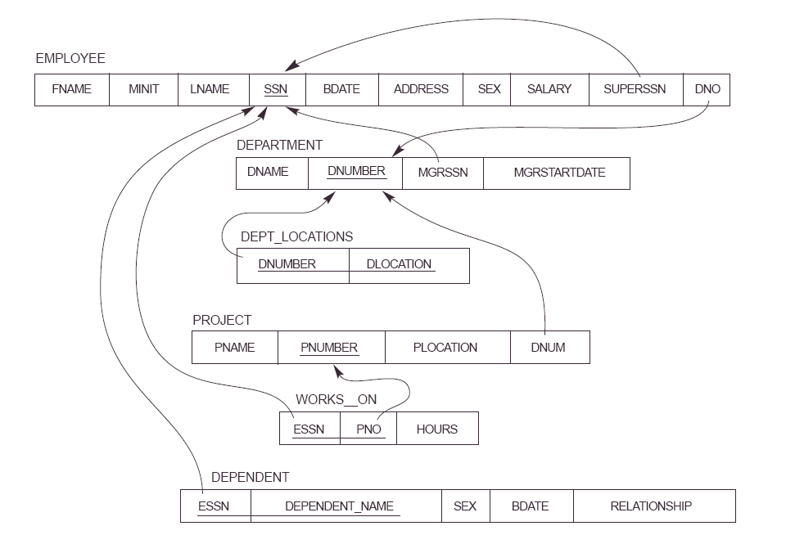

You can use the Relational Algebra Calculator to test your code
https://dbis-uibk.github.io/relax/calc.htm

(1) Retrieve the names (fname,lname) of employees who work more than 10 hours per week on the 'ASTU' project. (“ASTU” is project name.)

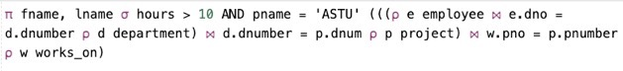

(2) Retrieve the names (fname, lname) of all employees who work on at least one project.

(3) Retrieve the locations of “CPE” department. (“CPE” is department name).

(4) Find the name (fname,lname) of the direct supervisor of “Mary Smith”. (“Mary Smith” is an employee).

π _{fname,lname} σ fname = 'Mary' and lname = 'Smith' ( ρ _{e} employee ⨝ _{e.ssn = d.mgrssn} ρ _{d} department )

5) Draw the query tree for question #4

