Jessica Walsh

CMPSC 221

Professor Zhu

29 April 2019

Final Project Part 2 Report

1. Index.xhtml

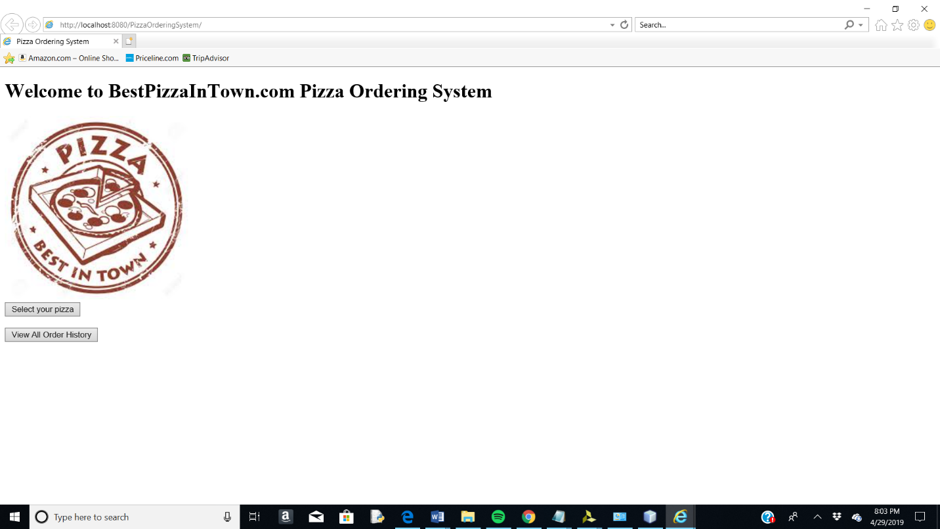

1. Orders.xhtml

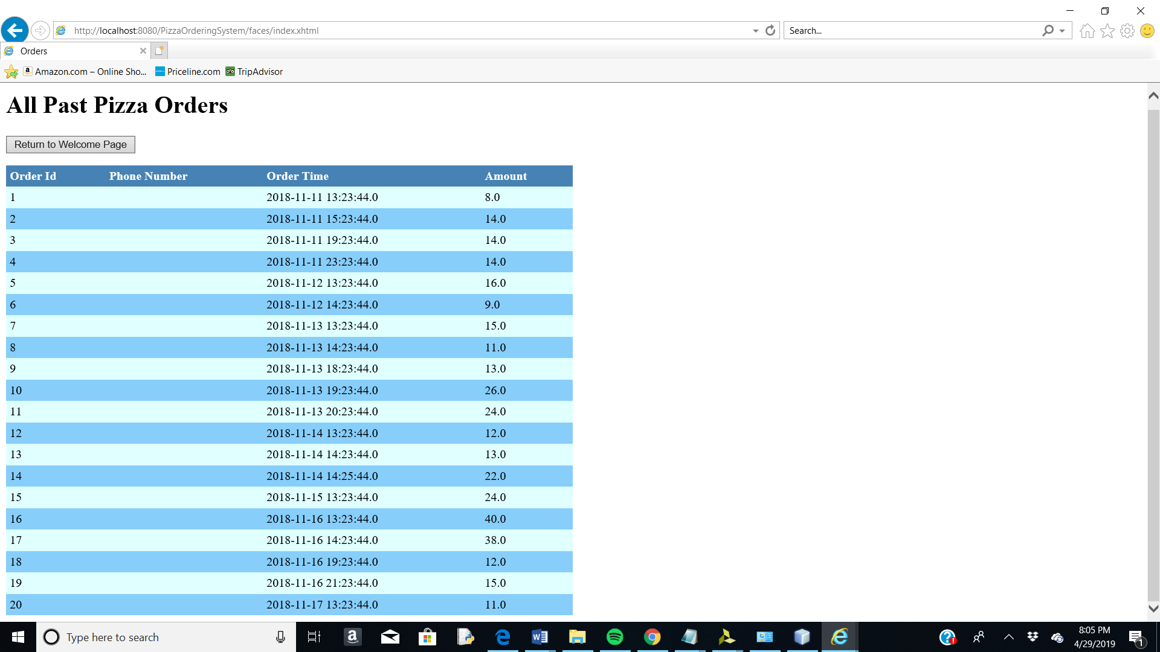

1. Selectpizza.xhtml

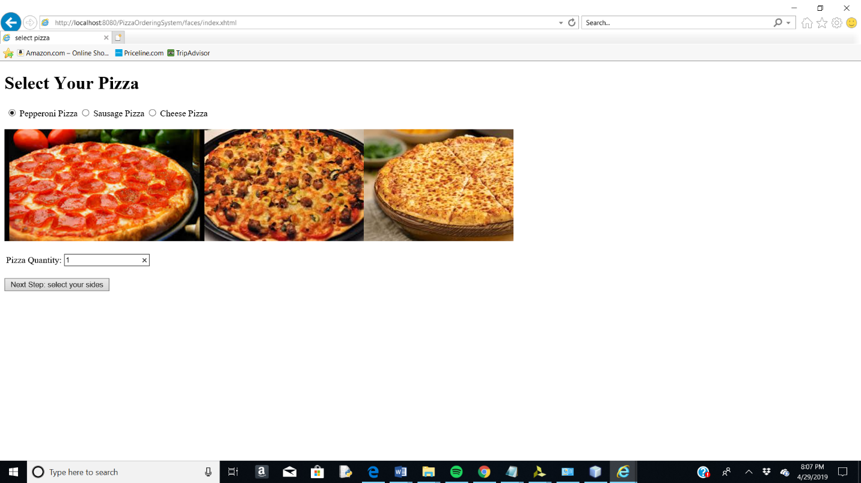

1. Selectsides.xhtml

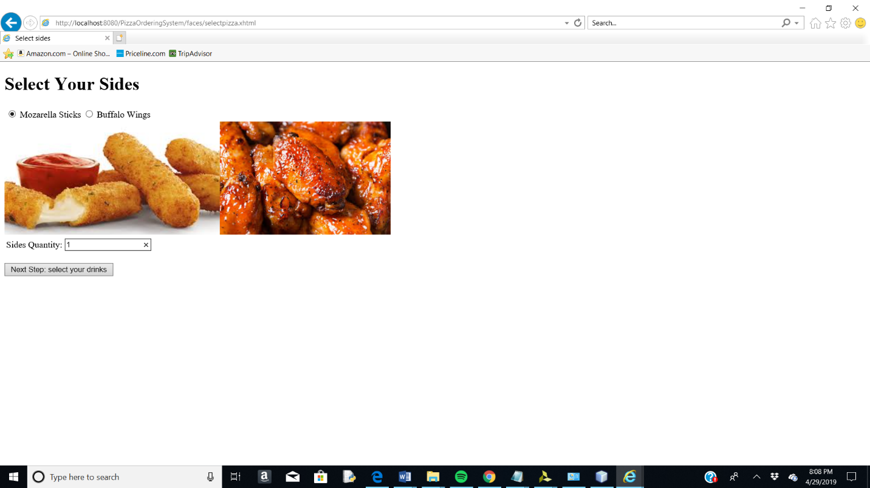

1. Selectdrink.xhtml

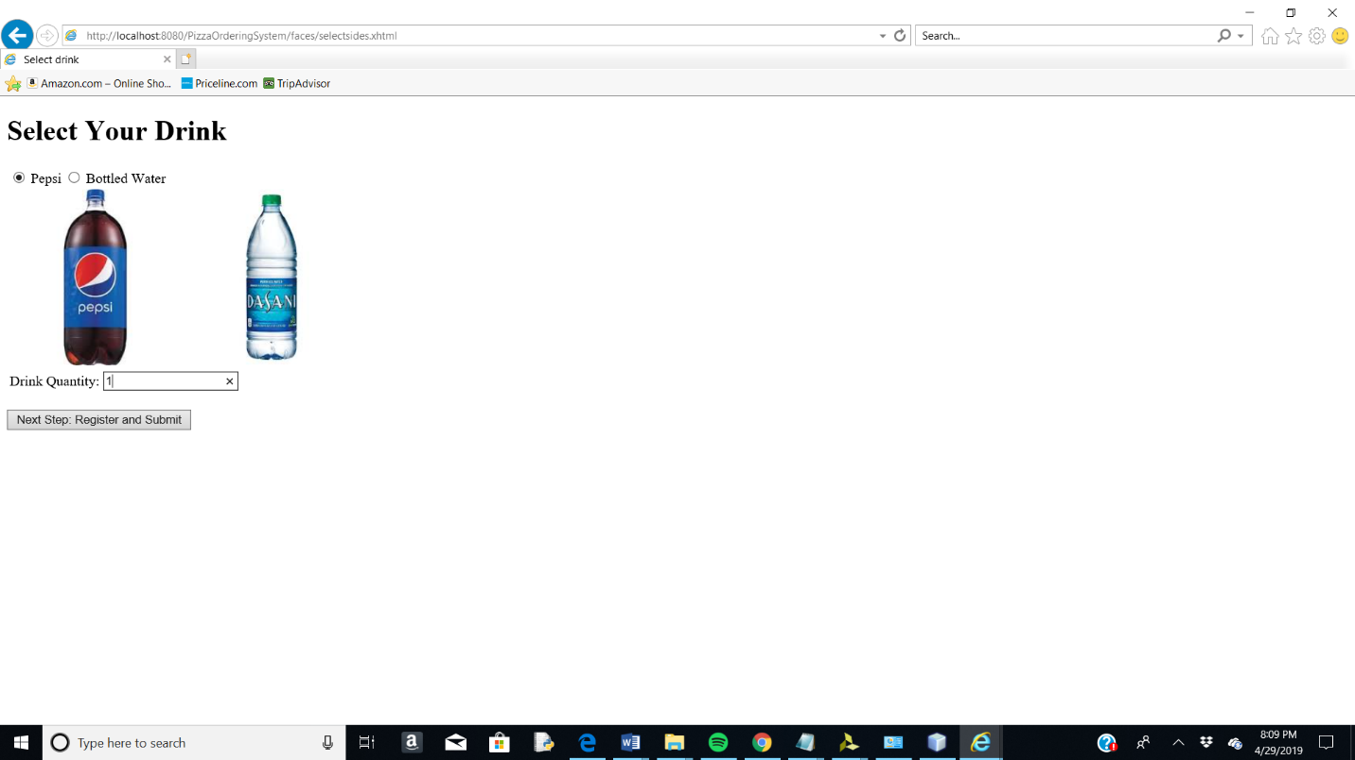

1. Regsiter2submit.xhtml

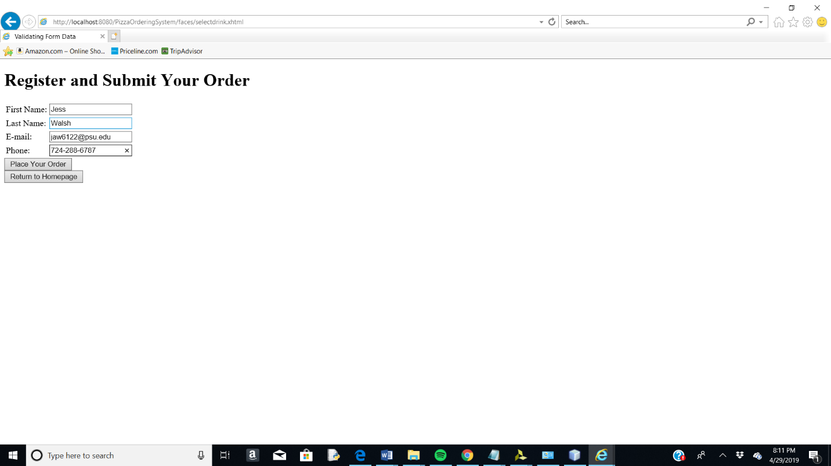

1. Updated order table

