02b_beeParasite_ExploratoryAnalysis

Jessie Dodge

2024-05-24

# Library

source(file="01i_beeReproDev_MasterData.R")

# Questions

Q1) How does landscape and climate variation affect bee parasitism? * Proposed analyses: MLRs ** Parasite abundance ~ Year + Hab + Landscape + Climate + Floral ** What variables to include? ** Predictor vars to include in stp-wise model: <https://journals.lww.com/picp/fulltext/2017/08030/Common_pitfalls_in_statistical_analysis__Logistic.9.aspx> 1) what vars have a sig, univariate relationship (P < 0.1) 2) Avoid highly correlated variables

Q2) How does parasitism abundance affect bee fitness traits? * Proposed analyses: SLRs ** bee % ~ parasite % ** bee abundance ~ parasite abundance ** bee mass ~ parasite abundance (2021) ** F% ~ parasite abundance (2021)

# Data org

# To add labels for sites sampled both years  
data<-data %>% group_by(Site) %>%  
 mutate(Year2 = n_distinct(Year)) %>%   
 #mutate(Year3 = as.factor(ifelse(Year2 == 2, "B", "")))  
 mutate(Year3 = as.factor(ifelse(Year2 == 2, Site, "")))  
  
data<-data[,c(1:5,77:78,6:76)]  
  
# omit site with no provisioned cells - zeros omitted (zo)  
zo.data<-filter(data, nTotProvised > 0)  
  
# for count/weight data  
## all  
or.data <- filter(zo.data, oligRatio > 0)  
w.data <- filter(zo.data, avgOligMass_mg > 0)  
fw.data <- filter(zo.data, avgOligFMass_mg > 0)  
mw.data <- filter(zo.data, avgOligMMass_mg > 0)  
lw.data <- filter(zo.data, avgOligLarvMass_mg > 0)  
  
# remove T. stan outlier  
zo.data.or <- filter(zo.data, nTstanCells < 10)  
fw.data.or <- filter(zo.data, nTstanCells < 10 & avgOligFMass_mg > 0)  
#or.data.or <- filter(or.data, nTstanCells < 10)

# General

For significantly different variables between years ## Field days between years

zo.data %>% group_by(Year) %>%   
 summarise_at(c("FieldDay", "DD_accumulated"),   
 list(mean = ~mean(.), se = ~ sd(.)/sqrt(length(.))), na.rm = TRUE)

## # A tibble: 2 × 5  
## Year FieldDay_mean DD_accumulated_mean FieldDay_se DD_accumulated_se  
## <fct> <dbl> <dbl> <dbl> <dbl>  
## 1 2020 62.6 1215. 2.53 67.7  
## 2 2021 36 429. 0 11.8

## Sites with 0 provisions or bee broods

data %>% group_by(Year) %>% tally(nTotProvised == 0) # 1 in 2020, 6 in 2021

## # A tibble: 2 × 2  
## Year n  
## <fct> <int>  
## 1 2020 1  
## 2 2021 6

data %>% group_by(Year) %>% tally(nOligGrowth == 0) # 1 in 2020, 7 in 2021

## # A tibble: 2 × 2  
## Year n  
## <fct> <int>  
## 1 2020 1  
## 2 2021 7

## T.stan nest colonization %

data %>% group_by(Year) %>%   
 summarise_at(c("nTstanCells", "nTotProvised"), sum) %>%  
 mutate(rel.freq = paste0(round(100* ((nTstanCells) /(nTotProvised)), 2), "%"))

## # A tibble: 2 × 4  
## Year nTstanCells nTotProvised rel.freq  
## <fct> <dbl> <dbl> <chr>   
## 1 2020 82 634 12.93%   
## 2 2021 49 786 6.23%

## By hab  
data %>% group_by(Habitat) %>%  
 summarise_at(c("nTstanCells", "nTotProvised"), sum)%>%  
mutate(rel.freq = paste0(round(100* ((nTstanCells) /(nTotProvised)), 2), "%"))

## # A tibble: 3 × 4  
## Habitat nTstanCells nTotProvised rel.freq  
## <fct> <dbl> <dbl> <chr>   
## 1 Burned 59 408 14.46%   
## 2 Control 30 384 7.81%   
## 3 Treated 42 628 6.69%

# Predictor vars to include in MLR

## 1) Sig univariate relationships

### Site

#### lms

lm1<- lm(nTstanCells ~ Year, data = zo.data)  
lm1<- lm(log(nTstanCells+1,base = 10) ~ Year, data = zo.data)  
lm1<- lm(log(nTstanCells+1,base = 10) ~ Year, data = zo.data.or)  
lm1<- lm(sqrt(nTstanCells) ~ Year, data = zo.data.or)  
plot(lm1) # megaphone resids, somewhat better? outlier

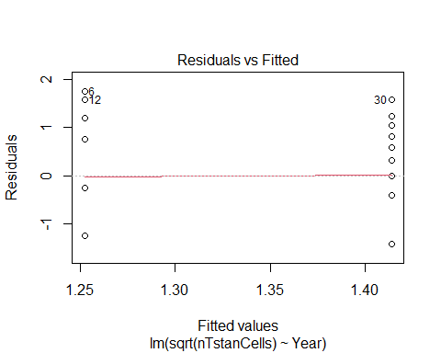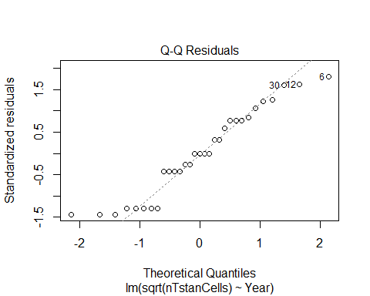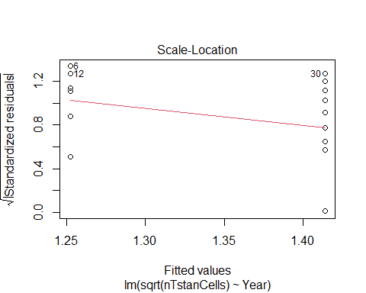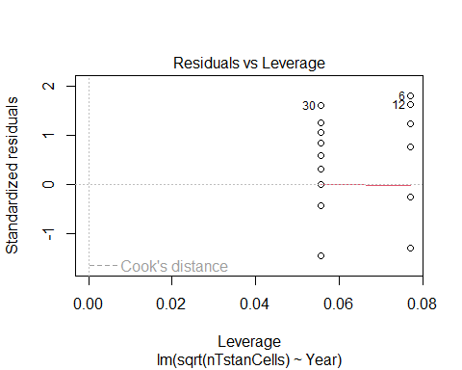

tidy(lm1)

## # A tibble: 2 × 5  
## term estimate std.error statistic p.value  
## <chr> <dbl> <dbl> <dbl> <dbl>  
## 1 (Intercept) 1.25 0.280 4.47 0.000111  
## 2 Year2021 0.162 0.368 0.440 0.663

lm2<- lm(nTstanCells ~ Habitat, data = zo.data)  
lm2<- lm(log(nTstanCells+1, base=10) ~ Habitat, data = zo.data)  
lm2<- lm(sqrt(nTstanCells) ~ Habitat, data = zo.data.or)  
plot(lm2) # megaphone resids, some outliers

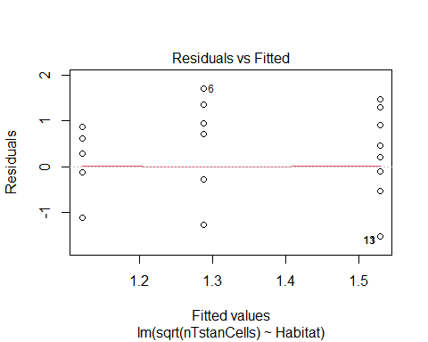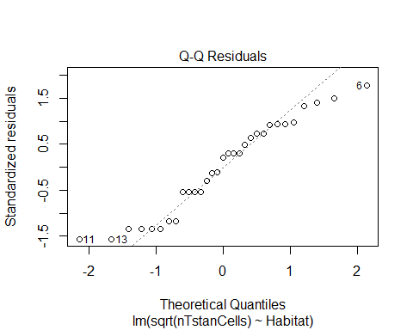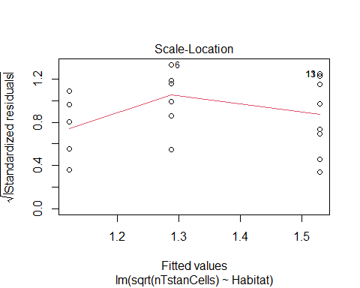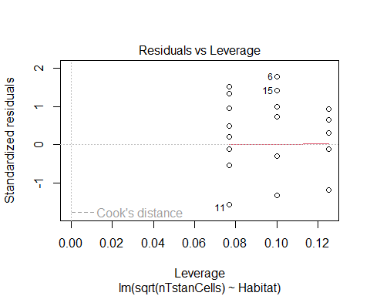

tidy(lm2) # not sig

## # A tibble: 3 × 5  
## term estimate std.error statistic p.value  
## <chr> <dbl> <dbl> <dbl> <dbl>  
## 1 (Intercept) 1.12 0.360 3.12 0.00416  
## 2 HabitatControl 0.166 0.482 0.345 0.733   
## 3 HabitatTreated 0.407 0.457 0.890 0.381

lm3<- lm(nTstanCells ~ HLI, data = zo.data)  
tidy(lm3) # not sig

## # A tibble: 2 × 5  
## term estimate std.error statistic p.value  
## <chr> <dbl> <dbl> <dbl> <dbl>  
## 1 (Intercept) 6.36 2.45 2.60 0.0144  
## 2 HLI 1.91 1.69 1.13 0.268

Significant vars: none

#### glms

glm1<-glm(nTstanCells ~ Year, data = zo.data.or, family = poisson())  
sglm1<-tidy(glm1) # not sig  
kable(sglm1, col.names = c("Term","Estimate", "Std. Error", "*z-value*", "*P-value*"), digits = 3 )

| Term | Estimate | Std. Error | *z-value* | *P-value* |
| --- | --- | --- | --- | --- |
| (Intercept) | 1.046 | 0.164 | 6.363 | 0.000 |
| Year2021 | -0.045 | 0.218 | -0.204 | 0.838 |

glm2<-glm(nTstanCells ~ Habitat, data = zo.data, family = poisson())  
glm2<-glm(nTstanCells ~ Habitat, data = zo.data.or, family = poisson())  
sglm2<-tidy(glm2) # sig  
kable(sglm2, col.names = c("Term","Estimate", "Std. Error", "*z-value*", "*P-value*"), digits = 3 )

| Term | Estimate | Std. Error | *z-value* | *P-value* |
| --- | --- | --- | --- | --- |
| (Intercept) | 0.560 | 0.267 | 2.094 | 0.036 |
| HabitatControl | 0.539 | 0.324 | 1.665 | 0.096 |
| HabitatTreated | 0.613 | 0.309 | 1.987 | 0.047 |

glm3<-glm(nTstanCells ~ HLI, data = zo.data, family = poisson())  
glm3<-glm(nTstanCells ~ HLI, data = zo.data.or, family = poisson())  
sglm3<-tidy(glm3) # not sig when outlier is removed  
kable(sglm3, col.names = c("Term","Estimate", "Std. Error", "*z-value*", "*P-value*"), digits = 3 )

| Term | Estimate | Std. Error | *z-value* | *P-value* |
| --- | --- | --- | --- | --- |
| (Intercept) | 1.159 | 0.186 | 6.234 | 0.000 |
| HLI | 0.118 | 0.133 | 0.884 | 0.377 |

Significant vars: Habitat

### Climate variables

#### lms

## Climate Normals  
lm4<- lm(nTstanCells ~ Ann_ppt_mm, data = zo.data)  
tidy(lm4) # not sig

## # A tibble: 2 × 5  
## term estimate std.error statistic p.value  
## <chr> <dbl> <dbl> <dbl> <dbl>  
## 1 (Intercept) -48.4 36.3 -1.33 0.193  
## 2 Ann_ppt_mm 0.0946 0.0654 1.45 0.158

lm5<- lm(nTstanCells ~ Ann_tmax_C, data = zo.data)  
tidy(lm5) # not sig

## # A tibble: 2 × 5  
## term estimate std.error statistic p.value  
## <chr> <dbl> <dbl> <dbl> <dbl>  
## 1 (Intercept) 6.25 14.3 0.438 0.665  
## 2 Ann_tmax_C -0.144 0.948 -0.152 0.881

lm6<- lm(nTstanCells ~ Ann_tmean_C, data = zo.data)  
tidy(lm6) # not sig

## # A tibble: 2 × 5  
## term estimate std.error statistic p.value  
## <chr> <dbl> <dbl> <dbl> <dbl>  
## 1 (Intercept) 2.06 9.48 0.218 0.829  
## 2 Ann_tmean_C 0.246 1.14 0.216 0.830

lm7<- lm(nTstanCells ~ Ann_tmin_C, data = zo.data)  
tidy(lm7) # not sig

## # A tibble: 2 × 5  
## term estimate std.error statistic p.value  
## <chr> <dbl> <dbl> <dbl> <dbl>  
## 1 (Intercept) 2.42 2.45 0.988 0.331  
## 2 Ann_tmin_C 1.10 1.32 0.834 0.411

## Jan - June Climate  
lm8<- lm(nTstanCells ~ bi_ppt_mm, data = zo.data)  
tidy(lm8) # not sig

## # A tibble: 2 × 5  
## term estimate std.error statistic p.value  
## <chr> <dbl> <dbl> <dbl> <dbl>  
## 1 (Intercept) 9.18 7.10 1.29 0.206  
## 2 bi_ppt_mm -0.0859 0.117 -0.731 0.470

lm9<- lm(nTstanCells ~ bi_tmax_C, data = zo.data)  
tidy(lm9) # not sig

## # A tibble: 2 × 5  
## term estimate std.error statistic p.value  
## <chr> <dbl> <dbl> <dbl> <dbl>  
## 1 (Intercept) -5.13 8.78 -0.584 0.563  
## 2 bi_tmax_C 0.989 0.929 1.06 0.296

lm10<- lm(nTstanCells ~ bi_tmean_C, data = zo.data)  
tidy(lm10) # not sig

## # A tibble: 2 × 5  
## term estimate std.error statistic p.value  
## <chr> <dbl> <dbl> <dbl> <dbl>  
## 1 (Intercept) 0.747 3.51 0.213 0.833  
## 2 bi_tmean_C 1.12 1.08 1.04 0.307

lm11<- lm(nTstanCells ~ bi_tmin_C, data = zo.data)  
tidy(lm11) # not sig

## # A tibble: 2 × 5  
## term estimate std.error statistic p.value  
## <chr> <dbl> <dbl> <dbl> <dbl>  
## 1 (Intercept) 8.42 4.60 1.83 0.0774  
## 2 bi_tmin_C 1.28 1.30 0.987 0.332

## May - July Climate  
lm12<- lm(nTstanCells ~ qrt_ppt_mm, data = zo.data)  
tidy(lm12) # not sig

## # A tibble: 2 × 5  
## term estimate std.error statistic p.value  
## <chr> <dbl> <dbl> <dbl> <dbl>  
## 1 (Intercept) 7.23 4.38 1.65 0.109  
## 2 qrt_ppt_mm -0.0497 0.0658 -0.756 0.456

lm13<- lm(nTstanCells ~ qrt_tmax_C, data = zo.data)  
tidy(lm13) # not sig

## # A tibble: 2 × 5  
## term estimate std.error statistic p.value  
## <chr> <dbl> <dbl> <dbl> <dbl>  
## 1 (Intercept) -16.3 21.2 -0.770 0.447  
## 2 qrt_tmax_C 0.865 0.896 0.965 0.342

lm14<- lm(nTstanCells ~ qrt_tmean_C, data = zo.data)  
tidy(lm14) # not sig

## # A tibble: 2 × 5  
## term estimate std.error statistic p.value  
## <chr> <dbl> <dbl> <dbl> <dbl>  
## 1 (Intercept) -6.00 16.2 -0.371 0.713  
## 2 qrt_tmean_C 0.615 0.982 0.626 0.536

lm15<- lm(nTstanCells ~ qrt_tmin_C, data = zo.data)  
tidy(lm15) # not sig

## # A tibble: 2 × 5  
## term estimate std.error statistic p.value  
## <chr> <dbl> <dbl> <dbl> <dbl>  
## 1 (Intercept) 2.28 9.41 0.243 0.810  
## 2 qrt_tmin_C 0.196 1.01 0.195 0.847

## ADD  
lm16<-lm(nTstanCells ~ DD_accumulated, data = zo.data)  
tidy(lm16) # significant

## # A tibble: 2 × 5  
## term estimate std.error statistic p.value  
## <chr> <dbl> <dbl> <dbl> <dbl>  
## 1 (Intercept) -1.27 2.76 -0.462 0.647   
## 2 DD_accumulated 0.00695 0.00313 2.22 0.0341

lm16<-lm(nTstanCells ~ DD_accumulated, data = zo.data.or)  
tidy(lm16) # not sig

## # A tibble: 2 × 5  
## term estimate std.error statistic p.value  
## <chr> <dbl> <dbl> <dbl> <dbl>  
## 1 (Intercept) 1.83 1.06 1.73 0.0942  
## 2 DD_accumulated 0.00126 0.00125 1.01 0.320

Significant vars: DD_accumulated, but not when outlier is removed

#### glms

## Climate Normals  
glm4<- glm(nTstanCells ~ Ann_ppt_mm, data = zo.data.or, family = poisson())  
cglm4<- tidy(glm4) # not sig  
kable(cglm4, col.names = c("Term","Estimate", "Std. Error", "*z-value*", "*P-value*"), digits = 3 )

| Term | Estimate | Std. Error | *z-value* | *P-value* |
| --- | --- | --- | --- | --- |
| (Intercept) | -3.297 | 3.091 | -1.067 | 0.286 |
| Ann_ppt_mm | 0.008 | 0.006 | 1.401 | 0.161 |

glm5<- glm(nTstanCells ~ Ann_tmax_C, data = zo.data.or, family = poisson())  
cglm5<- tidy(glm5) # not sig  
kable(cglm5, col.names = c("Term","Estimate", "Std. Error", "*z-value*", "*P-value*"), digits = 3 )

| Term | Estimate | Std. Error | *z-value* | *P-value* |
| --- | --- | --- | --- | --- |
| (Intercept) | 0.896 | 1.063 | 0.842 | 0.400 |
| Ann_tmax_C | 0.008 | 0.070 | 0.118 | 0.906 |

glm6<- glm(nTstanCells ~ Ann_tmean_C, data = zo.data.or, family = poisson())  
cglm6<- tidy(glm6) # not sig  
kable(cglm6, col.names = c("Term","Estimate", "Std. Error", "*z-value*", "*P-value*"), digits = 3 )

| Term | Estimate | Std. Error | *z-value* | *P-value* |
| --- | --- | --- | --- | --- |
| (Intercept) | 0.396 | 0.729 | 0.543 | 0.587 |
| Ann_tmean_C | 0.075 | 0.086 | 0.872 | 0.383 |

glm7<- glm(nTstanCells ~ Ann_tmin_C, data = zo.data.or, family = poisson())  
cglm7<- tidy(glm7) # sig  
kable(cglm7, col.names = c("Term","Estimate", "Std. Error", "*z-value*", "*P-value*"), digits = 3 )

| Term | Estimate | Std. Error | *z-value* | *P-value* |
| --- | --- | --- | --- | --- |
| (Intercept) | 0.666 | 0.218 | 3.057 | 0.002 |
| Ann_tmin_C | 0.218 | 0.109 | 2.003 | 0.045 |

## Jan - June Climate  
glm8<- glm(nTstanCells ~ bi_ppt_mm, data = zo.data.or, family = poisson())  
cglm8<- tidy(glm8) # not sig  
kable(cglm8, col.names = c("Term","Estimate", "Std. Error", "*z-value*", "*P-value*"), digits = 3 )

| Term | Estimate | Std. Error | *z-value* | *P-value* |
| --- | --- | --- | --- | --- |
| (Intercept) | 1.015 | 0.540 | 1.879 | 0.060 |
| bi_ppt_mm | 0.000 | 0.009 | 0.011 | 0.991 |

glm9<- glm(nTstanCells ~ bi_tmax_C, data = zo.data.or, family = poisson())  
cglm9<- tidy(glm9) # marginally sig  
kable(cglm9, col.names = c("Term","Estimate", "Std. Error", "*z-value*", "*P-value*"), digits = 3 )

| Term | Estimate | Std. Error | *z-value* | *P-value* |
| --- | --- | --- | --- | --- |
| (Intercept) | -0.133 | 0.688 | -0.194 | 0.846 |
| bi_tmax_C | 0.122 | 0.071 | 1.724 | 0.085 |

glm10<- glm(nTstanCells ~ bi_tmean_C, data = zo.data.or, family = poisson())  
cglm10<- tidy(glm10) # marginally sig  
kable(cglm10, col.names = c("Term","Estimate", "Std. Error", "*z-value*", "*P-value*"), digits = 3 )

| Term | Estimate | Std. Error | *z-value* | *P-value* |
| --- | --- | --- | --- | --- |
| (Intercept) | 0.602 | 0.283 | 2.128 | 0.033 |
| bi_tmean_C | 0.136 | 0.082 | 1.661 | 0.097 |

glm11<- glm(nTstanCells ~ bi_tmin_C, data = zo.data.or, family = poisson())  
cglm11<- tidy(glm11) # not sig  
kable(cglm11, col.names = c("Term","Estimate", "Std. Error", "*z-value*", "*P-value*"), digits = 3 )

| Term | Estimate | Std. Error | *z-value* | *P-value* |
| --- | --- | --- | --- | --- |
| (Intercept) | 1.510 | 0.334 | 4.522 | 0.000 |
| bi_tmin_C | 0.148 | 0.098 | 1.508 | 0.131 |

## May - July Climate  
glm12<- glm(nTstanCells ~ qrt_ppt_mm, data = zo.data.or, family = poisson())  
cglm12<- tidy(glm12) # not sig  
kable(cglm12, col.names = c("Term","Estimate", "Std. Error", "*z-value*", "*P-value*"), digits = 3 )

| Term | Estimate | Std. Error | *z-value* | *P-value* |
| --- | --- | --- | --- | --- |
| (Intercept) | 0.842 | 0.344 | 2.446 | 0.014 |
| qrt_ppt_mm | 0.003 | 0.005 | 0.553 | 0.581 |

glm13<- glm(nTstanCells ~ qrt_tmax_C, data = zo.data.or, family = poisson())  
cglm13<- tidy(glm13) # not sig  
kable(cglm13, col.names = c("Term","Estimate", "Std. Error", "*z-value*", "*P-value*"), digits = 3 )

| Term | Estimate | Std. Error | *z-value* | *P-value* |
| --- | --- | --- | --- | --- |
| (Intercept) | -1.408 | 1.620 | -0.869 | 0.385 |
| qrt_tmax_C | 0.102 | 0.068 | 1.510 | 0.131 |

glm14<- glm(nTstanCells ~ qrt_tmean_C, data = zo.data.or, family = poisson())  
cglm14<- tidy(glm14) # not sig  
kable(cglm14, col.names = c("Term","Estimate", "Std. Error", "*z-value*", "*P-value*"), digits = 3 )

| Term | Estimate | Std. Error | *z-value* | *P-value* |
| --- | --- | --- | --- | --- |
| (Intercept) | -0.613 | 1.231 | -0.498 | 0.619 |
| qrt_tmean_C | 0.099 | 0.074 | 1.340 | 0.180 |

glm15<- glm(nTstanCells ~ qrt_tmin_C, data = zo.data.or, family = poisson())  
cglm15<- tidy(glm15) # not sig  
kable(cglm15, col.names = c("Term","Estimate", "Std. Error", "*z-value*", "*P-value*"), digits = 3 )

| Term | Estimate | Std. Error | *z-value* | *P-value* |
| --- | --- | --- | --- | --- |
| (Intercept) | 0.358 | 0.715 | 0.501 | 0.616 |
| qrt_tmin_C | 0.071 | 0.075 | 0.944 | 0.345 |

## ADD  
glm16<-glm(nTstanCells ~ DD_accumulated, data = zo.data.or, family = poisson())  
cglm16<-tidy(glm16) # marginally sig  
kable(cglm16, col.names = c("Term","Estimate", "Std. Error", "*z-value*", "*P-value*"), digits = 3 )

| Term | Estimate | Std. Error | *z-value* | *P-value* |
| --- | --- | --- | --- | --- |
| (Intercept) | 0.684 | 0.234 | 2.923 | 0.003 |
| DD_accumulated | 0.000 | 0.000 | 1.700 | 0.089 |

Significant vars: Ann_tmin_C Marginally sig vars: bi_tmax_C, bi_tmean_C, and DD_accumulated

### Floral

#### lms

flm1<- lm(nTstanCells ~ stemabun, data = zo.data)  
tidy(flm1) # not sig

## # A tibble: 2 × 5  
## term estimate std.error statistic p.value  
## <chr> <dbl> <dbl> <dbl> <dbl>  
## 1 (Intercept) 3.98 1.76 2.26 0.0310  
## 2 stemabun 0.00317 0.0291 0.109 0.914

flm2<- lm(nTstanCells ~ stemdiv, data = zo.data)  
tidy(flm2) # not sig

## # A tibble: 2 × 5  
## term estimate std.error statistic p.value  
## <chr> <dbl> <dbl> <dbl> <dbl>  
## 1 (Intercept) 8.39 3.73 2.25 0.0318  
## 2 stemdiv -2.99 2.40 -1.24 0.223

flm3<- lm(nTstanCells ~ stemrich, data = zo.data)  
tidy(flm3) # not sig

## # A tibble: 2 × 5  
## term estimate std.error statistic p.value  
## <chr> <dbl> <dbl> <dbl> <dbl>  
## 1 (Intercept) 4.21 2.52 1.67 0.105  
## 2 stemrich -0.0176 0.306 -0.0577 0.954

Significant vars: none

#### glms

fglm1<- glm(nTstanCells ~ stemabun, data = zo.data.or, family = poisson())  
fsglm1<-tidy(fglm1) # not sig  
kable(fsglm1, col.names = c("Term","Estimate", "Std. Error", "*z-value*", "*P-value*"), digits = 3 )

| Term | Estimate | Std. Error | *z-value* | *P-value* |
| --- | --- | --- | --- | --- |
| (Intercept) | 0.912 | 0.136 | 6.722 | 0.000 |
| stemabun | 0.003 | 0.002 | 1.447 | 0.148 |

fglm2<- glm(nTstanCells ~ stemdiv, data = zo.data.or, family = poisson())  
fsglm2<-tidy(fglm2) # not sig  
kable(fsglm2, col.names = c("Term","Estimate", "Std. Error", "*z-value*", "*P-value*"), digits = 3 )

| Term | Estimate | Std. Error | *z-value* | *P-value* |
| --- | --- | --- | --- | --- |
| (Intercept) | 1.212 | 0.282 | 4.299 | 0.000 |
| stemdiv | -0.133 | 0.184 | -0.725 | 0.469 |

fglm3<- glm(nTstanCells ~ stemrich, data = zo.data.or, family = poisson())  
fsglm3<-tidy(fglm3) # not sig  
kable(fsglm3, col.names = c("Term","Estimate", "Std. Error", "*z-value*", "*P-value*"), digits = 3 )

| Term | Estimate | Std. Error | *z-value* | *P-value* |
| --- | --- | --- | --- | --- |
| (Intercept) | 0.804 | 0.192 | 4.185 | 0.000 |
| stemrich | 0.030 | 0.021 | 1.427 | 0.154 |

Significant vars: none

### Tree

#### lms

tlm1<- lm(nTstanCells ~ meanTreeCC, data = zo.data)  
tidy(tlm1) # not sig

## # A tibble: 2 × 5  
## term estimate std.error statistic p.value  
## <chr> <dbl> <dbl> <dbl> <dbl>  
## 1 (Intercept) 6.40 2.55 2.51 0.0176  
## 2 meanTreeCC -7.85 7.23 -1.09 0.286

tlm2<- lm(nTstanCells ~ Dead_BA_ha, data = zo.data)  
tidy(tlm2) # not sig

## # A tibble: 2 × 5  
## term estimate std.error statistic p.value  
## <chr> <dbl> <dbl> <dbl> <dbl>  
## 1 (Intercept) 3.31 1.91 1.73 0.0948  
## 2 Dead_BA_ha 0.120 0.147 0.815 0.422

tlm3<- lm(nTstanCells ~ Live_BA_ha, data = zo.data)  
tidy(tlm3) # not sig

## # A tibble: 2 × 5  
## term estimate std.error statistic p.value  
## <chr> <dbl> <dbl> <dbl> <dbl>  
## 1 (Intercept) 5.46 1.99 2.74 0.0105  
## 2 Live_BA_ha -0.119 0.131 -0.912 0.370

Significant vars: none

#### glms

tglm1<- glm(nTstanCells ~ meanTreeCC, data = zo.data.or, family = poisson())  
ttglm1<-tidy(tglm1) # not sig  
kable(ttglm1, col.names = c("Term","Estimate", "Std. Error", "*z-value*", "*P-value*"), digits = 3 )

| Term | Estimate | Std. Error | *z-value* | *P-value* |
| --- | --- | --- | --- | --- |
| (Intercept) | 0.967 | 0.204 | 4.741 | 0.000 |
| meanTreeCC | 0.175 | 0.562 | 0.311 | 0.756 |

tglm2<- glm(nTstanCells ~ Dead_BA_ha, data = zo.data.or, family = poisson())  
ttglm2<-tidy(tglm2) # not sig  
kable(ttglm2, col.names = c("Term","Estimate", "Std. Error", "*z-value*", "*P-value*"), digits = 3 )

| Term | Estimate | Std. Error | *z-value* | *P-value* |
| --- | --- | --- | --- | --- |
| (Intercept) | 1.157 | 0.133 | 8.725 | 0.000 |
| Dead_BA_ha | -0.015 | 0.012 | -1.273 | 0.203 |

tglm3<- glm(nTstanCells ~ Live_BA_ha, data = zo.data.or, family = poisson())  
ttglm3<-tidy(tglm3) # not sig  
kable(ttglm3, col.names = c("Term","Estimate", "Std. Error", "*z-value*", "*P-value*"), digits = 3 )

| Term | Estimate | Std. Error | *z-value* | *P-value* |
| --- | --- | --- | --- | --- |
| (Intercept) | 1.097 | 0.145 | 7.547 | 0.000 |
| Live_BA_ha | -0.005 | 0.010 | -0.465 | 0.642 |

Significant vars: none

### Landscape

#### lms

llm1<- lm(nTstanCells ~ EVT_H, data = zo.data)  
tidy(llm1) # not sig

## # A tibble: 2 × 5  
## term estimate std.error statistic p.value  
## <chr> <dbl> <dbl> <dbl> <dbl>  
## 1 (Intercept) 6.63 2.66 2.49 0.0185  
## 2 EVT_H -5.90 5.26 -1.12 0.271

llm2<- lm(nTstanCells ~ EVT_rich, data = zo.data)  
tidy(llm2) # marginally sig

## # A tibble: 2 × 5  
## term estimate std.error statistic p.value  
## <chr> <dbl> <dbl> <dbl> <dbl>  
## 1 (Intercept) 11.6 4.91 2.37 0.0244  
## 2 EVT_rich -2.49 1.55 -1.60 0.120

llm3<- lm(nTstanCells ~ EVT_J, data = zo.data)  
tidy(llm3) # not sig

## # A tibble: 2 × 5  
## term estimate std.error statistic p.value  
## <chr> <dbl> <dbl> <dbl> <dbl>  
## 1 (Intercept) 5.29 2.91 1.82 0.0791  
## 2 EVT_J -3.16 6.72 -0.471 0.641

llm4<- lm(nTstanCells ~ Barren, data = zo.data)  
tidy(llm4) # not sig

## # A tibble: 2 × 5  
## term estimate std.error statistic p.value  
## <chr> <dbl> <dbl> <dbl> <dbl>  
## 1 (Intercept) 4.27 1.47 2.90 0.00695  
## 2 Barren -340. 723. -0.470 0.642

llm5<- lm(nTstanCells ~ Coniferous_Forest, data = zo.data)  
tidy(llm5) # not sig

## # A tibble: 2 × 5  
## term estimate std.error statistic p.value  
## <chr> <dbl> <dbl> <dbl> <dbl>  
## 1 (Intercept) -0.955 5.67 -0.169 0.867  
## 2 Coniferous_Forest 6.23 6.78 0.920 0.365

llm6<- lm(nTstanCells ~ Deciduous_Forest, data = zo.data)  
tidy(llm6) # not sig

## # A tibble: 2 × 5  
## term estimate std.error statistic p.value  
## <chr> <dbl> <dbl> <dbl> <dbl>  
## 1 (Intercept) 5.23 1.85 2.83 0.00814  
## 2 Deciduous_Forest -150. 157. -0.955 0.347

llm7<- lm(nTstanCells ~ Rangeland, data = zo.data) # probably correlated with Habitat type  
tidy(llm7) # sig

## # A tibble: 2 × 5  
## term estimate std.error statistic p.value  
## <chr> <dbl> <dbl> <dbl> <dbl>  
## 1 (Intercept) 4.63 1.75 2.64 0.0131  
## 2 Rangeland -3.66 7.03 -0.520 0.607

llm8<- lm(nTstanCells ~ WUI, data = zo.data)  
tidy(llm8) # not sig

## # A tibble: 2 × 5  
## term estimate std.error statistic p.value  
## <chr> <dbl> <dbl> <dbl> <dbl>  
## 1 (Intercept) 5.34 1.64 3.26 0.00280  
## 2 WUI -36.7 25.9 -1.42 0.167

Significant vars: none Marginally sig vars: EVT_rich

#### glms

lglm1<- glm(nTstanCells ~ EVT_H, data = zo.data.or, family = poisson())  
liglm1<-tidy(lglm1) # sig  
kable(liglm1, col.names = c("Term","Estimate", "Std. Error", "*z-value*", "*P-value*"), digits = 3 )

| Term | Estimate | Std. Error | *z-value* | *P-value* |
| --- | --- | --- | --- | --- |
| (Intercept) | 1.527 | 0.188 | 8.116 | 0.000 |
| EVT_H | -1.297 | 0.442 | -2.937 | 0.003 |

lglm2<- glm(nTstanCells ~ EVT_rich, data = zo.data.or, family = poisson())  
liglm2<-tidy(lglm2) # sig  
kable(liglm2, col.names = c("Term","Estimate", "Std. Error", "*z-value*", "*P-value*"), digits = 3 )

| Term | Estimate | Std. Error | *z-value* | *P-value* |
| --- | --- | --- | --- | --- |
| (Intercept) | 1.79 | 0.344 | 5.204 | 0.000 |
| EVT_rich | -0.26 | 0.115 | -2.269 | 0.023 |

lglm3<- glm(nTstanCells ~ EVT_J, data = zo.data.or, family = poisson())  
liglm3<-tidy(lglm3) # sig  
kable(liglm3, col.names = c("Term","Estimate", "Std. Error", "*z-value*", "*P-value*"), digits = 3 )

| Term | Estimate | Std. Error | *z-value* | *P-value* |
| --- | --- | --- | --- | --- |
| (Intercept) | 1.564 | 0.194 | 8.062 | 0.000 |
| EVT_J | -1.597 | 0.528 | -3.026 | 0.002 |

lglm4<- glm(nTstanCells ~ Barren, data = zo.data.or, family = poisson())  
ltglm4<-tidy(lglm4) # sig  
kable(ltglm4, col.names = c("Term","Estimate", "Std. Error", "*z-value*", "*P-value*"), digits = 3 )

| Term | Estimate | Std. Error | *z-value* | *P-value* |
| --- | --- | --- | --- | --- |
| (Intercept) | 1.052 | 0.110 | 9.580 | 0.000 |
| Barren | -79.305 | 72.153 | -1.099 | 0.272 |

lglm5<- glm(nTstanCells ~ Coniferous_Forest, data = zo.data.or, family = poisson())  
ltglm5<-tidy(lglm5) # sig  
kable(ltglm5, col.names = c("Term","Estimate", "Std. Error", "*z-value*", "*P-value*"), digits = 3 )

| Term | Estimate | Std. Error | *z-value* | *P-value* |
| --- | --- | --- | --- | --- |
| (Intercept) | -0.098 | 0.560 | -0.174 | 0.861 |
| Coniferous_Forest | 1.343 | 0.643 | 2.088 | 0.037 |

lglm6<- glm(nTstanCells ~ Deciduous_Forest, data = zo.data.or, family = poisson())  
ltglm6<-tidy(lglm6) # not sig  
kable(ltglm6, col.names = c("Term","Estimate", "Std. Error", "*z-value*", "*P-value*"), digits = 3 )

| Term | Estimate | Std. Error | *z-value* | *P-value* |
| --- | --- | --- | --- | --- |
| (Intercept) | 1.094 | 0.139 | 7.840 | 0.000 |
| Deciduous_Forest | -9.832 | 12.512 | -0.786 | 0.432 |

lglm7<- glm(nTstanCells ~ Rangeland, data = zo.data.or, family = poisson())   
ltglm7<-tidy(lglm7) # not sig (is sig with outlier)  
kable(ltglm7, col.names = c("Term","Estimate", "Std. Error", "*z-value*", "*P-value*"), digits = 3 )

| Term | Estimate | Std. Error | *z-value* | *P-value* |
| --- | --- | --- | --- | --- |
| (Intercept) | 1.111 | 0.130 | 8.532 | 0.000 |
| Rangeland | -0.675 | 0.596 | -1.132 | 0.258 |

lglm8<- glm(nTstanCells ~ WUI, data = zo.data.or, family = poisson())  
ltglm8<-tidy(lglm8) # sig  
kable(ltglm8, col.names = c("Term","Estimate", "Std. Error", "*z-value*", "*P-value*"), digits = 3)

| Term | Estimate | Std. Error | *z-value* | *P-value* |
| --- | --- | --- | --- | --- |
| (Intercept) | 1.359 | 0.121 | 11.196 | 0 |
| WUI | -16.319 | 4.462 | -3.657 | 0 |

Significant vars: EVT_H, EVT_rich, EVT_J, Barren, Coniferous_Forest, Rangeland, and WUI

### Data check

# landscape EVT counts   
colSums(zo.data[,c(71:76)] > 0) # Crops are only in 3 sites, and Barren are only in 2 sites

## EVT_rich EVT_J Barren Coniferous_Forest   
## 32 30 2 32   
## Crops Deciduous_Forest   
## 3 16

### Tables

#### Site

stargazer(glm1, glm2, glm3, type = "text",  
 title = "Univariate variable effects on *T. stansburyi* abundance",  
 column.labels = c("Year", "Habitat", "HLI"),   
 colnames = FALSE, model.numbers = FALSE,  
 dep.var.caption = " ", dep.var.labels = "Site variables",  
 covariate.labels = c("Year - 2021", "Habitat - Control", "Habitat - Treated", "HLI", "Constant"),  
 keep.stat = c("n"), # number of observations. use "ll" for log likelihood  
 single.row=TRUE,  
 add.lines = list(c("AIC", round(AICc(glm1), 1), round(AICc(glm2), 1), round(AICc(glm3), 1))),  
 notes.align = "l",  
 out = "tables/univar.site.txt")

# Univariate variable effects on *T. stansburyi* abundance

-------------------------------------------------  
 Site variables   
 Year Habitat HLI

| Year - 2021 -0.045 (0.218) Habitat - Control 0.539* (0.324) Habitat - Treated 0.613** (0.309) HLI 0.118 (0.133) Constant 1.046*** (0.164) 0.560** (0.267) 1.159*** (0.186) |
| --- |
| AIC 164.4 162.3 163.6 Observations 31 31 31 =================================================================== Note: *p<0.1;* ***p<0.05;*** p<0.01 |
| #### Climate |
| r # Normals stargazer(glm4, glm5, glm6, glm7, type = "text", title = "Univariate variable effects on *T. stansburyi* abundance", colnames = FALSE, model.numbers = FALSE, dep.var.caption = "Climate variables", dep.var.labels = "Average 30-year normals", covariate.labels = c("Precipitation (mm)", "Max temperature (°C)", "Mean temperature (°C)", "Min temperature (°C)", "Constant"), keep.stat = c("n"), # number of observations. use "ll" for log likelihood single.row=TRUE, add.lines = list(c("AIC", round(AICc(glm4), 1), round(AICc(glm5), 1), round(AICc(glm6), 1), round(AICc(glm7), 1))), notes.align = "l", out = "tables/univar.climate-normals.txt") |
| Univariate variable effects on *T. stansburyi* abundance ================================================================================= Climate variables ———————————————————– Average 30-year normals |

Precipitation (mm) 0.008 (0.006)  
Max temperature (°C) 0.008 (0.070)  
Mean temperature (°C) 0.075 (0.086)  
Min temperature (°C) 0.218** (0.109) Constant -3.297 (3.091) 0.896 (1.063) 0.396 (0.729) 0.666*** (0.218) ——————————————————————————— AIC 162.4 164.4 163.7 160.1  
Observations 31 31 31 31  
================================================================================= Note: *p<0.1;* ***p<0.05;*** p<0.01

# Jan-June  
stargazer(glm12, glm13, glm14, glm15, type = "text",  
 title = "Univariate variable effects on *T. stansburyi* abundance",  
 colnames = FALSE, model.numbers = FALSE,  
 dep.var.caption = "Climate variables", dep.var.labels = "Jan - June Averages",  
 covariate.labels = c("Precipitation (mm)", "Max temperature (°C)", "Mean temperature (°C)", "Min temperature (°C)", "Constant"),  
 keep.stat = c("n"), # number of observations. use "ll" for log likelihood  
 single.row=TRUE,  
 add.lines = list(c("AIC", round(AICc(glm12), 1), round(AICc(glm13), 1), round(AICc(glm14), 1),   
 round(AICc(glm15), 1))),  
 notes.align = "l", out = "tables/univar.climate-jan-jun.txt")

# Univariate variable effects on *T. stansburyi* abundance

Climate variables   
 -----------------------------------------------------------  
 Jan - June Averages

| Precipitation (mm) 0.003 (0.005) Max temperature (°C) 0.102 (0.068) Mean temperature (°C) 0.099 (0.074) Min temperature (°C) 0.071 (0.075) Constant 0.842** (0.344) -1.408 (1.620) -0.613 (1.231) 0.358 (0.715) |
| --- |
| AIC 164.1 162.1 162.6 163.5 Observations 31 31 31 31 ================================================================================= Note: *p<0.1;* ***p<0.05;*** p<0.01 |
| #### Floral |
| r stargazer(fglm1, fglm2, fglm3, type = "text", title = "Univariate variable effects on *T. stansburyi* abundance", colnames = FALSE, model.numbers = FALSE, dep.var.caption = " ", dep.var.labels = "Floral variables", covariate.labels = c("Abundance", "Diversity", "Richness", "Constant"), keep.stat = c("n"), # number of observations. use "ll" for log likelihood single.row=TRUE, add.lines = list(c("AIC", round(AICc(fglm1), 1), round(AICc(fglm2), 1), round(AICc(fglm3), 1))), notes.align = "l", out = "tables/univar.floral.txt") |
| Univariate variable effects on *T. stansburyi* abundance =============================================================== |
| ————————————————– Floral variables |

Abundance 0.003 (0.002)  
Diversity -0.133 (0.184)  
Richness 0.030 (0.021)  
Constant 0.912*** (0.136) 1.212*** (0.282) 0.804*** (0.192) ————————————————————— AIC 162.5 163.9 162.5  
Observations 31 31 31  
=============================================================== Note: *p<0.1;* ***p<0.05;*** p<0.01

#### Trees

stargazer(tglm1, tglm2, tglm3, type = "text",  
 title = "Univariate variable effects on *T. stansburyi* abundance",  
 colnames = FALSE, model.numbers = FALSE,  
 dep.var.caption = " ", dep.var.labels = "Tree variables",  
 covariate.labels = c("Mean canopy cover (%)", "Dead basal area (m2ha-1)", "Live basal area (m2ha-1)", "Constant"),  
 keep.stat = c("n"), # number of observations. use "ll" for log likelihood  
 single.row=TRUE,  
 add.lines = list(c("AIC", round(AICc(tglm1), 1), round(AICc(tglm2), 1), round(AICc(tglm3), 1))),  
 notes.align = "l",  
 out = "tables/univar.tree.txt")

# Univariate variable effects on *T. stansburyi* abundance

--------------------------------------------------  
 Tree variables

| Mean canopy cover (%) 0.175 (0.562) Dead basal area (m2ha-1) -0.015 (0.012) Live basal area (m2ha-1) -0.005 (0.010) Constant 0.967*** (0.204) 1.157*** (0.133) 1.097*** (0.145) |
| --- |
| AIC 164.3 154.1 155.6 Observations 31 29 29 =========================================================================== Note: *p<0.1;* ***p<0.05;*** p<0.01 |
| #### Landscape |
| r # Indices stargazer(lglm1, lglm2, lglm3, type = "text", title = "Univariate variable effects on *T. stansburyi* abundance", colnames = FALSE, model.numbers = FALSE, dep.var.caption = "Landscape variables", dep.var.labels = "Indices", #covariate.labels = c("Diversity", "Richness", "Evenness", "Constant"), keep.stat = c("n"), # number of observations. use "ll" for log likelihood single.row=TRUE, add.lines = list(c("AIC", round(AICc(lglm1), 1), round(AICc(lglm2), 1), round(AICc(lglm3), 1))), notes.align = "l", out = "tables/univar.Landscape-indices.txt") |
| Univariate variable effects on *T. stansburyi* abundance ================================================================= Landscape variables —————————————————- Indices |

EVT_H -1.297*** (0.442)  
EVT_rich -0.260** (0.115)  
EVT_J -1.597*** (0.528) Constant 1.527*** (0.188) 1.790*** (0.344) 1.564*** (0.194) —————————————————————– AIC 155.2 159.5 154.9  
Observations 31 31 31  
================================================================= Note: *p<0.1;* ***p<0.05;*** p<0.01

# Landscape proportions  
stargazer(lglm4, lglm5, lglm6, lglm7, lglm8, type = "text",  
 title = "Univariate variable effects on *T. stansburyi* abundance",  
 colnames = FALSE, model.numbers = FALSE,  
 dep.var.caption = "Landscape variables", dep.var.labels = "Land type proportions",  
 covariate.labels = c("Barren (%)", "Coniferous Forest (%)", "Coniferous Forest (%)", "Rangeland (%)",  
 "Urban development (%)", "Constant"),  
 keep.stat = c("n"), # number of observations. use "ll" for log likelihood  
 single.row=TRUE,  
 add.lines = list(c("AIC", round(AICc(lglm4), 1), round(AICc(lglm5), 1), round(AICc(lglm6), 1),   
 round(AICc(lglm7), 1),round(AICc(lglm8), 1))),  
 notes.align = "l", out = "tables/univar.Landscape-types.txt")

# Univariate variable effects on *T. stansburyi* abundance

Landscape variables   
 -------------------------------------------------------------------------------------  
 Land type proportions

|  |
| --- |
| Barren (%) -79.305 (72.153) |
| Coniferous Forest (%) 1.343** (0.643) |
| Coniferous Forest (%) -9.832 (12.512) |
| Rangeland (%) -0.675 (0.596) |
| Urban development (%) -16.319*** (4.462) |
| Constant 1.052*** (0.110) -0.098 (0.560) 1.094*** (0.139) 1.111*** (0.130) 1.359*** (0.121) |

AIC 162.9 159.3 163.8 163 141.2  
Observations 31 31 31 31 31  
=========================================================================================================== Note: *p<0.1;* ***p<0.05;*** p<0.01

## 2) Correlations

### Climate

#### With Climate Normals

cor.cdata<-cor(zo.data.or[,c(17, 34:45, 49)], use='complete.obs', method = "spearman")  
pmat.cdata<-cor_pmat(cor.cdata, method = "spearman") # for ggcorrplot  
  
Ccorr.plot<-  
 ggcorrplot(cor.cdata, lab = TRUE, type= "lower", p.mat = pmat.cdata, show.diag = T, sig.level = 0.1,  
 ggtheme = ggplot2::theme_classic(), outline.col="white",  
 colors = c("grey50", "grey70", "grey90")) + labs(title = "Climate Variables")+  
 theme(plot.title = element_text(hjust = 0.5))  
   
save_plot("sfigures\\corplot.climateVars.png", Ccorr.plot, base_height=7.5, bg="white")

#### Without Climate Normals

cor.cdata2<-cor(zo.data.or[,c(38:45,49)], use='complete.obs', method = "spearman")  
pmat.cdata2<-cor_pmat(cor.cdata2, method = "spearman") # for ggcorrplot  
  
Ccorr.plot2<-  
 ggcorrplot(cor.cdata2, lab = TRUE, type= "lower", p.mat = pmat.cdata2, show.diag = T, sig.level = 0.1,  
 ggtheme = ggplot2::theme_classic(), outline.col="white",  
 colors = c("grey50", "grey70", "grey90")) + labs(title = "Climate Variables")+  
 theme(plot.title = element_text(hjust = 0.5))  
   
save_plot("sfigures\\corplot.climateVars2.png", Ccorr.plot2, base_height=7.5, bg="white")

DD_accumulated is not correlated to normals, but is correlated with bi and qrt climates. Bi-temps are correlated with normal temps and min/mean qrt temps. Use Ann_ppt_mm and DD_accumulated

### Flora

cor.pdata<-cor(zo.data.or[50:52], use='complete.obs', method = "spearman")  
pmat.pdata<-cor_pmat(cor.pdata, method = "spearman") # for ggcorrplot  
  
pcorr.plot<-  
 ggcorrplot(cor.pdata, lab = TRUE, type= "lower", p.mat = pmat.pdata, show.diag = T, sig.level = 0.1,  
 ggtheme = ggplot2::theme_classic(), outline.col="white",  
 colors = c("grey50", "grey70", "grey90")) + labs(title = "Plant Variables")+  
 theme(plot.title = element_text(hjust = 0.5))  
   
save_plot("sfigures\\corplot.plantVars.png", pcorr.plot, base_height=7.5, bg="white")

Not correlated, but none were significant predictors

### Tree

cor.tdata<-cor(zo.data.or[,c(56,66:67)], use='complete.obs', method = "spearman")  
pmat.tdata<-cor_pmat(cor.tdata, method = "spearman") # for ggcorrplot  
  
tcorr.plot<-  
 ggcorrplot(cor.tdata, lab = TRUE, type= "lower", p.mat = pmat.tdata, show.diag = T, sig.level = 0.1,  
 ggtheme = ggplot2::theme_classic(), outline.col="white",  
 colors = c("grey50", "grey70", "grey90")) + labs(title = "Tree Variables")+  
 theme(plot.title = element_text(hjust = 0.5))  
   
save_plot("sfigures\\corplot.treeVars.png", tcorr.plot, base_height=7.5, bg="white")

Not correlated, but none were significant predictors

### Landscape

# Landscape Indexes  
cor.idata<-cor(zo.data.or[,c(69:72)], use='complete.obs', method = "spearman")  
pmat.idata<-cor_pmat(cor.idata, method = "spearman") # for ggcorrplot  
  
icorr.plot<-  
 ggcorrplot(cor.idata, lab = TRUE, type= "lower", p.mat = pmat.idata, show.diag = T, sig.level = 0.1,  
 ggtheme = ggplot2::theme_classic(), outline.col="white",  
 colors = c("grey50", "grey70", "grey90")) + labs(title = "Landscape indexes")+  
 theme(plot.title = element_text(hjust = 0.5))  
  
# Landscape Types  
cor.ldata<-cor(zo.data.or[,c(73:78)], use='complete.obs', method = "spearman")  
pmat.ldata<-cor_pmat(cor.ldata, method = "spearman") # for ggcorrplot  
  
lcorr.plot<-  
 ggcorrplot(cor.ldata, lab = TRUE, type= "lower", p.mat = pmat.ldata, show.diag = T, sig.level = 0.1,  
 ggtheme = ggplot2::theme_classic(), outline.col="white",  
 colors = c("grey50", "grey70", "grey90")) + labs(title = "Landscape Variables")+  
 theme(plot.title = element_text(hjust = 0.5))  
   
save_plot("sfigures\\corplot.landIndex.png", icorr.plot, base_height=7.5, bg="white")   
save_plot("sfigures\\corplot.landVars.png", lcorr.plot, base_height=7.5, bg="white")

Only H and abundance are correlated WUI and Barren are correlated (0.53), as are Con Forests and Rangeland (-0.82), but only marginally

# Analysis

## Q1) T.stan by All vars

### Full model

f_model<-glm(nTstanCells ~ Habitat + Ann_tmin_C + DD_accumulated + EVT_rich + EVT_J + Coniferous_Forest + WUI, data = zo.data.or, family = poisson())  
plot(f_model) # megaphone resids, sort of skewed

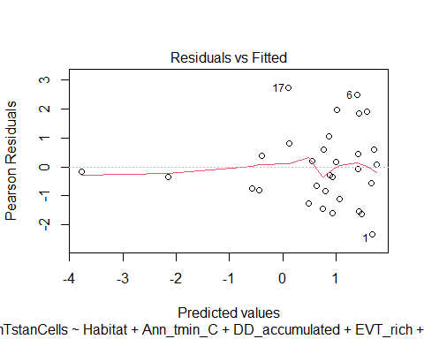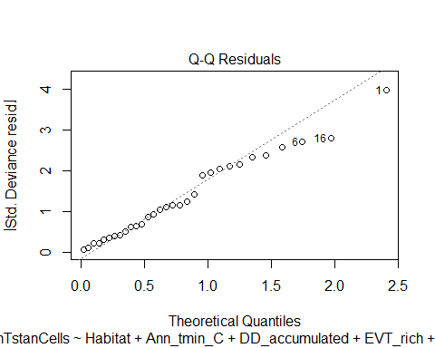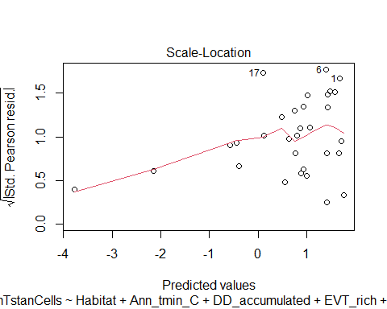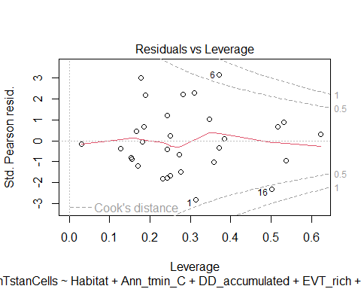

### Stepwise

f_model_stp <- step(f_model, direction = "both", trace = 0)  
summary(f_model_stp)

##   
## Call:  
## glm(formula = nTstanCells ~ Ann_tmin_C + WUI, family = poisson(),   
## data = zo.data.or)  
##   
## Coefficients:  
## Estimate Std. Error z value Pr(>|z|)   
## (Intercept) 0.8655 0.2315 3.739 0.000185 ***  
## Ann_tmin_C 0.3295 0.1194 2.759 0.005800 **   
## WUI -18.9129 4.7604 -3.973 7.1e-05 ***  
## ---  
## Signif. codes: 0 '***' 0.001 '**' 0.01 '*' 0.05 '.' 0.1 ' ' 1  
##   
## (Dispersion parameter for poisson family taken to be 1)  
##   
## Null deviance: 91.844 on 30 degrees of freedom  
## Residual deviance: 60.277 on 28 degrees of freedom  
## AIC: 134.43  
##   
## Number of Fisher Scoring iterations: 5

plot(f_model_stp) # megaphone resids, sort of skewed

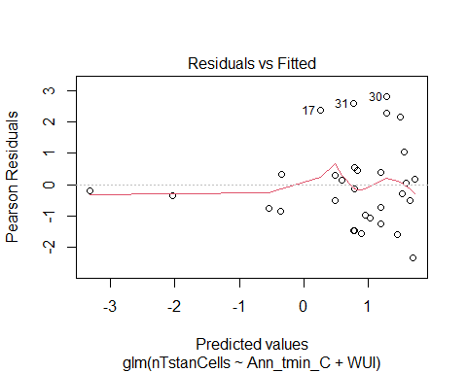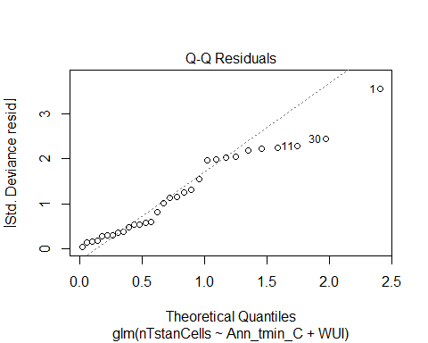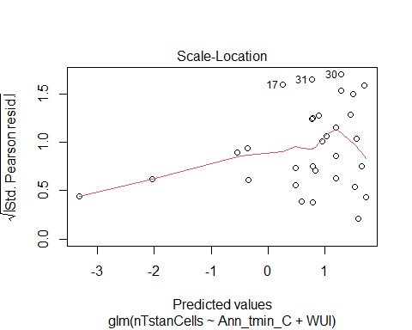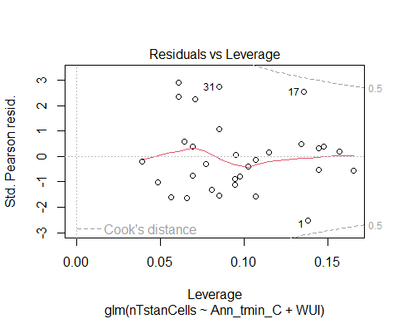

# Predictor vars include: Habitat + Ann_tmin_C + WUI  
#AIC(f_model_stp) # 135.3

Habitat, min temp mean normals, and WUI landscapes are best predictors

### Dredge

#### with both Barren and WUI

options(na.action = "na.fail", rank = "AIC")  
f_model_drd<-dredge(f_model)  
  
nrow(f_model_drd) #128

## [1] 128

f_model_drd[1,]

## Global model call: glm(formula = nTstanCells ~ Habitat + Ann_tmin_C + DD_accumulated +   
## EVT_rich + EVT_J + Coniferous_Forest + WUI, family = poisson(),   
## data = zo.data.or)  
## ---  
## Model selection table   
## (Int) Ann_tmn_C WUI df logLik AICc delta weight  
## 66 0.8655 0.3295 -18.91 3 -64.213 135.3 0 1  
## Models ranked by AICc(x)

head(f_model_drd)

## Global model call: glm(formula = nTstanCells ~ Habitat + Ann_tmin_C + DD_accumulated +   
## EVT_rich + EVT_J + Coniferous_Forest + WUI, family = poisson(),   
## data = zo.data.or)  
## ---  
## Model selection table   
## (Int) Ann_tmn_C Cnf_Frs DD_acc EVT_J EVT_rch Hbt WUI df logLik  
## 66 0.8655 0.3295 -18.91 3 -64.213  
## 68 0.6326 0.2835 0.3644 -18.65 4 -64.075  
## 70 0.9278 0.3375 -8.58e-05 -19.32 4 -64.161  
## 82 0.9759 0.3171 -0.03279 -18.51 4 -64.180  
## 74 0.9142 0.3187 -0.1093 -18.62 4 -64.197  
## 98 0.6830 0.2432 + -19.75 5 -63.156  
## AICc delta weight  
## 66 135.3 0.00 0.432  
## 68 137.7 2.37 0.132  
## 70 137.9 2.55 0.121  
## 82 137.9 2.58 0.119  
## 74 137.9 2.62 0.117  
## 98 138.7 3.40 0.079  
## Models ranked by AICc(x)

# Best predictors: Ann_tmin_C + WUI  
  
f_model_pdrd<-glm(nTstanCells ~ Ann_tmin_C + WUI, data = zo.data.or, family = poisson())  
summary(f_model_pdrd)

##   
## Call:  
## glm(formula = nTstanCells ~ Ann_tmin_C + WUI, family = poisson(),   
## data = zo.data.or)  
##   
## Coefficients:  
## Estimate Std. Error z value Pr(>|z|)   
## (Intercept) 0.8655 0.2315 3.739 0.000185 ***  
## Ann_tmin_C 0.3295 0.1194 2.759 0.005800 **   
## WUI -18.9129 4.7604 -3.973 7.1e-05 ***  
## ---  
## Signif. codes: 0 '***' 0.001 '**' 0.01 '*' 0.05 '.' 0.1 ' ' 1  
##   
## (Dispersion parameter for poisson family taken to be 1)  
##   
## Null deviance: 91.844 on 30 degrees of freedom  
## Residual deviance: 60.277 on 28 degrees of freedom  
## AIC: 134.43  
##   
## Number of Fisher Scoring iterations: 5

# AIC: 137.6

## Q2)

### Tstan cells ~ Provisioned cells

#### With outlier

glm.ntpc<- glm(nTstanCells ~ nTotProvised, data = zo.data, family = poisson())   
tidy(glm.ntpc) # sig. AIC: 153.5

## # A tibble: 2 × 5  
## term estimate std.error statistic p.value  
## <chr> <dbl> <dbl> <dbl> <dbl>  
## 1 (Intercept) -0.368 0.203 -1.82 6.91e- 2  
## 2 nTotProvised 0.0281 0.00214 13.2 1.29e-39

plot(glm.ntpc) # resids curved, normal

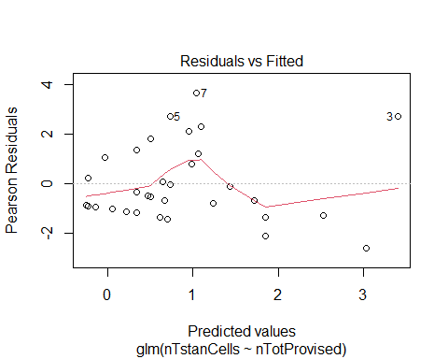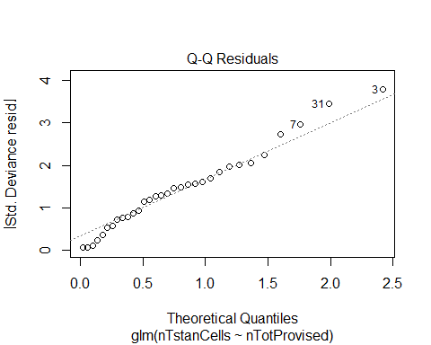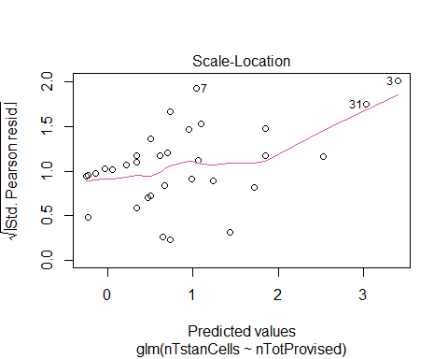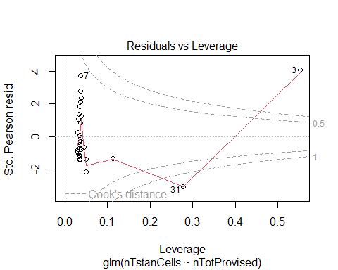

# check for over/underdispersion  
e2<-resid(glm.ntpc, type="pearson")  
n<-nrow(zo.data)  
p<-length(coef(glm.ntpc))  
sum(e2^2)/(n-p) # produces overdispersion (2.4)

## [1] 2.450051

# negative binomial glm  
glm.ntpc.nb<-glm.nb(nTstanCells ~ nTotProvised, data = zo.data, link = "log")   
tidy(glm.ntpc.nb) # sig, lower RSE (16), 12 df, AIC 137.06

## # A tibble: 2 × 5  
## term estimate std.error statistic p.value  
## <chr> <dbl> <dbl> <dbl> <dbl>  
## 1 (Intercept) -0.306 0.295 -1.04 3.00e- 1  
## 2 nTotProvised 0.0274 0.00443 6.20 5.71e-10

plot(glm.ntpc.nb) # curved resids, outlier pull

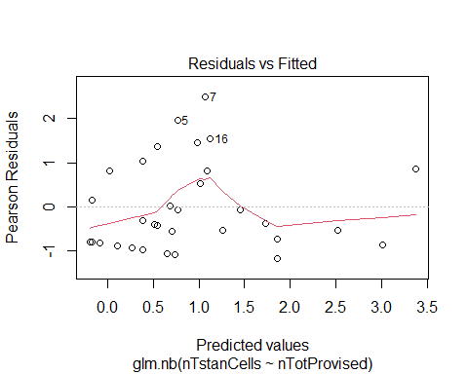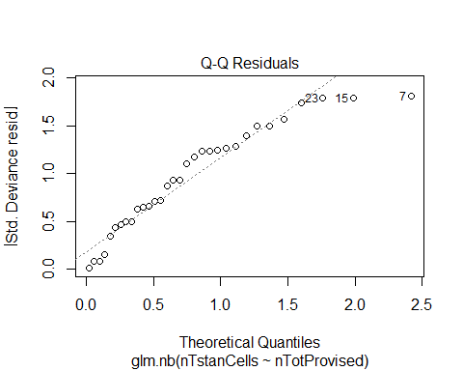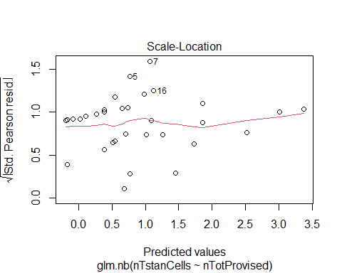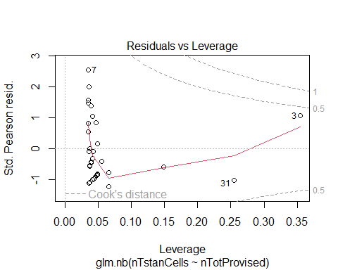

e2<-resid(glm.ntpc.nb, type="pearson")  
p<-length(coef(glm.ntpc.nb))  
sum(e2^2)/(n-p) # better (1.02)

## [1] 1.027707

glm.ntpc.nb1<-glm.nb(nTstanCells ~ sqrt(nTotProvised), data = zo.data, link = "log")   
tidy(glm.ntpc.nb1) # sig, lower RSE (16), 12 df, AIC 65.5

## # A tibble: 2 × 5  
## term estimate std.error statistic p.value  
## <chr> <dbl> <dbl> <dbl> <dbl>  
## 1 (Intercept) -1.85 0.534 -3.46 5.35e- 4  
## 2 sqrt(nTotProvised) 0.432 0.0699 6.18 6.43e-10

plot(glm.ntpc.nb1) # curved resids, not normal

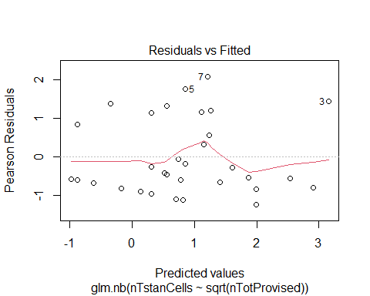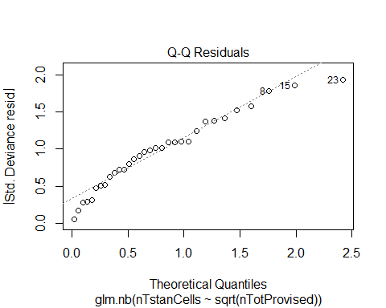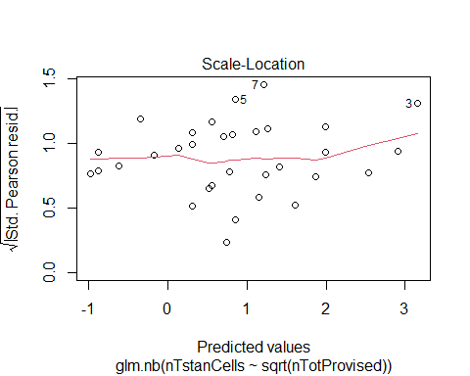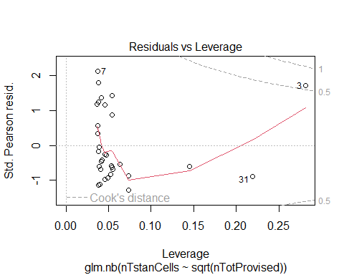

Poisson model seems to fit best #### Without outlier

glm.ntpc.rmo<- glm(nTstanCells ~ nTotProvised, data = zo.data.or, family = poisson())   
tidy(glm.ntpc.rmo) # sig. AIC: 130.85

## # A tibble: 2 × 5  
## term estimate std.error statistic p.value  
## <chr> <dbl> <dbl> <dbl> <dbl>  
## 1 (Intercept) 0.0554 0.218 0.254 0.800   
## 2 nTotProvised 0.0192 0.00315 6.11 0.00000000101

plot(glm.ntpc.rmo) # curved resids, not really normal

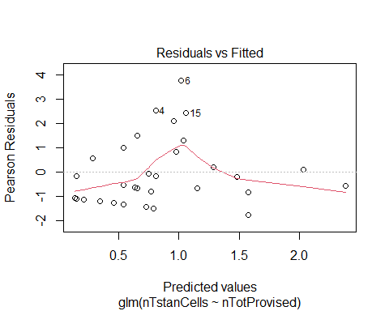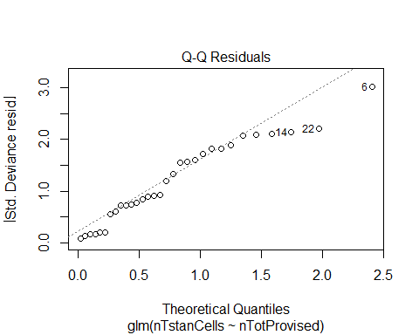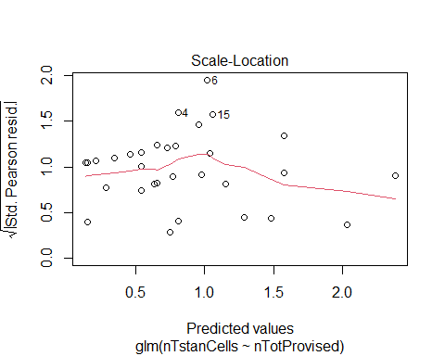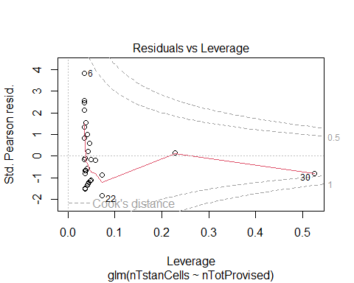

# check for over/underdispersion  
e2<-resid(glm.ntpc.rmo, type="pearson")  
n<-nrow(zo.data.or)  
p<-length(coef(glm.ntpc.rmo))  
sum(e2^2)/(n-p) # produces overdispersion (1.91)

## [1] 1.913785

# negative binomial glm  
glm.ntpc.rmo.nb<-glm.nb(nTstanCells ~ nTotProvised, data = zo.data.or, link = "log")   
tidy(glm.ntpc.rmo.nb) # sig, lower RSE (14), 11 df, AIC 56

## # A tibble: 2 × 5  
## term estimate std.error statistic p.value  
## <chr> <dbl> <dbl> <dbl> <dbl>  
## 1 (Intercept) -0.112 0.305 -0.367 0.714   
## 2 nTotProvised 0.0227 0.00517 4.38 0.0000119

plot(glm.ntpc.rmo.nb) # curved resids, not normal

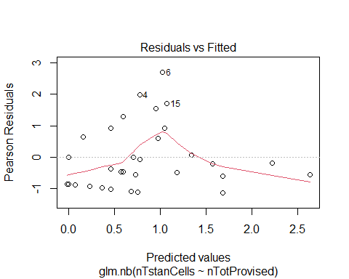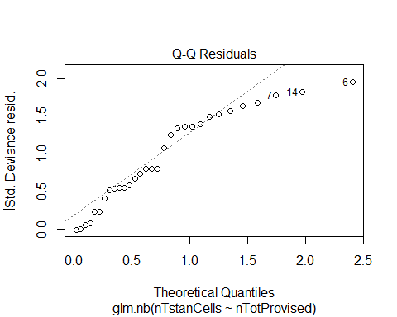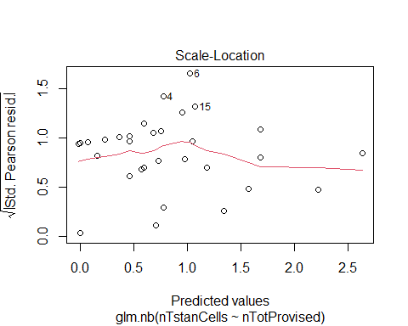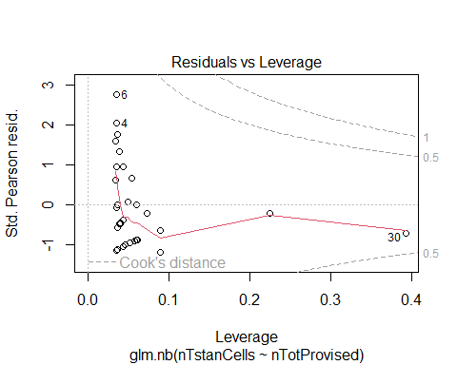

e2<-resid(glm.ntpc.rmo.nb, type="pearson")  
p<-length(coef(glm.ntpc.rmo.nb))  
sum(e2^2)/(n-p) # still some overdispersion (1.09)

## [1] 1.092497

### Tstan cells ~ O.lig cells

How does O. lignaria abundance predict T. stansburyi abundance?

# with outlier  
glm.nt1<-glm(nTstanCells ~ nOligGrowth, data=zo.data, family = poisson())  
tidy(glm.nt1) # sig. AIC:75.648

## # A tibble: 2 × 5  
## term estimate std.error statistic p.value  
## <chr> <dbl> <dbl> <dbl> <dbl>  
## 1 (Intercept) 0.212 0.187 1.14 2.56e- 1  
## 2 nOligGrowth 0.0342 0.00380 9.01 2.16e-19

plot(glm.nt1) # megaphone resids, oulier departure

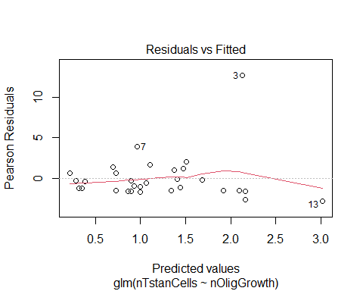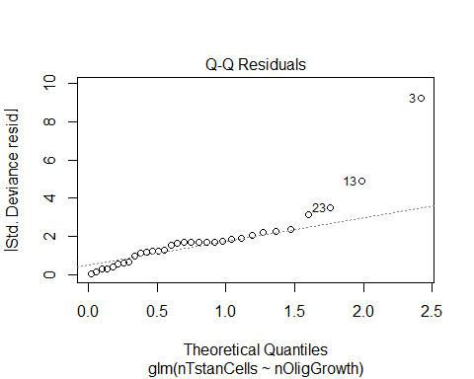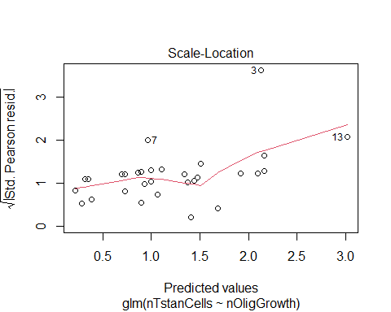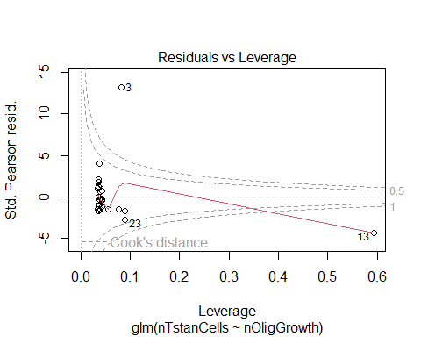

glm.nt1.nb<-glm.nb(nTstanCells ~ nOligGrowth, data=zo.data, link="log")  
tidy(glm.nt1.nb) # sig. AIC:235.4

## # A tibble: 2 × 5  
## term estimate std.error statistic p.value  
## <chr> <dbl> <dbl> <dbl> <dbl>  
## 1 (Intercept) -0.213 0.375 -0.567 0.571   
## 2 nOligGrowth 0.0459 0.00993 4.63 0.00000373

plot(glm.nt1.nb) # resids ok, normal

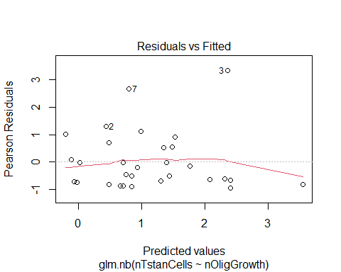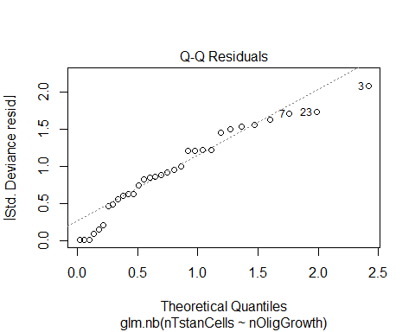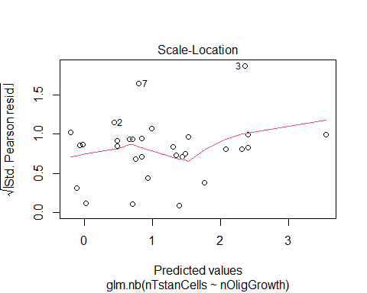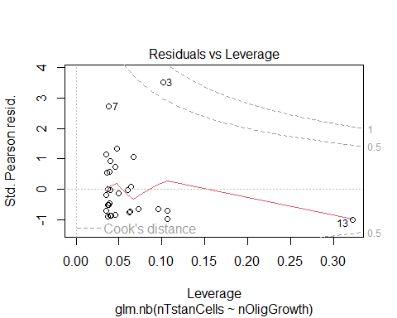

# without outlier  
glm.nt2<-glm(nTstanCells ~ nOligGrowth, data=zo.data.or, family = poisson())  
tidy(glm.nt2) # sig. AIC:141.9

## # A tibble: 2 × 5  
## term estimate std.error statistic p.value  
## <chr> <dbl> <dbl> <dbl> <dbl>  
## 1 (Intercept) 0.282 0.207 1.37 0.172   
## 2 nOligGrowth 0.0235 0.00478 4.92 0.000000879

plot(glm.nt2) # curved resids, mostly normal

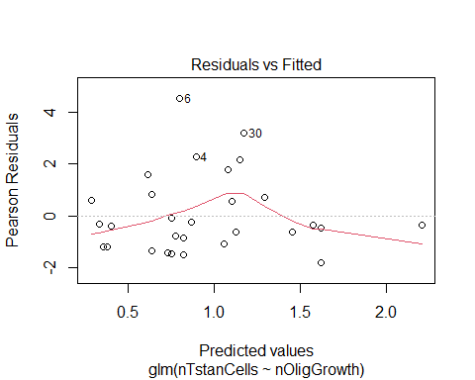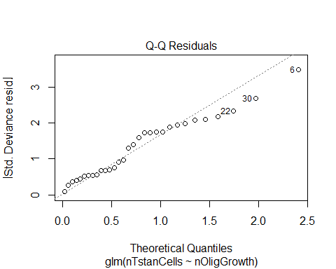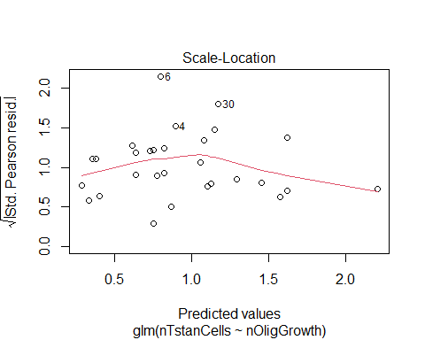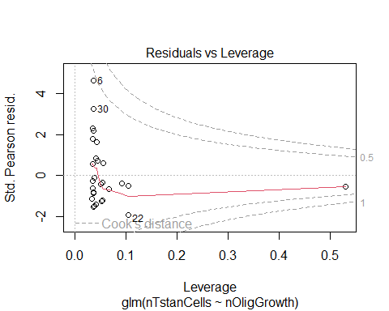

glm.nt2.nb<-glm.nb(nTstanCells ~ nOligGrowth, data=zo.data.or, link="log")  
tidy(glm.nt2.nb) # sig. AIC:132.41

## # A tibble: 2 × 5  
## term estimate std.error statistic p.value  
## <chr> <dbl> <dbl> <dbl> <dbl>  
## 1 (Intercept) 0.124 0.314 0.394 0.693   
## 2 nOligGrowth 0.0286 0.00847 3.38 0.000730

plot(glm.nt2.nb) # megaphone resids, normal

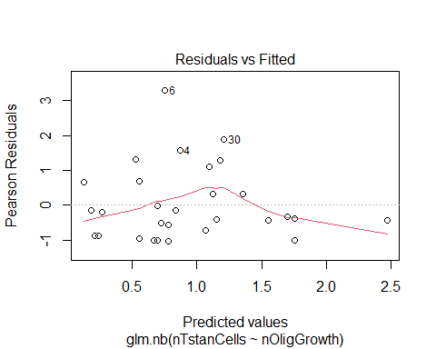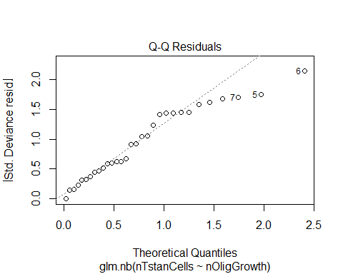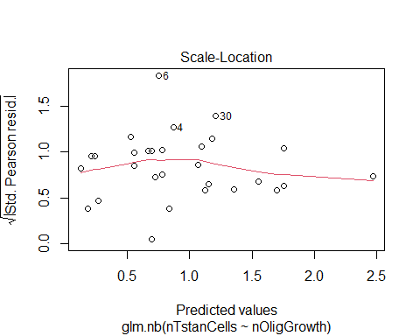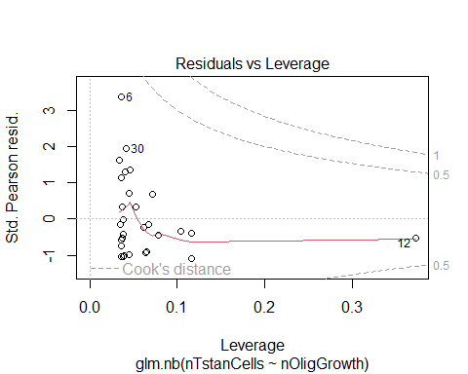

Does T. abundance abundance predict O. lignaria abundance? How does O. lignaria abundance predict T. stansburyi abundance?

lm.nt<-lm(nOligGrowth ~ nTstanCells, data=zo.data.or)  
tidy(lm.nt) # sig

## # A tibble: 2 × 5  
## term estimate std.error statistic p.value  
## <chr> <dbl> <dbl> <dbl> <dbl>  
## 1 (Intercept) 16.0 4.28 3.74 0.000802  
## 2 nTstanCells 3.77 1.09 3.45 0.00176

plot(lm.nt) # curved resids, normal

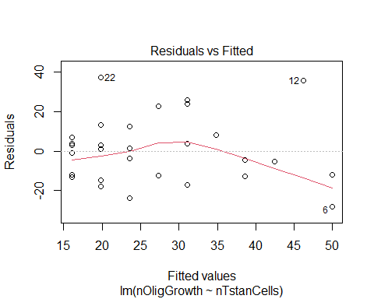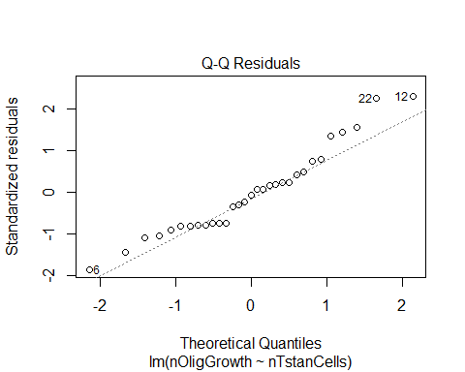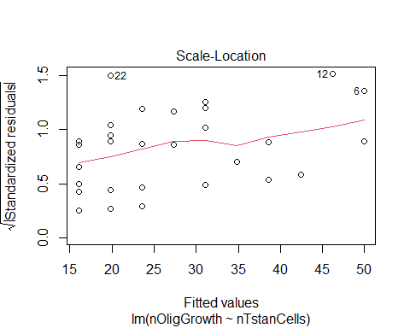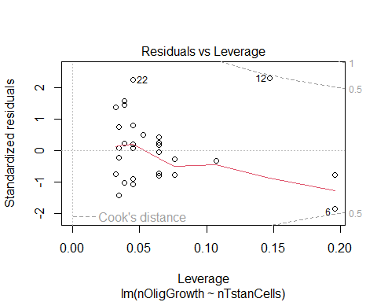

### O.lig Ratio ~ T.stan Ratio

How does T.stan brood ratios affect O. lignaria ratios #### Plots

plot(oligRatio ~ tstanRatio, data = zo.data.or) # slight decrease?

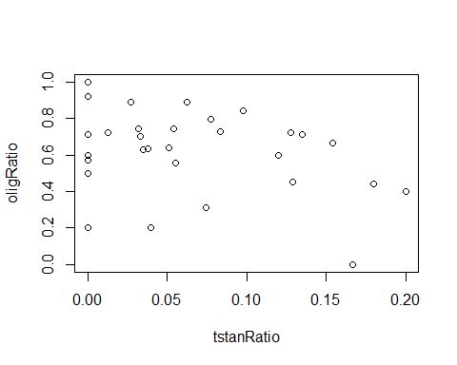 #### SLR Note: Olig ratios transformed become normal, but T.stan ratios still zero heavy. Sqrt does seem to help

# with outlier  
lm.to1<-lm(oligRatio ~ tstanRatio, data = zo.data)   
tidy(lm.to1) # marginally sig

## # A tibble: 2 × 5  
## term estimate std.error statistic p.value  
## <chr> <dbl> <dbl> <dbl> <dbl>  
## 1 (Intercept) 0.675 0.0532 12.7 1.35e-13  
## 2 tstanRatio -0.928 0.509 -1.82 7.80e- 2

plot(lm.to1) # megaphone residuals, some outliers, but fairly normal

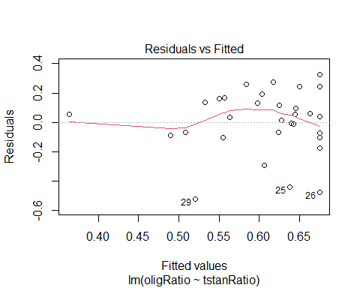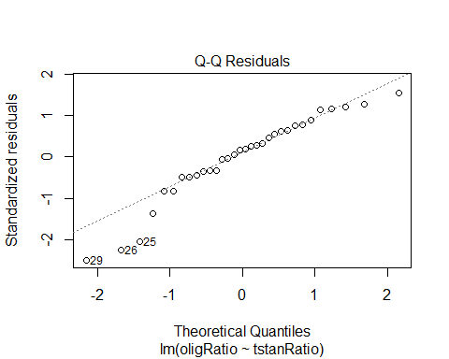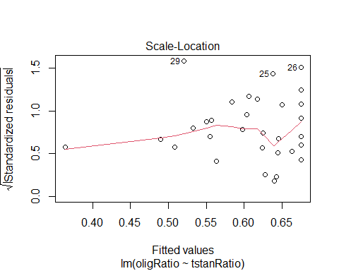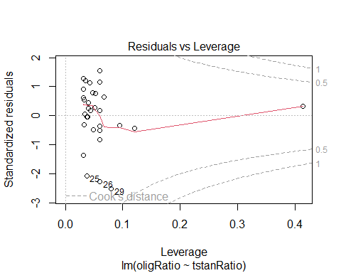

AIC(lm.to1)

## [1] -3.145844

shapiro.test(lm.to1$residuals) # sig

##   
## Shapiro-Wilk normality test  
##   
## data: lm.to1$residuals  
## W = 0.93298, p-value = 0.04744

e2<-resid(lm.to1, type="pearson")  
n<-nrow(zo.data.or)  
p<-length(coef(lm.to1))  
sum(e2^2)/(n-p) # under dispersion (0.05)

## [1] 0.04854594

lm.to2<-lm(oligRatio ~ tstanRatio, data = zo.data.or)  
tidy(lm.to2) # not sig.

## # A tibble: 2 × 5  
## term estimate std.error statistic p.value  
## <chr> <dbl> <dbl> <dbl> <dbl>  
## 1 (Intercept) 0.682 0.0580 11.8 1.50e-12  
## 2 tstanRatio -1.06 0.663 -1.60 1.20e- 1

plot(lm.to2) # megaphone residuals, departure from normal

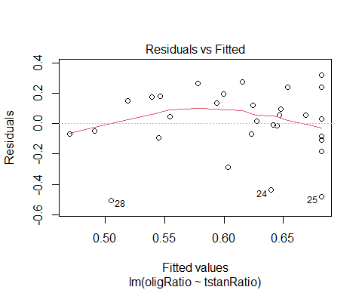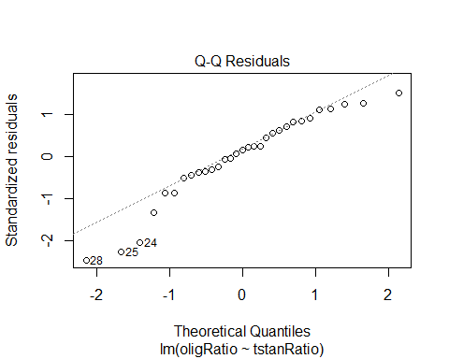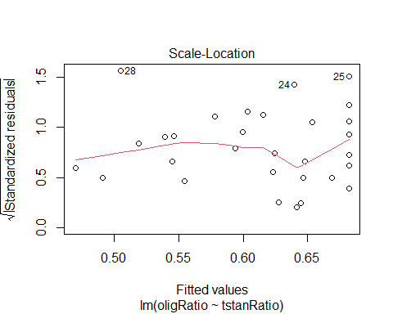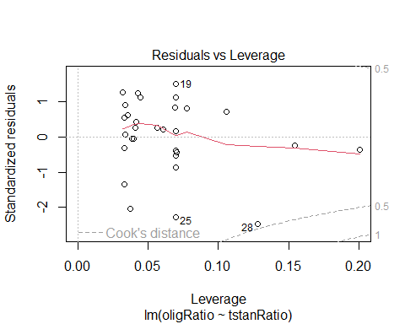

shapiro.test(lm.to2$residuals) # technically not sig

##   
## Shapiro-Wilk normality test  
##   
## data: lm.to2$residuals  
## W = 0.93215, p-value = 0.05017

lm.to3<-lm(oligRatio ~ log(tstanRatio+1,base=10), data = zo.data.or)  
tidy(lm.to3) # not sig

## # A tibble: 2 × 5  
## term estimate std.error statistic p.value  
## <chr> <dbl> <dbl> <dbl> <dbl>  
## 1 (Intercept) 0.682 0.0589 11.6 2.13e-12  
## 2 log(tstanRatio + 1, base = 10) -2.59 1.66 -1.56 1.29e- 1

plot(lm.to3) # megaphone residuals, departure from normal

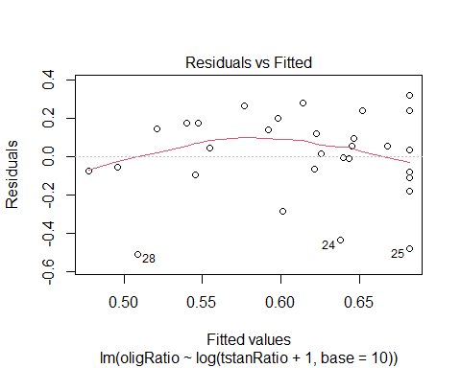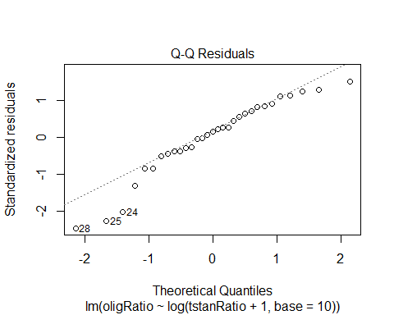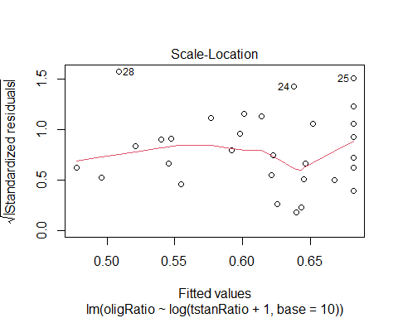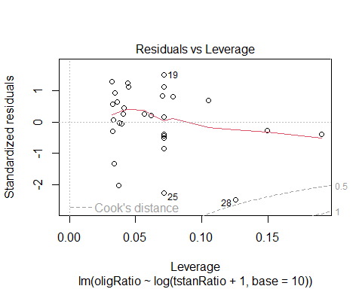

lm.to4<-lm(sqrt(oligRatio) ~ sqrt(tstanRatio), data = zo.data.or)  
tidy(lm.to4) # sig. r2 = 0.3

## # A tibble: 2 × 5  
## term estimate std.error statistic p.value  
## <chr> <dbl> <dbl> <dbl> <dbl>  
## 1 (Intercept) 0.820 0.0602 13.6 3.96e-14  
## 2 sqrt(tstanRatio) -0.290 0.238 -1.22 2.32e- 1

plot(lm.to4) # worse

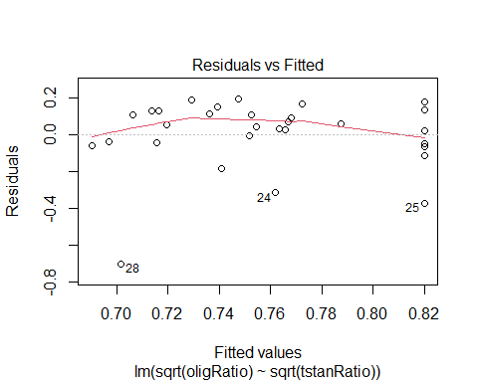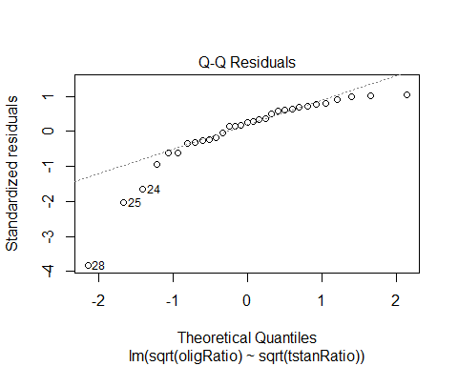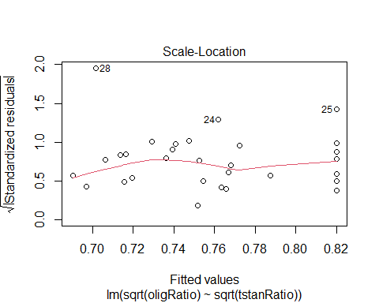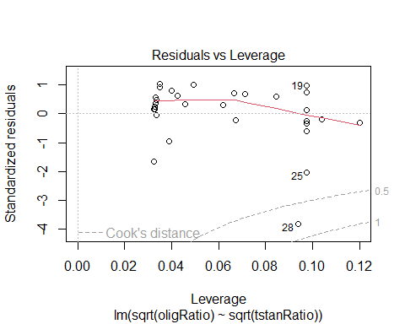

lm.to5<-lm(log(oligRatio+1, base=10) ~log(tstanRatio+1,base=10), data = zo.data)  
tidy(lm.to5) # marginally sig. r2 = 0.3

## # A tibble: 2 × 5  
## term estimate std.error statistic p.value  
## <chr> <dbl> <dbl> <dbl> <dbl>  
## 1 (Intercept) 0.221 0.0159 13.9 1.32e-14  
## 2 log(tstanRatio + 1, base = 10) -0.671 0.384 -1.75 9.11e- 2

plot(lm.to5) # megaphone residuals, some departure

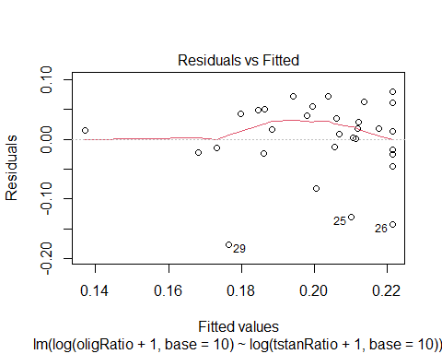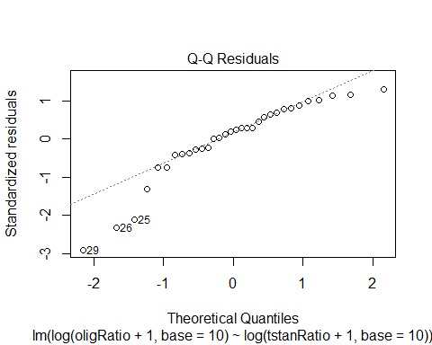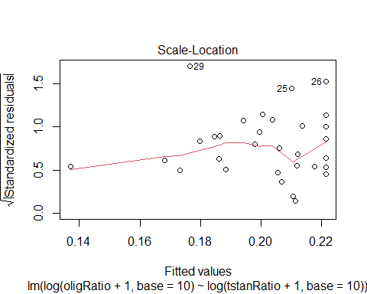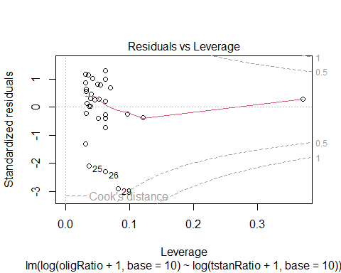

### O.lig fitness ~ T.stan ratio

#### Plots

# with T.stan outlier  
## T. stan Ratio  
plot(avgOligFMass_mg ~ tstanRatio, data = fw.data) # no difference

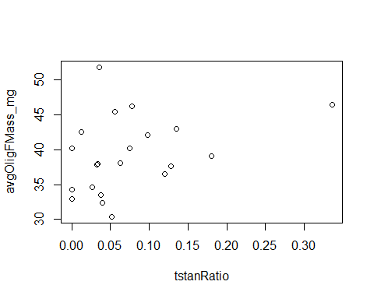

plot(avgOligMMass_mg ~ tstanRatio, data = mw.data) # no difference

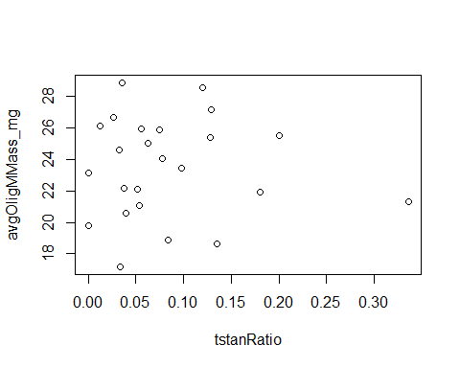

plot(oligFRatio ~ tstanRatio, data = fw.data) # decrease

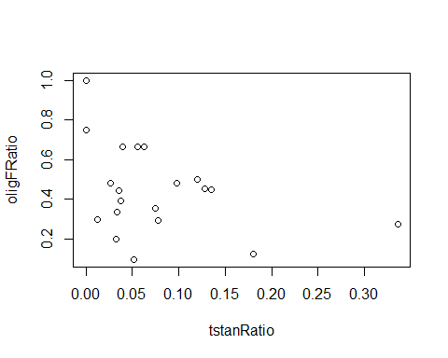

## T. stan abundance  
plot(avgOligFMass_mg ~ nTstanCells, data = fw.data) # increase? Hard to say with outlier

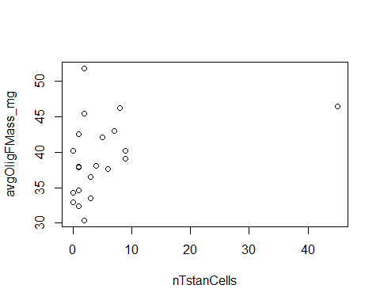

plot(avgOligMMass_mg ~ nTstanCells, data = mw.data) # hard to say with outlier

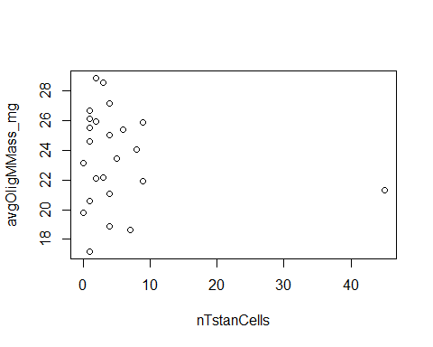

plot(oligFRatio ~ nTstanCells, data = fw.data) # decrease

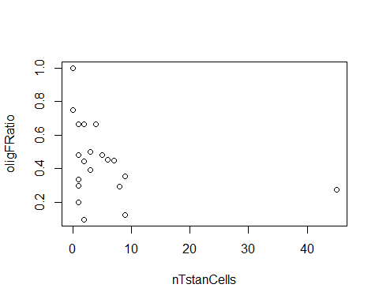

# no T.stan outlier  
## T. stan Ratio  
plot(avgOligFMass_mg ~ tstanRatio, data = fw.data.or) # no difference

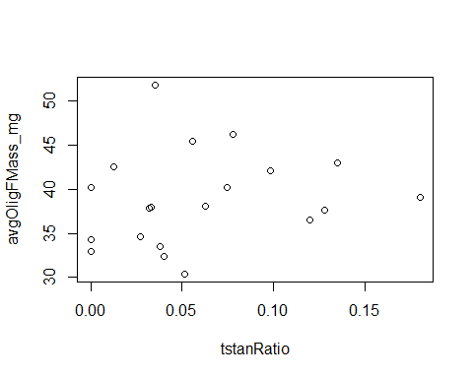

plot(avgOligMMass_mg ~ tstanRatio, data = mw.data[-c(2),]) # no difference

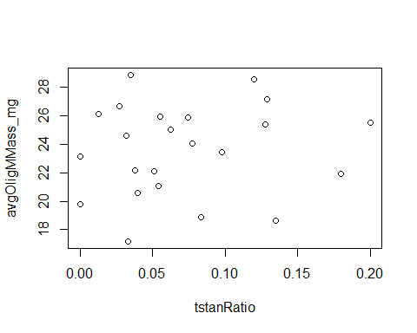

plot(oligFRatio ~ tstanRatio, data = fw.data.or) # no difference

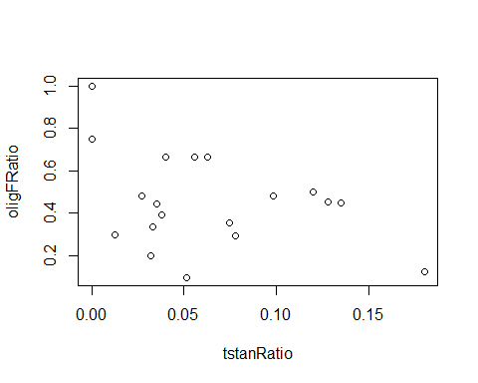

## T. stan abundance  
plot(avgOligFMass_mg ~ nTstanCells, data = fw.data.or) # no difference

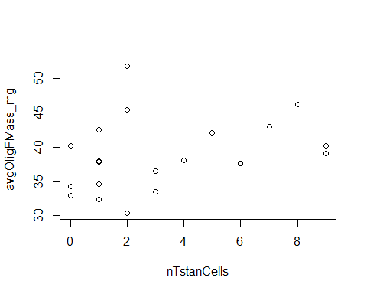

plot(avgOligMMass_mg ~ nTstanCells, data = mw.data[-c(2),]) # no difference

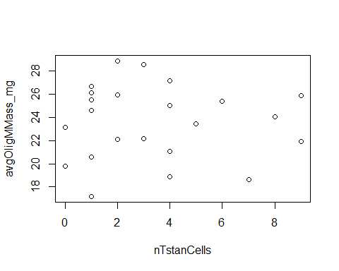

plot(oligFRatio ~ nTstanCells, data = fw.data.or) # decrease

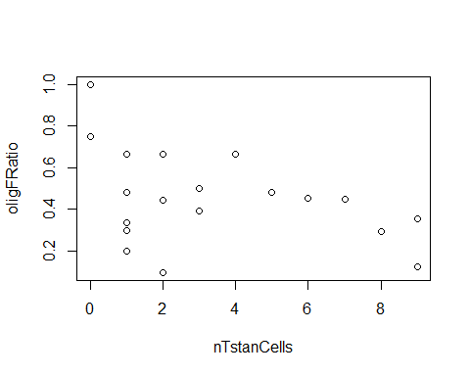

#### SLR

##### tstanRatio

lm.tmp<-lm(avgOligMMass_mg ~ tstanRatio, data = mw.data[-c(2),])  
tidy(lm.tmp) # not sig

## # A tibble: 2 × 5  
## term estimate std.error statistic p.value  
## <chr> <dbl> <dbl> <dbl> <dbl>  
## 1 (Intercept) 23.1 1.15 20.1 3.30e-15  
## 2 tstanRatio 6.78 12.8 0.530 6.01e- 1

plot(lm.tmp) # normal

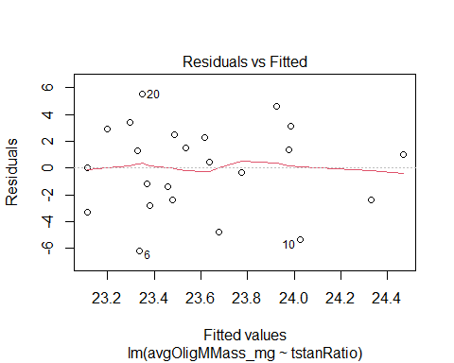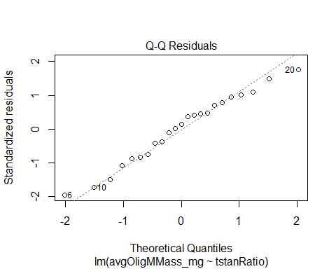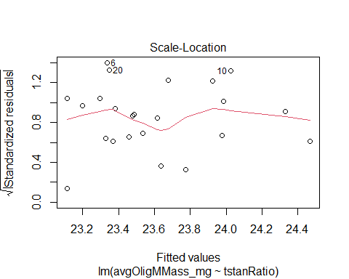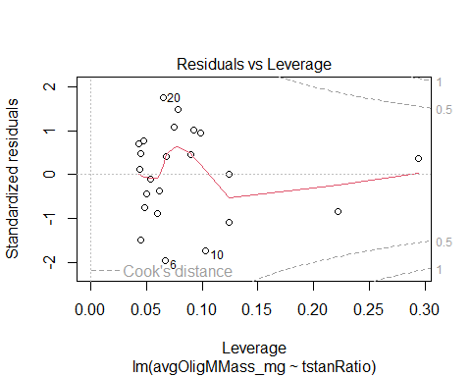

lm.tfp<-lm(avgOligFMass_mg ~ tstanRatio, data = fw.data.or)  
tidy(lm.tfp) # not sig

## # A tibble: 2 × 5  
## term estimate std.error statistic p.value  
## <chr> <dbl> <dbl> <dbl> <dbl>  
## 1 (Intercept) 37.7 1.90 19.8 1.14e-13  
## 2 tstanRatio 19.4 24.6 0.786 4.42e- 1

plot(lm.tfp) # curved residuals, some outlier departure

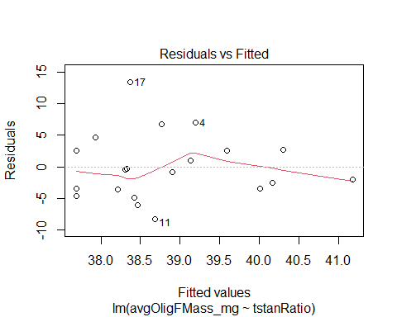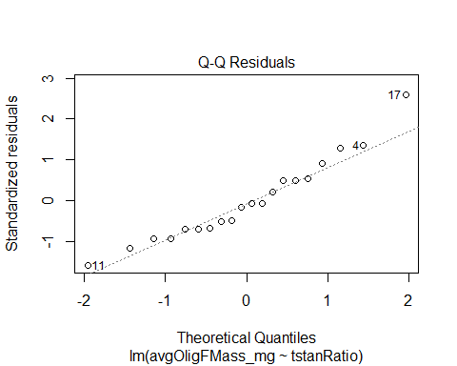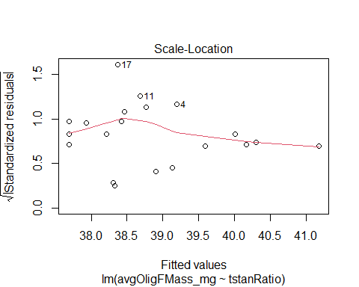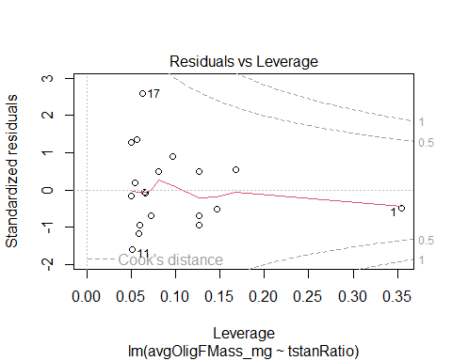

shapiro.test(lm.tfp$residuals) # not sig

##   
## Shapiro-Wilk normality test  
##   
## data: lm.tfp$residuals  
## W = 0.95305, p-value = 0.4158

lm.tfr<-lm(oligFRatio ~ tstanRatio, data = fw.data.or)  
tidy(lm.tfr) # marginally sig

## # A tibble: 2 × 5  
## term estimate std.error statistic p.value  
## <chr> <dbl> <dbl> <dbl> <dbl>  
## 1 (Intercept) 0.586 0.0755 7.76 0.000000377  
## 2 tstanRatio -1.93 0.977 -1.98 0.0634

plot(lm.tfr) # megaphone resids, some departure, but not bad

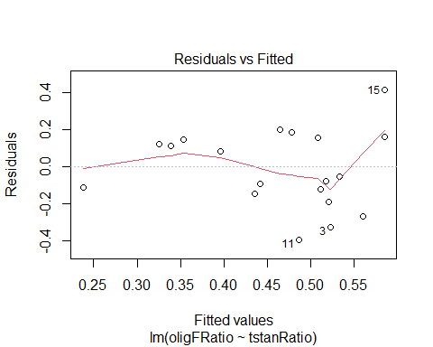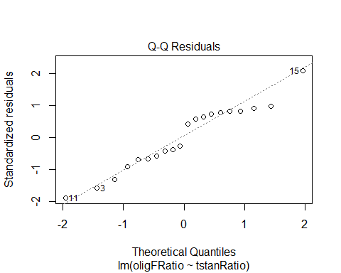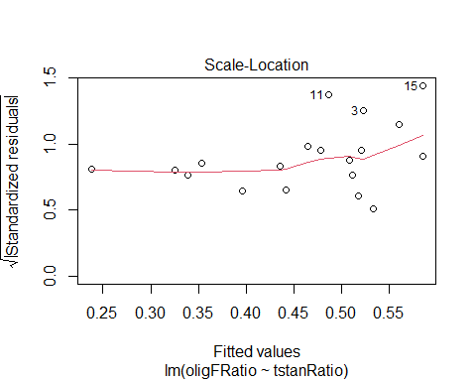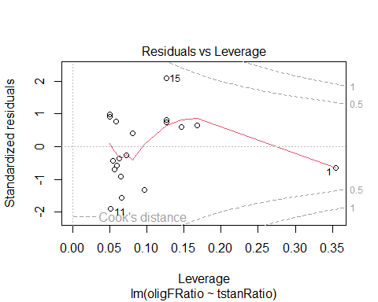

shapiro.test(lm.tfr$residuals) # not sig

##   
## Shapiro-Wilk normality test  
##   
## data: lm.tfr$residuals  
## W = 0.95424, p-value = 0.436

##### nTstanCells

lm.tm<-lm(avgOligMMass_mg ~ nTstanCells, data = mw.data[-c(2),])  
tidy(lm.tm) # not sig

## # A tibble: 2 × 5  
## term estimate std.error statistic p.value  
## <chr> <dbl> <dbl> <dbl> <dbl>  
## 1 (Intercept) 23.7 1.09 21.7 7.39e-16  
## 2 nTstanCells -0.0158 0.251 -0.0630 9.50e- 1

plot(lm.tm) # curved residuals, normal

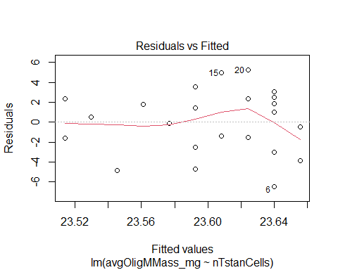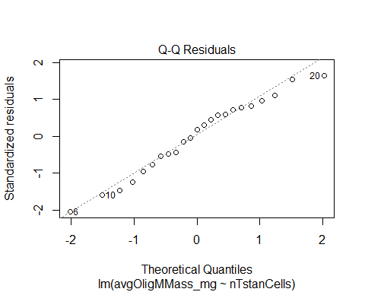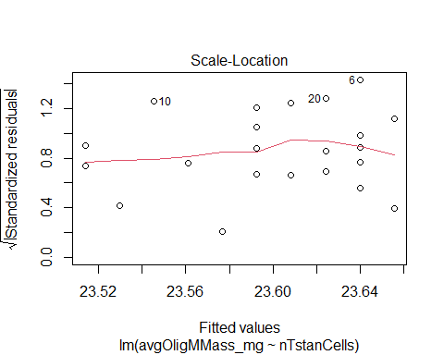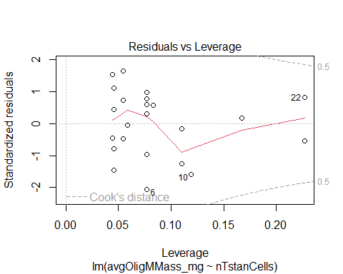

lm.tf<-lm(avgOligFMass_mg ~ nTstanCells, data = fw.data.or)  
tidy(lm.tf) # not sig

## # A tibble: 2 × 5  
## term estimate std.error statistic p.value  
## <chr> <dbl> <dbl> <dbl> <dbl>  
## 1 (Intercept) 37.0 1.71 21.6 2.50e-14  
## 2 nTstanCells 0.562 0.389 1.44 1.66e- 1

plot(lm.tf) # Some outliers, but not bad

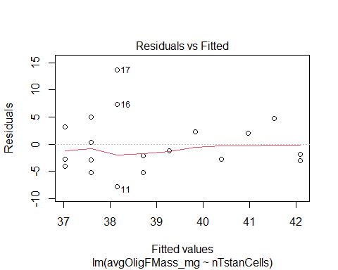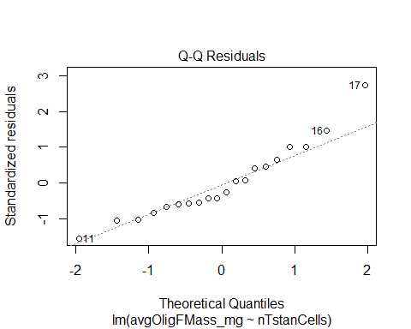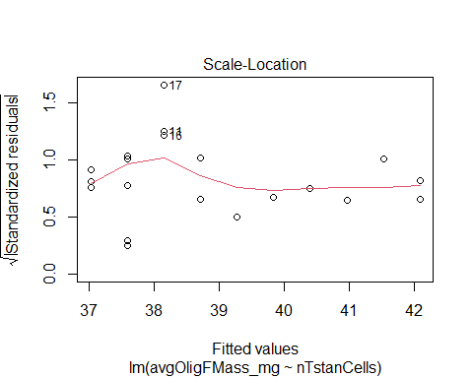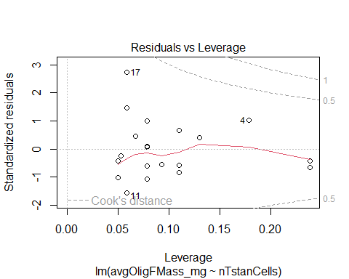

lm.tfr<-lm(oligFRatio ~ nTstanCells, data = fw.data.or)  
tidy(lm.tfr) # sig

## # A tibble: 2 × 5  
## term estimate std.error statistic p.value  
## <chr> <dbl> <dbl> <dbl> <dbl>  
## 1 (Intercept) 0.578 0.0696 8.31 0.000000143  
## 2 nTstanCells -0.0335 0.0158 -2.12 0.0486

plot(lm.tfr) # megaphone resids, some departure, but not bad

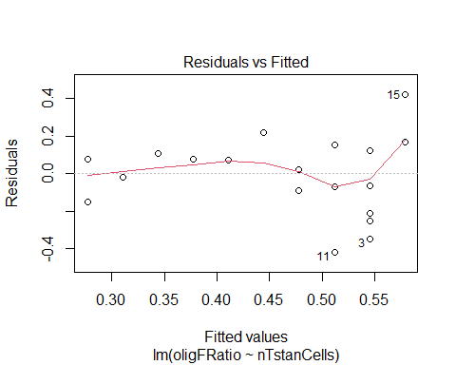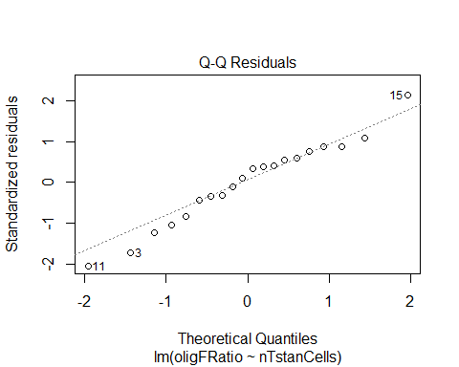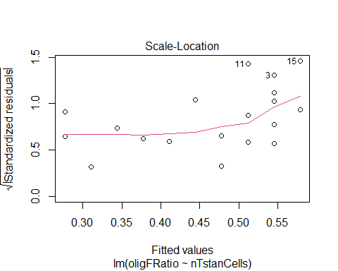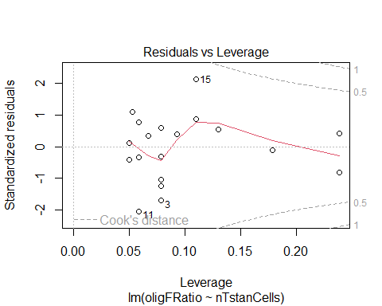

shapiro.test(lm.tfr$residuals) # not sig

##   
## Shapiro-Wilk normality test  
##   
## data: lm.tfr$residuals  
## W = 0.97451, p-value = 0.8456

# Figures

## Q1)

### Dredge

Ann_tmin_CC and WUI were sig

pem_atmin <- plot(predictorEffect("Ann_tmin_C", f_model_pdrd), main = "",   
 xlab = expression("Normal minimum temperature ("*~degree*C*")"),   
 ylab = expression(paste(italic("T. stansburyi"), " abundance")),   
 lines=list(col = "black"), lwd = 2)  
pem_wui <- plot(predictorEffect("WUI", f_model_pdrd), main = "",   
 xlab = expression("Low intensity development"),   
 ylab = expression(paste(italic("T. stansburyi"), " abundance")),   
 lines=list(col = "black"), lwd = 2)  
  
pem_tstan<-plot_grid(pem_atmin, pem_wui, ncol=2, labels = c("A", "B"))  
save_plot("figures\\tstan.landvars.pem.png", pem_tstan, base_height=7.5, bg="white")

## Q2)

### Tstan Count ~ Provisioned cells

# Poisson  
tpc.tstan<-  
ggplot(data = zo.data.or, aes(x=nTotProvised, y = nTstanCells))+  
 geom_point(aes(color = Habitat, fill = Habitat, shape = Habitat), size = 5, color = "black")+  
 scale_fill_manual(values=c("grey50", "grey70", "grey90")) +  
 scale_shape_manual(values=c(21:23))+  
 stat_smooth(method="glm", formula = y ~ x, color = "black", fill = "lightgray", method.args =  
 list(family = poisson))+  
 geom_text_repel(aes(x = nTotProvised, label = Year3), size = 5)+  
 xlab(expression(paste(italic("O. lignaria"), " provisioned cells")))+  
 ylab(expression(paste("Total ", italic("T. stansburyi "), "count"))) +  
 ylim(0, 10) + xlim(0,135)+  
 theme_classic()+  
 theme(plot.title = element_text(hjust = 0.5, size = 20), legend.position="right",   
 legend.text = element_text(size=16), axis.text.x = element_text(size=18),   
 axis.text.y = element_text(size=18), legend.title = element_text(size = 18),  
 axis.title.x = element_text(size=20), axis.title.y =element_text(size=20),  
 plot.margin=unit(c(1,1,1,1),"cm"))  
  
# Negative Binomial  
#ee <- emmeans(glm.ntpc.rmo.nb, "nTotProvised", type = "response", offset = log(1))  
# https://cran.r-project.org/web/packages/emmeans/vignettes/sophisticated.html#offsets  
  
#tpc.tstan.nb<-  
#https://stackoverflow.com/questions/76742036/how-to-make-a-plot-of-a-negative-binomial-regression-fitted-values-and-95-conf  
  
save_plot("figures\\tpc.tstan.png", tpc.tstan, base_height = 5.5, base_aspect_ratio = 2, bg="white")

### Tstan Count ~ Olig Count

tn.on.lm<-  
ggplot(data = zo.data.or, aes(x = nTstanCells, y = nOligGrowth))+  
 geom_point(aes(color = Habitat, fill = Habitat, shape = Habitat), size = 5, color = "black")+  
 scale_fill_manual(values=c("grey50", "grey70", "grey90")) +  
 scale_shape_manual(values=c(21:23))+  
 stat_smooth(method="lm", color = "black", fill = "lightgray")+  
 geom_text_repel(aes(x = nTstanCells, label = Year3), size = 5)+   
 xlab(expression(paste("Total ", italic("T. stansburyi"), " count"))) +   
 ylab(expression(paste("Total ", italic("O. lignaria"), " count")))+  
 xlim(0,10) + ylim(0,100)+   
 theme_classic()+  
 theme(plot.title = element_text(hjust = 0.5, size = 20), legend.position="right",   
 legend.text = element_text(size=16), axis.text.x = element_text(size=18),   
 axis.text.y = element_text(size=18), legend.title = element_text(size = 18),  
 axis.title.x = element_text(size=20), axis.title.y =element_text(size=20),  
 plot.margin=unit(c(1,1,1,1),"cm"))  
  
save_plot("figures\\tstann.olig.lm.png", tn.on.lm, base_height=5.5, base_aspect_ratio = 3, bg="white")

### O.lig Ratio ~ T.stan Ratio

tr.or.lm<-  
ggplot(data = zo.data.or, aes(x = (tstanRatio*100), y = (oligRatio*100)))+  
 geom_point(aes(color = Habitat, fill = Habitat, shape = Habitat), size = 5, color = "black")+  
 scale_fill_manual(values=c("grey50", "grey70", "grey90")) +  
 scale_shape_manual(values=c(21:23))+  
 #stat_smooth(method="lm", color = "black", fill = "lightgray", linetype = 2)+  
 geom_text_repel(aes(x = (tstanRatio*100), label = Year3), size = 5)+  
 ylab(expression(paste(italic("O. lignaria"), " brood ratio (%)")))+  
 xlab(expression(paste(italic("T. stansburyi")," brood ratio (%)"))) +  
 xlim(0,20)+ ylim(0,100)+  
 theme_classic()+  
 theme(plot.title = element_text(hjust = 0.5, size = 20), legend.position="right",   
 legend.text = element_text(size=16), axis.text.x = element_text(size=18),   
 axis.text.y = element_text(size=18), legend.title = element_text(size = 18),  
 axis.title.x = element_text(size=20), axis.title.y =element_text(size=20),  
 plot.margin=unit(c(1,1,1,1),"cm"))  
save_plot("figures\\tstanr.oligr.lm.png", tr.or.lm, base_height=5.5,base_aspect_ratio = 2, bg="white")

### O.lig F Ratio ~ T.stan Ratio/count

tr.fr.lm<-  
ggplot(data = fw.data.or, aes(x = (tstanRatio*100), y = (oligFRatio*100)))+  
 geom_point(aes(color = Habitat, fill = Habitat, shape = Habitat), size = 5, color = "black")+  
 scale_fill_manual(values=c("grey50", "grey70", "grey90")) +  
 scale_shape_manual(values=c(21:23))+  
 stat_smooth(method="lm", color = "black", fill = "lightgray",linetype = 2)+  
 geom_text_repel(aes(x = (tstanRatio*100), label = Year3), size = 5)+  
 ylab(expression(paste(italic("O. lignaria"), " female ratio (%) ")))+  
 xlab(expression(paste(italic("T. stansburyi")," brood ratio (%)"))) +  
 xlim(0,20)+ ylim(0,100)+  
 theme_classic()+  
 theme(plot.title = element_text(hjust = 0.5, size = 20), legend.position="right",   
 legend.text = element_text(size=16), axis.text.x = element_text(size=18),   
 axis.text.y = element_text(size=18), legend.title = element_text(size = 18),  
 axis.title.x = element_text(size=20), axis.title.y =element_text(size=20),  
 plot.margin=unit(c(1,1,1,1),"cm"))  
  
save_plot("figures\\tstanr.oligFr.lm.png", tr.fr.lm, base_height=5.5,base_aspect_ratio = 2, bg="white")  
  
tn.fr.lm<-  
ggplot(data = fw.data.or, aes(x = nTstanCells, y = (oligFRatio*100)))+  
 geom_point(aes(color = Habitat, fill = Habitat, shape = Habitat), size = 5, color = "black")+  
 scale_fill_manual(values=c("grey50", "grey70", "grey90")) +  
 scale_shape_manual(values=c(21:23))+  
 stat_smooth(method="lm", color = "black", fill = "lightgray")+  
 geom_text_repel(aes(x = (tstanRatio*100), label = Year3), size = 5)+  
 ylab(expression(paste(italic("O. lignaria"), " female ratio (%) ")))+  
 xlab(expression(paste("Total ", italic("T. stansburyi"), " count"))) +   
 xlim(0,10)+ ylim(0,100)+  
 theme_classic()+  
 theme(plot.title = element_text(hjust = 0.5, size = 20), legend.position="right",   
 legend.text = element_text(size=16), axis.text.x = element_text(size=18),   
 axis.text.y = element_text(size=18), legend.title = element_text(size = 18),  
 axis.title.x = element_text(size=20), axis.title.y =element_text(size=20),  
 plot.margin=unit(c(1,1,1,1),"cm"))  
  
save_plot("figures\\tstann.oligFr.lm.png", tn.fr.lm, base_height=5.5,base_aspect_ratio = 2, bg="white")

### Combine all

tstann.olign.all=ggarrange(tpc.tstan, tn.on.lm, tr.or.lm, tn.fr.lm,   
 ncol=2, nrow = 2, common.legend = TRUE, legend = "right",   
 labels = c("A", "B", "C", "D"))  
save_plot("figures\\tstann.olign.all.png", tstann.olign.all, base_height=10, base_aspect_ratio = 2, bg="white")