**BLINK PATTERN:**

* **BLINK PER SECOND (NO SIGNAL)**
* **BLINK PER 5 SECONDS (CONNECTED)**

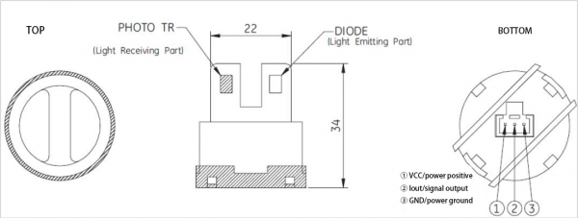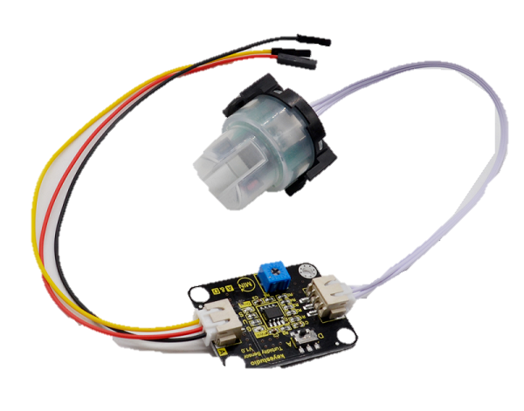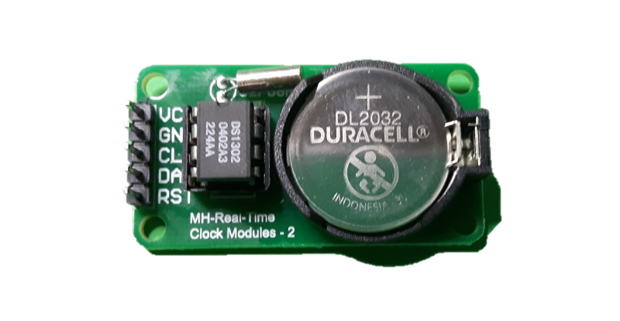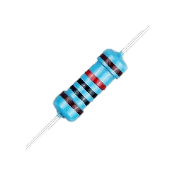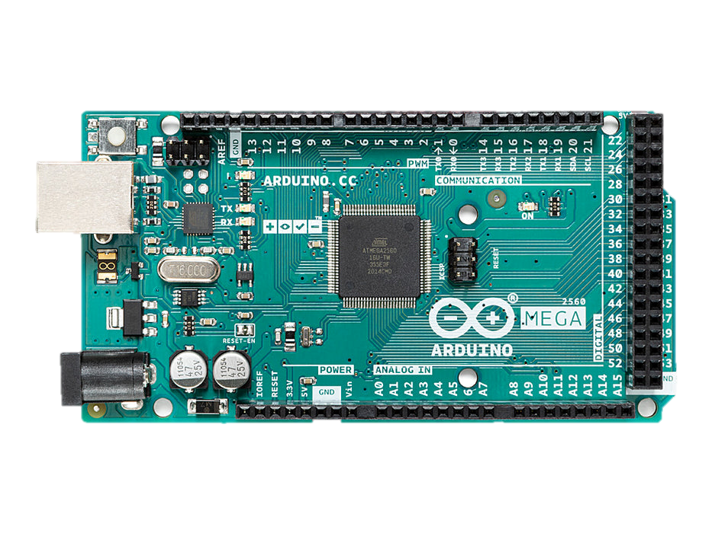

**GSM GND**

PWM (10)

PWM (11)

MAIN

**ANALOG PIN (A0)**

**CONNECTED TO MAIN GND**

**CONNECTED TO MAIN 5 VOLTS**

**PWM (2)**

**PWM (4)**

**PWM (5)**

**CONNECTED TO MAIN GND**

**CONNECTED TO MAIN 5 VOLTS**

**SENSOR MAIN GND**

**SENSOR MAIN GND**

**SENSOR MAIN 5 VOLTS**

**SENSOR MAIN 5 VOLTS**

**GSM GND**

**TEMPERATURE SENSOR 5 VOLTS**

**VCC 5 Volts**

**SIGNAL PIN (7)**

**TEMPERATURE SENSOR GND**

**GND**