Albertscode_forJessie

library(MARSS)

## Warning: package 'MARSS' was built under R version 4.0.5

library(xtable)

## Warning: package 'xtable' was built under R version 4.0.5

library(tidyverse)

## Warning: package 'tidyverse' was built under R version 4.0.5

## -- Attaching packages --------------------------------------- tidyverse 1.3.1 --

## v ggplot2 3.3.5 v purrr 0.3.4  
## v tibble 3.1.5 v dplyr 1.0.7  
## v tidyr 1.1.4 v stringr 1.4.0  
## v readr 2.0.2 v forcats 0.5.1

## Warning: package 'ggplot2' was built under R version 4.0.5

## Warning: package 'tibble' was built under R version 4.0.5

## Warning: package 'tidyr' was built under R version 4.0.5

## Warning: package 'readr' was built under R version 4.0.5

## Warning: package 'purrr' was built under R version 4.0.5

## Warning: package 'dplyr' was built under R version 4.0.5

## Warning: package 'forcats' was built under R version 4.0.5

## -- Conflicts ------------------------------------------ tidyverse_conflicts() --  
## x dplyr::filter() masks stats::filter()  
## x dplyr::lag() masks stats::lag()

#Read in data

#Matrix Klamath + pond dataset  
daily_means_long_klamath <- readRDS('daily_means_long_klamath.rds')  
transformed_dat_klamath <- readRDS('transformed_dat_klamath.rds')  
transformed_dat_klamath_df <- as.data.frame(t(transformed_dat_klamath))  
str(transformed_dat_klamath)  
  
#Matrix Airtemp dataset  
covariate_klamath <- readRDS('covariate.rds')  
transformed_covariate_klamath <- zscore(covariate_klamath)

# Steps:

# 1) Among sensor replicates, drop time series with (many) gaps.

# 2) Then take mean across replicate sensors, so that we end up with 1 time series per habitat, 2+9+1 (12 x 378)

#AP  
color <- c("AP1" = "blue", "AP3" = "red")  
transformed_dat_klamath_df %>% rowid_to_column(var = "day") %>% ggplot()+  
 geom_line(aes(x = day, y = AP1, color = "AP1")) +  
 geom_line(aes(x = day, y = AP3, color = "AP3"))+  
 labs(x = "day", y = "site", color = "Legend")+  
 theme_classic()+  
 scale_color_manual(values = color, labels = c("AP1","AP3"))

## Warning: Removed 63 row(s) containing missing values (geom_path).

## Warning: Removed 9 row(s) containing missing values (geom_path).

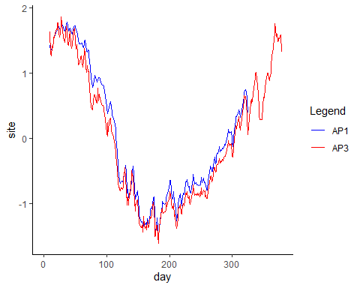

#need to remove AP1

#SP  
color <- c("SP1" = "blue", "SP2" = "red")  
transformed_dat_klamath_df %>% rowid_to_column(var = "day") %>% ggplot()+  
 geom_line(aes(x = day, y = SP1, color = "SP1")) +  
 geom_line(aes(x = day, y = SP2, color = "SP2"))+  
 labs(x = "day", y = "site", color = "Legend")+  
 theme_classic()+  
 scale_color_manual(values = color, labels = c("SP1","SP2"))

## Warning: Removed 10 row(s) containing missing values (geom_path).  
  
## Warning: Removed 10 row(s) containing missing values (geom_path).

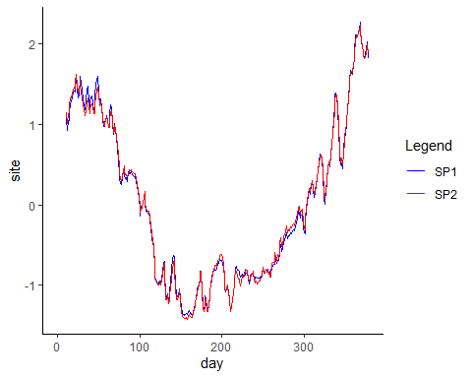

#both good, need to take average  
transformed_dat_klamath_df$SP <- (transformed_dat_klamath_df$SP1 + transformed_dat_klamath_df$SP2)/2

#FG  
color <- c("FG2" = "blue", "FG3" = "red")  
transformed_dat_klamath_df %>% rowid_to_column(var = "day") %>% ggplot()+  
 geom_line(aes(x = day, y = FG2, color = "FG2")) +  
 geom_line(aes(x = day, y = FG3, color = "FG3"))+  
 labs(x = "day", y = "site", color = "Legend")+  
 theme_classic()+  
 scale_color_manual(values = color, labels = c("FG2","FG3"))

## Warning: Removed 10 row(s) containing missing values (geom_path).  
  
## Warning: Removed 10 row(s) containing missing values (geom_path).

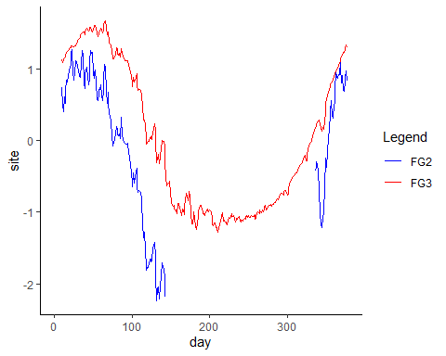

#need to remove FG2

#GP  
color <- c("GP1" = "blue", "GP2" = "red", "GP3" = "green")  
transformed_dat_klamath_df %>% rowid_to_column(var = "day") %>% ggplot()+  
 geom_line(aes(x = day, y = GP1, color = "GP1")) +  
 geom_line(aes(x = day, y = GP2, color = "GP2"))+  
 geom_line(aes(x = day, y = GP3, color = "GP3"))+  
 labs(x = "day", y = "site", color = "Legend")+  
 theme_classic()+  
 scale_color_manual(values = color, labels = c("GP1","GP2","GP3"))

## Warning: Removed 9 row(s) containing missing values (geom_path).  
  
## Warning: Removed 9 row(s) containing missing values (geom_path).  
  
## Warning: Removed 9 row(s) containing missing values (geom_path).

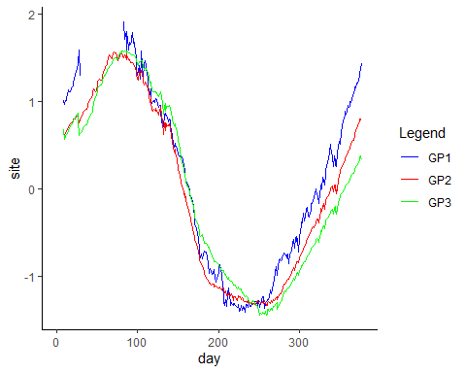

#need to remove GP1  
transformed_dat_klamath_df$GP <- (transformed_dat_klamath_df$GP2 + transformed_dat_klamath_df$GP3)/2

#UL  
color <- c("ULout" = "blue", "UL1" = "red", "UL3" = "green")  
transformed_dat_klamath_df %>% rowid_to_column(var = "day") %>% ggplot()+  
 geom_line(aes(x = day, y = ULout, color = "ULout")) +  
 geom_line(aes(x = day, y = UL1, color = "UL1"))+  
 geom_line(aes(x = day, y = UL3, color = "UL3"))+  
 labs(x = "day", y = "site", color = "Legend")+  
 theme_classic()+  
 scale_color_manual(values = color, labels = c("ULout","UL1","UL3"))

## Warning: Removed 7 row(s) containing missing values (geom_path).  
  
## Warning: Removed 7 row(s) containing missing values (geom_path).  
  
## Warning: Removed 7 row(s) containing missing values (geom_path).

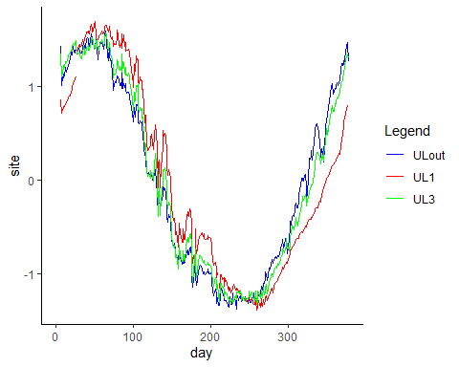

#need to remove UL1  
transformed_dat_klamath_df$UL <- (transformed_dat_klamath_df$ULout + transformed_dat_klamath_df$UL3)/2

#LL  
color <- c("LL1" = "blue", "LL2" = "red", "LL3" = "green")  
transformed_dat_klamath_df %>% rowid_to_column(var = "day") %>% ggplot()+  
 geom_line(aes(x = day, y = LL1, color = "LL1")) +  
 geom_line(aes(x = day, y = LL2, color = "LL2"))+  
 geom_line(aes(x = day, y = LL3, color = "LL3"))+  
 labs(x = "day", y = "site", color = "Legend")+  
 theme_classic()+  
 scale_color_manual(values = color, labels = c("LL1","LL2","LL3"))

## Warning: Removed 9 row(s) containing missing values (geom_path).  
  
## Warning: Removed 9 row(s) containing missing values (geom_path).  
  
## Warning: Removed 9 row(s) containing missing values (geom_path).

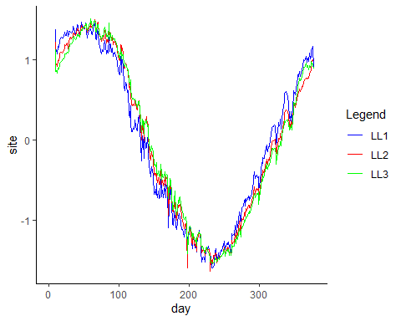

#all ok  
transformed_dat_klamath_df$LL <- (transformed_dat_klamath_df$LL1 + transformed_dat_klamath_df$LL2 + transformed_dat_klamath_df$LL3)/3

#SC  
color <- c("APck" = "blue", "SPck" = "red", "LSck" = "green", "MayCk"="orange")  
transformed_dat_klamath_df %>% rowid_to_column(var = "day") %>% ggplot()+  
 geom_line(aes(x = day, y = APck, color = "APck")) +  
 geom_line(aes(x = day, y = SPck, color = "SPck"))+  
 geom_line(aes(x = day, y = LSck, color = "LSck"))+  
 geom_line(aes(x = day, y = MayCk, color = "MayCk"))+  
 labs(x = "day", y = "site", color = "Legend")+  
 theme_classic()+  
 scale_color_manual(values = color, labels = c("APck","SPck","LSck","MayCk"))

## Warning: Removed 189 row(s) containing missing values (geom_path).

## Warning: Removed 104 row(s) containing missing values (geom_path).

## Warning: Removed 12 row(s) containing missing values (geom_path).  
  
## Warning: Removed 12 row(s) containing missing values (geom_path).

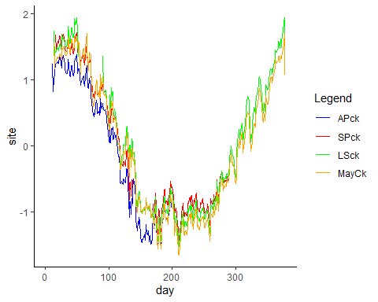

#need to remove APck and SPck  
transformed_dat_klamath_df$SC <- (transformed_dat_klamath_df$LSck + transformed_dat_klamath_df$MayCk)/2

#HC  
color <- c("FGck" = "blue", "GPck" = "red", "ULck" = "green")  
transformed_dat_klamath_df %>% rowid_to_column(var = "day") %>% ggplot()+  
 geom_line(aes(x = day, y = FGck, color = "FGck")) +  
 geom_line(aes(x = day, y = GPck, color = "GPck"))+  
 geom_line(aes(x = day, y = ULck, color = "ULck"))+  
 labs(x = "day", y = "site", color = "Legend")+  
 theme_classic()+  
 scale_color_manual(values = color, labels = c("FGck","GPck","ULck"))

## Warning: Removed 10 row(s) containing missing values (geom_path).

## Warning: Removed 16 row(s) containing missing values (geom_path).

## Warning: Removed 7 row(s) containing missing values (geom_path).

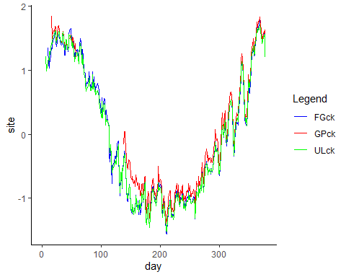

#need to remove GPck  
transformed_dat_klamath_df$HC <- (transformed_dat_klamath_df$FGck + transformed_dat_klamath_df$ULck)/2

#Matrix of transformed data with 12 sites (condensed_transdat)

condensed_transdat_df <- cbind(AP = transformed_dat_klamath_df$AP3, SP = transformed_dat_klamath_df$SP, Durazo = transformed_dat_klamath_df$Durazo, LS = transformed_dat_klamath_df$LS, May = transformed_dat_klamath_df$May, FG = transformed_dat_klamath_df$FG3, GP = transformed_dat_klamath_df$GP, UL = transformed_dat_klamath_df$UL, LL = transformed_dat_klamath_df$LL, SC = transformed_dat_klamath_df$SC, HC = transformed_dat_klamath_df$HC, KSV = transformed_dat_klamath_df$KSV)  
condensed_transdat <- as.matrix(t(condensed_transdat_df))  
str(condensed_transdat)

## num [1:12, 1:378] NA NA NA NA NA NA NA NA NA NA ...  
## - attr(*, "dimnames")=List of 2  
## ..$ : chr [1:12] "AP" "SP" "Durazo" "LS" ...  
## ..$ : NULL

saveRDS(condensed_transdat, "condensed_transdat.rds")

# Hypothesis 1: all states have different levels of stochastic (Q) and deterministic (C) variability

## AICc -9599.906

mod1_condense = list()  
mod1_condense$A = "zero"   
mod1_condense$Z = "identity"  
mod1_condense$R = "zero" #all the sensors are same, so observation error should be same  
mod1_condense$Q = "diagonal and unequal"   
mod1_condense$B = "diagonal and unequal" #assuming no species interactions  
mod1_condense$U = "zero"   
mod1_condense$C = "unequal"   
mod1_condense$c = transformed_covariate_klamath  
mod1_condense.fit = MARSS(condensed_transdat, model=mod1_condense)

## Success! abstol and log-log tests passed at 141 iterations.  
## Alert: conv.test.slope.tol is 0.5.  
## Test with smaller values (<0.1) to ensure convergence.  
##   
## MARSS fit is  
## Estimation method: kem   
## Convergence test: conv.test.slope.tol = 0.5, abstol = 0.001  
## Estimation converged in 141 iterations.   
## Log-likelihood: 4848.501   
## AIC: -9601.003 AICc: -9599.906   
##   
## Estimate  
## B.(X.AP,X.AP) 0.942875  
## B.(X.SP,X.SP) 0.968046  
## B.(X.Durazo,X.Durazo) 0.967188  
## B.(X.LS,X.LS) 0.987706  
## B.(X.May,X.May) 0.966784  
## B.(X.FG,X.FG) 0.972812  
## B.(X.GP,X.GP) 0.987907  
## B.(X.UL,X.UL) 0.965388  
## B.(X.LL,X.LL) 0.965302  
## B.(X.SC,X.SC) 0.920376  
## B.(X.HC,X.HC) 0.891281  
## B.(X.KSV,X.KSV) 0.945554  
## Q.(X.AP,X.AP) 0.008070  
## Q.(X.SP,X.SP) 0.006837  
## Q.(X.Durazo,X.Durazo) 0.008850  
## Q.(X.LS,X.LS) 0.005552  
## Q.(X.May,X.May) 0.024014  
## Q.(X.FG,X.FG) 0.003015  
## Q.(X.GP,X.GP) 0.000809  
## Q.(X.UL,X.UL) 0.004623  
## Q.(X.LL,X.LL) 0.005431  
## Q.(X.SC,X.SC) 0.014274  
## Q.(X.HC,X.HC) 0.013268  
## Q.(X.KSV,X.KSV) 0.005327  
## x0.X.AP 2.469808  
## x0.X.SP 1.288292  
## x0.X.Durazo 1.693972  
## x0.X.LS 1.694906  
## x0.X.May 1.932740  
## x0.X.FG 1.296963  
## x0.X.GP 0.632369  
## x0.X.UL 1.631587  
## x0.X.LL 1.487274  
## x0.X.SC 3.274469  
## x0.X.HC 2.572893  
## x0.X.KSV 1.106298  
## C.X.AP 0.057589  
## C.X.SP 0.035406  
## C.X.Durazo 0.033547  
## C.X.LS 0.010415  
## C.X.May 0.028575  
## C.X.FG 0.030953  
## C.X.GP 0.018791  
## C.X.UL 0.037363  
## C.X.LL 0.037844  
## C.X.SC 0.082593  
## C.X.HC 0.112211  
## C.X.KSV 0.057921  
## Initial states (x0) defined at t=0  
##   
## Standard errors have not been calculated.   
## Use MARSSparamCIs to compute CIs and bias estimates.

mod1_condense.params =MARSSparamCIs(mod1_condense.fit)  
MARSSparamCIs(mod1_condense.fit)

##   
## MARSS fit is  
## Estimation method: kem   
## Convergence test: conv.test.slope.tol = 0.5, abstol = 0.001  
## Estimation converged in 141 iterations.   
## Log-likelihood: 4848.501   
## AIC: -9601.003 AICc: -9599.906   
##   
## ML.Est Std.Err low.CI up.CI  
## B.(X.AP,X.AP) 0.942875 9.98e-03 0.923307 0.962442  
## B.(X.SP,X.SP) 0.968046 8.89e-03 0.950628 0.985464  
## B.(X.Durazo,X.Durazo) 0.967188 1.01e-02 0.947479 0.986897  
## B.(X.LS,X.LS) 0.987706 7.41e-03 0.973185 1.002226  
## B.(X.May,X.May) 0.966784 1.29e-02 0.941406 0.992162  
## B.(X.FG,X.FG) 0.972812 5.22e-03 0.962583 0.983041  
## B.(X.GP,X.GP) 0.987907 1.86e-03 0.984254 0.991560  
## B.(X.UL,X.UL) 0.965388 6.54e-03 0.952573 0.978204  
## B.(X.LL,X.LL) 0.965302 6.46e-03 0.952634 0.977969  
## B.(X.SC,X.SC) 0.920376 1.34e-02 0.894165 0.946586  
## B.(X.HC,X.HC) 0.891281 1.33e-02 0.865288 0.917274  
## B.(X.KSV,X.KSV) 0.945554 8.96e-03 0.927994 0.963113  
## Q.(X.AP,X.AP) 0.008070 5.94e-04 0.006906 0.009235  
## Q.(X.SP,X.SP) 0.006837 5.04e-04 0.005849 0.007825  
## Q.(X.Durazo,X.Durazo) 0.008850 6.54e-04 0.007567 0.010132  
## Q.(X.LS,X.LS) 0.005552 4.10e-04 0.004748 0.006357  
## Q.(X.May,X.May) 0.024014 1.84e-03 0.020409 0.027618  
## Q.(X.FG,X.FG) 0.003015 2.22e-04 0.002579 0.003450  
## Q.(X.GP,X.GP) 0.000809 5.96e-05 0.000692 0.000926  
## Q.(X.UL,X.UL) 0.004623 3.39e-04 0.003958 0.005289  
## Q.(X.LL,X.LL) 0.005431 4.00e-04 0.004648 0.006215  
## Q.(X.SC,X.SC) 0.014274 1.11e-03 0.012093 0.016455  
## Q.(X.HC,X.HC) 0.013268 9.78e-04 0.011351 0.015185  
## Q.(X.KSV,X.KSV) 0.005327 4.00e-04 0.004544 0.006111  
## x0.X.AP 2.469808 4.56e-01 1.575747 3.363869  
## x0.X.SP 1.288292 3.47e-01 0.607678 1.968907  
## x0.X.Durazo 1.693972 4.64e-01 0.785031 2.602912  
## x0.X.LS 1.694906 3.16e-01 1.075654 2.314157  
## x0.X.May 1.932740 7.65e-01 0.433209 3.432270  
## x0.X.FG 1.296963 2.09e-01 0.887045 1.706882  
## x0.X.GP 0.632369 9.13e-02 0.453480 0.811259  
## x0.X.UL 1.631587 2.17e-01 1.206646 2.056529  
## x0.X.LL 1.487274 2.75e-01 0.948631 2.025918  
## x0.X.SC 3.274469 9.89e-01 1.336580 5.212358  
## x0.X.HC 2.572893 8.24e-01 0.957794 4.187993  
## x0.X.KSV 1.106298 7.76e-02 0.954217 1.258379  
## C.X.AP 0.057589 9.89e-03 0.038206 0.076971  
## C.X.SP 0.035406 8.78e-03 0.018195 0.052617  
## C.X.Durazo 0.033547 9.94e-03 0.014059 0.053034  
## C.X.LS 0.010415 7.33e-03 -0.003957 0.024788  
## C.X.May 0.028575 1.35e-02 0.002122 0.055029  
## C.X.FG 0.030953 5.18e-03 0.020806 0.041101  
## C.X.GP 0.018791 1.84e-03 0.015179 0.022403  
## C.X.UL 0.037363 6.48e-03 0.024652 0.050073  
## C.X.LL 0.037844 6.40e-03 0.025305 0.050383  
## C.X.SC 0.082593 1.33e-02 0.056465 0.108721  
## C.X.HC 0.112211 1.31e-02 0.086439 0.137983  
## C.X.KSV 0.057921 8.88e-03 0.040523 0.075318  
## Initial states (x0) defined at t=0  
##   
## CIs calculated at alpha = 0.05 via method=hessian

# Hypothesis 2: all states have save levels of stochastic (Q) and deterministic (C) variability

## AICc -8356.184

mod2_condense = list()  
mod2_condense$A = "zero"   
mod2_condense$Z = "identity"  
mod2_condense$R = "zero" #all the sensors are same, so observation error should be same  
mod2_condense$Q = "diagonal and equal"   
mod2_condense$B = "diagonal and equal" #assuming no species interactions  
mod2_condense$U = "zero"   
mod2_condense$C = "equal"   
mod2_condense$c = transformed_covariate_klamath  
mod2_condense.fit = MARSS(condensed_transdat, model=mod2_condense)

## Success! abstol and log-log tests passed at 91 iterations.  
## Alert: conv.test.slope.tol is 0.5.  
## Test with smaller values (<0.1) to ensure convergence.  
##   
## MARSS fit is  
## Estimation method: kem   
## Convergence test: conv.test.slope.tol = 0.5, abstol = 0.001  
## Estimation converged in 91 iterations.   
## Log-likelihood: 4193.148   
## AIC: -8356.295 AICc: -8356.184   
##   
## Estimate  
## B.diag 0.9632  
## Q.diag 0.0084  
## x0.X.AP 2.0931  
## x0.X.SP 1.3314  
## x0.X.Durazo 1.7112  
## x0.X.LS 2.0103  
## x0.X.May 1.8911  
## x0.X.FG 1.3816  
## x0.X.GP 0.6887  
## x0.X.UL 1.6519  
## x0.X.LL 1.5104  
## x0.X.SC 2.1999  
## x0.X.HC 1.5357  
## x0.X.KSV 1.0923  
## C.1 0.0388  
## Initial states (x0) defined at t=0  
##   
## Standard errors have not been calculated.   
## Use MARSSparamCIs to compute CIs and bias estimates.

mod2_condense.params =MARSSparamCIs(mod2_condense.fit)  
MARSSparamCIs(mod2_condense.fit)

##   
## MARSS fit is  
## Estimation method: kem   
## Convergence test: conv.test.slope.tol = 0.5, abstol = 0.001  
## Estimation converged in 91 iterations.   
## Log-likelihood: 4193.148   
## AIC: -8356.295 AICc: -8356.184   
##   
## ML.Est Std.Err low.CI up.CI  
## B.diag 0.9632 0.00251 0.95832 0.96814  
## Q.diag 0.0084 0.00018 0.00805 0.00876  
## x0.X.AP 2.0931 0.36301 1.38157 2.80454  
## x0.X.SP 1.3314 0.38696 0.57302 2.08986  
## x0.X.Durazo 1.7112 0.44018 0.84846 2.57393  
## x0.X.LS 2.0103 0.44120 1.14556 2.87503  
## x0.X.May 1.8911 0.44077 1.02721 2.75499  
## x0.X.FG 1.3816 0.36131 0.67345 2.08976  
## x0.X.GP 0.6887 0.33496 0.03219 1.34519  
## x0.X.UL 1.6519 0.28435 1.09464 2.20926  
## x0.X.LL 1.5104 0.33587 0.85215 2.16873  
## x0.X.SC 2.1999 0.44197 1.33363 3.06611  
## x0.X.HC 1.5357 0.36160 0.82702 2.24446  
## x0.X.KSV 1.0923 0.09520 0.90569 1.27888  
## C.1 0.0388 0.00250 0.03394 0.04374  
## Initial states (x0) defined at t=0  
##   
## CIs calculated at alpha = 0.05 via method=hessian

# Hypothesis 3: Habitat type: Creeks vs ponds vs Klamath

mod3_condense = list()  
## Modify matrices  
# 1st: group time series into categories  
hypothesis = c("pond","pond","pond","pond",  
 "pond","pond","pond","pond",  
 "pond","creek","creek","Klamath")  
  
# 2nd: build C matrix (12 x 1)  
mod3_condense$C = matrix(hypothesis)  
mod3_condense$c = transformed_covariate_klamath  
  
# 3rd: build Q matrix (12 x 12, with "C vector" in its diagonal)  
Q<-as.data.frame(diag(12))  
diag(Q) = hypothesis#Ahhhh! Can't put numbers and characters in the same matrix! Tried as a data frame but MARSS got mad.   
  
# 4th: B, identical as Q  
B=Q  
  
mod3_condense$A = "zero"   
mod3_condense$Z = "identity"  
mod3_condense$R = "zero" #all the sensors are same, so observation error should be same  
mod3_condense$Q = Q   
mod3_condense$B = Q  
mod3_condense$U = "zero"   
mod3_condense$C = matrix(hypothesis)   
mod3_condense$c = transformed_covariate_klamath  
mod3_condense.fit = MARSS(condensed_transdat, model=mod3_condense)  
mod2_condense.params =MARSSparamCIs(mod3_condense.fit)  
MARSSparamCIs(mod3_condense.fit)