Executive Summary
This report provides a comprehensive analysis of Thien Long Group Corporation (HOSE: TLG), a leading national brand in the stationery market with over 40 years of development. The first section details TLG’s background and market position, highlighting its strategic transition toward international expansion, which now constitutes 24% of revenue. Following a detailed investigation of historical data from 2018-2022, the subsequent analysis evaluates TLG’s financial health through various metrics, revealing a fortress-like balance sheet with an Altman Z-Score consistently above 5.0, yet identifying operational bottlenecks such as an elongated cash conversion cycle of 206 days and current ratios that suggest underutilized capital. Central to this study is a multi-method valuation, comprising DCF, APV, DDM, and relative metrics, which determines a weighted intrinsic share price of 73,287 VND based on a conservative 2.4% terminal growth rate and a WACC of 5.73%. Furthermore, the risk management section assesses critical operational and economic vulnerabilities, including inventory management risks, exchange rate volatility, and the long-term structural threat of digital education. Ultimately, the report concludes that while TLG is a high-quality defensive asset, its future value creation is contingent upon improving supply chain efficiency and successfully navigating the digital transformation of the global education sector; hence we issue a “BUY” recommendation for the investors.

Introduction

Company Background
With the first Thien Long ballpoint pen facility established in 1981, over 40 years of development, Thien Long Group Corporation (HOSE: TLG) is now a big name in the field of stationery in Vietnam. Thien Long has the attitude of "national product" present in all 63 domestic provinces and cities and 70 countries worldwide (Tu, 2022). Typical products of TLG include Thien Long brand specializing in pens and office utility products; Bizner is a distributor of high-end stationery products; FlexOffice is about office supplies products; finally, ColorKit with tools related to Arts. Currently, TLG's international business activities have been mostly stable in a positive direction when increasing the proportion from 21% to 24% in Thien Long's revenue structure by the market in the period of 2021 - 2022 (TLG, 2023).

Vision & Mission
TLG’s vision aims to become a company that delivers great influence and offers complete and effective solutions for happy lifelong learning. Therefore, it established five main missions: Enhancing the brand with a dream to become the most well-known stationery and pen brand in Southeast Asia with the brand FlexOffice; Promoting the multi-channel model to firmly grasp the position in the domestic market; Upgrading communication and marketing channels to reach the world-class stationery brand; Expanding the ecosystem to respond to the change of the times; And strengthening sustainable development initiatives (ESG) and speeding digital transformation in the workplace to maximize employee performance.

Organizational Structure
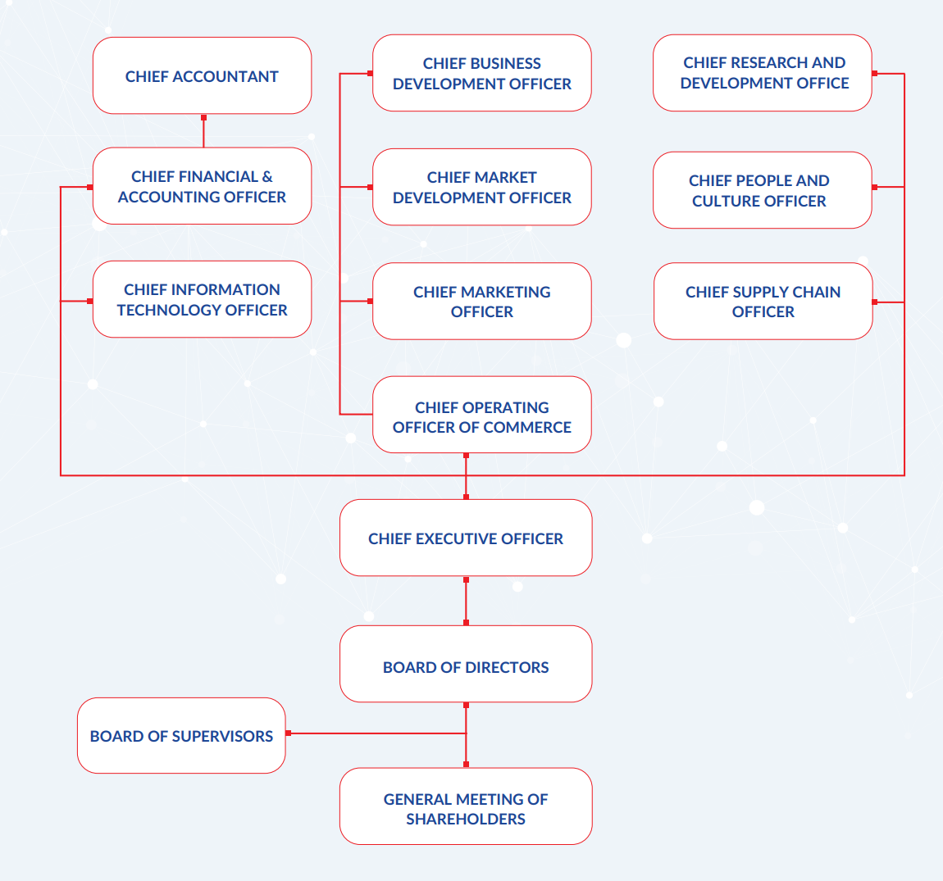
Thien Long Group showed its organizational structure as a vertical organization with a functional structure, which gives shareholders the ability to select the board of directors (BOD). The Board of Directors (BOD) then chose a Chief Executive Officer (CEO), who will oversee the leaders of other departments (Tamplin, 2023). However, the special thing about TLG is that the governance structure is a reverse model, meaning that the position of CEO is the lowest position to support employees. According to Ms. Phuong Nga, the current CEO of Thien Long, stated that the old traditional structure was no longer suitable for the no longer effective at the current time, when the market always requires innovation. As a result, Thien Long's organizational chart is newly structured in the form of a network, people become the bottlenecks for Thien Long's development to rejuvenate from product to function (Tu, 2022).

Market Overview
Since the first Thien Long "Made in Vietnam" ballpoint pen was made more than 40 years ago, the Vietnamese stationery market has always been noted as still very attractive. There have been more than 2,780 large and small enterprises registered to produce and trade stationery in Ho Chi Minh City. In this dynamic sector, both domestic and foreign brands have emerged, including Thien Long, Deli, Hong Ha, and others. The Vietnamese stationery and supply market was valued at US$381.7 million in 2020 and with a CAGR of 6.2%, this figure is forecast to continue to reach US$522.4 million by 2027. This growth is a combination of factors such as the entry of many small and medium-sized companies into the domestic market, as well as the consistently growing demand in the school segment. However, the implementation of smart classrooms in the education industry could lead to a shift in consumption from traditional stationery towards environmentally friendly technical products.

Data and Methodology

Data selection
The report accesses TLG through primary and secondary data. The former, including historical data (financial statements, stock prices) and operating plan (Historical annual report), is collected from the company's official website and some popular websites like CafeF, Vietstock, etc. The latter is generated via financial websites like World Bank, Vietnambiz and competitors’ information, consisting of market data (beta, risk free rate, inflation rate) and news related to the stationery industry,

Data characteristics
Operating results of TLG are estimated based on the historical data of revenue (oversea and domestic markets) and COGS (cost of returning goods, discount), inferring gross profit and EBIT. Operating cost and non-operating cost are also collected to assess business risk linked to financial leverage and cost management. To a stationery company like Thien Long, managing inventories is vital because it shows the initial cost such as shipping and purchasing. Tangible and intangible assets depict TLG’s depreciation and other problems related to intellectual property rights. Due to the outbreak of Covid-19 pandemic, maturity investment like time deposit supports us to analyze the asset allocation trend and the efficiency of this trend. Similarly, the equity structure plays an important role in calculating WACC and conducting some forecasting methods used in this report.

Methodology

Financial ratio
Financial ratio analysis depicts TLG’s management in their operating and financial activities. Eight ratios, which are listed in the table below, are calculated based on TLG’s financial data from 2018 to 2022. These estimations help to analyze business capability of controlling liquidity, leverage level, profitability and market value, when comparing with its competitors and industry benchmark.
Ratio | Description
Liquidity
Current ratio | Current ratio measures a firm's capability of paying liabilities in the short-term periods (below 1 year). In detail, it shows how effectively a business can use current assets to pay off its current liabilities like short-term debts or/and other payables.
Quick ratio | This ratio has a similar function to current assets but without the effect of inventories and prepaid expense accounts. Because it may take more time to convert inventories and prepaid expenses are not used to pay for current liabilities. In general, a quick ratio seems to be a more conservative method to gauge liquidity.
Cash conversion cycle: | The ratio shows the amount of time needed (measured in days) used to convert cash spent on inventories into cash received when selling products.
Operating cash flow ratio | A ratio evaluates business short-term risk of liquidity when comparing cash flow from operating activities and its current liabilities.
Solvency Ratios
Debt to equity ratio: | D/E ratio used to measure business financial leverage, which infers TLG’s effectiveness in capital management. The higher ratio warns a firm of the higher possibility of defaulting.
Times interest earned ratio (interest coverage ratio) | The capability of covering debts or/and interest of debts. The low ratio indicates a firm’s poor use of resources in managing debts.
Market Value Ratios
Price-earnings ratio: | This ratio helps to estimate a company's value when considering the link between its market price and earnings per share.
Profitability ratios
Gross profit margin | The metric shows a company's profit after eliminating the effect of COGS. The high ratio is desirable and vice versa.

Valuation method
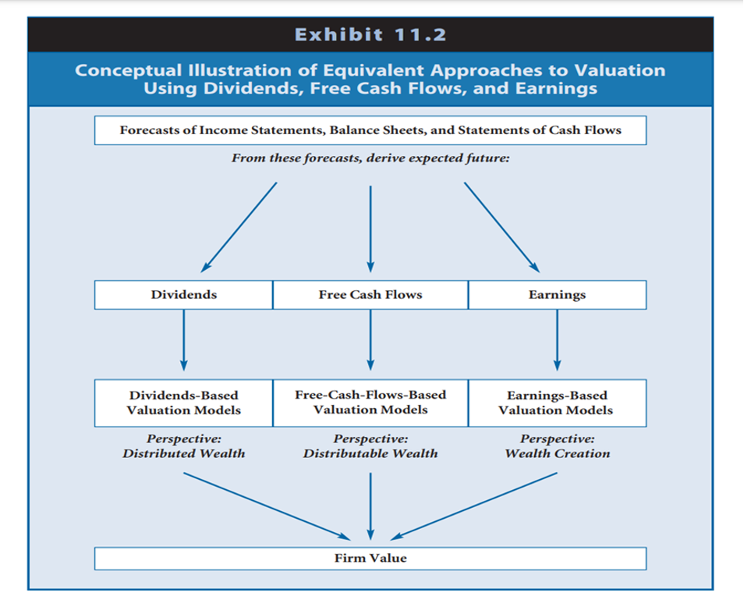
According to Wahlan et al. (2020), there are 3 common perspectives to investigate when evaluating a business. They are dividend-based, free cash flow based and earning-based valuation models which represent different perspectives such as distributed wealth, distributable wealth, and wealth creation respectively. All three valuation methods have their strengths and weaknesses. The valuation combines 3 different approaches and definitely covers all valuation flaws that each model carries. Fortunately, Thien Long Group has satisfied all criteria to be evaluated under 3 perspectives.
The value of TLG, in order to ensure its consistency as well as reliability over a certain span of scenarios, will accommodate all three basic valuation methods. Each method will be analyzed with specific techniques below:
FCF-Based Valuation Models:
- Discounted Cash Flow
- Adjusted Present Value
Earned-Based Valuation Models:
- P/E Valuation
Dividend-based Valuation Models:
- Dividend Discount Models
Furthermore, we will perform a simple valuation of TLG from a market perspective through average industry number with Comparable Valuation using EV/EBITDA multiply and P/E ratios.
Out of the 4 valuation models we will use, FCF-Based Valuation Models will be our focus as this technique reflects true company characteristics and capabilities in profitability manufacturing.
- Discounted Cash Flow (DCF)
DCF is a method of considering the company's future free cash flow value then discount to present value using a suitable discount rate. DCF uses firm free cash flow projections to value the company's future cash flow while using a discount rate to arrive at the firm’s present value. The appropriate discount rate accommodates the suitable risk of the company and time value of money which account for both opportunities costs and inflation.
This method is more than suitable to evaluate companies with sole business operations such as Thien Long. However, this valuation requires a significant amount of work and largely depends on the accuracy of cash flow projection as well as the discount rate used.
- Adjusted Present Value (APV)
APV is similar to DCF but still has distinct differences. APV still relies on firm free cash flow for valuation purposes. However, APV separates the firm value and the value of firm-financing actions such as tax-shield effect. This technique is useful when evaluating a firm which has both debt and equity as its financing structure. Although TLG does not carry enough debt. However, during our projections, we assume TLG will use low-cost debt as its financing source for future development and expansion. Thus, APV will prove critical in considering the firm’s futures values.
- Dividend valuation method (DDM)
DDM is a valuation method aimed at valuing a company based on its expected future dividend payout. Although the dividend payout fluctuates over the years and the payout decision rests in firm governing structure, the results from DDM method will have high margin of error and are prone to inaccuracy if the firm changes its dividend policy. However, based on the information that Thien Long Group has paid its dividend constantly during the period of 2018 and 2023. We believe that this valuation will make a significant contribution to overall firm valuation.
4. P/E Ratio
P/E valuation provides a brief estimation of the company’s value regarding its share price and earnings from operation activities. Based on the company's business plan and historical value, we obtain the corresponding P/E ratios for estimation. However, since P/E valuation only considers the company’s revenue and EPS, which fluctuate relatively over the periods, we then take the average calculated price to neutral the volatility.
Although P/E is not a reliable indicator of company value. However, we decided to use this valuation and assigned a little weight to increase the diversity of valuation.
5. Comparable valuation method
This method focuses solely on comparing firm important figures and ratios with their competitors in the same industry to have the general firm valuation based on competitors’ values. As TLG is a manufacturing company operating solely in office supply manufacturing, this method can be used to evaluate TLG reliably. With TLG group characteristics, we are determined to use P/E ratio as well as EV/EBITDA to derive the company's true value through an average comparable ratio with its competitors internationally due to TLG being the largest player in Vietnam office supply industry.

Scenario and sensitivity analysis
To increase accuracy and precision as well as accounting for uncertain economic conditions and input variables fluctuations, we will conduct scenario and sensitivity analysis to measure the company values in each different scenario. We aim to explore how each change affects the company’s value, the magnitude of value changes under each circumstance as well as the worst- and best-case scenario. We intend to employ 3 different analyses to the valuation results:
- We will perform scenario analysis as well as sensitivity analysis at each valuation method, if possible, with their crucial variables such as cost of capital, internal growth rate or EV/EBITDA.
- We will analyze firm sales growth scenarios during best, base, and worst-case scenarios as well as carry break-even analysis to analyze the effect of firm expenses on net income.
- Lastly, we will perform Monte Carlo simulation to analyze TLG price probability outcome under predetermined critical variable distribution.

Forecasting performance
To assist with the FCF-Based Valuation Model, specifically DCF and APV. We adopt the use of Pro-Forma. Pro-Forma, which projects companies earning in the future, will help us to gauge the company's true value reliably.
On the other hand, discounted cash flow valuation is the valuation of the firm’s present value in accordance with its expected future earnings. To successfully perform discounted cash flow valuation, Pro Forma statements are crucial with its future revenue, costs, and assets. Thus, we firmly agree that a Pro-Forma will be more precise in analyzing company value as well as become an essential help in discounted cash flow valuation method. We have developed detailed step-by-step progress to assist with valuation control and management. The detailed plan is showed below:

Steps | Detailed explanation
1. Collect historical data | We will first collect TLG’s financial information from the company website.
2. Break down revenue | We will then break down sales revenue according to product brands and market
3. Forecast future revenue | We will forecast sales revenue of each product brands and sum up for the total revenue of TLG
4. Forecast other items | We will forecast other items in financial statements based on percentage of sales, historical trends, or company policy.
5. Construct pro-forma financial statement | We will then construct the pro forma statement based on those forecasted values.
6. Derive company value | We then will derive company value using discounted cash flow valuation, dividend valuation and comparable ratio.
7. Calculate company total value | We will adjust and assign sufficient to each valuation methods and calculate the TLG’s final value
8. Perform scenario analysis | We will perform the scenario and sensitivity analysis to predict company in both best- and worst-case scenario

Empirical Results

Financial Statement Analysis: Ratio Analysis
The ratio analysis is categorized into 5 key ratios: liquidity ratios, solvency ratios, efficiency ratios, profitability ratios and market value ratios. The purpose of analyzing these ratios is not only to track the performance of TLG, but it also provides a comparison of TLG with other companies in the same sector or industry.

Liquidity Ratios
Liquidity Indicators | Average | 2018 | 2019 | 2020 | 2021 | 2022
Current Ratio | 2.86 | 2.37 | 3.30 | 3.41 | 3.23 | 2.57
Quick Ratio | 1.72 | 0.99 | 2.25 | 2.35 | 2.03 | 1.47

The current ratio is an indicator that estimates the ability of a business to cover its short-term liabilities by using short-term assets. It can be seen that TLG has a current ratio of always above 1.0 during the period of 2018 - 2022, it can be said that TLG can cover debt well with short-term assets. However, it is worth noting that from 2019 to 2021, this coefficient exceeds 3.0, which is not a positive sign for TLG's fund management activities. A possible reason for this index to increase significantly lies in TLG's current assets. In 2019, TLG recorded a rapid increase when TLG's short-term financial investment reached 466 billion VND and short-term receivables reached more than 581 billion VND.

In terms of quick ratio, it has the same measurement as the current ratio but excluding inventory, so it is more descriptive of the ability of assets to be converted to cash in 90 days or less than. In general, the ratio of TLG over the years has remained above 1.0, generally suggesting a company's ability to meet its immediate obligations without relying heavily on inventory sales. Particularly, in 2018 alone, it recorded 0.99 below the benchmark and then jumped to 2.25 the following year. However, the coefficient declined in 2021 and 2022 to 2.03 and 1.47, respectively, indicating a potential decrease in the company's ability to cover short-term obligations. The downward trend in the quick ratio from 2020 to 2022 raises some concerns about the company's liquidity position. A decreasing quick ratio could indicate an increased reliance on less liquid assets or an underlying need to improve working capital management.

Efficiency Ratios
Operating Efficiency Indicators | Average | 2018 | 2019 | 2020 | 2021 | 2022
Inventory Turnover | 2.81 | 2.89 | 3.13 | 2.84 | 2.45 | 2.44
Operating Cycle (Days) | 11.80 | 13.41 | 10.20 | 8.23 | 9.01 | 11.61
Inventory Period | 131.38 | 126.23 | 116.75 | 128.60 | 149.10 | 149.43
Receivables Turnover | 8.99 | 10.52 | 7.08 | 5.39 | 6.56 | 9.16
Accounts Receivable Period | 45.57 | 34.69 | 51.59 | 67.74 | 55.63 | 39.83
Cash Conversion Cycle (Days) | 206.21 | 186.34 | 192.39 | 222.93 | 236.76 | 228.14

Inventory turnover is an indicator of the sales speed of a business. The higher this ratio, the higher the revenue the business has, and vice versa, the business will show it has weak revenue if the ratio is low. For Thien Long Group, this coefficient is always positive, showing that TLG is effectively managing its inventory and can sell and replace inventory at a moderate rate of 2.44 to 3.13. The company's inventory turnover ratios show a consistent pattern over the years, with minor fluctuations. This indicates that Thien Long Group has been able to maintain a steady level of inventory management performance during this period. The inventory turnover ratios of TLG fall below the ideal benchmark of 4 to 6 for most industries (Kuuse, 2020), indicating that Thien Long Group could potentially improve its inventory management efficiency.
The cash conversion cycle (CCC) indicates the amount of time it takes for a company to convert its inventory investments into cash. As displayed in the Table (...), there was an upward trend showing TLG operated its cash conversion cycle ranging from 186.34 to 236.76. This means it takes the company several months to convert its inventory investments and accounts receivable into cash flow from sales. Nevertheless, CCC tends to increase over the years, indicating potential challenges in working capital management. It is conceivable that Thien Long Group may be hoarding a substantial amount of capital in its operations, including inventory and accounts receivable, for a long period of time before generating cash inflows.

Solvency Ratios
 | Average | 2018 | 2019 | 2020 | 2021 | 2022
Debt/Assets | 0.09 | 0.12 | 0.09 | 0.08 | 0.08 | 0.09
Debt/Equity | 0.13 | 0.18 | 0.12 | 0.10 | 0.10 | 0.13
EBIT/Interest expense (Interest Coverage ratio) | 41.07 | 34.27 | 39.20 | 26.62 | 52.08 | 58.05

Financial leverage strengthens the power of every dollar business invests through enjoying tax deduction. Therefore, many firms choose debts to finance their operations despite high potential risk. To avoid risk, TLG maintains a more conservative ratio of leverage. In detail, debt-to-asset and debt-to-equity ratio are around 0.09 and 0.13 respectively and tend to slightly decrease. The capital structure of TLG is nearly stable because there is no major change in these two ratios.

On the other hand, a firm's capability of servicing interest expense coming due through EBIT can be measured through interest coverage ratio. During the period, a high ratio indicates that TLG had enough profits available to pay debts despite a drop in 2020 with 26.62.

Profitability Ratio
 | Average | 2018 | 2019 | 2020 | 2021 | 2022
Gross Margin | 39.24% | 37.35% | 36.82% | 38.36% | 42.24% | 43.29%
EBITDA Margin | 16.02% | 15.59% | 16.17% | 14.75% | 16.85% | 16.99%
Net profit Margin | 10.41% | 10.31% | 10.73% | 8.93% | 10.37% | 11.39%
Return on Assets (ROA) | 15.03% | 16.40% | 14.44% | 10.36% | 11.31% | 13.97%
Return on Equity (ROE) | 21.16% | 23.20% | 19.32% | 13.72% | 15.16% | 20.48%

TLG’s gross margin experienced a slight drop from 2018 to 2020, then recovered and reached 43.29% in 2022, increased by 16% compared to 37.35% in 2018. In 2019, gross margin reached the bottom of 36.82% because of an increase in raw material during Covid-19 period. Similarly, the EBITDA margin slightly increased by 7.74% after hitting the bottom of 14.75% in 2020. The efficiency of TLG’s operation strategy did not make fortune when a small increase was seen in the net profit margin.

As for return on assets (ROA), TLG experienced a slight decrease in the period between 2018 and 2022. In detail, this ratio started at 16.40% in 2018, then continuously decreased and reached 13.97% in 2022. The reason behind this decrease in ROA is that TLG invested in more assets, which beat the growth of EBIT. In addition, EBIT growth during this period was curbed by the outbreak of Covid-19. However, in 2022, this ratio tended to recover when TLG improved their profits, which nearly balanced the gap between asset growth and EBIT growth.

In terms of Return on equity (ROE), TLG saw the same trend as its ROA from 2018 to 2022. ROE dramatically decreased by 40.86% from 2018 to 2020, then rising to 20.48% at the end of the estimated period. The primary reason for this is the huge loss of TLG’s EBIT during the Covid-19 outbreak when educational institutions and offices stopped working, thus limiting the demand for stationery. However, after witnessing the decline from 2018 to 2020, some optimistic signs were recorded when ROE recovered and reached the final one of 20.48% in 2022.

Market Ratio
 | 2018 | 2019 | 2020 | 2021 | 2022
P/B | 2.99 | 1.72 | 1.56 | 1.80 | 2.03
P/E | 12.21 | 8.2 | 12.51 | 12.82 | 9.88

P/B is an indicator used by investors that conveys data about a company's book value of a share. A high P/B ratio demonstrates confidence in the company's prospects (Lestari & Susetyo, 2020), signifying strong financial performance. In the case of Thien Long, its P/B decreased from 2.99 in 2018 to 1.56 in 2020, then gradually recovered to reach 2.03 in 2022. With P/B stably greater than 1, investors seem to have much confidence in TLG’s financial performance.
P/E, so-called Earnings multiple, is another ratio used to evaluate the price of a stock as it compares the market price of a stock to its EPS. Fahruri & Ikhsan (as cited in Alfarago, 2021) stated that P/E is employed in fundamental analysis to estimate a company's potential for future growth. A high P/E ratio suggests that the stock is overvalued, or there is expectation for the company to have a higher growth rate in the future. Thien Long had its P/E ratio dropped from 12.82 to 9.88 in 2022 in the context of Vietnam's economic being volatile and recovering from the Covid-19 pandemic. There requires more supportive information from corporate strategy and economic situation to confirm if this will form a downward trend.

Forecasting Cash Flows
Forecasting cash flow is the technique of estimating a company's future cash inflows and outflows over a specific time period. The goal of cash flow forecasting is to provide insight into the company's anticipated financial state and to identify prospective cash deficits or surpluses for future investments.
In our investigation, we use common size Income Statement and Balance Sheet to transform each item into percentage of Net Sales (for IS) or Total Assets or Total Liabilities and Owner’s Equity (for BS). This method allows us to easily evaluate the company's operation and financial performance from one period to the next on an overview. Furthermore, by looking at the percentage, the indexes become comparable to other competitors, regardless of company size and capitalization.
We also developed certain reasonable assumptions and calculations to deploy in future cash flow computation according to the common size financial statements. However, to avoid resulting in constant statistics in the upcoming 5 years, we initially forecast the Net Sales by growth rate based on product categories and market distribution. The detailed calculation can be found in Appendix [...].

Stock Price Valuation

WACC calculation
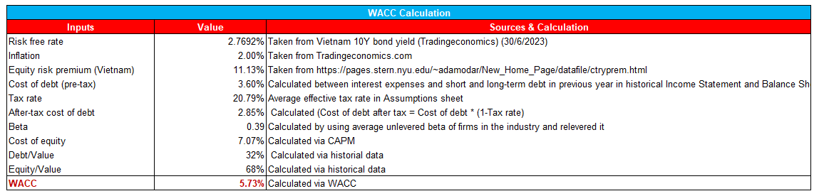
WACC is weighted cost of capital which accounts for company cost of debt, cost of equity and their proportionate value compared to company structure. WACC is a useful tool when it comes to evaluating a company's average cost.
For WACC calculation, we arrive at the result WACC at 5.73% likely due to significant cost of equity. The risk-free rate is taken from Vietnam 10Y bonds from Tradingeconomic while the Equity risk premium was collected from professor Damodaran’s websites. The beta is from our calculation with regard to competitors to adjust for any outlier’s behaviors. Cost of equity is calculated under CAPM formula while cost of debt is calculated based on interest expenses in proportion to total short-term and long-term debt in the company balance sheet. TLG does not carry large amounts of debt, therefore, the WACC is heavily affected by the cost of equity.

Terminal growth rate
After 42 years of operation, TLG has reached a mature stage in terms of terminal growth rate; as a result, the company is anticipated to continue growing at a steady rate indefinitely even in the future. According to information gathered and the looming global recession as well as Vietnam's economic capability, we decide to collect Vietnam’ GDP growth rate at 6.65% while the current inflation of Vietnam at 2% (World Bank, 2023).
Thus, we decided to choose the terminal growth rate at 2.4% slightly higher than the inflation rate. There are 2 main reasons for this decision:
- TLG has already dominated the domestic market with literally little room for expansion, therefore, it will be hard for the company to really grow at the growth rate of the economy. The firm growth rate will obviously be higher than the inflation but still close to inflation as the domestic limited opportunities for growth.
- Although TLG is currently expanding its business to foreign countries, this expansion is still at an infant stage with lots of risks and competition and it will take a long time for the company to actually achieve its profitable results to reflect in its share price.
In conclusion, as the company cannot outperform the Vietnam market and its still infant presence in foreign market. We conclude that a rate at 2.4% which is slightly higher than inflation rate and significantly lower than GDP rate is sufficiently accurate.
Terminal growth and WACC are such important figures that these numbers will be used repeatedly in all valuation methods.

Valuation results
- DCF Valuation
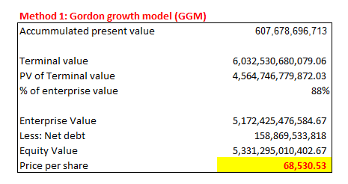
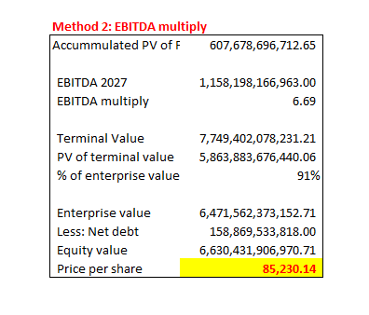
With the DCF Valuation method, we propose forecasting the future cash flows to achieve the final free cash flow for the next five years then discounted back to present value using the WACC. In order to achieve greater accuracy, we divided DCF valuation into two smaller valuations of terminal value using EV/EBITDA and Gordon Growth Model (GGM) respectively. Although the two valuation models use the same present value of free cash flow. Their terminal value was calculated differently using different rates (using EV/EBITDA and WACC). Thus, 2 valuations will arrive at different prices. However, EV/EBITDA is prone to manipulation as the EV/EBITDA multiply can be changed at ease by changing competitors with higher or lower ratios affecting the integrity of the number. Thus, we assign a slightly lower weight to EV/EBITDA multiply compared to the reliable WACC.
- APV valuation
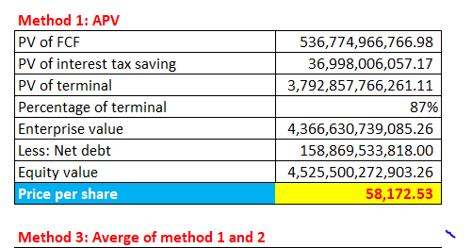
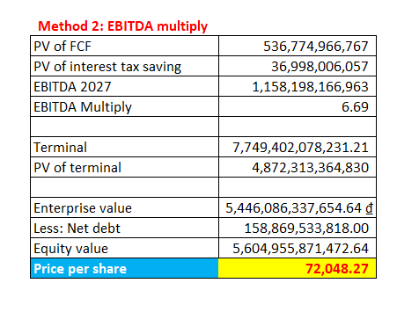
After recovering from the impact of Covid-19, under the pressure of internal and external difficulties like high inflation and interest rate, unstable global economy, TLG has to be flexible in capital structure and operating approaches. Therefore, an APV method that does not stick to the constant capital structure is useful in evaluating this corporation. We estimated 58,673.06 VND per share for APV using traditional WACC and more optimistically 72.405.00 VND per share for APV with an EBITDA effect. The weight allocation for WACC and EV/EBITDA are 20% and 15% respectively for the reason mentioned in DCF valuation.
- DDM Valuation
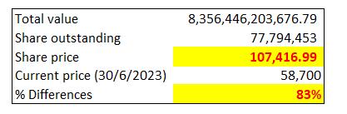
With DDM Valuation method, we arrive at the share price of 107,417 VND. The price is significantly higher than the price recorded on 30/06/2023. The high price is positive for the company investors. However, this price is prone to be affected by dividend payout policy and is not really stable. This price can change significantly even in the opposite direction if the company decides to withhold the dividend in the future. However, TLG actually paid dividends and there is no sign that the company will withhold the dividend. Thus, we still accept these results to ensure diversity and account for the value of company dividend affecting the company share price but allocate only a small proportion of total weight to this valuation (10%)

- P/E Valuation

The P/E valuation method was conducted by collecting three distinctive TLG related earning multiples to estimate corresponding share price using the number of shares outstanding then taking the average of them.
The first P/E ratio was collected from consulting financial website (Vietstock) as the representative of the stationery field at 16.39. Using this P/E value, TLG’s stock price at the end of 2023 was estimated as 89,847.75 VND per share.
By calculating the average P/E ratios of the previous 5 years (2018-2022), we came up with an index of 11.12 and value TLG at 60,980.26 VND during the similar period.
The last P/E ratio referred to the current price multiple by Investing.com (June 30th, 2023), resulting in the price of 72,141.33 VND per share.
Taking the average of the calculated prices, we got 74,323.11 VND as a suitable price for a Thien Long share according to the P/E valuation method.
- Relative valuation
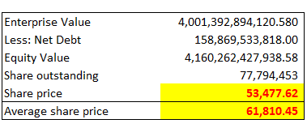
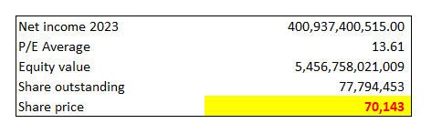
Although the share price reflects the company's intrinsic value, it also tends to fluctuate with the movement of the market and specifically the movement of the industry. Thus, by using comparable ratios such as EV/EBITDA and P/E from the industry, we hope to adjust TLG’s share price under the effect of the market.

Valuation Summary and Analysis
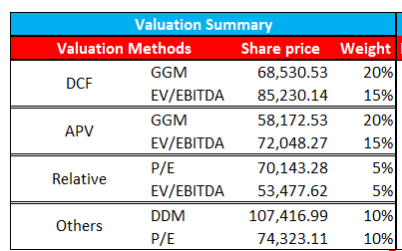
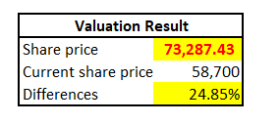
In conclusion, the combination of literally 5 major valuations produces the final share price for TLG at 73,287 VND. The reliable FCF-Based Valuation Models get the total of 70% of total weight under the DCF and APV valuation. Both the Earning-Based and Dividend-Based Valuation Models each get 10% due to characteristics of dividend and price. The supplement relative or comparable valuation will get 10% divided for P/E and EV/EBITDA multiple equally to recognize the effect of market and competitors to TLG share price as well as share valuation.

Sensitivity analysis and Scenario Analysis

For each valuation, we will perform sensitivity analysis as well as scenario analysis. The detailed results will be shown under Appendix.

To carry out sensitivity analysis we will look at the changes of importance such as WACC, internal growth rate, EV/EBITDA, etc. The changes in each ratio or percentage will be 1 unit or 1 percent respectively. Various results share price under difference ratio and figures are shown in the table format with illustrating color from green to red representing highest to lowest logically.

Monte Carlo Simulation
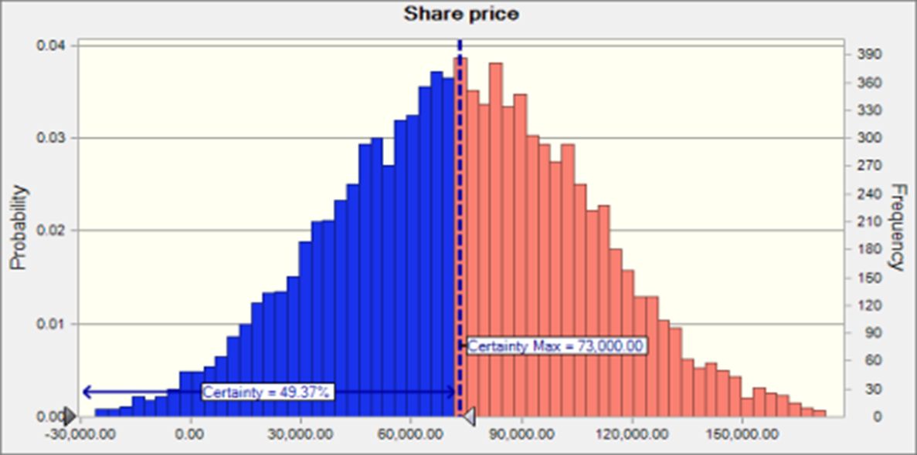
For Monte Carlo Simulation, based on predetermined probability of several important factors affecting the final share price such sales growth domestically and internationally, WACC, EV/EBITDA, Tax rates, and expenses, etc. The results show that more than 50% of the share price will be higher than the approximate final calculated share price at 73,000 VND. However, in some extreme circumstances, share prices can reach as low as zero and negative or as high as 180,000 VND. The extreme situation will only have a really small probability when all the factors move together favorably or negatively.

Potential Risks

Operational Risks

Inventory management risks:
From the inventory turnover analysis above, it is clear that TLG always has an inventory risk, so any disruption related to production, supply chain or personnel will seriously affect TLG's inventory management. These aspects can have consequences such as work accidents, unsatisfactory quality control, delivery delays or simply product inefficiencies leading to an increase in inventory capacity. The most obvious is in the field of supply chain, facing uncertain events in the world related to inflation and politics (Anh, 2022). Any disruption related to the supply chain will increase Thien Long's inventory backlog issues. Thus, TLG must always be in a state of readiness to respond to such cases.

Technology and IT Risks:
The digital age has exposed Thien Long Group to experience some possible risks such as system failures, data leaks, cyber-attacks or online platform disruptions. These risks can lead to operational disruptions, loss of sensitive data, reputational damage, and financial losses. However, it should be noticed that in 2020, TLG and FPT have had an agreement of Digital Transformation Procedure in 2 years with a view to reducing technology risks as well as sustaining and developing its business. This means that TLG is aware of these digital risks and willing to solve them for the best of interest.

Economics Risks:

Exchange rate volatility risk:
With the world economic situation facing many difficulties in 2023, exchange rates have fluctuated and inflation happens in many countries. This adversely affects Thien Long Group as this company mostly imports input materials from abroad, increasing the risk of risks related to TLG's production cost management activities (TLG, 2023). Exchange rate fluctuations may also affect the export competitiveness of Thien Long Group. If the VND strengthens against the currencies of export markets, it could make the prices of Thien Long Group's products more expensive relative to foreign buyers. This is likely to reduce demand for the company's products and affect its export revenue.

Inflation risk:
In the first 5 months of 2023, CPI recorded an increase of 3.55% over the same period last year; core inflation increased by 4.83% (Hai, 2023). This affects the ability to consume and especially the production costs that are likely to increase, leading to an increase in output prices. It will be a challenge for TLG to control the balance in cost calculation.

Financial Risks

Liquidity Risk
 | 2016 | 2017 | 2018 | 2019 | 2020 | 2021 | 2022
X1 = Working capital / Total assets | 0.442 | 0.394 | 0.379 | 0.528 | 0.519 | 0.527 | 0.454
X2 = Retained earnings / Total assets | 0.228 | 0.255 | 0.237 | 0.198 | 0.177 | 0.187 | 0.193
X3 = Earnings before interest and taxes / Total assets | 0.111 | 0.125 | 0.151 | 0.101 | 0.034 | 0.046 | 0.138
X4 = Market value of equity / Book value of total liabilities | 8.411 | 10.040 | 8.122 | 5.089 | 5.357 | 5.716 | 4.355
X5 = Sales / Total assets | 1.562 | 1.592 | 1.591 | 1.346 | 1.160 | 1.091 | 1.227
Altman Z-Score = 1.2X1+1.4X2+3.3X3+0.6X4+1X5 | 7.824 | 8.858 | 7.751 | 5.644 | 5.356 | 5.565 | 5.112

To measure the company’s financial health, we use Altman Z-score to analyze TLG’s liquidity risk. We extend the period to 2016 in order to clarify more clearly about the trend of the Z-score. As shown in the Table (...), the Z-score of Thien Long Group maintained above 3.0 throughout the period 2016 to 2022, meaning that it has low probability of bankruptcy and guarantees the safety for investors to invest in its business. One of the clearest reasons is because TLG has significantly low debt and liability throughout the years as TLG is a stable and mature company that does not need any leverage. The most ideal period was from 2016 to 2018, when the Z-score estimated between 7.0 to above 8.0. However, it showed a downward trend in the following year, from 2019 to 2022, to nearly 5.0, indicating an increased risk of potential financial difficulties. Even though these numbers are still in the safe zone, they indicate a worsening financial situation.

Market Risk
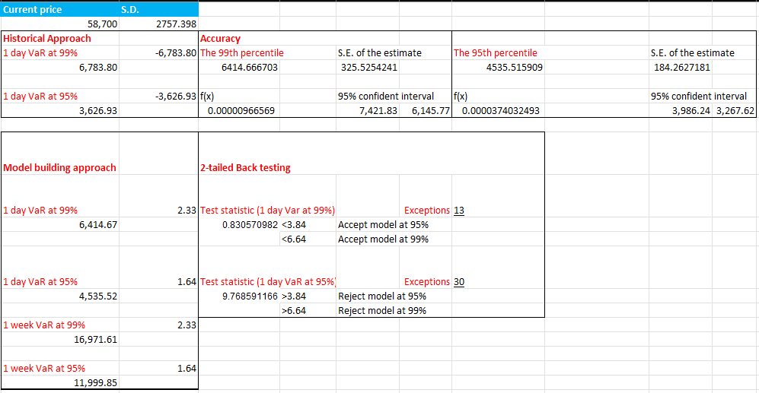
The value at risk (VaR) is an important aspect to measure the volatility of stock price of TLG in the market. We use our data of TLG’s stock price of 1000 trading days from 3 July, 2019 to 30 June, 2023 to calculate and analyze. With regard to the historical approach, the outcomes show that the investor's maximum daily loss would be 3,626.93 VND at a 95% confidence level and 6,783.80 VND at a 99% confidence level. The results of the model-building strategy are slightly different from those of the historical technique. The daily VaR was 6,414.67 VND and 4,535.52 VND, respectively, at 99% and 95%. Moreover, we also apply the 2-tailed backtesting to check the model's correctness. 13 exceptions exist for the daily VaR at 99%, which means that 13 times out of every 1000 days, the value was higher than the VaR at 99%. The 2-tailed backtesting also shows that we should accept the result for VaR at 99%. Meanwhile, there were 30 exceptions in the daily VaR at 95% VaR, or 30 out of 1000 chances where the investor lost more money than what we had predicted for a day. The 1-day VaR model at 95% is also invalid, as shown by the result of the testing. Thus, we can draw the conclusion that the outcome should be rejected.

Limitations
During the process of collecting information, conducting research, and delivering the report, there are some limitations.
First, we intended to include a bottom-up valuation method, but there are restricted available sources of information to obtain a detailed understanding of the entire production and distribution process of a company's products and services. It affects the overall estimation as each of the methods contributes a certain percentage to comprehensively analyze the company’s stock value.
Second, the stationery industry in Vietnam has the participation of both local companies such as Thien Long and Hong Ha, and foreign companies such as Pentel, Deli. However, when considering listed companies, as of June 30, 2023, only Thien Long remained listed with its ticker - TLG. This makes it difficult to compare and evaluate micro-factors about competitors in the market due to the lack of publicly available information.
Last, we also determine that there is a limitation to our estimation as some of our numbers and ratios are assumed. This is because of the lack of information and data as we have mentioned above. However, we have managed to give assumptions with the most precise reasoning that increases the validity of our results.

Recommendations
Generally, based on the financial ratio analysis, cash flow forecast and valuation, TLG has had stable financial performance throughout the years and great potential to grow. Therefore, we can suggest a “Buy” recommendation for the investors as the company can guarantee a return for its shareholders.
Additionally, we also suggest solutions for TLG to enhance its issues and weaknesses that we have mentioned in the previous parts. To begin with, TLG should focus on optimizing its revenue from the advantageous international markets. TLG has had the ambition of developing its exports expansion for years and according to our revenue analysis, TLG has a great opportunity with this plan. Moreover, to reduce the effect and cost of its inventory backlog problems, we believe TLG should create comprehensive inventory management guidelines. Lastly, as we have noticed, TLG has had significantly high retained earnings throughout the years, which is understandable at some points since TLG is in its maturity stage. However, the corporation can make use of these retained earnings wisely into its plan of international expansion or factory and manufacturing investment.

Conclusion
Regarding analysis about macro- and micro-economic factors, we conclude that Thien Long Group still retains its position as the national stationery brand in Vietnam and is gradually developing and expanding in foreign markets. Although the profit growth rate in foreign markets has not yet achieved the expected results, Thien Long still recorded an increase in annual revenue from this segment, showing a positive change in revenue structure between local and foreign streams. Considering TLG’s financial health, the ratios indicate that Thien Long has performed well throughout the years. However, there are some rather unsatisfying numbers which may bring possible issues for TLG, for example, long inventory turnover rate implies an ineffectiveness in inventory management. In terms of risk, we indicated that TLG has some macro and micro risks, two of the most important ones are market risk and liquidity risk. Fortunately, TLG does not endure the chances of bankruptcy as its Z-core has remained high (above 3.0). Meanwhile, we also estimated the maximum loss for TLG stock price via two approaches in determining value at risk. Understanding strengths and weaknesses of Thien Long Group, the valuation of TLG shares was conducted using five different methods with sensitivity and scenario analysis for each to measure and evaluate the possible share price performance under the market fluctuations. In conclusion, we recommend investors purchase TLG shares at price 73,287.43 VND per share to earn an expected profit of 25% upside at the end of 2023 in comparison to the current price on June 30th, 2023. By forecasting an increment in share price, we strongly believe in TLG’s potential to grow both locally and globally. Therefore, we suggest a BUY RECOMMENDATION for the investors.

References

Alfarago, D. (2023). Analysis of Stock Investment Decisions through Price Earnings Ratio (A Case Study on Construction Service Companies). Vol 8, No 1, 857 - 859. Retrieved from http://jmas.unbari.ac.id/index.php/jmas/article/view/525/598
Anh, N. (2022). Attempts made to minimise supply chain disruptions. Vietnam Investment Review - VIR. https://vir.com.vn/attempts-made-to-minimise-supply-chain-disruptions-96636.html
Hai, T. (2023). 5 tháng đầu năm 2023 CPI, lạm phát tăng nhẹ. https://www.qdnd.vn. https://www.qdnd.vn/kinh-te/tin-tuc/5-thang-dau-nam-2023-cpi-lam-phat-tang-nhe-729556
Lestari, A. P., & Susetyo, A. (2020). The Influence of NPM , EPS , DER and PBV on Share Prices in IDX HIDIV20 Registered Companies with DPR as Intervening Variable. Scientific Journal of Management, Business and Accounting Students, 2(4), 184–196. Retrieved from https://ejournal.up45.ac.id/index.php/maksipreneur/article/view/810/641
Thien Long Group. (2023). Annual Report 2022. https://thienlonggroup.com/storage/media/KHF1Cidt1WIoWugTwPKiR8UOJYq51Vo6pnMv39fF.pdf
Tu, M. (2022). CEO Thiên Long: “Trẻ hóa để giữ thế dẫn đầu.” vnexpress.net. https://vnexpress.net/ceo-thien-long-tre-hoa-de-giu-the-dan-dau-4531514.html

Appendix

Appendix 1:
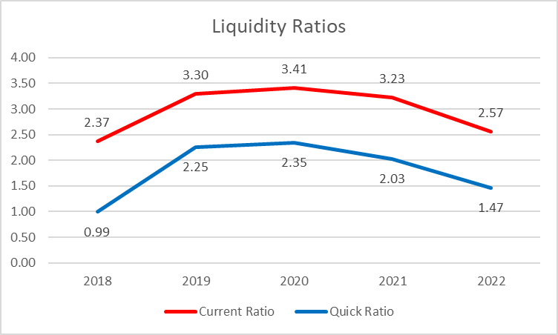
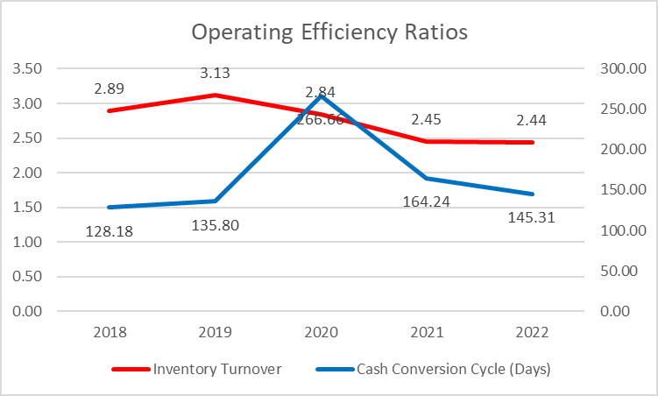
Proforma IS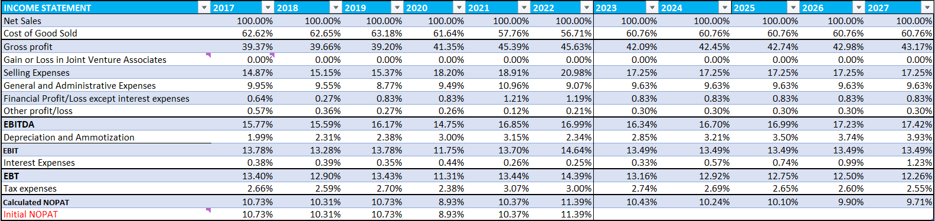
Proforma BS (1)
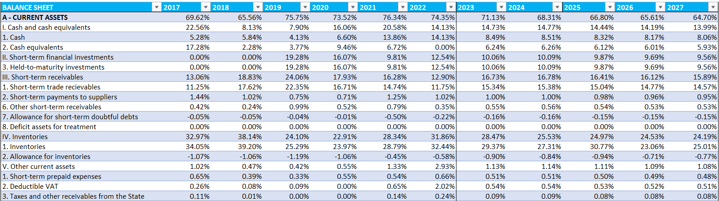
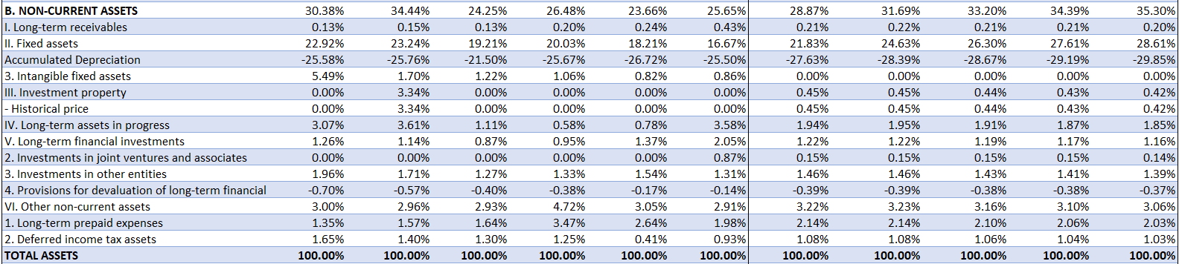
Proforma BS (2)
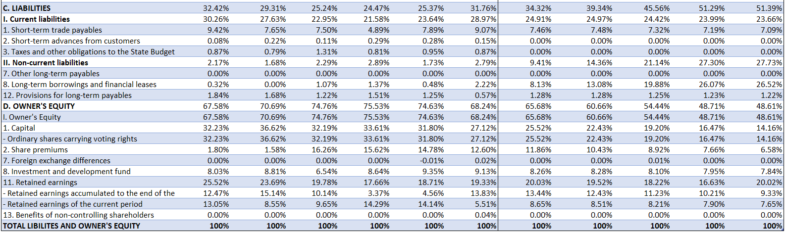
Proforma BS (3)
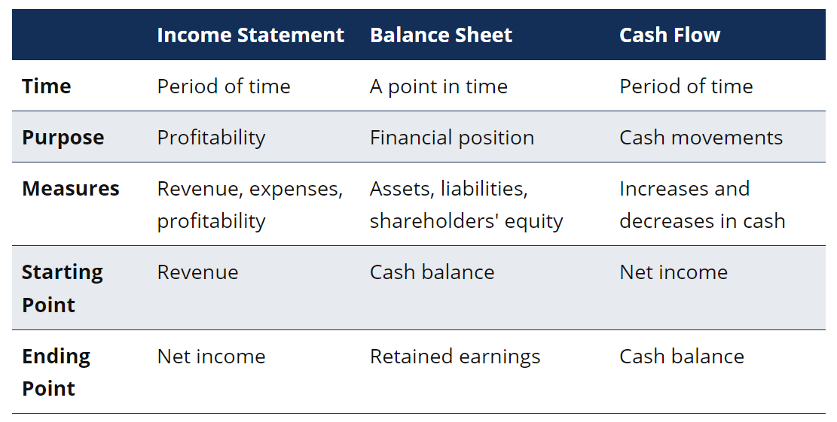
Figure 4.1 (Corporate Finance Institute, 2022)

