Here are the steps below:

1. Clone this URL: <https://dev.azure.com/jessiepfurigay0946/_git/ADACA> in your hard drive but you need to give your email address for allowing to access this link.
2. After clone the source code then, Go to the ADACA folder
3. Then Login in your docker account
4. Run docker-compose up
5. Go to inside of ADACA folder
6. Run dotnet ef migrations add initial (Im using macbook) for windows: add-migration InitialCreate
7. Run dotnet ef database update, for windows : update-database
8. Open the solutions ADACA.sln
9. Run the application.
10. I have 2 types of application
    1. Web application with UI
    2. API

**Web Application**

**UI Form**

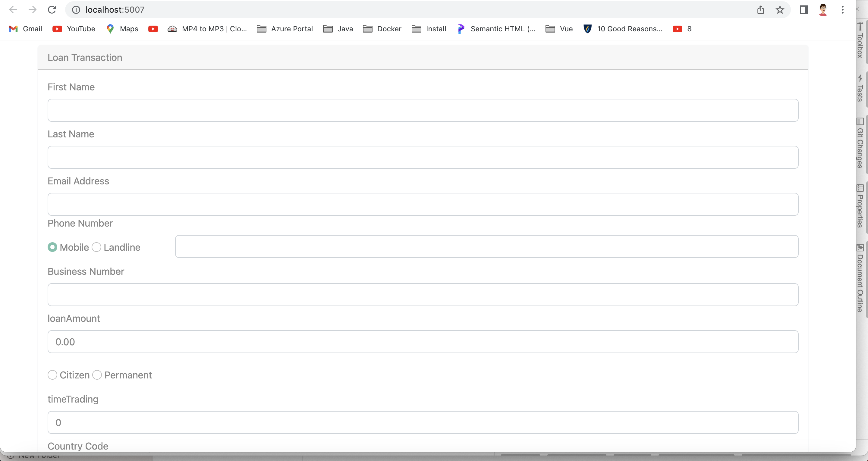

Validation

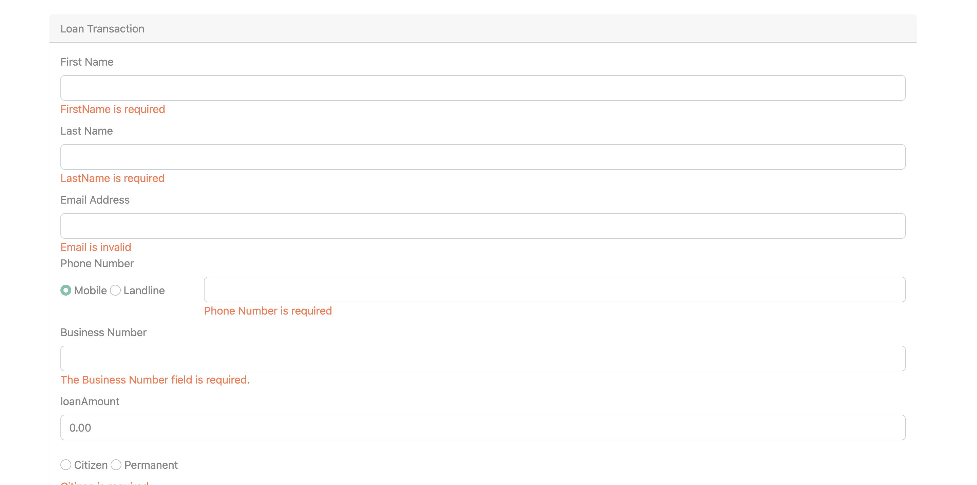

Here are the sample data

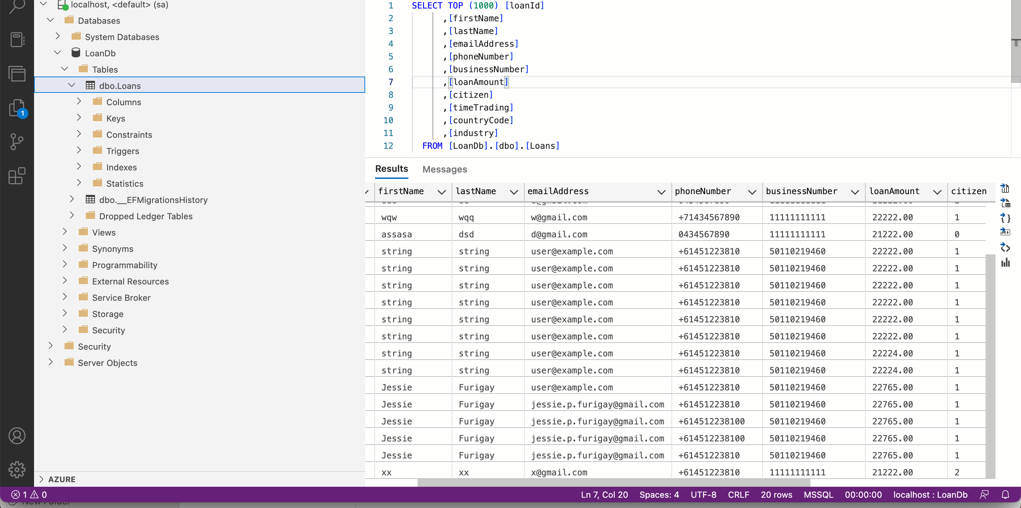

API

Here is the sample

{

"firstName": "xxxx",

"lastName": "Furigay",

"emailAddress": "jessie.p.furigay@gmail.com",

"phoneNumber": "+614512238106",

"businessNumber": "501102194600",

"loanAmount": 227656,

"citizen": 1,

"timeTrading": 21,

"countryCode": "string",

"industry": "industry 1"

}

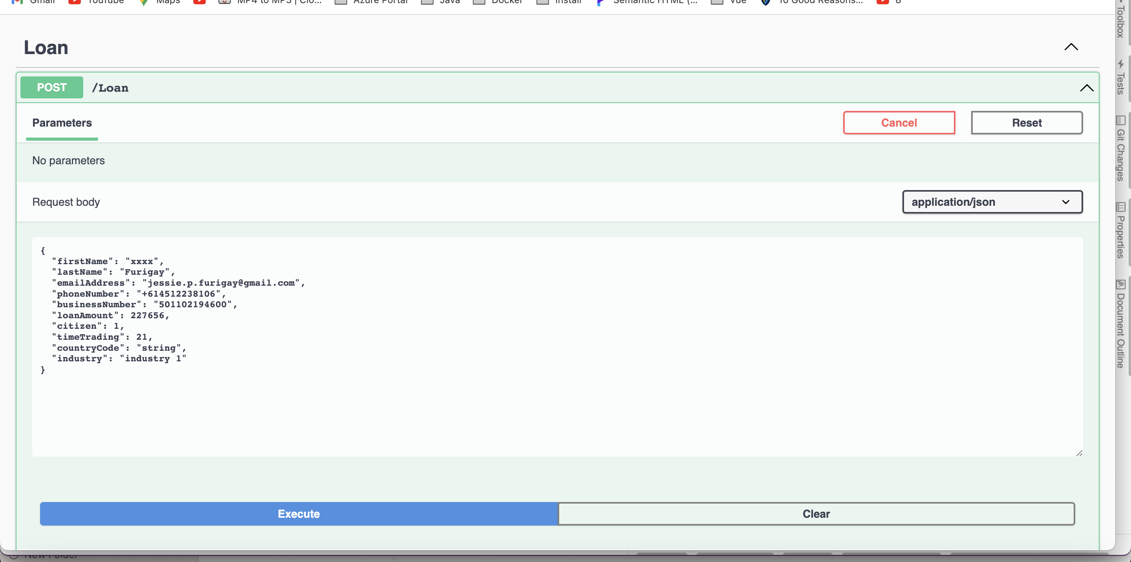

Response

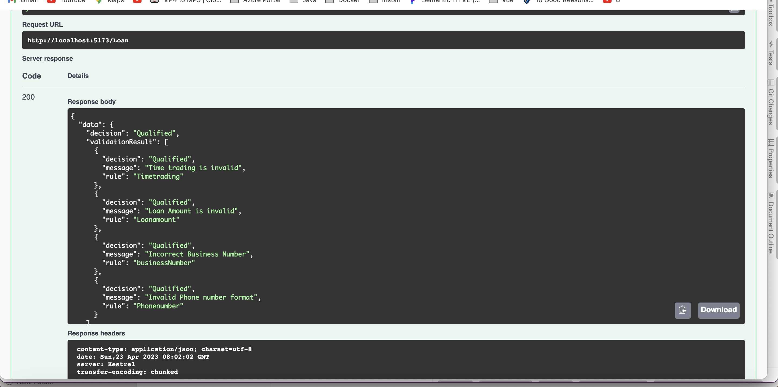

Here is the sample data for success

{

"firstName": "xxxx",

"lastName": "Furigay",

"emailAddress": "jessie.p.furigay@gmail.com",

"phoneNumber": "+61451223810",

"businessNumber": "50110219460",

"loanAmount": 22765,

"citizen": 1,

"timeTrading": 19,

"countryCode": "string",

"industry": "industry 1"

}

Here is the result

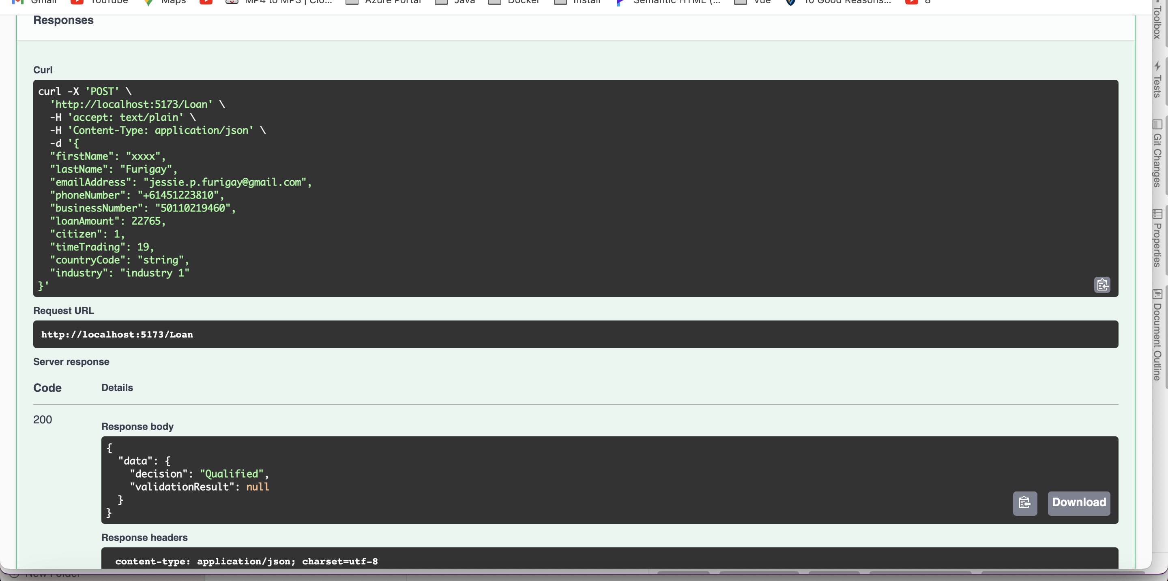

Here is the architecture

