Science/Technical/Management Section
I. Decision-Making Activity

Beaches are central to the tourism and recreation that fuel the economy of the states of North and South Carolina. For public health and safety, advisories are issued on North Carolina beaches for degraded water quality events such as high bacteria levels (e.g., E. coli, enterococci). High bacteria levels often occur in the hours, days, or weeks after a king tide event or storm event with heavy rainfall and high river discharge from surrounding rivers. Low salinity, high turbidity, and high chlorophyll-a concentration (Chl-a) are indicators of degraded water quality and can serve as proxies for bacterial contamination. The proposed project will progress collaboratively with end-user organization the North Carolina Department of Environmental Quality (NC-DEQ) in the Division of Marine Fisheries. NC-DEQ is the decision-making authority on issuing and lifting advisories at 200+ sampling locations at beaches throughout North Carolina, and our work will directly address their needs.
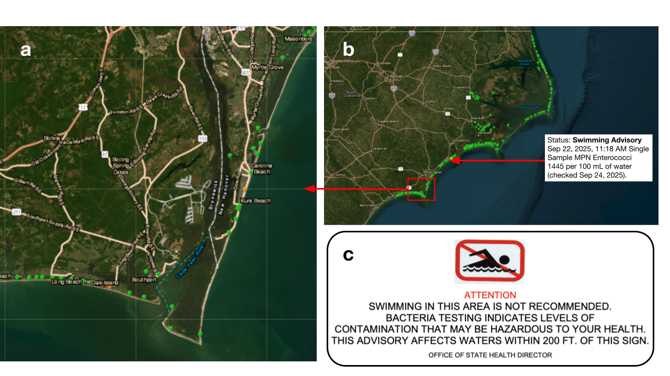
Currently, advisories are issued based on observed bacteria levels and are left in place until a clean sample is measured. However, due to logistical sampling constraints, sites are typically monitored once weekly, limiting how quickly advisories can be lifted. Specifically, an advisory is issued when the Single Sample Most Probable Number (MPN), a measurement of fecal indicator bacteria levels, exceeds 104 per 100 mL of water (Figure 1). This measurement is a statistical estimate of how many bacteria are in a water sample, rather than an exact count, using dilution and growth tests to determine the most likely number of bacteria present after a 24-hour incubation. In addition to these regular advisories, informal "precautionary advisories" can be issued; are not based on the presence of a contaminated sample but are rather currently based on knowledge of stormwater discharges and rainfall only. A regular advisory is a reactive response to measured contamination, while a precautionary advisory is proactive and used when risk conditions exist (e.g. storm, flooding, wastewater discharge), either before data have been collected or when data collection is impractical. The precautionary approach helps protect public health by warning beachgoers; however, there are currently no rules in place for issuing precautionary advisories due to the complexity of environmental forcings.
Figure 1. Advisory map issued by the North Carolina Department of Environmental Quality (NC-DEQ, 2025). Icons indicate Enterococcus sampling sites at a) our case study region surrounding the Cape Fear River mouth and b) the entire state of North Carolina, with c) the notice posted at a beach when an advisory is issued.
Degraded water quality events in this region are complex and involve not only predicted rainfall but also many other oceanographic and meteorological factors. The magnitude of river discharge and behavior of river plumes impact where the degraded water quality events will occur and how long they will last. NC-DEQ is concerned about public health consequences if an advisory is lifted too quickly, depending on the winds and/or tides. Out of logistical necessity, present sampling practices may miss the river plume, and associated fecal indicator bacteria could actually be impacting a beach with a recently lifted advisory on the next tide cycle or shift in wind direction.
The decisions of when to issue and lift an advisory are not to be taken lightly and the Coastal Carolinas region deserves improved decision-making capabilities. The public weighs these advisories carefully when planning vacations to the Carolina coast, often canceling travel plans in the event of degraded water quality conditions. Therefore, the issuance and length of an advisory can have dramatic economic impacts. North Carolina tourism broke the spending record in 2024 as total spending by visitors to the state reached $36.7 billion [1]. Beach closures of a single swimming area can trigger net economic losses on the order of $1,000 to $10,000 per day [2]. In the proposed work we focus on the state of North Carolina and the surrounding coastline to the south (e.g., Myrtle Beach). Our work will provide an analysis of higher temporal resolution data and spatial visualization of hazards integrating satellite remote sensing and numerical model output, both of which will allow decision-makers to plan whether additional in situ monitoring is needed at certain beaches or during certain time periods in order to issue or lift an advisory more appropriately than what is currently possible.

II. Anticipated Results and Improvements

In the current decision-making framework, it is often impossible for advisories to be lifted more quickly than ~7 days. These temporal gaps could be addressed if the decision-makers could quickly and easily access mapping tools with additional information provided by earth-observing satellites and model forecasts. The proposed work will result in an enhanced understanding of the timing and spatial patterns of degraded water quality at NC beaches through 1) historical analysis, 2) high temporal resolution beach sampling, and 3) water quality mapping tools. Degraded water quality events are economically influential but transient. We will advance our idea from ARL3 (Proof of Application Concept) to ARL6 (Demonstration in Relevant Environment) through the course of the project, in direct collaboration with end-user NC-DEQ to iteratively assess the usefulness of tools. This interaction will be accomplished via regular check-ins and by running in-person stakeholder workshops in Beaufort, North Carolina with input from our NC-DEQ partner at existing annual local meetings. Major activities are briefly listed here and then described more fully in the next Section.
1. Historical analysis of past storm events (Figure 2) using satellite data and model output will be analyzed in conjunction with NC DEQ’s database of past advisories (e.g., date issued, date lifted). During the 28-year dataset (1997-2025) we expect to see 3-4 large daily rainfall events per month during the beach tourism season, May-September (Figure 3c). We aim to combine salinity data from existing in situ assets and satellite-derived Chl-a, turbidity, and SST from several past storm and king tide events with beach advisory information (e.g., day advisory was issued following the event, day advisory was lifted following the event, lag time between event and day lifted). Using cutting edge hydrodynamic-biogeochemical modeling tools, we will simulate three of the historical events to test the spatial extent and timing of degraded water quality, and we will simulate one event during the current/future period of the proposed work (2026 through 2029). This historical analysis will allow us to compare the timing and location of past advisories against satellite-mapped conditions, in situ data, and model output.
2. High temporal resolution beach sampling will provide information about the timing of bacterial pollution with relation to tidal advection at a case study beach site. A member of our team will shadow the NC-DEQ technician at a site near Wilmington, North Carolina that experiences degraded water quality conditions following king tides and storm events. We will additionally return to that same site to sample for a full tidal cycle (daily for 14 days) surrounding one king tide event and one storm event. This result will allow us to better define when a beach could have its advisory lifted after each type of degraded water quality event. High temporal resolution beach sampling will occur in Year 1 of the proposed work and target the beach tourism season in months April to October, which is also the time of year when this region experiences the highest rainfall and highest tidal range. Coordination with NC-DEQ, including sample collection and processing protocols, will happen at least weekly for the month leading up to each 2-week sampling period.
3. Water quality mapping tools: “Nowcasts” in the form of maps of coastal ocean Chl-a, turbidity, sea surface temperature (SST), and salinity will provide the means to visualize the advection of water masses with potential contamination from river plumes and stormwater outfalls following storm and king tide events. Providing spatially mapped information at a higher temporal resolution to NC-DEQ will help managers decide if and where additional in situ enterococcus monitoring is needed, aiding in issuing and lifting advisories as soon as possible. By incorporating ocean data, this will improve on existing nowcast tools that are based only on rainfall (e.g., Virtual Beach, How’s the Beach?, ShellCast; NC-DEQ, personal communication). To accomplish this improvement, we will assess the needs of NC-DEQ (e.g., latency, spatial resolution) and add layers of satellite data to existing web mapping tools used for decision making, starting with the NC DEQ advisory map [3].

III. Project Elements

1. Motivation

Beaches are often closed when harmful bacteria are detected, which has become more common as stormwater and animal waste and associated harmful bacteria are increasingly carried into the water [4], [5]. In North Carolina, health officials monitor safety by testing beach water once a week for fecal indicator bacteria Enterococci, bacteria from animal and human intestines that signal contamination. High levels of indicator bacteria suggest the possible presence of other dangerous pathogens from sewage that are harder to measure directly. In the United States, 7,530 total beach closures or advisories were issued in 2024, of which 27% were due to stormwater runoff, sewer outflow, and septic overflow [6].
Storms and king tides enhance the likelihood of advisories, increasing risk to local communities [4]. Storm event impacts on beach water quality are driven by intense precipitation and storm surge, which drive episodic but large fluxes of freshwater and transport contaminants such as bacteria to new locations, stimulate toxic algal blooms, and flood a greater spatial extent of beach than is normally covered at high water. In addition to the direct transport of contaminants, flooding on land transports large amounts of contaminants, organic matter, nitrogen and other nutrients to the ocean. Flooding of hog lagoons (Figure 2), coal ash pits, and other industrial and agricultural sites, for example, have been linked to the creation of algae blooms and fish kills offshore of the Cape Fear River following Hurricanes Floyd in 1999, Matthew in 2016, and Florence in 2018 [7]. However, the risk to communities is often delayed due to remote processes, complicating efforts to keep people safe. During Hurricane Florence in 2018, severe flooding of agricultural and industrial sites, including hog farms, led to the release of various contaminants into the Cape Fear watershed. Over a week later, some coastal municipalities were caught off- guard by the delayed arrival of these contaminants, which had transited through the Cape Fear watershed into the ocean, and had traveled long distances down-coast within the river plume. Thus, extreme precipitation at up-river hog farms in Bladen County, North Carolina led to the need for swimming and shellfishing advisories downcoast, up to hundreds of kilometers away, including in Myrtle Beach, South Carolina.

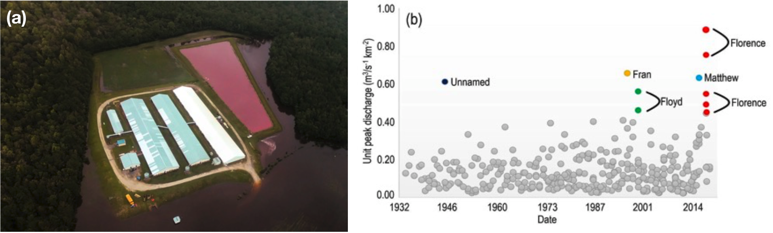
Figure 2. Wetter storms over time have implications for flooding of low-lying areas. a) hog waste lagoon (pink region in right center of image) breached during Hurricane Florence (Rodrigo Gutierrez/Reuters). b) Annual peak discharges from USGS gaging stations for the Cape Fear River and its five major tributaries, i.e. the Haw River at Bynum, Deep River at Moncure, Little River at Manchester, Black River at Tomahawk, Northeast Cape Fear River at Chinquapin and Cape Fear River at Kelly. Colors indicate the top ten discharges (from Yin et al., 2021).
Tidal flooding can also mobilize contaminants and bacteria from the coastal zone, creating degraded water quality conditions similar to those following high-precipitation storms. So-called “king tides” occur when Earth’s astronomical position with the moon and sun align for the highest possible tides each year, which happens in the fall season along the southeastern U.S. Atlantic coast. These tides can lead to excessive flooding in low-lying coastal areas, mobilizing additional contaminants and bacteria. For example, more than 80% of the floodwater samples collected during king tide events in Norfolk, Virginia showed Enterococcus abundance that exceeded the threshold for recreational water use in Virginia (104 MPN per 100 mL) [8].
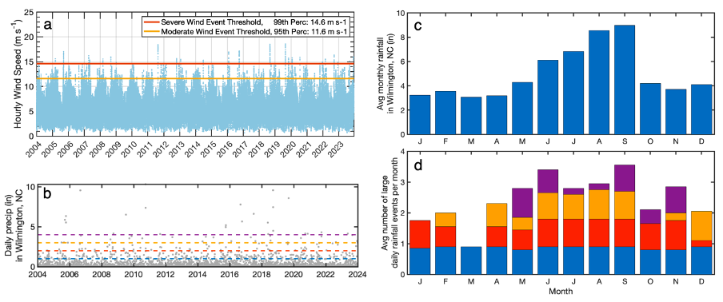
Figure 3. (a) Historical hourly wind speed from the Cape Fear, NC region from the ERA5 reanalysis; horizontal lines indicate the 95th (moderate events; yellow) and 99th (extreme/severe events; red) percentiles. (b) Daily precipitation at Wilmington Airport, NC (NCEI). (c) Average monthly rainfall and (d) average number of large daily rainfall events based on the same 20-year dataset. In (b) and (d) the dashed lines indicate 1, 2, 3 and 4 inch events, and the shading indicates 1-2 inch events (blue), 2-3 inch events (orange/red), 3-4 in events (gold), and >4 inch events (purple). A similar seasonal climatology of average and extreme winds will be performed to optimize the glider sampling period.

The extent to which harmful bacteria are mobilized and transported by the flood waters and river plume waters varies widely among events. This complicates efforts to predict how flooding from storms and king tides impacts downstream hazards for beach communities [9]. Following intense precipitation events (Figure 3), the transport of possibly contaminated freshwater within buoyant river plumes varies in response to the magnitude and time-history of discharge, the strength, duration and direction of wind, and other environmental conditions [10], [11], [12], [13], [14]. However, variations in the path of river plumes due to temporal changes in discharge and winds, including “within-event” variability, is poorly understood [15]. This can complicate the prediction of when river water and any associated contaminants reach downstream coastal areas, such as the beaches southwest of river plumes in the coastal Carolinas. For instance, variations in winds and river discharge prevented managers from anticipating the arrival of contaminated Cape Fear River water in Myrtle Beach following Hurricane Florence (Figure 4) [9]. Improved understanding of how storm characteristics and king tides affect contaminant transport and beach water quality will facilitate predictions of related hazards and how risks may change in the future.
Turbidity and Chl-a can be important indicators of water quality in coastal systems because fecal indicator bacteria can persist in sandy beach environments and become resuspended in turbid water conditions [16]. Beach sands can act as an environmental reservoir of Enterococcus, and that under certain tidal and moisture conditions those bacteria may transfer between sand and adjacent waters [17]. Such persistence in sand poses challenges to traditional water‐quality monitoring, because bacteria stored in substrate may influence bacterial counts in overlying water independent of new fecal inputs. A sediment transport model is thus needed to understand the potential for remobilization of harmful bacteria and the time scale of the threat to human health.
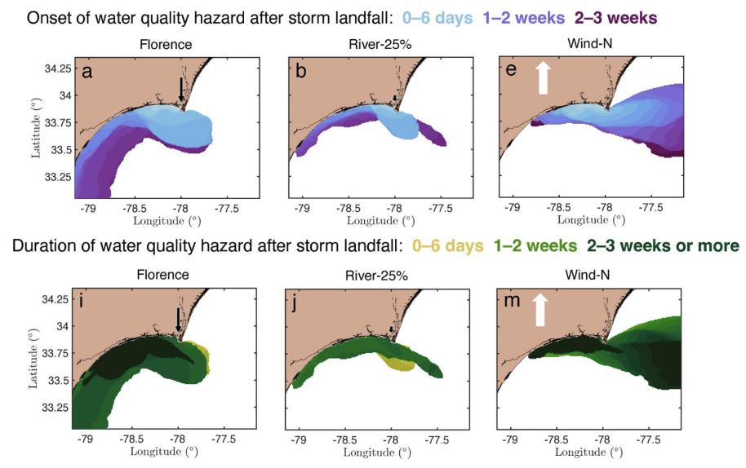
Figure 4: Maps of water quality hazard onset (top row) and duration (bottom row) in days since storm landfall for land‐sourced ‘contaminants’ in the Cape Fear watershed following Hurricane Florence (first column), a lower-rainfall event (second column), and an event with a different post-storm wind pattern (third column). The maps can be used to look up when water quality hazards (here defined concentrations of tracers representing contaminants exceeding a threshold of 5% of the riverine concentration) may begin and end at a particular coastal location of interest following a storm. This hydrodynamics only simulation with passive tracers may overestimate the persistence of some contaminants and does not simulate nutrient cycling, blooms, or deoxygenation. This motivates implementation of a biogeochemical model.

A detailed high-temporal-resolution analysis of the relationship between winds, river discharge, tidal stage and bacterial pollution has not yet been conducted on coastal Carolina beaches. While the timing of bacterial pollution on beaches has been examined in southern California [18], Louisiana [19], and South Carolina [20], a similar analysis has not yet been conducted throughout the coastal Carolinas. In southern California, spring-ebb tides (spring tide range and ebb tide stage) were most strongly associated with bacterial pollution [18]. In Louisiana, a forecasting system similar to the proposed work could accurately predict enterococci levels throughout the day, rather than relying on single weekly measurements [19]. At beaches on South Carolina’s Edisto Island, wind direction and tidal stage (near high tide) had a stronger relationship to bacterial levels than rainfall, and that bacterial pollution was largely due to bird and dog fecal matter when more of the beach surface was flooded during high tides [20].
Future storms are expected to move more slowly and have more precipitation, both of which will increase flooding [21], [22], [23], and biogeochemical impacts [24]. Agricultural expansion and intensification, urbanization, or other changes in land use may also exacerbate the threat from coastal storms. The flooding of hog farms is a concern worldwide [25], for example, and is expected to become a more important issue in the US as commercial pork production in the United States has steadily increased since the mid-1980s [26] (Figure 2).
The proposed work will deliver improved understanding of oceanographic and meteorological drivers behind the space and time scales of degraded water quality events in North Carolina. This will offer NC-DEQ improved tools to issue and lift advisories, modernizing regional water quality monitoring, reducing risks to swimmers, and supporting tourism and recreation. This project integrates satellite remote sensing, in situ measurements, and numerical modeling to improve the water quality advisory framework in North Carolina. The resulting framework, achieved through collaboration between the state regulatory agency and academic partners, is relevant and can be transferable to other U.S. coastal regions where recreational water quality is a public-health concern.

2. Applied Research Questions and Hypotheses

All central research questions in the proposed work involve the creation and adoption of quantifiable thresholds. For example, if viable, we will link specific turbidity, Chl-a, and/or salinity levels to bacterial exceedance probability based on historical analysis, in situ sampling, and mapping, and use those linkages to inform future advisory protocols. In answering all of the following research questions we will estimate the turbidity, Chl-a, and/or salinity thresholds associated with bacterial pollution and analyze how those values vary by season and by characteristics of the storm. Specific applied research questions are as follows:

RQ1. (Historical Analysis) What spatial and temporal patterns of salinity, temperature, turbidity, and chlorophyll-a are associated with past advisories that were issued following storms and king tide events?
- RQ1.a. Based on past storm events, are spatial patterns of degraded water quality and their indicators (turbidity, etc.) predictable from environmental drivers?
- RQ1.b. What was the lag time between past storm events and the dates that downstream advisories were issued and lifted, and how did that lag depend on storm characteristics ( e.g., durations and magnitudes of rainfall, wind direction, wind speed, and tides)?
- RQ1.c. What was the lag time between a king tide event and the dates that advisories were issued and lifted?

RQ2. (High temporal resolution beach sampling) How long do degraded water quality conditions persist after a beach swimming advisory is issued during current/future storms and king tide events?
- RQ2.a. How soon after degraded water quality events caused by (1) storm events and (2) king tide events can a beach safely reopen for recreation?
- RQ2.b. Should advisories be in place longer than the current practices by NC-DEQ for follow-up sampling (usually 2-3 days after advisory is issued), due to winds, tides, and river plume location?

RQ3. (Mapping tools) What processes are important for and what specific temporal and spatial resolution of satellite data is needed in the future to support real-time decisions?
- RQ3.a. What satellite products and variables capture the space and time scales of previous degraded water quality events?
- RQ3.b.What processes and what temporal and spatial resolution of satellite data are needed to issue and lift an advisory?
- RQ3.c.Can a hydro-biogeochemical numerical simulation accurately capture the space and time scales of a degraded water quality event?

The applied research hypotheses are as follows:
H1: The spatial and temporal distribution of beach bacterial pollution events following storms and king tides aligns closely with low salinity, high turbidity, and (to a lesser extent) high Chl-a, and depended on river discharge and wind speed:
- H1.a. Degraded water quality (e.g., high turbidity, low salinity, elevated Chl-a) following past storm events is spatially distributed in a river plume that generally hugs the coast southwest of the mouth of the Cape Fear River, and this distribution depends on river discharge and wind speed.
- H1.b. Downstream advisories at beaches were issued within a week following past storm events (0-6 days) and lifted within 2 weeks; exceptionally large river discharges increased the length of the advisories, and persistent winds to the east decreased it
- H1.c. Advisories at beaches were issued within days (0-3 days) following past king tide events and lifted within a week (0-6 days); the length of advisories following king tides was shorter than the time scale of storm-driven bacterial pollution.

H2: Degraded water quality conditions persist after an advisory is issued for up to 2 weeks, with a shorter time scale following king tide events than following storms.
- H2.a. Advisories could be lifted within 2 weeks of storm events, depending on projected river discharge and wind direction; advisories could be lifted within 3 days of king tide events.
- H2.b. Advisories could be lifted 1-3 days sooner than the current one-week interval used by NC-DEQ for follow-up sampling, particularly for king tide events.
H3. Sub-daily satellite data is needed to predict the spatial and temporal patterns of degraded water quality river plumes and king-tide-associated waters with enough sophistication to be useful for managers; current ocean color satellites do not provide the temporal scales needed for this decision-making activity.
- H3.a. Chl-a, turbidity, and SST at daily, 1 km resolution capture the space and time scales of historical degraded water quality events.
- H3.b. Sub-daily data could help NC-DEQ decide when and where to sample a beach that will likely experience bacterial pollution or re-sample a beach that could potentially be reopened, beyond what is possible now with daily data.
- H3.c. Numerical model simulations with hourly output can accurately capture the space and time scales of a degraded water quality event.

3. Proposed Methods

3.1. Study Site and Time Periods
To analyze how storm events and king tides alter water quality conditions relevant for issuing and lifting advisories, the proposed work will analyze beaches in the Coastal Carolinas, including beaches throughout the state of North Carolina and the surrounding coastline to the south (e.g., Myrtle Beach). This broader region encompasses the Outer Banks and other high-use recreational beaches where tourism is a central driver of the economy. This coastline is experiencing increasing severity of storms over time [27], [28]. Beaches along the Coastal Carolinas are also experiencing sea level rise and shoreline change via barrier island migration [29], [30], [31]. Many areas have dense populations during beach season (April-October) and wastewater treatment outfalls and stormwater outfalls may not be equipped to handle the human impacts combined with rising sea levels [32], [33]. The region is representative of many coastal systems nationwide where increasing severity of tropical and extratropical cyclones, sea level rise, and shoreline change combine with high use by tourism to heighten vulnerability to water-quality impairments that threaten public safety. By analyzing this large set of beaches (especially to address RQ3: mapping tools), the proposed work will capture the broader spatial patterns of environmental change and public-health risk across a tourism-dependent coastline.
For many of the proposed analyses (e.g., addressing RQ1 historical analysis and RQ2 high temporal resolution beach sampling), we will focus on a case study at the mouth of the Cape Fear River and adjacent beaches as a sentinel site for beach pollution monitoring. The basin is representative of many other industrialized coastal watersheds and associated river-plume systems that are experiencing changes to tropical and extratropical cyclone activity [13], [27]. The Cape Fear is the largest river basin contained entirely within North Carolina, with a drainage area of 23,889 km². It is the most industrialized watershed in North Carolina with large industries, including one of the most concentrated animal feeding operations worldwide, and dozens of large cities with wastewater treatment plants that significantly contribute to riverine nitrogen concentrations [34]. While deepening of the central channel has also been proposed [35], and future dredging could alter the hydrodynamics and water quality due to shifted patterns of sediment transport, process-based studies are useful frameworks for decisions as the system changes, and shifted patterns of the Cape Fear River discharge and the fate of plume waters are more important to the proposed work than the sediments [36].
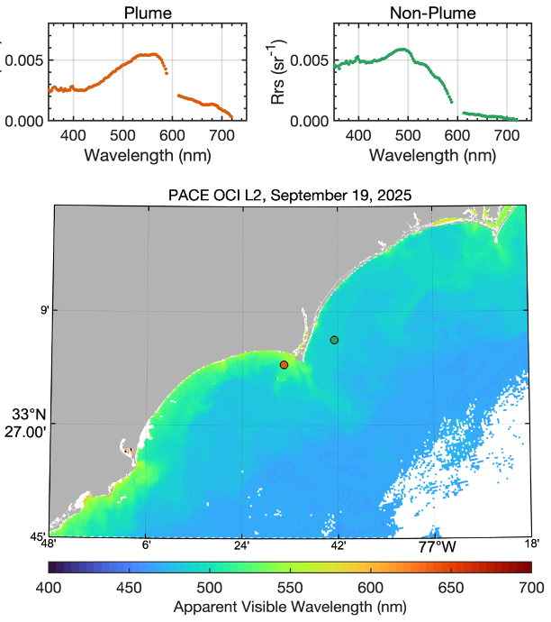
The proposed research will focus on time periods during and after storm events and king tide events. For storm events, we will focus on two common types of large precipitation events: (a) Tropical storms and hurricanes; and (b) other high-precipitation storm events. Tropical storms such as Hurricane Florence have dramatic impacts. Due to Florence’s slow speed ahead of and after landfall in North Carolina, a record breaking 30 inches of rain fell over southeastern North Carolina, with a maximum of ~36 inches near Elizabethtown. This precipitation, as well as ocean storm surge, caused catastrophic flooding throughout the watershed, carrying bacteria from land into the rivers and ocean. Nevertheless, tropical storms such as Florence are relatively infrequent and may not be observed in any given field-sampling year; therefore, this project will focus on hindcasting a subset of historical storms in addition to analyzing one high-precipitation storm and one future king tide during the period of the project, i.e., 2026-2029 (Table 2). Note that non-tropical-storm high-precipitation events are relatively frequent, and we expect to see 9-12 of these types of events over the course of the proposed work from 2026-2029 (3-4 events/month during August and September) (Figure 3).

3.2. Satellite, modeling, & in situ data

3.2.1. Satellite Observations
Satellite data will be used to 1) define spatial extents of coastal river plumes; 2) characterize coastal ocean water quality conditions and driver covariates (e.g., wind), in order to determine a proxy for degraded water quality through remotely sensed variables and to track the response of river plume waters during variable wind, discharge, tide conditions, and 3) validate model estimates of plume hydrodynamic and biochemical response to oceanic forcing, and 4) provide a basis for mapping tools for the NC-DEQ.
Figure 5. Example satellite data for mapping conditions surrounding the Cape Fear River plume from NASA PACE Ocean Color Instrument (OCI) on September 19, 2025, Level-2 Remote sensing reflectance data from (a) location impacted by the river plume and (b) location offshore, upstream of the river plume.
Satellite ocean color data will be downloaded and processed from satellite missions including Sentinel-3 OLCI, NASA PACE OCI, and (upon launch) NASA GLIMR. The two satellite-derived variables of most interest to our end-users at NC-DEQ are Chl-a and Turbidity. While satellite ocean color data offers solutions well beyond these two variables, we aim to provide actionable information to our end-user by focusing specifically on the data that they have requested to help them make decisions. Chl-a will initially be calculated using standard global algorithms [37], then later assessed alongside in situ data to determine whether a custom approach is needed for these coastal waters, such as a red-band difference approach or other red-edge approach that takes advantage of fluorescence line height (e.g., [38], [39]). Turbidity will be calculated from red-band reflectance following Nechad et al.[40], [41], a straightforward proven method for optically complex coastal waters with highly variable turbidity. Satellite observations will be compared with Coastal Ocean Research and Monitoring Program (CORMP) buoy data outfitted with additional bio-optical sensors (particulate backscatter, chlorophyll-a fluorescence, and dissolved organic matter fluorescence) over the North Carolina shelf (see Section 3.3.1). Differences in imagery before and after events and differences between “plume” and “non-plume” waters (e.g. Figure 5) will be used to estimate the storm-induced and king-tide-induced changes in water quality.
The extent and variability of ocean river plumes will be analyzed using the Geostationary Operational Environmental Satellite (GOES), which can be used to track rapid evolution of sea surface temperature [42], [43] and to generate true-color images in conjunction with PACE and OLCI [44]. GOES has high spatial and temporal resolution with the ability to capture the western-hemisphere at 15-min intervals and 0.5–2.0 km spatial resolution. Localized cloud removal methods [43] will be used to provide high-quality cloud-free images of the study site along with VIIRS sea surface temperature will also be used to analyze river plumes (e.g., [45], [46]).

Table 1. Satellite data to be used in the proposed work.
Satellite | Sensor (s) | Revisit Time | Spatial Res. | Years Available | Variables
VIIRS | Suomi NPP, NOAA-20, & NOAA-21 | 1 day | 750 m | 2011-Present | SST
GOES | ABI | Continuous | 2 km | 1975-Present | SST
Sentinel-3A &-3B | OLCI | 2 days | 300 m | 2016-Present | Chl-a,* Turbidity**
PACE | OCI | 1 day | 1 km | 2024-Present | Chl-a,* Turbidity**
_ | GLIMR | 3 hours | ~ 400 m | Planned launch 2026-2027 | Chl-a,* Turbidity**
*Begin with global algorithm, assess with in situ data, and potentially refine using regionally-tuned red-edge/FLH approaches as needed.
**[40], [41]

3.2.2. Coupled Numerical Modeling (addresses RQ1: historical analysis, RQ2: time scale of advisories, and RQ3:mapping tools)
This study will use a coupled hydrodynamic-sediment-biogeochemical model in order to account for river plume dynamics and resultant water quality impacts in the marine nearshore and shelf environments. We will build on the Regional Ocean Modeling System (ROMS; [47], [48], [49]) configuration used in a prior 3D hydrodynamic model study of passive tracer pathways in North Carolina [9]. Specifically, for this study, the ocean model domain will span the North Carolina coast and a portion of the South Carolina coast (Figure 6) with variable horizontal resolution from 1-km offshore to 500-m near the coastlines (approximately 400k horizontal grid points) and 25 vertical sigma levels (Figure 6). This domain balances spanning the region relevant for the end-user while remaining computationally feasible for coupled modeling. The research team has access to similar grids that have been applied in prior studies (e.g., [9], [50]). ROMS will be coupled with the spectral wave model SWAN [51] on the same grid. Atmospheric and surface wave forcing including surface winds, pressure, relative humidity, and air temperature will be derived from NOAA Rapid Refresh v4 [52] at approximately 13-km spatial resolution and hourly temporal resolution, or the ECMWF ERA5 reanalysis at 0.25° spatial resolution and hourly temporal resolution, depending on data availability for each simulation time period [53]. Ocean and wave boundary forcing will be obtained from a 30-year (1993–2022) ocean reanalysis for the Northwest Atlantic (NAOR) [54], along with nowcasts/forecasts (2023–present) from the East Coast Community Ocean Forecast System (ECCOFS), both with 4-km horizontal resolution and 50 vertical layers. These products build on the longstanding Coupled Northwest Atlantic Prediction System (CNAPS) [54]. We will also test benefits of merging these forcings with higher resolution information from the ChesROMS Chesapeake Bay model [55], [56] and the Doppio Mid-Atlantic Bight model [57].
Freshwater discharge from rivers to the ocean will be implemented at a set of streamflow reanalysis output points from NOAA’s Office of Weather Prediction National Water Model (NWM) [58], which also provides predictive output. Analyses of results from the hydrodynamic model will allow us to evaluate the impact of storms and tides on salinity, a key variable of interest from our stakeholders. In addition, we will implement a suite of dye tracers tagging (1) all freshwater discharge and (2) individual discharges of several major rivers, with several e-folding decay timescales: (a) fast (~1 day), (b) medium (~10 days), and (c) non-decaying, representing typical decay timescales for enterococci, E. coli, norovirus, heavy metals, and other substances of concern [59], [60], [61], [62]. Variations of decay timescales with sunlight, turbidity, and sedimentation will not be considered here and will be the focus of future work. As riverine concentrations of contaminants are uncertain and our study is not attempting to predict absolute concentrations, concentrations of the dye tracers at beach locations will primarily be analyzed as a fraction of the river-mouth concentration, with total dye inputs thus scaling with river discharge.

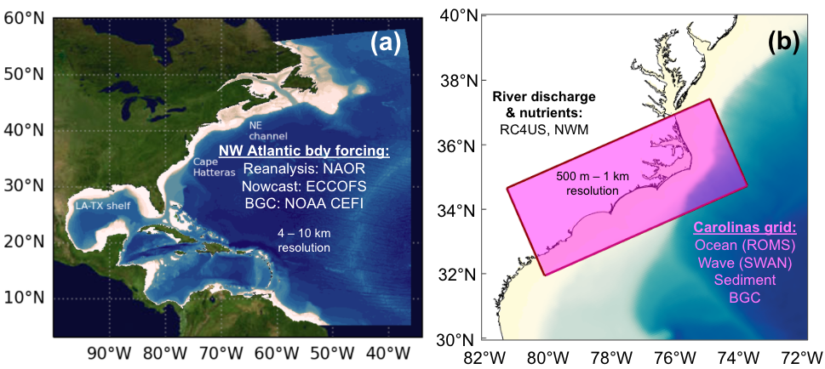
Figure 6. Hydrodynamic-biogeochemical model configuration. (a) NW Atlantic boundary forcing from several sources: NAOR, ECCOFS, NOAA CEFI, (b) Hydrodynamic-wave-biogeochemistry-sediment grid (shaded box) proposed for this study, spanning North and South Carolina at 500 m – 1 km resolution.

To consider storm- and tide-induced impacts on turbidity and chlorophyll, a sediment-biogeochemical model will be coupled to the inner grid of the ocean hydrodynamic model described above (Figure 6b). For this project, we will add coupling to the Community Sediment Transport Modeling System (CSTMS) and the Estuarine Carbon Biogeochemistry (ECB) models, which have previously been used and coupled in coastal environments; accounts for CDOM, organic and inorganic particles, and chlorophyll impacts on light attenuation; is nitrogen-based; and is open source [56], [63], [64], [65]. River sediment and biogeochemistry inputs will be derived from USGS river gauges [34], [66, p. 20], [67], RC4USCoast [68], a high-quality high-resolution product for US rivers, and other published data [34], [69]. Boundary data for biogeochemical variables (e.g., NO₃, O₂) will be obtained from NOAA’s Changing Ecosystems and Fisheries Initiative (CEFI) model for the Northwest Atlantic Ocean [70]. This is a MOM6-based coupled ocean-biogeochemistry model with approximately 8–10 km resolution. If the NOAA CEFI product becomes unavailable, we will derive biogeochemical boundary conditions from the World Ocean Atlas [71]. We will also assess benefits of including information from the ChesROMS-ECB simulations on the northern boundary conditions [55], [56] and the Doppio Mid-Atlantic Bight model [57]. Parameters will be based on in-situ data (see next section), satellite data collected during this project (see previous section), as well as the scientific literature (e.g., [72], [73], [74]).
The coupled hydrodynamic-sediment-biogeochemistry model described above will be implemented for five time periods (Table 2) representing different storm and tide conditions. These model runs will include both historical events and time periods during our study period, i.e., 2026 - 2029. The final choice for what time periods to simulate will be guided by historical advisory records and enterococci exposure patterns to capture variability in the water quality response following different precipitation events. The suite of simulations will also include one future high-precipitation storm event and
Table 2. Events targeted for coupled hydrodynamic-biogeochemical-sediment modeling.
Hindcasts (1997-2025)
- 1 high-precipitation storm event (e.g., Florence: extreme example)
- 2 medium-precipitation storm events with different wind conditions (sensitivity tests as needed)
- 2 king tide events (sensitivity tests as needed)
Model runs during study period (2026-2029)*
- 1 medium- or high-precipitation storm event
- 1 king tide event
*Concurrent with the proposed high-temporal resolution sampling operations
one future king tide event, targeting the first-year field season if feasible. The model will be evaluated based on input from NC-DEQ of what parameters are most useful in decision making, as well as in-situ data (see next section), satellite data (see previous section), previously published literature (e.g. [72], [73], [74]). Analysis of the model output will focus on salinity, decaying tracers representing pathogens/contaminants, turbidity, and chlorophyll based on stakeholder interests. Model output will be analyzed for spatiotemporal connectivity, using approaches such as K-Means and DBSCAN, unsupervised machine learning approaches to aid in identifying and quantifying patterns (e.g., [75], [76]). The spatial connectivity analysis will be critically compared with the current sampling stations used by NCDEQ (Fig. 1) to assess whether different spatial or temporal sampling plans may provide more representative observations of theheterogeneity in water quality following storms and king tides (RQ1 & 2). These analyses will also be used to provide inform what frequency and spatial resolution would be most useful for the mapping activities (RQ3)

3.2.3. Existing in situ data (toward RQ1: historical analysis and RQ3: mapping tools)
To characterize water quality events, time series of weekly sampled bacterial abundance and advisories from NCDEQ sites (1997 - present), including both regular advisories and precautionary advisories, will be analyzed for among-site co-variation and temporal lags. Climatological cycles will be removed from environmental drivers—including Cape Fear River discharge, NOAA tide-gauge data, and regional meteorological variables (e.g., precipitation and wind)—to isolate anomalous conditions associated with storms and king tides.
To create the salinity maps, ground-truth satellite water quality observations, and evaluate model estimates, we will use existing in situ data from gliders, buoys, and moored observatories (Figure 7). We will leverage publicly available glider observations from the South East Coastal Ocean Observing Regional Association (SECOORA), which has carried out regional glider deployments for over a decade including measurements of temperature, salinity, chlorophyll-a, fDOM, and oxygen (Fig. 8). These data are typically available in near-real-time and temperature and salinity data are regularly assimilated into operational ocean modeling systems [77]. The Coastal Ocean Research and Monitoring Program (CORMP) maintains a network of coastal buoys extending from central North Carolina to the Atlantic coast of Florida. Several shelf buoys in 10-m to 30-m water depth have been outfitted with surface CTD sensors from 2008 - present in addition to meteorological and ocean wave measurements (Figure 7). These data, in particular stations offshore of Charleston, SC and Wilmington, NC will provide point time series measurements of historical low salinity events and their duration in the region. In 2024, the NSF Ocean Observing Initiative (OOI) relocated the Coastal Pioneer Array to Nag’s Head, North Carolina near the Gulf Stream separation point at Cape Hatteras. With moored and autonomous assets sampling bio-physical ocean variables from 30-m to 600-m water depth, the array provides an additional resource for placing the proposed data collection and satellite analyses in a broader context (See Letter of Support in Non-anonymized document).

3.3 Initial Field Work in the 2026 - 2027 Season

3.3.1 Addition of in situ bio-optical sensors to CORMP buoys (toward RQ 1: historical analysis, will support of RQ3: mapping tools)
To complement the historical measurements of moored salinity and satellite data analysis, two of the CORMP buoys are selected as case studies during the proposed research. Here, in collaboration with CORMP technicians (See Letter of Support in Non-anonymized document), we propose to add near-surface bio-optical sensors (RBR Tridente measurements of Chl-a, fDOM, and turbidity). Both buoys are in approximately 10-m water depth with one situated to the northeast of the Cape Fear River mouth, only experiencing river plume waters during sustained northerly wind events. The other buoy is located to the southwest and consistently shows low-salinity events associated with the advection of the river plume to this location (Figure 7). Although the sensors will be outfitted with automated wipers, due to bio-fouling we predict successful collection for a few weeks at a time following deployment. Therefore, we will deploy cleaned sensors at two targeted times: 1) in anticipation of a high river discharge, low salinity event associated with river plume conditions (spring season) and 2) in anticipation of a king tide event (fall season). Satellite-derived Chl-a and turbidity products will be compared to in situ temperature and salinity data from the CORMP buoys and the additional bio-optical sensor measurements (e.g., turbidity, Chl-a fluorescence, dissolved organic matter fluorescence).
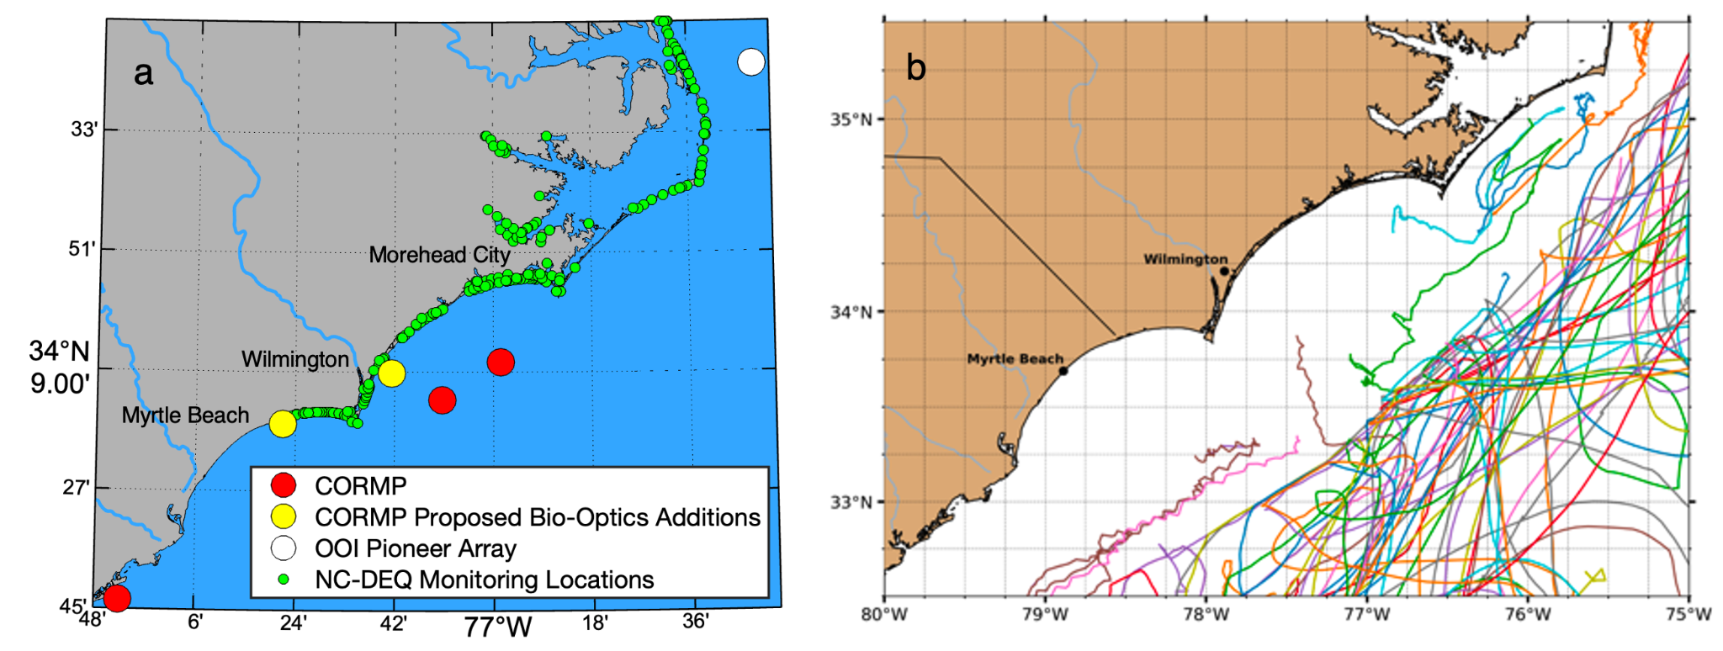
Figure 7. Existing in situ data sources, including (a) Coastal Ocean Research and Monitoring Program (CORMP) buoys in red with locations of proposed bio-optical sensor additions colored yellow, the Ocean Observatories Initiative’s Pioneer Array central mooring colored white, and the NC-DEQ end user monitoring locations colored green, large red, yellow, and white circles all continuously monitor surface salinity; and (b) publicly available glider deployments in the Cape Fear region from 2017-2022 from the IOOS Data Assembly Center. Each colored line represents an independent glider deployment.

3.3.2 High temporal resolution beach sampling (addresses RQ 2: time scale of advisories)
To complement the repeat weekly sampling of ~220 NCDEQ stations (Figure 1, Figure 7), we will conduct in situ high temporal resolution (daily) sampling at a subset of Wilmington, NC area beaches during a closure event. At least two local project participants will work in collaboration with NCDEQ to be trained in sampling location and collection protocols. Outside of the NCDEQ workflow, the trained participants will then collect water samples in-between the weekly sampling and deliver them to NC state-approved contracted laboratory (Environmental Chemists, Inc.) to process samples for Enterococci. Additionally, other water quality variables will be collected alongside indicator bacterial abundance using a YSI sonde equipped with Chl, Salinity, and Turbidity sensors. The high-resolution sampling will be adaptive and dependent on beach closure events, but will target two specific periods to manage field work planning: (1) the high river discharge period in spring, and (2) the fall king tide event. This high temporal resolution sampling will facilitate analyses of the onset and duration of degraded water quality, directly addressing RQ2 to test Hypotheses 2a and 2b.

4. Engagement and Needs Assessment

The proposed work aligns with “Type 1” proposals for early-stage application development in direct partnership with end-user agency NC DEQ, from ARL3 (Proof of Application Concept) to at least ARL6 (Demonstration in Relevant Environment) through iterative testing and user feedback.

4.1. Current ARL at Submission:
At the time of submission, this project is best characterized as ARL 3. Currently, observational analyses of episodic storm impacts on coastal water quality exist in fragmented form, and satellite and in situ datasets are not yet systematically integrated to address decision-making needs in this specific region of the United States. Although NC DEQ has a weekly monitoring program and online mapping platform for their bacteria-based beach advisories, no forecasting capability or precautionary advisory framework currently exists that integrates satellite-derived water quality data. NASA satellite data streams (e.g., PACE, GOES, Sentinel-3) are well established, but their utility in real-time decision-making for North Carolina coastal water quality has not been applied. Thus, this project begins at an early ARL stage, where scientific methods are in place (e.g., existing Chl-a, Turbidity, and SST algorithms) and proof-of-concept applications are feasible, but a validated decision-support product is not yet available to managers.

4.2. Expected ARL Advances During the Project:
By the project’s end, we expect to advance the work to at least ARL 6, developing an application that is actively tested and refined by our partner end users. This will be achieved through three steps: (1) synthesizing datasets into usable maps of salinity, turbidity, and chlorophyll-a; (2) integrating these products into a web-based decision-support mapping tool alongside NC DEQ’s advisory framework; and (3) iteratively engaging with NC DEQ managers to validate, refine, and deploy the tool in real-world decision-making contexts. Through this process, the project will move from exploratory science to an applied forecasting system with demonstrated relevance and utility for issuing and lifting advisories.

5. Solution Development and Testing

The proposed project will co-develop a decision-support tool that integrates NASA Earth observations, hydrodynamic-biogeochemical modeling, and in situ datasets to improve water quality management decisions for North Carolina beaches. Working in close partnership with a scientist at the NC-DEQ as our end-user Co-I, we will iteratively design and test web-based mapping tools that visualize high-temporal-resolution satellite and modeled water quality indicators—including salinity, turbidity, and chlorophyll-a—to support the issuance and lifting of advisories. Solution development will begin with historical analyses that combine satellite products (GOES, Sentinel-3 OLCI, and NASA PACE), modeled hydrodynamic outputs, and NC-DEQ’s 28-year archive of swimming advisories to identify spatial and temporal relationships among storm events, king tides, and degraded water quality. In situ measurements from CORMP and SECOORA buoys, supplemented by added optical and biogeochemical sensors, will be used to validate satellite and model products. Prototype mapping layers will then be integrated into NC-DEQ’s existing online advisory framework for real-time visualization and evaluation.
Through iterative feedback with NC-DEQ managers and technicians during quarterly meetings, the project team will refine product latency, spatial resolution, and usability.

6. Implementation and Evaluation

6.1. Usefulness of results and tools determined by feedback from NC-DEQ:
The collaborative testing process described above will ensure that the developed tools meet operational needs, advance from proof-of-concept (ARL 3) to demonstrated application in a relevant environment (ARL 6), and ultimately transition into sustained use by NC-DEQ for water quality decision-making. In addition to the iterative engagement throughout the project, the usefulness of the final prototype tool will be evaluated in a feedback focus group with several NC-DEQ water-quality decision-makers near the end of the project. In addition, in the final year of the project, we will perform individual virtual interviews with water-quality managers in several other states, including South Carolina, which will be partially included in our study region, Virginia, New Jersey, and California. These engagements will be used to share our prototype tools and get feedback on how they may be modified to be transferable to states with different regulatory procedures and environmental controls on water quality. PI Turner and project graduate and undergraduate researchers will lead the evaluation work, supported by the co-PIs, with development support from Co-I#3 who has experience conducting focus groups. The project team will create a white paper summarizing all findings and outputs in an easy to access fashion to be distributed to decision-makers at the end of the project.

6.2. Outreach/education about scientific research relevant to water-quality decision-making:
Outreach and education about scientific research relevant for water quality decision-making will be orchestrated by the project team at regional meetings that attract interested members of the community, such as the Coastal Carolina River Watch fisheries symposium, the NC Boating and Intracoastal Waterways Association, SECOORA, and meetings of the Cape Fear River Watch group. During this project, as layers are added to the online maps (e.g., NC-DEQ web tool), this same warning will continue to be in place, i.e. that the project’s online mapping tool presents non-formalized data and is not a substitute for formal swimming advisories. Engaging interested parties such as members of the fishing community, public ‘community scientists’, and county and city leaders will improve public understanding of the state water-quality decision-making processes, and inform future work via knowledge exchange about how water-quality decisions affect public actions.

IV. Project Management Plan

The project will be managed iteratively with the end-user partner, the NC DEQ (Figure 8). NC-DEQ will serve as the primary end-user, providing historical beach advisory datasets, feedback on the results of the high temporal resolution beach water quality sampling, and feedback on prototype mapping tools. The PI will oversee overall project coordination, communication, and integration of research outputs with end-user needs. The PI and Co-Is #1-4 will lead subsets of this work according to their expertise:
- End-User, NC-DEQ (end user, iterative testing of provided results and tools)
- PI (project integration, lead developer and deliverer of mapping tool to stakeholders, water quality satellite data mapping, stakeholder surveys, management of student)
  - Graduate student (water quality satellite data mapping, stakeholder surveys)
- Co-I #1(high temporal frequency SST satellite data analysis)
- Co-I #2 (biogeochemical modeling, guidance on hydrodynamic modeling, management of postdoc)
  - Postdoc (hydrodynamic modeling, biogeochemical modeling)
- Co-I #3 (hydrodynamic modeling, guidance on water-quality manager focus groups)
- Co-I #4 (adding in situ sensors to CORMP buoys, high temporal resolution beach sampling, consulting on hydrodynamic modeling)
  - Undergraduate student (high temporal resolution beach sampling)

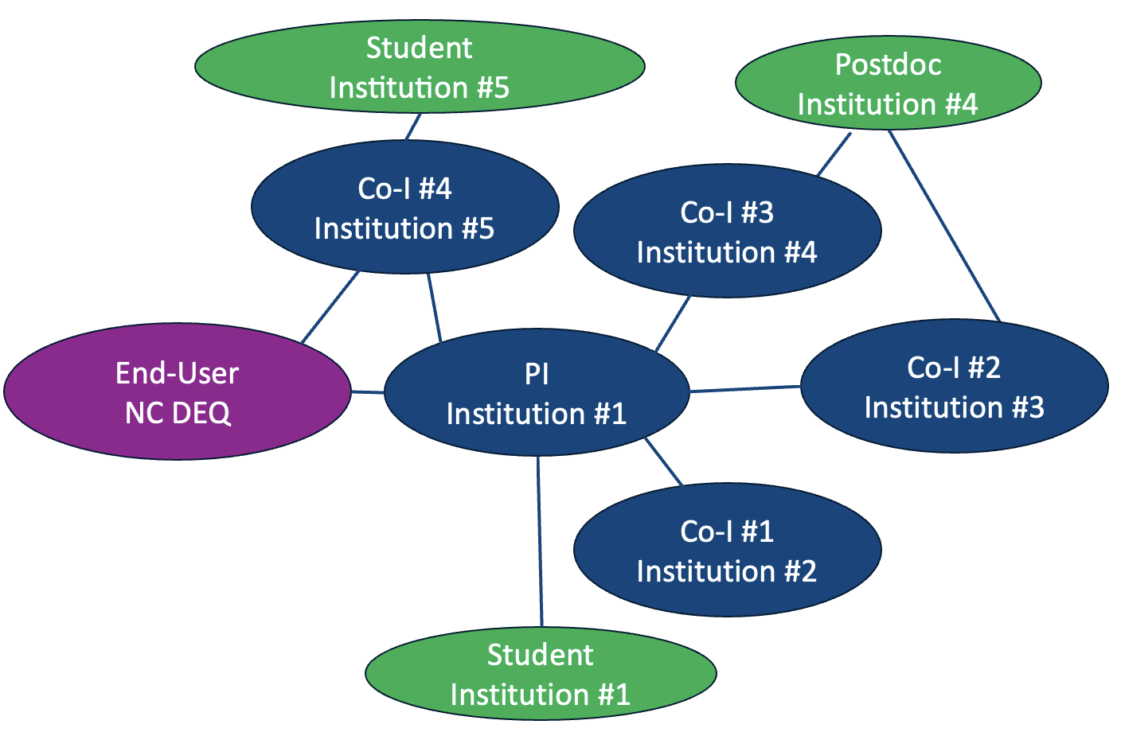
Figure 8. Proposed project management structure including end-user partner NC-DEQ.

V. Earth Science to Action (ES2A)

The proposed work is directly aligned with two of the ES2A priorities: 1) “KR 2.1 Models that capture the intricacies of the Earth System” and 2) “KR 2.3 Science-based information we can trust and act on.” Our project thus most closely represents the Earth System Science and Applied Research tier of the pyramid, and the planned work will progress up the pyramid. The solutions and societal value of the proposed work lies in its ability to deliver a spatial mapping tool and higher-temporal resolution data to the managers who issue and lift advisories at economically important beaches. Planned outreach and education activities at state- and watershed-level water-quality conferences will enhance public understanding and exchange and provide input to inform subsequent work. Gathering information from frequent engagement with NC-DEQ will allow for the integration of feedback into the next iteration of the mapping tool. The results of this work, i.e., improved knowledge of the temporal scale of data needed to effectively issue and lift advisories, will be relevant to foundational knowledge, technology, missions, and data (the ground tier of the ES2A pyramid), since results will inform what can be done with higher temporal resolution satellite-derived water quality data in the future, upon launch of the planned GLIMR mission. Modeling the time scales of storm and tide impacts will not only be helpful to our stakeholders but will also help the aquatic sciences community better understand the capabilities of GLIMR, as high temporal resolution model output can serve as an example of simulated GLIMR measurements.

References

[1] NC Department of Commerce, “N.C. Breaks Tourism Spending Record, Continues to Be #5 Most Visited State.” 2025. [Online]. Available: https://www.commerce.nc.gov/news/press-releases/2025/05/07/nc-breaks-tourism-spending-record-continues-be-5-most-visited-state
[2] S. J. M. Rabinovici, R. L. Bernknopf, A. M. Wein, D. L. Coursey, and R. L. Whitman, “Economic and Health Risk Trade-Offs of Swim Closures at a Lake Michigan Beach,” Environ. Sci. Technol., vol. 38, no. 10, pp. 2737–2745, May 2004, doi: 10.1021/es034905z.
[3] NC-DEQ, “Recreational Advisory Status Public Map. ArcGIS Web Application.” 2025. Accessed: Oct. 09, 2025. [Online]. Available: https://ncdenr.maps.arcgis.com/apps/webappviewer/index.html?id=3a38378983874a88aeaf6c3027292587
[4] A. B. Boehm et al., “A sea change ahead for recreational water quality criteria,” Journal of Water and Health, vol. 7, no. 1, pp. 9–20, Mar. 2009, doi: 10.2166/wh.2009.122.
[5] A. B. Boehm, K. E. Graham, and W. C. Jennings, “Can We Swim Yet? Systematic Review, Meta-Analysis, and Risk Assessment of Aging Sewage in Surface Waters,” Environ. Sci. Technol., vol. 52, no. 17, pp. 9634–9645, Sept. 2018, doi: 10.1021/acs.est.8b01948.
[6] USEPA, “EPA’s Beach Report: 2024 Swimming Season.” United States Environmental Protection Agency, 2025. [Online]. Available: https://ordspub.epa.gov/ords/beacon2/f?p=BEACON2:DNR
[7] S. Paul, D. Ghebreyesus, and H. O. Sharif, “Brief communication: Analysis of the fatalities and socio-economic impacts caused by Hurricane Florence,” Geosciences, vol. 9, no. 2, p. 58, 2019, doi: 10.3390/geosciences9020058.
[8] A. Macías-Tapia, M. R. Mulholland, C. R. Selden, J. D. Loftis, and P. W. Bernhardt, “Five Years Measuring the Muck: Evaluating Interannual Variability of Nutrient Loads From Tidal Flooding,” Estuaries and Coasts, vol. 46, no. 7, pp. 1756–1776, Nov. 2023, doi: 10.1007/s12237-023-01245-3.
[9] M. Moulton et al., “Modeled Coastal‐Ocean Pathways of Land‐Sourced Contaminants in the Aftermath of Hurricane Florence,” JGR Oceans, vol. 129, no. 3, p. e2023JC019685, Mar. 2024, doi: 10.1029/2023JC019685.
[10] J. O’Donnell, “The dynamics of estuary plumes and fronts,” in Contemporary Issues in Estuarine Physics, 1st ed., A. Valle-Levinson, Ed., Cambridge University Press, 2010, pp. 186–246. doi: 10.1017/CBO9780511676567.009.
[11] R. J. Chant, “Interactions between estuaries and coasts: river plumes—their formation transport and dispersal,” in Treatise on Estuarine and Coastal Science, vol. 2, E. Wolanski and D. McLusky, Eds., Amsterdam: Elsevier, 2011, pp. 213–235.
[12] R. D. Hetland, “Relating River Plume Structure to Vertical Mixing,” Journal of Physical Oceanography, vol. 35, no. 9, pp. 1667–1688, Sept. 2005, doi: 10.1175/JPO2774.1.
[13] A. R. Horner-Devine, R. D. Hetland, and D. G. MacDonald, “Mixing and Transport in Coastal River Plumes,” Annu. Rev. Fluid Mech., vol. 47, no. 1, pp. 569–594, Jan. 2015, doi: 10.1146/annurev-fluid-010313-141408.
[14] S. L. Dykstra, G. Ricche, G. Marmorino, and A. E. Yankovsky, “Forcing conditions of cross-shelf plumes on a wide continental shelf, Winyah Bay, South Atlantic Bight,” Remote Sensing of Environment, vol. 311, p. 114279, Sept. 2024, doi: 10.1016/j.rse.2024.114279.
[15] E. Lemagie and J. Lerczak, “The Evolution of a Buoyant River Plume in Response to a Pulse of High Discharge from a Small Midlatitude River,” Journal of Physical Oceanography, vol. 50, no. 7, pp. 1915–1935, July 2020, doi: 10.1175/JPO-D-19-0127.1.
[16] E. Halliday and R. J. Gast, “Bacteria in Beach Sands: An Emerging Challenge in Protecting Coastal Water Quality and Bather Health,” Environ. Sci. Technol., vol. 45, no. 2, pp. 370–379, Jan. 2011, doi: 10.1021/es102747s.
[17] E. E. A. Halliday, “Sands and environmental conditions impact the abundance and persistence of the fecal indicator bacteria enterococcus at recreational beaches,” 2012.
[18] A. B. Boehm and S. B. Weisberg, “Tidal Forcing of Enterococci at Marine Recreational Beaches at Fortnightly and Semidiurnal Frequencies,” Environ. Sci. Technol., vol. 39, no. 15, pp. 5575–5583, Aug. 2005, doi: 10.1021/es048175m.
[19] Z. Zhang, Z. Deng, K. A. Rusch, and N. D. Walker, “Modeling system for predicting enterococci levels at Holly Beach,” Marine Environmental Research, vol. 109, pp. 140–147, Aug. 2015, doi: 10.1016/j.marenvres.2015.07.003.
[20] C. Ek et al., “Enterococci Contamination on Edisto Island, South Carolina: Frequency, Sources of Contamination, and Prospects on How to Improve Water Quality,” JSCWR, pp. 68–82, 2021, doi: 10.34068/JSCWR/08.01.08.
[21] B. A. Colle, J. F. Booth, and E. K. M. Chang, “A Review of Historical and Future Changes of Extratropical Cyclones and Associated Impacts Along the US East Coast,” Curr Clim Change Rep, vol. 1, no. 3, pp. 125–143, Sept. 2015, doi: 10.1007/s40641-015-0013-7.
[22] R. D. Harp and D. E. Horton, “Observed Changes in Daily Precipitation Intensity in the United States,” Geophysical Research Letters, vol. 49, no. 19, p. e2022GL099955, Oct. 2022, doi: 10.1029/2022GL099955.
[23] M. Wehner and C. Sampson, “Attributable human-induced changes in the magnitude of flooding in the Houston, Texas region during Hurricane Harvey,” Climatic Change, vol. 166, no. 1–2, p. 20, May 2021, doi: 10.1007/s10584-021-03114-z.
[24] H. W. Paerl et al., “Recent increase in catastrophic tropical cyclone flooding in coastal North Carolina, USA: Long-term observations suggest a regime shift,” Sci Rep, vol. 9, no. 1, p. 10620, Dec. 2019, doi: 10.1038/s41598-019-46928-9.
[25] M. S. Lee, T. Y. Chen, C. M. Kao, J. L. Hung, and C. Y. Chen, “Development of Watershed Management Strategies for the Chiang-Chun River Basin, Taiwan,” Pract. Period. Hazard. Toxic Radioact. Waste Manage., vol. 12, no. 1, pp. 47–52, Jan. 2008, doi: 10.1061/(ASCE)1090-025X(2008)12:1(47).
[26] USDA, “Hogs & Pork - Sector at a Glance. U.S. Department of Agriculture, Economic Research Service.” 2025. Accessed: Dec. 08, 2025. [Online]. Available: https://www.ers.usda.gov/topics/animal-products/hogs-pork/sector-at-a-glance
[27] Intergovernmental Panel On Climate Change (Ipcc), Climate Change 2021 – The Physical Science Basis: Working Group I Contribution to the Sixth Assessment Report of the Intergovernmental Panel on Climate Change, 1st ed. Cambridge University Press, 2023. doi: 10.1017/9781009157896.
[28] C. J. Feehan, K. Filbee-Dexter, M. S. Thomsen, T. Wernberg, and T. Miles, “Ecosystem damage by increasing tropical cyclones,” Commun Earth Environ, vol. 5, no. 1, p. 674, Nov. 2024, doi: 10.1038/s43247-024-01853-2.
[29] R. E. Kopp, B. P. Horton, A. C. Kemp, and C. Tebaldi, “Past and future sea-level rise along the coast of North Carolina, USA,” Climatic Change, vol. 132, no. 4, pp. 693–707, Oct. 2015, doi: 10.1007/s10584-015-1451-x.
[30] L. Velasquez-Montoya, E. J. Sciaudone, E. Smyre, and M. F. Overton, “Vulnerability Indicators for Coastal Roadways Based on Barrier Island Morphology and Shoreline Change Predictions,” Nat. Hazards Rev., vol. 22, no. 2, p. 04021003, May 2021, doi: 10.1061/(ASCE)NH.1527-6996.0000441.
[31] B. P. Hayden, R. Dolan, and P. Ross, “Barrier island migration,” in Thresholds in Geomorphology, Routledge, 2020, pp. 363–384.
[32] J. F. Flood and L. B. Cahoon, “Risks to Coastal Wastewater Collection Systems from Sea-Level Rise and Climate Change,” Journal of Coastal Research, vol. 274, pp. 652–660, July 2011, doi: 10.2112/JCOASTRES-D-10-00129.1.
[33] L. Vorhees, J. Harrison, M. O’Driscoll, C. Humphrey, and J. Bowden, “Climate Change and Onsite Wastewater Treatment Systems in the Coastal Carolinas: Perspectives from Wastewater Managers,” Weather, Climate, and Society, vol. 14, no. 4, pp. 1287–1305, Oct. 2022, doi: 10.1175/WCAS-D-21-0192.1.
[34] C. N. Brown, M. A. Mallin, and A. N. Loh, “Tracing nutrient pollution from industrialized animal production in a large coastal watershed,” Environ Monit Assess, vol. 192, no. 8, p. 515, Aug. 2020, doi: 10.1007/s10661-020-08433-9.
[35] USACE, “WIlmington Harbor 403 Letter Report and Environmental Impact Statement. U.S. Army Corps of Engineers. U.S. Department of Defense.” 2025. [Online]. Available: https://www.saw.usace.army.mil/Missions/Navigation/Dredging/Wilmington-Harbor/Wilmington-Harbor-403-Letter-Report-and-EIS/
[36] R. Familkhalili and S. A. Talke, “The effect of channel deepening on tides and storm surge: A case study of Wilmington, NC,” Geophysical Research Letters, vol. 43, no. 17, pp. 9138–9147, Sept. 2016, doi: 10.1002/2016GL069494.
[37] C. Hu et al., “Improving satellite global chlorophyll a data products through algorithm refinement and data recovery,” JGR Oceans, vol. 124, no. 3, pp. 1524–1543, Mar. 2019, doi: 10.1029/2019JC014941.
[38] F. Henderikx Freitas and H. M. Dierssen, “Evaluating the seasonal and decadal performance of red band difference algorithms for chlorophyll in an optically complex estuary with winter and summer blooms,” Remote Sensing of Environment, vol. 231, no. June, p. 111228, 2019, doi: 10.1016/j.rse.2019.111228.
[39] T. T. Wynne et al., “Evaluating the Efficacy of Five Chlorophyll-a Algorithms in Chesapeake Bay (USA) for Operational Monitoring and Assessment,” JMSE, vol. 10, no. 8, p. 1104, Aug. 2022, doi: 10.3390/jmse10081104.
[40] B. Nechad, K. G. Ruddick, and G. Neukermans, “Calibration and validation of a generic multisensor algorithm for mapping of turbidity in coastal waters,” Proc. SPIE, vol. 7473, p. 74730H, 2009, doi: 10.1117/12.830700.
[41] B. Nechad, K. G. Ruddick, and Y. Park, “Calibration and validation of a generic multisensor algorithm for mapping of total suspended matter in turbid waters,” Remote Sensing of Environment, vol. 114, no. 4, pp. 854–866, 2010, doi: 10.1016/j.rse.2009.11.022.
[42] B. Petrenko, A. Ignatov, Y. Kihai, and M. Pennybacker, “Optimization of Sensitivity of GOES-16 ABI Sea Surface Temperature by Matching Satellite Observations with L4 Analysis,” Remote Sensing, vol. 11, no. 2, p. 206, Jan. 2019, doi: 10.3390/rs11020206.
[43] S. C. Murphy et al., “Persistent upwelling in the Mid-Atlantic Bight detected using gap-filled, high-resolution satellite SST,” Remote Sensing of Environment, vol. 262, p. 112487, Sept. 2021, doi: 10.1016/j.rse.2021.112487.
[44] J. K. Jolliff, M. D. Lewis, S. Ladner, and R. L. Crout, “Observing the Ocean Submesoscale with Enhanced-Color GOES-ABI Visible Band Data,” Sensors, vol. 19, no. 18, p. 3900, Sept. 2019, doi: 10.3390/s19183900.
[45] V. Klemas, “Remote Sensing of Coastal Plumes and Ocean Fronts: Overview and Case Study,” Journal of Coastal Research, vol. 278, pp. 1–7, Jan. 2012, doi: 10.2112/JCOASTRES-D-11-00025.1.
[46] N. D. Walker, W. J. Wiseman, L. J. Rouse, and A. Babin, “Effects of River Discharge, Wind Stress, and Slope Eddies on Circulation and the Satellite-Observed Structure of the Mississippi River Plume,” Journal of Coastal Research, vol. 216, pp. 1228–1244, Nov. 2005, doi: 10.2112/04-0347.1.
[47] D. B. Haidvogel, H. G. Arango, K. Hedstrom, A. Beckmann, P. Malanotte-Rizzoli, and A. F. Shchepetkin, “Model evaluation experiments in the North Atlantic Basin: simulations in nonlinear terrain-following coordinates,” Dynamics of Atmospheres and Oceans, vol. 32, no. 3–4, pp. 239–281, Aug. 2000, doi: 10.1016/S0377-0265(00)00049-X.
[48] D. B. Haidvogel et al., “Ocean forecasting in terrain-following coordinates: Formulation and skill assessment of the Regional Ocean Modeling System,” Journal of Computational Physics, vol. 227, no. 7, pp. 3595–3624, 2008, doi: 10.1016/j.jcp.2007.06.016.
[49] J. C. Warner, B. Armstrong, R. He, and J. B. Zambon, “Development of a Coupled Ocean–Atmosphere–Wave–Sediment Transport (COAWST) Modeling System,” Ocean Modelling, vol. 35, no. 3, pp. 230–244, 2010, doi: 10.1016/j.ocemod.2010.07.010.
[50] J. C. Warner et al., “Numerical Simulation of Sound‐Side Barrier‐Island Inundation and Breaching During Hurricane Dorian (2019),” JGR Earth Surface, vol. 130, no. 6, p. e2025JF008309, June 2025, doi: 10.1029/2025JF008309.
[51] N. Booij, R. C. Ris, and L. H. Holthuijsen, “A third-generation wave model for coastal regions: 1. Model description and validation,” Journal of Geophysical Research, vol. 104, no. No. C4, pp. 7649–7666, 1999, doi: 10.1029/98JC02622.
[52] NOAA, “NOAA Rapid Refresh v4 (RAP). Global Systems Laboratory. https://rapidrefresh.noaa.gov/.” 2025. [Online]. Available: https://rapidrefresh.noaa.gov/
[53] C3S, “ERA5: Fifth generation of ECMWF atmospheric reanalyses of the global climate. Copernicus Climate Change Service,” Copernicus Climate Change Service Climate Data Store (CDS). [Online]. Available: https://cds.climate.copernicus.eu/cdsapp#!/home
[54] R. He et al., “Advanced Ocean Reanalysis of the Northwestern Atlantic: 1993-2022,” 2025, arXiv. doi: 10.48550/ARXIV.2503.06907.
[55] I. Irby, M. A. M. Friedrichs, F. Da, and K. Hinson, “The competing impacts of climate change and nutrient reductions on dissolved oxygen in Chesapeake Bay,” Biogeosciences, vol. 15, pp. 2649–2668, 2018, doi: 10.5194/bg-15-2649-2018.
[56] Y. Feng et al., “Chesapeake Bay nitrogen fluxes derived from a land-estuarine ocean biogeochemical modeling system: Model description, evaluation, and nitrogen budgets,” Journal of Geophysical Research: Biogeosciences, vol. 120, no. 8, pp. 1666–1695, 2015, doi: 10.1002/2015JG002931.
[57] A. G. López, J. L. Wilkin, and J. C. Levin, “Doppio – a ROMS (v3.6)-based circulation model for the Mid-Atlantic Bight and Gulf of Maine: configuration and comparison to integrated coastal observing network observations,” Geosci. Model Dev., vol. 13, no. 8, pp. 3709–3729, Aug. 2020, doi: 10.5194/gmd-13-3709-2020.
[58] B. Cosgrove et al., “NOAA’s National Water Model: Advancing operational hydrology through continental‐scale modeling,” J American Water Resour Assoc, vol. 60, no. 2, pp. 247–272, Apr. 2024, doi: 10.1111/1752-1688.13184.
[59] A. B. Boehm, A. I. Silverman, A. Schriewer, and K. Goodwin, “Systematic review and meta-analysis of decay rates of waterborne mammalian viruses and coliphages in surface waters,” Water Research, vol. 164, p. 114898, Nov. 2019, doi: 10.1016/j.watres.2019.114898.
[60] V. Agarwal et al., “Real‐Time Empirical Risk Assessment From Recurrent Coastal Sewage Plumes,” GeoHealth, vol. 9, no. 12, p. e2025GH001434, Dec. 2025, doi: 10.1029/2025GH001434.
[61] F. Feddersen, A. B. Boehm, S. N. Giddings, X. Wu, and D. Liden, “Modeling Untreated Wastewater Evolution and Swimmer Illness for Four Wastewater Infrastructure Scenarios in the San Diego‐Tijuana (US/MX) Border Region,” GeoHealth, vol. 5, no. 11, p. e2021GH000490, Nov. 2021, doi: 10.1029/2021GH000490.
[62] E. Brasseale, F. Feddersen, X. Wu, A. G. Zimmer-Faust, and S. N. Giddings, “Performance of a One-Dimensional Model of Wave-Driven Nearshore Alongshore Tracer Transport and Decay with Applications for Dry Weather Coastal Pollution,” Environ. Sci. Technol., vol. 57, no. 39, pp. 14674–14683, Oct. 2023, doi: 10.1021/acs.est.2c08656.
[63] C. R. Sherwood, A. L. Aretxabaleta, C. K. Harris, J. Paul Rinehimer, R. Verney, and B. Ferré, “Cohesive and mixed sediment in the Regional Ocean Modeling System (ROMS v3.6) implemented in the Coupled Ocean-Atmosphere-Wave-Sediment Transport Modeling System (COAWST r1234),” Geoscientific Model Development, vol. 11, no. 5, pp. 1849–1871, 2018, doi: 10.5194/gmd-11-1849-2018.
[64] J. N. Druon et al., “Modeling the dynamics and export of dissolved organic matter in the Northeastern U.S. continental shelf,” Estuarine, Coastal and Shelf Science, vol. 88, no. 4, pp. 488–507, 2010, doi: 10.1016/j.ecss.2010.05.010.
[65] J. M. Moriarty, M. A. M. Friedrichs, and C. K. Harris, “Seabed resuspension in the Chesapeake Bay: Implications for biogeochemical cycling and hypoxia,” Estuaries and Coasts, vol. 44, pp. 103–122, 2021, doi: 10.1007/s12237-020-00763-8.
[66] T. B. Spruill, P. S. Jen, and R. B. Rasmussen, “Suspended Sediment and Nutrients in the Upper Cape Fear River Basin, North Carolina, 2002–04, with an Analysis of Temporal Changes, 1976–2004. USGS Report,” Scientific Investigations Report, 2006.
[67] M. A. Mallin, M. H. Posey, G. C. Shank, M. R. McIver, S. H. Ensign, and T. D. Alphin, “Hurricane effects on water quality and benthos in the cape fear watershed: natural and anthropogenic impacts,” Ecological Applications, vol. 9, no. 1, pp. 350–362, Feb. 1999, doi: 10.1890/1051-0761(1999)009%5B0350:HEOWQA%5D2.0.CO;2.
[68] F. A. Gomez et al., “RC4USCoast: a river chemistry dataset for regional ocean model applications in the US East Coast, Gulf of Mexico, and US West Coast,” Earth Syst. Sci. Data, vol. 15, no. 5, pp. 2223–2234, June 2023, doi: 10.5194/essd-15-2223-2023.
[69] M. A. Mallin, L. B. Cahoon, M. R. McIver, D. C. Parsons, and G. C. Shank, “Alternation of Factors Limiting Phytoplankton Production in the Cape Fear River Estuary,” Estuaries, vol. 22, no. 4, p. 825, Dec. 1999, doi: 10.2307/1353064.
[70] A. C. Ross et al., “A high-resolution physical–biogeochemical model for marine resource applications in the northwest Atlantic (MOM6-COBALT-NWA12 v1.0),” Geosci. Model Dev., vol. 16, no. 23, pp. 6943–6985, Nov. 2023, doi: 10.5194/gmd-16-6943-2023.
[71] T. P. Boyer, O. K. Baranova, C. Coleman, H. E. Garcia, A. Grodsky, and R. A. Locarnini, “World Ocean Database 2018. AV Mishonov, Technical Editor,” NOAA Atlas NESDIS, vol. 87, 2018, doi: 10.13140/RG.2.2.34758.01602.
[72] P. Kowalczuk, W. J. Cooper, M. J. Durako, A. E. Kahn, M. Gonsior, and H. Young, “Characterization of dissolved organic matter fluorescence in the South Atlantic Bight with use of PARAFAC model: Relationships between fluorescence and its components, absorption coefficients and organic carbon concentrations,” Marine Chemistry, vol. 118, no. 1–2, pp. 22–36, Jan. 2010, doi: 10.1016/j.marchem.2009.10.002.
[73] T. N. Miles and R. He, “Temporal and spatial variability of Chl-a and SST on the South Atlantic Bight: Revisiting with cloud-free reconstructions of MODIS satellite imagery,” Continental Shelf Research, vol. 30, no. 18, pp. 1951–1962, Oct. 2010, doi: 10.1016/j.csr.2010.08.016.
[74] S. E. Lohrenz, D. G. Redalje, P. G. Verity, C. N. Flagg, and K. V. Matulewski, “Primary production on the continental shelf off Cape Hatteras, North Carolina,” Deep Sea Research Part II: Topical Studies in Oceanography, vol. 49, no. 20, pp. 4479–4509, Jan. 2002, doi: 10.1016/S0967-0645(02)00126-1.
[75] P. C. Gray, E. Boss, J. X. Prochaska, H. Kerner, C. B. Demeaux, and Y. Lehahn, “The promise and pitfalls of machine learning in ocean remote sensing,” Oceanography, vol. 37, no. 3, 2024.
[76] M. Sonnewald, C. Wunsch, and P. Heimbach, “Unsupervised Learning Reveals Geography of Global Ocean Dynamical Regions,” Earth and Space Science, vol. 6, no. 5, pp. 784–794, May 2019, doi: 10.1029/2018EA000519.
[77] T. Miles et al., “Uncrewed Ocean Gliders and Saildrones Support Hurricane Forecasting and Research,” Oceanog, pp. 78–81, Dec. 2021, doi: 10.5670/oceanog.2021.supplement.02-28.

Open Science and Data Management Plan (OSDMP)

In compliance with NASA’s Earth Science data policy, we will make our data, code, models and model outputs publicly available after completion of the project. Data Sharing: The PI will be primarily responsible for facilitating the transfer of data between collaborators. The PI will use the regular monthly meetings to rapidly identify and resolve any issues in model data management to ensure the project can progress rapidly as required by the timeline.

In situ data from beaches collected during the proposed work: In situ data collected during the proposed work (high temporal resolution beach sampling) will be archived in the SeaWiFS Bio-optical Archive and Storage System (SeaBASS) within the Ocean Biology Distributed Active Archive System (OB.DAAC) with appropriate metadata. Bio-optical field data, including phytoplankton flow-through imagery, will be archived following the protocols at SeaBASS and following the relevant International Ocean Colour Coordinating Group (IOCCG) Ocean Optics & Biogeochemistry Protocols for Satellite Ocean Colour Sensor Validation (https://ioccg.org/what-we-do/ioccg-publications/). Metadata: Our metadata will include: 1) Data Set Overview, 2) Description 3) Documentation 4) Citation, 5) Project Information, 6) Companion Files, and 7) Data Files. In addition to a summary, the Description section will contain details on 1) Data Set Overview, 2) Data Characteristics, 3) Application and Derivation, 4) Quality Assessment (Error, Uncertainty), 5) Data Acquisition, Materials, and Methods, 6) Data Access, and 7) References. Persons responsible for data management: PI, Student #1, Co-I#4, and Student #2 will be responsible for in-situ biogeochemical data management and archiving efforts (approximately 0.1, 0.2, and 1 months of their allocated time per year).

Other in situ data –NC-DEQ: Data from the North Carolina Department of Environmental Quality (NC-DEQ) including past sampling data for bacterial pollution at 200+ beach sites are freely available from 1997 to 2025 at their website (https://xapps.ncdenr.org/mf/beaches/smplData.do). These data will be accessed to perform the historical analysis. Analyses and code to create figures using NC-DEQ data will be uploaded to publicly available data repositories with DOIs corresponding to each respective resulting publication, with direct communication with end-user partners at NC-DEQ to make sure the data collection, curation, and archiving are properly acknowledged. Persons responsible for data management: the PI and student #1 at Institution #1 will be primarily responsible for data use and attribution in collaboration with our end user (approximately 0.1 mnth of allocated time per year for PI, approximately 0.5 months per year planned for student #1).

Other in situ data - CORMP: This project leverages data from the Coastal Ocean Research and Monitoring Program (CORMP) which has its own protocols for data management that will be followed (https://cormp.org).
Data available on the CORMP website, but provided by programs other than CORMP, are subject to their own disclaimers and access policies. All CORMP real-time and archived data available through cormp.org may be freely used. Use of CORMP data will be discussed with CORMP points of contact prior to publication, and CORMP investigators will be properly acknowledged. If data are used in publications, the appropriate acknowledgement will be included. Persons responsible for data management: Co-I #4 and their student at Institution #5 will be responsible for collaborating with the CORMP leaders to ensure that data sharing and archiving is achieved accordingly (approximately 0.1 month of allocated time per year).

Remote sensing data: Ocean color imagery and products from the PACE mission (OCI, Spex-One, and HARP-2) and products from other complimentary missions (VIIRS, Sentinel-3 OLCI) are supported by the Ocean Biology Processing Group (OBPG) at NASA's Goddard Space Flight Center OB.DAAC through EarthData Searth. Ocean color satellite remote sensing data will be downloaded, analyzed, and visualized using using open-access python scripts and/or jupyter notebooks. These scripts/notebooks for downloading data were created by NASA OBPG during past PACE training courses (https://oceancolor.gsfc.nasa.gov/resources/docs/tutorials/). Data Volume: for Level-2 data, PACE OCI data are approximately 250 MB per granule for each data “suite” (e.g., AOP suite) and Sentinel-3 OLCI and VIIRS data are approximately 100 MB per granule. Data will be spatially subset to the study area to reduce storage needs. These data will be manipulated in NetCDF format on local machines. Post-analysis products will be of manageable file size to share with collaborators as needed. In the long-term, products of the satellite data analysis, including the code used to produce mapped/gridded products and figures, will be shared via GitHub and made available in open-access repositories corresponding to the respective publications. Persons responsible for data management: the PI and Graduate Student #1 at Institution #1 as well as Co-I #1 at Institution #2 will be responsible for downloading, analyzing, and visualizing remote sensing data, including ensuring that the code is made available in each data repository corresponding to each publication (approximately 0.1 months of allocated time per year for PI and Co-I, 1 month per year of time planned for student).

Model output: Output from coupled hydrodynamic-biogeochemical model runs used for final published results of the project will be made available by the end of the proposed work. Data from numerical model experiments will be archived via appropriate model data storage and server infrastructure and will be made publicly available in data repositories corresponding to each relevant publication. Data from the hydrodynamic-biogeochemical model simulations will be archived and available via Globus data transfer and/or rsync for collaborators, who can all get free accounts on Institution #3’s HPC. Data from numerical simulations are stored in self-defining formats, which contain the necessary metadata for interpreting and analyzing the simulation data. These data will be archived in formats readily usable (commonly CF-compliant netCDF, but also supporting ASCII) by the Project Team and other interested parties. Additional technical documentation will be prepared and provided as needed. Persons responsible for data management: Co-I #2 and their postdoc at Institution #3 as well as Co-I #3 at Institution #4 will be responsible for analyzing, archiving and uploading model output, including ensuring that the code is made available in each data repository corresponding to each publication (approximately 0.1, 1, and 0.1 months of their allocated time per year).

Publications: All publications resulting from this award will be publicly available as-accepted manuscript versions of at the time of publication by prioritizing publishing manuscripts as open access in journals participation in the Clearinghouse for the Open Research of the United States (CHORUS). The authors will then verify that accepted manuscripts have been automatically uploaded to the NASA STI Repository. If a journal publisher is not covered by CHORUS, the final published article (open access) or the final-peer-reviewed version (i.e., not open access submission) will be manually submitted to the NASA STI Repository via the PubSpace submission page. With each publication, a specific corresponding data repository with its own DOI will be created including the code used to create the figures, and each publication will explicitly cite its data repository (Zenodo, PANGAEA, etc.). Persons responsible for data management: Depending on authorship of the respective publication, the PI, all Co-Is, the postdoc, and both future students will all be responsible for managing open-access publications and corresponding open-access data repositories (approximately 0.1 month of allocated time each per year for PI and Co-Is, approximately 1 month per year planned for postdoc and student time).

ANONYMIZED TABLE OF PERSONNEL AND WORK EFFORT

Name | Role | Commitment (months per year)
Name | Role | Year 1 (2026-27) |  |  | Year 2 (2027-28) |  |  | Year 3 (2028-29) |  |  | Sum
Name | Role | This Project |  | Other Funded Projects | This Project |  | Other Funded Projects | This Project |  | Other Funded Projects | This Project |  | Other Funded  Projects
Name | Role | NASA  Support | Total | Other Funded Projects | NASA  Support | Total | Other Funded Projects | NASA  Support | Total | Other Funded Projects | NASA  Support | Total | Other Funded  Projects
PI | PI | 1 | 1 | 1 | 1 | 1 | 1 | 1 | 1 | 0 | 2 | 2 | 2
End-User | Co-I | 0 | 0 | 0 | 0 | 0 | 0 | 0 | 0 | 0 | 0 | 0 | 0
Co-I #1 | Co-I | 1 | 1 | 3 | 1 | 1 | 3 | 1 | 1 | 2 | 3 | 3 | 8
Co-I #3 | Co-I | 1 | 1 | 8.2 | 1 | 1 | 4 | 1 | 1 | 3.5 | 3 | 3 | 15.7
Co-I #2 | Co-I | 0.5 | 0.5 | 2 | 0.5 | 0.5 | 1.5 | 0.5 | 0.5 | 1 | 1.5 | 1.5 | 4.5
Co-I #4 | Co-I | 1 | 1 | 0 | 0.5 | 0.5 | 0 | 0.5 | 0.5 | 0 | 2 | 2 | 0
Postdoc | Postdoc | 7 | 7 | 0 | 12 | 12 | 0 | 5 | 5 | 0 | 24 | 24 | 0
Prospective Student 1 | Graduate Student | 12 | 12 | 0 | 12 | 12 | 0 | 12 | 12 | 0 | 36 | 36 | 0
Prospective Student 2 | Graduate Student | 6 | 6 | 0 | 6 | 6 | 0 | 6 | 6 | 0 | 18 | 18 | 0
Sum of work effort: |  | 29.5 | 29.5 | 14.2 | 34 | 34 | 9.5 | 27 | 27 | 6.5 | 89.5 | 89.5 | 30.2
Comments: Proposed start date: August 1, 2026; Proposed end date: July 31, 2029

