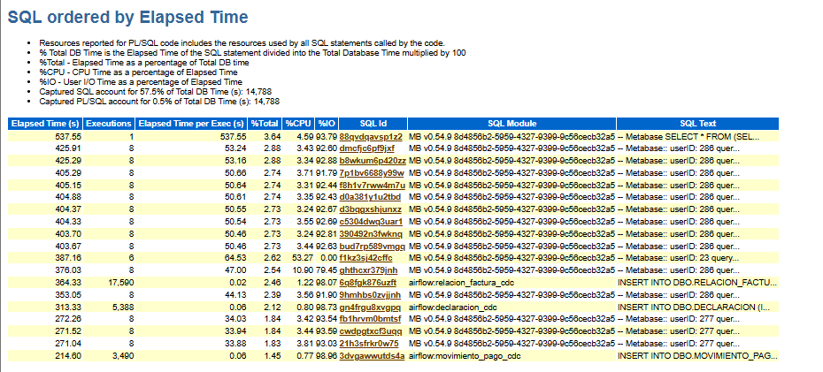

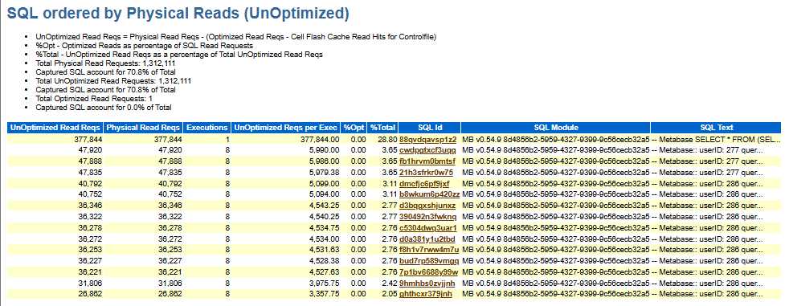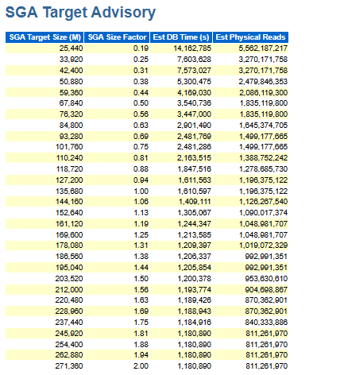
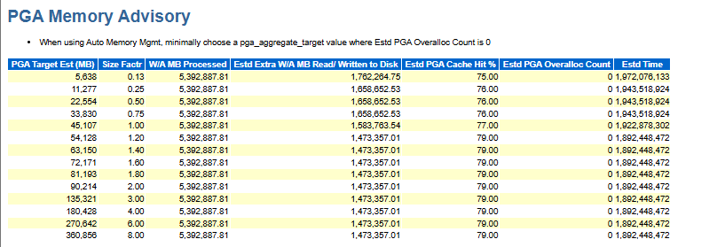
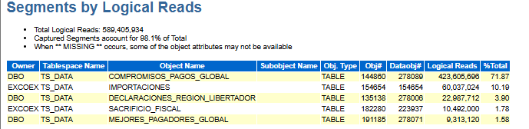
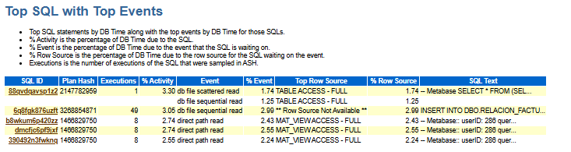
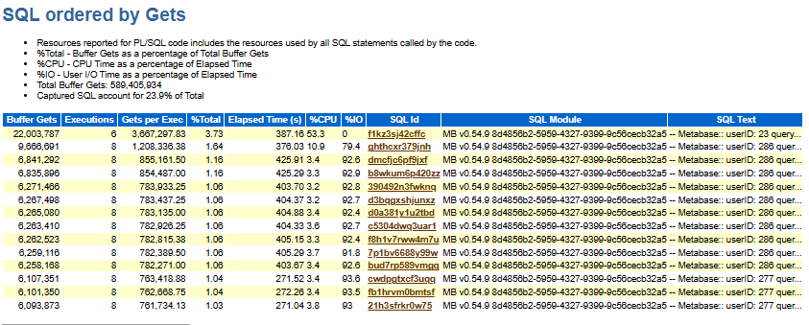

b8wkum6p420zz
88qvdqavsp1z2

f1kz3sj42cffc
dmcfjc6pf9jxf

cwdpgtxcf3uqq
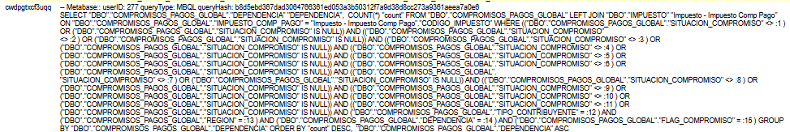
fb1hrvm0bmtsf
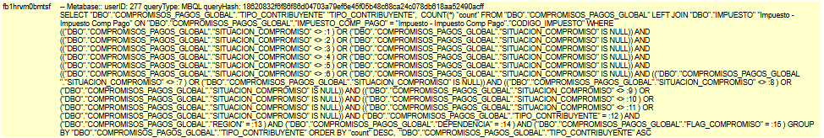
21h3sfrkr0w75
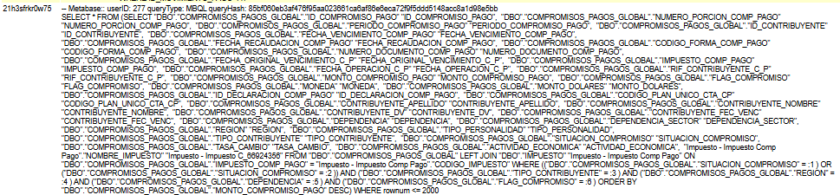

7p1bv6688y99w
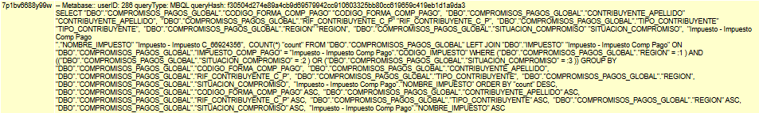
f8h1v7rww4m7u
d0a381y1u2tbd
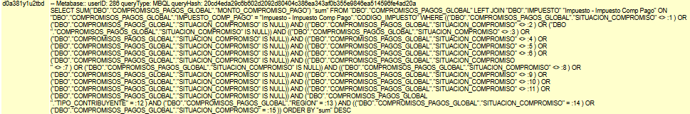
d3bqgxshjunxz
c5304dwq3uar1
390492n3fwknq
bud7rp589vmgq
ghthcxr379jnh
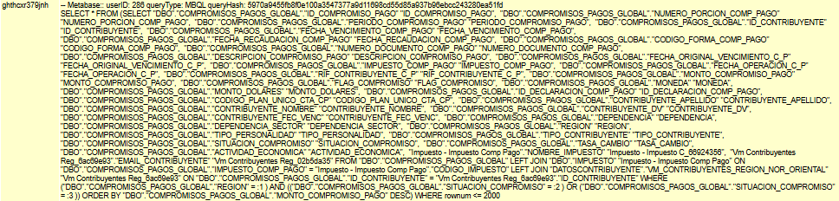
6q8fgk876uzft
gn4frgu8xvgpq
3dvgawwutds4a

