JESS JAMES
23MIS0241
FACULTY:
SLOT:

TASK 1: Jenkins Familiarization Objective: Understand Jenkins UI and basic navigation
Tasks:
1. Open Jenkins Dashboard in browser
2. Identify:
o Dashboard
o Manage Jenkins
o New Item
o Build History
3. Check Jenkins version Expected
Output:
• Screenshot or note of Jenkins version
OUTPUT

1)/2)Opening Jenkins and identifying the Dashboard

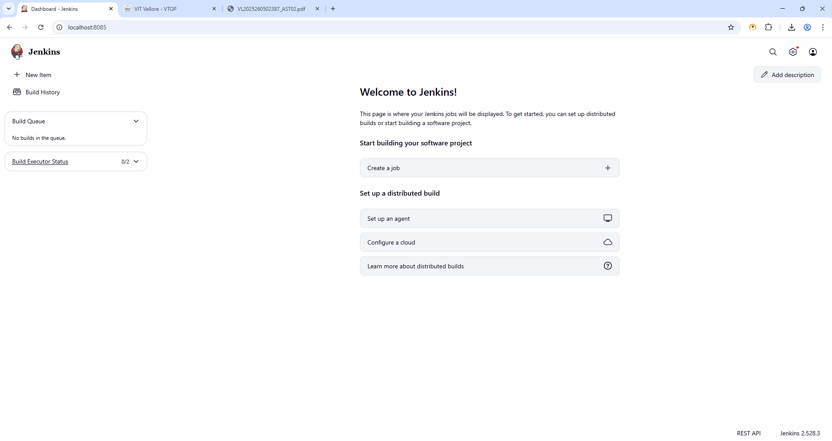
Manage Jenkins
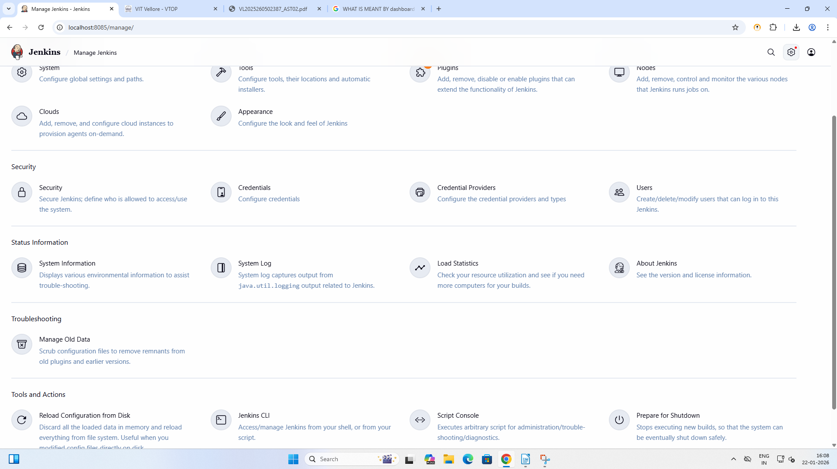

New Items
New Item Created as JESSJAMESITEM1
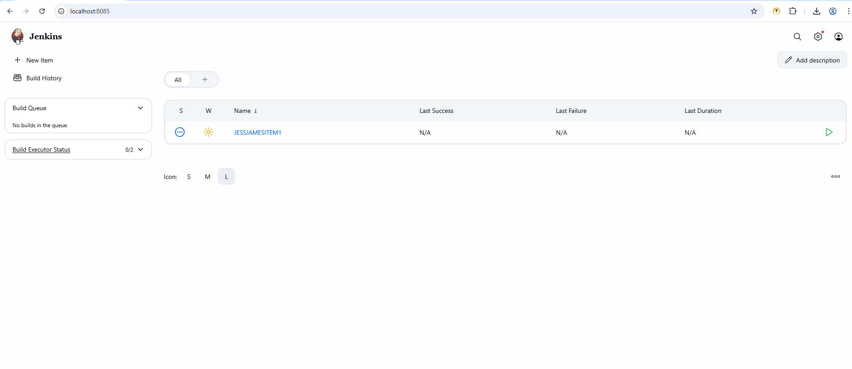
Build History
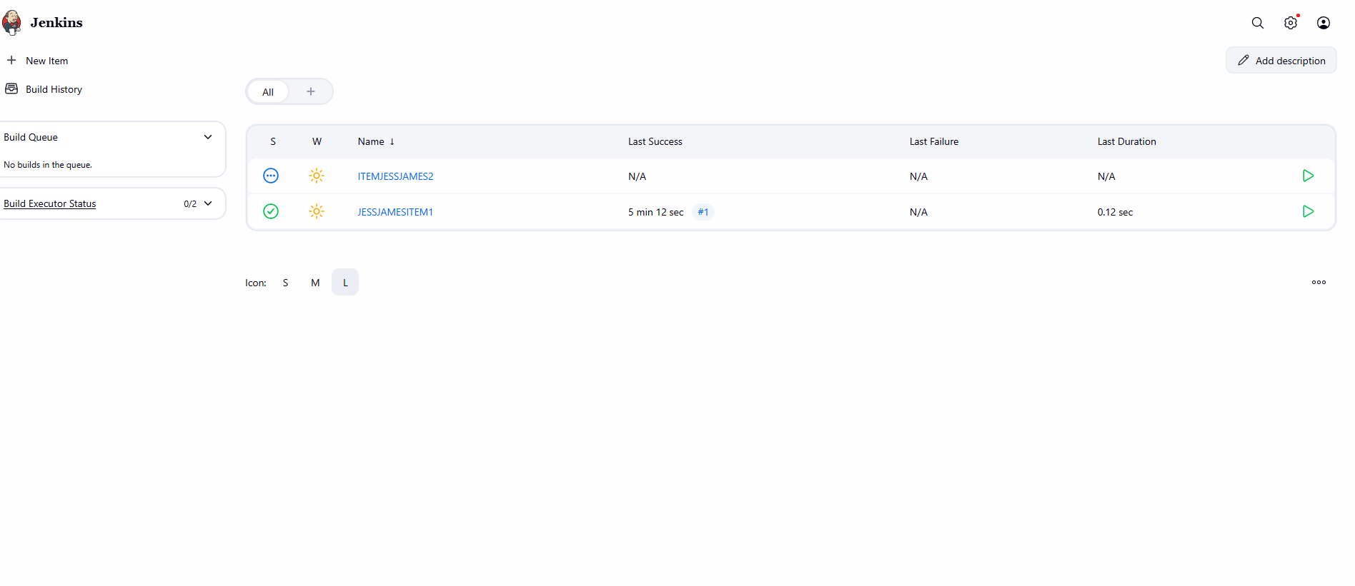
3)VERSION EXPECTED
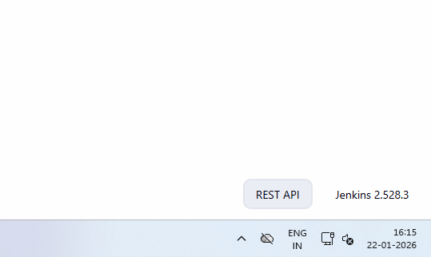
TASK 2:
Create First Freestyle Job Objective: Create and run a Jenkins job
Tasks:
1. Create a Freestyle project named Hello-Jenkins
2. Add a description
3. Add build step: o Execute shell / Windows batch command o Print "Hello Jenkins"
4. Build the job manually
Expected Output: • Console output showing message
OUTPUT
Creating Hello-jenkins as freestyle project
1)
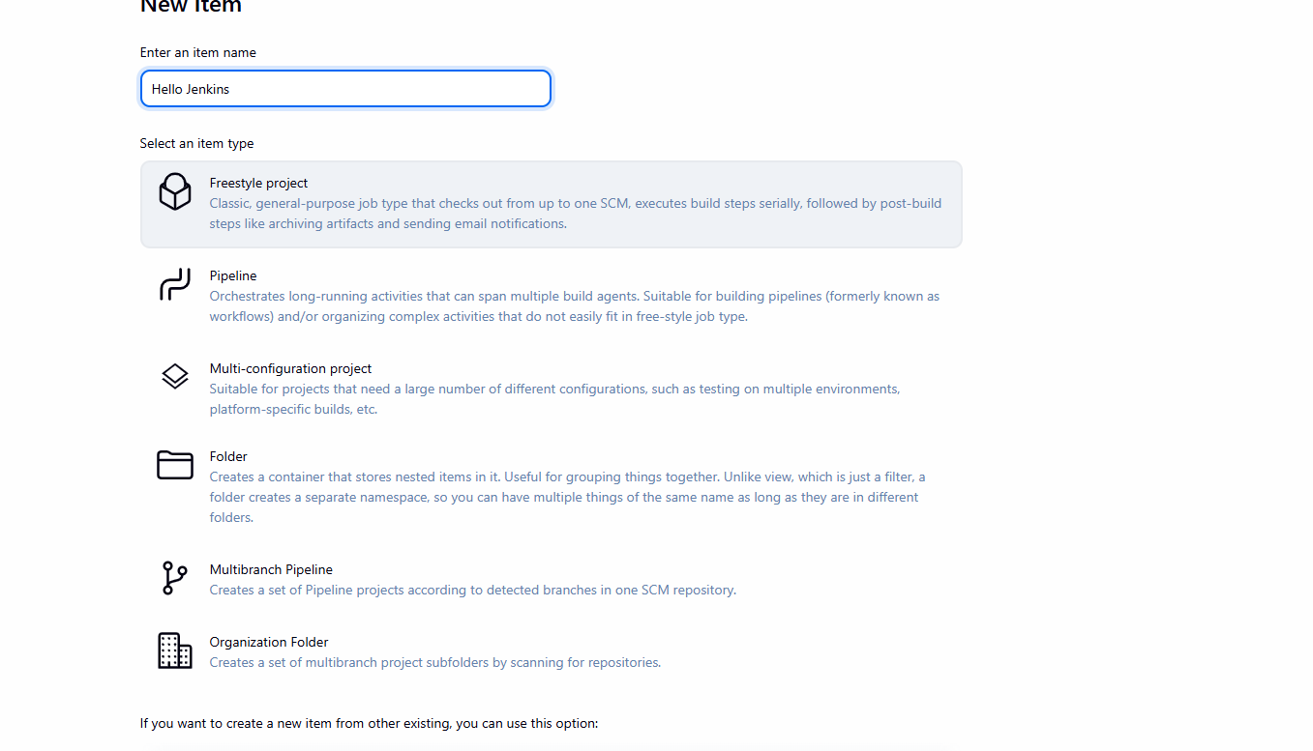
2)STATUS OF CREATED FREE STYLE PROJECT WITH DESCRIPTION
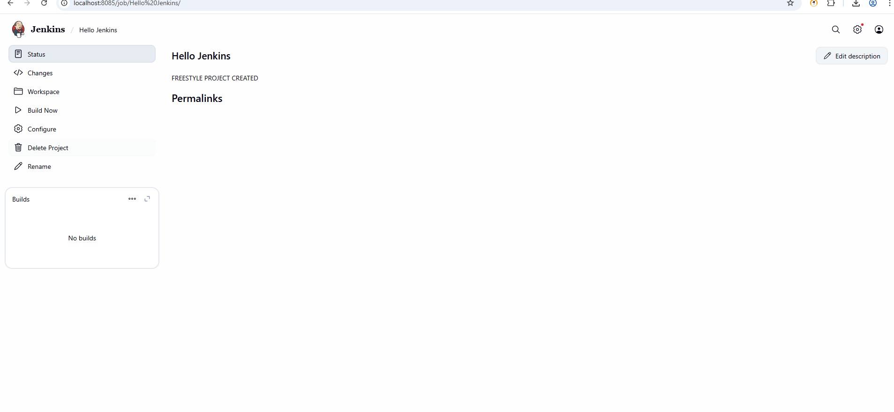
3)Command to build and print hello jenkins by building manually
Used echo “Hello Jenkins”
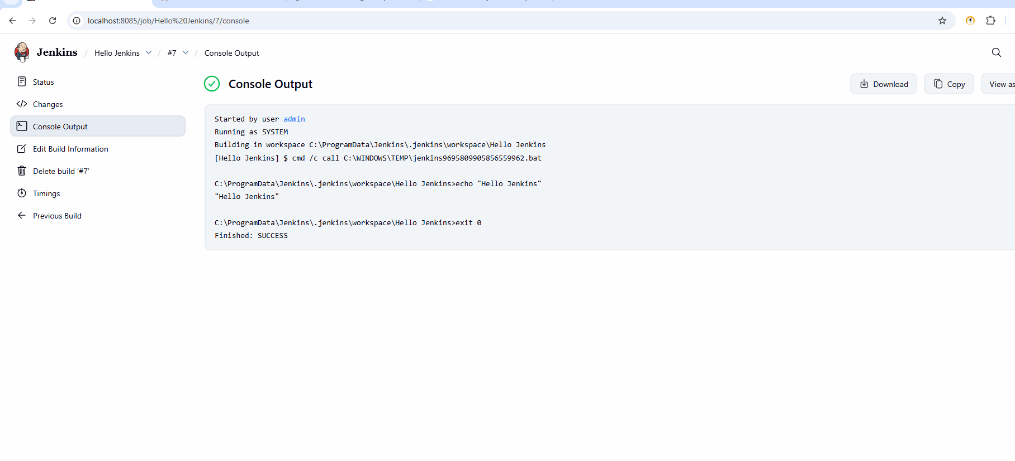
TASK 3:
Jenkins Workspace & Commands Objective: Understand workspace usage
Tasks:
1. Navigate to job workspace
2. Create a text file using build step
3. Display file contents in console
Expected Output: File created inside workspace
OUTPUT
1)navigating to job workspace
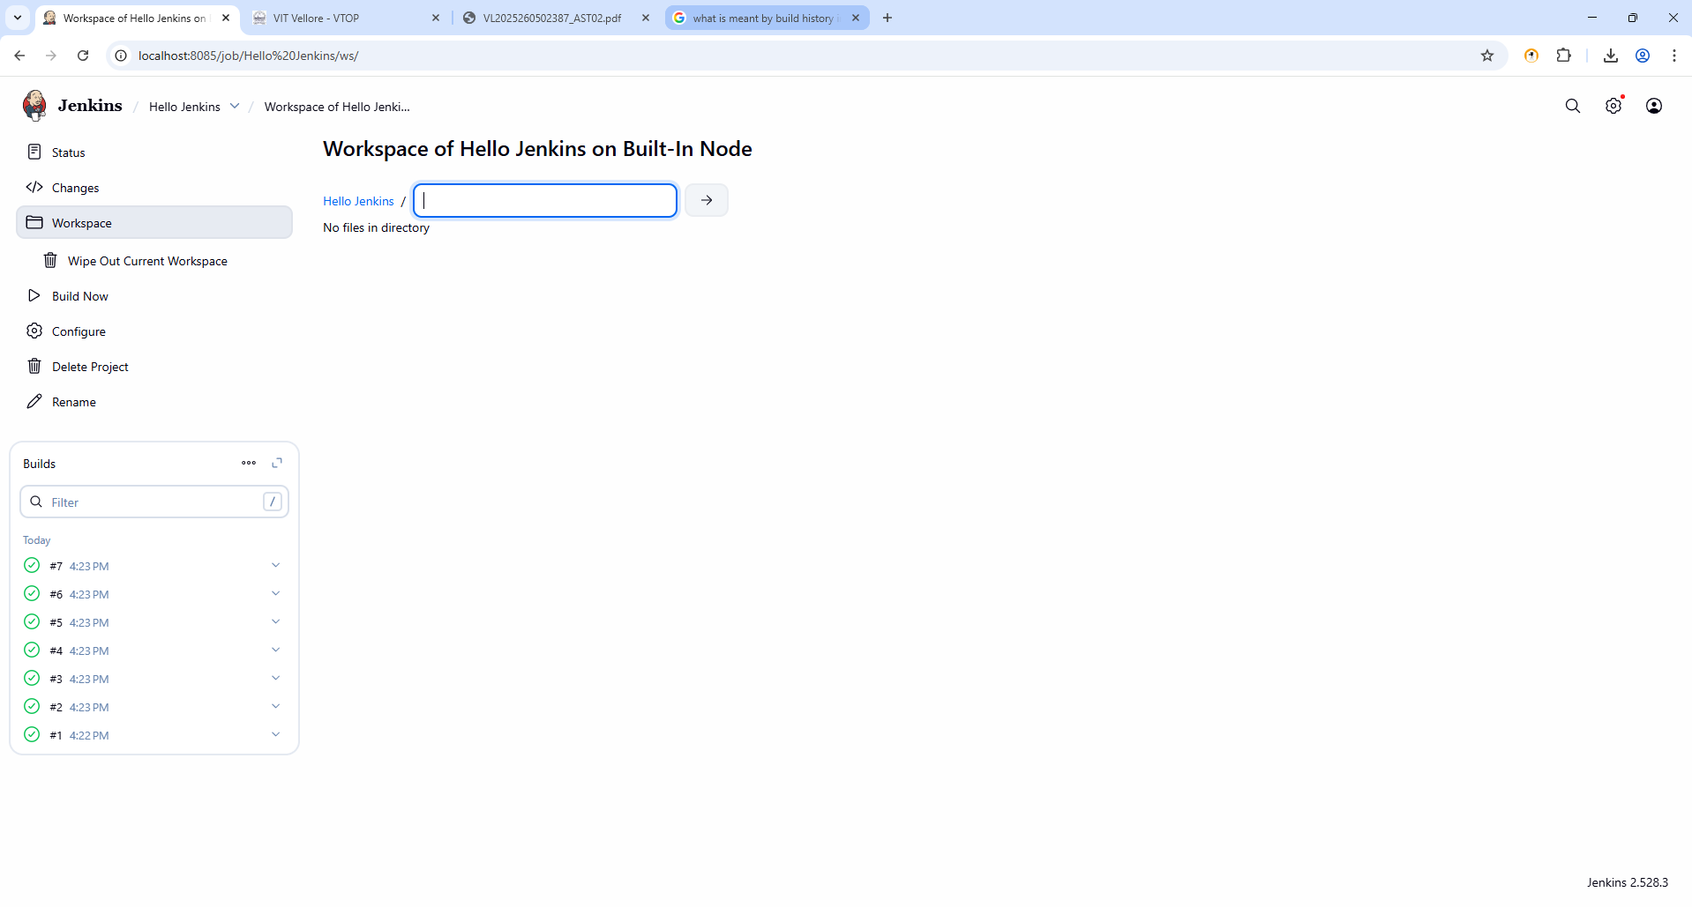
Creating text file using build step
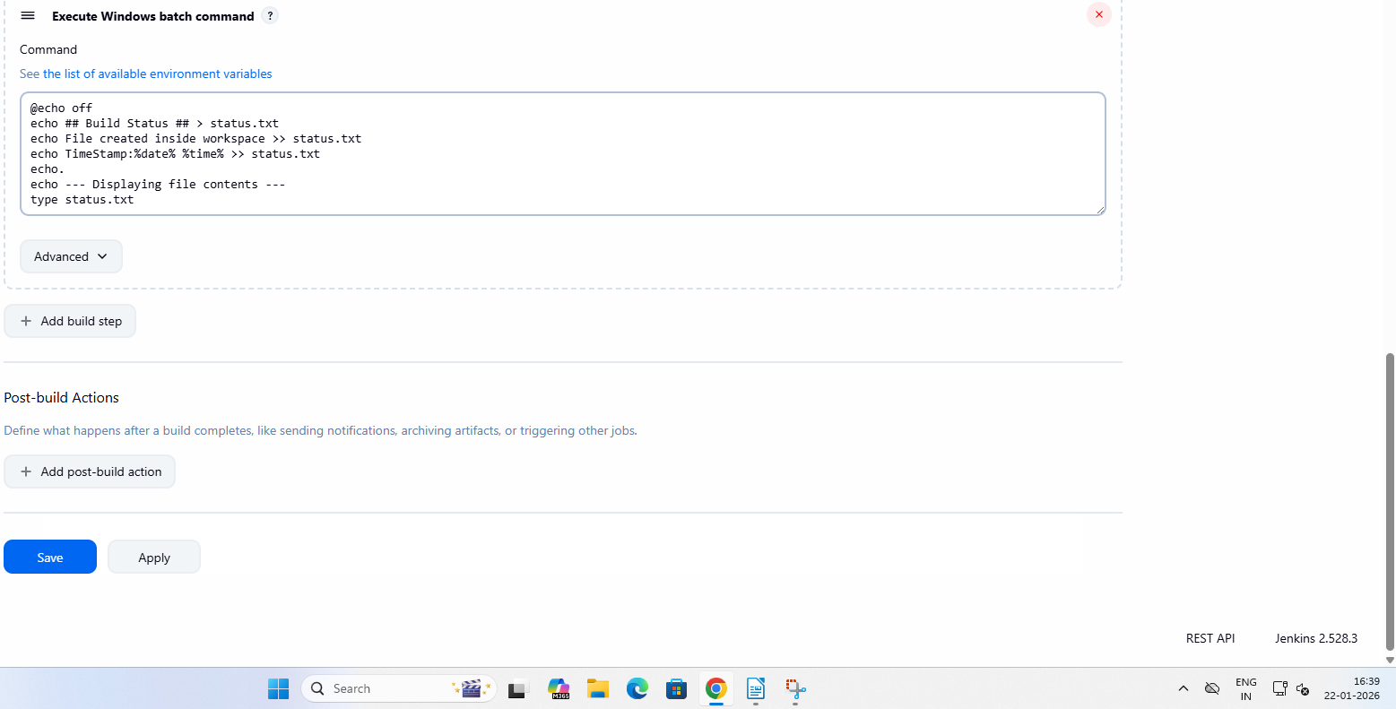

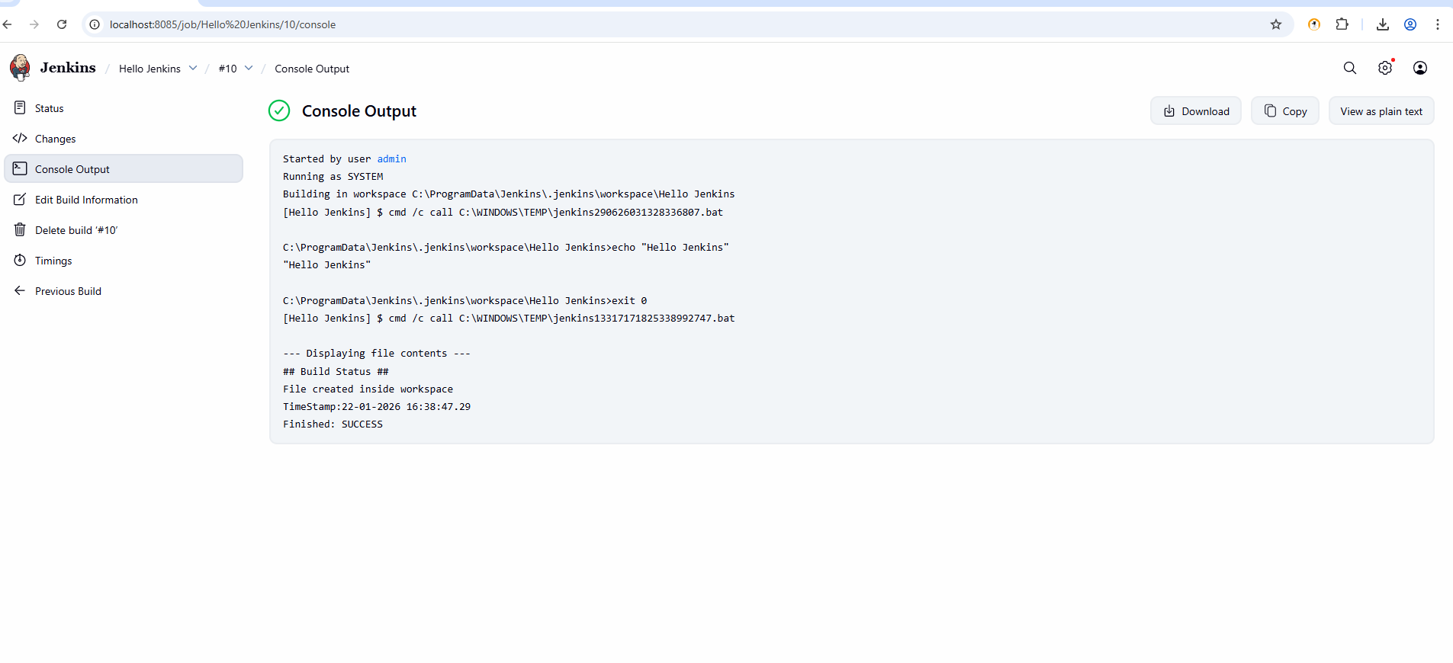
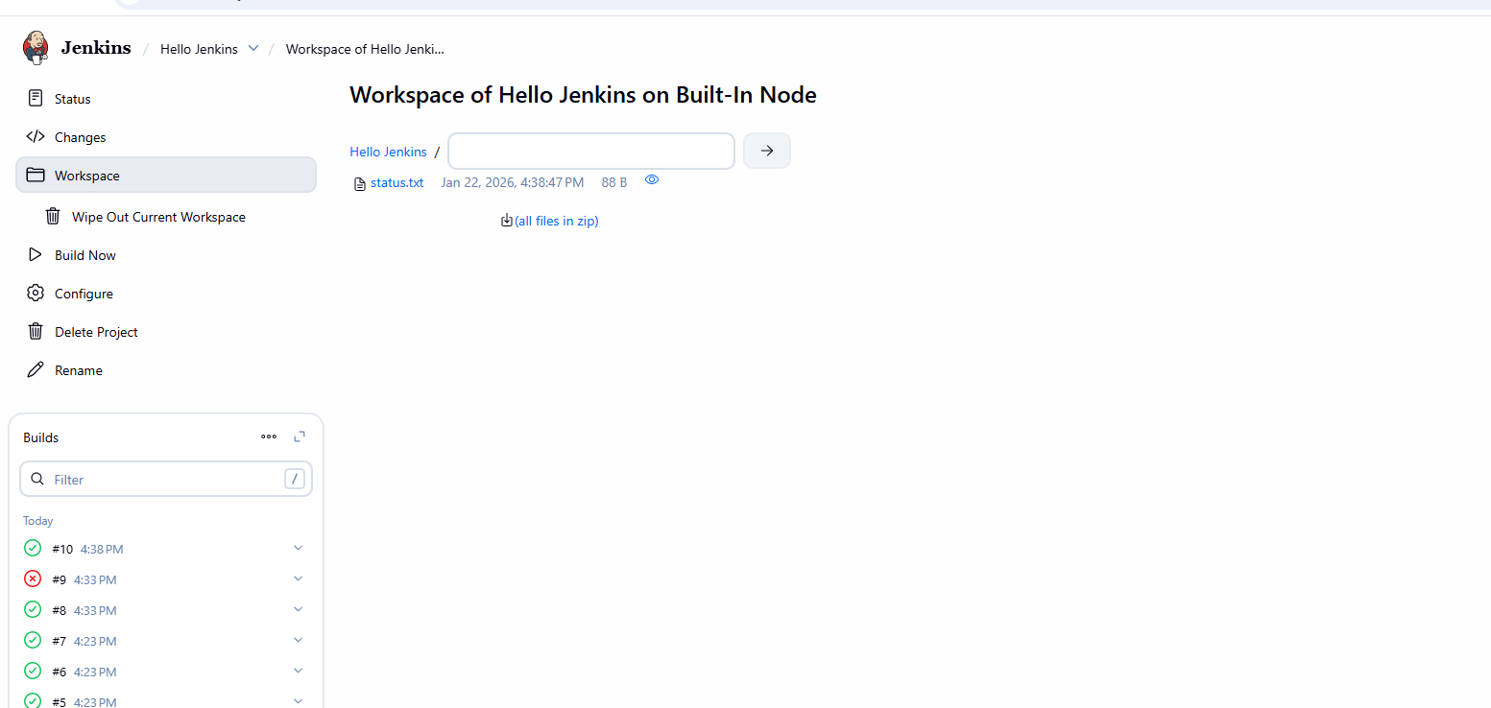
TASK 4: Git Integration Objective: Integrate Jenkins with GitHub
Tasks: 1. Create a GitHub repository with sample code
2. Configure Git in Jenkins
3. Add Git repository URL in job
4. Build and verify code checkout Expected
Output:
• Source code visible in workspace
Output
