UI/UX Assignment-01
Jess James
23MIS0241
Github Upload
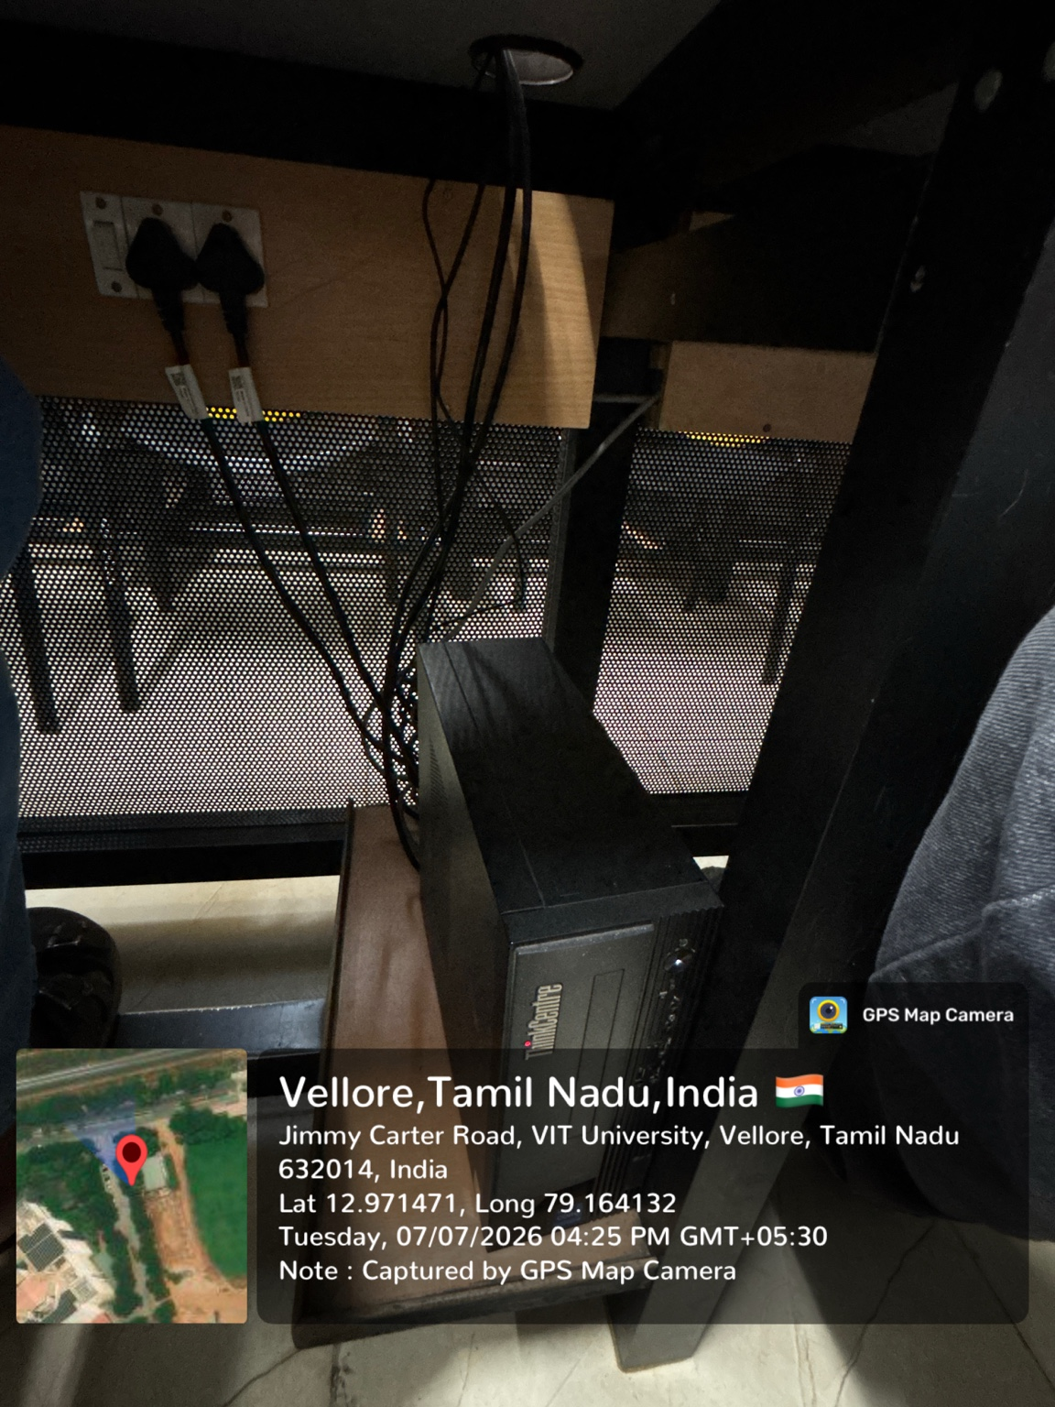
Identified Problems
The issue of the wires arranged are random and cause of losse connection
Solution
We can place a proper channel and insulation for all the wires together so that no wires touches the student in case of any insulation issue of the wire due to bending this also allows the student to sit comfortably
In all a single big tube can be placed so that all wires can be put into it.
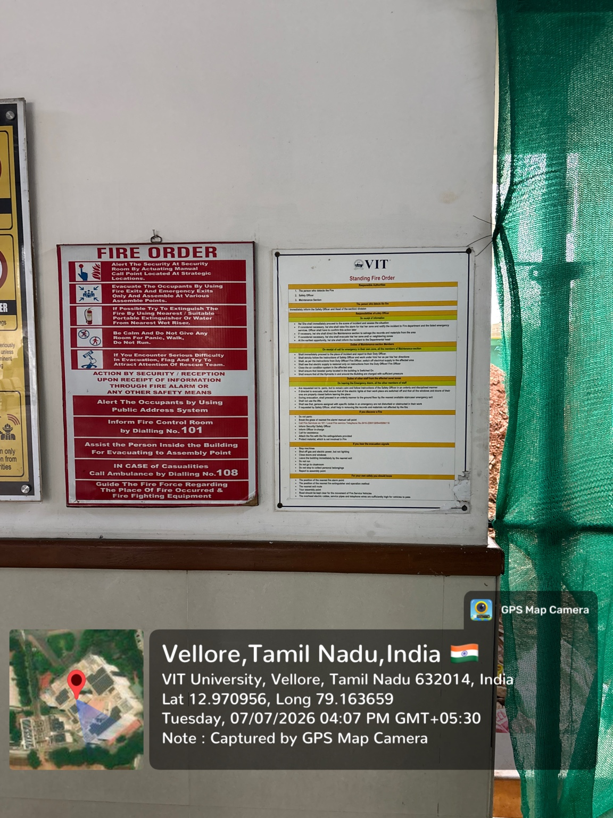

Identified Issue:
The writings are tool small to read in case of an emergency situation and is placed inside the block.
Solution
Better to keep the letters big enough and place it outside the entrance where the people entering the building can read it once they enter and other fire order alerts be placed inside
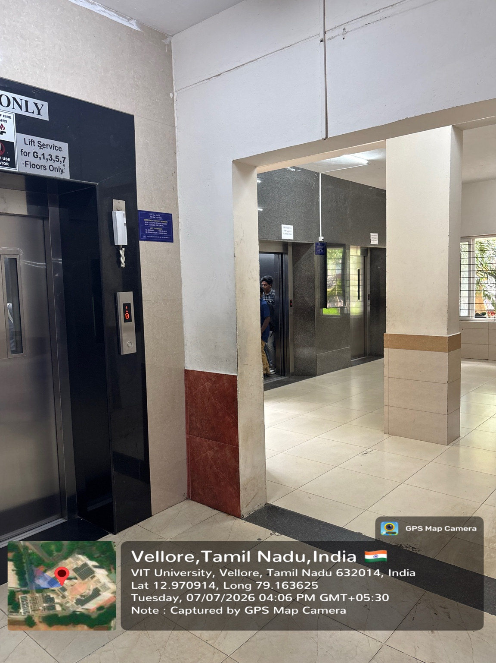
Identified Issue
The Lift for the faculty,students and the shop is placed some close that it can cause crowd in the rush hours.
Also the separator can be placed for going out and in near the lift so it can be easier for people to get in and get out
Solutions
The shop and the 3 set of lifts should be placed in seprate areas to control the crowd as it can be easy for students to reach the lifts.

