JESS JAMES
23MIS0241

CASE STUDY 1
Use appropriate Git Commands to Execute the following case studies in VS Code Case Study 1: New Project Version Control Setup Scenario: You are assigned to develop a Library Management System. Before coding, your team decides to enable version control. Tasks: - Create a project folder and open it in VS Code - Initialize a Git repository - Create a Python file and track it using Git - Commit the initial version
ans)
File created as Jess in desktop
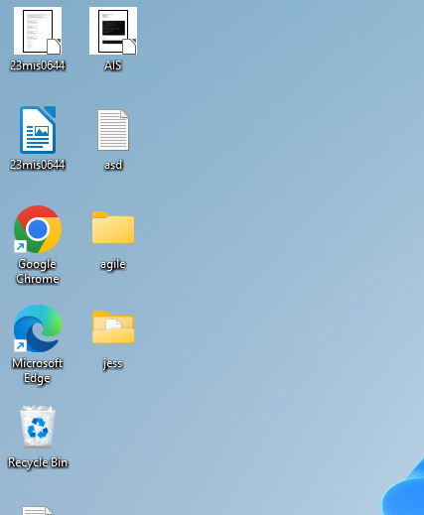

FINAL ANSWER

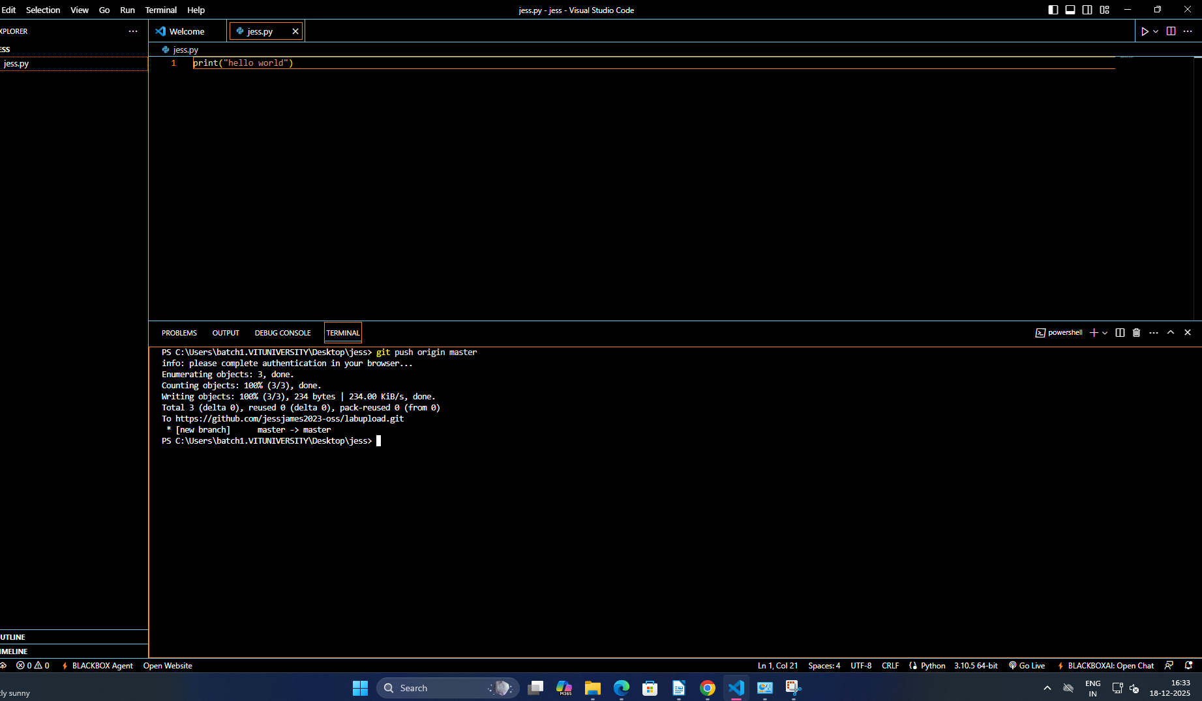

Case Study 2: Tracking Daily Code Changes Scenario: You are working on a Student Registration Module. You make small updates daily and need to record them. Tasks: - Modify an existing file - Check file differences - Stage and commit changes - View commit history
ans)
CREATING THE FILE NAMED jess4.py in github
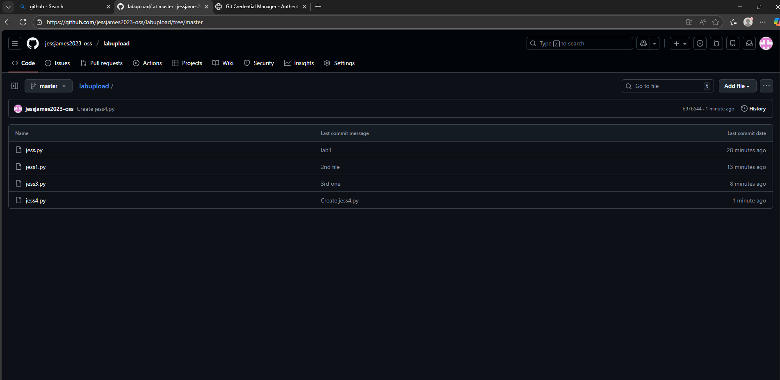

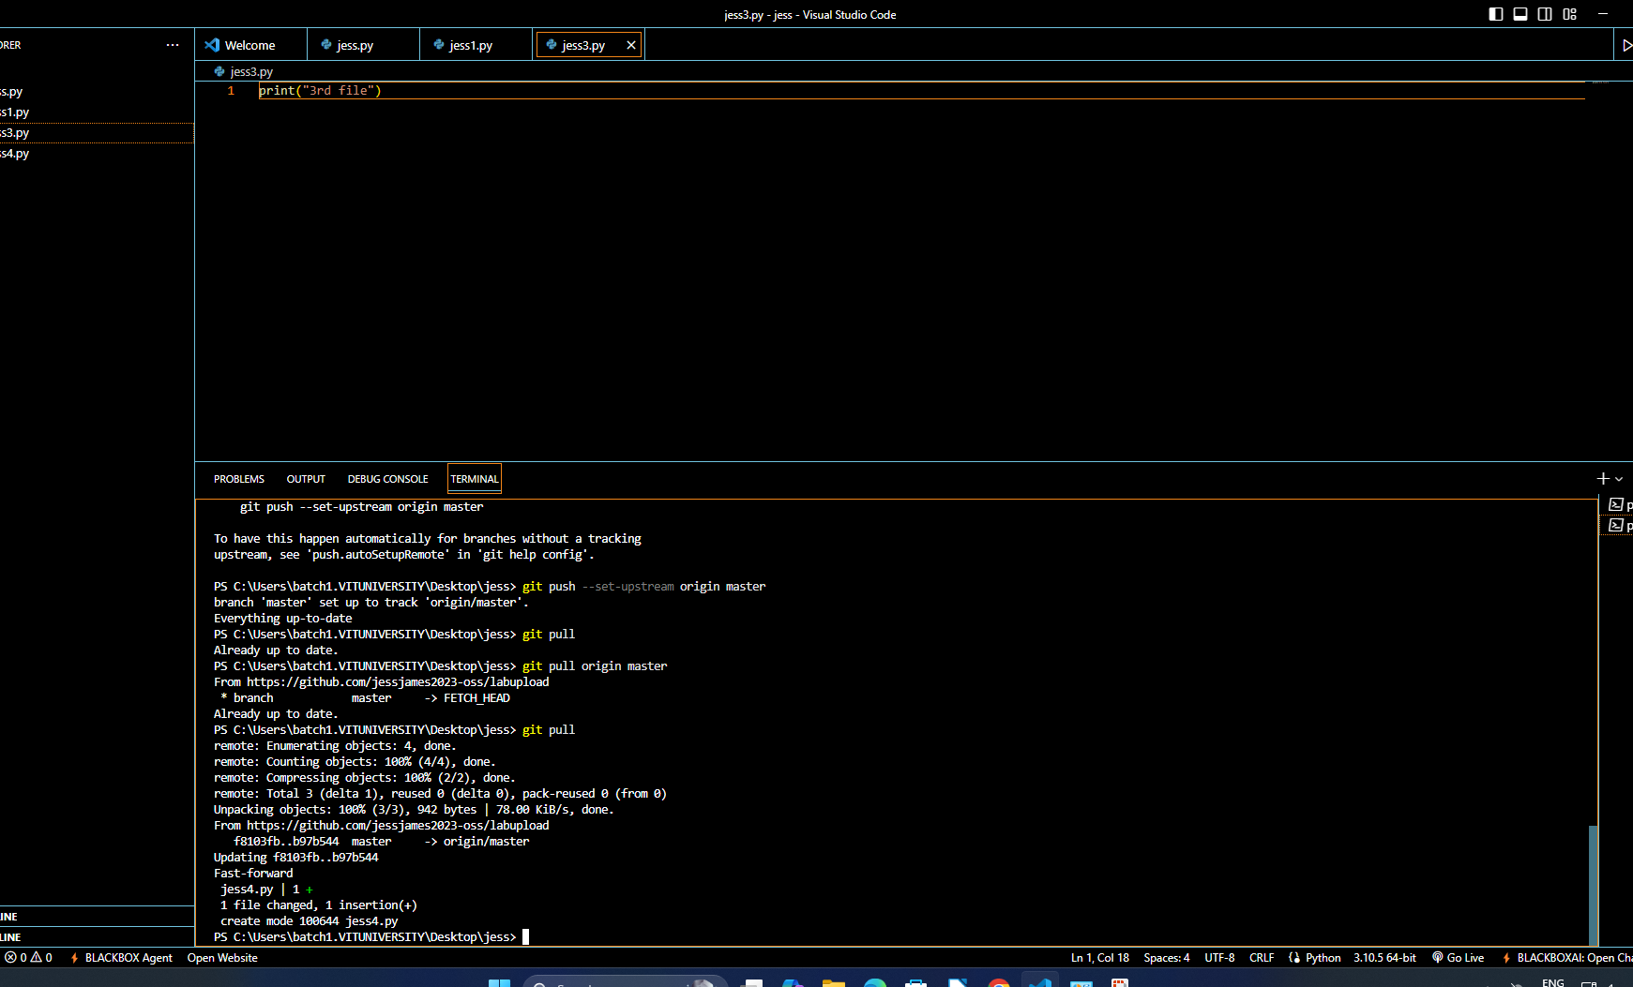
FILE MODIFICATION

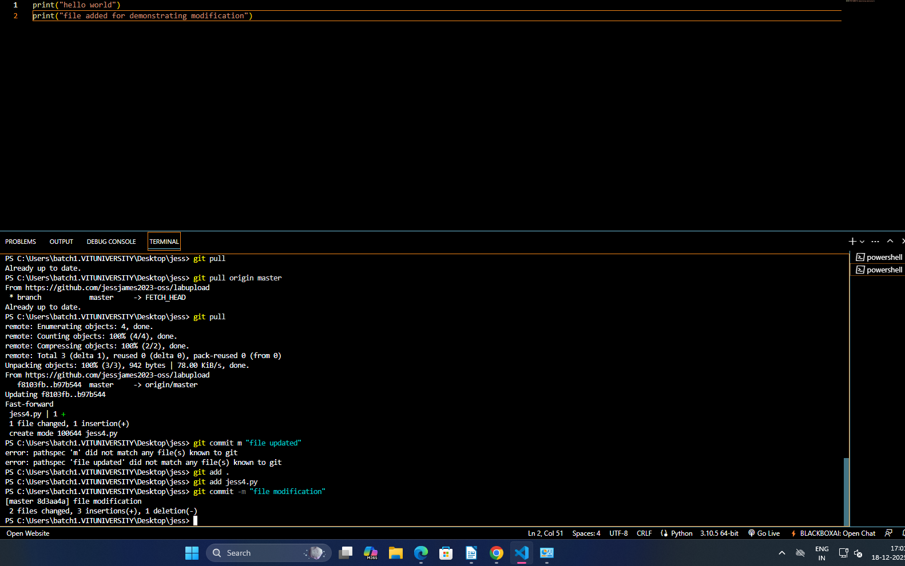
file modified image
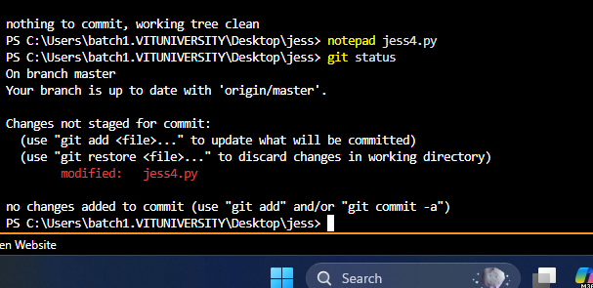

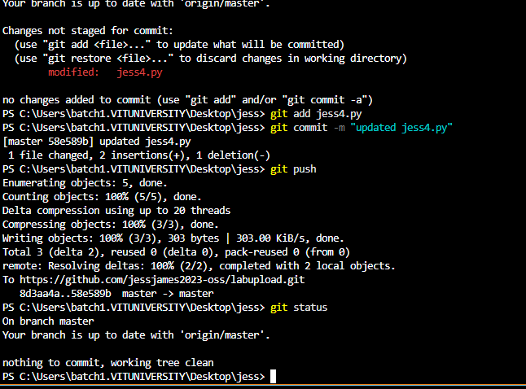

file difference
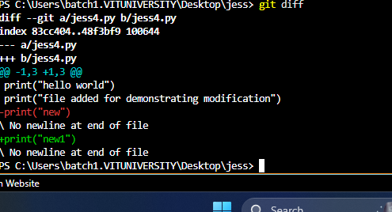

commit history
