JESS JAMES
23MIS0241

CASE STUDY 1
Use appropriate Git Commands to Execute the following case studies in VS Code Case Study 1: New Project Version Control Setup Scenario: You are assigned to develop a Library Management System. Before coding, your team decides to enable version control. Tasks: - Create a project folder and open it in VS Code - Initialize a Git repository - Create a Python file and track it using Git - Commit the initial version
ans)
File created as Jess in desktop
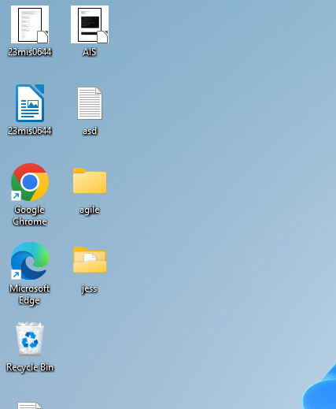

FINAL ANSWER

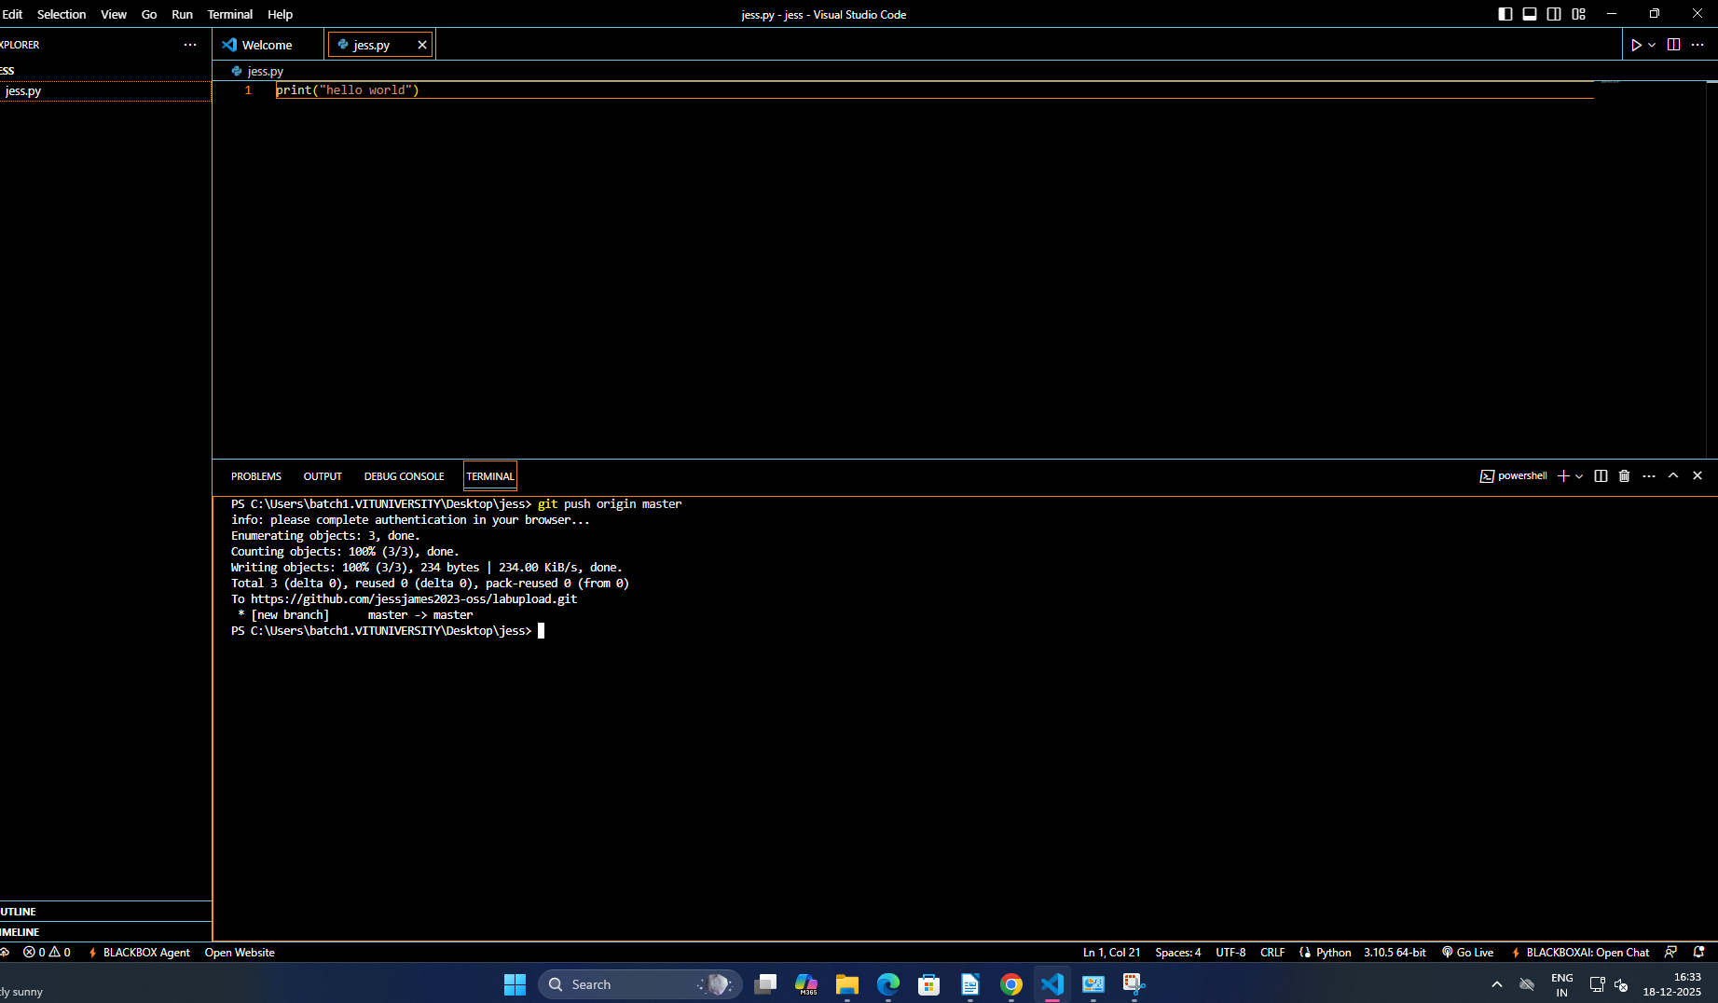

Case Study 2: Tracking Daily Code Changes Scenario: You are working on a Student Registration Module. You make small updates daily and need to record them. Tasks: - Modify an existing file - Check file differences - Stage and commit changes - View commit history
ans)
CREATING THE FILE NAMED jess4.py in github
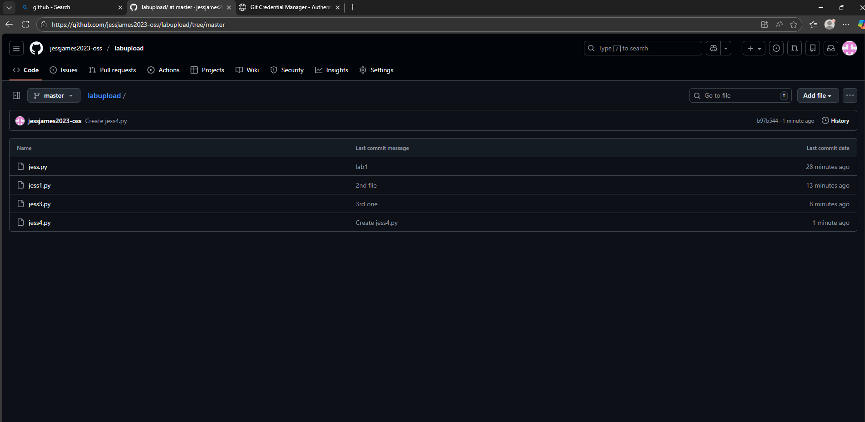

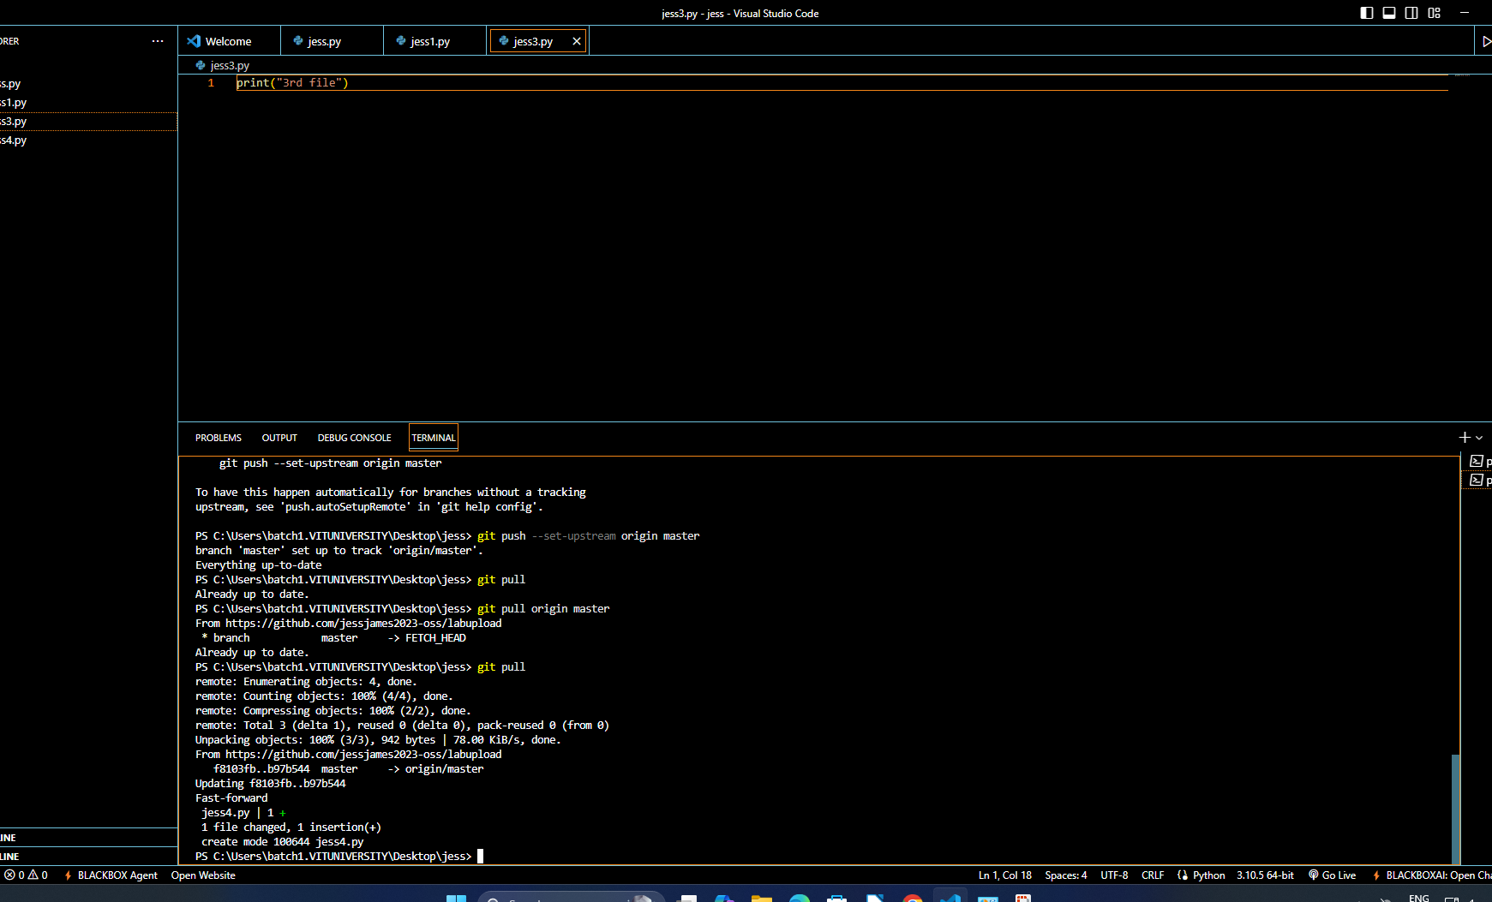
FILE MODIFICATION

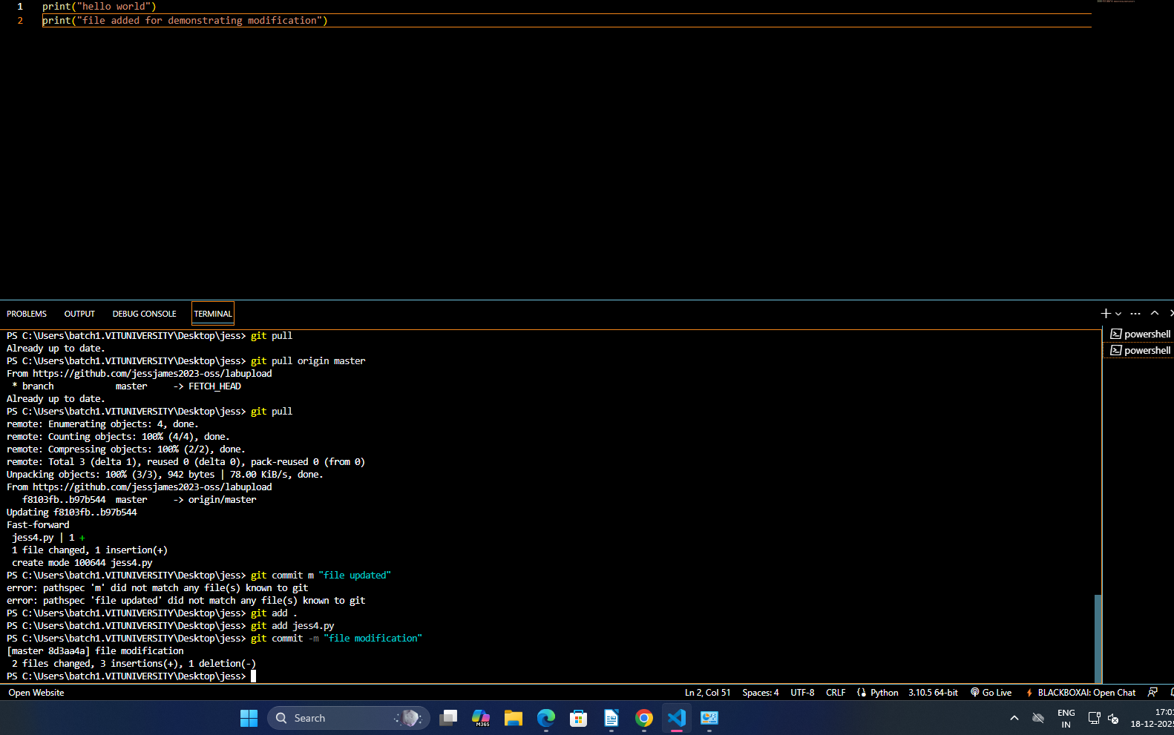
file modified screen shot
Stage and commit chnages
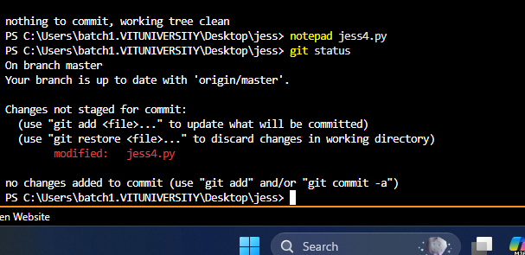

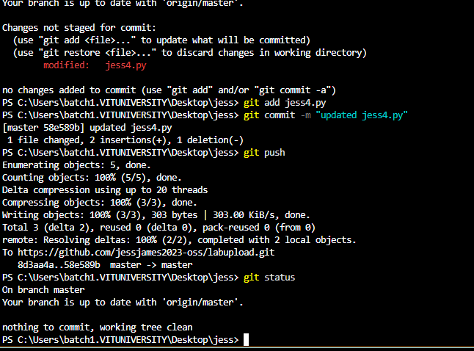

file difference commit history

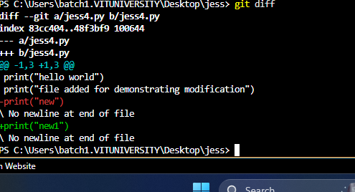
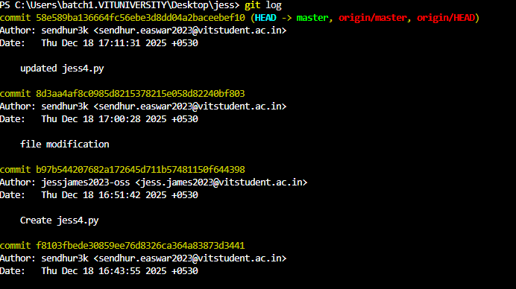
Case Study 3: Feature Development Using Branches Scenario: A new Login feature must be developed without disturbing main code. Tasks: -
Create a new branch -
Add login-related code -
Commit changes -
Switch between branches

CREATING A NEW BRANCH
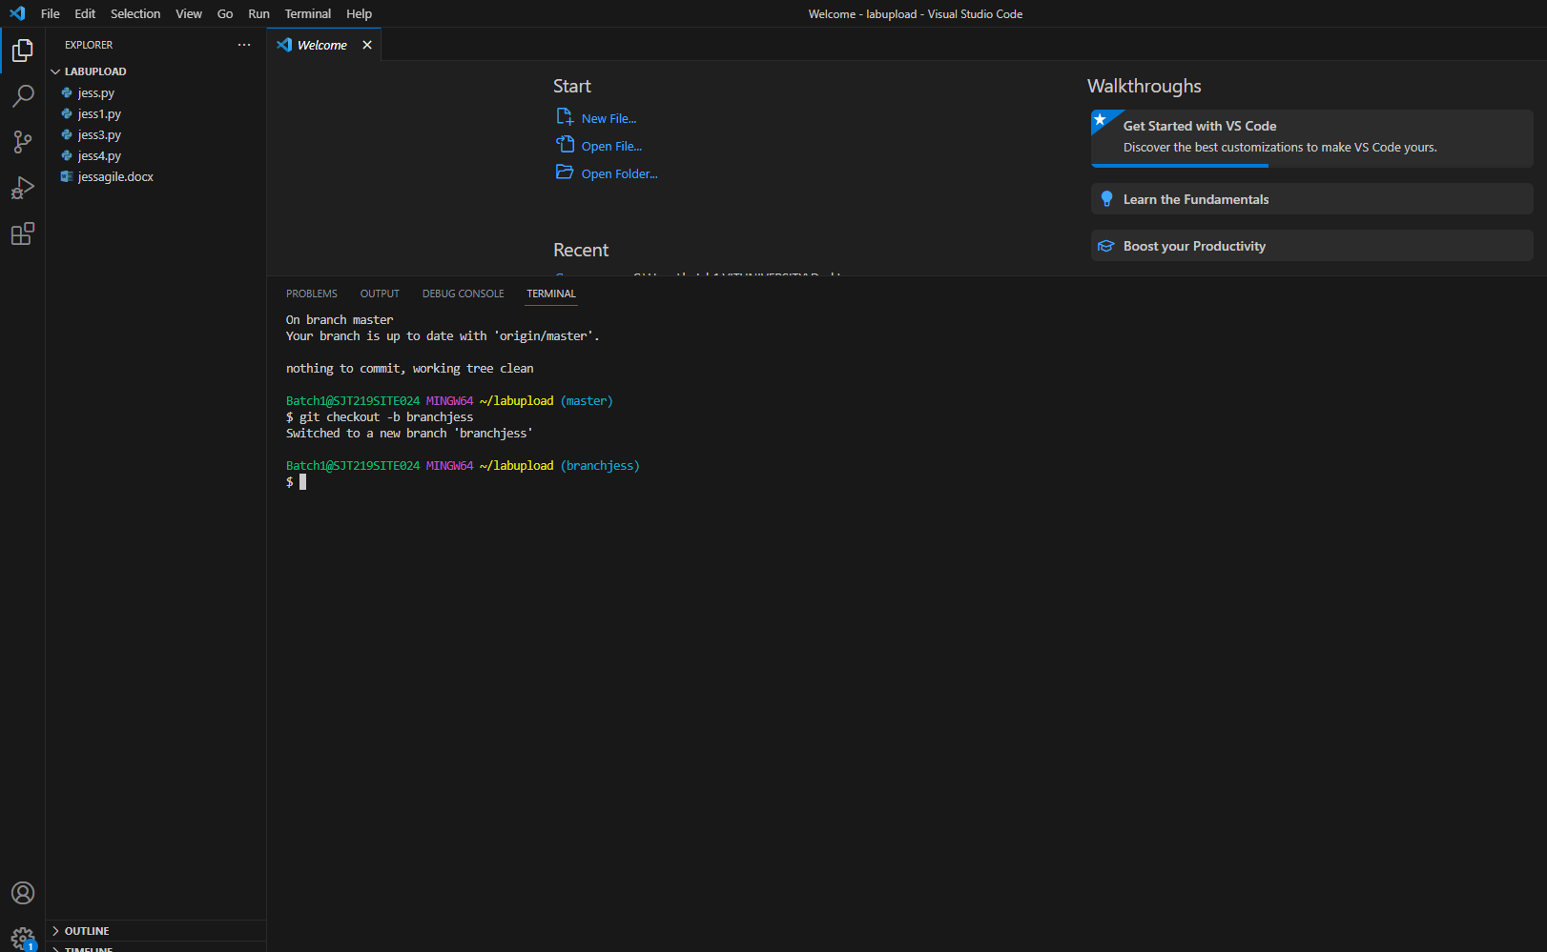

ADDING A LOGIN RELATED CODE

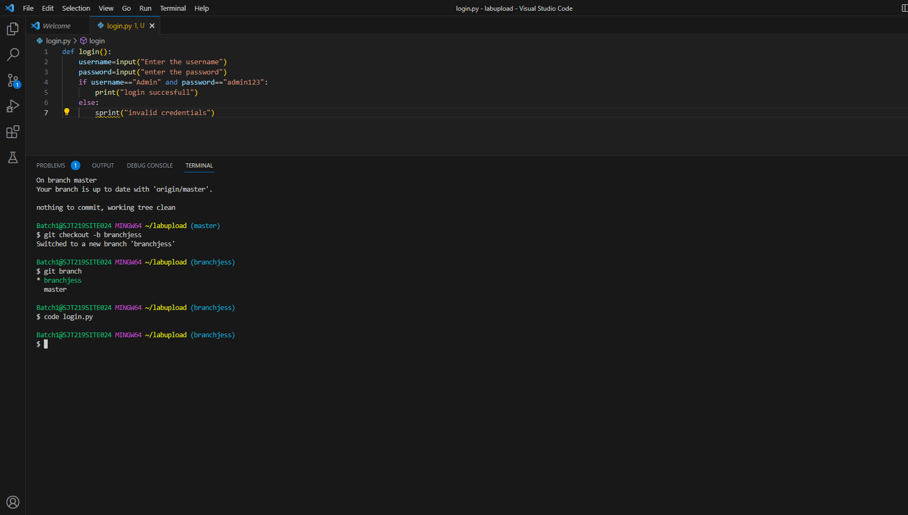

COMMITING CHANGES
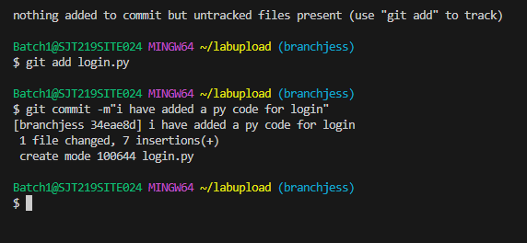

SWITCHING THE BRANCH

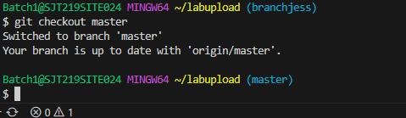
\

Case Study 4: Merging Feature into Main Code Scenario: The login feature is tested and approved. Tasks: -
Switch to main branch -
Merge feature branch -
Verify merged content
MAIN BRANCH
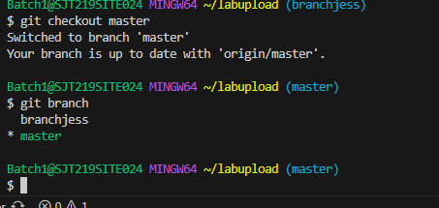

MERGE FEATURE BRANCH
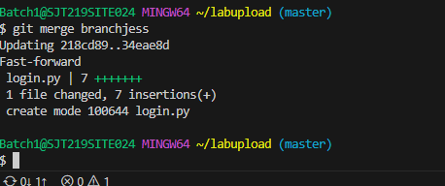
VERIFY MERGED CONTENTS
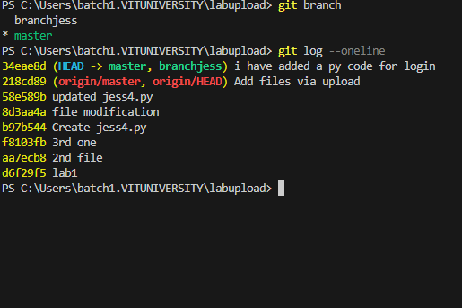

Case Study 5: Working with Remote Repository Scenario: The project must be shared using GitHub. Tasks: -
Create remote repository -
Add remote origin -
Push code to GitHub
CREATE REMOTE REPOSITORY

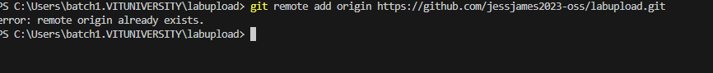
..
ADD REMOTE ORIGIN
PUSHING CODE TO GITHUB

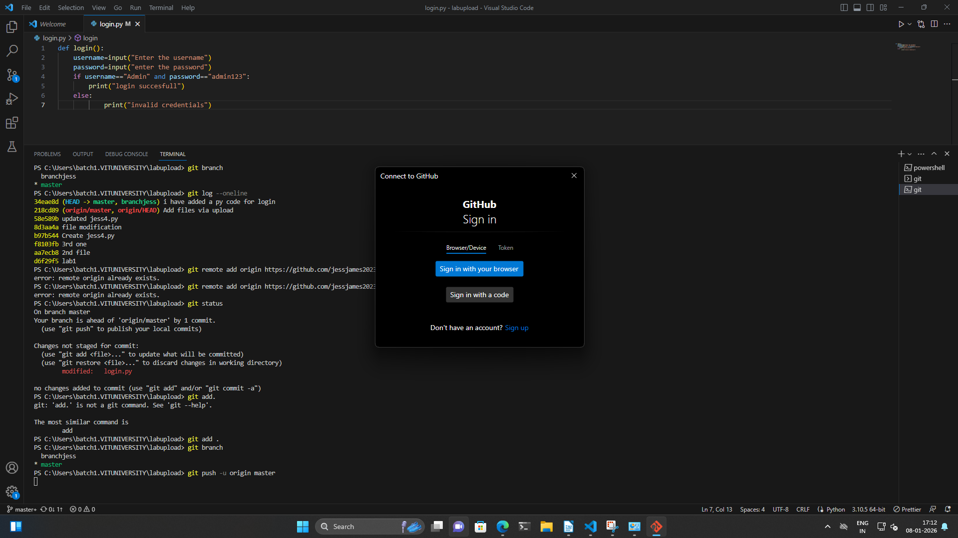
.

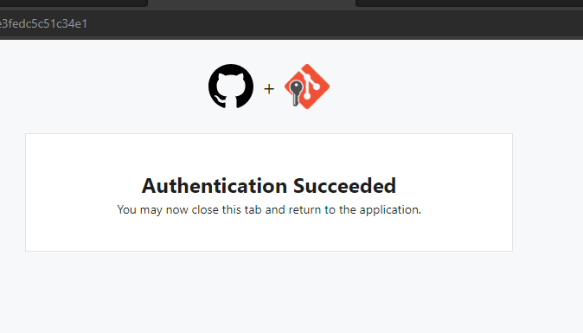
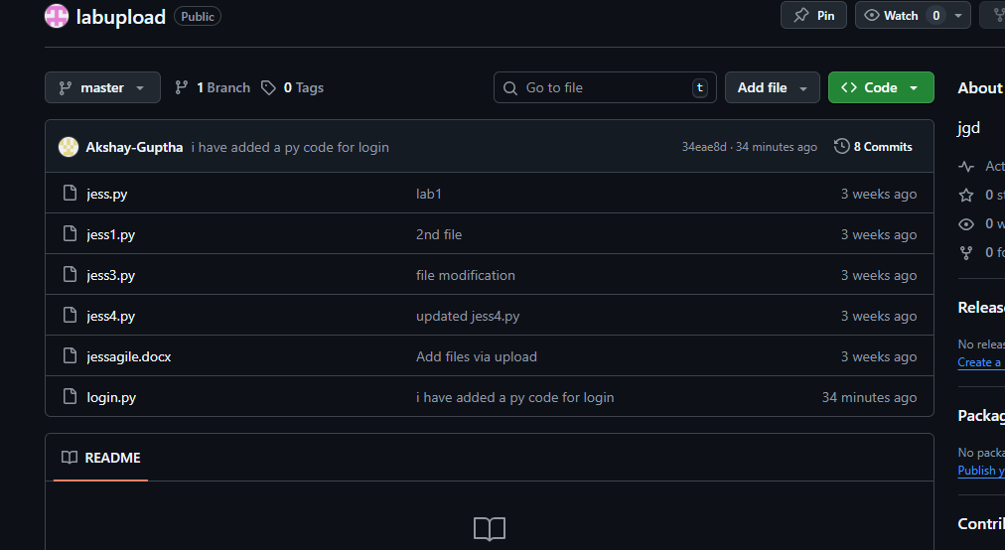
Case Study 6: Undoing Mistakes Scenario: A file is modified incorrectly.
Tasks:
- View file changes
- Discard uncommitted changes
FILE CHANGES

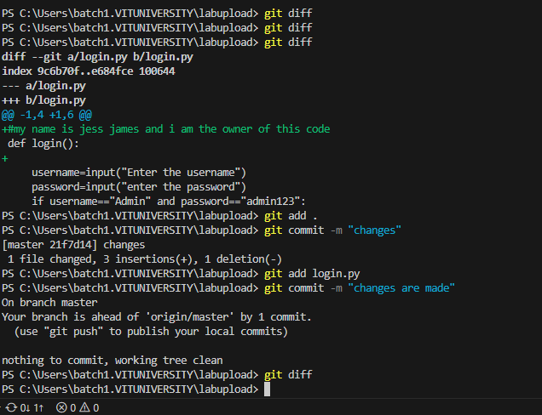
.
DISCARDING UNCOMMITTED CHANGES
