# TROUBLESHOOTER: MANAGING RESERVATIONS

# Sales Orders and reservations

You may find you have part(s) on your sales order and **stock in your warehouse** but when you press Express picking journal, **no picking journal is created, or a picking journal for less than the full quantity is created.** This is because a reservation has not happened.

*…See Creating a reservation.*

You may find you have a part on your sales order and *no* stock in your warehouse, but when you go to the **backorder review screen the part does not appear**. This may be because a reservation has happened against a transaction with Receipt status ‘Ordered’.

*…See Removing a reservation.*

## Creating a reservation

When processing a sales order in some circumstances **you may not get a Picking Journal for the whole quantity**, even though you have stock available. In this case you will need to create a Reservation.

Reservations only happen if the stock exists at the time the item was added to the sales order, so if stock is transferred to your warehouse after the sales order was created no reservation will exist and you will not be able to produce a picking journal.

There are two solutions to this.

1. Remove the item from the line and add it again. The reservation will be created, and your picking journal will be produced.

OR

1. If pricing has been adjusted previously or for any reason you don’t want to remove the line, add the reservation manually by going to Sales order lines > Inventory > Reservation

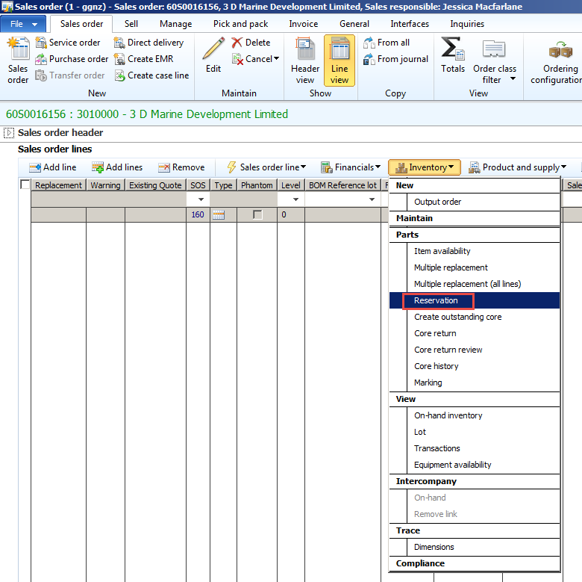

In the Reservation form that opens find your warehouse in the list and look for the row showing a quantity in the ‘Available physical’ field, type the quantity required into the Reservation column that matches the quantity you entered on the sales order line.

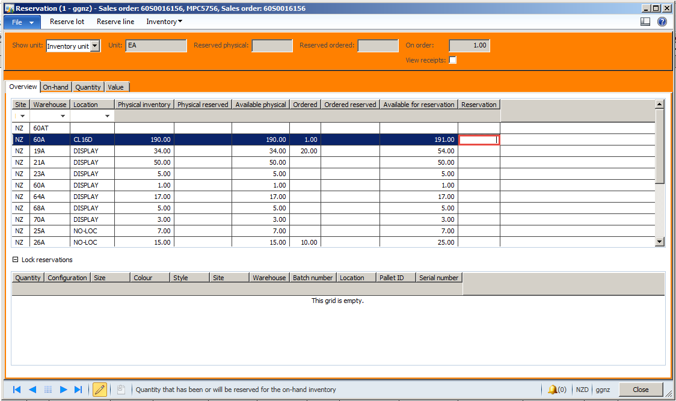

See below with the reservation added. Now you can create your picking journal in the usual way.

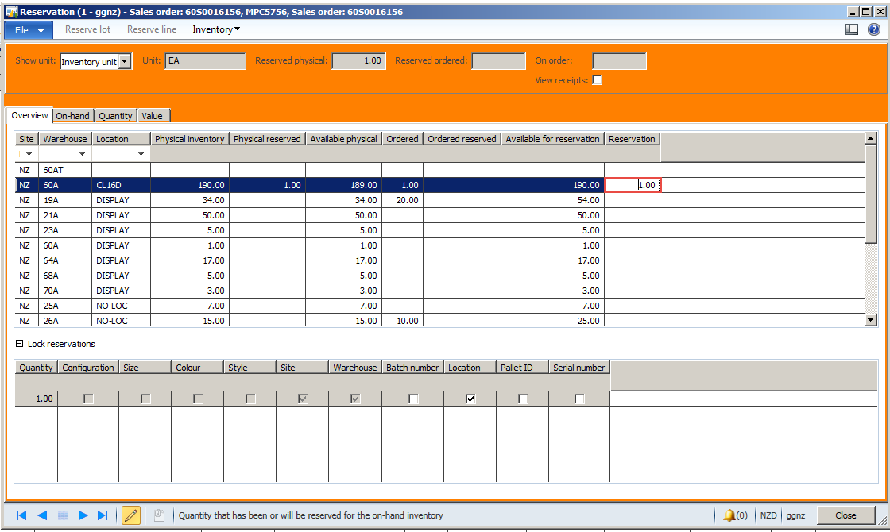

## Removing a reservation

As a general rule you should not be removing reservations. However, if your part happens to be on an existing purchase order or transfer order for stock that is coming to your warehouse and not due to arrive in time to meet the customer’s needs, you may need to review the reservations and remove them to be able to raise an emergency purchase order.

Alternatively, a part may be required for a very important customer in which case you might like to check with other sales order creators to see if you can reserve physical stock already in your warehouse instead of them.

If your part is ‘Reserved ordered’ it will mean **the part won’t appear in the backorder review screen**. To be able to backorder the item, you will have to remove the reservation.

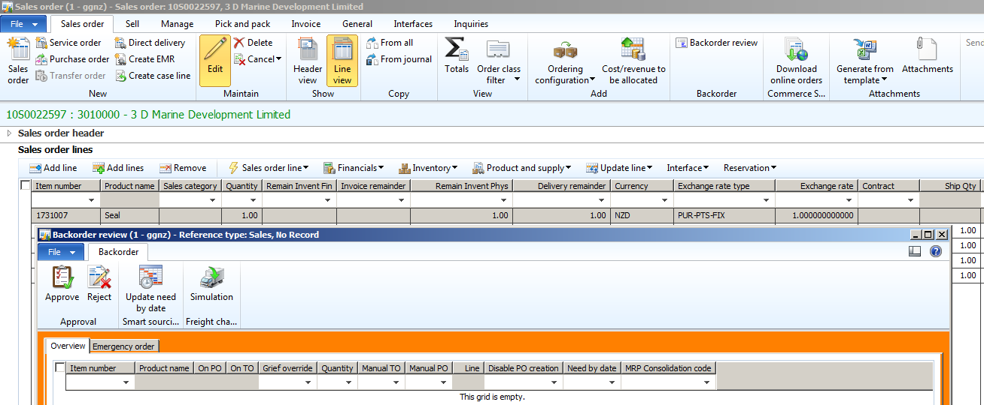

First check these two things:

On-hand screen shows there are none on hand at the sales order warehouse.

Go to Sales order lines > Inventory > On-hand.

NOTE! Do not trust **Item availability** to find out this information as it will be blank if the physical amount in your warehouse is also fully reserved.

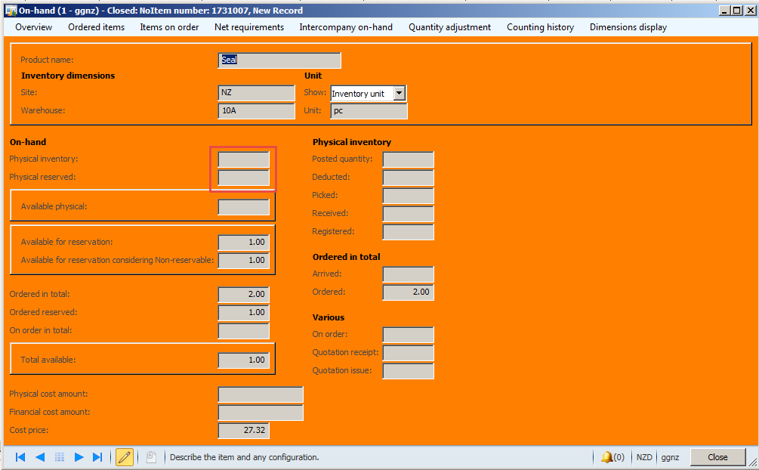

Second, check to see if there is not an emergency purchase order already linked. If you’ve already raised an emergency purchase order, you should not need to remove any reservations.

The most reliable way to check if the sales order line is marked to a purchase order is via the **Purchased Parts Tracking** report. Filter using the sales order number.

* This report is not filtered by order class or warehouse and will show any purchase order raised in NAXT and any linked sales order, arrival journal, landed costing document and delivery note.

<http://chcaxdw1/Reports/Pages/Report.aspx?ItemPath=%2fGough+NAXT+Reports%2fProduct%2fPartTrackingReport>

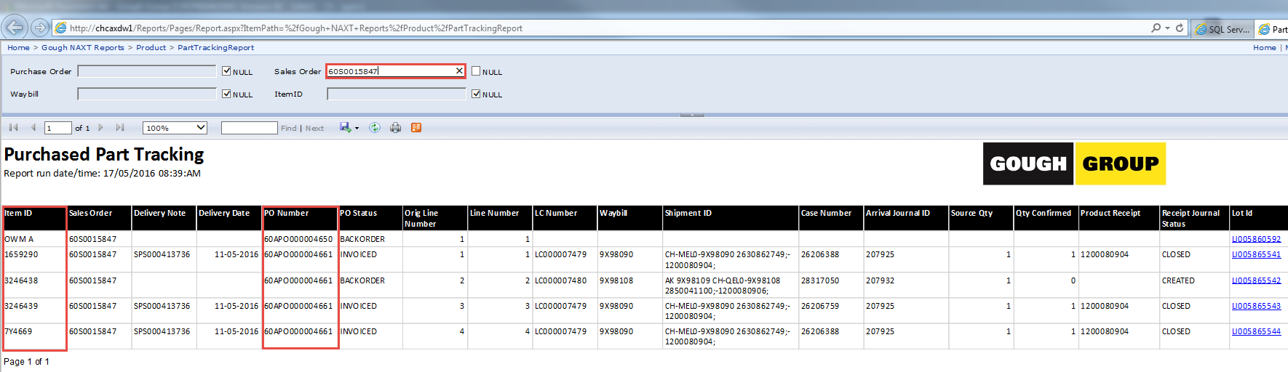

**NOTE:** Even if the PO is linked via marking, the Marking form in NAXT will be blank if an arrival journal has been produced. You can see the linked AJ on the **Purchased Part Tracking** report also.

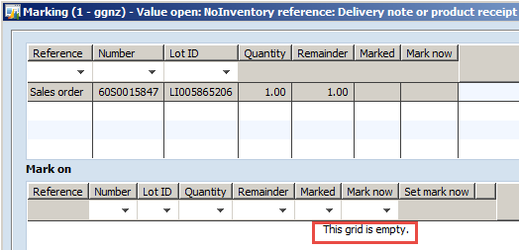

**NOTE:** The Sales order lines > Product tab > reference field usually shows the linked marked transfer order or purchase order but may be blank if only part of the quantity is marked, so will not always be reliable.

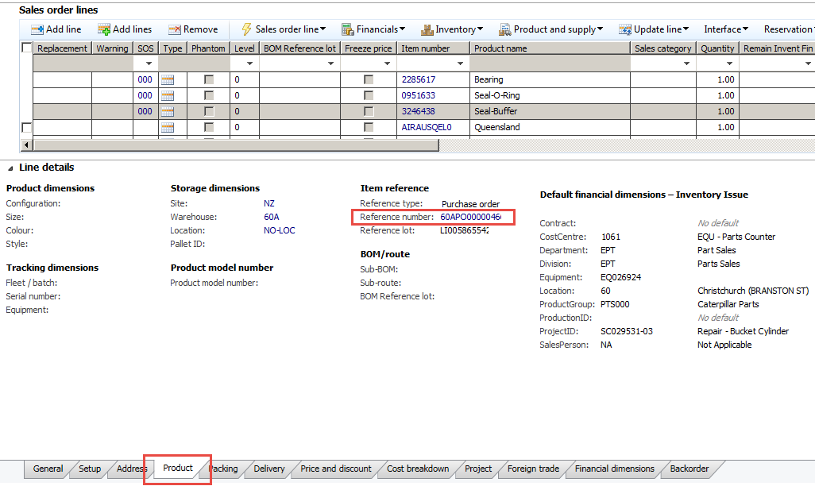

If your sales order line is not linked to a purchase order via marking and nothing appears on the **Purchased Part Tracking** report, read on:

Now review reservations and find the transaction the item has reserved against by going to:

Sales order lines > Inventory > Reservation

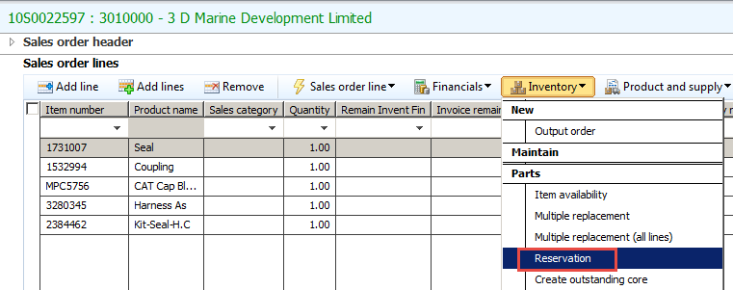

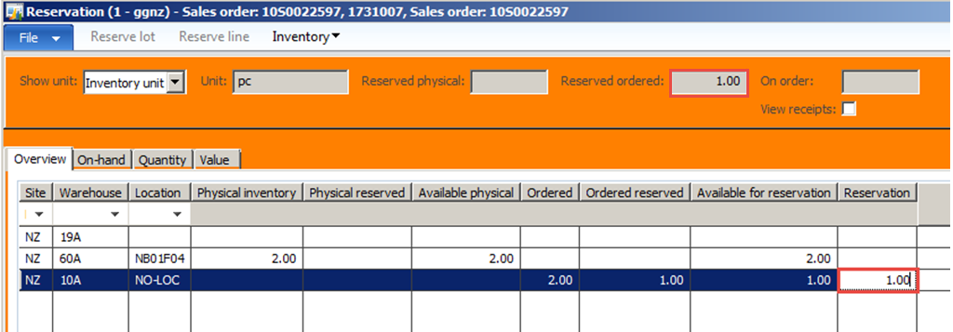

Highlight the row for your warehouse where the reservation quantity appears in the ‘Reservation column on the right. Note the quantity will also appear in one or more of the boxes above to indicate what type of reservation(s) have been made. In this case 1 has been ‘Reserved ordered’.

* If you want to backorder the part right away, just remove the quantity from the reservation column.
* If you’d like to check what transactions the part has reserved against, or negotiate with other sales takers who may have reserved items in your warehouse, read on.

Highlighting the line with the reservation, go to Inventory drop down > On-hand transactions. This will open Inventory transactions for your warehouse.

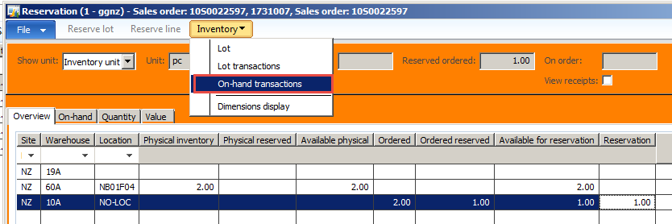

In the Inventory transactions screen hold ctrl then press HOME to get to the top and see ‘in process’ transactions.

Look in the Receipt column for status ‘Ordered’. The oldest transaction(s) (with earlier created date and time) in here will be the one(s) your part(s) have reserved against. Depending on the quantity the part could have reserved against one or more transactions. You can then right click view details on the purchase order or transfer to find out more or contact the warehouse (or H/O parts) to ask them about it if it’s something they could speed up for you or give you an ETA. Otherwise, you can also see the Issue status of sales orders. If you find an issue status ‘Reserved physical’ then you could talk to that sales order creator about removing their reservation so that you can sell the stock to your more important customer.

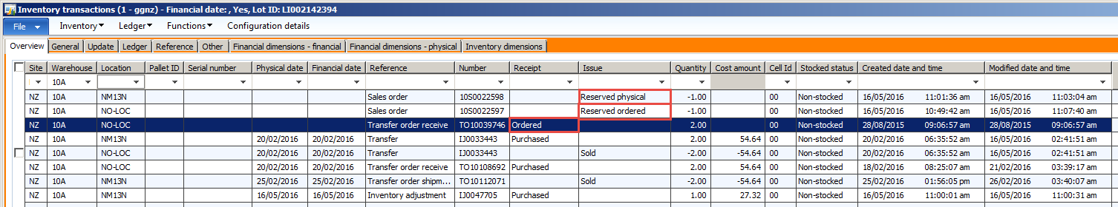

If the transaction with Receipt status ‘Ordered’ relates to a **purchase order**, you can get information relating to that (e.g. linked arrival journal, waybill number, receipt status) in the **Purchased Parts tracking** report here:

<http://chcaxdw1/Reports/Pages/Report.aspx?ItemPath=%2fGough+NAXT+Reports%2fProduct%2fPartTrackingReport>

This example shows seafreight waybill AUO0020136 and Shipment number 2630857931. Case numbers can also be seen in this report.

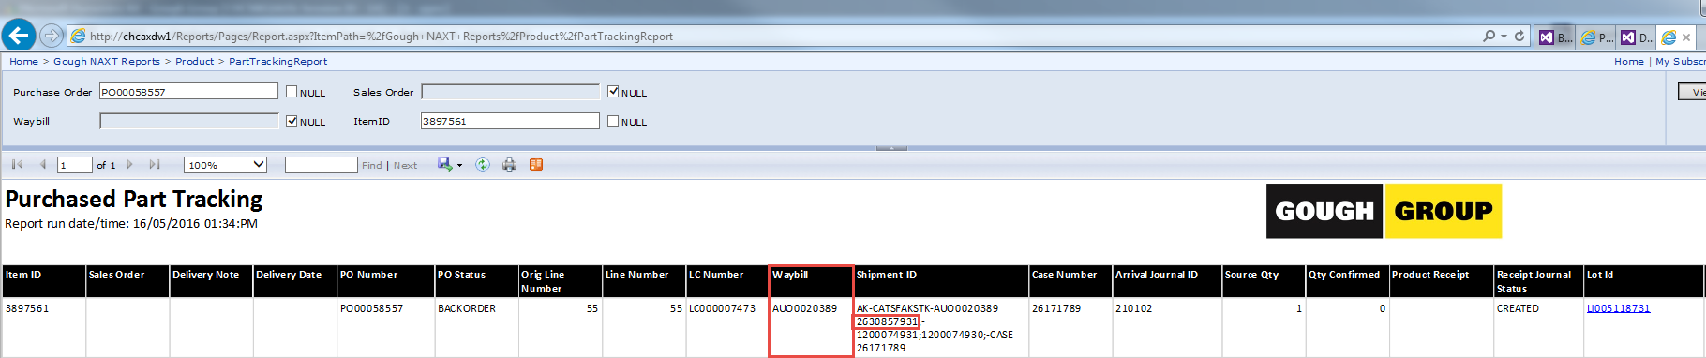

Airfreight waybill – DHL Global Forwarding 9X98326

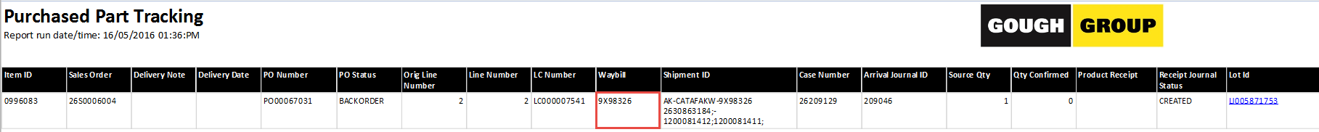

Airfreight waybill – DHL Express 4410520461

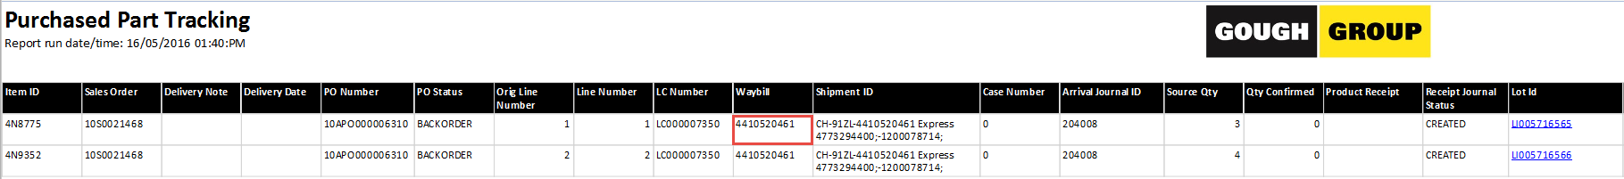

One you’ve identified the waybill relating to the purchase order you can use it to find further information:

For CAT ***sea freight take the bill of lading e.g. AUO0019865 or ASN / CSO / Shipment number e.g. 2630806224 and*** lookin the P drive for estimated arrival times, case numbers and more:

P:\Cat Business Unit\!Shipping Status\Shipping Status

For ***airfreight Waybills*** for CAT parts you can track them using your CWS logon:

[**https://otv.cat.com/dot/ot/search.do?reset=YES&dealerCode=&partNumber**](https://otv.cat.com/dot/ot/search.do?reset=YES&dealerCode=&partNumber)**=**

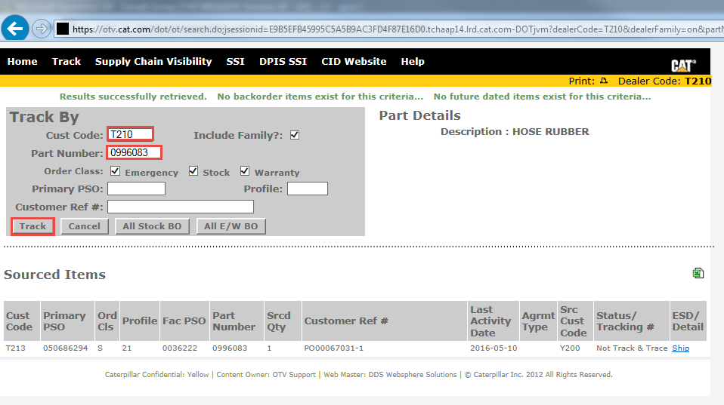

or search for **DHL Global Forwarding or DHL Express waybills** here:

|  |
| --- |
| <http://www.dhl.com/en/logistics/freight_transportation/air_freight.html> |
|  |
| <http://www.dhl.com/en/express/tracking.html> |

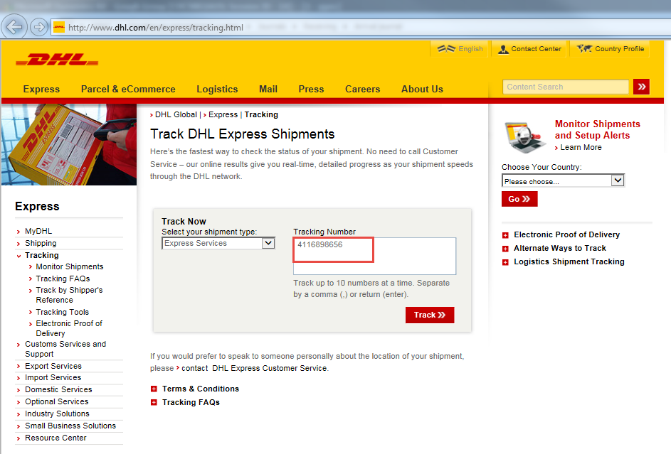

If you decide you really don’t want your sales order connected to the purchase order or transfer (or journal), and you don’t need to negotiate with other sales takers, then go back to the reservations screen and remove the quantity from the ‘Reservation’ column.

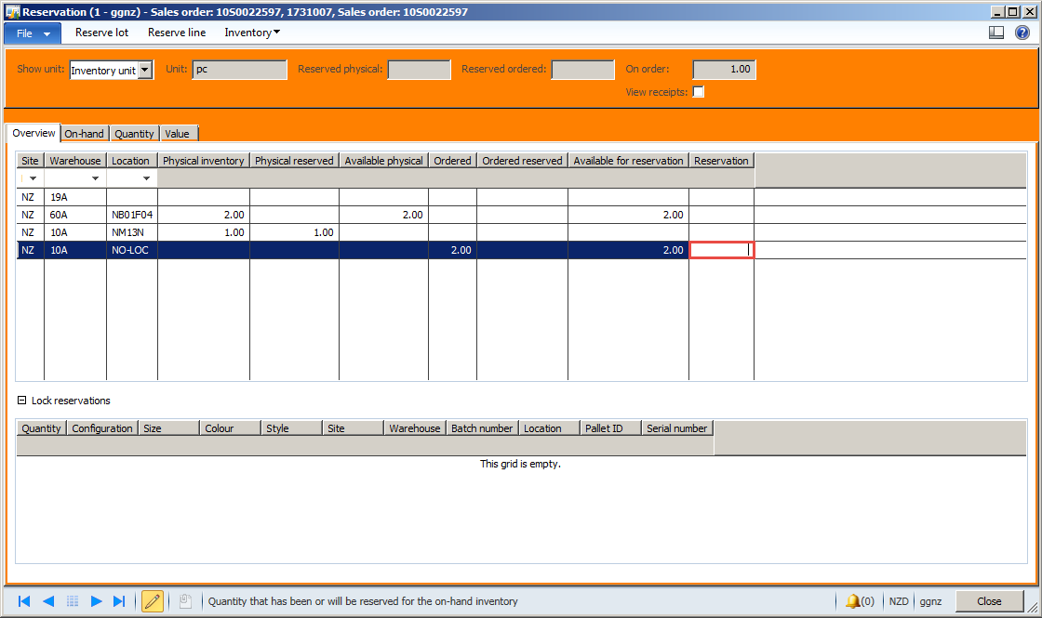

Go back to Backorder review – you can now see your part in the backorder review screen where you can action a new purchase order or transfer as needed.

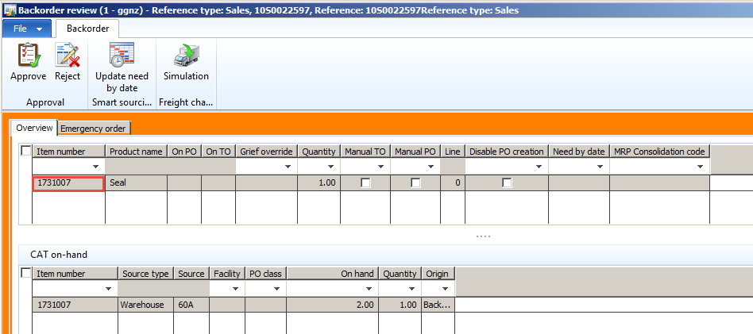

See these SOPS on processing backorders:

PRT_3.1(SOP)Create a Purchase Order from Backorder

PRT_3.4(SOP)Source Parts through Backorder

## Managing reservations

Sales and Transfer Orders, adjustment journals and any other transactions that are **taking stock out** create reservations against stock held at the relevant warehouse which means that stock cannot be subsequently used for other transactions. That means it’s important to finish your sales orders or delete them, and do not create them a long way in advance of the parts being sold if possible.

A journal created on Friday and left open over the weekend will block sales of those items all weekend, so journals too must be kept up to date and not left open.

When you create a purchase order or transfer order for **stock going in,** reservations can also happen against these orders. If you know the parts will not be supplied it is important to delete or cancel or amend these transactions. ***The exception is CAT purchase orders*** – please contact H/O parts about these as the purchase must also be cancelled in Antares otherwise the parts will still be sent to us by CAT and problems will be caused for H/O parts who must deal with the landed costing process.

Transfer orders that are only partially supplied must be finished by reducing the quantity of the transfer to match the reduced picked amount.

For more detailed instructions on how to manage transfers related to a backorder please refer to the following SOP: **PRT_5.2(SOP)Manage Discrepancies**