# Bartender

<https://support.seagullscientific.com/hc/en-us/articles/360003425874-Message-6670-Failed-to-connect-to-database>

<http://barcode-labels.com/wp-content/uploads/Connecting_Excel_to_BarTender.pdf>

<https://support.seagullscientific.com/hc/en-us/articles/360003425874-Message-6670-Failed-to-connect-to-database>

An issue that regularly arises is that Bartender **“cannot connect to database”**

It is usually fixed by changing what spreadsheet it is connected to. However, here is a similar fix that has proven to work so far.

**The spreadsheet that is being used by Bartender – you need to duplicate the file**

1. To do this – right click on the spreadsheet and click **copy**

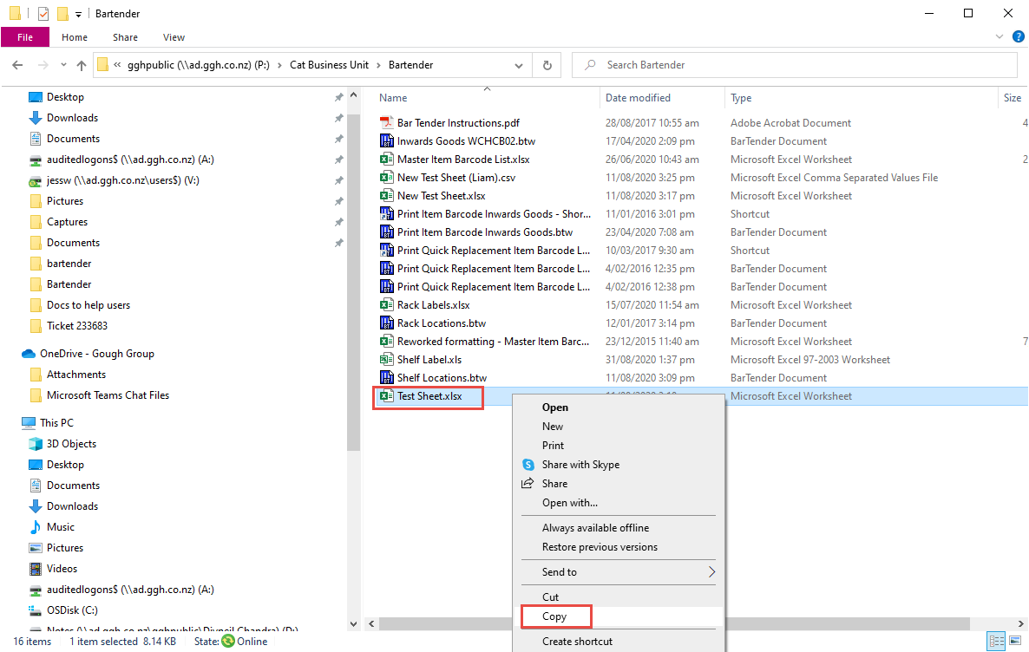

1. Right click in an empty area and click **paste**
2. As you see now, the word “**copy**” is in the name of the new file

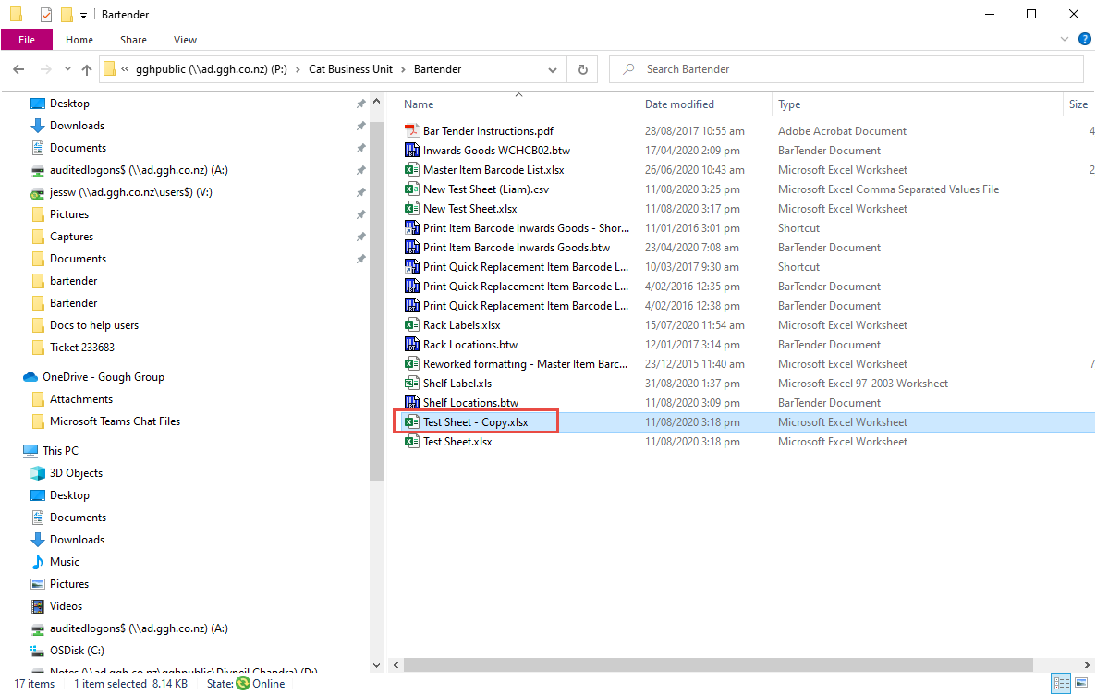

The original file will be saved as a **.xlsx** (Microsoft Excel Worksheet) like in the image below

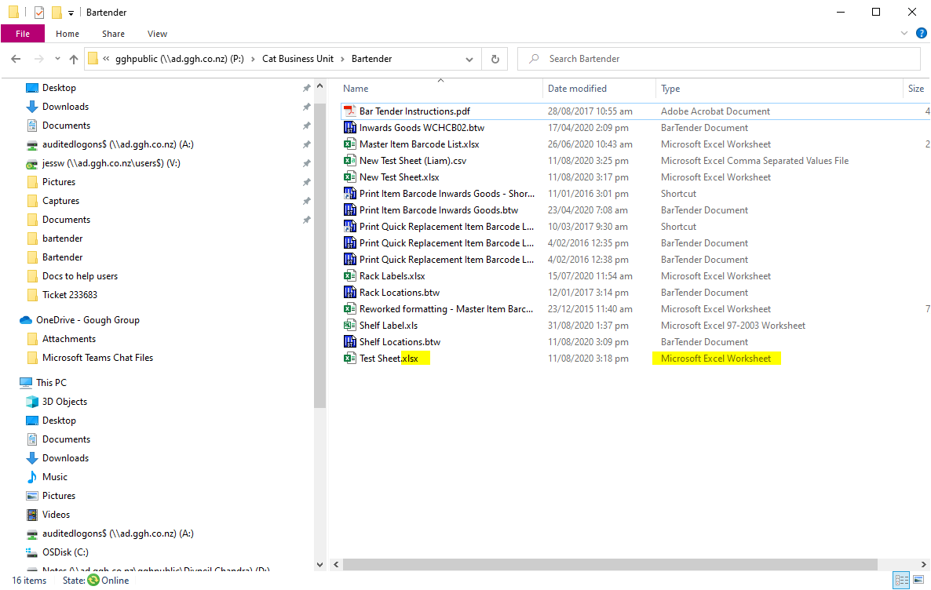

The new one will also be saved as **.xlsx**

1. You need to change the file format of the new file - Right click on the file – click **rename**

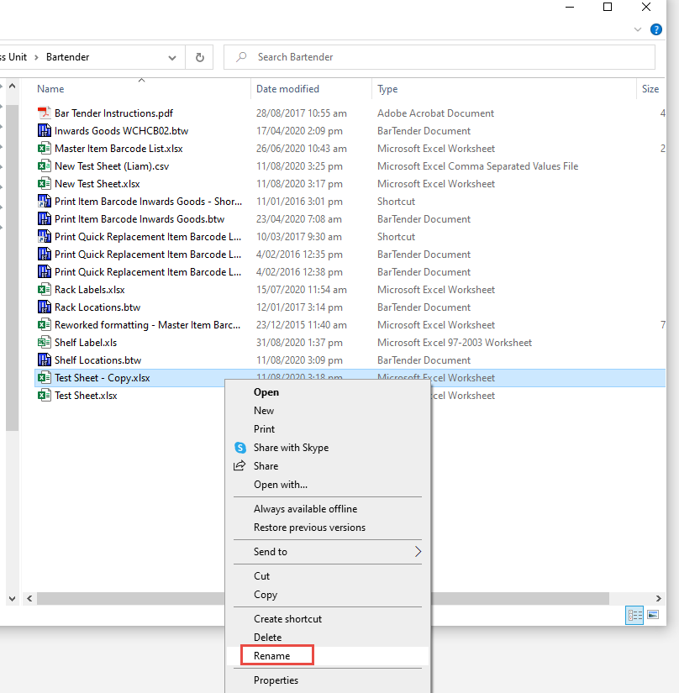

1. Rename it to the file format of **.xls** (Microsoft Excel 97-2003 Worksheet), like in the image below – press **enter** to save the new name

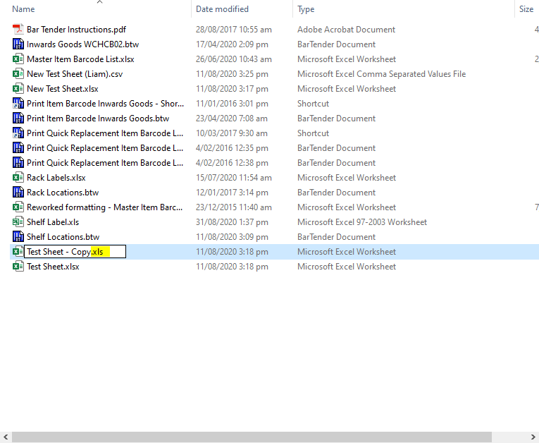

Now it has changed

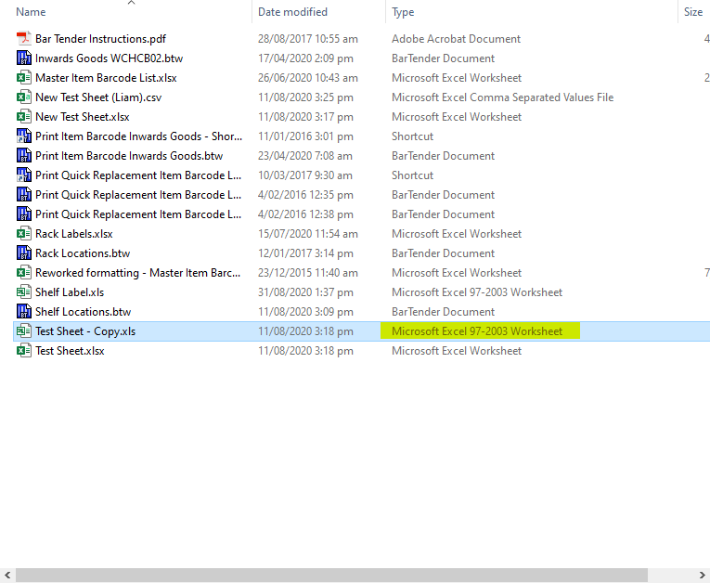

1. Now open **Bartender** (There may already be an icon on your desktop)

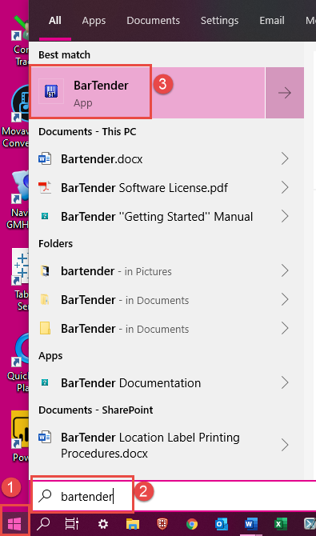

1. Double click on any of the recent files (doesn’t matter which one at this point)

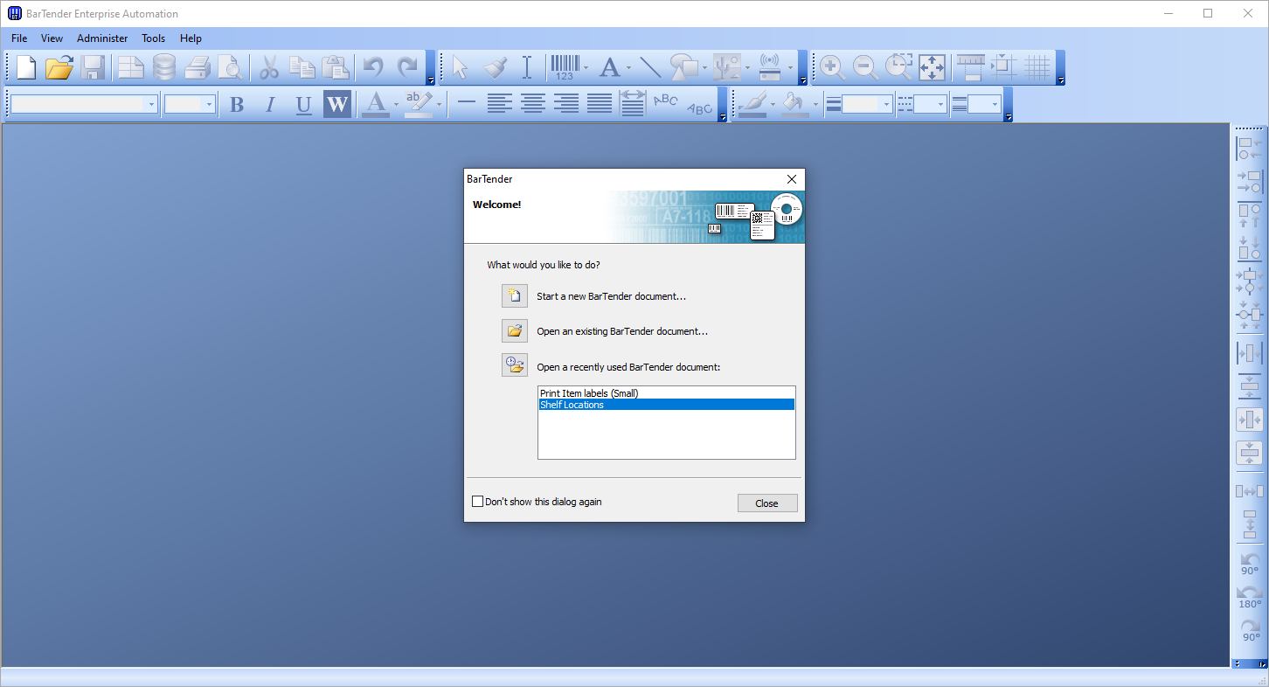

1. Click on the **Database Connection Setup** icon at the top

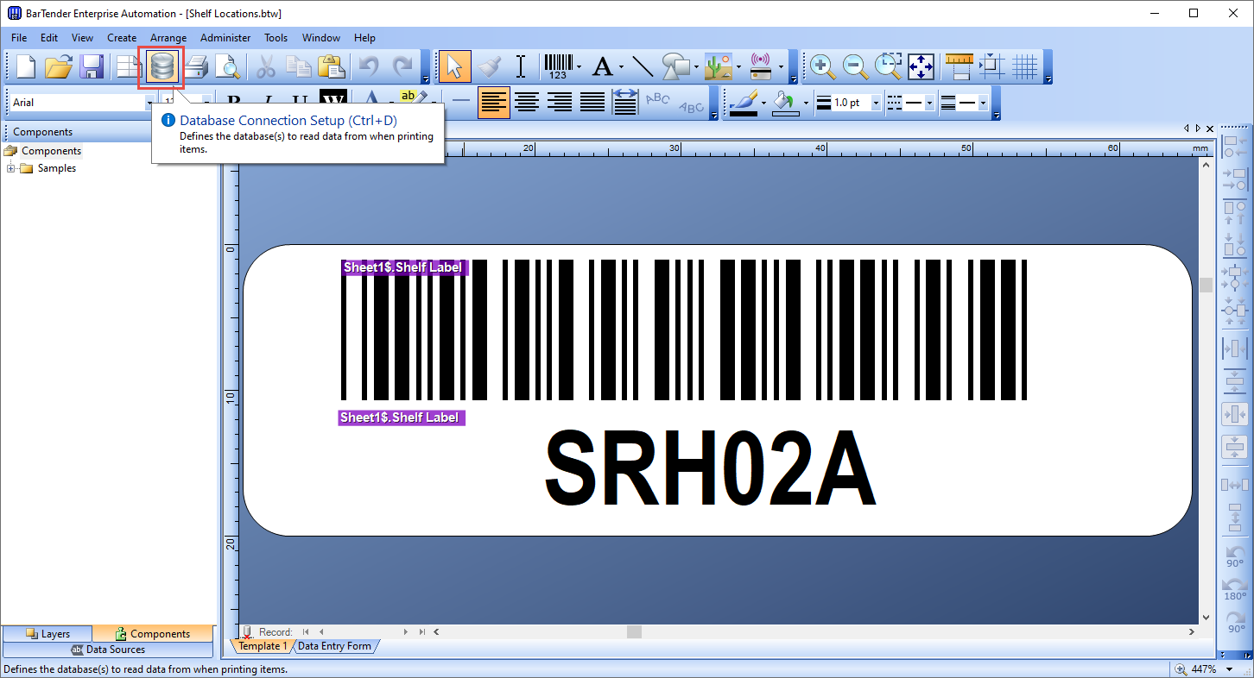

1. Click on the current sheet
2. Click **remove**

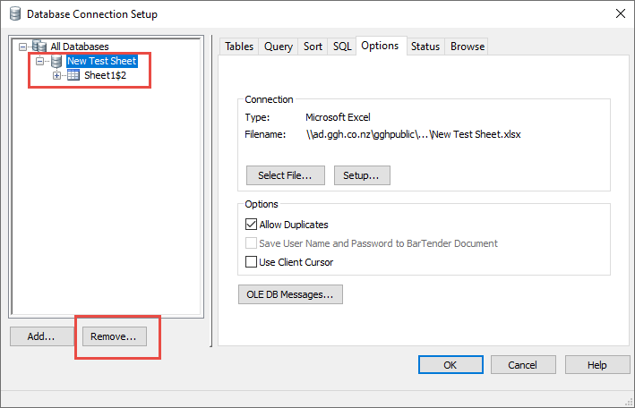

1. Click **yes**

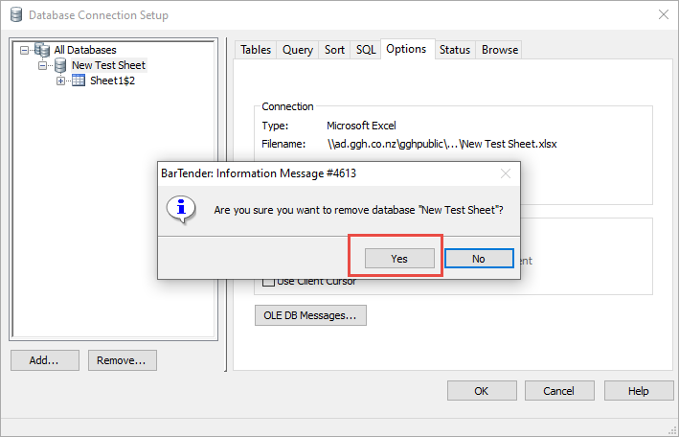

1. Click **add**

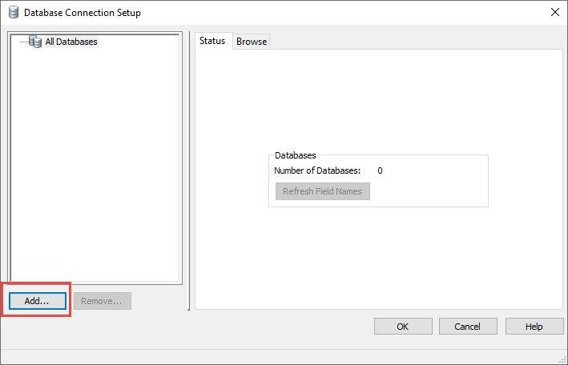

1. Click **Next**

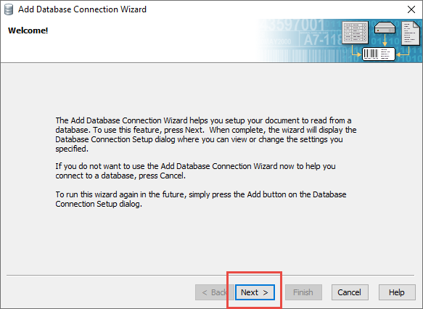

1. Select **Microsoft Excel** – Click **Next**

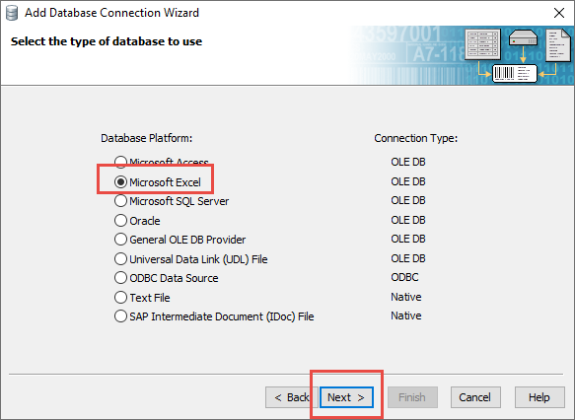

1. Click **Browse**

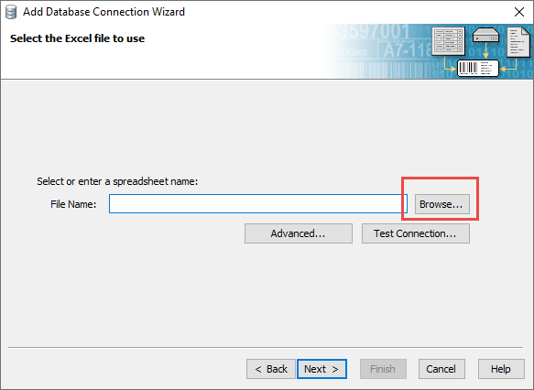

1. Browse to the location of the spreadsheet
2. Double click on the file to open it

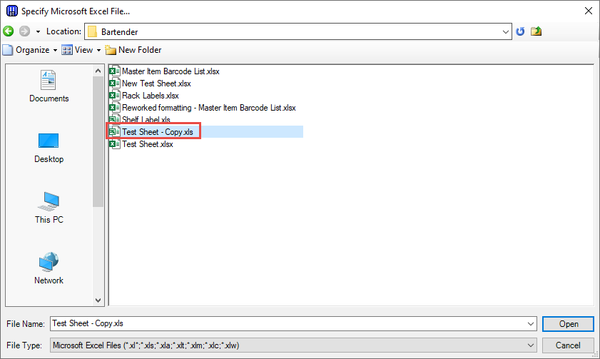

1. Click **Next**

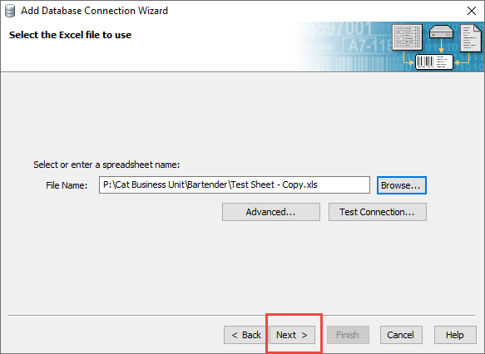

1. Click **Finish**

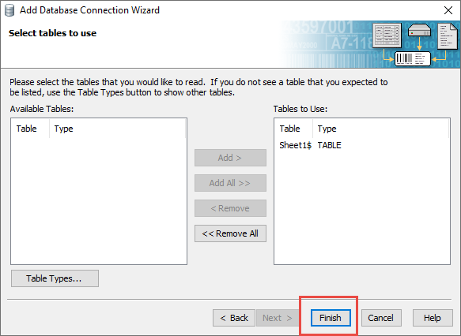

1. Click **Ok**

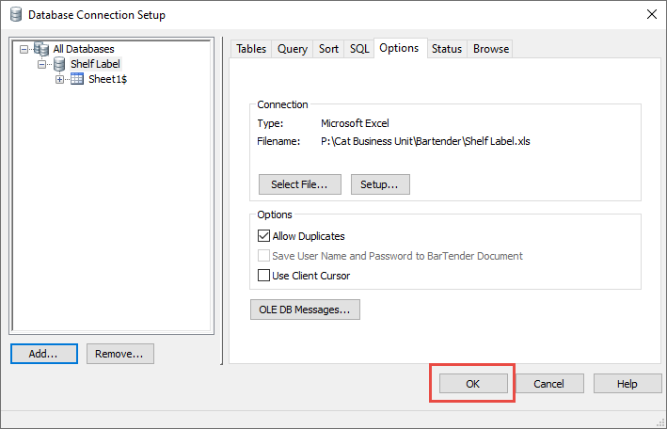

**Now Bartender should be working**

1. To test – click the **print symbol** at the top

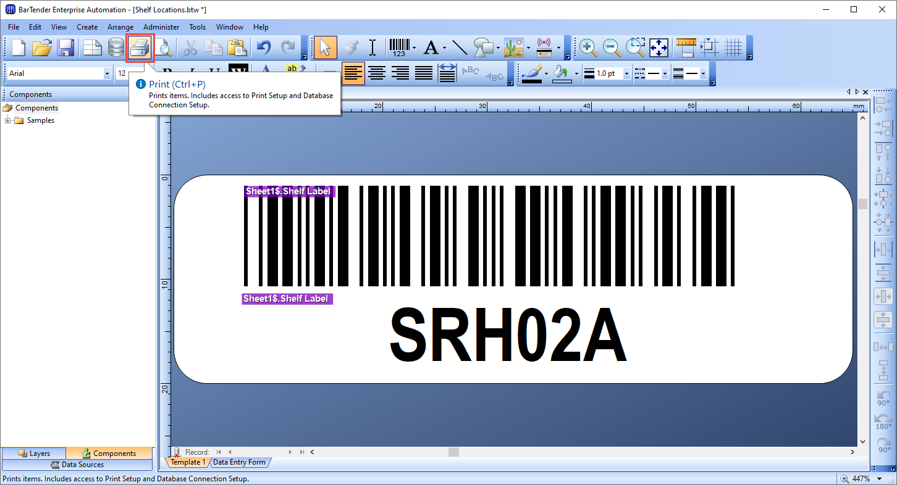

1. Click **print**

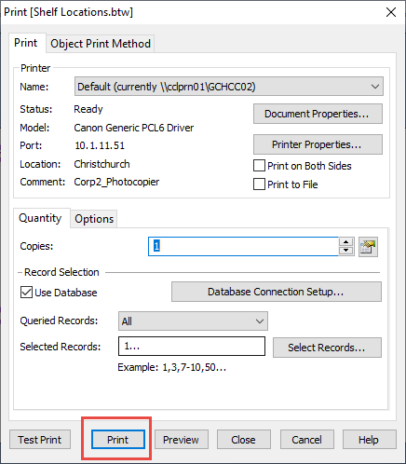

**Now you need to delete the old worksheet**

1. Right click on the file – click **delete**

