Jess Laudie

DS 3002

ETL Lab

24 February 2022

ETL Processing Screenshots

Northwind_dw with 5 new tables: dim_customers, dim_employees, dim_products, dim_shippers, fact_orders

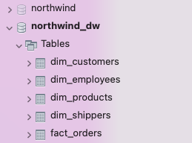

Dim_customers table

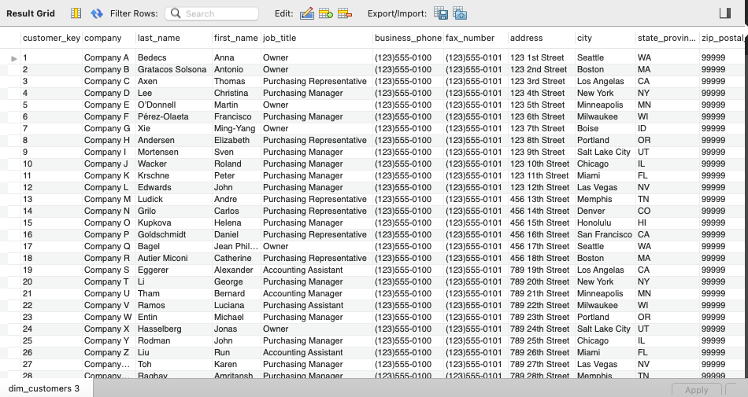

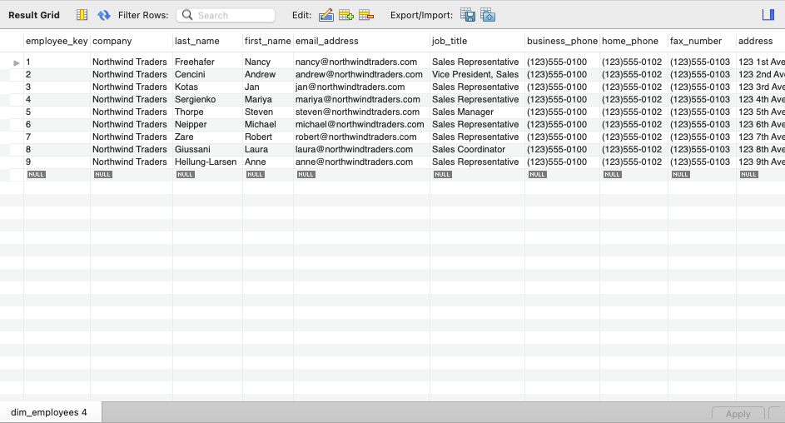Dim_employees table

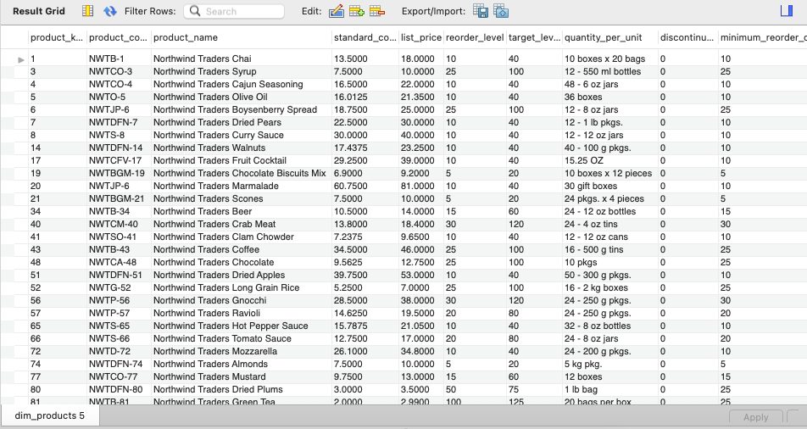Dim_products table

Dim_shippers table

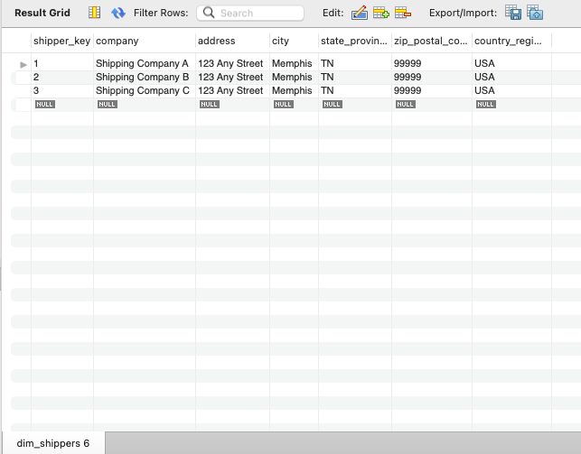

Fact_orders table

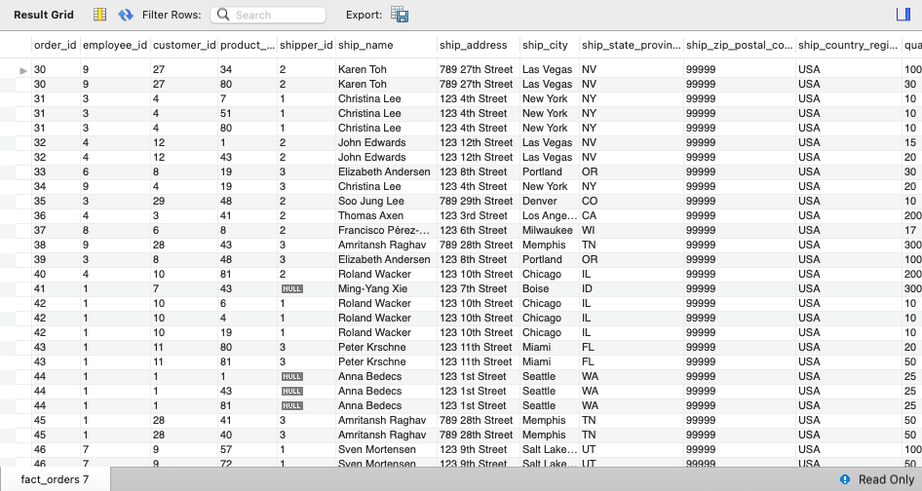

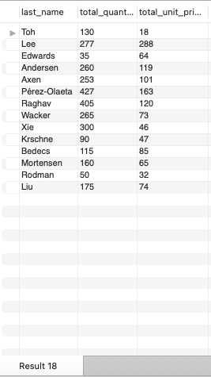Dimension report